PENSION AND FIDUCIARY Service
PMC VSR Advanced Core Course
Phase 6: Practical Application and Experience
Process Dependency Adjustment Claims
Trainee Guide
July 2024

Process Dependency Adjustment Claims

Lesson Overview
Topic | Description
Time Estimate: | 4.5 hours
Purpose of the Lesson: | This lesson is part of the entry-level course for PMC VSRs. The purpose of this lesson is to train you on how to process dependency adjustment claims through demonstration and practice. This lesson also includes instruction on how to use the systems for processing dependency adjustment claims.
Prerequisite Training Requirements: | Prior to taking the Process Dependency Adjustment Claims lesson, you must complete the entry level course:  - Phases 1–5.6.
Target Audience: | This lesson is for entry-level PMC VSRs.
Lesson References: | - 38 CFR 3.54 (Marriage dates)  - 38 CFR 3.57 (Child)  - 38 CFR 3.204 (Evidence of dependents and age)  - 38 CFR 3.205 (Marriage)  - 38 CFR 3.210 (Child’s relationship)  - 38 CFR 3.356 (Conditions which determine permanent incapacity for self-support)  - 38 CFR 3.667 (School attendance)  - M21-1 X.ii.3 (Applicability of Due Process )  - M21-1 III.i.2.D (Evidence Requested From the Claimant)  - M21-1 VII (Dependency)  - M21-1 VII.i.1.A (General Information on Relationship and Dependency)  - M21-1 VII.i.1.B (Verification of Marital Status and the Status of Dependents)  - M21-1 VII.i.1.C (Adjusting Awards for Dependents)  - M21-1 VII.i.2.E. (Remarriage of a Surviving Spouse)  - M21-1 IX.iii.1.F (Dependents for Current-Law Pension Purposes)  - Processing a Dependency Adjustment Claim Checklist job aid  - Appendix A for references introduced in earlier lessons
Technical Competencies: | - Program Benefits and Eligibility (PMC VSR)  - Processing Claims (PMC VSR)  - VBA Applications (PMC VSR)  - Income Counting and Net Worth
Knowledge Check: | Phase 6 Process Dependency Adjustment Claims Knowledge Check
Lesson Objectives: | - Process a dependency adjustment claim (Demonstrations and Practice Exercises)  - Recognize indicators of a dependency adjustment claim.  - Confirm claim characteristics.  - Determine if claim may be denied without development.  - Determine if evidence is sufficient to process a dependency adjustment claim.  - Determine if development, contemporaneous notice, or due process is applicable to the claim.  - Apply the correct development actions for the information/ evidence missing from claim.  - Determine entitlement to a dependency adjustment claim.  - Determine if claim should be submitted to rating activity.  - Determine whether an administrative decision is required.  - Decide the award action for a dependency adjustment claim.  - Create decision notice.  - Submit the claim to the Authorizer.
What You Need: | - Trainee Guide  - Access to the Processing a Dependency Adjustment Claim Checklist job aid from VSR Assistant  - Appendix A for other job aids from prerequisite lessons.

PowerPoint Slides | Notes
Process Dependency Adjustment Claims
Lesson Objectives (1 of 3)
- Dependency Eligibility Review
- Process a dependency adjustment claim (Demonstrations and Practice Exercises)
  - Demonstrations: Instructor will provide claim scenarios and questions for trainee review. Instructors will process production claims from start to finish with opportunities for questions.
  - Guided Practice Exercises: Trainees will process claims with questions and feedback/remediation.

Lesson Objectives (2 of 3)
- Recognize indicators of a dependency adjustment claim.
- Confirm claim characteristics.
- Determine if claim may be denied without development.
- Determine if evidence is sufficient to process a dependency adjustment claim.
- Determine if development, contemporaneous notice, or due process is applicable to the claim.
- Apply the correct development actions for the information/evidence missing from claim.
Lesson Objectives (3 of 3)
- Determine entitlement to a dependency adjustment claim.
- Determine if claim should be submitted to rating activity.
- Determine whether an administrative decision is required.
- Decide the award action for a dependency adjustment claim.
- Create decision notice.
- Submit the claim to the Authorizer.

Characteristics of Dependency
Adjustment Claims
- Relationship (definition) refers to an individual’s legal status with respect to the Veteran.
- Dependency (definition) refers to the question of whether or not an individual relies on a Veteran for financial support.
- End Product: EP 130 is generally used to control dependency adjustment claims.
Characteristics of Dependency Adjustment Claims
Importance of establishing the relationship of an individual to a Veteran is critical (for pension purposes) because
- the existence of dependents and the amount of their income is a factor in determining entitlement in both Veterans Pension and Survivors Pension cases, and
- a claimant’s entitlement to survivors benefits, such as DIC and Survivors Pension, is contingent on the relationship of the claimant to the Veteran on whose death the benefit is based.
Evidence to Establish a Dependent (1 of 2)
Effective March 24, 2015, a claimant must submit VA Form 21-686c or one of the prescribed forms listed in M21-1 II.iii.1.A.1.a, to initiate the process of adding a dependent to the award.
- Biological Child: Evidence is only required for the following reasons:
  - The claimant does not reside within a State
  - The claimant’s statement raises question of its validity, or
  - Reasonable indication of fraud or misrepresentation
- School Age Child (18-23): VA Form 21-674 (child must be attending school)
Evidence to Establish a Dependent (2 of 2)
- Helpless Child: Medical Evidence
- Adopted Child:
  - Official adoption papers
  - Adoptive Placement agreement
  - Certified copy of child’s revised birth certificate
Note: The VA does not require beneficiaries to use a specific form to report a change in a dependent’s status that will result in the removal of the dependent from the beneficiary’s award.
Dependent for Pension
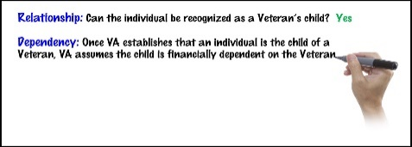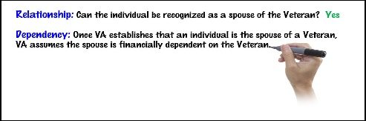
Dependent for Pension
- Biological child
- Adopted child under the age of 18
- Stepchild residing in the household of the Veteran prior to reaching the age of 18
- Veteran’s Spouse
- Veteran’s estranged spouse receiving contributions
- Helpless Child
- School Age child 18-23
Establish Spouse for Pension Purposes
If the Veteran and spouse physically live …
- Together in the same residence…a dependent
- apart for reasons related to marital discord, but the Veteran makes reasonable contributions to the support of the spouse…a dependent
- apart for reasons not related to marital discord…a dependent
- apart for reasons related to marital discord, and the Veteran does not make reasonable contributions to the support of the spouse…not a dependent
Establish Child for Pension Purposes
If the child…
- lives with the Veteran/surviving spouse…a dependent
- does not live with the Veteran/surviving spouse, but is still in the Veteran’s/surviving spouse’s custody for pension purposes…a dependent
- does not live with the Veteran/surviving spouse, and is not in the Veteran’s/surviving spouse’s custody for pension purposes, but the Veteran contributes to the child’s support…a dependent
- does not live with the Veteran/surviving spouse, is not in the Veteran’s/surviving spouse’s custody, and does not receive contributions of support from the Veteran/surviving spouse…not a dependent
Counting Income of Dependents (1 of 3)
There is one major exception to the general rule that all income must be counted for 12 months. A dependent’s income does not have to be counted for a full 12 months if the dependent is removed from the award.
The dependent’s income is removed with the dependent, even if this results in the income being counted for less than 12 months.
Counting Income of Dependents (2 of 3)
Spouse
If the spouse is established as a dependent, the Veteran’s IVAP automatically includes the spouse’s income regardless of whether it is available to the Veteran.
Child
A dependent child’s income is countable in computing a Veteran’s or surviving spouse’s IVAP if the income is reasonably available to the Veteran or surviving spouse.
A dependent child’s income is reasonably available if it can readily be applied to meet the Veteran’s or surviving spouse’s expenses necessary for reasonable family maintenance, per 38 CFR 3.23(d)(6).
Counting Income of Dependents (3 of 3)
Child
It is possible that part of a dependent child’s income could be considered available to the Veteran or surviving spouse, while the remainder might be considered unavailable, and therefore, not countable.
Example: A child remains in the Veteran’s legal custody, but lives with a grandmother. The child’s Social Security check is payable to the grandmother, but income from a trust fund is payable to the Veteran as guardian of the child. The child’s Social Security is unavailable to the Veteran, but the trust fund income is available to the Veteran.
Overview of Processing Dependency
Adjustment Claim
- Many of the steps required to process dependency adjustment claims are done simultaneously by PMC VSRs in the field.
- For the purpose of instruction, the steps are broken out individually.
- A dependency adjustment claim may be associated with other award adjustments.
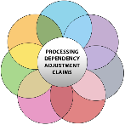
Dependency Adjustment Claims
Lesson Exercise
Question 1:
Who is a dependent for pension purposes?
Dependency Adjustment Claims
Lesson Exercise
Question 2:
A Veteran is currently estranged from spouse. However, the Veteran contributes $250 monthly for spousal support. Is the spouse a dependent for pension purposes? Why or Why not?
Dependency Adjustment Claims
Lesson Exercise
Question 3:
What form is required to add a school age child?
Scenario 1 – Dependency Adjustment Claim
Emily Veteran, has been receiving Veteran pension benefits since 2019 based on no income and no dependents. Emily submitted VA Form 21-686c (Application Request to Add and/or Remove Dependents) on June 30, 2021, reporting that she married John, on May 26, 2021. The claim included the marriage certificate (this is their 1st marriage), income, and net worth information. John receives Social Security benefits in the amount of $400.50 monthly, pays SMIB of $100.50 monthly, and has a checking account balance of $500. Emily’s income and net worth remains $0.
Why It Matters!
- Can the award be adjusted based on information submitted?
- What is the effective date to add the Veteran’s spouse?
- Will the adjustment result in an increase, reduction, or termination of benefits?
Why It Matters! Answers
- Can the award be adjusted based on information submitted?
- What is the effective date to add the Veteran’s spouse?
- Will the adjustment result in an increase, reduction, or termination of benefits?
Demonstration Claim 1— Dependency Adjustment Claim (Add Dependent)

Instructor processes a dependency adjustment claim from start to finish with opportunities for questions. Claim selected for demo should add a dependent to the award. Instructor will also prepare a decision notification letter and discuss the required information to be included in the letter.
Guided Practice Exercise – Add Dependent (1 of 5)
- Trainees will review a sample dependency adjustment claim and answer questions related to sample case. Provide 15 minutes to review sample claim and answer questions.
- Sample 1 VA Form 21-686c, Application Request to Add and/or Remove Dependents
- Sample 1 VA Form 21P-0516-1: Eligibility Verification Report
- 21-686c (va.gov): Application Request to Add and/or Remove Dependents
Guided Practice Exercise – Add Dependent (2 of 5)
Review Sample 1 VA Form 21-686c Application
Brief Description
- Veteran with running award based on no dependents, no income/net worth since 2019
- Reporting first marriage for both Veteran and spouse
- Date of marriage: February 23, 2022/ DOC: April 28, 2022
- Income Statement (VA Form 21-0516-1)
Guided Practice Exercise – Add Dependent (3 of 5)
Questions
- What is the correct EP for the dependency adjustment claim?
- What is the effective date to add the Veteran’s spouse?
- What is the time limit to add a dependent from the event date?
- Would the dependency adjustment result in an increase, reduction, or termination of pension benefits?
- Is additional evidence required before processing the dependency claim?
Guided Practice Exercise – Add Dependent (4 of 5)
Answers
- What is the correct EP for the dependency adjustment claim?
- What is the effective date to add the Veteran’s spouse?
- What is the time limit to add a dependent from the event date?

Guided Practice Exercise – Add Dependent (5 of 5)
Answers
- Would the dependency adjustment result in an increase, reduction, or termination of pension benefits?
- Is additional evidence required before processing the dependency claim?
Guided Practice Exercise –
Dependency Adjustment Decision Letter
Trainees will prepare an amended dependency adjustment decision letter for Sample 1 Dependency Adjustment claim
Instructions:
- Use the job aids, references, and systems available.
- Be prepared to discuss letter with the class.
Time allowed: 20 minutes
Identify Missing Information/Evidence
If a claim for dependency is received, must determine if the evidence submitted is sufficient to process the dependency claim. If information is missing to process claim, determine whether development or due process is required.
Development must be issued if the dependency claim is missing information, but failure to submit the information will not have a negative effect on the claim.
Due process must be issued if the dependency adjustment claim lacks evidence or information received is third party that will negatively impact the primary beneficiary claim.
Development Example
The Veteran submits a claim to add dependent spouse. Veteran has been receiving pension benefits for the last 5 years. Date of marriage is February 22, 2022, date of claim is March 22, 2022. The Veteran submits income and net worth information for spouse but fails to report prior marital history. The Veteran submits a marriage certificate that shows this is the Veteran’s 3rd marriage and spouse’s 4th marriage.
Result: Development is needed for complete marital history. Allow 30 days to submit information, if no response, the dependency award will be adjusted to count the income/net worth of spouse (if applicable) but will not add spouse to award.
Due Process Example
The Veteran submits a claim to add dependent spouse. Veteran has been receiving pension benefits for the last 5 years based on no income and no dependent. Date of marriage is February 22, 2019, date of claim is March 22, 2022. The Veteran submits complete marital history (first marriage for Veteran and spouse) but fails to report income and net worth information for spouse.
Result: Due process is required as income and net worth information is a factor to determine entitlement to pension benefits. Allow 60 days to submit information, if no response, the dependency award will be adjusted to terminate benefits effective first of the month following date of marriage for failure to submit required evidence.
Scenario 2 – Missing Information
Bee Kind, a Veteran, has been receiving Veteran pension benefits since 2019 based on Social security income of $500 monthly and 1 dependent child. The Veteran’s dependent child, Hope, was removed on November 22, 2021 (18th birthday). Bee submitted VA Form 21-674, Request for Approval of School Attendance, to add Hope back on as she is still attending high school. The claim was received on February 23, 2022. Upon review of the form, the expected date of graduation is missing. Hope has no income/ net worth to report.
Why It Matters!
- Can the award be adjusted based on information submitted?
- What information is missing to add the school age child?
- Is development or due process required?
Why It Matters! Answers
- Can the award be adjusted based on information submitted?
- What information is missing to add the school age child?
- Is development or due process required?
Demonstration Claim 2—
Dependency Adjustment Claim
(Development/Due Process)
Instructor processes a dependency adjustment claim from start to finish with opportunities for questions. Claim selected for demo should require development or due process action. Instructor will discuss the required information to be included in the development/due process letter.
Development vs Due Process
Exercise (1 of 2)
Review the following scenarios and determine if development or due process is needed.
Scenario 1
VA receives a correspondence on November 5th, showing that the Veteran currently in receipt of pension benefits based on no income and no dependents, was married on July 4th. Claim is not signed by the Veteran and is not on a prescribed form.
Development vs Due Process
Exercise (2 of 2)
Scenario 2
VA receives dependency claim on August 25^{th,} , showing that the Veteran currently in receipt of pension benefits based on no income and no dependents, was married on July 4th. VA Form 21 686c is received and signed by Veteran. Veteran also submits income information for current spouse. Marriage certificate is submitted showing this is the third marriage for both Veteran and spouse. However, no prior marital history is of record.
Removal of Dependent Spouse –
Reduction/Discontinue Pension
If the Veteran’s award will result in a reduction or discontinuance based on removal of spouse for…
- Death, Divorce, or annulment = remove spouse first of the month following event
- Estrangement (no contributions) = date of the separation (Do not apply the end-of-the-month rule)
- Cessation of contributions = day after the last contribution (Do not apply the end-of-the-month rule)
Removal of Dependent Child –
Reduction/Discontinue Pension
If the Veteran’s/surviving spouse’s award will result in a reduction or discontinuance based on removal of child(ren) for…
- Death/Marriage = first of the month following event
- Turning 18/23 = actual birthdate (for pension purposes)
- No longer in school = first of the month following
- Cessation of contributions = day after the last contribution
Note: If a schoolchild marries and stays in school, continue to pay benefits until the first of the month after the month of marriage. However, if the child discontinues school attendance before marrying, reduce the award effective the first day of the month following the date the child last attended school.
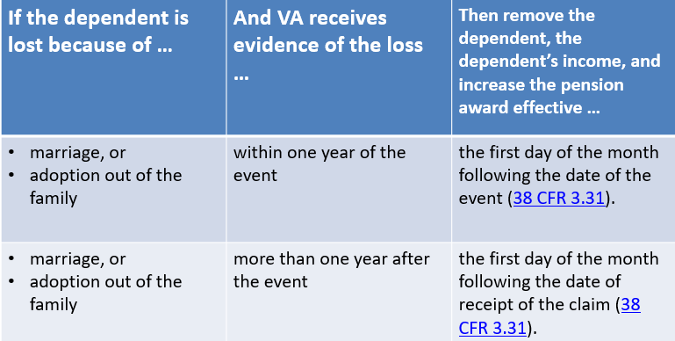
Removal of Dependent –
Increase Pension Rate (1 of 2)

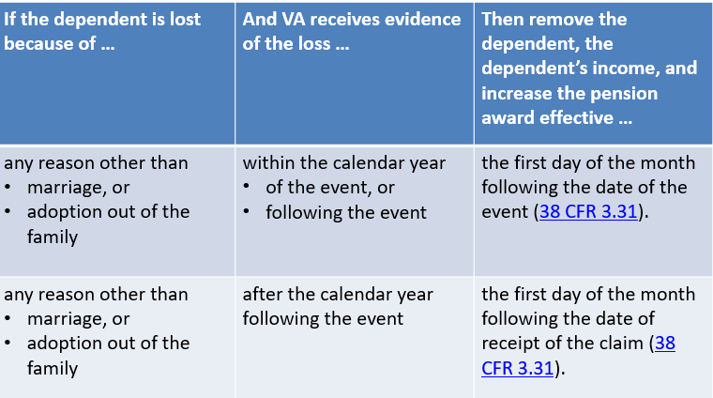
Removal of Dependent – Increase Pension Rate (2 of 2)

Removal of Dependent-
Lesson Exercise
Question 1:
- A married Veteran’s spouse has no income. The Veteran reports separating from the spouse on May 6, 2022. The Veteran does not contribute to the spouse’s support. What is the effective date to remove the spouse?
Removal of Dependent-
Lesson Exercise
Question 2:
A child turns 18 on October 14, 2021. The child marries on October 29, 2021. What is the effective date to remove the child?
Scenario 3 – Removal of Dependent
Carl Veteran, has been receiving Veteran pension benefits since 2019 based on social security income of $500 monthly and 1 dependent spouse, Mildred (no income). Carl submitted VA Form 21-4138, Statement in Support of Claim on March 16, 2022, informing the VA that Mildred passed away on March 7, 2022. Please adjust award accordingly.
Why It Matters!
- Can the award be adjusted based on information submitted on VA Form 21-4138: Statement in Support of Claim (prescribed form criteria)?
- Will the removal of the Veteran’s spouse result in an increase, reduction, or termination of benefits?
- What is the effective date to remove the spouse?
Why It Matters! Answers
- Can the award be adjusted based on information submitted on VA Form 21-4138: Statement in Support of Claim (prescribed form criteria)?
- Will the removal of the Veteran’s spouse result in an increase, reduction, or termination of benefits?
- What is the effective date to remove the spouse?
Demonstration Claim 3—
Dependency Adjustment Claim
(Remove Dependent)
Instructor processes a dependency adjustment claim from start to finish with opportunities for questions. Claim selected for demo should remove a dependent from the award. Instructor will also prepare a decision notification letter and discuss the required information to be included in the letter.
Knowledge Check: Lesson Summary Review

Time Allowed: 15 minutes
What’s Next
- Complete the Process Dependency Adjustment Claims course survey. TMS ID # 4408411.

