Pension and Fiduciary Service
PMC VSR Advanced Core Course Phase 6: Processing Claims
Lesson 15: Process 810 Series Work Items
Trainee Guide
June 2022

Process 810 Series Work Items Claims

Lesson Overview
Topic | Description
Time Estimate: | 2.5 hours
Purpose of the Lesson: | This lesson is part of the entry-level course for PMC VSRs. The purpose of this lesson is to train PMC VSRs to process 810 series work items through demonstration, practice, and feedback.
Prerequisite Training Requirements: | Prior to taking the Process 810 Series Work Items lesson, you must complete the entry-level course Phases 1–5 and Phase 6, lessons 1–14.
Target Audience: | This lesson is for entry-level PMC VSRs.
Lesson References: | - M21-1 II.i.2.C.2.d. (Placing Claims and 800 Series Work Items Under EP Control)  - M21-1 II.i.2.C.6.d. (Procedure for Obtaining a Correct Address for Undeliverable Essential Mail)  - M21-1 II.i.2.C.6.k. (Processing 800 Series Work Items Commonly Related to Lack of a Correct Address)  - M21-4 Appendix B. Section 3. (800 Series Work Items)  - M21-4 Appendix B. Section 4 (Processing 800 Series Work Items)  - M21-4 Appendix C, Section 1.b (Index of Claim Labels)  - Processing an Award Adjustment job aid  - Appendix A for references introduced in earlier lessons.
Technical Competencies: | - Program Benefits and Eligibility (PMC VSR)  - Processing Claims (PMC VSR)  - VBA Applications (PMC VSR)  - Income Counting and Net Worth
Lesson Objectives: | - Differentiate the 800 series work items status categories.  - Process 810 series work items.  - Determine which 800 series work item was received.  - Determine the reason for the work item.  - Determine the appropriate steps to take to process the 810 series work item.  - Perform the required actions to process the 810 series work item.  - Submit the outcomes of the 810 series work item to the Authorizer.
What You Need: | - Trainee Guide  - Pen and paper  - Access to the Processing an Award Adjustment job aid from VSR Assistant  - Appendix A for other job aids and references

PowerPoint Slides | Notes
Lesson 15: Process 810 Series Work Items

Lesson Objectives
- Differentiate 800 series work items status categories
- Process 810 series work items:
  - Determine which 800 series work item was received
  - Determine the reason for the work item
  - Determine the appropriate steps to take to process an 810 series work item
  - Perform the required actions to process an 810 series work item
  - Submit the outcomes of the 810 series work item to the Authorizer
Why It Matters!
It is important to know how to process 810 series work items because the PMC VSR will be able to track cases that require follow up action regarding notification of benefit payment transactions.
Introduction to 800 Series Work Items
- According to M21-4 Appendix B.3.a. (Definition: 800 Series Work Items) an 800 series work item is a system-generated message issued to assist VSCs and PMCs in identifying and tracking cases that require follow-up action.
- Important:
  - Primarily for tracking; do NOT complete any development, rating, or award actions under an 800 series work item.
  - Manually establishing an 800 series work item is not possible.
800 Series Work Items Claim Labels
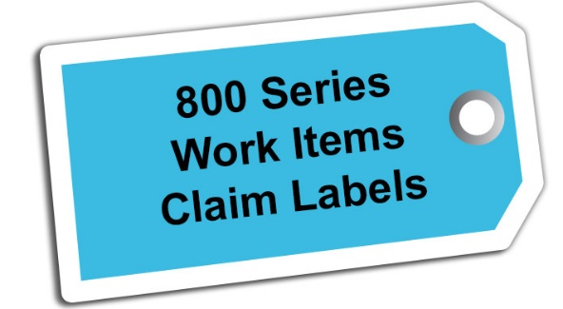
- Each 800 series work item status category has additional subcategories called claim labels.
- Claim labels specify the issue that needs to be resolved within the broader 800 series work items status category.
810 Series Work Items (Notice of Benefit Payment Transaction)
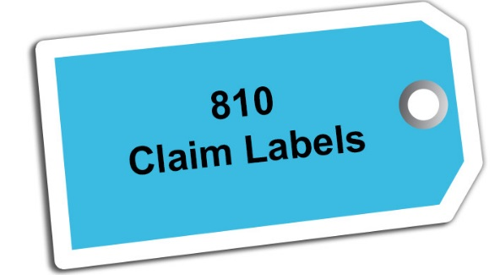
- 603
- 605/606 and 611
- 607
- 626
- 634
810-603 Returned Payment Applied to Accts Receivable
- Reason: this work item generates when a claimant has a current debt with VA and a payment was returned to VA, but instead of going to proceeds, it was applied to their debt
- Actions:
  - In SHARE, look at the Corporate Record>Awards/Rating tab
  - Pay Status will probably show Suspended
  - In VBMS, check last received address to verify it is the same one on file

810-605/606 Payee Deceased – Accrual Segment Established/Increased and 611 Payment Returned Death of Person Entitled (1 of 2)
- Reason: these work items indicate the following:
  - That the beneficiary is reported as deceased
  - An overpayment was created on the account for monies that were paid after the first of the month of death
- Actions: ensure that the beneficiary’s award is terminated.
  - If the Award Information screen shows no monies in the Receivables Balance, then Finance has already addressed the issue. Perform PIF Clear Function in SHARE.


PowerPoint Slides | Notes
810-605/606 Payee Deceased – Accrual Segment Established/Increased and 611 Payment Returned Death of Person Entitled (2 of 2)
  - If the Award Information screen shows monies in the Receivables Balance and in Proceeds, then e-mail Finance to apply the Proceeds to the Receivable Balances since the beneficiary is deceased.
  - After e-mailing Finance, perform the PIF Clear Function in SHARE.
810-607 Miscellaneous Returned Payment
- Reason: this work item is generated based on an automatic burial payment being returned.
- Actions:
  - Confirm the beneficiary’s name and address to which the burial payment was sent is correct.
  - Correct if needed.
  - After updating the address, request the appropriate prescribed form and generate an award to reissue the payment.
  - If the beneficiary is not entitled, ask Finance to return the funds to appropriations.

PowerPoint Slides | Notes
810-612 Account Suspended – Undeliverable Payment
- Reason: this generates when an automatic burial or MOD payment is returned/rejected or if a payment issued by the Debt Management Center (DMC) is returned.
- Actions:
  - Determine whether the payment needs to be reissued or needs to be taken back by VA.
  - Verify with an SSA inquiry that the beneficiary is still alive.
  - Check the last received address to verify if it is the same as the one that is on the General Information tab of the SHARE Corporate Award Screen.
  - CEST an EP to adjust the award.
PowerPoint Slides | Notes
810-626 Paid EFT – Verify Home Address (1 of 2)
- Reason: this work item generates when a direct deposit payment has been returned.
- Actions:
  - Verify the beneficiary is still alive.
  - If unable to verify, look in VBMS to check the last received direct deposit information.
  - Compare it to the information listed on the General Information tab of the SHARE Corporate Award Screen.
  - If benefits were recently awarded, check the application and compare to SHARE to look for a typing error.
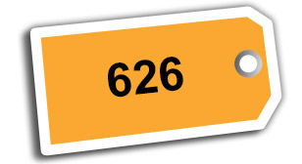

PowerPoint Slides | Notes
810-626 Paid EFT – Verify Home Address (2 of 2)
  - If the direct deposit/EFT information is updated by another user or action, perform the PIF Clear Function in SHARE.
  - To change a beneficiary's direct deposit/EFT information and prompt the system to resume payments, enter the updated information in the SHARE Change of Address Function
  - Confirm updated direct deposit information in SHARE on the General information tab.
810-634 Proceeds Established in Participant Record (1 of 2)
- Reason: this work item typically generates with an 810-626 Paid EFT – Verify Home Address, indicating that a beneficiary has not received the money (likely because of an incorrect address or 810-626).
- NOTE: when the 810-634 is a stand-alone item, award action may be needed to pay proceeds, including from a returned MOD payment.
- Actions:
  - Identify the reason(s) the payment was returned.
  - Look at Pay Status field in SHARE.
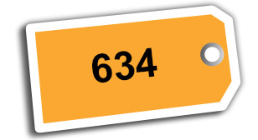
810-634 Proceeds Established in Participant Record (2 of 2)
  - Pay Status will show one of the following entries:
    - Terminated
    - Suspended
    - Authorized

Demonstration and Guided Practice
- Demonstration—Instructor processes a work item from start to finish with opportunities for questions.
- Guided Practice—Trainees process a claim with questions and feedback/remediation.
Step By Step Guide -
810: 611 Work Item
- A PMC VSR, receives an 810: 611 Payment Returned Death of Person Entitled work item to her work queue for Surviving Spouse Angela.
- The PMC VSR recognizes that the work item may be due to the death of the Surviving Spouse.
- The PMC VSR reviews the corporate record and determines the Surviving Spouse’s award has been suspended due to a returned check and no action has been completed to terminate based on her death.
- The PMC VSR then pulls an SSA SHARE print to review for the Surviving Spouse’s date of death. The SHARE print verifies that the Surviving Spouse passed away June 18, 2017.
- The PMC VSR clears the 810-611 work item and CESTs an EP 130 PMC Report of Death of Beneficiary (if one is not already pending).
- The PMC VSR then inputs the appropriate date of death into VBMS to terminate the Surviving Spouse’s award.
- The PMC VSR creates an estate letter to inform the estate of the terminated award based on the death of the Surviving Spouse and submits the pending claim to the Authorizer.

Demonstration Example 1—
Determine Which 800 Series Work Item Was Received

Demonstration Example 1—
Determine the Reason for the Work Item
- Work item was not cleared previously, but no update is needed
- An update is needed in the system
- An award adjustment is needed
Demonstration Example 1—
Determine the Appropriate Steps to Take to Process the 810 Series Work Items
Demonstration Example 1—
Perform the Required Actions to Process an 810 Series Work Item
Demonstration Example 1—Submit the Outcomes of the 810 Series Work Items to the Authorizer
Questions About Demonstrations?


PowerPoint Slides |  | Notes
Guided Practice Exercise Overview—810 Series Work Items (1 of 2)
- Instructions:
  - Process 810 series work item from beginning to end.
  - Use the job aids, references, and systems available.
  - Select a partner before beginning the exercise to confer with after completing each step individually.
  - Consult with instructors for assistance.
  - Be prepared to discuss your results with the class.
  - Take credit in ASPEN as directed at the completion of the exercise.
Guided Practice Exercise Overview—810 Series Work Items (2 of 2)
- This exercise includes the following parts of the work items process:
  - Determine which 800 series work item was received
  - Determine the reason for the work item
  - Determine the appropriate steps to take to process an 810 series work item
  - Perform the required actions to process an 810 series work item
Submit the outcomes of the 810 series work item to the Authorizer
Guided Practice Exercise—810 Series Work Items
Guided Practice Exercise Example:
- {Work item}
- {Other information}
Guided Practice Exercise—
Determine Which 800 Series Work Item Was Received
- Instructions:
  - Determine which 800 series work item was received.
  - Confer with your partner.
  - Be prepared to discuss your results with the class.
Time allowed: 5 minutes
Guided Practice Exercise—Determine the Reason for the Work Item
- Instructions:
  - Determine the reason for the work item.
  - Confer with your partner.
  - Be prepared to discuss your results with the class.
Time allowed: 15 minutes
Guided Practice Exercise—
Determine the Appropriate Steps to Take to Process the 810 Series Work Item
- Instructions:
  - Determine the steps to take to process the 810 series work item.
  - Use the job aids, references, and systems available.
  - Confer with your partner.
  - Be prepared to discuss your results with the class.
Time allowed: 20 minutes
Guided Practice Exercise—
Perform the Required Actions to Process an 810 Series Work Item
- Instructions:
  - Perform the required actions to process the specific claim label for the 810 series work item.
  - Use the job aids, references, and systems available.
  - Confer with your partner to assess each other’s steps to process the work item.
  - Ask for guidance from the instructor if you identify discrepancies.
  - Time allowed: 40 minutes

PowerPoint Slides | Notes
Guided Practice Exercise—Submit the Outcomes of the 810 Series Work Item to the Authorizer
- Instructions:
  - Finalize notes for work items and save completed work in appropriate locations for review by Authorizer.
  - Use the job aids, references, and systems available.
Time allowed: 10 minutes
Questions?
Lesson Summary
- What is an 800 series work item?
- What are the main tasks a PMC VSR must accomplish to process 810 series work items
What’s Next?
Complete the Process 810 Series Work Items course evaluation TMS ID #4408410

