Pension and Fiduciary Service
PMC VSR Advanced Core Course
Phase 6: Practical Application and Experience
Process Expense Adjustment Claims
Trainee Guide
July 2024

Process Expense Adjustment Claims

Lesson Overview
Topic | Description
Time Estimate: | 4 hours
Purpose of the Lesson: | This lesson is part of the entry-level course for PMC VSRs. The purpose of this lesson is to train PMC VSRs to process expense adjustment claims through demonstration, practice, and feedback.
Prerequisite Training Requirements: | Prior to taking the Process Expense Adjustment Claims lesson, you must complete the entry-level Core Pension Training (CPT) course Phases 1–5.6.
Target Audience: | This lesson is for entry-level PMC VSRs.
Lesson References: | - M21-1 IX.iii.1.G.1.b (Reporting Deductible Expenses to Reduce Overpayment)  - M21-1 IX.iii.1.G.2.a (Rules for Deductibility of UMEs)  - M21-1 IX.iii.1.G.2.c (List of Common Allowable Medical Expenses)  - M21-1 IX.iii.1.G.3 (Sources of Medical Expenses)  - M21-1 IX.iii.1.G.4.a (General Rule on Allowing Medical Expenses)  - M21-1 IX. iii.1.G.4.b (Requirements for a Medical Expense Deduction Claim)  - M21-1 IX.iii.1.G.4.f (Allowing Medical Expenses Prospectively)  - M21-1 IX.iii.1.G.4.m (Nonrecurring Medical Expenses)  - M21-1 IX.iii.1.K.2.a (Period to Deduct Final Expenses)  - M21-1 IX.iii.1.K.3.a (General Information on Education Expense Deductions)  - M21-1 IX.iii.1.K.3.c (Period of Deduction)  - M21-1 IX.i.3.D.2 (Developing for UMEs)  - M21-1 IX.i.3.D.3 (Developing for Unreimbursed Funeral and Other Final Expenses)  - M21-1 IX.i.3.D.4.a (Applicability of the Educational Expense Deduction to Veteran or Surviving Spouse Payees)
Lesson Objectives: | By the end of this lesson, you will be able to:  - Recognize indicators of expense adjustment claims  - Confirm claim characteristics assigned by claims assistant  - Determine if evidence is sufficient to process expense adjustment claims without development  - Apply the correct development actions for missing information or evidence  - Determine whether to apply due process provisions  - Determine qualifying expenses and whether entitlement has changed  - Decide the award action for expense adjustment claims within VBMS-A  - Prepare a decision notice for expense adjustment claims.  - Submit the claim to the Authorizer
What You Need: | - Access to the Processing Expense Adjustment Claims Checklist job aid from VSR Assistant  - Care Expense Guide job aid.  - Applicable VBA applications used in job aids
Knowledge Check | Phase 6: Process Expense Adjustment Clams

PowerPoint Slides | Notes
Process Expense Adjustment Claims
Lesson Objectives
By the end of this lesson, you will be able to:
- Recognize indicators of expense adjustment claims
- Confirm claim characteristics assigned by claims assistant
- Determine if evidence is sufficient to processing expense adjustment
actions for missing information or evidence
- Determine whether to apply due process provisions
- Determine qualifying expenses and whether entitlement has changed
- Decide the award action for expense adjustment claims within VBMS-A
- Prepare a decision notice for expense adjustment claims
- Submit the claim to the Authorizer
Why It Matters!
It is important to know how to process expense adjustment claims because the claimants rely on VA income and the amount they receive may be increased by their expenses.

Review: Types of Qualifying Expenses
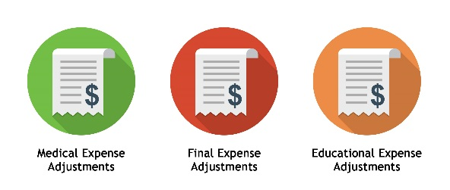
Review: Award Adjustment Process for Expense Adjustments
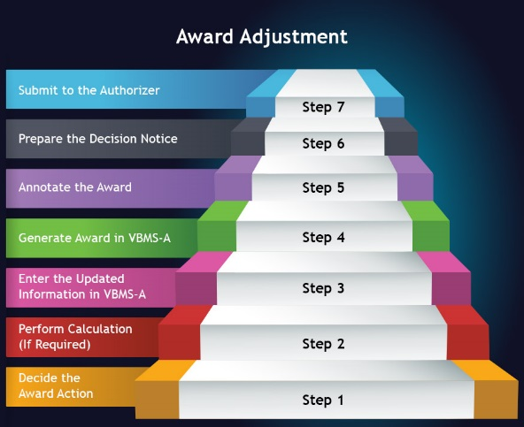
Medical Expenses Recap
- Unreimbursed medical expenses may be used to reduce a claimant’s countable income to pay an increase in benefits or reduce an overpayment.
- Claims for medical expense deductions resulting in increased benefits must be submitted on a proper standard form
  - (21P-527EZ, 21P-534EZ, 21P-8416)
- A deduction for medical expenses is permitted if all the following conditions exist:
  - Expenses are actually paid by the beneficiary or dependent for VA purposes,
  - Expenses are unreimbursed,
  - Expenses are for a beneficiary or relative who is a member or constructive member of the household,
  - Expenses are paid on or after the date of pension entitlement (or date of Veteran’s death, if applicable), and
  - Expenses exceed the five percent medical deductible.
Common Medical Expenses Recap
- Adaptive Equipment
- Care Services, Including:
  - In-home care,
  - Care facilities other than a nursing home, or
  - Nursing home and medical foster home care.
- Health Insurance Premiums, Including But Not Limited To:
  - Medicare Part B Premiums (SMIB)
  - Private Medical Insurance (PMI)
  - Dental Insurance
  - Long-Term Care Insurance
Common Medical Expenses Recap: Continued
- Medical Supplies, including but not limited to:
  - Incontinence Supplies
  - Bandages
  - Compression Stockings
  - Heating Pads
  - Diabetes Test Strips
- Medications (both prescription and non-prescription)
- Vitamins, Food Supplements, and Herbal Remedies:
  - Up to $1,500.00 allowed per household member per calendar year
  - A higher amount requires proof from healthcare professionals of need.

Processing Medical Expenses Recap: CMEs
- When first allowing prospective medical expenses, known as continuing medical expenses (CMEs), deduct the estimated actual amount from the beginning of the
calendar year or initial year the expenses began.​
- Determine the date the expense was first paid and calculate the total amount paid (or to be paid) during the year it began and enter it appropriately into the VBMS-A medical expense calculator.
- If 12 months of the expense was not considered and the expense is continuing and reasonably predictable, a full 12 months of the expense must be considered for the following year.
- All medical expense adjustments are made at the beginning of a calendar year (January 1 or February 1, subject to omnibus).​
- Exception: initial year adjustments may be made mid-year (at the beginning of the A, B, or C periods).
Processing Medical Expenses Recap: UMEs
Medical expenses not categorized as CMEs are considered non-recurring medical expenses and are commonly called unreimbursed medical expenses (UMEs).​
- Count UMEs on a one-time basis.​
- Enter the expense into the VBMS-A calculator for the period during which it was paid.​
- Financial lines may be affected by UMEs and require review for accuracy.​
- If an adjustment is being made during the initial year on a running award, review all financial lines within the initial year period.​
- Enter a calendar year adjustment in the VBMS-A calculator following the year in which they were allowed, to remove UMEs.
- A financial line is also required to stop counting the non-recurring expenses within the IVAP calculation.
Processing Medical Expenses Recap: Time Limits
To request an increase in VA benefits based on medical expenses, a beneficiary must submit a valid claim within the same or following calendar year in which the expenses were paid.

Initial Year Exception:​
- Claimants have an additional year after the initial year period to submit medical expenses as far back as the A period.

Overpayment Exception:​
- There is no time limit for submitting a report of deductible expenses to reduce or eliminate an overpayment.​

- Note: Expenses used to reduce an overpayment must have been paid during the same reporting period for which the overpayment was created.
Processing Medical Expenses:
Scenario 1
VA receives a VA Form 21P-8416, Medical Expense Report from James Veteran on 02/14/22. The Veteran is claiming $3,498.00 monthly in nursing home expenses and $170.10 in monthly Medicare Part B premiums for 2022. Review of the Veteran’s record shows he began receiving Veteran’s pension with special monthly pension benefits effective 04/01/21. VA has been counting CMEs from nursing home expenses of $3,120.00 monthly and Medicare Part B premiums of $148.50 monthly. VA pulls a SSA data match and identifies the Veteran’s Social Security increased from $1,845.50 in 2021 to $1,953.10 effective 12/01/21. The SSA data match verifies the Veteran’s SMIB premium amount is listed as $170.10 monthly. The Veteran’s only other income is from his pension of $2,568.00 monthly.
Processing Medical Expenses:
Scenario 1 Questions
- What type of expenses has the Veteran claimed?
- On what date would VA adjust benefits to consider the claimed medical expenses from the 21P-8416?
- What rate will VA pay to James effective 02/01/22 based on the scenario?
Final Expenses Recap
- A claimant’s income may be reduced from deducting unreimbursed final expenses paid by the claimant.
- Final expenses are made up of expenses related to the Veteran’s:
  - Last Illness: The period from the onset of the acute attack causing death to the date of death, (Generally within one year of the Veteran’s passing)
  - Burial: Include all funeral and burial expenses incident to disposition of the remains of deceased persons, (Excludes any reimbursed burial expenses including VA burial benefits) OR
Just Debts: Includes any debt that would be recognized by a probated court. (Legally enforceable and not fraudulent)
Final Expenses Recap: Last Illness
- If the Veteran’s death resulted from a lingering or prolonged illness instead of an acute attack, the period of last illness is considered to have begun at the time the person became so ill as to require the regular and daily attendance of another person.
- Last illness expenses are allowable when paid by:
  - Surviving spouse or child, for the deceased Veteran.
  - Veteran, for their spouse or child’s last illness.
  - Veteran’s dependent spouse or surviving spouse, for the Veteran’s child.
Note: The death certificate may provide the date of onset of the primary or contributing disabilities which caused the Veteran’s death. Additionally, expenses paid by the Veteran for the last illness of their spouse or child, likely qualify as medical expenses.
Final Expenses Recap: Burial
- Accept the amount reported by the claimant as an unreimbursed final expense unless conflicting amounts are provided on a funeral home statement. If the amount reported by the claimant differs from the funeral statement, use the lowest total amount and explain within the decision notice.
- VA will accept the following final expenses listed on a funeral statement of account when submitted with an application claiming final expenses:
  - Clergy
  - Copies of death certificates
  - Flowers
  - Funeral service announcements, and Organist.
Final Expenses Recap: Just Debts
- Payments of unsecured debts incurred solely by the Veteran and those incurred by the Veteran and surviving spouse, are deductible as just debts.

- Exclusions:
  - Payments of secured or unsecured debts for the purchase of real or personal property. (Includes payments on home and car loans.)
  - Just debts paid during the Veteran’s lifetime.

Notes: Medical expenses not deductible as final expenses can be considered as a just debt of the Veteran.
Processing Final Expenses: Scenario 2
Ms. Debbie requests a deduction for payment of just debts from payments she’s making for the deceased Veteran’s monthly mortgage payment. Both she and the Veteran were joint obligors on the mortgage as it has been their primary residence for the last 12 years.
Processing Final Expenses: Scenario 2 Questions
- Is Debbie an eligible claimant to request expenses for just debts of the deceased Veteran?
- Can VA consider Debbie’s requested expense?
Educational Expenses Recap
- VA can allow unreimbursed expenses for either a Veteran or surviving spouse pursuing a course of education or vocational rehabilitation.
- Allowable Educational Expenses:
  - Tuition,
  - Fees,
  - Books, and
  - Necessary Materials

Note: Unusual transportation expenses
are also allowable if the Veteran or Surviving spouse is rated for A&A. In such cases, allow expenses related to their school attendance and exceed reasonable amount that would be incurred by a non-disabled person.
Guided Practice
Instructions:
- Instructors assign expense adjustment claims to trainees (including medical, final and/or educational expenses).
- Trainees review pending claims and take necessary action.
- Use the job aids, references, and systems available.
- Consult with instructors for assistance with processing questions.
Knowledge Check: Lesson Summary Review

Time Allowed: 10 minutes
What’s Next?
Complete the Process Expense Adjustment Claims course evaluation: TMS ID #4408407

