Pension and Fiduciary Service
PMC VSR Advanced Core Course Phase 6: Practical Application and Experience
Process Income and Net Worth Adjustment Claims
Trainee Guide

June 2024

Process Income and Net Worth Adjustment Claims

Lesson Overview
Topic | Description
Time Estimate: | 4 hours
Purpose of the Lesson: | This lesson is part of the entry-level course for PMC VSRs. The purpose of this lesson is to train you to process income and net worth adjustment claims through demonstration, practice, and feedback.
Prerequisite Training Requirements: | Prior to taking the Process Income and Net Worth Claims lesson, you must complete the entry-level course Phases 1–5.6.
Target Audience: | This lesson is for entry-level PMC VSRs.
Lesson References: | - M21-1 IX.i.3.A (General Information on Pension Income and Net Worth Development)  - M21-1 IX.i.3.B (Income and Net Worth Development Forms and Acceptable Statements)  - M21-1 IX.i.3.C (Pension Income Development)  - M21-1 IX.i.3.D (Reduction of Income Due to Unreimbursed Expenses)  - Appendix A
Technical Competencies: | Program Benefits and Eligibility (PMC VSR)  Processing Claims (PMC VSR)  VBA Applications (PMC VSR)  Income Counting and Net Worth
Knowledge Check: | Phase 6: Process Income and Net Worth Adjustment Claims Knowledge Check
Lesson Objectives: | By the end of this lesson, you should be able:  Process income and net worth adjustment claims (Demonstrations and Practice Exercise).  Recognize indicators of income and net worth adjustment claims.  Confirm claim characteristics.  Determine if evidence is sufficient to process income and net worth changes without development or due process.  Apply the correct development/ due process procedures for the information/evidence missing from the claim.  Determine whether entitlement has changed as a result of income and net worth adjustment claims.  Decide the award action for income and net worth adjustment claims.  Create a PCGL decision notification.  Submit the claim to the Authorizer.
What You Need: | Trainee guide  Access to VBA intranet  Access to CPKM  Access to the production systems  Appendix A for job aids and references

PowerPoint Slides | Notes
Process Income and Net Worth Adjustment Claims
Lesson Objectives (1 of 3)
By the end of this lesson, you should be able to:
Income and Net Worth Review
Process income and net worth adjustment claims (Demonstrations and Practice Exercises)
Demonstrations: Instructor will provide claim scenarios and questions for trainee review. Instructors will process production claims from start to finish with opportunities for questions.
Guided Practice Exercises: Trainees will process claims with questions and feedback/remediation.
Lesson Objectives (2 of 3)
Recognize indicators of income and net worth adjustment claims.
Confirm claim characteristics.
Determine if evidence is sufficient to process income and net worth changes without development or due process.
Apply the correct development/ due process procedures for the information/evidence missing from the claim.
Lesson Objectives (3 of 3)
Determine whether entitlement has changed as a result of income and net worth adjustment claims.
Decide the award action for income and net worth adjustment claims.
Create a PCGL decision notification letter.
Submit the claim to the Authorizer.
Review—Award Adjustment Process
Change in Income Information from First Party
Change in Income Information from Third Party
Net Worth Change Does Not Cause Bar to Benefits
Net Worth Change Is a Bar to Benefits
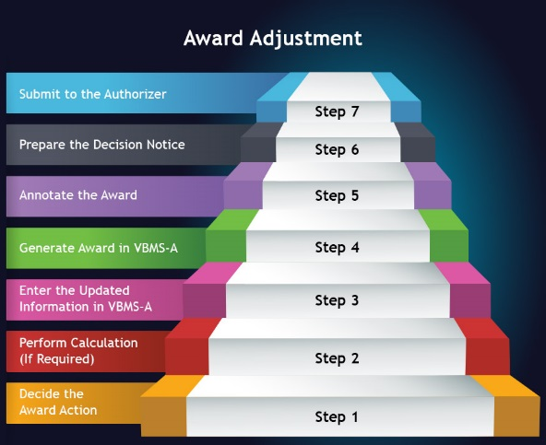
Review Types of Income

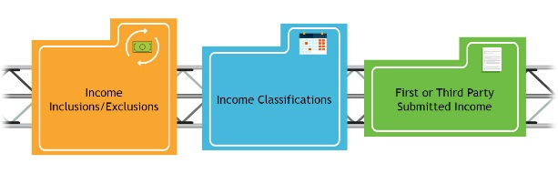
Review—Determining Award Adjustment Based on Change of Income
Determine whether income type is countable.
Determine whether to develop for amended income information.
Determine whether amended income information is received within the time limit.
Determine whether amended income qualifies for an award adjustment.
Review—Determining Award Adjustment Based on Change of Income
General Rule: If income changes, count the income change the 1st of the month after the income change occurred.
Date of Receipt Unknown
For original and new awards, if the date of receipt of income is not known, count the income from the effective date of the award. Explain discrepancy in the decision notification letter.
For running awards, the date of income change is needed (at least month/year). If this information is not of record, initiate development (may need due process if adverse action is required).
Review—Determining Award Adjustment Based on Change of Income
Income is annualized for the purpose of determining entitlement to pension benefits.
Generally, income must be counted for at least 12 months.
First, classify the income.
Second, determine how to count it based on the classification.
When income stops
If the beneficiary has been in receipt of recurring income for more than 12 months and that income is stopped, we remove the income the first of the month after the income stopped.
Review—Determining Award Adjustment Based on Change of Income
Reduction or Termination of Benefits
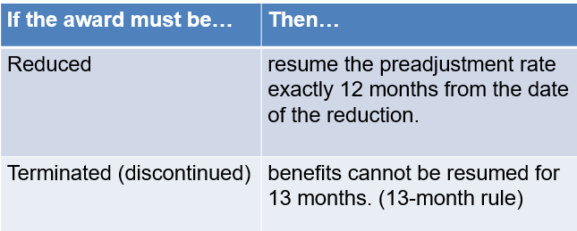
Review—Determining Award Adjustment Based on Changes in Income
Reduction or Termination of Benefits:
Examples- Non-recurring income can be Social Security lump sum payments, one time gift or inheritance, etc.
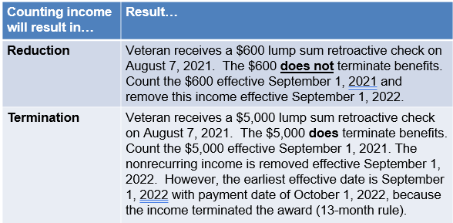
Income Adjustment Lesson Exercise
Question 1
The Veteran has been working for two years and earns $7,000 annually. He reports that he quit his job on October 15th.
When is this income removed?
Income Adjustment Lesson Exercise
Question 2
A Veteran started receiving earned income of $200 per month, effective March 14, 2021. The Veteran has no other income. The award was adjusted effective April 1, 2021, to count $2,400 ($200 * 12mths) on an open-ended basis. The Veteran later reports losing the job and states that the last check was received on July 14, 2021. The total earnings received were $1,000.
What type of income is this classified as?
What date would you adjust the income and how much should be counted?
Income Adjustment Lesson Exercise
Question 3
A Veteran receives a one-time payment of income on August 7, 2021. The amount of the payment causes the Veteran’s income to exceed the MAPR. The award is discontinued effective September 1, 2021.
What is the earliest effective date pension can be resumed?
Scenario 1- Income Adjustment Claim
Mr. Paul first applied for benefits on June 14, 2019. On August 13, 2019, he received a decision notification letter stating that he was granted pension benefits, based on no income. On September 19, 2021, Mr. Paul submits VA Form 21-4138, Statement in Support of Claim, showing he started receiving retirement income beginning June 25, 2021 in the amount of $600 monthly.
Scenario – Income Adjustment (Questions)
- Can the award be adjusted based on information submitted on VA Form 21-4138: Statement in Support of Claim (prescribed form criteria)?

- Is the income change based on first party or third-party information?

- What date should the retirement income be counted?
- Amount?
Activity - Determine Action for Income Changes
Instructions:
- Access CPKM to use M21-1 to complete the activity.
- Work in assigned group.
- Read the scenarios from Appendix B, Income Change Section.
- Work with your group to answer the questions about income for each scenario.
- Record your answers on the worksheet provided.
- Be prepared to share your group’s answers during the activity debrief.
Time allowed: 15 min.
Activity - Determine Action for Income Changes
Scenario 1 Questions
- Is the information submitted considered first party or third party?

- What information is missing?

Scenario 2 Questions
- Social security income is classified as what type of income?

- Would the amended income increase, reduce or terminate the award?

Activity - Determine Action for Income Changes
Scenario 3 Questions
- Would the amended income increase, reduce or terminate the award?

- Can action be taken to process the income adjustment based on the information received?

Scenario 4 Questions
- Would the amended income increase, reduce or terminate the award?

- What is the period for counting this income? When would benefits be resumed?

Guided Practice Exercise –
Income Adjustment
Review Sample 1 Income Adjustment Claim
Brief Description
- Veteran with running award for the past 5 years (basic pension with no dependent).
- Current income counted is Social Security benefits
- Current expenses counted on award
- Private medical insurance - $250 monthly (BCBS)
- 2021 SMIB- $145.00 monthly
- Received a change of income claim
- Received one-time payment: $1,000 on April 2, 2021
- Monthly payment of $300 monthly starting May 1, 2021
Guided Practice Exercise –
Income Adjustment
Questions
- What is the correct EP for the income adjustment claim?

- What is the MAPR for a Veteran with no dependent for 2021?

- Would the amended income increase, reduce or terminate the award?

- Is the one-time payment income countable?

  - If so, what is the period this income is counted

- What income and medical expenses are counted beginning March 1, 2022?

Guided Practice Exercise –
Income Adjustment Decision Letter
Trainees will prepare an amended income adjustment decision letter for Sample 1 Income Adjustment claim
Instructions:
- Use the job aids, references, and systems available.
- Be prepared to discuss letter with the class.
Time allowed: 20 minutes

Review Net Worth
Inclusions/Exclusions
Inclusion Examples
- Real estate (not including primary residence)
- Retirement
- Stocks
- Bonds
- Bank deposits
- Fine Art
- Antique automobiles
- Coin collections
Exclusion examples
- The claimant's primary residence
- Normal household objects and possessions
  - Motor vehicles used for family transportation
Review—Determining Award Adjustment Based on Changes in Net Worth
When to Calculate Net Worth
Calculate net worth when VA receives:
- an original pension claim
- a supplemental pension claim after a period of non-entitlement
- a request to establish a new dependent, or
- information that a Veteran’s, surviving spouse’s or child’s net worth has increased or decreased.
Exception: If the claimant does not meet other factors necessary for pension entitlement, such as military service requirements, VA will deny the claim without calculating net worth.
Review—Determining Award Adjustment Based on Changes in Net Worth
How Net Worth Decreases
Net worth can decrease by one or both of the following ways:
- assets can decrease in value, or
- annual income can decrease.
Exception: A transfer of assets such as a purchase of an annuity or similar financial instrument does not decrease assets.
Review—Determining Award Adjustment Based on Changes in Net Worth
Running Awards
If the net worth of a beneficiary with a running award becomes excessive
- determine the date from which net worth became excessive, and
- discontinue the award effective the first of the following calendar year (unless an earlier date of discontinuance is appropriate because of other reasons).
Review—Determining Award Adjustment Based on Changes in Net Worth
When to pay a claimant based on reconsideration of net worth
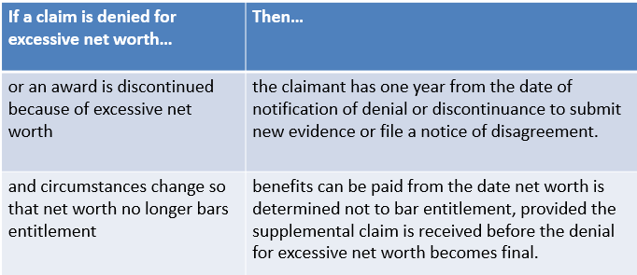
How to Calculate Net Worth
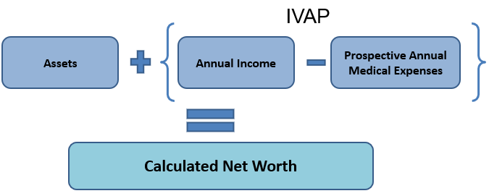
What does this mean? IVAP cannot be less than $0
- At or Under the limit: Eligible for Benefits
- Over the limit: Not Eligible for Benefits
How to Calculate Net Worth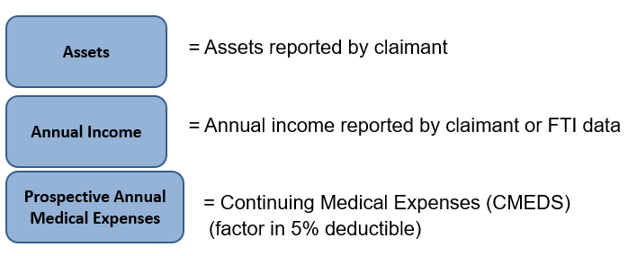
- Funeral expenses cannot be used to reduced IVAP for NW calculations.
- Non-recurring medical expenses should not be considered when calculating net worth
- If claimant reports an annuity as both income and asset, should consider as asset portion of net worth, not income
- If claimant reports an annuity as income, consider it as income
Calculating Net Worth
Example
The bright line limit is $138,489. A claimant has assets of $116,000, annual income of $8,000, and annual nursing home expenses of $29,000.
Result: Apply the nursing home expense to income, which reduces IVAP to $0. Because IVAP is $0, the claimant’s net worth is $116,000; therefore, net worth is not excessive for VA pension.
Net Worth Adjustment Lesson Exercise
Question 1
Veteran with a running award owns a painting valued at $30,000. The artist dies on June 24, 2020, and the value of the painting goes up to $200,000.
The Veteran submits VA Form 21P-8049, and reports that the painting is valued at $200,000 making the Veteran’s net worth excessive effective June 24, 2020.
What is the effective date to discontinue the award for excess net worth?
Net Worth Adjustment Lesson Exercise
Question 2
Veteran is denied pension effective July 1, 2021 (entitlement date June 20, 2021) because net worth is above the bright line limit (calculated net worth was $140,000). On December 9, 2021, Veteran submits a new claim showing net worth is $100,000 effective October 25, 2021 (submitted bank statements showing the Veteran has been paying medical expenses, which reduced assets).
What is the effective date pension can be granted based on net worth is now below the bright line limit?
Net Worth Adjustment Lesson Exercise
Question 3
The surviving spouse has been running on survivors pension since July 2018. The surviving spouse reported that he sold his primary residence on June 20, 2021 and received $350,000 from the sale of the home.
Is this income countable for pension purposes? Why or Why not?
Should we terminate the surviving spouse pension benefits? If so, what is the date of termination?
Scenario 2- Net Worth Adjustment Claim
Christina, a Veteran with no income and $165,000 in cash assets applies for Veteran pension on August 5, 2021. The claim is denied on September 23, 2021 because assets exceed the bright-line limit. On February 18, 2022, Christina spends $60,000 on home improvements to her primary residence. The Veteran submits a supplemental claim on March 25, 2022, showing assets decreased to $105,000 on February 18, 2022.
Scenario 2 – Net Worth Adjustment (Questions)
- What is the bright line limit effective August 5, 2021?

- What are some ways net worth can be decreased?

- What is the effective date to grant Veteran pension benefits?

Activity - Determine Action for
Net Worth Changes
Instructions:
- Access CPKM to use M21-1 to complete the activity.
- Work in assigned group.
- Read the scenarios from Appendix B, Net Worth Change Section.
- Work with your group to answer the questions about net worth for each scenario.
- Record your answers on the worksheet provided.
- Be prepared to share your group’s answers during the activity debrief.
Time allowed: 15 min.
Activity - Determine Action for
Net Worth Changes – (1 of 2)
Scenario 5 Questions
- What is outcome of the amended net worth?

- What is the bright line limit effective January 21, 2022?

Scenario 6 Questions
- What is the Veteran’s calculated net worth?

- Is the Veteran’s net worth within the bright line limit?

Activity - Determine Action for
Net Worth Changes – (2 of 2)
Scenario 7 Questions
- What is the Veteran’s calculated net worth?

- Is the Veteran’s net worth within the bright line limit? If no, what is the effective date her award should be discontinued?
Guided Practice Exercise –
Net Worth Adjustment (2 of 5)
Review Sample 2 Net Worth Adjustment Claim
Brief Description
- Veteran with running award for the past 5 years (basic pension with no dependent).
- Current income counted is Social Security benefits
- Current expenses counted on award
- Private medical insurance - $250 monthly (BCBS)
- 2021 SMIB- $145.00 monthly
- Received a change of net worth claim
- Sold primary residence in the amount of $250,000 on April 2, 2021
Guided Practice Exercise –
Net Worth Adjustment (3 of 5)
Questions
- What is the correct EP for the net worth adjustment claim?

- Is the sale of the primary residence proceeds countable income?
  - Why or why not?

- Would the change in net worth increase, reduce or terminate the award?
  - Effective date to take action?

- What is the bright line limit effective 2021?
  - 2022?

- What is the calculated net worth?

Lesson Summary Review Questions

Time Allowed: 10 minutes

What’s Next?
- Complete Process Income and Net Worth Adjustment Claims evaluation, TMS #4408406 VA

