PENSION AND FIDUCIARY Service
PMC VSR Advanced Core Course
Phase 6: Practical Application and Experience
Process Accrued Claims
Trainee Guide
June 2024

Process Accrued Claims

Lesson Overview
Topic | Description
Time Estimate: | 4.5 hours
Purpose of the Lesson: | This lesson is part of the entry-level course for PMC VSRs. The purpose of this lesson is to train PMC VSRs on how to process accrued and substitution claims through demonstration and practice. This lesson also includes instruction on how to use the systems for processing accrued and substitution claims.
Prerequisite Training Requirements: | Prior to taking the Processing an Accrued Claim lesson, you must complete entry-level courses in Phases 1–5.
Target Audience: | This lesson is for entry-level PMC VSRs.
Lesson References: | - VA Form 21P-601 (Application for Accrued Amounts Due a Deceased Beneficiary)  - VA Form 21P-0847 (Request for Substitution of Claimant Upon Death of Claimant)  - VA Form 21P-534 (Application for Dependency and Indemnity Compensation, Survivors Pension and Accrued Benefits by a Surviving Spouse or Child [including Death Compensation if Applicable]  - VA Form 21P-534EZ (Application for DIC, Survivors Pension, and/or Accrued Benefits)  - VA Form 21P-535, Application for Dependency and Indemnity Compensation by Parent(s) (Including Accrued Benefits and Death Compensation When Applicable),  - M21-1 XI.ii.3.A (Entitlement to Accrued Benefits Under 38 U.S.C. 5121)  - M21-1 XI.ii.3.B (Substitution in Case of Death of Claimant)  - M21-1 XI.ii.3.C (Development for Accrued and Requests for Substitution)  - M21-1 XI.ii.3.D.1.g (Payment of Accrued Benefits for the Month of Death)  - M21-1 XI.ii.3.E.11 (Payment of Accrued Benefits as Reimbursement)  - M21-1 XI.ii.3.E.12 (Allowable Items for Reimbursement)  - M21-4 Appendix A.2.a (Payee Codes)  - Appendix A for references introduced in earlier lessons
Technical Competencies: | - Program Benefits and Eligibility (PMC VSR)  - Processing Claims (PMC VSR)  - VBA Applications (PMC VSR)
Lesson Objectives: | - Determine entitlement to accrued benefits.  - Determine if claim may be denied without development.  - Determine if evidence is sufficient to process claim for accrued benefits.  - Apply the correct development actions for the information/evidence missing from claim.  - Decide the award action for an accrued claim.  - Create the Personal Computer-Generated Letter (PCGL) decision notification.  - Submit the claim to the Authorizer.
What You Need: | - Trainee Guide  - Access to the Accrued Benefits job aid and Processing an Accrued Claim Checklist job aid  - Applicable VBA applications used in job aids and references listed in Appendix A  - Practice Exercise Worksheet

PowerPoint Slides | Notes
Processing an Accrued Claim
Lesson Objectives
- Determine entitlement to accrued benefits.
- Determine if claim may be denied without development.
- Determine if evidence is sufficient to process claim for accrued benefits.
- Apply the correct development actions for the information/evidence missing from claim.
- Decide the award action for an accrued claim.
- Create the Personal Computer-Generated Letter (PCGL) decision notification.
- Submit the claim to the Authorizer.
Why This Matters
This course matters because it centers on:
- Date of beneficiary’s (original claimant) death
- Date of claim for accrued benefits: within one year of beneficiary’s (original claimant) death
- Availability of accrued benefits
- Substitution claims
- Basis of claim:
- Proper claimant based on relationship category
- Proper receipts based on reimbursement category
Important Accrued Claim Definitions
Accrued benefits: Benefits due but unpaid at the time of the beneficiary’s death. Can be paid based upon the death of any payee.
Substitution: The right of a living person to submit additional evidence in support of the deceased claimant’s pending claim, request for decision review, or appeal of decision.
End Product: EP 165 is generally used to control accrued claims. EP 290 is generally used to control substitution claims.
Slide 5
Original claimant: The deceased claimant whose claim, request for decision review, or appeal was pending at the time of death
Substitute claimant: an individual whom the VA has recognized to replace the original claimant in a pending claim or pending appeal
- Any eligible survivor submitting a claim for accrued benefits
  - will automatically be considered as requesting to substitute, and
  - may be able to submit additional evidence in support of the claim.
Slide 6
Evidence in the file at date of death: evidence in VA’s possession on or before the date of the beneficiary’s death, even if the evidence was not physically located in the VA claims folder on or before the date of death.

Evidence in VA’s possession: evidence physically located at any VA facility, including, but not limited to
- VA regional offices
- VA insurance centers
- VA medical centers
- VA outpatient clinics
- Vet Centers, and
- the Records Management Center
Slide 7
Relationship
- Upon the death of a Veteran to the living person first listed as follows:
- Spouse
- Dependent children (in equal shares)
- His or her dependent parents (in equal shares) or the surviving parent (if a dependent at the date of the Veteran’s death): Compensation
- The amount granted is the total amount of benefits owed independent of any expenses paid
Slide 8
Reimbursement
- Any person who paid the last illness or burial expenses of a Veteran, surviving spouse, or child.
  - Can only receive reimbursement for actually paid last illness and burial expenses
- Must provide evidence showing claimant paid last illness or burial expenses for the deceased beneficiary/ claimant
Time Limits
Generally, applications for accrued benefits must be filed within one year from the date of death of the beneficiary.
- The one-year limitation for filing a claim for accrued benefits also applies to cases in which a
  - rating or authorization decision was made prior to the date of death, or
  - claim or higher-level review (HLR) or legacy appeal was pending and evidence sufficient to allow that claim, HLR, or legacy appeal was in file at the date of death
Exception to the 1-year time limit can be found in manual. Please review time limit manual reference for additional information
Accrued Lesson Exercise
Question 1:
If accrued benefits are due to a claimant, but the claimant does not submit evidence showing funeral expenses were paid. If the accrued claimant is:
- Eligible surviving spouse (relationship)
- Adult child who paid funeral expenses (reimbursement)
- 2 Claimants:
  - Eligible surviving spouse (relationship) and an adult child (reimbursement)
Do you grant? Deny? Develop for missing evidence?

Accrued Lesson Exercise Answer:
If the accrued claimant is:
Eligible surviving spouse (relationship)
Answer:
Adult child who paid funeral expenses (reimbursement)?
Answer:
2 Claimants: Eligible surviving spouse (relationship) and an adult child (reimbursement)
- Answer:
Accrued Lesson Exercise Question 2:
If accrued benefits are due to a claimant based on reimbursement, but VA granted burial benefits. Do we subtract the amount paid for burial benefits?
Answer:

Accrued Lesson Exercise Question 3:
The Veteran submitted a claim for Veteran pension benefits on January 6, 2020. The Veteran passed away on July 18, 2020, prior to the VA adjudicating the claim. Review of the pension claim confirms the Veteran would have been entitled to pension benefits (accrued payable). The Veteran’s sister applies for accrued benefits on January 5, 2022. Is accrued payable?
Answer:

Accrued Lesson Exercise Question 4:
(Accrued benefits may exist) Original claimant had a claim pending at time of death. Accrued claim is received. Review of the original claimant’s claim shows information is missing to complete claim (income/ net worth section incomplete). Can we develop for the missing information or deny?
Answer:

Scenario—Accrued Claim
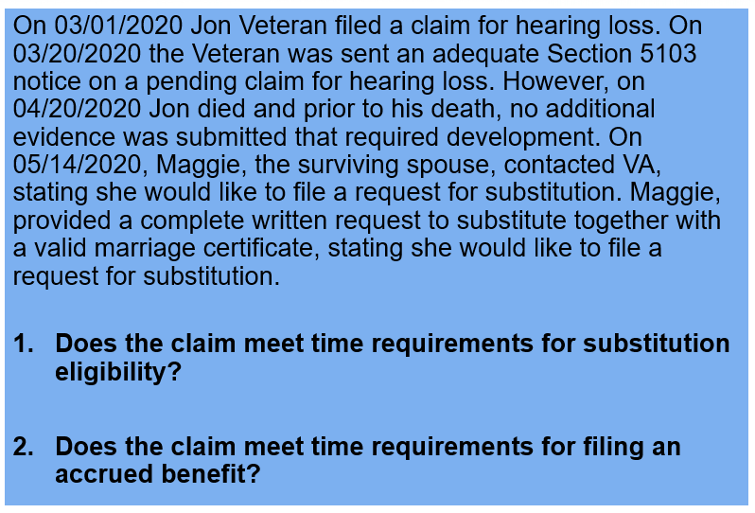
Scenario 1: Accrued Claim (Questions)
- Does the claim meet time requirements for filing an accrued benefit?
- Does accrued benefits exist?
- Is Mr. Veteran’s brother eligible for reimbursement for the funeral expenses?
Overview of Processing an Accrued Claim
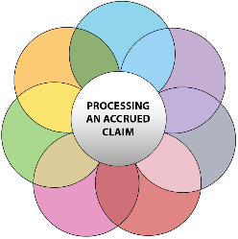
- Many of the steps required to process an accrued claim are done simultaneously by PMC VSRs.
- For the purpose of instruction, the steps are broken out individually.
- An accrued claim may be part of a claim for multiple benefits.

Overview of Processing an Accrued Claim (1 of 3)
- Review Application (Applicable applications for accrued claims)
- Confirm Characteristics
- End Product (EP)
  - EP 165 (Accrued)​
  - EP 290 (Substitution)
- Date of Claim (DOC)
- Payee Code: should be established based on the original claimant (person who passed away and under whom accrued benefit is payable)
- Veteran dies: should be Payee 00, ​
- Surviving Spouse dies: should be Payee 10​
- Surviving child: should be applicable child payee code

Overview of Processing an Accrued Claim (2 of 3)
  - Benefit Type/ Claim Label
  - POA (if applicable)
  - Date of Beneficiary Death
- Determine entitlement to accrued benefits
- Determine if claim may be denied without development

Overview of Processing an Accrued Claim (3 of 3)
- Determine if evidence is sufficient to process claim for accrued benefits
- Apply the correct development actions for the information/evidence missing from claim
- Determine if claim should be submitted to rating activity
- Decide the award action for an accrued claim
- Create PCGL decision notification for an accrued
- Submit the claim to the Authorizer

Guided Practice Exercise (Grant)
- Instructions:​
  - Review the Sample 1 Accrued Claim for the practice exercise​ to answer the questions.
  - VA Form 21P-601: Application for Accrued Amounts Due a Deceased Beneficiary
- Time allowed: 15 minutes
Guided Practice Exercise - Grant (3 of 5)
Questions
- What is the correct EP and payee code for the accrued claim?
- Is accrued payable based on the time limit to submit an accrued claim?
- Which category is accrued payable based on the claimant filling accrued benefits?
- Is additional evidence required before processing the accrued claim?
- How much is payable for accrued benefits, if applicable?
Guided Practice Exercise – Grant (4 of 5) Answers
- What is the correct EP and payee code for the accrued claim?
  - Answer:
- Is accrued payable based on the time limit to submit an accrued claim?
  - Answer:
- Which category is accrued payable based on the claimant filling accrued benefits?
  - Answer:
Guided Practice Exercise - Grant (5 of 5) Answers
- Is additional evidence required before processing the accrued claim?
  - Answer:
- How much is payable for accrued benefits?
- Answer:
Guided Practice Exercise Grant Decision Letter
- Instructions:​
- Review the Sample 1 Accrued Claim to prepare a grant decision letter the claim
- Be prepared to discuss your results.
- Time allowed: 20 minutes
Accrued Development
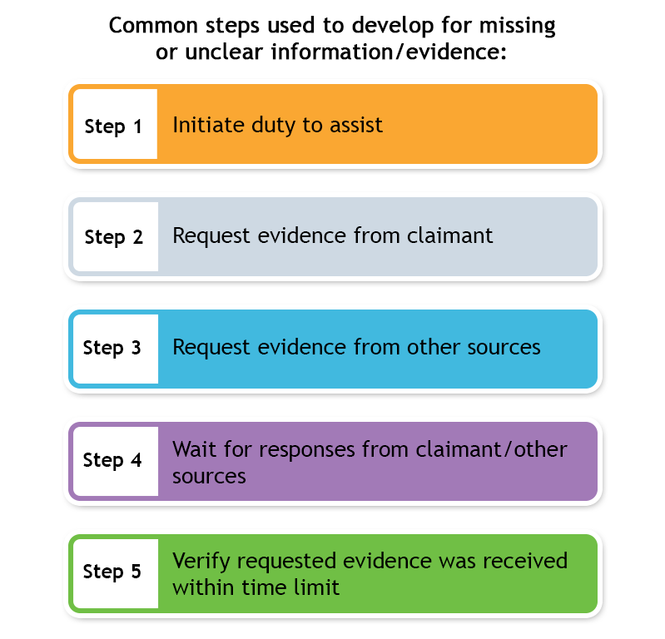
Lack of Eligibility
(Denial without Development)
It is not required to issue development when
- accrued benefits do not exist
- there is a lack of legal eligibility
- the claim lacks merit, or
- the claimant is not entitled to the benefit as a matter of law
Guided Practice Exercise - Denial (1 of 5)
Trainees will review a sample accrued claim and answer questions related to sample case. Provide 15 minutes to review sample application and answer questions.
- Sample 2 Accrued Application Form
- VA Form 21P-601: Application for Accrued Amounts Due a Deceased Beneficiary
Development (1 of 2)
- If the claim is based on relationship, develop for any missing information required to establish the relationship
  - Example: place of marriage, date of birth
- If the claim is based on reimbursement, develop for missing information:
  - Receipted bill – determine whose funds were used
  - Statement of account for burial expenses
  - Executor of estate documentation
*Must have potential to pay accrued to develop*
Development (2 of 2)
If the claim is based on relationship, develop for any missing information required to establish the relationship
If the claim is based on reimbursement, develop for missing information:
- Receipted bill – determine whose funds were used
- Statement of account for burial expenses
- Executor of Estate documents

Guided Practice Exercise –
Development
- Instructions:​
  - Review the Sample 2 Accrued Claim to create a development letter
  - Be prepared to discuss your results.
- Time allowed: 30 minutes
Substitution
- The request to substitute for a substitute claimant must be received no later than one year after the date of the substitute’s death (not the original claimant’s death).
- Once a substitution request is granted, the substitute claimant must complete any action required by law or regulation within the time period remaining for the original claimant to take such action on the date of their death.
Substitution - Scenario 2
On 03/01/2020 Jon Veteran filed a claim for hearing loss. On 03/20/2020 the Veteran was sent an adequate Section 5103 notice on a pending claim for hearing loss. However, on 04/20/2020 Jon died and prior to his death, no additional evidence was submitted that required development. On 05/14/2020, Maggie, the surviving spouse, contacted VA, stating she would like to file a request for substitution.
- Does the claim meet time requirements for substitution eligibility?
- Does the claim meet time requirements for filing an accrued benefit?
Why It Matters!
- Does the claim meet time requirements for substitution eligibility?

- Does the claim meet time requirements for filing an accrued benefit?
Why It Matters! Answers
- Does the claim meet time requirements for substitution eligibility?

- Does the claim meet time requirements for filing an accrued benefit?
Determine If Claim Should
Be Submitted to Rating Activity
Accrued claims may require rating activity review. Claims that should be referred for rating activity (not inclusive) include:
- Special monthly pension (SMP) claim pending at time of beneficiary death (A&A could not be granted administratively)
- Compensation claim pending at time of Veteran’s death
- Veteran pension requiring P&T decision pending at time of Veteran’s death
Practice Exercise: Process an Accrued Claim
- Instructions:
  - Process Claim 1 assigned by instructor from beginning to end.
  - Use the job aids, references, and systems available.
  - Select a partner before beginning the exercise to confer with after completing each step individually.
  - Consult with instructors for assistance.
  - Be prepared to discuss your results with the class.
- Time Allowed: 30 minutes
Claim 2—Prepare a Decision Notice (1 of 2)
Instructions:
  - Process Claim 2 from beginning to end.
  - Perform the steps to prepare the decision notice for Claim 2.
  - Use the job aids, references, and systems available.
  - Confer with a partner to assess each other’s decision notice.
  - Ask for guidance from the instructor if you identify discrepancies.
Time allowed: 30 minutes
Claim 2—Prepare a Decision Notice
Remember to include the specific paragraphs, templates, and autotext when preparing the decision notice.
Knowledge Check: Lesson Summary Review Questions

Time Allowed: 15 minutes
Questions?

What’s Next?
- Complete Process Accrued Claims evaluation, TMS ID 4408395

Accrued Lesson Exercise
Directions: Based on the material covered, provide answers for the following.
Question 1:
If accrued benefits are due to a claimant, but the claimant does not submit evidence showing funeral expenses were paid. If the accrued claimant is:
  - Eligible surviving spouse (relationship)
  - Adult child who paid funeral expenses (reimbursement)
  - 2 Claimants:
    - Eligible surviving spouse (relationship) and an adult child (reimbursement)
Do you grant? Deny? Develop for missing evidence?

Question 2:
If accrued benefits are due to a claimant based on reimbursement, but VA granted burial benefits. Do we subtract the amount paid for burial benefits?

Question 3:
The Veteran submitted a claim for Veteran pension benefits on January 6, 2020. The Veteran passed away on July 18, 2020, prior to the VA adjudicating the claim. Review of the pension claim confirms the Veteran would have been entitled to pension benefits (accrued payable). The Veteran’s sister applies for accrued benefits on January 5, 2022. Is accrued payable?

Question 4:
(Accrued benefits may exist) Original claimant had a claim pending at time of death. Accrued claim is received. Review of the original claimant’s claim shows information is missing to complete claim (income/ net worth section incomplete). Can we develop for the missing information or deny?

Scenario 1: Accrued Claim Questions
Directions: Based on the material covered, provide answers for the following.
- Does the claim meet time requirements for filing an accrued benefit?

- Does accrued benefits exist?

- Is Mr. Veteran’s brother eligible for reimbursement for the funeral expenses?

Guided Practice Exercise 1
Directions: Based on the material covered, provide answers for the following.

- What is the correct EP and payee code for the accrued claim?

- Is accrued payable based on the time limit to submit an accrued claim?

- Which category is accrued payable based on the claimant filling accrued benefits (relationship/reimbursement)?

- Is additional evidence required before processing the accrued claim?

