Pension and Fiduciary Service
PMC VSR Advanced Core Course Phase 6: Practical Application and Experience
Process Original Survivors Pension Claims
Trainee Guide
June 2024

Process Original Survivors Pension Claims

Lesson Overview
Topic | Description
Time Estimate: | 4 hours
Purpose of the Lesson: | This lesson is part of the entry-level curriculum, Core Course for PMC VSRs. The purpose of this lesson is to train you to process Original Survivors Pension claims through demonstration, practice, and feedback. Lesson includes how to use the systems for processing the claims.
Prerequisite Training Requirements: | Prior to taking the Process Original Survivors Pension Claims lesson, you must complete PMC VSR Core Course Phases 1–5.6.
Target Audience: | This lesson is for entry-level PMC VSRs.
Lesson References: | - M21-1 I.i.1.A.4.b (Refraining from or Discontinuing Assistance)  - M21-1 I.i.1.A.4.c (Claims That are Inherently Incredible or Lack Merit)  - M21-1 I.i.1.A.4.f (Definition: Substantially Complete Application)  - M21-1 I.ii.2.2.b (Definition: Survivors Pension)  - M21-1 II.iii.1.A.3.e (Non-Discretionary Application of 38 CFR 3.152[b])  - M21-1 XI.ii.1.1.b (General Policy Regarding the Referral of Survivors Benefits Claims to the Rating Activity)  - M21-1 XI.ii.1.1.c (Specific Situations in Which Survivors Benefits Claims Should Be Referred to the Rating Activity)  - M21-1 VII.i.2.A (Establishing the Validity of a Marriage for Department of Veterans Affairs (VA) Purposes)  - M21-1 VII.i.2.B (Establishing Common Law Marriages)  - M21-1 VII.i.2.C (Establishing Other Types of Marriages)  - M21-1 VII.i.2.D (Establishing Marital Relationship in Survivors Cases)  - M21-1 VII.i.3.A (Establishing a Child’s Age and Relationship)  - M21-1 VII.i.3.B (Biological Children, Adopted Children, and Stepchildren)  - M21-1 VII.ii.1.A (Benefit Entitlement for School Children)  - M21-1 VII.ii.1.B (Awards and Adjustments Based Upon School Attendance)  - M21-1 X.ii.6.B (A Child’s Permanent Incapacity for Self-Support)  - M21-1 XII.i.2.A.1.g (When a Survivor’s Claim Does Not Require a Rating Decision)  - M21-1 IX.ii.2.C (Special Monthly Pension Ratings)  - M21-1 IX.i.2.1.d (Effective Dates and Payment Dates for Survivors Pension)  - M21-1 IX.iii.1.A.2.i (Time Allowed for Completion of Data Exchange for IRS/SSA)  - Process an Original Survivors Pension Claim Checklist job aid
Technical Competencies: | - Program Benefits and Eligibility (PMC VSR)  - Processing Claims (PMC VSR)  - VBA Applications (PMC VSR)  - Income Counting and Net Worth
Lesson Objectives: | By the end of this lesson, you should be able to:  - Process a claim for Original Survivors Pension.  - Recognize indicators of an Original Survivors Pension claim.  - Confirm claim characteristics assigned by claims assistant.  - Screen claim to determine if claim may be denied without development.  - Identify and develop for any missing information or evidence.  - Determine if claim should be submitted to rating activity.  - Decide the award action for an Original Survivors Pension claim.  - Prepare a decision notification for an Original Survivors Pension claim.  - Submit the claim to the Authorizer.
What You Need: | - Trainee guide  - Access to VBA intranet  - Pen and paper  - Access to the following systems:  - SHARE  - VBMS  - MAP-D  - VBMS-A  - Access to CPKM  - Process an Original Survivors Pension Claim Checklist job aid

PowerPoint Slides | Notes
Process Original Survivors Pension Claims
Lesson Objectives
By the end of this lesson, you should be able to:
- Recognize indicators of an Original Survivors Pension claim.
- Confirm claim characteristics assigned by claims assistant.
- Screen claim to determine if claim may be denied without development.
- Identify and develop for any missing information or evidence.
- Determine if claim should be submitted to rating activity.
- Decide the award action for an Original Survivors Pension claim.
- Prepare a decision notification for an Original Survivors Pension claim.
- Submit the claim to the Authorizer.
Lesson Overview
- Demonstration— Instructor goes over a claim scenario and review questions with trainees. Instructor discusses the claims review process from start to finish with opportunities to discuss trainee questions.
- Guided Practice— Trainees are assigned Original Survivors Pension claims to process.
Why It Matters!
Knowing how to Process Original Survivors Pension Claims correctly enables the VSR with handling the variations that may arise with these claim types.
Survivors Original Pension Overview
Characteristics of Survivors Original Pension:
- A tax-free monetary benefit
- For un-remarried surviving spouse and/or child/children of deceased wartime Veterans
- Meets low-income and net worth requirements
- Receipt of VA Form 21P-534 (Application for Dependency and Indemnity Compensation, Survivors Pension, and Accrued Benefits by a Surviving Spouse or Child [Including Death Compensation if Applicable]) or VA Form 21P-534EZ (Application for DIC, Survivors Pension, and/or Accrued Benefits)
Process Original Survivors Pension Claims
Practice Exercise: Claim 1
- Instructions:
  - Work Independently.
  - Access Appendix A - Claim 1
  - Read the scenario to determine the actions needed.
  - Use the worksheet to record a response.
  - Be prepared to discuss your rationale.
- Time allowed: 10 minutes

Claim 1 Processing Questions
- Is there sufficient information to decide the claim?
- Does the claim require a rating decision?
- Does Ms qualify for Survivors Pension, and if so, what rate of pension would she receive?
Process Original Survivors Pension Claims
Practice Exercise: Claim 2
- Instructions:
  - Work Independently.
  - Access Appendix A - Claim 2
  - Read the scenario to determine the actions needed.
  - Use the worksheet to record a response.
  - Be prepared to discuss your rationale.
- Time allowed: 10 minutes

Claim 2 Processing Questions
- Is there sufficient information to decide the claim?

- Does the claim require a rating decision?

- Does Deb qualify for Survivors Pension, and if so, what rate of pension would she receive?

Process Original Survivors Pension Claims
Practice Exercise: Claim 3
- Instructions:
  - Work Independently.
  - Access Appendix A - Claim 3
  - Read the scenario to determine the actions needed.
  - Use the worksheet to record a response.
  - Be prepared to discuss your rationale.
- Time allowed: 10 minutes

Claim 3 Processing Questions
- Is there sufficient information to decide the claim?

- Does Don qualify for Survivors Pension, and if so, what rate of pension would he receive?

Process Original Survivors Pension Claims
Practice Exercise: Claim 4
- Instructions:
  - Work Independently.
  - Access Appendix A - Claim 4
  - Read the scenario to determine the actions needed.
  - Use the worksheet to record a response.
  - Be prepared to discuss your rationale.
- Time allowed: 10 minutes

Claim 4 Processing Questions
- Is there sufficient information to decide the claim?

- Does Lisa qualify for Survivors Pension, and if so, what rate of pension could she receive?

Process Original Survivors Pension Claims
Demonstration: Claim 5
- Instructions:
  - Work Independently.
  - Access Appendix A - Claim 5
  - Read the scenario to determine the actions needed.
  - Use the worksheet to record a response.
  - Be prepared to discuss your rationale.
- Time allowed: 10 minutes

Claim 5 Processing Questions
- Is there sufficient information to decide the claim?

- Does Steve qualify for Survivors Pension, and if so, what rate of pension could he receive?

Process Original Survivors Pension Claims
Practice Exercise: Claim 6
- Instructions:
  - Work Independently.
  - Access Appendix A - Claim 6
  - Read the scenario to determine the actions needed.
  - Use the worksheet to record a response.
  - Be prepared to discuss your rationale.
- Time allowed: 10 minutes

Claim 6 Processing Questions
- Is there sufficient information to decide the claim?

Process Original Survivors Pension Claims
Practice Exercise: Claim
- Instructions:
  - Work Independently.
  - Access Appendix A - Claim 7
  - Read the scenario to determine the actions needed.
  - Use the worksheet to record a response.
  - Be prepared to discuss your rationale.
- Time allowed: 10 minutes

Claim 7 Processing Questions
- Is there sufficient information to decide the claim?

- Does Ed qualify for Survivors Pension, and if so, what rate of pension could he receive?
Guided Practice Overview
Instructions:
- Instructors assign live cases to trainees.
- Trainees review pending claims and take necessary action
- Use the job aids, references, and systems available.
- Consult with instructors for assistance.
Knowledge Check: Lesson Summary Review
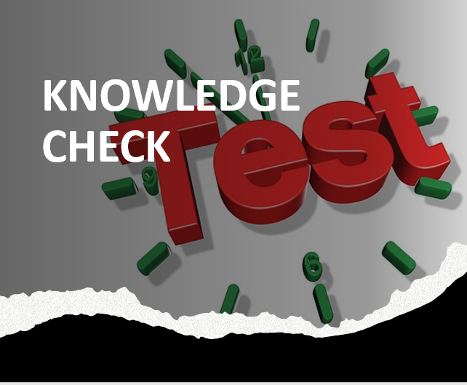
Time Allowed: 15 minutes
What’s Next?
Complete the Process Original Survivors Pension Claims course evaluation: TMS ID# 4408393

