Pension and fiduciary service
PMC VSR Intermediate Core Course
Phase 5: Proficiency Development
Part 1(b): Basic Eligibility
Determine Dependency Eligibility: Child
Trainee Guide
May 2024

Determine Dependency Eligibility: Child

Lesson Overview
Topic | Description
Time Estimate: | 2.5 hours
Purpose of the Lesson: | This lesson is part of the entry-level curriculum, Core Course for PMC VSRs. The purpose of this lesson is to prepare you to determine if a claimant meets the eligibility requirements of a child of a Veteran.
Prerequisite Training Requirements: | Prior to taking this lesson, trainees must complete PMC VSR Core Course Phases 1–4 and Phase 5.1(a).
Target Audience: | This lesson is for entry level PMC VSRs.
Lesson References: | - Compensation and Pension Knowledge Management (CPKM)  - 38 CFR 3.24 (Improved Pension Rates – Surviving Children)  - 38 CFR 3.57 (Child)  - 38 CFR 3.204 (Evidence of Dependents and Age)  - 38 CFR 3.461 (Dependency and indemnity Compensation)  - 38 CFR 3.660 (Dependency, Income and Estate)  - 38 CFR 3.667 (School Attendance)  - M21-1 VII.i.1.A (General Information on Relationship and Dependency  - M21-1 VII.i.3.A (Establishing a Child’s Age and Relationship)  - M21-1 VII.i.3.B (Biological Children, Adopted Children, and Stepchildren)  - M21-1 VII.i.3.C (Marriage o a Child)  - M21-1 VII.i.3.D (Children with Two Veteran-Parents)  - M21-1 IX.iii.1.E.4 (Suriving Child Entitled to Survivors Pension in Their Own Right)  - M21-1 X.ii.6.B. (A Child’s Permanent Incapacity for Self-Support)  - Dependency Eligibility Requirements job aid
Lesson Objectives: | By the end of this lesson you will be able to:  - Determine dependency eligibility for a child of a Veteran.  - Define child for VA purposes.  - Determine DIC dependency eligibility requirements for a child of a Veteran.  - Determine dependency eligibility requirements for a helpless child of a Veteran.  - Determine pension (Veteran and Survivors) dependency eligibility requirements for a child of a Veteran.  - Determine what to develop for a child of a Veteran.
Knowledge Check: | Phase 5.1(b) Determine Dependency Eligibility: Child Knowledge Check
What You Need: | - Trainee Guide  - Access to VBA Intranet  - Access to CPKM  - Access to the following job aids from VSR Assistant:  - Dependency Eligibility Requirements job aid  - Dependency Eligibility: Child Notes Page

PowerPoint Slides | Notes
Determine Dependency Eligibility: Child
Lesson Objectives
By the end of this lesson you will be able to:
- Determine dependency eligibility for a child of a Veteran.
- Define child for VA purposes.
- Determine DIC dependency eligibility requirements for a child of a Veteran.
- Determine dependency eligibility requirements for a helpless child of a Veteran.
- Determine pension (Veteran and Survivors) dependency eligibility requirements for a child of a Veteran.
- Determine what to develop for a child of a Veteran.
Why it Matters!
- The course Determining Dependency Eligibility: Child is important because dependent children (with or without the surviving spouse) may be eligible to receive benefits based on an established relationship to the deceased Veteran in their own right.
  - VA may pay additional DIC to a surviving spouse for children that VA recognizes as a child of the Veteran on whose death a DIC award is based.
Child Dependency VA Forms
- VA Form 21P-534 (Application for DIC, Survivors Pension and/or Accrued Benefits)
- VA Form 21P-534a, Application for Dependency and Indemnity Compensation by a Surviving Spouse or Child- In-Service Death Only
- VA Form 21-686c (Application Request To Add and/or Remove Dependents)
- VA Form 21-674 (Request for Approval of School Attendance)
Definitions (1 of 2)
- The term child of the Veteran means an unmarried person who is a legitimate child, a child legally adopted before the age of 18 years, a stepchild who acquired that status before the age of 18 years and who is a member of the Veteran's household or was a member of the veteran's household at the time of the veteran's death, or an illegitimate child; and
  - under the age of 18 years; or who before reaching the age of 18 years, became permanently incapable of self-support; or
- Who, after reaching the age of 18 years and until completion of education or training (but not after reaching the age of 23 years) is pursuing a course of instruction at an educational institution approved by VA
Definitions (2 of 2)
- An interlocutory decree of adoption is a decree of adoption that is not final until some future point in time, or future events take place.
- An adoptive placement agreement is an agreement between adoptive parents and an agency authorized by law to arrange adoptions.
- Stepchild refers to the legitimate or illegitimate child of a Veteran’s spouse. It also refers to the child of a surviving spouse whose marriage to a Veteran VA has deemed valid.
- Schoolchild refers to a Veteran’s child who is between the ages of 18 and 23 and attending an accredited educational institution.
Required Elements to Establish a Child
Before VA may pay benefits to or for a child, a claimant must provide VA with the child’s:
- name
- Social Security number (SSN), if one has been assigned
- date of birth (month, day and year)
- birthplace (city and State, or city and country), and
- relationship to the Veteran
- child must be unmarried

PowerPoint Slides | Notes
Surviving Child (1 of 2)
A surviving child is entitled to Survivors Pension in their own right only if
- the surviving child is not in the custody of the surviving spouse (as the term custody is defined in 38 CFR 3.57(d)), or
- there is no surviving spouse who is eligible for pension, for example, the surviving spouse is deceased or remarried
Surviving Child (2 of 2)
- To find the MAPR for a surviving child claiming Survivors Pension, first determine whether the child is in the legal custody of some person.
- For purposes of pension, a child is in the legal custody of the person who
  - is legally responsible for the child’s support, and
  - has the right to exercise parental control over the child
  - Physical custody of the child is not determinative

PowerPoint Slides | Notes
Custodian/Custody
- If a surviving child does not have a personal custodian or is in the custody of an institution, determine the child’s rate of pension by subtracting the child’s IVAP from the child's MAPR in the Survivors Pension rate tables
- If the child is in custody, pay the lesser of the following two pension rates:
  - child alone MAPR, reduced by the child’s IVAP only, or
  - surviving spouse with one dependent MAPR, reduced by the combined IVAP of the
    - child
    - person having custody of the child, and
    - spouse of the person having custody of the child if the child is in the custody of a biological or adoptive parent
Multiple Surviving Children in Custody
If multiple surviving children are in custody, pay the lesser of the following two pension rates:
- child alone MAPR times the number of eligible children, reduced by the qualifying children’s total IVAP only, or
- surviving spouse with one dependent MAPR plus the additional amount added to the MAPR for each additional child, reduced by the combined IVAP of the
  - children
  - person having custody of the child, and
  - spouse of the person having custody of the child if the child is in the custody of a biological or adoptive parent

PowerPoint Slides | Notes:
Not In Custody
- A child is in the custody of some person as the term “custody” is defined for current-law pension
- A child is not in custody for current-law pension purposes if one of the following applies:
  - both parents are deceased, and no guardian is appointed
  - parental rights are terminated by legal action and the child is placed in the custody of an institution or governmental agency, or
  - the child is emancipated by a court action

PowerPoint Slides | Notes:
School Child (1 of 2)
- VA Form 21-674, Request for Approval of School Attendance, is an acceptable prescribed form for a request to recognize school children between the ages of 18 to 23 under the provisions for the purpose of payment of pension, or DIC
- Upon receipt of a request for benefits based on school attendance not submitted on the proper form attempt to contact the claimant via telephone to gather the information necessary to complete VA Form 21-674 on behalf of the claimant
  - if attempts to contact the claimant via telephone are unsuccessful, document the phone call attempt and handle the correspondence as a request for application
School Child (2 of 2)
- A VA Form 21-674 can be accepted as a standard form for a school child claiming DIC in his or her own right if the child was previously on a surviving spouse’s DIC award
- Discontinuation of an additional, separate award of DIC to a child attending school, or a child that is 18 years old and incapable of self-support, because of the marriage or death of that child, does not affect the surviving spouse’s award.
- The death or marriage of an out-of-custody child to whom VA is apportioning DIC under 38 CFR 3.461(a) does not require a corresponding adjustment to the surviving spouse’s award, and the surviving spouse is not entitled to additional benefits for the child through the end of the month in which the child died or married.

Point Slides | Notes:
Effective Date: Removing Dependents (1 of 2)
- When a beneficiary requests removal of a dependent, the beneficiary must, at a minimum, provide VA with the date (month, day, and year) of the event (such as death or marriage of a child) that necessitates such action.
- A notice of proposed adverse action to remove a dependent is not required if a beneficiary or a custodian provides VA with the evidence or information that triggers a reduction or discontinuation of benefits.
Effective Date: Removing Dependents (2 of 2)
- If a Veteran or surviving spouse is receiving additional benefits for a child, and that child dies or marries, reduce or discontinue benefits effective the earlier of the following: first day of the month following the date of death or marriage, or
- date of a previously scheduled reduction or discontinuance based on the
  - child’s 18th birthday, or
  - schoolchild’s
    - 23rd birthday, or
  - scheduled discontinuance of school attendance

PowerPoint Slides: | Notes:
Effective Date: End-of-the-Month Rule
- The end-of-month rule applies to the total award amount paid to the Veteran or surviving spouse as the primary beneficiary.
- The effective date of reduction or discontinuance of an award of current-law pension, or DIC is the last day of the month in which the event occurs if the reduction or discontinuance is due to the loss of a child because of marriage, adoption, death, or discontinuance of school attendance.
- The last day of the month in which the event took place that resulted in the loss of a dependent represents the last date benefits are payable to or for the dependent.
Effective Date: Child’s Marriage (1 of 2)
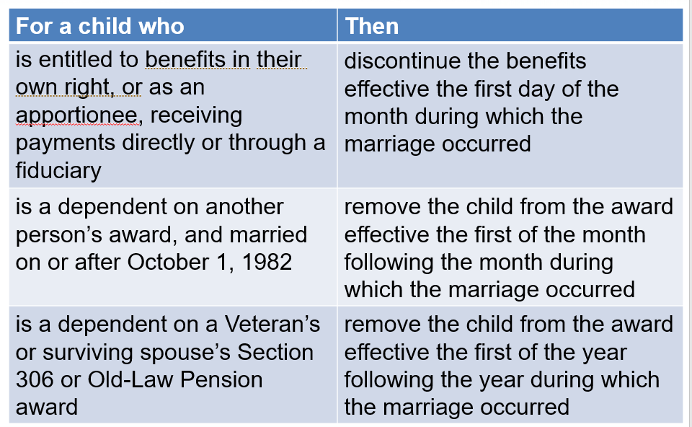

PowerPoint Slides | Notes:
Effective Date: Child’s Marriage (2 of 2)
- Adjust a survivors benefits because of a child’s marriage if a surviving spouse is receiving payments on account of the married child, or the married child is receiving an apportioned share of a surviving spouse’s award
  - If notice of marriage is for a child deemed permanently incapable, remove the child from the award effective the first day of the month following the month in which the marriage occurred
  - Upon receipt of notice of the marriage of a child deemed permanently incapable of self-support, who VA is paying benefits to, discontinue the child’s award effective the first day of the month in which the marriage occurred

PowerPoint Slides | Notes:
What is a Helpless Child for VA Purposes?
- A helpless child is a Veteran’s child who is permanently incapable of self-support through his/her own efforts due to physical or mental disabilities.
- A helpless child has to be rated by the rating team and requires evidence to support the permanent incapacity for self-support.
- A helpless child must be shown to be permanently incapable of self-support by reason of mental or physical defect at the date of attaining the age of 18 years.
Establishing the Extent of the Child’s Disability (1 of 2)
The information necessary to establish the extent of the child's disability includes:
- the extent to which the child is and was, prior to reaching his/her 18th birthday, physically or mentally deficient, as evidenced by factors such as his/her ability to perform
  - self-care functions, and
  - ordinary tasks expected of a child of that age
- whether or not the child attended school and, if so, the maximum grade attended
- if any material improvement in the child’s condition has occurred

PowerPoint Slides | Notes:
Establishing the Extent of the Child’s Disability (2 of 2)
The information necessary to establish the extent of the child's disability includes:
- if the child has ever been employed and, if so, the
  - nature and dates of such employment, and
  - amount of pay received
- whether or not the child has ever married, and
- a description of the child’s present condition
Knowledge Check: Lesson Summary Review Questions
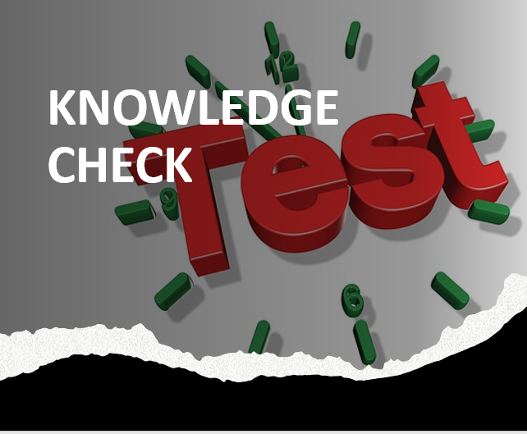
Time Allowed: 10 minutes
Questions?

What’s Next?
- Complete Determine Dependency Eligibility: Child course evaluation: TMS ID # 4189368

