Pension and Fiduciary Service

PMC VSR Intermediate Core Course  
Phase 5: Proficiency Development  
Part 1(b): Basic Eligibility

Determine Dependency Eligibility: Spouse

Trainee Guide

May 2024

Determine Dependency Eligibility: Spouse

Lesson Overview

| Topic | Description |
| --- | --- |
| Time Estimate: | 2 hours |
| Purpose of the Lesson: | This lesson is part of the entry-level curriculum, Core Course for PMC VSRs. The purpose of this lesson is to prepare PMC VSRs to determine if a claimant meets the eligibility requirements of a spouse. |
| Prerequisite Training Requirements: | Prior to taking the Determine Dependency Eligibility: Spouse lesson, trainees must complete PMC VSR Core Course Phases 1–4, and Phase 5.1(a). |
| Target Audience: | This lesson is for entry level PMC VSRs. |
| Lesson References: | * **38 CFR 3.50 (Spouse and Surviving Spouse)** * **38 CFR 3.52 (Marriages Deemed Valid)** * **38 CFR 3.55 (Reinstatement of Benefits Eligibility Based Upon Terminated Marital Relationships)** * **38 CFR 3.205 (Marriage)** * **38 CFR 3.213 (Change of Status Affecting Entitlement)** * **M21-1 VII.i.2.A (Establishing the Validity of a Marriage for Department of Veterans Affair (VA) Purposes** * M21-1 VII.i.2.B (Establishing Common Law Marriages) * M21-1 VII.i.2.B.1.e. (Establishing that Parties Held Themselves out to the Public as Married) * M21-1 VII.i.2.B.1.f. (Evidence to Prove Parties Held Themselves Out to the Public as Married) * M21-1 VII.i.2.D (Establishing Marital Relationship in Survivors Cases) * M21-1 VII.i.2.E (Remarriage of a Surviving Spouse) * M21-1 XIV.2.C (Social Security Number (SSN) Verification) * **Dependency Eligibility Requirements** job aid * **Dependency Eligibility: Spouse** job aid |
| Knowledge Check: | Phase 5.1(b) Determine Dependency Eligibility: Spouse Knowledge Check |
| Technical Competencies: | * Program Benefits and Eligibility (PMC VSR) |
| Lesson Objectives: | **By the end of this lesson, you will be able to:**   * Understand what dependency is for VA purposes and why it is important * Understand the general information on establishing marital relationships * Know how to establish marital relationships in live veteran cases * Know how to establish marital relationships in death cases |
| What You Need: | * Trainee guide * Access to VBA Intranet * Pen and paper * Access to electronic examples of the following forms:   + VA Form 21P-527EZ, Application for Pension   + VA Form 21P-534EZ, Application for DIC, Survivors Pension, and/or Accrued Benefits   + VA Form 21-686c, Application Request to Add And/Or Remove Dependents   + VA Form 21-4170, Statement of Marital Relationship   + VA Form 21P-4171, Supporting Statement Regarding Marriage * Access to the following job aids from VSR Assistant:   + **Dependency Eligibility Requirements** job aid   + **Dependency Eligibility: Spouse** job aid |

| PowerPoint Slides | Notes |
| --- | --- |
| **Determine Dependency Eligibility: Spouse**  **NOTE**: Some of the images used for this course are in the Appendix at the end of the lesson. |  |
| **Lesson Objectives**  **By the end of this lesson, you will be able to:**   * Understand what dependency is for VA purposes and why it is important * Understand the general information on establishing marital relationships * Know how to establish marital relationships in live veteran cases * Know how to establish marital relationships in death cases |  |
| **Why This Matters!**  The **Determine Dependency Eligibility: Spouse** course matters because upon establishing an individual’s relationship to a Veteran,   * VA may pay additional Dependency and Indemnity Compensation (DIC) toa surviving spouse for children that VA recognizes as a child of the Veteran on whose death the DIC award is based, and * a claimant’s entitlement to survivors benefits, such as DIC and Survivors Pension, is contingent on the relationship of the claimant to the Veteran on whose death the benefit is based |  |
| **Prescribed Forms**   * VA Form 21P-527EZ, Application for Pension * VA Form 21P-534EZ, Application for DIC, Survivors Pension, and/or Accrued Benefits * VA Form 21-686c, Application Request to Add And/or Remove Dependents * VA Form 21-4170, Statement of Marital Relationship * VA Form 21P-4171, Supporting Statement Regarding Marriage |  |
| **Relationship vs. Dependency** |  |

| PowerPoint Slides | Notes |
| --- | --- |
| **Definition**   * A ***legal impediment to marriage*** is a condition that prevents a marriage from being recognized under State law.  The following are examples of legal impediments to marriage:   + prior undissolved marriage of the Veteran   + one or both parties     - were underage when married     - lacked mentalcapacity to contract marriage, or     - were too closely related to marry under State law, and/or   + failure to comply with procedural prerequisites under State law such as bloodtests, length of residence, or a marriage license |  |
| **Family Composition** |  |
| **Valid Marriage** |  | |
| **Marital History**  Before a marriage may be established for VA purposes, it is necessary to have the claimant’s statement of marital history to list all prior marriages of both parties and include the following information:   * + First and last name of prior marriage partners   + Current spouse's Social Security number (SSN)   + Current spouse's date of birth   + How the prior marriages terminated (death, divorce, annulment)   + Date the prior marriages terminated (month and year, at a minimum), and   + Place where the prior marriages terminated (city and state) |  |

| PowerPoint Slides | | Notes | |
| --- | --- | --- | --- |
| **Common Law Marriage (1 of 3)** |  | |
| **Common Law Marriage (2 of 3)** |  | |
| **Common Law Marriage (3 of 3)** |  | |
| **Spouse’s Residence** |  | |
| **Establishing a Marriage in Death Cases**   * To establish spousal dependency in survivor cases, the claimant must meet the following requirements:   + **Valid Marriage requirements**   + **Proper Marriage Dates**   + **Continuous Cohabitation**   + **Has not remarried since the death of the Veteran** |  | |

| PowerPoint Slides | Notes |
| --- | --- |
| **Deemed Valid Marriage** |  |
| **Deemed Valid Marriage**   * A marriage may be deemed valid for VA purposes if: * the marriage occurred one year or more before the Veteran died or existed for any period of time if a child was born   + of the marriage   + to the parties before the marriage, or   + after the death of the Veteran if it is established that the Veteran was the parent of the child * the surviving spouse   + entered into the marriage without knowledge of impediment, and   + lived with the Veteran at the time of the Veteran’s death or, if they had separated, the surviving spouse was not at fault in the separation, and * no other claimant has established entitlementto VA benefits as the Veteran’s legal surviving spouse |  |
| **Legal Impediments**   * A marriage *cannot* be deemed valid if the impediment is the claimant’s inability to prove the dissolution of his/her own prior marriage. * An administrative decision is required when a VSR deems a marriage valid |  |
| **Marriage Date Requirement**   * The marriage dates requirement of [38 CFR 3.54](https://www.ecfr.gov/cgi-bin/text-idx?SID=1da966130ae3538298605afaa92208bb&mc=true&node=se38.1.3_154&rgn=div8) states that benefits may not be paid to the surviving spouse unless one of the following requirements is met: * the claimant was married to the Veteran for at least one year immediately preceding the Veteran’s death * a child was born of the marriage or born to them before the marriage, or   + the marriage occurred before a certain delimiting date |  |
| **Continuous Cohabitation** |  |
| **Continuous Cohabitation Development**   * Development should be initiated if there is an indication the Veteran and claimant were not living together immediately prior to the Veteran’s death. * Exception- if there is no contradictory evidence of record, accept the claimant’s statement as to the reasons for the separation without further development |  |
| **Rules for Remarriage**   * A surviving spouse who previously lost eligibility to DIC due to a remarriage occurring between the ages of 55 and 57, are eligible to have the DIC reinstated effective January 5, 2021 * Do not reinstate or apply continuous payment of DIC to a surviving spouse who remarried upon attaining age 55, but before age 57, ***earlier than January 5, 2021***   + When processing a claim for reinstatement or continuation of DIC eligibility based on remarriage upon attaining age 55, assign EP 130 |  |
| **Knowledge Check: Lesson Summary Review**    **Time Allowed: 10 minutes** |  |
| **Questions?** |  |
| **What’s Next?**   * Complete Determine Dependency Eligibility: Spouse course evaluation: **TMS ID #4189367** |  |

Appendix

**Common Law Marriage**

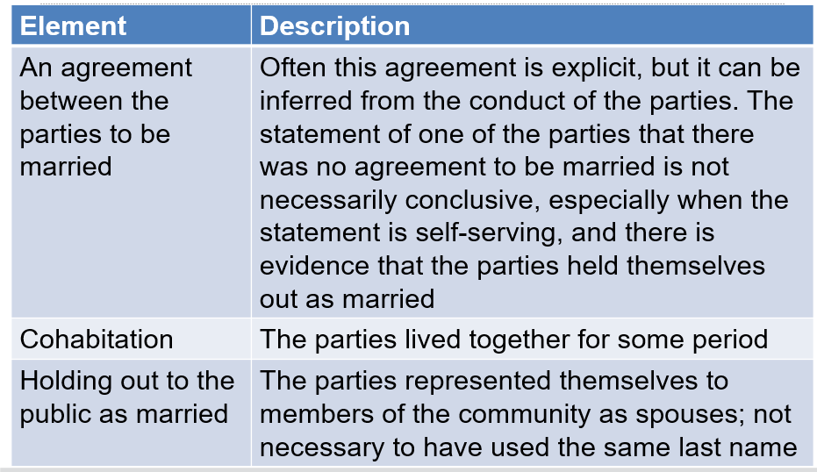

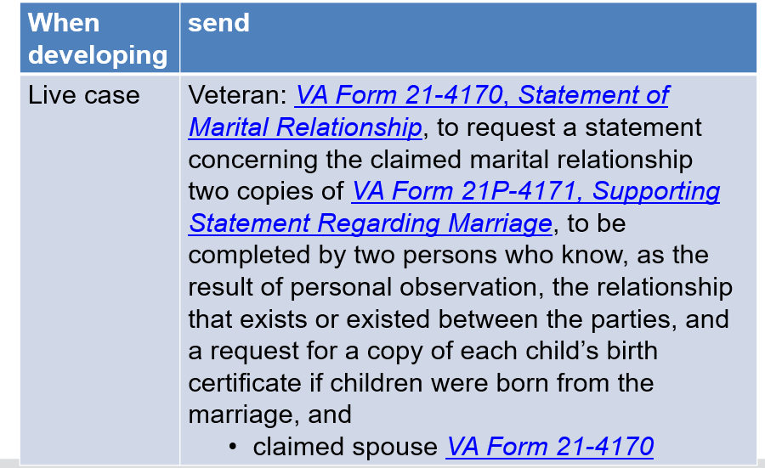

**Common Law Marriage**

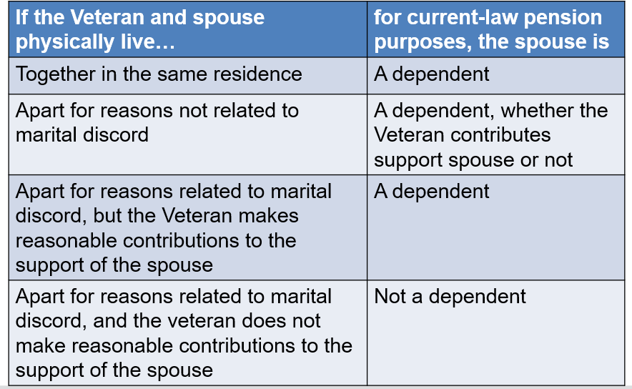

**Deemed Valid Marriage**

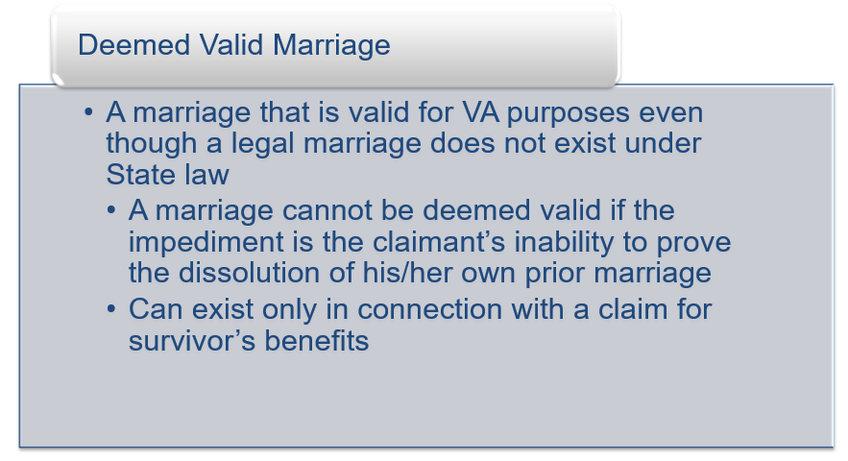

**Legal Impediments**

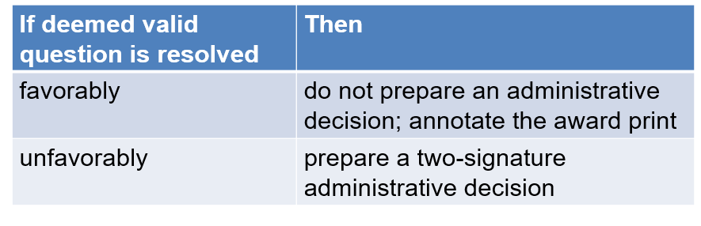

**Continuous Cohabitation**

