Pension and Fiduciary SErvice

PMC VSR Intermediate Core Course  
Phase 5: Proficiency Development  
Part 1(b): Basic Eligibility

Presumptive Criteria for Permanent and Total (P&T) Disability

Trainee Guide

March 2024

Determine Whether Veteran Meets Presumptive Criteria for Permanent and Total Disability

Lesson Overview

| Topic | Description |
| --- | --- |
| Time Estimate: | 1 hour |
| Purpose of the Lesson: | This lesson is part of the entry level curriculum, Core Course for PMC VSRs. The purpose of this lesson is to prepare PMC VSRs to determine whether the Veteran meets presumptive criteria for permanent and total disability. |
| Prerequisite Training Requirements: | Prior to taking the Determine Whether Veteran Meets Presumptive Criteria for Permanent and Total Disability lesson, trainees must complete PMC VSR Core Course Phases 1–4. |
| Target Audience: | This lesson is for entry level PMC VSRs. |
| Lesson References: | * 38 CFR 3.208 (Claims Based on Attained Age) * 38 CFR 3.209 (Birth) * 38 CFR 3.342 (Permanent and Total Disability Ratings for Pension Purposes) * M21-1 III.ii.1.A (Requesting Evidence from Federal Record Custodians) * M21-1 IX.ii.2.A.1 (Evidence of Disability for Veterans Pension Purposes) * M21-1 IX.i.2 (Original Pension Claims Development) * M21-1 IX.iii.1.G.3.j. (Medical Expense Deduction for Nursing Home Fees) * PACT Act SOP |
| Technical Competencies: | * Program Benefits and Eligibility (PMC VSR) * Processing Claims (PMC VSR) |
| Knowledge Check | * Phase 5.1(b): Presumptive Criteriat for Permanent and Total Disabililities |
| Lesson Objectives: | By the end of this lesson, you will be able to:   * Define Permanent and Total (P&T) Disability * Determine if Veteran meets the presumptive criteria to satisfy the requirements for Permanent and Total (P&T) disability * Determine when evidence is required to satisfy Permanent and Total (P&T) disability |
| What You Need: | * Trainee guide * Access to VBA Intranet * Access to CPKM |

| PowerPoint Slides | Notes |
| --- | --- |
| Presumptive Criteria for Permanent and Total (P&T) Disability |  |

| PowerPoint Slides | Notes |
| --- | --- |
| **Objectives**  By the end of this lesson, you will be able to:   * Define Permanent and Total (P&T) Disability. * Determine if Veteran meets the presumptive criteria to satisfy the requirements for Permanent and Total (P&T) disability. * Determine when evidence is required to satisfy Permanent and Total (P&T) disability. |  |
| **Why This Matters:**  The **Presumptive Criteria for P&T Disability** course matters because it discusses requirements for Veterans Pension. For instance,   * Meeting the definition of permanently and totally disabled (P&T) * Requirement can be met by a presumptive measure or by a rating decision |  |
| PowerPoint Slides | Instructor Activities |
| **Presumptive P&T Disability**  A rating determination of P&T disability is not required to establish eligibility for Veterans Pension when a veteran is:   * Age 65 or older, or * Presumed to be P&T disabled for pension purposes because he/she is:   + A patient in a nursing home for long-term care because of disability, or   + Disabled, as determined by the Commissioner of Social Security |  |
| **Definition: What Are Presumptive Criteria for P&T Disability?** |  |
| PowerPoint Slides | Instructor Activities |
| **Evidence of Age (1 of 2)**   * If the Veteran is age 65 or older, a rating determination of P&T disability is not required * If the date of birth as given by the Veteran agrees with other dates of birth shown in the records, no further development is necessary   + Otherwise accept the youngest age shown in the records, pending receipt of acceptable evidence of birth |  |
| **Evidence of Age (2 of 2)** |  |

| PowerPoint Slides | Notes |
| --- | --- |
| **Social Security Disability Evidence** |  |
| **Verify Social Security Disability Evidence (1 of 2)**   * If the Veteran is younger than age 65, but SSA has determined he or she is disabled, the Veteran may be presumed P&F disabled for pension purposes from the date of disability onset. * Title XVI Status has a “Y” indicator: A “Y” in this field indicates that SSA data is available.   + View the SSI BASIC INFO tab to determine if SSI is payable   + If a Veteran is found entitled to SSI, he or she meets the disability requirements for VA pension |  |

| PowerPoint Slides | | Notes |
| --- | --- | --- |
| **Verify Social Security Disability Evidence (2 of 2)** | |  |
| Social Security Disability Evidence (1 of 4)    SSI is payable. Therefore, the Veteran meets the disability requirement for VA pension benefits. The Veteran is considered P&T. | |  |
| **Social Security Disability Evidence (2 of 4)**   * Title II Status has a “Y” indicator: This indicates that either Social Security retirement or Social Security disability is payable.   + If Veteran’s age is under 62, Social Security is based on disability. Presume that the VA pension disability requirement is met. Vet is P&T | |  |
| **Social Security Disability Evidence (3 of 4)**   * If the Veteran’s age is 62, 63, or 64, SS may be based on retirement or on disability   + If the date in the DATE OF INITIAL ENT field is exactly six full months after the date in the DISABILITY ONSET DATE field, then presume that the VA pension disability requirement is met.   + If the date in the DATE OF INITIAL ENT field is not shown or is not exactly six full months after the date in the DISABILITY ONSET DATE field, then develop to the claimant and the SSA for a disability award letter and medical evidence of disability |  | | |
| Social Security Disability Evidence (4 of 4)    The initial entitlement date of 5/2006 is six months after the disability onset date of 11/09/2005. Therefore, VA will presume that the VA pension disability requirement is met. |  | | |

| PowerPoint Slides | Notes |
| --- | --- |
| **Nursing Home Evidence (1 of 2)** |  |
| **Nursing Home Evidence (2 of 2)**   * Veteran must be a patient in a nursing home for long-term care because of disability.   + A medical foster home that VA has recognized and approved is equivalent to a nursing home |  |

| PowerPoint Slides | Notes | |
| --- | --- | --- |
| **Presumptive Criteria for P&T  Disability Not Satisfied**   * If the Veteran does not meet the presumptive P&T criteria, then the claim will need a rating decision |  | |
| **Rating Determination of P&T Disability**   * In order to be granted P&T disability by a rating decision, the medical evidence must show the veteran:   + Meets the disability percentage requirements set forth in 38 CFR 4.16 and 4.17 or have an extra-scheduler evaluation approved under 38 CFR 3.321(b)(2), and   + Unable to secure and follow a substantially gainful occupation (unemployable) by reason of disabilities which are likely to be permanent |  | |
| **Medical Evidence (1 of 3)**   * Determine if adequate medical evidence is of record before sending the claim for rating activity * Medical evidence is adequate if it addresses all medical or mental conditions provided by the Veteran and can be used to evaluate the impact of each condition on the Veteran’s employability.   + A statement from a physician, certified Nurse Practitioner, Clinical Nurse Specialist, or Physician Assistant, or   + A hospital or examination report from any government or private institution |  | |
| **Medical Evidence (2 of 3)**   * If medical evidence is of record, but is not adequate for rating purposes, schedule the claimant for a VA examination * Once adequate medical evidence is of record, refer the claim to the rating activity |  | |
| **Medical Evidence (3 of 3)**   * If no medical of the claimed disability is of record, request medical evidence from the claimant. * If no medical evidence is received and 30 days have passed from the date of the request:   + Deny the claim,   + Notify the veteran the evidence must be provided, and,   + Notify the Veteran he/she must file a supplemental claim.   No additional development is needed and no rating decision is completed |  | |
| **Federal Records**   * When relevant treatment is alleged at a VA facility, claim processors must attempt to obtain the records, unless it is concluded that it is reasonably certain the records do not exist * If the claimant does not indicate treatment at a VAMC or provide dates or treatment an enterprise search must be completed, and any relevant treatment records associated into the claims folder |  | |
| **PACT Act – Presumptive**  A claim under the PACT Act may include claims in which the Veteran   * explicitly states a disability is related to service in a newly recognized or existing presumptive location, or as due to toxic exposure * does ***not*** explicitly state what has caused a claimed disability, but there is service in a newly recognized or existing presumptive location * claims a newly recognized presumptive disability, or * claims a non-presumptive disability and either explicitly claims it or evidence implicitly indicates participation in toxic exposure risk activity (TERA) |  | |
| **Knowledge Check: Lesson Summary Review**    **Time Allowed**: **10 minutes** | |  |
| ****What’s Next****  **Complete Establish Veteran Status course evaluation: TMS ID #: 4189366** | |  |

**Appendix**

**Definition: What are Presumptive Criteria for P&T Disability?**

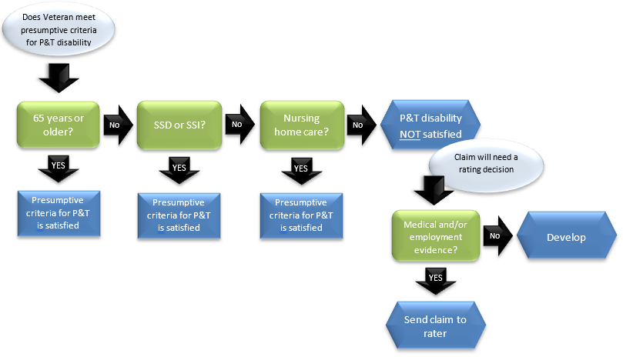

**Evidence of Age**

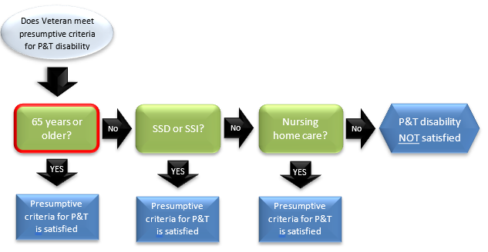

**Social Security Disability Evidence**

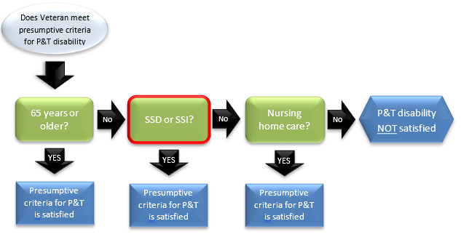

**Nursing Home Evidence**

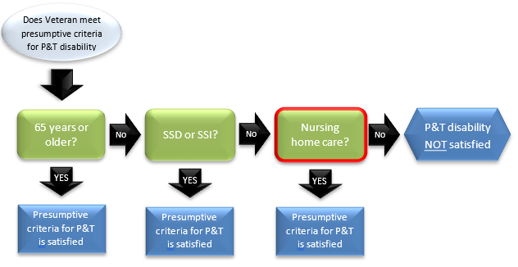

**Presumptive Criteria for P&T Disability NOT Satisfied**

