Pension and Fiduciary Service

PMC VSR Intermediate Core Course   
Phase 5: Proficiency Development  
Part 4: Prepare the Decision Notice

Overview of Administrative Decisions

Trainee Guide

November 2024

Overview of Administrative Decisions

Lesson Overview

| Topic | Description |
| --- | --- |
| Time Estimate: | 1.5 hours |
| Purpose of the Lesson: | This lesson is part of the entry-level curriculum, Core Course for PMC VSRs. The purpose of this lesson is to introduce PMC VSRs to administrative decisions. You will learn to recognize administrative decisions and the procedures unique to administrative decisions. |
| Prerequisite Training Requirements: | Prior to taking the Prepare the Decision Notice lesson, trainees must complete PMC VSR Core Course Phases 1–4, and Phase 5, Parts 1-3. |
| Target Audience: | This lesson is for entry level PMC VSRs. |
| Lesson Objectives: | By the end of this lesson, you should be able to:   * Demonstrate the administrative decision-making process * Recognize administrative decisions * Recognize evidentiary procedures for an administrative decision * Recognize notification procedures for an administrative decision |
| Lesson References: | * 38 USC 1111 (Presumption of Sound Condition) * 38 USC 1153 (Aggravation) * 38 CFR 3.100 (Delegation of Authority) * 38 CFR 3.102 (Reasonable Doubt) * 38 CFR 3.104 (Binding Nature of Decisions) * 38 CFR 3.23 (Improved Pension Rates – Veterans and Surviving Spouses) * 38 CFR 4.3 (Resolution of Reasonable Doubt) * 38 CFR 4.6 (Evaluation of Evidence) * M21-1 III.i.1.A.1.f. (Deciding Claims Based on Qualifying Service) * M21-1 VII.i.2.D.7.g (Administrative Decision when the Validity of a Marriage is at Issue) * M21-1 V.ii.1.A (Principles of Reviewing and Weighing Evidence) * M21-1.X.v.1.C.1 (General Information on Administrative Decisions) * M21-1.X.v.1.C.2 (Making an Administrative Decision) * M21-1.X.v.1.C.3 (Documenting Administrative Decisions) |
| What You Need: | * Trainee Guide * Slides * Access to CPKM to display the references * **Prepare the Decision Notification** job aid * **Notification Language** job aid * **Worsheet (located at the end of the trainee guide)** |

| PowerPoint Slides | Notes |
| --- | --- |
| **Overview of Administrative Decisions** |  |
| Lesson Objectives  At the end of this lesson, you will be able to:   * Demonstrate the administrative decision-making process * Recognize administrative decisions * Recognize evidentiary procedures for an administrative decision * Recognize notification procedures for an administrative decision |  |
| Why This Matters!   * Understanding the Overview of Administrative Decisions is important because such decisions are needed to o determine whether a claimant or payee has forfeited the right to gratuitious benefits or to remit a prior forfeiture.   + VA system is *non-adversarial*, and decision makers are expected to be impartial and liberally apply VA’s pro-Veteran policies, procedures, and regulations in accordance with any applicable VA guidance. |  |
| **Definitions**   * The term ***evidence*** signifies all of the means by which an alleged matter of fact may be established or disproved.  For decision-making purposes in VA, the term generally refers to   + testimony (including statements in support of a claim)   + various kinds of documentary proof, and   + medical or field examination reports * ***Rules of evidence*** are guidelines on evaluation of the evidence submitted or obtained in a case. * **Standard of proof** specifies the degree of persuasion or confidence in the evidence with regard to the subject of the proof that is required in order to find a fact proven. * ***Findings of fact*** are the true facts that a decision maker finds to exist after the analysis of all evidence of record. * ***Conclusions of law*** are the ultimate determinations made regarding whether key governing substantive and/or procedural legal requirements defined by the claim are proven. * ***Evaluating evidence*** refers to a series of analytical steps that must be performed by a VA decision maker in making findings of fact for the purpose of drawing conclusions of law on each aspect or criterion of the legal standard for entitlement to the benefit and on applicable procedural matters. * The ***reasonable doubt rule*** means that the evidence provided by the claimant/beneficiary (or obtained on the claimant’s/beneficiary’s behalf) must only persuade the decision maker that each factual matter is at least as likely as not. * **Presumptive provision** refers to when certain facts are proven, a presumption arises that additional facts are true unless the presumption is rebutted by other evidence. * ***Credibility*** is a blanket term for the fact finding of whether evidence is believable or not believable. * ***Competent evidence*** refers generally to evidence offered from a qualified source. * A determination of evidentiary competency involves analysis of whether a person offering evidence is qualified to establish a matter. * ***Competent medical evidence*** means evidence provided by a person who is qualified through education, training, or experience to offer medical diagnoses, statements, or opinions. * Evidence has ***probative value*** if it makes a matter material to the determination more or less likely, and has sufficient weight, either by itself or in combination with other evidence, to persuade the decision maker about a fact. |  |
| **Finality of Administrative Decisions**   * Administrative decisions, made in accordance with existing guidance and by application of the same criteria and based on the same facts are binding when issued under [38 CFR 3.104(b)](https://www.ecfr.gov/current/title-38/chapter-I/part-3/subpart-A/subject-group-ECFR63da83ba671b92b/section-3.104), which include:   + line of duty   + COD   + relationship   + dependency   + domestic relations questions   + homicide   + findings of fact of death, and   + presumptions of death |  |
| **Types of Evidence** |  |
| **Weighing the Evidence**   * The absence of evidence that supports a claimant’s position is considered negative evidence that must be weighed when deciding. * After collecting all the available evidence that is relevant to a pending issue, weigh the positive and negative evidence, and determine if the weight of the positive evidence is greater than, less than, or equal to the weight of the negative evidence. |  |
| In Equipoise   * An equipoise decision is necessarily more qualitative than quantitative; it is one not capable of mathematical precision and certitude.   + Equal weight is not accorded to each piece of material contained in the record; every item of evidence does not have the same probative value. * Evidence is not necessarily in relative equipoise when the number of acceptable items of evidence tending to support a fact isequal to the number of items tending to not support a fact. |  |
| Evidentary Proof |  |
| Accepting Evidence Offered   * Evidence is accepted and made part of the official evidentiary record, which, for VA claims, is the claims folder, and all electronic records associated with the processing of a claim. * All evidence is admitted into the record with exceptions for:   + unsworn or uncertified testimony   + duplicate copies of records, and   + evidence submitted in support of a request for higher-level review (HLR) |  |
| Credibility of Evidence   * When determining whether evidence is new and relevant in connection with a supplemental claim, presume that the evidence is credible.   + once the new and relevant determination has been made, assess the evidence as usual for credibility, competence, and weight * Factors to consider in making a fact finding of credibility include:   + facial plausibility   + consistency with other evidence submitted   + internal consistency   + demeanor of a witness (who is offering in person testimonial evidence), and   + interest/bias |  |
| Probative Evidence   * Evidence from a source that is not competent to establish a fact does not have probative value on that fact. * Factors to consider in determining the probative value of evidence:   + competency   + credibility   + thoroughness   + precision   + relevancy, and   + date of the evidence |  |
| Absence of Evidence   * The absence of evidence on a particular question cannot be construed as substantive negative evidence against a claimant *unless* there is a foundation in the record that demonstrates that such silence tends to prove or disprove a relevant fact. * Decision makers must apply the following principles when evaluating the absence of evidence in the record:   + Absence of an entry in a record may be evidence against the existence of a fact if such a fact would ordinarily be recorded.   + A claimant’s lay statement may be weighed against the absence of contemporary medical evidence |  |
| Preponderance of Evidence   * There are issues, however, that require a preponderance of the evidence to decide in the claimant’s favor   + includes questions of status, such as a person’s relationship to a Veteran * Preponderance of the evidence exists if the evidence is not in equipoise, which means it is not evenly balanced both for and against the fact or proposition at issue.   + a fair preponderance of the evidence, one side clearly outweighs the other   + apply the reasonable-doubt rule when determining whether the character of a Veteran’s service renders him/her ineligible for certain VA benefits |  |
| Issues Requiring an Administrative Decision  Examples of when an administrative decision is required: |  |
| Presumptive Provisions   * Presumptive provisions alleviate part of the claimant’s burden of proof.   + a presumption has evidentiary value, but it is not a form of evidence   + is a legal mechanism that relieves a party from having to produce evidence sufficient to establish the point at issue   + VA presumptions may be rebutted   + VA presumptions include: soundness, aggravation, and service connection |  |
| **Required Elements**   * Administrative decisions must include the following elements:   + identification of the issue(s) adjudicated   + summary of the evidence considered, and laws and regulations applicable to the claim   + identification of the element(s) required to grant the claim that were not met. * PMCs are not required to list favorable findings in administrative decisions.   + Favorable findings are addressed in PMC decision notices. |  |
| **Decision Narrative**   * When discussing the evaluation of evidence in a decision *Narrative*,   + be objective and fair in the consideration of evidence   + ensure that any inferences, findings, and conclusions madeare supported under the facts and law   + follow the evidentiary guidance in this chapter   + be professional and courteous even when claimants are antagonistic, critical, or abusive   + not allow any bias or personal feelings into the evaluation of evidence or the decision   + not arbitrarily or capriciously refuseto assign weight to a claimant’s evidence, and   + not adopt or express an adversarial position towards a claimant or beneficiary |  |
| **Administrative Decisions: Reasons and Bases**  When citing the reasons and bases apply the following rules:   * State the reasons and bases in clear, simple, easy-to-understand terms.   + Fully describe the reasoning that led to the decision * Support conclusions by analysis and explanation of the credibility and value of the evidence on which they are based   + The assertion of unsupported conclusions is unnecessary. * Acknowledge contentions that argue against the decision, and explain why they did not prevail   When citing the reasons and bases apply the following rules:   * Quote directly from relevant laws and regulations, as needed, to support the conclusion reached, but do not rely on the citing of regulatory text in its entirety as a substitute for a qualitative discussion * Impartially list all evidence, both favorable and unfavorable   + identify and paraphrase pertinent information from the available evidence instead of quoting from it at length * Evaluate all the evidence, including sworn oral testimony and certified statements submitted by claimants, and clearly explain why that evidence is found to be persuasive or unpersuasive * Explicitly address each item of evidence and each of the claimant’s contentions |  |
| **Administrative Decisions: Favorable Findings**  In **all *favorable*** administrative decisions, include the following statement as part of the reasons and bases:  *All elements required to decide the issue of* [issue] *were met, and all findings were favorable to the claimant*.  In **all *unfavorable*** administrative decisions,   * + discuss as part of the reasons and bases all unmet elements that were required to grant the claim   + clearly label and identify findings that were favorable to the claimant |  |
| **Unfavorable Administrative Decisions**   * When an administrative decision is unfavorable, send notice to the claimant in a letter containing the elements in [M21-1, Part VI, Subpart i, 1.B.1.b](https://vaww.vrm.km.va.gov/system/templates/selfservice/va_kanew/help/agent/locale/en-US/portal/554400000001034/content/554400000179469/M21-1,-Part-VI,-Subpart-i,-Chapter-1,-Section-B---Decision-Notices). * *A single* decision notice will be prepared and released to the claimant *after* the administrative decision is completed ***and***the claims processor   + denies benefits, or   + denies benefits based on a rating decision |  |
| **Administrative Decision: Authorization Activity**   * For decisions made bythe authorization activity that require an administrative decision, the authorization activity is responsible for explaining in the body of the administrative decision the reasons and bases for said decision * For decisions made by the authorization activity that *do not* require an administrative decision, the authorization activity must provide in the decision notice sufficient detail regarding the rationale used in reaching the decision to ensure the claimant will understand its basis |  |
| **Continuous Cohabitation**   * When continuous cohabitation has not been established prepare a two-signature administrative decision. * In cases where a lack of continuous cohabitation has definitely been established, and there is a question of the validity of the marriage,   + deny the claim due to the continuous cohabitation requirement not being met without resolving the question of the legality of the marriage, and   + include the following statement in the denial notice:  *A determination has not been made as to whether you may be recognized as the legal surviving spouse of the Veteran*. |  |
| **Validity of Marriage**   * An administrative decision is required to determine whether a marriage can be deemed valid   + if the deemed valid question is resolved as favorable the administrative decision is not required   + if unfavorable prepare a two-signature administrative decision |  |
| **Hardship Determinations**  When making a hardship determination:   * If the claimed expenses exceed the sum of IVAP and pension entitlement, it is determined that some expenses are unnecessary for family maintenance, and the disallowed expenses are needed to offset all of children’s income   + prepare an administrative decision for approval   + ensure that the decision indicates which claimed expenses are unnecessary for reasonable family maintenance and the reason why   + in the discussion portion of the administrative decision, cite the definition of expenses necessary for reasonable family maintenance in [38 CFR 3.23(d)(6)](https://www.ecfr.gov/current/title-38/chapter-I/part-3/subpart-A/subject-group-ECFRf5fe31f49d4f511/section-3.23) |  |
| **Duplicate Payments**  If evidence of record indicates a duplicate payment of benefits was due to administrative error:   * prepare an administrative decision to document that fact * submit the administrative decision for approval, and after receiving approval * establish EP 600 to control for due process and propose to stop the duplicate payments from the effective date of the award * include appropriate language in the notice of proposed adverse action that states if the proposed adjustment is made, it *may* result in an overpayment of benefits |  |
| **Contested Claims**   * Make an administrative decision after completely developing the facts associated with a contested claim. * If one of the claimants in acontested claim establishes entitlement,   + deny the claim of the other claimant(s), and   + notify all claimants and other interested persons of the actions taken   + attach [*VA Form 20-0998, Your Right to Seek Review of Our Decision*](http://www.vba.va.gov/pubs/forms/VBA-20-0998-ARE.pdf), to the decision notice |  |
| **Knowledge Check: Lesson Summary Review**  **Time Allowed**: 10 minutes |  |
| **What’s Next?**  **TMS Evaluation:** Overview of Administrative Decisions **(TMS# 4189363)** |  |

Appendix

**Types of Evidence**

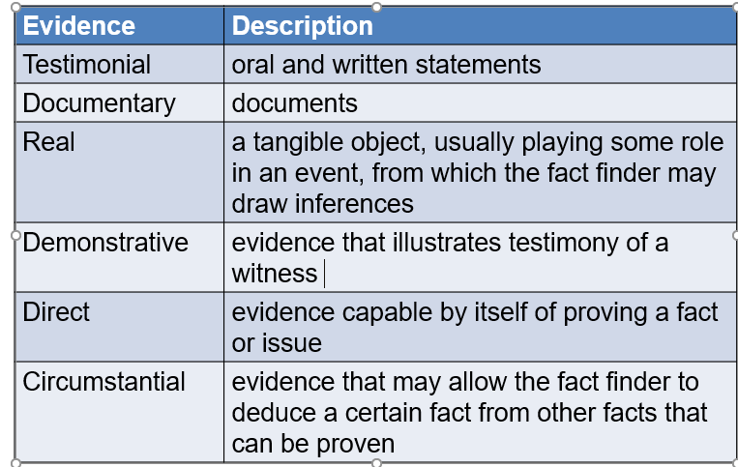

**Weighing Evidence**

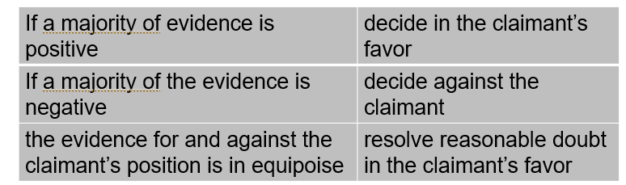

**Evidentary Proof**

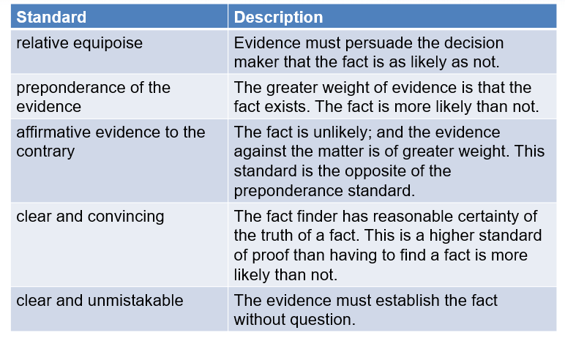

**Issues Requiring an Administrative Decision**

