Pension and Fiduciary Service

PMC VSR Basic Core Course
Phase 4: Foundational Enrichment
Establish a Claim
Trainee Guide
December 2024

Establish a Claim

Lesson Overview
Topic | Description
Time Estimate: | 1 hour
Purpose of the Lesson: | This lesson is part of the entry-level curriculum, Core Course for PMC VSRs. The purpose of this lesson is to prepare you to establish a claim.
Prerequisite Training Requirements: | Prior to taking the Establish a Claim lesson, you must complete PMC VSR Core Course Phases 1–3.
Target Audience: | This lesson is for entry level PMC VSRs.
Lesson References: | - M21-1 II.iii.3.A, Claims Establishment  - M21-4 Appendix B, End Product Codes and Work-Rate Standards for Quantitative Measurements  - M21-4 Appendix C, Index of Claim Labels
Knowledge Check | Phase 4: Establish a Claim Knowledge Check
Lesson Objectives: | By the end of this lesson, you should be able to:  - Establish a claim (CEST)  - Recognize common EPs a PMC VSR will CEST  - Select the correct system in which to CEST the claim  - Demonstrate the CEST process in VBMS and SHARE
What You Need: | - Trainee Guide  - Access to VBMS  - Access to SHARE  - VBMS User Guide  - SHARE User Guide  - Appendix A - Practice Exercise Worksheet: Where to CEST  - Access to the Assessment Portal

PowerPoint Slides | Notes
Establish a Claim
Objectives
By the end of this lesson, you should be able to:
- Establish a claim (CEST)
- Recognize common End Products (EP) a PMC VSR will CEST
- Select the correct system in which to CEST
- Demonstrate the CEST process in VBMS and SHARE
Why It Matters
- The Establish a Claim course matters because claim labels provide a more specific description of the claim type that a corresponding end product (EP) represents.
Definitions
- For claims establishment (CEST) purposes, the date of claim (DOC) is the earliest date the claim or information is received in any Department of Veterans Affairs (VA) facility.
- Unidentifiable mail is defined as any mail lacking identifying attributes or adequate information necessary to conclusively identify an individual, associate the correspondence with an existing claims folder, or create a new eFolder.
- A paper claims folder is a repository for paper documents related to a single Veteran and associated with a claims folder number.
  - VBA has two types of paper claims folders: claims folders and notice of death folders.
- An electronic claims folder (eFolder) is an electronic repository for scanned documents related to a single Veteran and associated with a claims folder number.
Common PMC EPs
- Rating EPs
  - 180
  - 190
  - 120
  - 140
  - 020
- Maintenance EPs
  - 130
  - 150
  - 290
  - 600
- Survivor EPs
  - 140
  - 165
  - 160
  - 190
- Miscellaneous Eps
  - 930
Payee Codes and Benefit Types
Payee codes are based on the claimant/beneficiary:
- Veteran = 00
- Spouse = 10
- First child = 11
- Subsequent children = 12, 13, 14, etc.
- Father = 50
- Mother = 60
Benefit types are either:
- Live CPL – Compensation –Pension Live
Death CPD – Compensation – Pension Death
Where to CEST
- VBMS
  - All initial and subsequent claims for compensation
  - Pension and survivors claims
  - Claims where the claimant has a VA-appointed fiduciary
  - Most claim types for which a VBMS record already exists
- SHARE
  - Any claim where the claimant is an organization
  - Exception: State plot claims can be established in VBMS.
  - Legacy appeals where the appellant is not a child, spouse or parent of the Veteran
  - Accrued claims upon the death of a surviving spouse or child
- Caseflow
  - EPs 030 and 040
  - Only certain employees have access to Caseflow

PowerPoint Slides | Notes
Practice Exercise: Where to CEST
- Instructions:
  - Work with a partner to answer the questions on the worksheet in the Trainee Guide.
  - Refer to M21-1 II.iii.3.A.1.a. Types of Claims Excluded From Establishment in VBMS
  - Be prepared to share your responses.
- Time allowed: 10 minutes

PowerPoint Slides | Notes
Common CESTing Errors
- Failure to enter correct payee number
- Failure to update the claimant's address
- Failure to update or to enter the POA
Knowledge Check: Lesson Summary Review
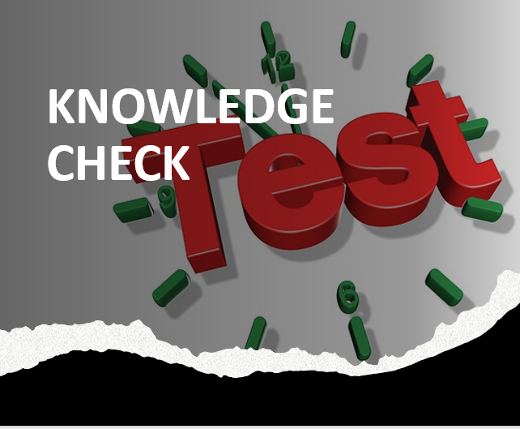
Time Allowed: 10 minutes
What’s Next?
- Complete Establish a Claim evaluation course: TMS ID: 4189361

