Pension and fiduciary service
PMC VSR Basic Core Course
Phase 4: Foundational Enrichment
End Product (EP) Codes
Trainee Guide
August 2024

EP Codes

Lesson Overview
Topic | Description
Time Estimate: | 1.5 hours
Purpose of the Lesson: | This lesson is part of the entry-level curriculum, Core Course for PMC VSRs. The purpose of this lesson is to show PMC VSRs how to decide whether the end product established by the claims assistant is correct.
Prerequisite Training Requirements: | Prior to taking the End Product Codes lesson, trainees must complete PMC VSR Core Course Phases 1–3.
Target Audience: | This lesson is for entry level PMC VSRs.
Lesson References: | - Compensation and Pension Knowledge Management (CPKM)  - M21-1 II.iii.1.A (Applications for Benefits)  - M21-1 II.iii.2.B (Supplemental Claims)  - M21-4 Appendix B (End Product (EP) Codes)  - PACT Act Implementation Standard Operating Procedure (SOP)
Knowledge Check: | Phase 4: PMC VSR End Product Codes Knowledge Check
Technical Competencies: | - Program Benefits and Eligibility (PMC VSR)  - Processing Claims (PMC VSR)  - VBA Applications (PMC VSR)
Lesson Objectives: | By the end of this lesson, you should be able to:  - Confirm End Product (EP) is correct  - Define an EP code  - Verify the EP code matches the type of claim  - Modify the EP code in VBMS
What You Need: | - Training Guide  - Access to VBA Intranet  - Access to CPKM

PowerPoint Slides | Notes
End Product (EP) Codes

Lesson Objectives
By the end of this lesson, you should be able to:
- Confirm End Product (EP) code is correct
- Define an EP code.
- Verify the EP code matches the type of claim.
- Modify the EP code in VBMS
Why This Matters!
- The End Product (EP) Codes course matters because the EP system is the primary workload monitoring and management tool for the Veterans Service Center (VSC), Pension Management Center (PMC), and Fiduciary Hubs (Hubs).
What Is an End Product Code?
- Correct use of the EP system facilitates proper control of pending workloads and appropriate work measurement credit
- Each claim should promptly be placed under EP control
- EP codes are three-digit numbers

EP Codes and Claim Types
- An Initial claim is any complete claim, other than a supplemental, for a benefit on a form prescribed by the Secretary.
  - An original EP code is still an initial claim but is further defined as the first initial claim for one or more benefits received by VA.
- Maintenance EPs are generally used for awards that are already running.
  - Maintenance applies to non-rating EPs.
- Supplemental claim is any claim for VA benefit on a prescribed form where the Veteran and/or their representative disagrees with a prior decision on an initial or supplemental claim for the same or similar benefit on the same or similar basis)
List of Authorized EP Codes
Pension Claim Types:
- Initial (Original and Non-Original)
  - Original
    - Rating (180)
    - Survivor (190)
  - Non-original
    - Rating (120)
    - Maintenance (130,150, etc.)
- Supplemental (040)
Full list of Comp and Pension EP: M21-4 Appendix B
Claim establishment for PACT Act-related survivor claims should align with EP controls per M21-4, Appendix B and C, unless otherwise specified in the PACT Act Implementation Standard Operating Procedure (SOP)
EP Codes and Claim Types: Original Claim
Original claims:
- EP 180—Veteran who is applying for pension benefits and has never applied for pension before.
- EP 190—Surviving spouses or children applying for pension who have never applied before.
- EP 140—Surviving spouses, children, or parents of Veterans applying for the Dependency and Indemnity Compensation (DIC) who have never applied before.

PowerPoint Slides | Notes
EP Codes and Claim Types:
Non-Original Initial Claims
- A non-original initial or supplemental claim EP would be any EP OTHER than an original EP.
- Example EPs for initial claims:
  - EP 020- DIC re-adjudication, A&A or HB, helpless child or competency issues
  - EP 120- re-adjudication of Veterans or Survivors Pension; SMP; helpless child claim; liberalizing legislation or new competency issues
  - EP 130- dependency adjustments; new death claims previously adjudicated not involving basic eligibility; death of surviving dependent’s award; reinstating DIC due to termination of marriage; apportionments; school child adjustments
EP Codes and Claim Types:
Non-Original Initial Claims
- Example EPs for initial claims (Continued):
  - EP 135- hospital adjustment
  - EP 150- income/net worth adjustment; elections of current law pension
  - EP 290- re-adjudication of eligibility; month of death; incarceration adjustments; fugitive felon; resume suspended award; disappearance of veteran; renouncements; fiduciary program matters
  - EP 600- pre-determination (due process)
EP Codes and Claim Types:
Initial Claims
- Example EPs for initial claims:
  - EP 160- claims for the statutory burial allowance, plot allowance, supplemental claims for reconsideration of a prior decision, and claim for reimbursement of headstone, marker, or additional engraving expenses
  - EP 165- accrued benefits payable as reimbursement to the payer of the expenses of last sickness and burial, or accrued benefits payable based on relationship
EP Codes and Claim Types: Higher Level and Supplemental
- EP 030- higher-level review
- EP 040- supplemental claim (disagreement with the decision VA made on an initial or supplemental claim for the same or similar benefit on the same or similar basis)

PowerPoint Slides | Notes
EP 400 – Correspondence
Applies to disability and death cases when the action is independent and involves correspondence action on a letter, e-mail, inquiry, form, document, official notice, etc., which can usually be handled on the basis of existing records and decisions, and a rating or authorization determination is not required for final disposition of the issue created.
EP 930 – Review, Referrals, Other
Reviews and issues where no other EP is applicable and where the appropriate EP credit has already been taken to include the following:
- missed issues or prematurely cleared EPs
- correction of previous erroneous actions identified during quality review
Modifying an EP Code
For PMCs, when it is discovered that an EP is incorrect, the PMC should first attempt to select the pencil icon to Update Claim Details in VBMS and attempt to make the necessary corrections before canceling the incorrect EP. If the EP cannot be modified with the necessary attributes, PMCs are authorized the use of an EP 930 as a work around to establish the correct EP.
Modifying the EP Code
A permanent, claim-associated note in VBMS is required to document
- an explanation for establishing and/or cancelling an EP 930, and
- the details of an EP 930 or quality review error correction, which must include the
  - specific corrective action(s) taken,
  - date of the action(s) taken, and
  - station number of the regional office (RO) that took the action(s).
Modifying the EP Code
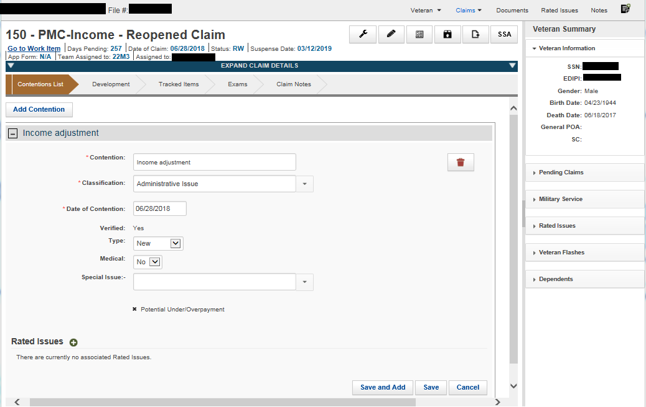
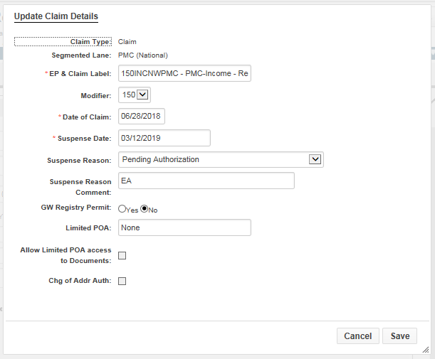
KC- Lesson Summary Review Questions

Time allowed: 15 minutes

PowerPoint Slides | Notes
What’s Next
Complete the End Product (EP) Codes course evaluation in TMS #4189359.

