Pension and fiduciary

PMC VSR Intermediate Core Course   
Phase 5: Proficiency Development   
Part 1(a): Types of Claims

VA Representation and Third Party Authorization

Trainee Guide

April 2024

VA Representation and Third-Party Authorization

Lesson Overview

| Topic | Description |
| --- | --- |
| Time Estimate: | 1 hour |
| Purpose of the Lesson: | This lesson is part of the entry-level curriculum, Core Course for PMC VSRs. The purpose of this lesson is to prepare you to recognize indicators of a POA and verify the POA. |
| Prerequisite Training Requirements: | Prior to taking the VA Representation and Third Party Authorization lesson, the trainee must complete PMC VSR Core Course Phases 1–4. |
| Target Audience: | This lesson is for entry level PMC VSRs. |
| Lesson References: | * VA Form 21-22 (Appointment of Veterans Service Organization as Claimant's Representative) * VA Form 21-22a (Appointment of Individual as Claimant's Representative) * VA Form 21-0845 (Authorization to Disclose Personal Information to a Third Party) * 38 CFR 1.600 (Purpose) * 38 CFR 1.601 (Qualification for Access) * 38 CFR 1.602 (Utilization of Access) * 38 CFR 1.603 (Disqualifications) * 38 CFR 3.103 (Procedural Due Process and Other Rights) * 38 CFR 14.630 (Authorization for a Particular Claim) * M21-1 I.i.2.A (General Information on Power of Attorney (POA)) * M21-1 I.i.2.B (A Representative’s Right to Notification and Review of Records) * M21-1 I.i.2.C. (System Updates for Power of Attorney (POA) Appointments) * M21-1 XIV.4.B.3.c. (Disclosure to POA) |
| Knowledge Check: | Phase 5.1(a): VA Representation and Third-Party Authorization Knowledge Check |
| Lesson Objectives: | By the end of this lesson, you will be able to:   * Understand a claimant’s right to representation * Define POA * Understand the types of POAs * Know the authority of the representative * Review the POA forms * Modify VBMS with correct POA information * Know the process for revoking and terminating representation * Understand the Third Party Authorization process |
| What You Need: | * Trainee guide * Access to VBA Intranet * Access to CPKM * Access to the SHARE * Access to VBMS * Access to the Assessment Portal |

| PowerPoint Slides | Notes |
| --- | --- |
| **VA Representation and Third Party Authorization** |  |
| **Objectives**  By the end of this lesson, you will be able to:   * Understand a claimant’s right to representation * Define POA * Understand the types of POAs * Know the authority of the representative * Review the POA forms * Modify VBMS with correct POA information. * Know the process for revoking and terminating representation * Understand the Third-Party Authorization process |  |
| **Why This Matters!**  All Claimants have the right to representation before the Department of Veterans Affairs in claims affecting the payment of benefits or relief. |  |
| **Definitions (1 of 2)**   * **VA representation** means that an individual has completed legal formalities to authorize a VSO, attorney, agent, or individual to perform functions on his or her behalf in business before the VA   + The term “power of attorney” (POA) refers to VA representation, unless otherwise specified. * A ***declaration of representation*** is the form a claimant uses to designate a person or organization as his or her representative for VA purposes. |  |
| **Definitions (2 of 2)**   * ***Unlimited representation*** means that the representative represents the claimant for all VA claims. * ***Limited representation*** means that the representation is for a specific claim or claims. * The term ***exclusive contact*** refers to sending communications with the claimant directly to a representative and generally ***not*** communicating directly with the claimant. * A represented individual who ends the relationship with his/her appointed representative at any time by expressly telling VA, is known as ***express revocation*** of the representative’s appointment. |  |
| **Appointment of a Representative for Incompetent Claimants**   * Until a fiduciary is appointed for a claimant in the process of being declared incompetent,accept the appointment of a representative from any of the following people in the following order   + claimant   + spouse   + mother or father, or   + next of kin * Once VA appoints a fiduciary, the fiduciary may appoint a new POA representative   + The prior representative is *not* automatically revoked |  |
| **Types of POAs**   * Accredited   + Service Organization Representative   + Claims Agent   + Attorney * Non-licensed   + Any individual   May represent a claimant on a one-time, on claim basis per the provisions of 38 CFR 14.630. |  |
| **Representative’s Authority (1 of 2)**   * Some responsibilities of a POA include: * Review the claimant’s records * Submit information, evidence, and argument on behalf of claimant * Authorize administrative changes on behalf of claimant (change of address, direct deposit) * Coordinate with VA on development matters such as the scheduling of a hearing or an examination * Prepare and submit forms and other procedural documents on behalf of the claimant * Withdraw a claim at any stage of adjudication |  |
| **Representative’s Authority (2 of 2)**   * A properly appointed representative has the authority to prepare and submit certain types of claims and claim-related documents on behalf of the claimant without the claimant’s signature such as:   + Request for an application for benefits   + Intent to File (ITF)   + Supplemental Claim   + Request for revision of a decision based on a clear and unmistakable error (CUE)   + Request for higher-level review (HLR)   + Legacy notice of disagreement (NOD), or   + Legacy substantive appeal |  |
| **Representative’s Authority: Limitations**   * A POA may prepare and submit, but may not sign, documents that require the claimant’s signature:   + Original applications   + Forms requiring claimant certification, such as eligibility verification reports   + VA Form 21-4142   + Various compensation related forms |  |
| **VA Forms for POAs**   * When reviewing a submitted VA Form 21-22 or VA Form 21-22a, take the following actions:   + Check the form for compliance regarding 38 U.S.C. 7332 and authorization for disclosure of protected records   + Check that the form is complete as described in M21-1 I.i.2.C.1.e.   + Process each copy of the properly completed and current form, and   + Update electronic systems to reflect the appointment |  |
| **VA Form 21-22** |  |
| **VA Form 21-22a** |  |

| PowerPoint Slides | Notes |
| --- | --- |
| **Incomplete Form**  If the VSO is: |  |
| **Current POA Status**  The POA status of a Veteran/claimant can be viewed in VBMS or SHARE. |  |

| PowerPoint Slides | Notes |
| --- | --- |
| **Updating POA Information**   * When a claimant appoints a new representative or revokes a current representative system updates are required in VBMS and VACOLS (if there is an active legacy appeal)   + Navigate to the Veteran’s profile and access the POA screen from the VETERAN drop-down menu   + Click the EDIT GENERAL POA button and make appropriate selections |  |
| **POA Codes**   * POA codes are shown by the corporate record as either alphanumeric codes or by the name of the organization. BIRLS shows the codes prefixed by a zero. * A list of POA codes can be found in M21-1 I.i.2.C.3.a. through g.   Practice:   1. What is the POA Code for Vietnam Veterans of America? 2. What is the Veterans Service Organization with a POA Code of 085? |  |
| **POA System Access**   * Under the provisions of 38 CFR 1.600 through 1.603 accredited attorneys and agents associated or employed by the same legal service office as the appointed representative of record to qualify for direct access to specific VA systems. * Remote access to specific VA systems will also be granted to non-accredited-administrative support staff assisting in the representation of a claimant before VA, including paralegals, law students and interns. |  |
| **Revoking and Terminating Representation (1 of 2)**   * Representation can end without specific action by the representative or represented individual   + Death * Represented party may:   + Appoint another representative   + Choose to explicitly terminate the relationship   The representative may choose to withdraw from representation |  |
| **Revoking and Terminating Representation (2 of 2)**   * When a claimant revokes or changes a representative, notice must be provided and there are required system updates.   + Updates in VBMS and VALCOS (if applicable)   + The electronic copy of the VA Form 21-22 or VA Form 21-22a must be edited to show that the POA status has been revoked.   + Actions to revoke POA M21-1 I.i.2.E.1.f.   + Notify the revoked representative |  |
| **Exclusive Contact**   * The term exclusive contact refers to sending communications with the claimant directly to a representative and generally not communicating directly with the claimant. * VA does not honor requests for exclusive contact to restrict the communication between VA and the claimant. * If you have a POA requesting exclusive contact, send the POA a letter with the verbiage found in M21-1 I.i.2.A.5.b. |  |
| **Disclose Records Protected by 38 USC 7332 (1 of 2)**   * The claimant must specifically authorize consent VA to disclose records to the claimant's representative that relate to conditions protected under the provisions of [38 U.S.C. 7332](http://www.law.cornell.edu/uscode/text/38/7332), namely   + drug abuse   + alcoholism or alcohol abuse   + infection with the human immunodeficiency virus (HIV), or   + sickle cell anemia * The claimant may authorize disclosure of all protected records, or limit disclosure to *one or more* categories of protected records. |  |
| **Disclose Records Protected by 38 USC 7332 (2 of 2)**   * When a claimant has completed a [38 U.S.C. 7332](https://www.law.cornell.edu/uscode/text/38/7332) authorization in connection with appointment of a representative using [*VA Form 21-22*](http://www.vba.va.gov/pubs/forms/VBA-21-22-ARE.pdf) or [*VA Form 21-22a*](http://www.vba.va.gov/pubs/forms/VBA-21-22a-ARE.pdf), the authorization remains in effect until the *earliest* of the following:   + the claimant revokes the [38 U.S.C. 7332](https://www.law.cornell.edu/uscode/text/38/7332) authorization by filing a written revocation with VA   + the claimant revokes the representative’s appointment explicitly, or   + the claimant implicitly revokes the representative’s appointment by appointing another representative |  |
| **POA Access to Federal Tax Information (FTI)**   * VA may disclose tax return information to an individual or a VSO designated by the individual that the tax information pertains to * For FTI purposes, the assignment of a VSO as POA is restricted to five years from the date the *VA Form 21-22,* is signed.   + If the beneficiary and his/her spouse are both income recipients for the same tax year match, each must execute a separate POA.   + If IVM development action appears necessary and the date the [*VA Form 21-22*](http://vbaw.vba.va.gov/bl/20/cio/20s5/forms/VBA-21-22-ARE.pdf) was signed exceeds five years, or will likely exceed five years before the FTI action is completed, then forward the claimant a new [*VA Form 21-22*](http://vbaw.vba.va.gov/bl/20/cio/20s5/forms/VBA-21-22-ARE.pdf) to complete. |  |
| **Representation Upon Death of Survivor**   * Representation based on a POA signed by the claimant during his/her lifetime ends with the death of the claimant and does not extend to any survivors.   + In order for the same representative to represent a survivor, the survivor must execute a separate POA. |  |
| **Third Party Authorization**   * National Call Center and RO employees are allowed to release specified information normally protected under privacy provisions to family members or other designated persons who are not POAs, agents, or fiduciaries. * A substantially complete VA Form 21-0845, Authorization to Disclose Personal Information to a Third Party must be completed and signed |  |
| **Third Party Authorization**   * VA Form 21-0845 must contain or meet the following criteria to be substantially complete:   + the signature of the individual whose information is being released and the date the form is signed   + the name and claims number of the Veteran/claimant   + the contact information the type of information authorized for release   + the length of time authorization is valid, if applicable   + a security question and answer   + the form date stamped by the VA   + the form designates only one person or organization, and   + if the individual has a court-ordered or VA-appointed fiduciary, the signature of the fiduciary. |  |
| **Knowledge Check: Lesson Summary Review Questions**    **Time Allowed: 10 minutes** |  |
| **What’s Next?**  Complete VA Representation and Third-Party Authorization course evaluation: **TMS ID #4189357** |  |

­­­­­­­­­­­­­­­­­__________________________________________________________________

**Appendix**

**VA Form 21-22 (Page 1)**

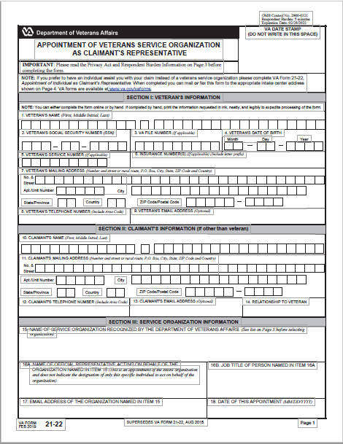

**VA Form 21-22 (Page 2)**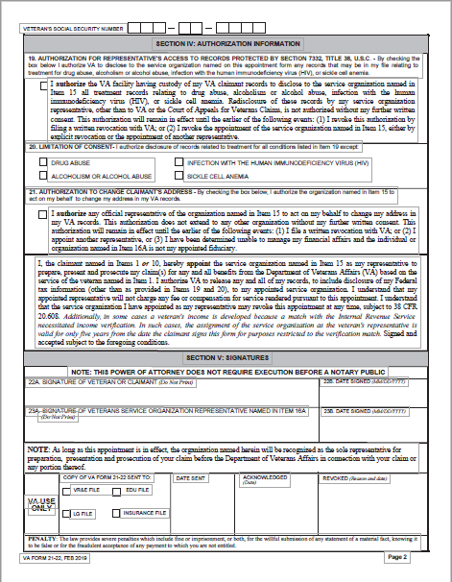

**VA Form 21-22a (Page 1)**

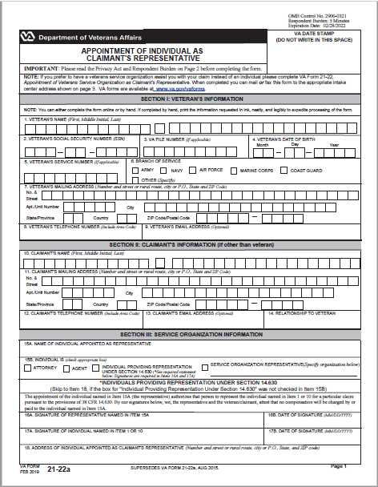

**VA Form 21-22a (Page 2)**

