Pension and fiduciary service

PMC VSR Basic Core Course Phase 4 Foundational Enrichment

Date of Claim

Trainee Guide

December 2024

Date of Claim

Lesson Overview

| Topic | Description |
| --- | --- |
| Time Estimate: | 1 hour |
| Purpose of the Lesson: | This lesson is part of the entry-level curriculum, Core Course for PMC VSRs. The purpose of this lesson is to show you how to confirm whether the date of claim established by the claims assistant is correct. |
| Prerequisite Training Requirements: | Prior to taking the Date of Claim lesson, trainees must complete PMC VSR Core Course Phases 1–3. |
| Target Audience: | This lesson is for entry level PMC VSRs. |
| Lesson References: | * Compensation and Pension Knowledge Management (CPKM) * M21-1 II.i.2.B (Recording the Date of Receipt and Handling Signatures and Outdated Forms) * M21-1 II.i.2.C.2 (Handling Incoming Mail) * M21-1 II.i.2.C.3. (Handling Miscellaneous Mail) * M21-4 Appendix B (End Product (EP) Codes) * M21-4 Appendix B.1.c (Correct Date of Claim) |
| Technical Competencies: | * Program Benefits and Eligibility (PMC VSR) * Processing Claims (PMC VSR) * VBA Applications (PMC VSR) |
| Knowledge Check: | Phase 4: Date of Claim Knowledge Check |
| Lesson Objectives: | At the end of this training, you should be able to:   * Confirm Date of Claim (DOC) is correct * Define a DOC * Identify the date of receipt * Recognize exceptions to DOC * Determine if the DOC is correct in the systems |
| What You Need: | * Trainee Guide * Access to VBA Intranet * Access to CPKM |

| PowerPoint Slides | ****Notes**** |
| --- | --- |
| **Date of Claim** |  |
| Lesson Objectives  By the end of this lesson, you should be able to:   * Confirm Date of Claim (DOC) is correct. * Define a DOC * Identify the date of receipt * Recognize exceptions to DOC * Determine if DOC is correct in the systems |  |
| Why This Matters!  The **Date of Claim** course matters because the effective date of an evaluation and award of pension or DIC based on an initial claim or supplemental claim is based on the date of receipt of the claim or the date entitlement arose. |  |
| **Definition: What Is a DOC?**  For claims establishment purposes, **DOC** is the earliest date any VA facility received the claim  **Note:** There might be several dates, make sure to locate and use the earliest possible one. |  |
| **Definition: Digital Signatures**   * A ***digital signature*** is an encrypted digital code appended to an electronic document to verify that the document was created by a known source and has not been altered. * An ***electronic signature*** is a signature, or its equivalent, that is affixed to an electronic document. |  |

| PowerPoint Slides | ****Notes**** |
| --- | --- |
| **DOC and VA Facilities**   * **Facilities approved to provide a DOC on documentation:**    + Regional Office (RO)   + Veterans Affairs Medical Center (VAMC)   + Records Management Center (RMC)   + Contracted scanning vendor * **Facilities where the date stamp is NOT considered the official VA date stamp for DOC purposes:**   + Veterans Service Organizations (VSOs)   Two date stamps. Starting from the top is the correct date stamp from a VA regional office with a checkmark next to the date stamp. The bottom is a date stamped from a VSO which is not an approved date stamp. Next to the date stamp is an x. |  |

| PowerPoint Slides | ****Notes**** |
| --- | --- |
| **Claim Documentation**  Claim documentation is received by:   * **Mail** * **Electronic forms** * **Scanning vendors** * **Veteran Online Applications (VONAPPs)** * **Phone or facsimiles using:**   + **VA Form 27-0820** |  |
| **Date Stamped**   * Each document submitted to VA *must* receive a stamp with the date of receipt. * Identify the proper DOC |  |
| **Examples of VA Date of Receipt Stamps** |  |

| PowerPoint Slides | ****Notes**** |
| --- | --- |
| **Document Without a Date Stamp (1 of 2)**   * If the receipt of the document by VA is determined to be the current date, stamp the document with an official date stamp * If the receipt of the document by VA is determined to be prior to the current date, hand-write the date of receipt on the document * If the receipt of the document by VA is determined to be unknown:   + Hand-write the best estimate for the date of receipt   + Identify it as an estimate on the document |  |
| **Document Without Date Stamp (2 of 2)**  Examples of claim documentation without a date stamp:   * When a phone call is received by a beneficiary/claimant, POA, or other third party and noted on VA Form 27-0820, then the DOC is the date the phone call was received. * When a document is scanned by a vendor, then the date scanned is the DOC. |  |
| **Centralized Mail Portal Date Stamp**  Date of receipt for mail routed through the CM portal is determined by the *earliest* official date   * Stamped by the RO upon receipt and prior to forwarding to the scanning vendor * Applied to the converted image by the scanning vendor for mail it received directly or * Found on documents such as VA Form 27-0820. |  |
| **DOC Example**  **Example:** E-mails received at VA facilities are uploaded to VBMS as Portable Document Format (PDF) documents. The sent date on the saved document represents the date received; therefore, the sent date will be used as the DOC.  Example E-mail with sent date circled as the DOC. |  |

|  |  |
| --- | --- |
| PowerPoint Slides | ****Notes**** |
| **DOC Exceptions**     * If Pre-Discharge claim then use a future DOC (the day after the anticipated date of separation from service * If prematurely cleared or closed a pending EP then use the DOC of the EP that was prematurely cleared * If 800 series work items then use the date of the write-out for the controlling end product of the 800 Series WI * If a PACT Act related claim in some cases when pending on the date the PACT Act became law, August 10, 2022, both a pre-PACT Act and a PACT Act provision will apply. |  |

|  |  |
| --- | --- |
| PowerPoint Slides | ****Notes**** |
| **DOC in VBA Application**  **Side by side comparison of VA Form 21-527EZ with DOC of 09/04/15 circled and SHARE claim status screen with claim date of 09/04/2015 circled.** |  |
| **DOC in VBA Application** |  |
| **VBMS Notes**  To document information or recent actions taken on a claim, users may add a note from any screen in VBMS that displays the ADD NOTE icon.   * A permanent, claim associated note in VBMS is required to document the rationale for changing the DOC on an EP |  |

|  |  |
| --- | --- |
| **DOC for Previously Rejected Signatures**   * If the request for review is received within one year of the date of receipt of the rejected claim, consider the request for review as sufficient evidence to complete the prior incomplete claim. * Review the prior claim as if it was properly signed at the time and   + establish the proper end product (EP) control based on the type of claim with a date of claim corresponding with the date of receiptof the request for review, and   + award any associated benefits based on the date of receipt of the previously-rejected claim * If the request was not received within one year of the date of receipt of the rejected claim, no revision or reconsideration of prior actions to reject a signature should be made.   A complete, signed claim on a prescribed claim form must be submitted. |  |

| PowerPoint Slides | Notes |
| --- | --- |
| **Knowledge Check: Lesson Summary Review**    **Time Allowed: 10 minutes** |  |
| **What’s Next**   * Complete the Date of Claim course evaluation using **TMS ID: #4189354** |  |

Appendix

**Definition: What is a Date of Claim (DOC)?**

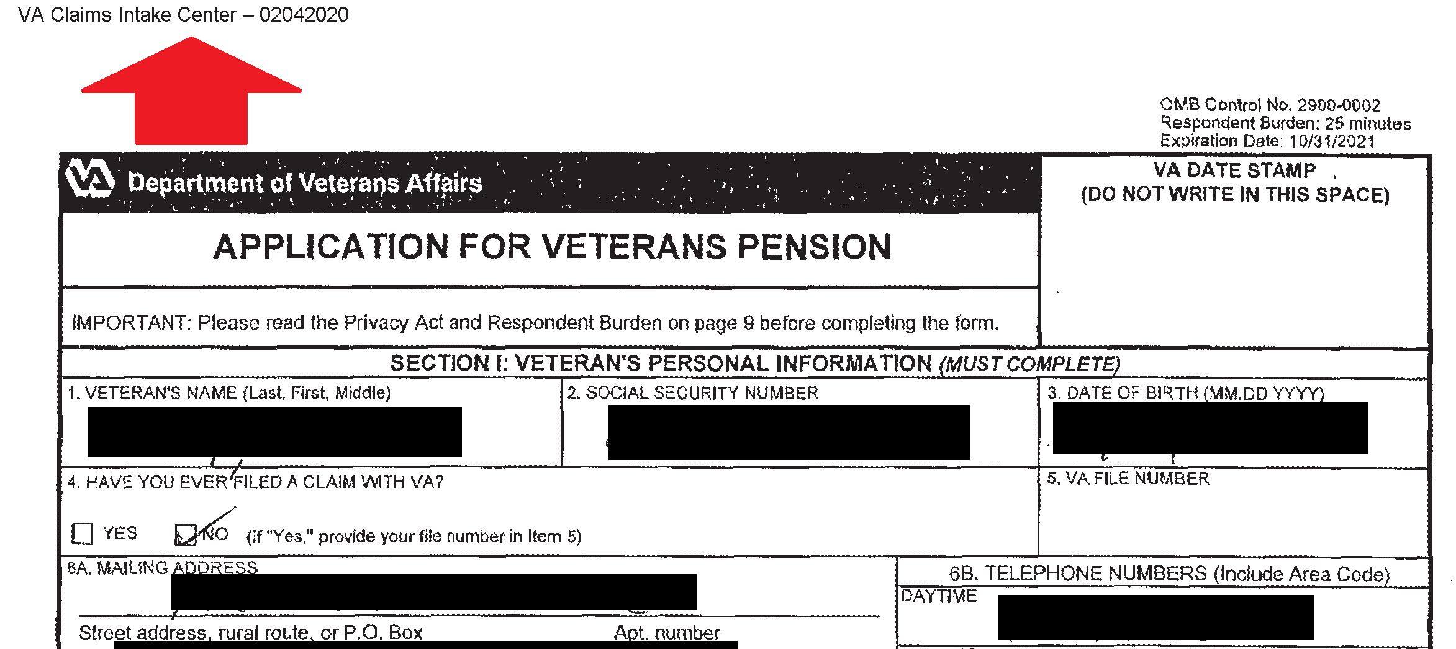

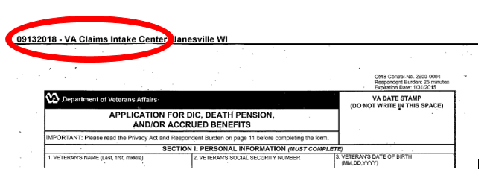

**DOC and VA Facilities**

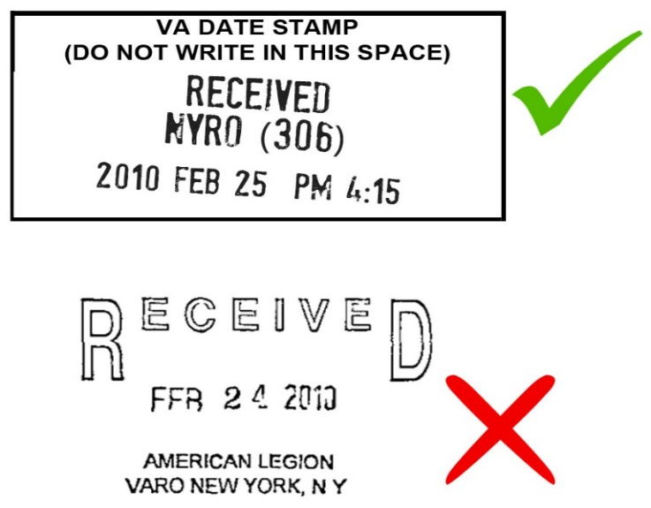

**Date Stamped**

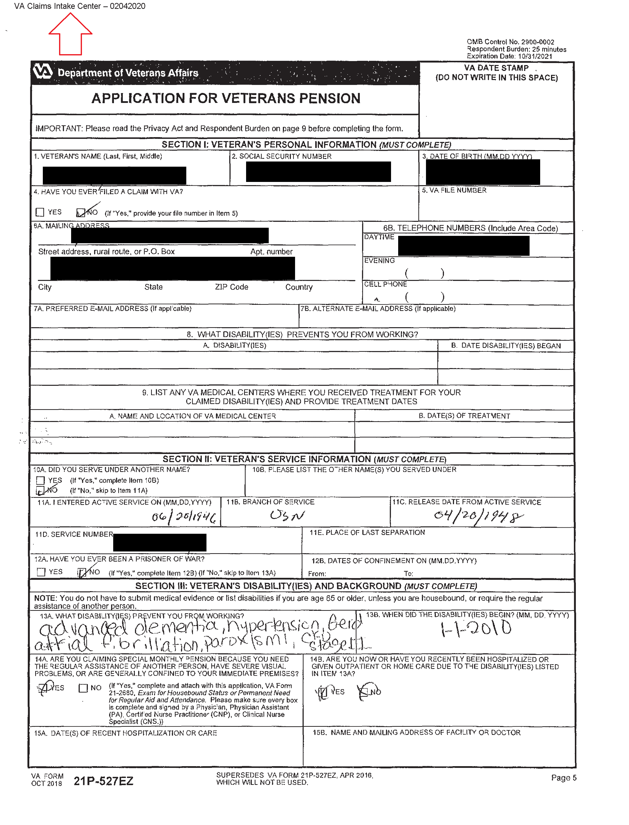

**Examples of VA Date of Receipt Stamps**

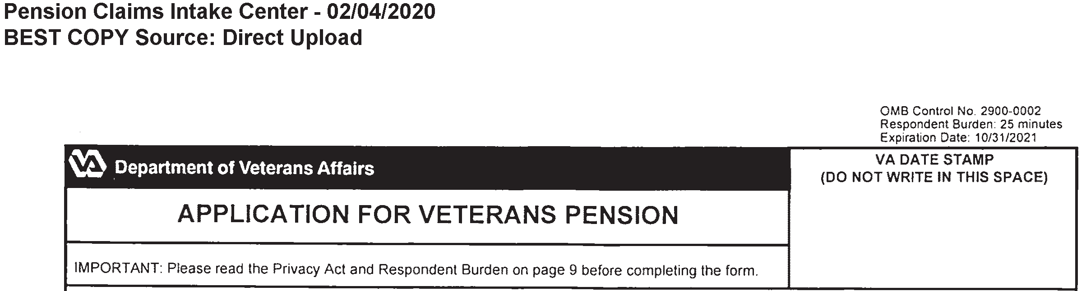

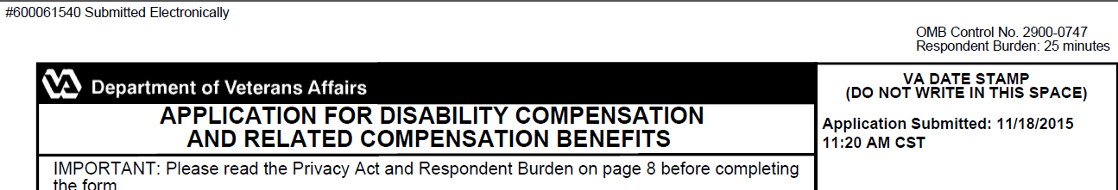

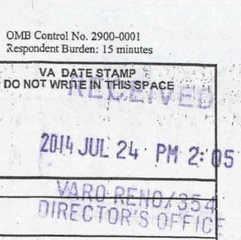 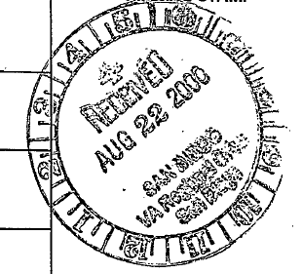

**DOC Example:**

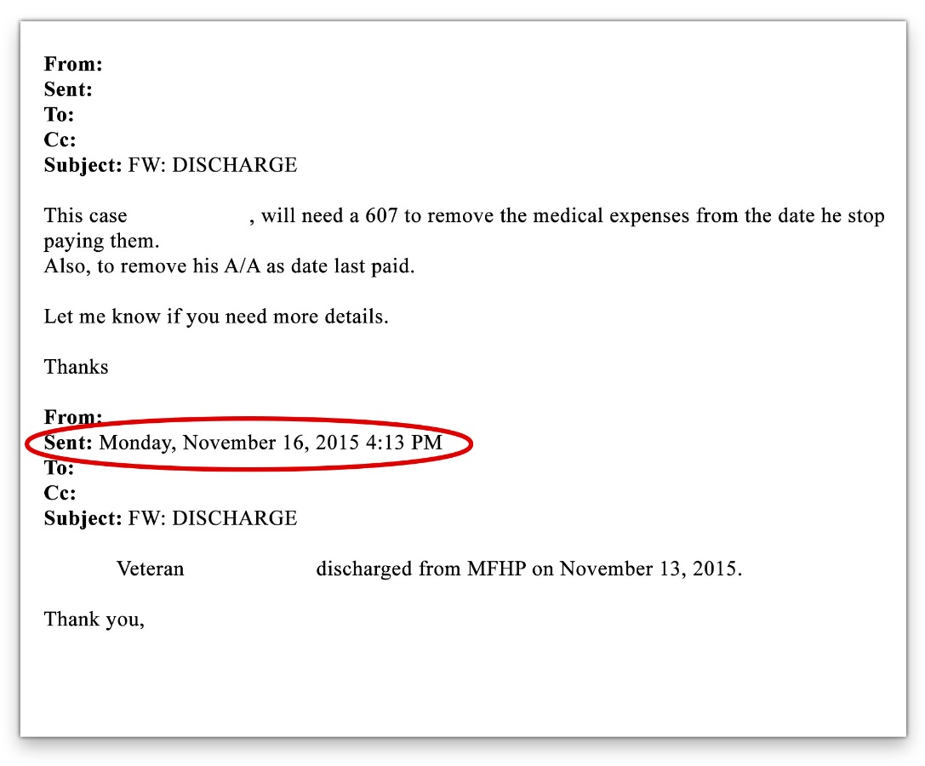

**DOC in VBA Applications**

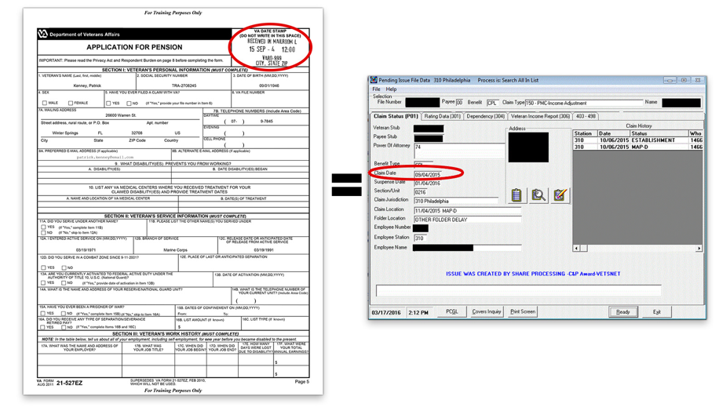

**DOC in VBA Applications**

