Pension and fiduciary service
PMC VSR Intermediate Core Course
Phase 5: Proficiency Development
Part 1(a): Types of Claims
Types of Claims and Priority Processing
Trainee Guide
May 2024

Types of Claims and Priority Processing

Lesson Overview
Topic | Description
Time Estimate: | 1.5 hours
Purpose of the Lesson: | This lesson is part of the entry-level curriculum, Core Course for PMC VSRs. The purpose of this lesson is to prepare PMC VSRs to identify claim types and reasons for priority processing.
Prerequisite Training Requirements: | Prior to taking this lesson, trainees must complete PMC VSR Core Course Phases 1–4.
Target Audience: | This lesson is for entry level PMC VSRs.
Lesson References: | - 38 CFR 1.710 (Homeless Claimants: Delivery of Benefit Payments and Correspondence)  - 38 CFR 3.156 (New and Material Evidence)  - 38 CFR 3.160 (Status of Claims)  - 38 CFR 3.2500 (Review of Decisions)  - 38 CFR 3.2501 (Supplemental Claims)  - M21-1 X.i.1.1.a. (Types of Claims That Require Priority Processing)  - M21-1 X.i.1.1.d. (Use of VA Form 20-10207)  - M21-1 XIII.i.6 (Medal of Honor Pension (MOHP)  - M21-4 Appendix B (End Product Codes)  - M21-4 Appendix C (Index of Claim Labels)
Lesson Objectives: | By the end of this lesson, you will be able to:  - Confirm the special claim types  - Identify various types of claims  - Identify claims that require priority processing
Knowledge Check: | Phase 5.1(a) Types of Claims and Priority Processing Knowledge Check
What You Need: | - Trainee Guide  - Slides  - Access to VBA Intranet  - Pen and paper or access to a whiteboard  - Access to the following systems:  - SHARE  - MAP-D  - VBMS

PowerPoint Slides | Notes
Types of Claims and Priority Processing
Lesson Objectives
By the end of this lesson, you will be able to:
- Confirm the special claim types
- Identify various types of claims
- Identify claims that require priority processing
Why This Matters!
- This course matters because it introduces various types of claims and priority processing, as field offices are required to prioritize claims for beneficiaries experiencing extreme financial hardship or are terminally ill.
Definitions (1 of 2)
- A serious illness or injury is defined as a disability that occurred as a result of participation in a military operation and will likely result in discharge from military service.
- A former prisoner of war (FPOW) is defined as a person who, while serving in the active military, naval, or air service, was forcibly detained or interned in the line of duty by
  - an enemy government or its agents, or a hostile force, during a period of war, or
  - a foreign government or its agents, or a hostile force, under circumstances which the Secretary finds to have been comparable to the circumstances under which persons have generally been forcibly detained or interned by enemy governments during periods of war
Definitions (2 of 2)
- Imminent risk of homelessness refers to a Veteran will imminently lose his or her primary nighttime residence, including owned, rented, or free permanent housing, shared housing, and hotel or motel rooms not paid for by federal, state, or local government programs for low-income individuals or charitable organizations.
- Medal of Honor Pension (MOHP) is a monthly entitlement paid to Veterans or service members who were awarded the Medal of Honor for distinguished military service.
Claims That Require Priority Processing (1 of 3)
- The types of claims that require priority processing claims from any claimant who is
  - homeless
  - terminally ill, or
- a survivor of a former prisoner of war (FPOW)
  - disability compensation claims from any claimant who is experiencing extreme financial hardship,
  - claimants more than 85 years old
Claims That Require Priority Processing (2 of 3)
The types of claims that require priority processing:
- Claims from any current or former member of the Armed Forces who
  - became very seriously ill or injured/seriously ill or injured (VSI/SI) during service and is not already receiving Department of Veterans Affairs (VA) disability benefits
  - is diagnosed with Amyotrophic Lateral Sclerosis (ALS) or Lou Gehrig's Disease
  - is an FPOW, or
  - received the Medal of Honor

PowerPoint Slides | Notes
Claims That Require Priority Processing (3 of 3)
The types of claims that require priority processing:
- Claims from any current or former member of the Armed Forces or a claimant whose claim is based on the death of a service member or former service member who received the Purple Heart:
  - original compensation or pension claims, or
  - an original claim for Dependency and Indemnity Compensation (DIC)
Demonstration: VA Form 20-10207

Note to trainee: This form can be used but is not a requirement for requesting priority processing.
Handling VSI/SI Claims
- Duties of the VSI/SI Coordinator include, but are not limited to,
  - ensuring the Seriously Injured/Very Seriously Injured corporate flash is appended to the claimant’s record
  - acting as a liaison with VA medical facilities, military facilities, and other RO divisions, and
  - acting as a direct point of contact for VSI/SI claimants and their dependents
Prioritizing Processing for Medal of Honor (MOH) or Purple Heart
- Priority processing is required for all claims for Veterans or service members who have earned the Medal of Honor original compensation or pension claims for a Veteran or service member who earned the Purple Heart, and original
  - DIC claims based on the death of a Veteran or service member who earned the Purple Heart
Add the Medal of Honor or Purple Heart flash (when it is not already present) when a claim is received from a Veteran, service member, or survivor and receipt of the Purple Heart or Medal of Honor is documented
Prioritizing Processing for Medal of Honor Pension (MOHP)
- MOHP entitlement is independent of entitlement to any other benefits, and does not require service connection or even a disability
  - Veterans or service members are not denied entitlement to any other pension, compensation, or other benefit
Not based on income and net worth
Prioritizing Processing for MOHP – Surviving Spouse
- MOHP for a surviving spouse is a monthly entitlement paid to a surviving spouse of a Medal of Honor recipient.
MOHP for a surviving spouse may be independent of entitlement to any other benefits and does not require service connection for the Medal of Honor recipient’s cause of death or deprive the surviving spouse of entitlement to any other pension, compensation, or other benefit
Claims of Extreme Financial Hardship
- If a claimant states that they are experiencing extreme financial hardship and submits documentation to support the assertion, accept the claimant’s statement as factual.
- Documentation to support the assertion of extreme financial hardship includes, but is not limited to,
  - an eviction notice or statement of foreclosure
  - notices of past-due utility bills, and/or
- collection notices from creditors
Homeless Claims
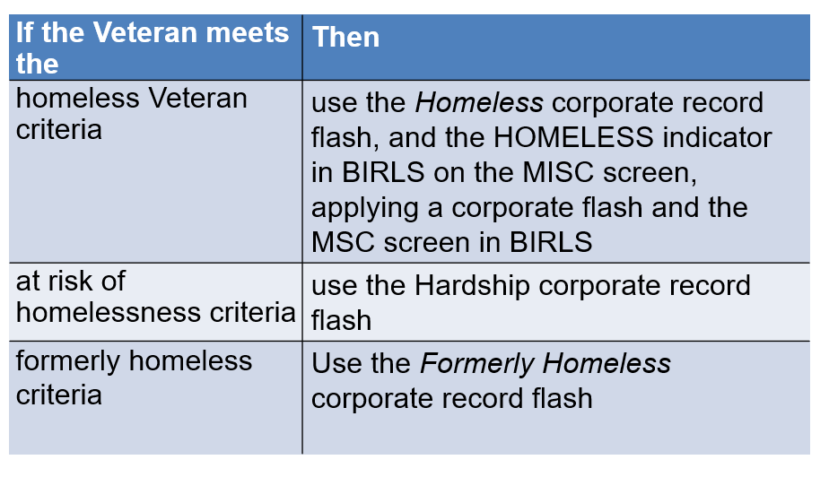
Prioritization of Terminally Ill Claims
- When priority processing of a claim based on terminal illness is warranted, and the claimant has a paper claim folder:
  - attach a paper flash to the front of the claims folder that reads Process Next – Terminal Illness, and include the Terminally Ill flash to the corporate record using Share
- When priority processing of a claim based on terminal illness is warranted, and the claimant has an eFolder only
  - add the Terminally Ill flash to the corporate record using Share and change the claim priority in the VBMS to High

PowerPoint Slides | Notes
Former Prisoner of War (FPOW)
- FPOW claims require priority processing.
- Add the POW flash (when it is not already present) when a claim is received from a
  - Veteran or survivor who claims FPOW status, or
- Veteran whose FPOW status has been previously verified, or the Veteran’s survivor
Types of Claims
- As a VSR, you will review the following types of claims:
  - Initial claims
  - Supplemental claims
  - Higher-level reviews (HLRs)
  - Intent to File (ITF)
    - applies to claims for pension, Survivors Pension, and DIC
Initial Claims
- An initial claim is a substantially complete claim for a benefit, other than a supplemental claim, on an application form prescribed by the Secretary, including:
  - the first filing by a claimant (original claim), and
  - a subsequent claim filed by a claimant for an increase in a disability evaluation a new benefit, or
a new disability
Supplemental Claims
- A supplemental claim is any complete claim for a VA benefit on a prescribed application form where the claimant or his/her authorized representative disagrees with the decision VA made on an initial or supplemental claim for the same or similar benefit on the same or similar basis.
  - A supplemental claim can be submitted at any time
  - Claimants may file a supplemental claim on a decision issued before February 19, 2019, the date of implementation of the Appeals Modernization Act
  - Supplemental claims must be submitted on the prescribed supplemental claim form, VA Form 20-0995, Decision Review Request: Supplemental Claim
Claims for Increase
- A claim for increase is a type of initial claim that requests an increase in a disability evaluation or rate of a benefit being paid based on a change or worsening in condition or circumstance since the last decision issued by the VA for the benefit
- Claims for increase may include:
  - increased non-service-connected (NSC) pension including a claim
    - showing either a reduction of, or a deduction from, income, and
    - for entitlement to special monthly pension (SMP)
Higher-Level Reviews
- Higher-level reviews (HLRs) consist of de novo reviews of the issue(s) identified by requesters on a completed VA Form 20-0996, Decision Review Request: Higher-Level Review
- De novo review means the reviewer reexamines and readjudicates the claim in question without deference to the prior decision, except for proper favorable findings
- VA must receive the completed VA Form 20-0996 within one year of the notification letter for a decision made on or after February 19, 2019
  - If not timely received, inform the claimant using letter HLR Not Timely
Intent to File (ITF) – (1 of 2)
- On March 24, 2015, 38 CFR 3.155 was revised to include procedures for a claimant to indicate a desire to file a claim via submission of an ITF.
- Claimants desiring the benefit of filing an informal claim must now communicate to VA an ITF a claim by:
  - submitting a completed VA Form 21-0966, Intent to File a Claim for Compensation and/or Pension, or Survivors Pension and/or DIC
  - contacting a national call center at 1-800-827-1000
  - initiating an application for benefits via a VA claims submission service website, or
  - contacting a Veterans Service Center (VSC)/pension management center (PMC) employee by telephone or in person
  - provides VA with enough information to identify the Veteran (and the claimant, if the claimant is not the Veteran), and
  - specifies the general benefit they are seeking (pension, or Survivors Pension and/or DIC)
What is New and Material Evidence?
- New evidence is evidence not previously part of the actual record before agency adjudicators.
- Material evidence means existing evidence that, by itself or when considered with previous evidence of record, relates to an unestablished fact necessary to substantiate the claim.
- New and material evidence can be neither cumulative nor redundant of the evidence of record at the time of the last prior final denial of the claim sought to be reopened, and must raise a reasonable possibility of substantiating the claim.
Knowledge Check: Lesson Summary Review Questions

Time Allowed: 10 minutes
What’s Next
- Complete Types of Claims and Priority Processing evaluation course: TMS ID #4189352

