Pension and fiduciary Service
PMC VSR Intermediate Core Course Phase 5: Proficiency Development
Part 1(a): Types of Claims
Fully Developed Claims (FDCs)
Trainee Guide
April 2024

Fully Developed Claims (FDCs)

Lesson Overview
Topic | Description
Time Estimate: | 2 hours
Purpose of the Lesson: | This lesson is part of the entry-level curriculum, Core Course for PMC VSRs. The purpose of this lesson is to prepare you to recognize FDCs and determine if information received is sufficient.
Prerequisite Training Requirements: | Prior to taking the Fully Developed Claims (FDCs) lesson, you must complete PMC VSR Core Course Phases 1–4.
Target Audience: | This lesson is for entry level PMC VSRs.
Lesson References: | - Compensation and Pension Knowledge Management (CPKM)  - M21-1 X.i.2.A (General Information About the Fully Developed Claim (FDC) Program)  - M21-1 X.i.2.B.2. (Excluding Claims From the FDC Program)  - M21-1 X.i.2.B.3. (Development the Department of Veterans Affairs (VA) Undertakes in Connection with FDCs)  - M21-1 X.i.2.B.3.a. (Limitations on the Development of FDCs)  - VA Form 21P-527EZ (Application for Pension)  - VA Form 21P-534EZ (Application for DIC, Death Pension, and/or Accrued Benefits)
Technical Competencies: | - Program Benefits and Eligibility (PMC VSR)  - Processing Claims (PMC VSR)
Knowledge Check | Phase 5.1(a): Fully Developed Claims Knowledge Check
Lesson Objectives: | By the end of this lesson, you will be able to:  - Determine if claim can be processed as an FDC  - Determine if a claim meets FDC criteria for Veterans non-service-Connected Pension Benefits  - Determine if a claim meets FDC criteria for DIC, survivors’ pension, and/or accrued benefits  - Determine under what circumstances a claim needing development can remain in FDC program  - Determine to exclude a claim from FDC program
What You Need: | - Trainee Guide  - Access to VBA Intranet  - Access to CPKM  - Appendix A worksheet  - Access to the Assessment Portal

PowerPoint Slides | Notes
Fully Developed Claims (FDCs)
Objectives
By the end of this lesson, you will be able to:
- Determine if a claim can be processed as an FDC.
- Determine if a claim meets FDC criteria for Veterans non-service-connected pension benefits.
- Determine if a claim meets FDC criteria for DIC, survivors’ pension, and/or accrued benefits.
- Determine under what circumstances a claim needing development can remain in FDC program.
- Determine to exclude a claim from FDC program.
Why This Matters!
The Fully Developed Claims (FDC) course is important because the Department of Veterans Affairs (VA) designed the FDC Program for the purpose of reducing its backlog of pending claims and improving claims-processing timeliness.
Although VA no longer prioritizes FDC Claims, claimants can participate in the FDC program by providing claims with supporting documentation that are ready for processing according to VA prescribed application forms.
Icebreaker Activity
- On November 5, 2021, the Milwaukee PMC received a VA Form 21P-527, Income, Net Worth and Employment Statement, for Dwight Veteran. Mr. Veteran lives in Green Bay, WI, which is within the PMC’s jurisdiction. Mr. Veteran can be properly identified in SHARE. All the information on the application has been completed and the form has been signed.
FDC Forms
- VA Form 21P-527EZ (Application for Pension)
- VA Form 21P-534EZ (Application for DIC, Death Pension, and/or Accrued Benefits)
Evidence Required for FDC Application for Pension
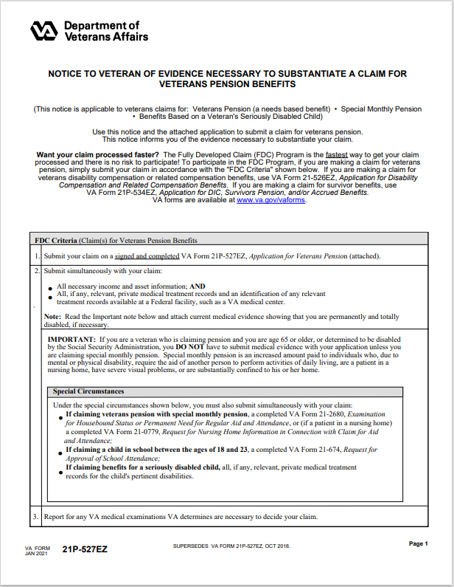

PowerPoint Slides | Notes
Evidence Required for FDC Application for DIC, Survivors Pension, and/or Accrued Benefits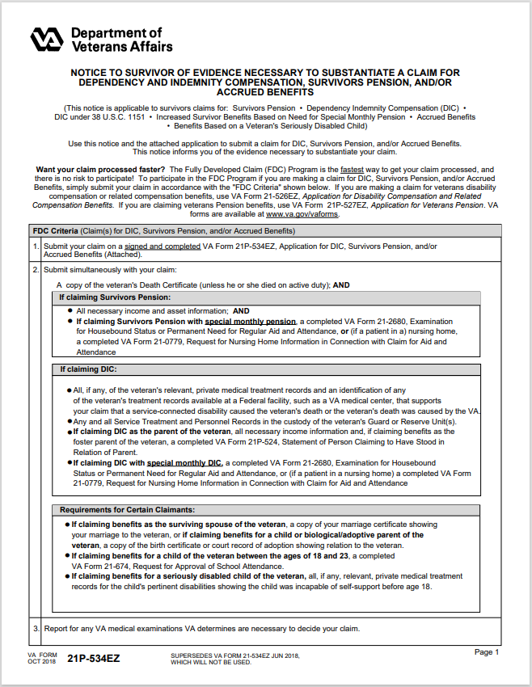

PowerPoint Slides | Notes
Processing FDCs: Exclusions
- M21-1 X.i.2.B.2 (Excluding Claims From the FDC Program)
Processing FDCs: Development
- M21-1 X.i.2.B.3 (Development the Department of Veterans Affairs (VA) Undertakes in Connection with FDCs)
Quiz: Develop or Exclude?
- Instructions:
- Access the Appendix A – FDC worksheet (Quiz: Develop or Exclude)
- Work independently to complete the quiz
- For each scenario in the Quiz: Develop or Exclude section, assume a complete application on the correct FDC application form, writing a D for develop, to allow the claim to remain in the FDC program, or an E to exclude the claim from the FDC program because additional development is required.
- Refer to M21-1 X.i.2.B
- Time allowed: 10 minutes

PowerPoint Slides | Notes
Practice Exercise—FDCs
- Instructions:
  - Divide into two groups.
  - Each group will receive claim information:
    - Group 1: Claim 1
    - Group 2: Claim 2
  - Complete Appendix A FDCs worksheet
  - Use M21-1 X.i.2.A.1 (Overview of the FDC Program) and the instruction pages on the application form to answer the questions in the worksheet
- Time allowed: 30 minutes

PowerPoint Slides | Notes
Knowledge Check: Lesson Summary Review Questions
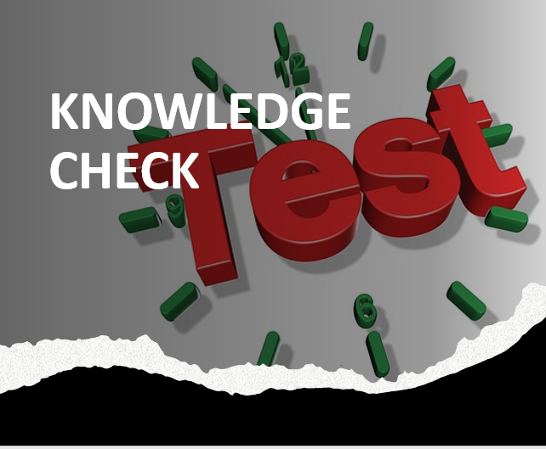
Time Allowed: 10 minutes
What’s Next
- Complete the Fully Developed Claims course evaluation in TMS ID #4189349

