Pension and fiduciary service
PMC VSR Basic Core Course
Phase 4: Foundational Enrichment
Initial Screening Policies for Applications
Trainee Guide

May 2024

Initial Screening Policies for Applications

Lesson Overview
Topic | Description
Time Estimate: | 1 hour
Purpose of the Lesson: | This lesson is part of the entry-level curriculum, Core Course for PMC VSRs. The purpose of this lesson is to prepare PMC VSRs to understand the initial screening policies that must occur when reviewing applications for benefits.
Prerequisite Training Requirements: | Prior to taking the Initial Screening Policies for Applications lesson, trainees must complete PMC VSR Course Phases 1–3.
Target Audience: | This lesson is for entry level PMC VSRs.
Lesson References: | - Compensation and Pension Knowledge Management (CPKM)  - 38 CFR 3.159 (Department of Veterans Affairs assistance in developing claims)  - 38 CFR 3.2130 (Will VA Accept a Signature by Mark or Thumbprint?)  - M21-1 III.i.2.B (Duty to Notify Under 38 U.S.C.5103)  - M21-1 I.i.2.A.4.b (Representative’s Authority to Submit Claims and Other Claim-Related Documents)  - M21-1 II.i.2.A. (Process Overview for Screening Mail)  - M21-1 II.iii.1.A. (Applications for Benefits)  - M21-1 II.iii.2.H.1. (Informal Claims Received Prior to March 24, 2015)
Technical Competencies: | - Program Benefits and Eligibility (PMC VSR)
Knowledge Check | Phase 4: Initial Screening Policies for Applications Knowledge Check
Lesson Objectives: | By the end of this lesson, you will be able to:  - Identify the characteristics of a substantially complete application  - Define the signature requirements for claimants  - Explain concept of prescribed forms  - Recognize outdated and discontinued forms and explain the process alerting claimants  - Define what classifies as an incomplete claim  - Explain the historic concept of informal claims  - Recognize the requirements for an Intent to File  - Recognize the requirements for a Request for Application (RFA)
What You Need: | - Trainee guide  - Access to VBA Intranet  - Access to CPKM

PowerPoint Slides | Notes
Initial Screening Policies for Applications

Lesson Objectives
By the end of this lesson, you will be able to:
- Identify the characteristics of a substantially complete application
- Define the signature requirements for claimants
- Explain concept of prescribed forms
- Recognize outdated and discontinued forms and explain the process alerting claimants
Lesson Objectives
- Define what classifies as an incomplete claim
- Explain the historic concept of informal claims
- Recognize the requirements for an Intent to File
- Recognize the requirements for a Request for Application (RFA)
Why This Matters!
- The Initial Screening Policies for Applications course is important because initial mail screening permits a review of all incoming applications, correspondence, and evidence to determine if a claim,
- warrants priority processing because of its nature or facts
- is submitted with evidence that requires review by the rating activity
- is incomplete and requires further development, or
- warrants denial
Definition: Substantially Complete Application
Upon receipt of an application for benefits, VA must determine if it is substantially complete. This includes:
- The claimant’s name
- His/her relationship to the Veteran
- Sufficient service information
- The benefit sought
- The claimant’s signature
- A statement of income for applicable claims
- Identification or inclusion of new evidence in supplemental clams
- For Higher Level Reviews, identification of the date of decision
Informal Claims
- Prior to March 24, 2015, VA accepted informal claims
- Any communication or action that showed an intent to apply for benefits
  - An original claim not filed on the prescribed form
  - An unsigned application
- Informal claims were important because they served as an effective date placeholder, if VA received a substantially complete claim within one year of the date VA notified the claimant one was needed

PowerPoint Slides | Notes
Signature Requirements
- Signature by the claimant
  - Thumbprint or “X” is acceptable in certain circumstances
  - Faxed and photocopied signatures are acceptable
  - Digital or electronic signatures are acceptable
- POA representative may prepare and submit certain types of claims and claim-related documents
- Alternate Signatures are acceptable for certain individual claimants
  - Alternate signature must have appropriate credentials
Prescribed Forms
- VA will only recognize claims if they are submitted on the required standard forms.
- Example of prescribed forms:
  - Veterans Pension (initial) – VA Form 21P-527EZ
  - Survivors Pension (initial) – VA Form 21P-534EZ
  - Burial benefits (initial)- VA Form 21P-530EZ
  - Income Adjustments (increase) – EVRs or 21P-8416
  - Housebound Status or Permanent Need for Regular Aid and Attendance - VA Form 21-2680
  - Medicaid Adjustments/SMP - VA Form 21-0779
Outdated Forms
- A form becomes outdated when a newer version of the form is released.
- Outdated versions of forms may only be accepted when:
  - When submitted through a VA electronic claims submission system
  - When submitted by an authorized VSO representative
  - When not submitted by a VSO, the outdated form may be accepted for 12 months after a revision of a form
Outdated Forms
- When accepting an outdated version, develop for any information required to process the claim based on the current version of the form but not requested on the outdated form.
- If a claim is submitted on an outdated version of a claim form, and no exceptions apply or the claim is otherwise incomplete, handle the claim as an incomplete claim, following M21-1 II.iii.1.C.2.b.
Discontinued Forms
- A form becomes discontinued when its creation and distribution is stopped without a replacement under the same form number and/or name.
- The use of the discontinued form ceases effective the date of discontinuance
  - Do not apply outdated forms policies and procedures to a discontinued form
  - The suitable correspondence letter is sent to the claimant who used the discontinued form
Incomplete Claims (1 of 2)
- If VA receives the proper prescribed form, but it is incomplete, VA does not establish EP control.
- The form is returned to the claimant under EP 400 – PMC Incomplete Application
- If a complete claim is submitted within one year of receipt of the incomplete application or of VA’s notification informing the claimant of the incomplete application, VA will consider it as filed as the date VA received the incomplete application.
  - This protects the DOC.
Incomplete Claims (2 of 2)
Remember, if a claim is submitted on the proper VA form, but does not have ALL of the following, it is considered incomplete:
Claimant Name, Claimant Signature, Relationship to Veteran, Service Information, Benefit Sought, Income Statement for applicable claims, New evidence for Supplemental Claims, Date of Decision for HLRs
Intent to File
- After March 24, 2015 claimants desiring the benefit of filing an information claim must now communicate an “intent to file” or an ITF
- ITFs can be submitted by:
  - Submitting a complete VA Form 21-0966
  - Contacting the Call Center (1-800-827-1000)
  - Initiating an application for benefits via a VA claims submission service website, or
  - Contacting a VSC or PMC employee by telephone or in person
Required Elements of an ITF
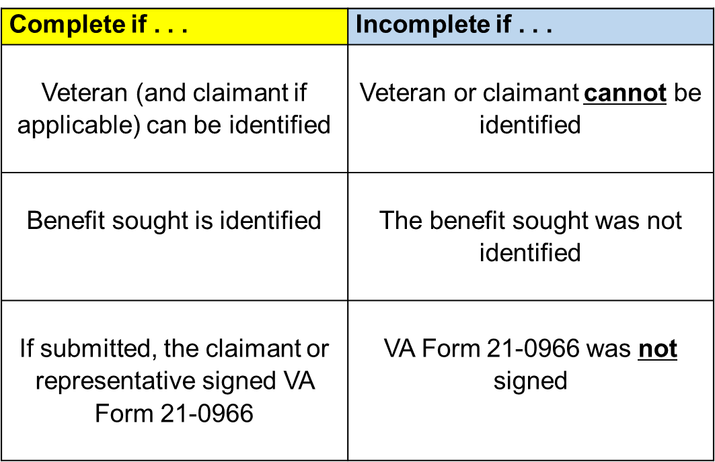
Does ITF Apply?
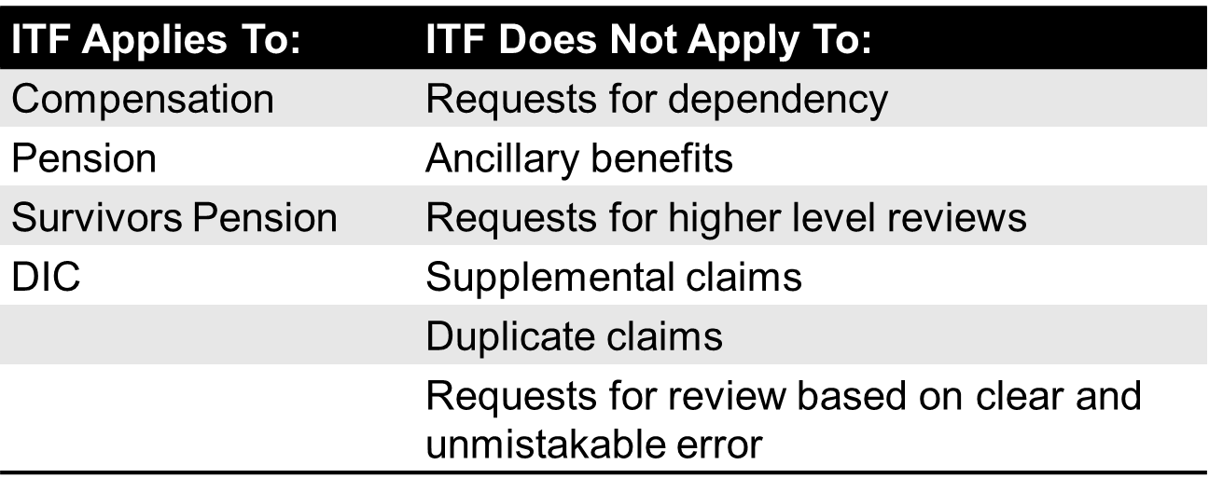
Status of an ITF
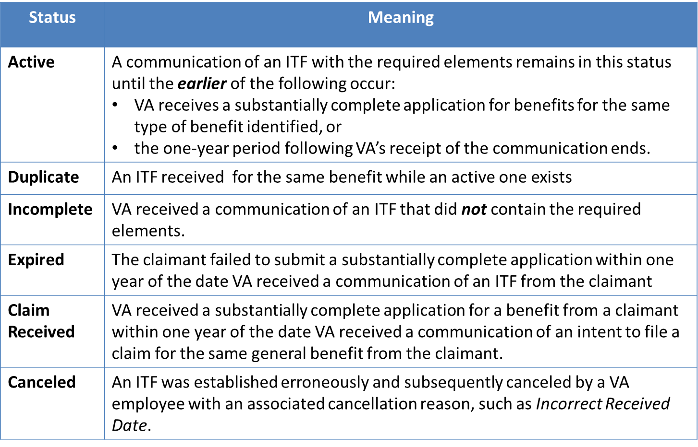
Active – A communication of an ITF with the required elements remains in this status until the earlier of the following occur:
- VA receives a substantially complete application for benefits for the same type of benefit identified, or
- The one-year period following VA’s receipt of the communication ends
Duplicate – An ITF received for the same benefit while an active one exists
Incomplete – VA received a communication of an ITF that did not contain the required elements
Expired – The claimant failed to submit a substantially complete application within one year of the date VA received a communication of an ITF from the claimant
Claim Received – VA received a substantially complete application for a benefit from a claimant within one year of the date VA received a communication of an intent to file a claim for the same general benefit from the claimant.
Canceled – An ITF was established erroneously and subsequently canceled by a VA employee with an associated cancellation reason, such as Incorrect Received Date.
Request for Application
- A Request for Application (RFA) is a request for benefits which was not filed on an appropriate prescribed form on or after March 24, 2015
- RFA does NOT protect the date of claim
- VA will establish EP 400- PMC Request for Application and inform the claimant of the appropriate form to submit to establish a claim
Request for Application
- A Request for Application letter for the benefit sought can be made in VBMS
  - RFA- Accrued
  - RFA- Apportionment
  - RFA- Burial
  - RFA- Dependent
  - RFA- General
  - RFA- Income and NW
  - RFA- Medical Expenses
  - RFA- SMP or SMC
Knowledge Check: Lesson Summary Review

Time Allowed: 10 minutes
What’s Next
Complete the Initial Screening Policies for Applications course survey: TMS ID #4189348

