Pension and fiduciary service
PMC VSR Basic Core Course
Phase 4: Foundational Enrichment
Pension Claims eFolder/Records Management
Trainee Guide
February 2024

Pension Claims eFolder/Records Management

Lesson Overview
Topic | Description
Time Estimate: | 2 hours
Purpose of the Lesson: | This lesson is part of the entry-level curriculum, Core Course for PMC VSRs. The purpose of this introductory lesson is to introduce you to the structure and function of the eFolder and train you to update the claimant’s records.
Prerequisite Training Requirements: | Prior to taking the Pension Claims eFolder/Records Management lesson, trainees must complete PMC VSR Core Course Phases 1-3.
Lesson References: | - M21-1 II.iii.3.B.1 (Updating Contact and Direct Deposit Information)  - M21-1 II.ii.1.B (Lost Paper Claims Folders and Reconciliation of Duplicate Records)  - Common VA Terms job aid  - Locating and Updating a Claimant Record job aid  - Pension Systems and Applications job aid
Knowledge Check: | Phase 4: Introduction to Pension Management Knowledge Check
Lesson Objectives: | By the end of this lesson, you will be able to:  - Locate information in a record  - Update records when errors are identified  - Address lost claims
What You Need: | - Trainee Guide  - Appendix A: Pension Claims eFolder/Records Management worksheet  - Access to VBA Intranet  - Pen and paper  - Access to the following systems:  - SHARE  - MAP-D  - PIES  - VBMS  - Access to the following job aids from VSR Assistant:  - Common VA Terms job aid  - Locating and Updating a Claimant Record job aid  - Pension Systems and Applications job aid

PowerPoint Slides | Notes
Pension Claims eFolder/Records Management
Lesson Objectives
By the end of this lesson, you will be able to:
- Locate information in a record
- Update records when errors are identified
- Address lost claims
Why This Matters!
- The Pension Claims eFolder/Records Management course is important because as a PMC VSR, one of the main duties involves locating and updating records in the eFolder, corporate record, and claimant record. These records must be tracked and updated to ensure the claimant is receiving the benefits entitled and to ensure that you, the PMC VSR, have the evidence needed to justify claim decisions.
For Your Review—Pension Systems and Applications
- PIES: Used to request service treatment records and personnel records from the National Personnel Records Center (NPRC).
- VBMS: Used for electronic storage for applications and non-restricted evidence received by VA. It can perform and upload SSA inquiries.
- eFolder contains:
  - Any information or documentation sent by the claimant
  - Any VA correspondence sent to the claimant
  - Award or Rating Decision Documents
  - Internal evidence
- SHARE: This system is used to access:
  - BIRLS
  - Pre-conversion Compensation and Pension Master Records
  - Pending issue file
  - Payment history file
  - Corporate database
  - Social Security Administration (SSA) inquiries
- FFR: PMCs must maintain all FTI created for upfront verification or Post Award Audits (PAA) in the restricted FTI File Repository (FFR).
  - FTI related to IVMs or to upfront verification and PAAs can be viewed via the restricted FTI DOCUMENTS tab within the Veterans Benefits Management System (VBMS).
- MAP-D: Used mainly for claimant development, third-party development, and internal claim tracking
Locating and Updating a Claimant Record Job Aid
- The Locating and Updating a Claimant Record job aid, located in the VSR Assistant from the PMC VSR button, will be used throughout this lesson.
- The job aid contains the following information:
  - The system/application
  - How to locate a record in a specific system/application
  - What information can be updated in a specific system/application
  - How to update information in a specific system/application
The eFolder
- Housed in VBMS
- Contains the following information:
  - Any information or documentation sent by the claimant
  - Information used by the PMC VSR or RVSR to make a claim decision
  - Any correspondence sent to the claimant

The Corporate Record
- Contains Veteran information that is created/updated in SHARE and/or VBMS
- Veteran information found in the corporate record includes:
  - Veteran’s name
  - DOB
  - SSN
  - Dependents
  - Service information
  - Information regarding previous claims
  - Award information
The Claimant Record
- The claimant record includes everything from the eFolder and corporate record.
- Any information found in any system or application pertaining to the claim is part of the claimant record.
Locate and Update the Record—SHARE
- SHARE is used to access:
  - BIRLS
  - Pre-conversion Compensation and Pension Master Records
  - Pending issue file
  - Payment history file
  - Corporate database
  - Social Security Administration (SSA) inquiries
Locate and Update the Record—VBMS
- Used for electronic storage for applications and non-restricted evidence received by VA
- eFolder contains:
  - Any information or documentation sent by the claimant
  - Any VA correspondence sent to the claimant
  - Award or Rating Decision documents
  - Internal evidence
- Can perform and upload Social Security Administration (SSA) inquiries
Locate and Update the Record—MAP-D
- Used mainly for claimant development, third-party development, and internal claim tracking
- All development actions are automatically tracked
Locating and Updating the Record—PIES
- PIES is used to request the Veteran’s service personnel records and service treatment records from the National Personnel Records Center (NPRC)
- Can be used to search for:
  - An existing 3101 request
  - Checking the status of a 3101 request
  - Printing a 3101 request
  - Selecting appropriate reports
Locating and Updating the Record: Military Service
- The Corporate military record updates with a VBMS update function on the Military Service tab
Lost Claims
- Consider a claim lost if there is an electronic record of a pending EP but the eFolder contains no documents related to the EP.
- In the event the claim documents cannot be located, first attempt to locate the documents in the Centralized Mail Portal.
- If this is unsuccessful, follow the steps in M21-1 II.ii.2.A.3.b. Replacing Missing Claims Material That Was Previously of Record.
Lost Claims Checklist
- Each PMC has a Lost Claims Checklist used to document the attempts made to determine if a claim is lost.
- The VSR is responsible for attempting to locate the claim and completing the checklist.
- Once completed, the checklist should be digitally signed and forwarded to your supervisor.
- Instances of lost claims have been greatly reduced and are rare due to upfront scanning.

ILER
- The Individual Longitudinal Exposure Record (ILER) is used when reviewing and processing certain service-connected claims that may be subject to a toxic exposure risk activity (TERA).
- ILER currently provides access to Veteran records and acts as a single access point to deployment history
- ILER has the capability of enabling a search by individual, location, and exposure type
Practice Exercise: Pension Claims eFolder/Record Management
- Instructions:​​
  - Work independently.​
  - Access Appendix A.​
  - Follow the directions to answer each review question.​​
  - Be prepared to discuss your outcome. ​
Time: 15 minutes
Knowledge Check: Lesson Summary Review
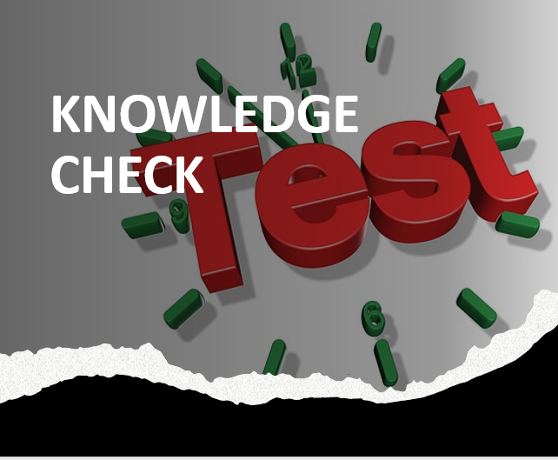
Time Allowed: 10 minutes
What’s Next
- Complete Pension Claims eFolder/Records Management course evaluation TMS ID: 4189344

