# VBMS Creating an FTI Custom 5103 Notice Letter Job Aid

Updated: 12/5/2024

## Overview

FTI Letters UI is a component of the Veterans Benefits Management System (VBMS) software application for use by the Veterans Benefits Administration (VBA) Veteran Service Representatives (VSRs) to manage the letters sent to a claimant.

This job aid provides guidance on how to create an FTI version of the Custom 5103 Notice Letter in FTI Letters UI. This will allow the user to request information from a claimant or to notify the claimant of modifications to claim contentions.

## Contents

Overview 1

Contents 1

Creating Letters in the FTI Letters UI 2

Creating an FTI Custom 5103 Notice Letter 3

General 6

Custom Fields 7

Associated Evidence 9

Development Actions 10

Standard & eFolder Enclosures 16

Free Text 20

Previewing or Deleting the Letter 21

Saving the Letter 22

## Creating Letters in the FTI Letters UI

Navigate to the **Letters** tab on the Development Plan task bar. Select the **FTI Letters UI** button. Refer to Figure 1.

Figure 1: FTI Letters UI Button

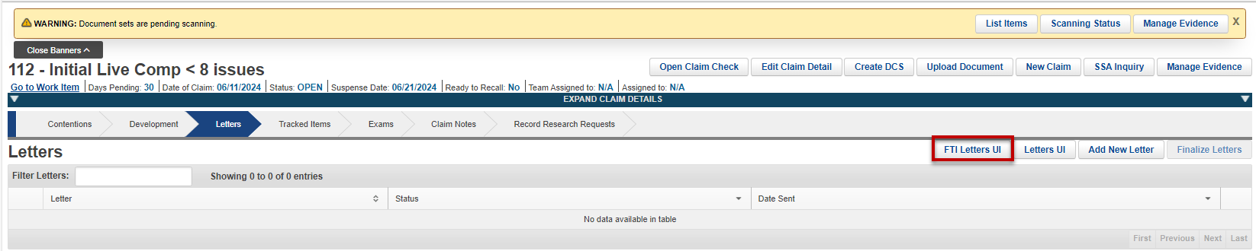

**Note:** The FTI Letters UI button is restricted by permission and only appears to users who have required access.

When the FTI Letters UI button is selected, a warning message is displayed. Users are required to confirm their acknowledgment of this warning before accessing the **FTI Letter UI**. Refer to Figure 2.

Figure 2: Warning Message

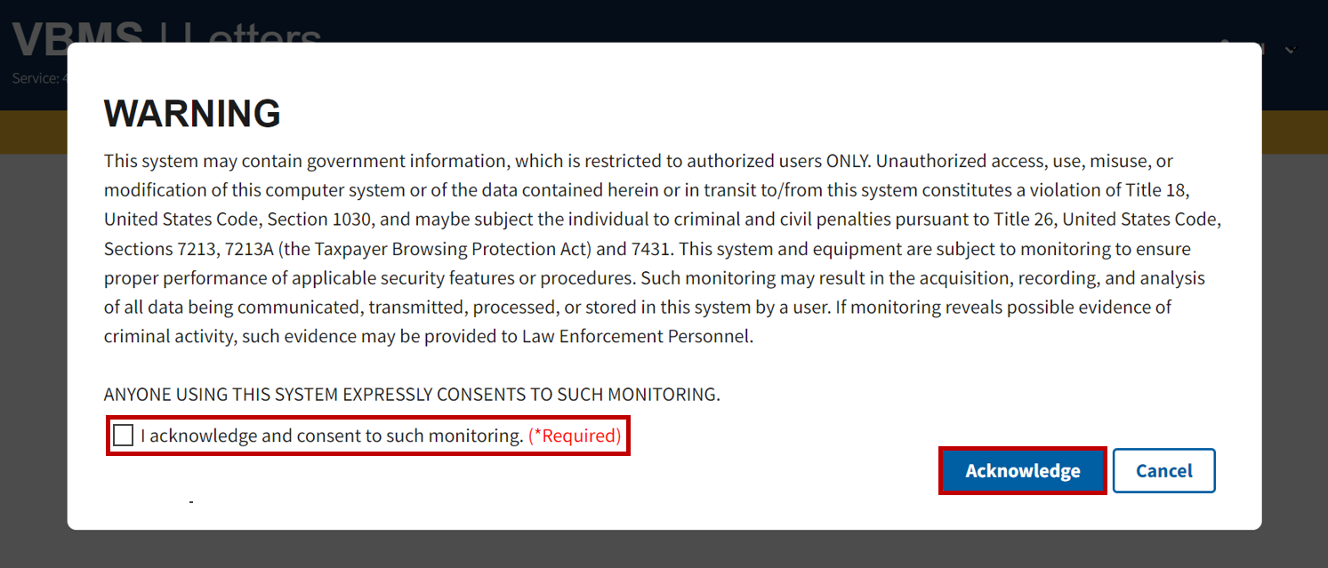

Each page of the FTI Letters UI will display a banner stating, “**This application contains FTI data**”. Refer to Figure 3.

Figure 3: FTI Letters Banner

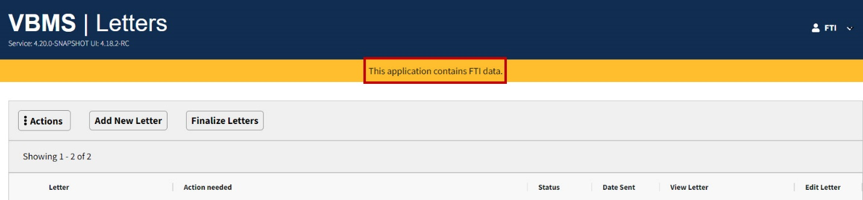

## Creating an FTI Custom 5103 Notice Letter

Step 1

From the **Letters** page, select the **Add New Letter** button. Refer to Figure 4.

Figure 4: Add New Letter Button

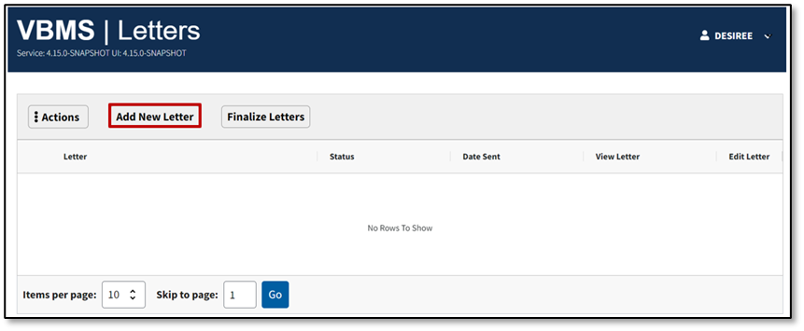

Step 2

Search for the **FTI** **Custom 5103 Notice** in the **Search a Letter** field by typing in the letter name. Refer to Figure 5.

Figure 5: Search a Letter Field

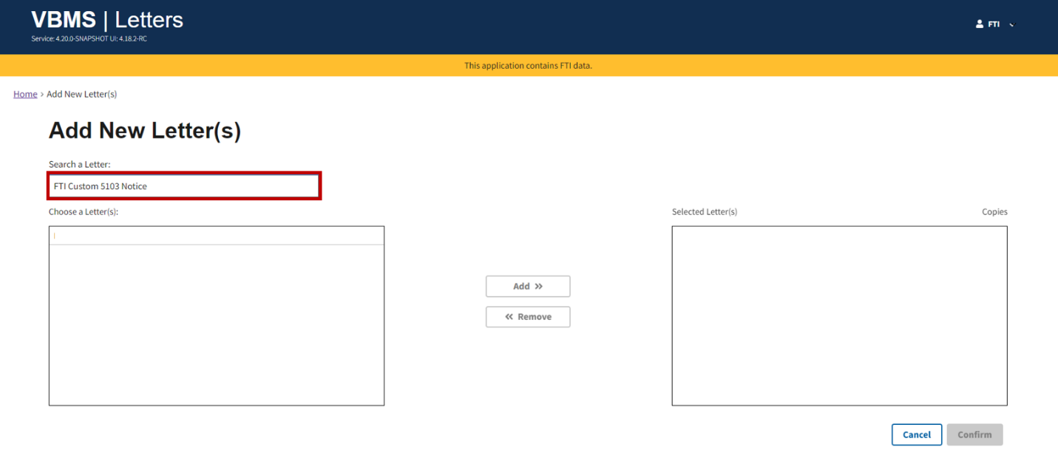

Step 3

Select **FTI Custom 5103 Notice** from the Choose a Letter(s) drop-down menu. Refer to Figure 6.

Figure 6: Choose a Letter Drop-down Menu

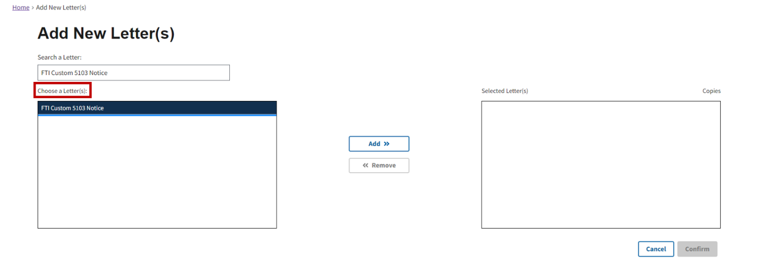

Step 4

Select the **Add** button. The letter will be displayed in the **Selected Letter(s)** field. Refer to Figure 7.

Figure 7: Add Button

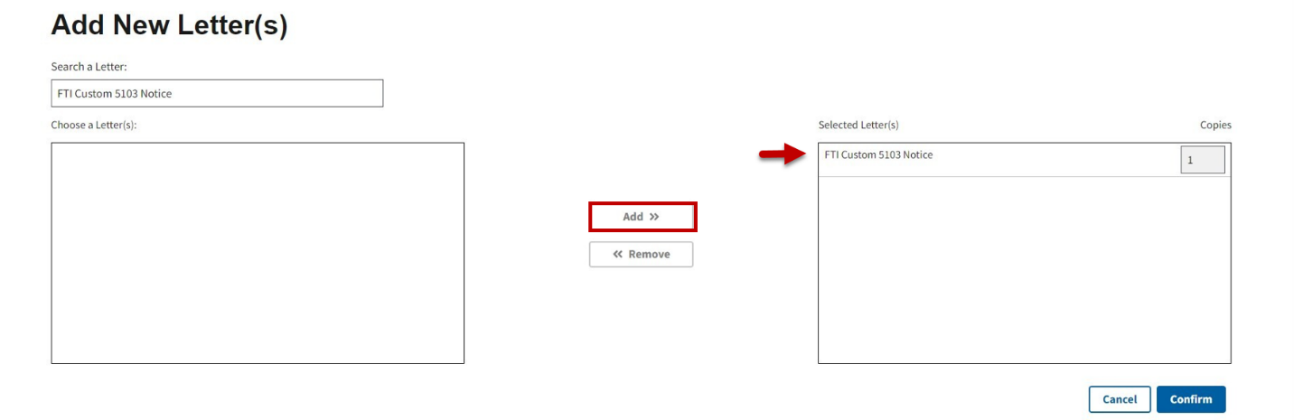

Step 5

Select **Confirm** once you have added the FTI Custom 5103 Notice letter. Refer to Figure 8.

Figure 8: Confirm Button

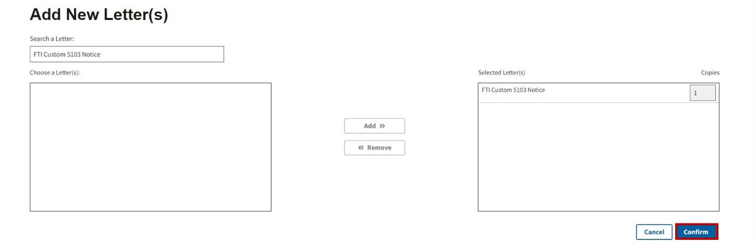

### General

Navigate to the **General** section and confirm **FTI** **Custom 5103 Notice** is the selected **Letter Type**. Required fields are indicated with a red asterisk. Include information in the following required fields: Title, Preferred Name, and Refer To. Refer to Figure 9.

Figure 9: General Section

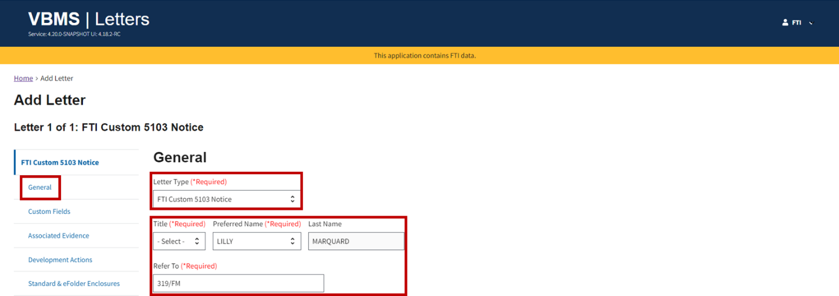

**Note:** The user has the option to switch between letter types **FTI** **Custom 5103 Notice** and **FTI Subsequent Development Letter**.

### Custom Fields

Step 1

Navigate to the **Custom Fields** section. Select one of the following required options under the **FTI POA Disclosure Selection**: VA Form 21-22 signature date within last 5 years, VA Form 21-22 signature date exceeds 5 years, VA Form 21-22a Private POA - Not Eligible, or No VA Form 21-22 Appointment of Record. Refer to Figure 10 and Figure 11.

Figure 10: FTI POA VSO Disclosure Selection with Power of Attorney

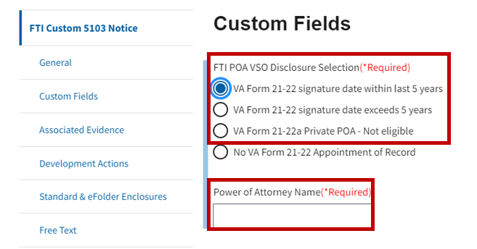

**Note:** Selecting any of the first three options will trigger a text box where the user is required to enter the **Power of Attorney Name**.

Figure 11: FTI POA VSO Disclosure Selection without Power of Attorney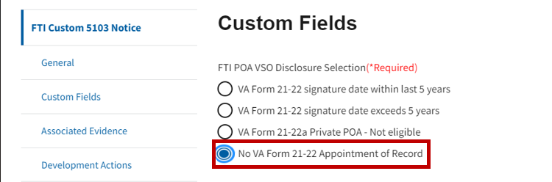

Step 2

Choose one or more of the required selections under **5103 Type** listed to add the corresponding encloses to the letter.

* 38 U.S.C 5103 Notice
* 38 U.S.C 5103 Notice for Veteran’s Pension
* 38 U.S.C 5103 Notice for Survivor’s Benefits

Refer to Figure 12.

Figure 12: Required Corresponding Enclosures

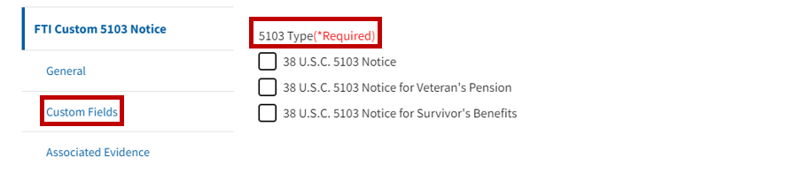

### Associated Evidence

Step 1

Navigate to the Associated Evidence section. Select the **Select Associated Evidence** button. Refer to Figure 13.

Figure 13: Associated Evidence Section

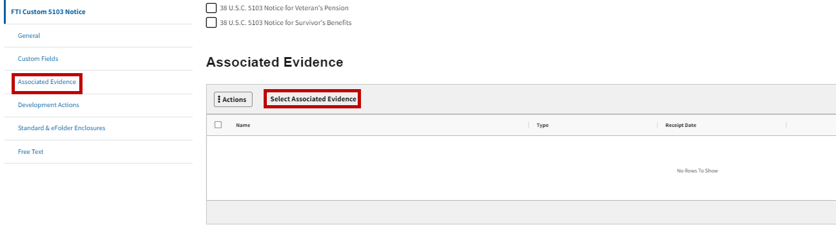

Step 2

The **Add Evidence** modal opens. Select the **Add additional evidence** button (updates to both Solicited and Unsolicited evidence are made in the Edit Letter Screen). Enter the Evidence Name and Receipt Date. Select the **Add to Letter** button. Refer to Figure 14.

Figure 14: Add Evidence Modal

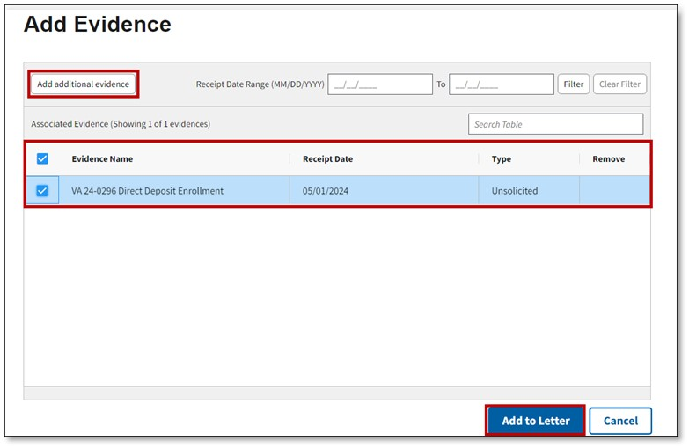

**Note:** Upon Saving Unsolicited Evidence, updates to the following will be reflected in the Edit Letter Screen, generated letter, and the Manage Evidence folder in Core.

**Note:** Upon saving Solicited Evidence, updated names will be reflected in the Edit Letter Screen and the generated letter but will remain unchanged in the Manage Evidence folder in Core.

### Development Actions

Step 1

Navigate to the **Development Actions** section. The system will automatically populate the required development actions related to **FTI** **Custom 5103 Notice**. Required actions include 5103 Notice Response and VSO Notice.Refer to Figure 15.

Figure 15: Development Actions Section with Required Actions

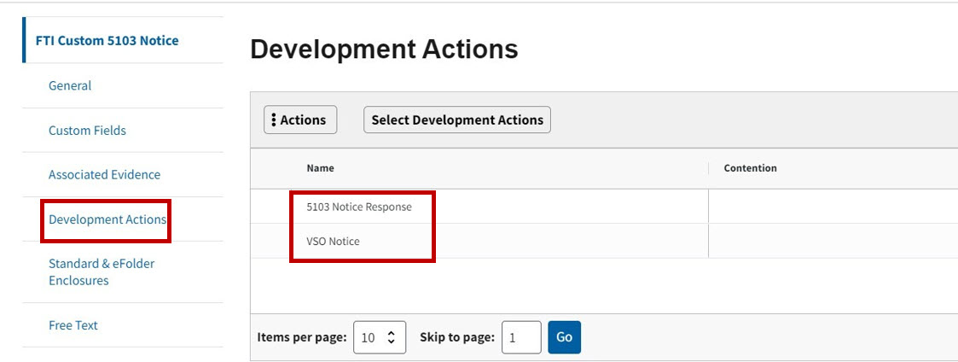

Note: The user can not remove **Development Actions** that are required for the **FTI** **Custom 5103 Notice.**

Step 2

The user can manually add Development Actions by selecting the **Select Development Actions** button. Refer to Figure 16.

Figure 16: Select Development Actions Button

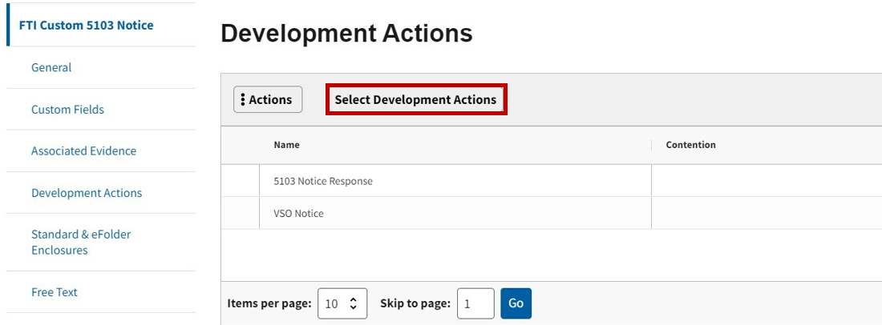

Step 3

Enter FTI in the **Search for Development Actions** fieldon the Add Development Actions modal. The **Choose a Development Action(s)** menu will display the two FTI options available. Refer to Figure 17.

Figure : Add Development Actions Modal

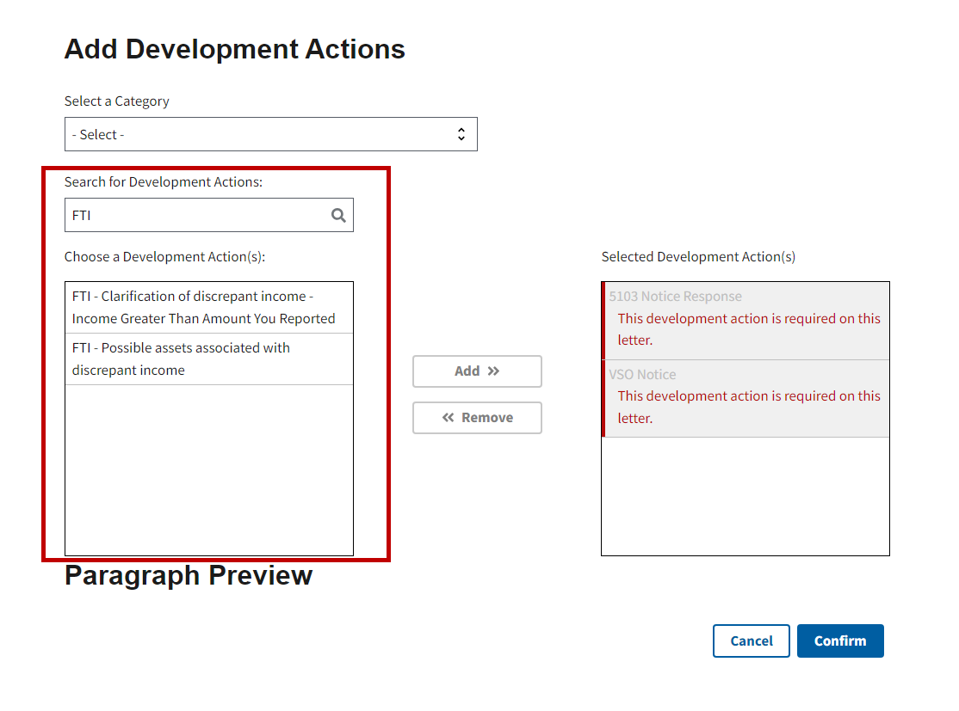

Step 4

Select one or more of the FTI Development Actions. The Paragraph Preview will display with the information that will be added to the letter for the selected action. Select the **Add** button to add it to the **Selected Development Action(s)** field. Refer to Figure 18 and Figure 19.

Note: Press the CTRL button on the keyboard to select both FTI development actions, if desired.

Figure : FTI-Clarification of Discrepant Income and Add Button

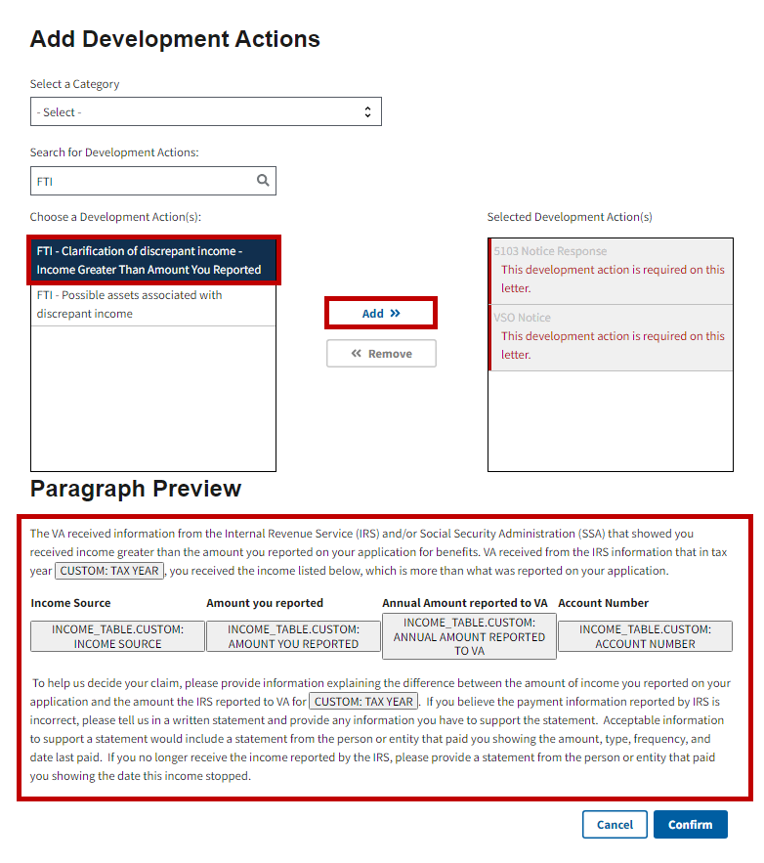

Figure : FTI-Possible Assets Associated with Discrepant Income and Add Button

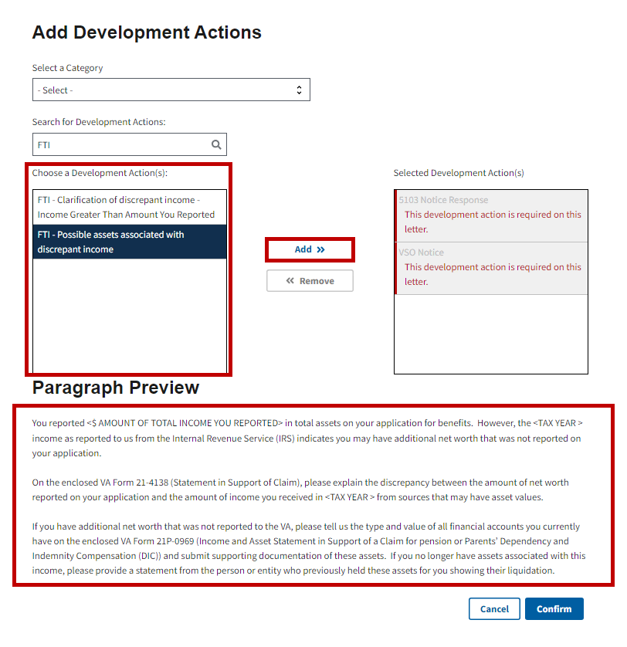

The selected development action(s) will appear in the **Selected Development Action(s)** field.

**Note:** If the user manually adds development actions to the **Custom 5103 Notice** and then changes the letter to **Subsequent Development Letter**, all manually added development actions will remain, and the user will need to remove them if necessary.

Step 4

Select the **Confirm** button to continue with adding the development action. Refer to Figure 20.

Figure : Confirm Button

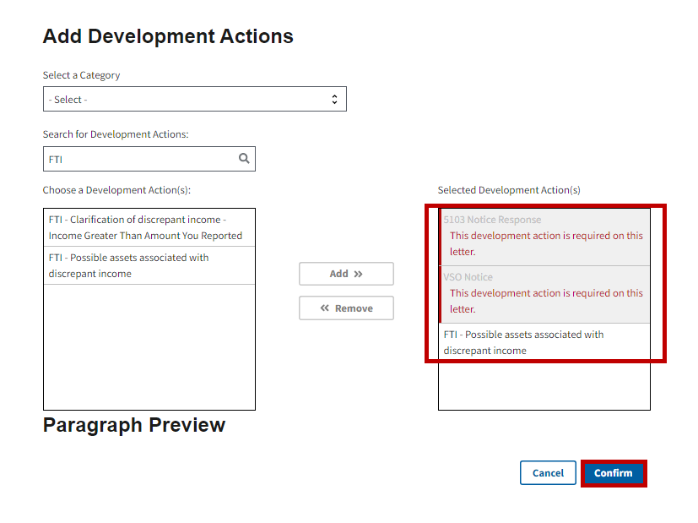

The selected development action(s) will appear in the Development Actions section. Refer to Figure 21.

Figure 21:Development Action Added

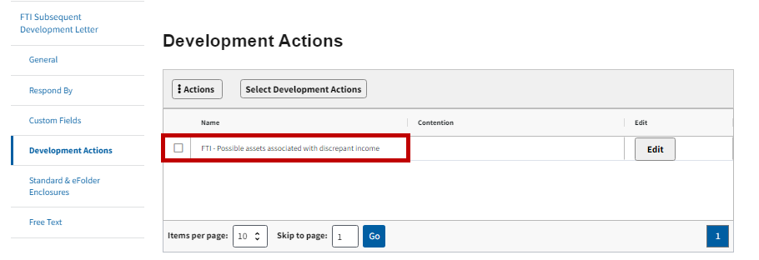

### Standard & eFolder Enclosures

Step 1

Navigate to the **Standard & eFolder Enclosures** section. The required enclosures will populate for the FTI Custom 5103 Notice. Refer to Figure 22.

Figure 22: Standard & eFolder Enclosure

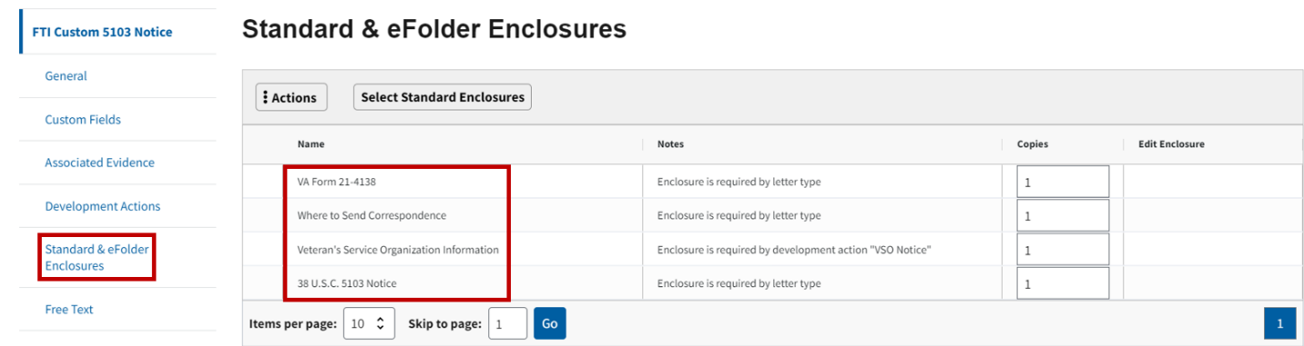

Step 2

Select the **Select Standard Enclosures** button to add additional enclosures. Refer to Figure 23.

Figure 23: Select Standard Enclosures Button

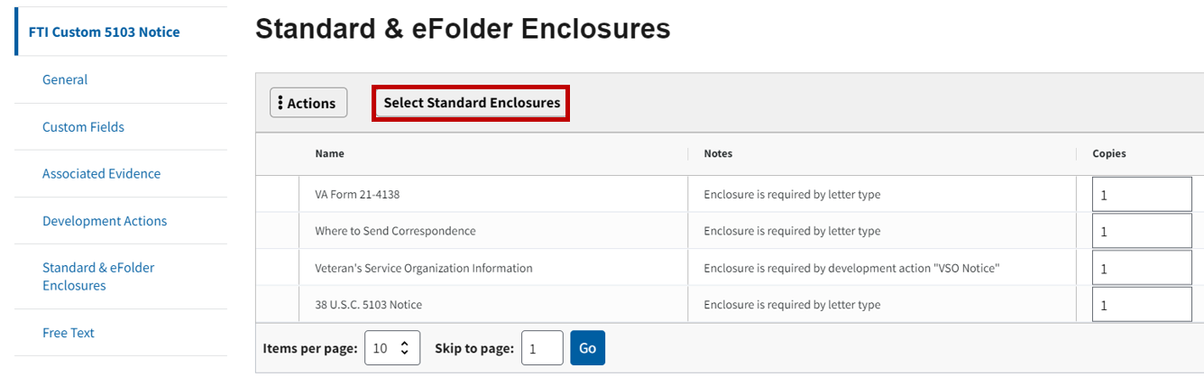

Step 3

The **Select Standard Enclosures** modal will open. Select the enclosures from the **Choose a Enclosure(s) Type** field. Select the **Add** button. The document will appear in the **Selected Enclosures Type** field. Refer to Figure 24.

Figure 24: Select Standard Enclosures Modal

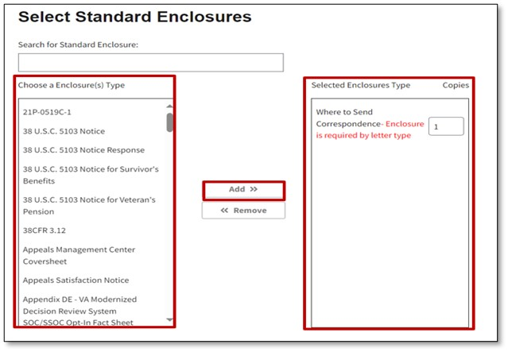

**Note:** If the user manually adds enclosures to the **FTI** **Custom 5103 Notice** and then changes the letter to the **FTI** **Subsequent Development Letter**, all manually added enclosures will remain and the user will need to remove them if necessary.

Step 4

To add **eFolder Enclosures** to the letter, select the **Select eFolder Enclosures** button. Refer to Figure 25.

Figure 25: Select eFolder Enclosures Button

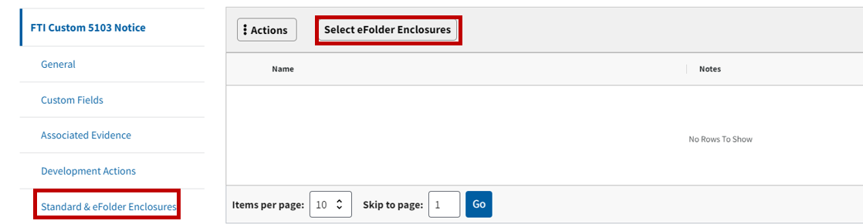

Step 5

A modal will open to display **Select eFolder Enclosures**. Users can type in an enclosure to search for or select the document from the **Choose a Enclosure(s) Type** box. After the enclosure is chosen, select the **Add** button. The document will appear in the **Selected Enclosures Type** field. Refer to Figure 26.

Figure 26: Select eFolder Enclosures Modal

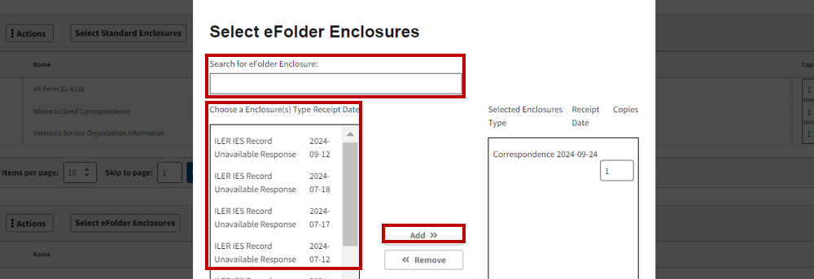

**Note:** **eFolder Enclosures** will only populate in the eFolder Enclosure screen if documents have been manually uploaded by the user.

Step 6

Select the **Confirm** button. Refer to Figure 27.

Figure 27: Confirm Button

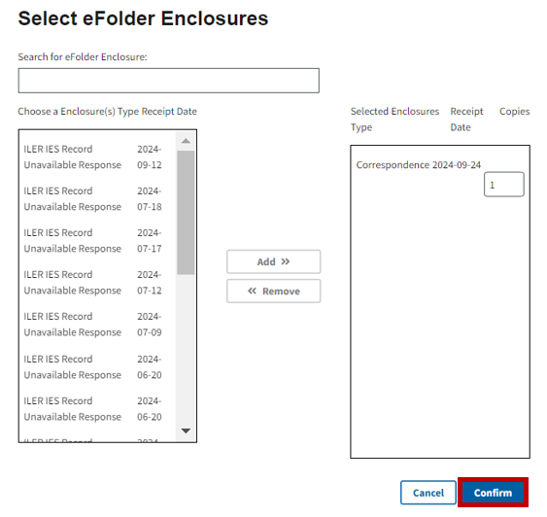

### Free Text

Step 1

Navigate to the **Free Text** section. Users can select an option from the Add New Free Text drop-down menu. Refer to Figure 28.

Figure 28: Free Text Section

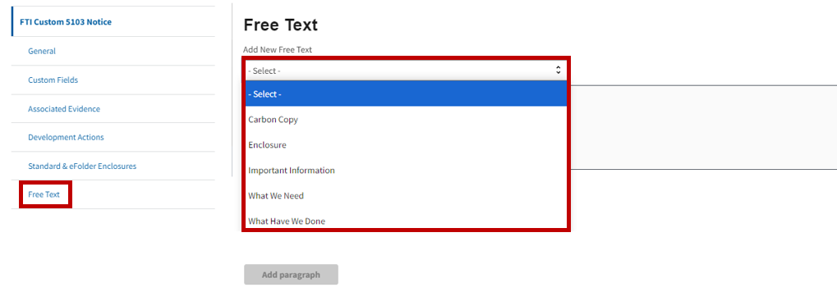

Step 2

Users have the option to enter text in the appropriate section once they select from the drop-down menu. Select the **Add paragraph** button once the text has been entered. Refer to Figure 29.

Figure 29: Add Paragraph Button

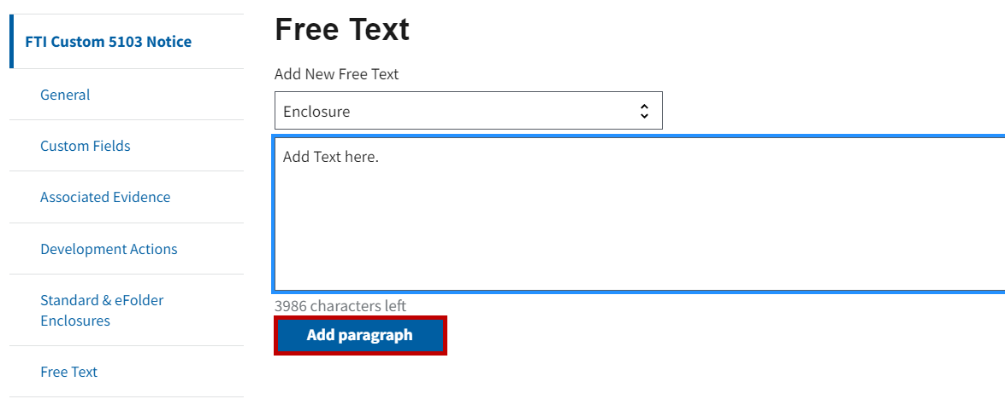

**Note:** The user may only use each category once and must select the **Add paragraph** button once completed.

### Previewing or Deleting the Letter

Before finalizing the letter, the user has the option to preview or delete the text by selecting the **Preview** or **Delete** buttons. Refer to Figure 30.

Figure 30: Preview and Delete Buttons

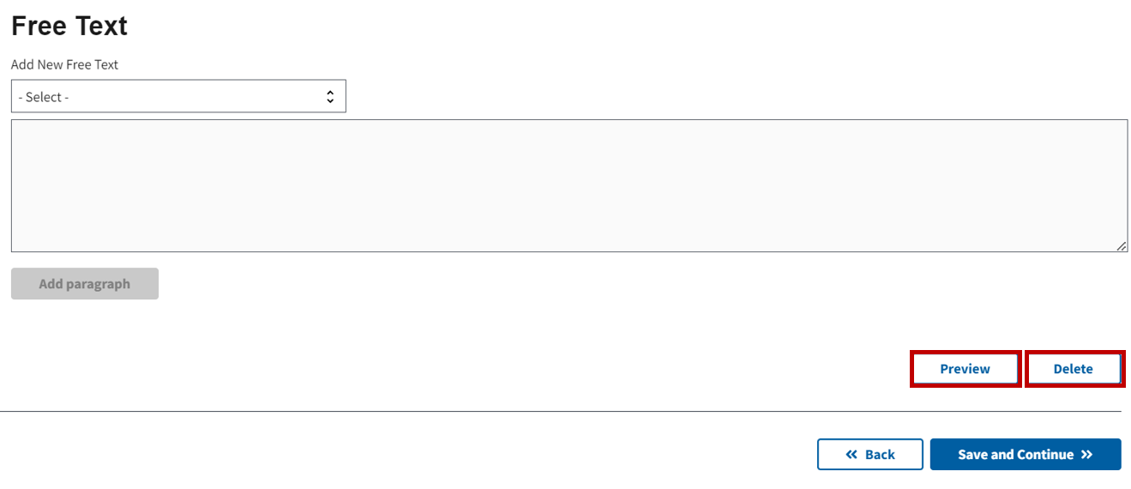

**Note:** If **Preview** is selected, a new tab will open in the browser displaying the completed letter in PDF format. If **Delete** is selected, the user will receive a prompt to confirm they want to delete the letter. Once the user confirms they would like to delete the letter, the letter will be deleted, and the user will be returned to the Letters List page.

### Saving the Letter

Select the **Save and Continue** button once the necessary sections are complete. Refer to Figure 31.

Figure 31: Save and Continue Button

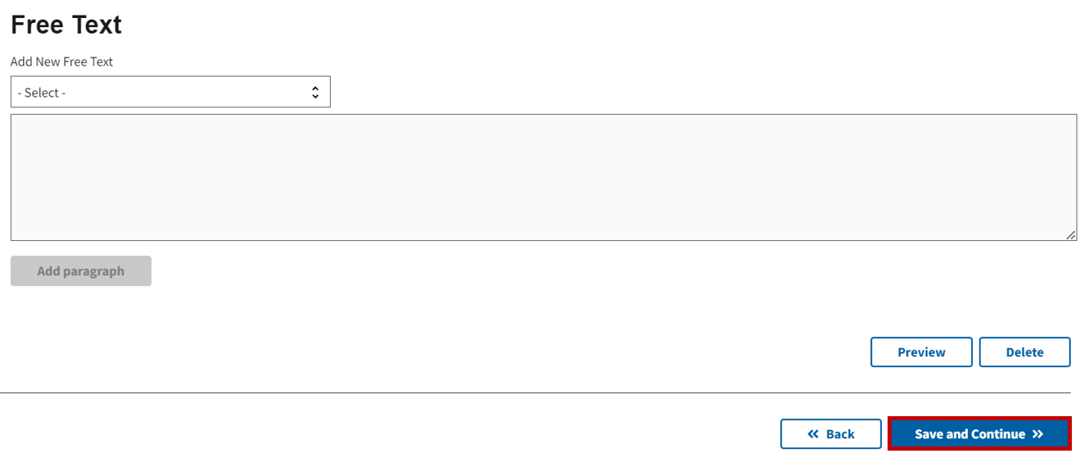

A success banner will appear on the **Letters List** page, notifying the user that the letter has successfully been saved. The FTI Custom 5103 Notice Letter will appear on the list. Refer to Figure 32.

Figure 32: Success Banner

