# VBMS Creating an FTI Subsequent Development Letter Job Aid

Updated: 12/05/2024

## Overview

FTI Letters UI is a component of the Veterans Benefits Management System (VBMS) software application for use by the Veterans Benefits Administration (VBA) Veteran Service Representatives (VSRs) to manage the letters sent to a claimant.

This job aid provides guidance on how to create an FTI Subsequent Development Letter in FTI Letters UI. This will allow the user to effectively communicate with the claimant regarding any further information needed on the claim.

## **Contents**

VBMS Creating an FTI Subsequent Development Letter Job Aid 1

Overview 1

Creating Letters in the Letters UI 2

Creating an FTI Subsequent Development Letter 3

General 5

Respond By 6

Custom Fields 7

Development Actions 8

Standard & eFolder Enclosures 12

Free Text 16

Previewing or Deleting the Letter 17

Saving the Letter 18

## Creating Letters in the Letters UI

From the **Letters** tab on the Development Plan task bar, select **FTI** **Letters UI**. The Letters page opens in a new tab. Refer to Figure 1.

Figure : FTI Letters UI Button

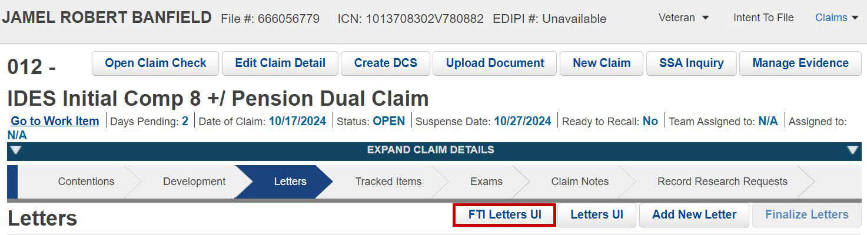

**Note**: The FTI Letters UI button is restricted by permissions and only appears to users who have the required access.

When the user selects the **FTI Letters UI** button, a warning message will appear. Users are required to confirm their acknowledgment of this warning before they can access the FTI Letter UI. Refer to Figure 2.

Figure : Warning Message

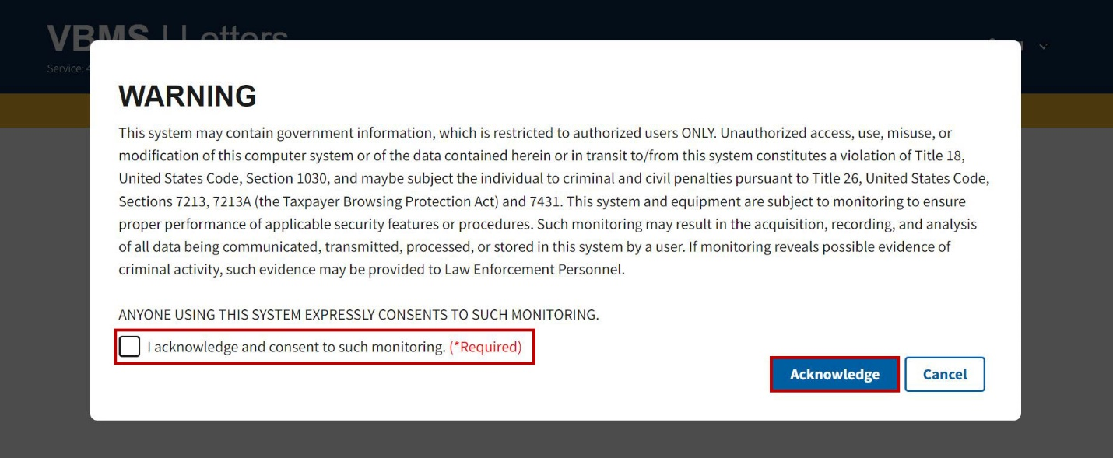

Each page in the FTI Letters UI will display a banner stating, "**This application contains FTI data**". Refer to Figure 3.

Figure : FTI Letters UI Banner

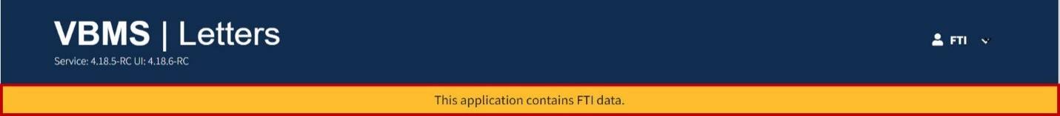

## Creating an FTI Subsequent Development Letter

To create an FTI Subsequent Development Letter, complete the following steps:

Step 1

From the Letters page, select **Add New Letter**. Refer to Figure 4.

Figure : Add New Letter Button

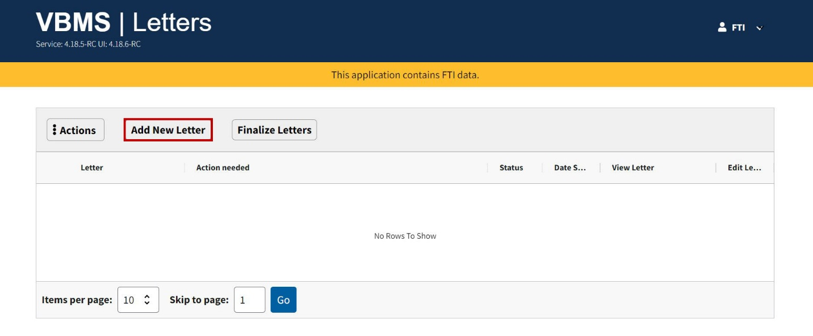

Step 2

Search for **FTI Subsequent Development Letter** in the **Search a Letter** field. Users can also select FTI Subsequent Development Letter from the **Choose a Letter(s)** field’s drop-down menu. Refer to Figure 5.

Figure : Search a Letter

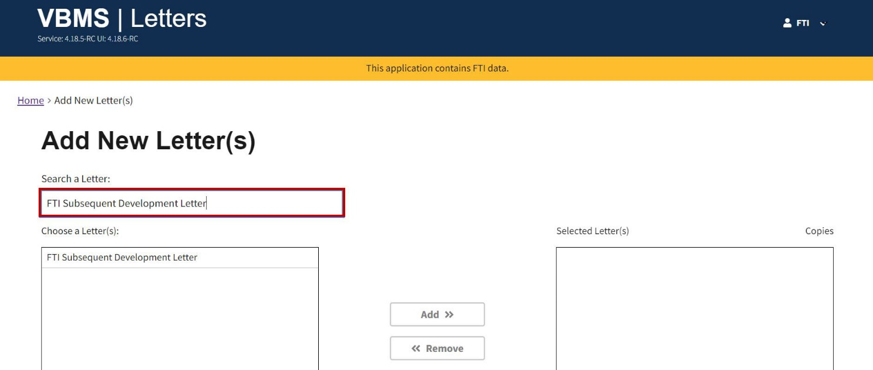

Step 3

Ensure FTI Subsequent Development Letter is highlighted and select the **Add** button to add it to the **Selected Letter(s)** field. Refer to Figure 6.

Figure : Add Button

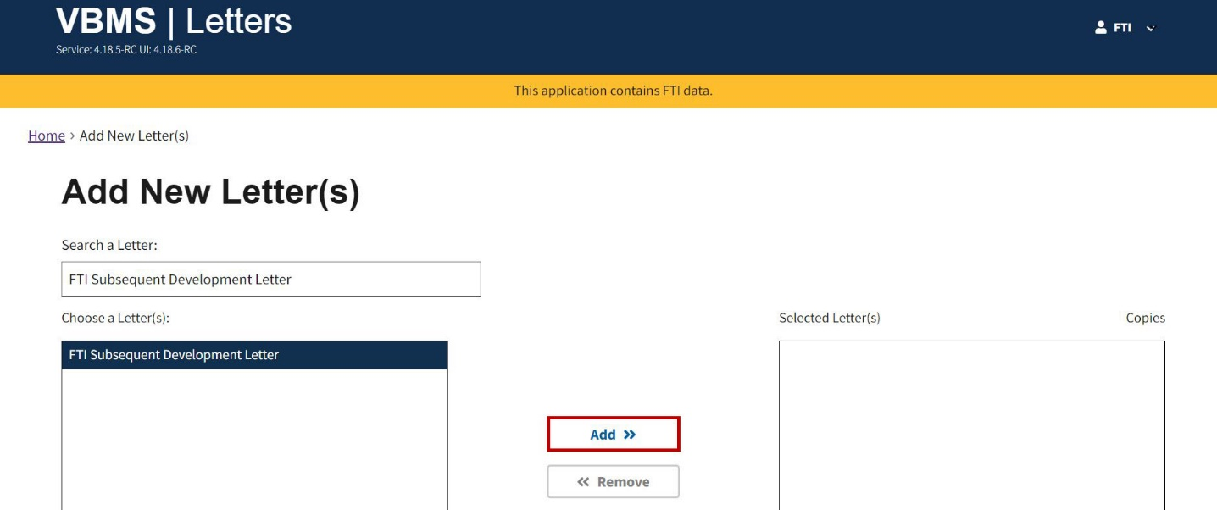

Step 4

Select the **Confirm** button once you have the FTI Subsequent Development Letter in the Selected Letter(s) field. Refer to Figure 7.

Figure : Confirm Button

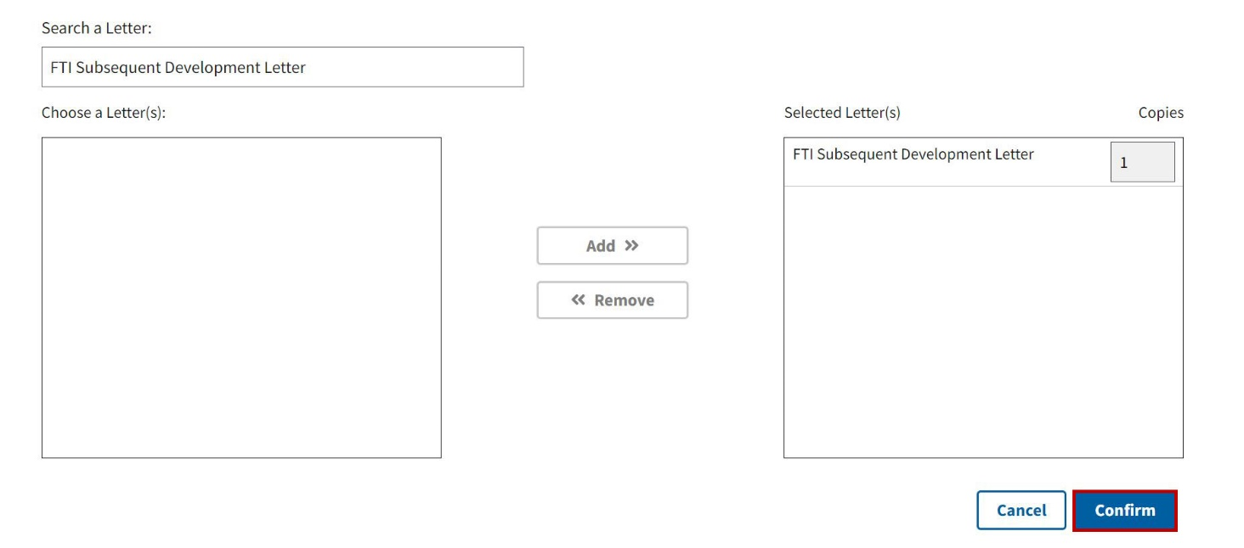

### General

The Edit Letter page will open. Navigate to the **General** section. Include information in the following required fields: Letter Type, Title, Preferred Name, and Refer To. Required fields are indicated with a red asterisk. Refer to Figure 8.

Figure : General Section

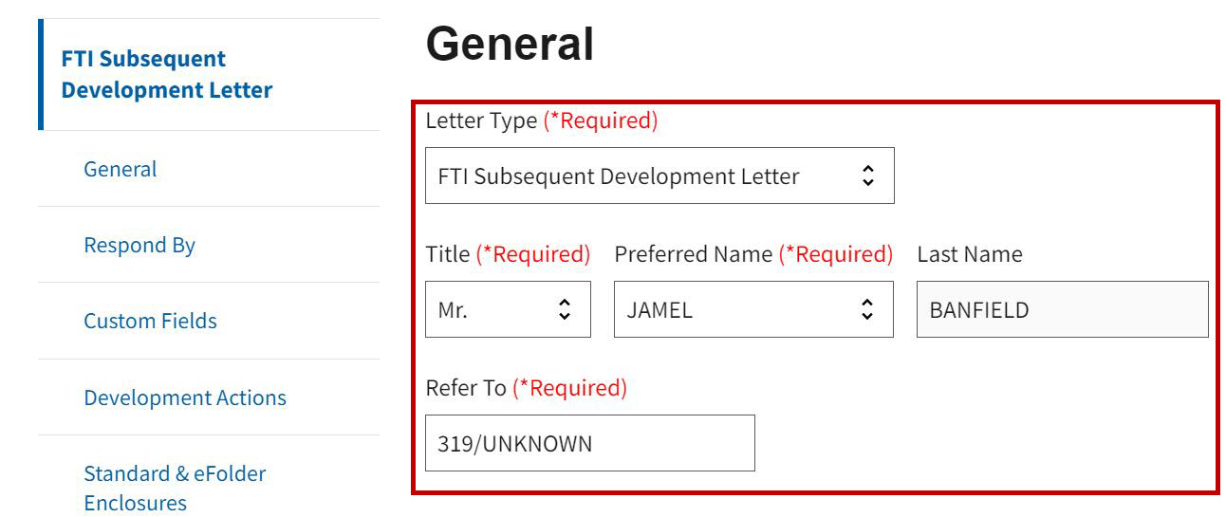

**Note:** Users can choose between the FTI Subsequent Development Letter and the FTI Custom 5103 Notice.

### Respond By

Step 1

Navigate to the **Respond By** section. Refer to Figure 9.

Figure : Respond By Section

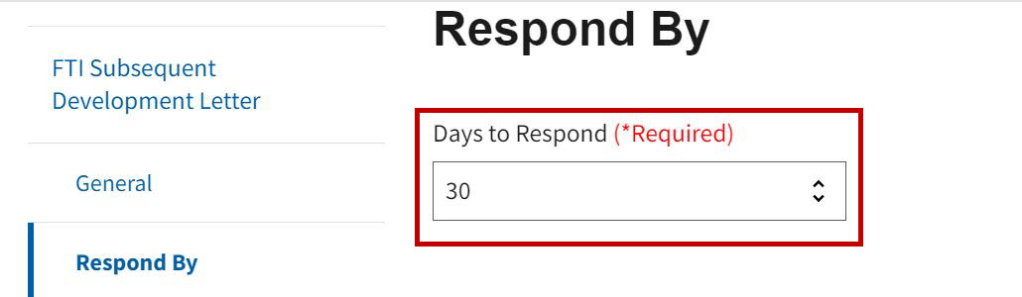

Step 2

Select the drop-down menu and choose an option to change the **Days to Respond**. Refer to Figure 10.

Figure : Days to Respond Drop-down Menu

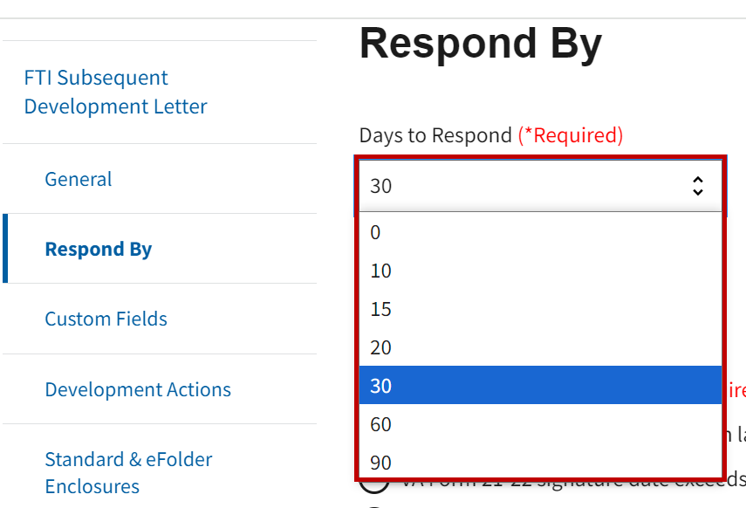

**Note:** Days to Respond field automatically defaults to 30.

### Custom Fields

Navigate to the **Custom Fields** section. Users are required to select one of the following under **FTI POA VSO Disclosure Selection**: VA Form 21-22 signature date within last 5 years, VA Form 21-22 signature date exceeds 5 years, VA Form 21-22a Private POA - Not Eligible, or No VA Form 21-22 Appointment of Record. Refer to Figure 11 and Figure 12.

Figure : Custom Fields - FTI POA VSO Disclosure Selection with Power of Attorney

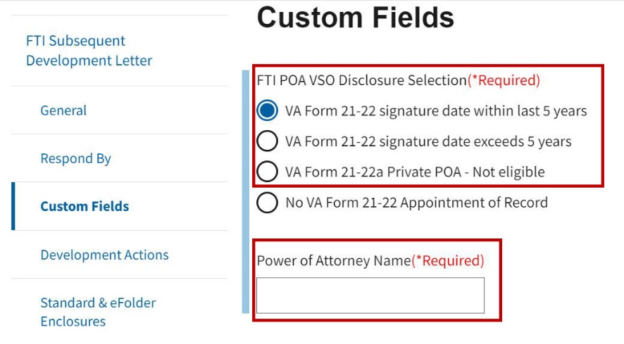

**Note:** Selecting any of the first three options will trigger a text box where users are required to enter the **Power of Attorney Name**.

Figure : Custom Fields - FTI POA VSO Disclosure Selection Without Power of Attorney

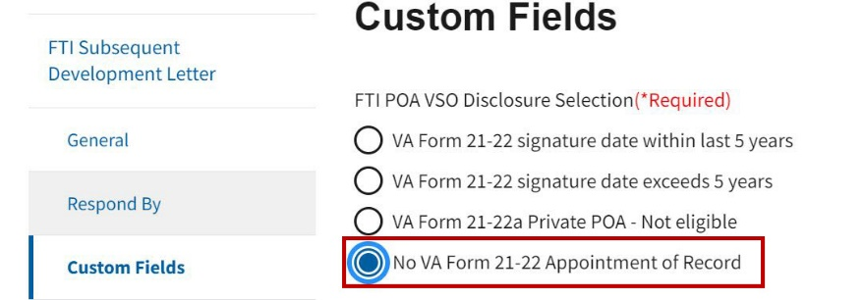

### Development Actions

Step 1

Navigate to the Development Actions section. The user can manually add development actions by selecting the **Select Development Actions** button. Refer to Figure 13.

Figure : Select Development Actions Button

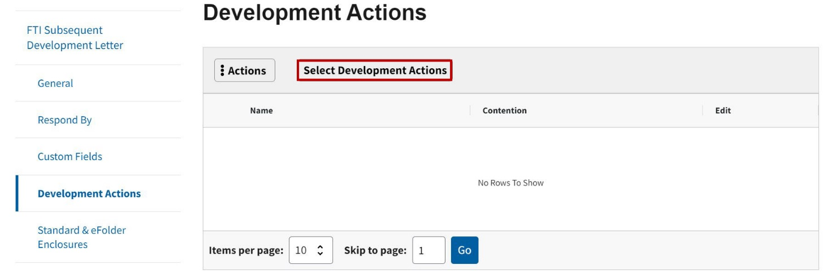

Step 2

Enter FTI in the **Search for Development Actions** fieldon the Add Development Actions modal. The **Choose a Development Action(s)** menu will display the two FTI options available. Refer to Figure 14.

Figure : FTI Add Development Actions Modal

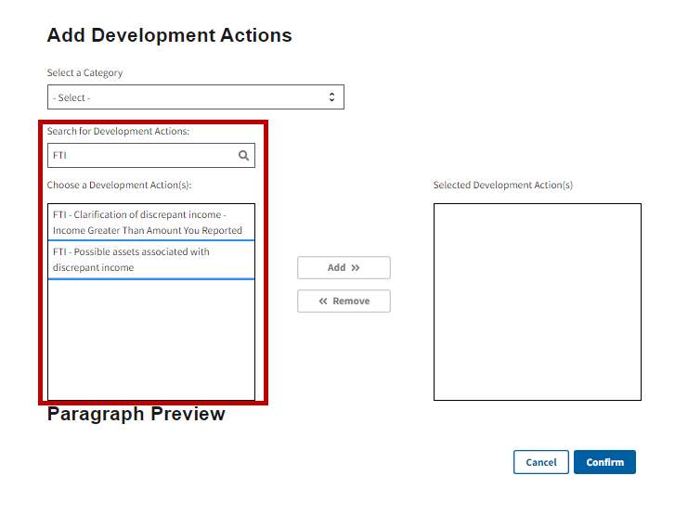

Step 3

Select one or more of the FTI Development Actions. The Paragraph Preview will display with the information that will be added to the letter for the selected action. Select the **Add** button to add it to the **Selected Development Action(s)** field. Refer to Figure 15 and Figure 16**Error! Reference source not found.**.

Note: Press the CTRL button on the keyboard to select both FTI development actions, if desired.

Figure : FTI-Clarification of Discrepant Income and Add Button

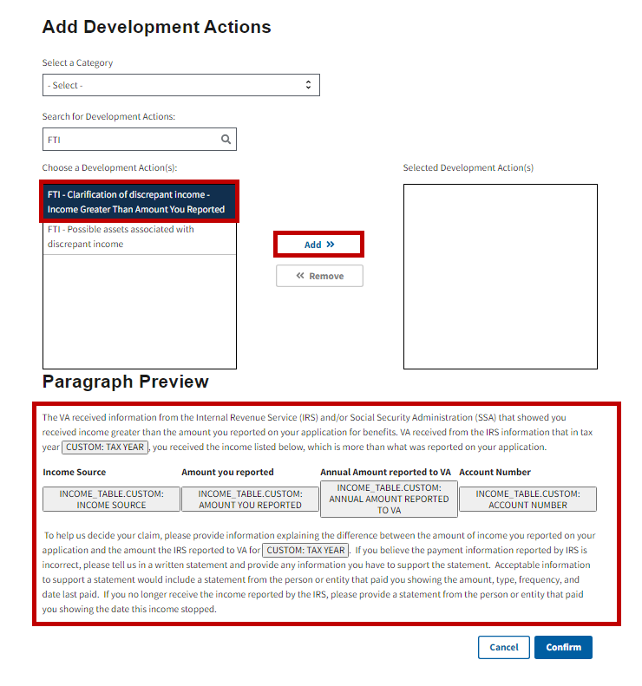

Figure : FTI-Possible Assets Associated with Discrepant Income Add Button

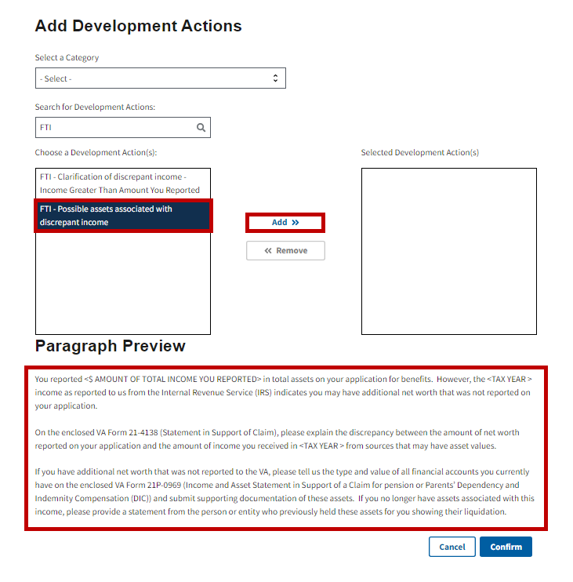

The selected development action(s) will appear in the **Selected Development Action(s)** field.

Step 4

Select the **Confirm** button to continue with adding the development action. Refer to Figure 17.

Figure : Confirm Button

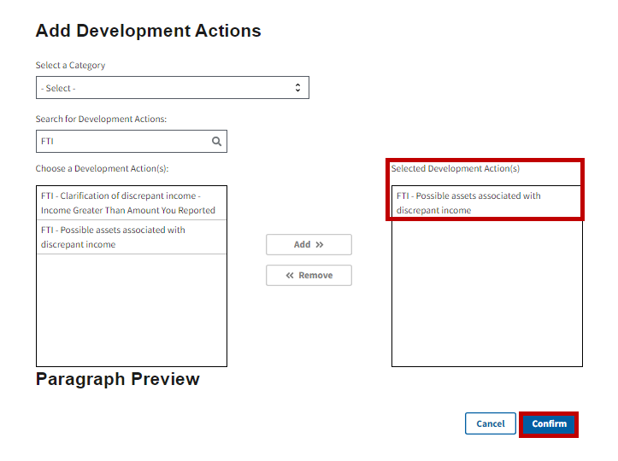

**Note:** If users manually add development actions to the Subsequent Development Letter and then change the letter to Custom 5103 Notice, all manually added development actions will remain. Users will need to remove them if necessary.

The selected development action(s) will appear in the Development Actions section. Refer to Figure 18.

Figure : Development Action Added

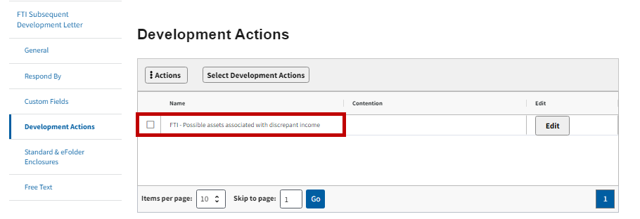

### Standard & eFolder Enclosures

Step 1

Navigate to the **Standard & eFolder Enclosures** section. The system will populate the Standard Enclosures required for the FTI Subsequent Development Letter. Refer to Figure 19.

Figure : Standard & eFolder Enclosures Section

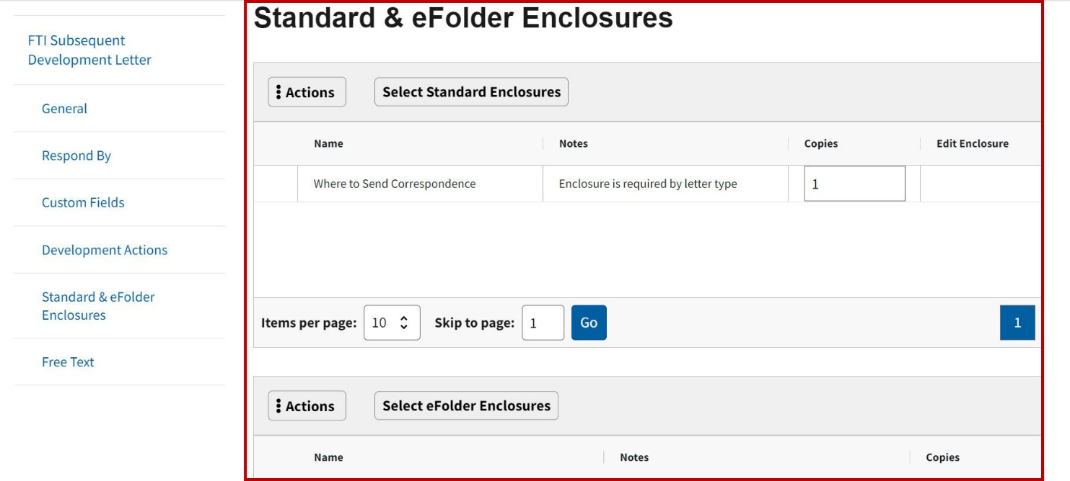

Step 2

Select the **Select Standard Enclosures** button to add additional standard enclosures. Refer to Figure 20.

Figure : Select Standard Enclosures Button

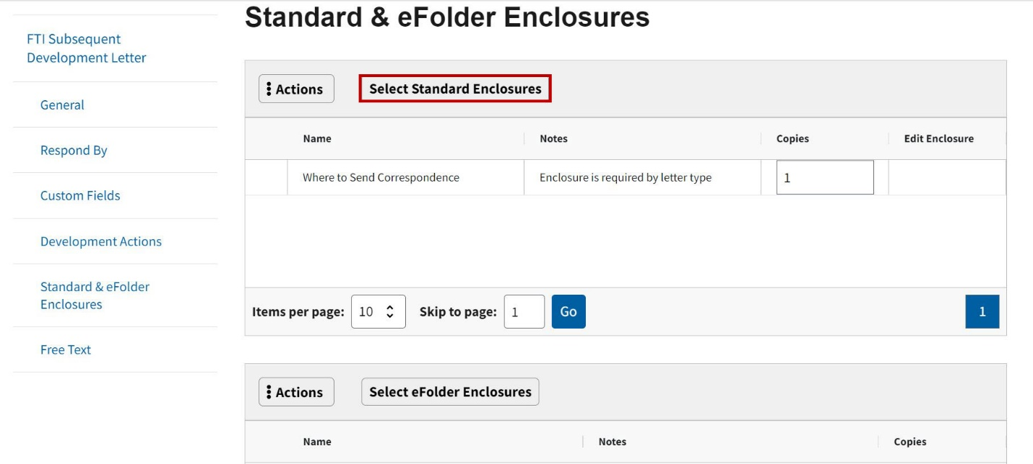

Step 3

The **Select Standard Enclosures** modal will open. Search for and select the enclosures from the Choose a Enclosure(s) Type field. Select the **Add** button. Refer to Figure 21.

Figure : Select Standard Enclosures Modal

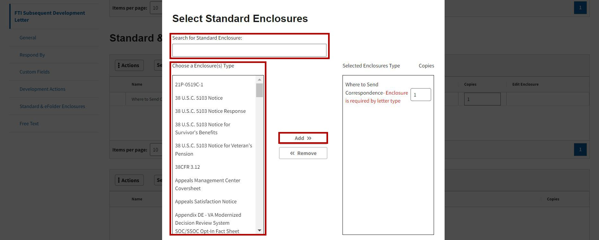

**Note:** If the user manually adds enclosures to the FTI Subsequent Development Letter and then changes the letter to FTI Custom 5103, all manually added enclosures will remain. Users will need to remove them if necessary.

Step 4

The enclosures will appear in the **Selected Enclosures Type** field. Select the **Confirm** button to continue with adding the standard enclosure. Refer to Figure 22.

Figure : Confirm Button

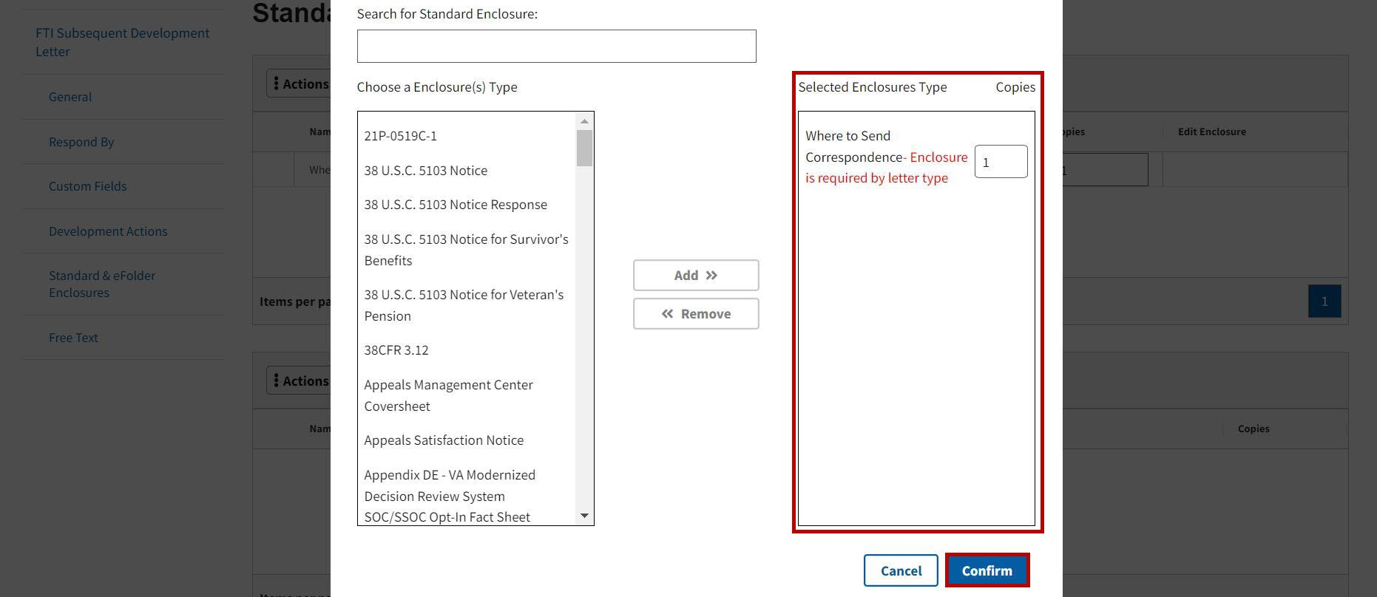

The Standard Enclosures will appear in the Standard & eFolder Enclosures section. Refer to Figure 23.

Figure : Standard Enclosures Added

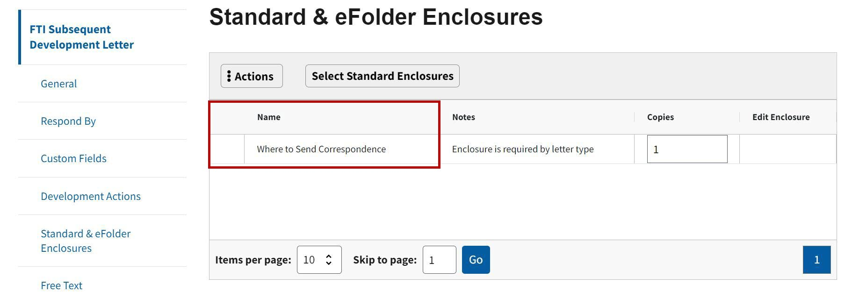

Step 5

Select the **Select eFolder Enclosures** button to add eFolder enclosures. Refer to Figure 24.

Figure : Select eFolder Enclosures Button

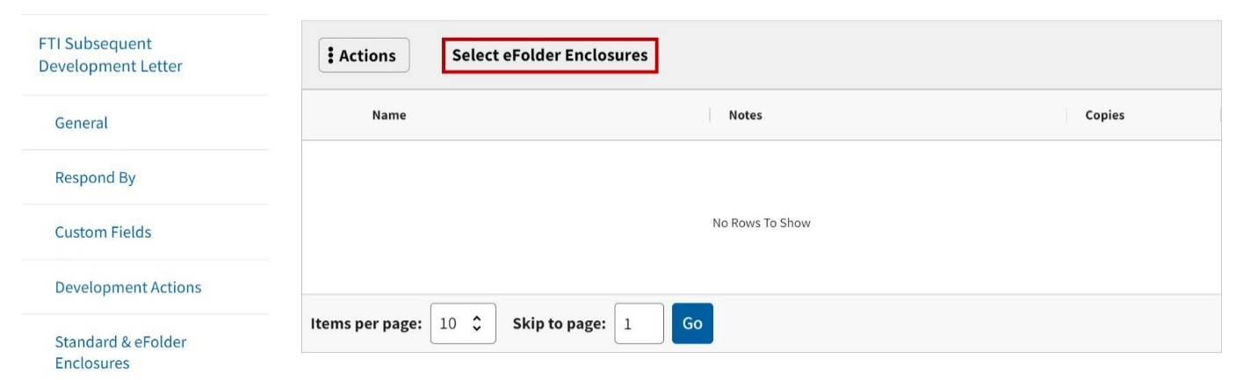

Step 6

The **Select eFolder Enclosures** modal will open. Search for and select the enclosures from the **Choose** **a Enclosure(s) Type Receipt Date** field. Select the **Add** button. Refer to Figure 25.

Figure : Select eFolder Enclosures Modal

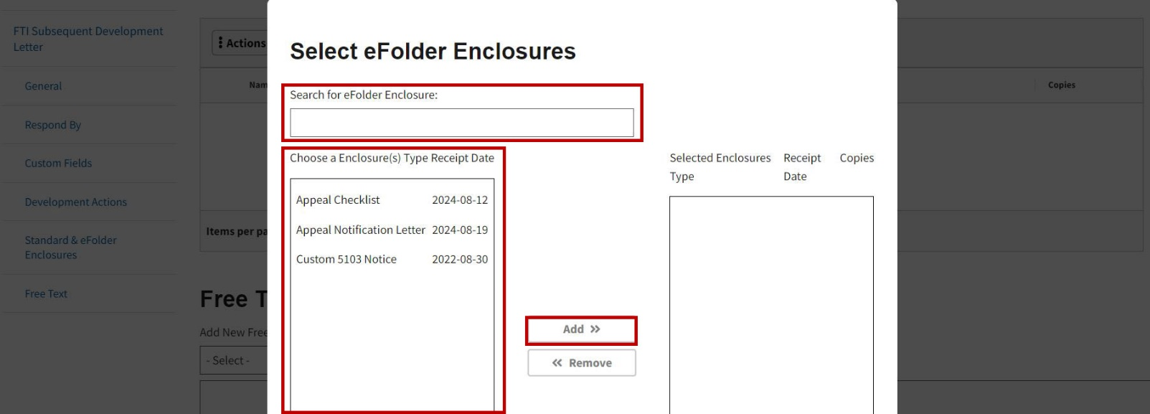

**Note:** eFolder Enclosures will appear on the eFolder Enclosure page only if documents are manually uploaded by the user.

### Free Text

Step 1

Navigate to the **Free Text** section and select an item from the drop-down menu. Refer to Figure 26.

Figure : Free Text Section

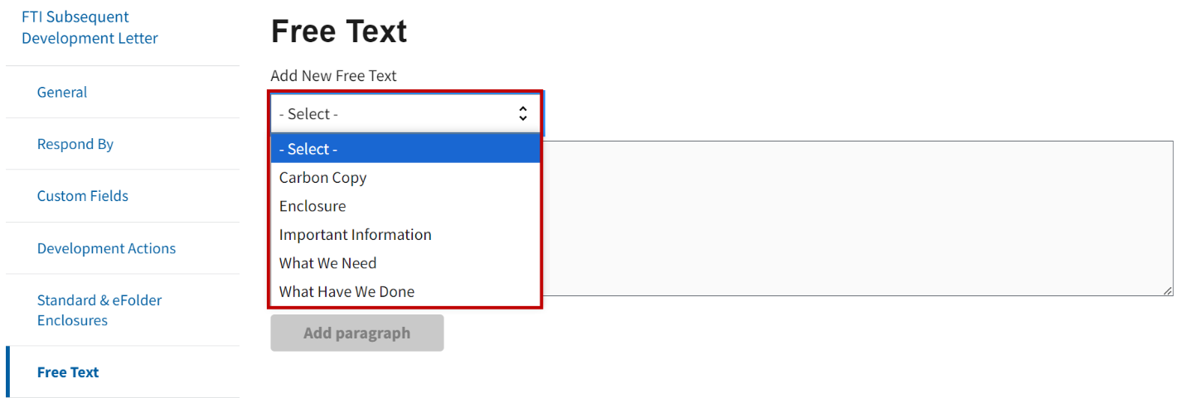

Step 2

Enter relevant information in the Add New Free Text field, then select the **Add paragraph** button. Refer to Figure 27.

Figure : Free Text Field

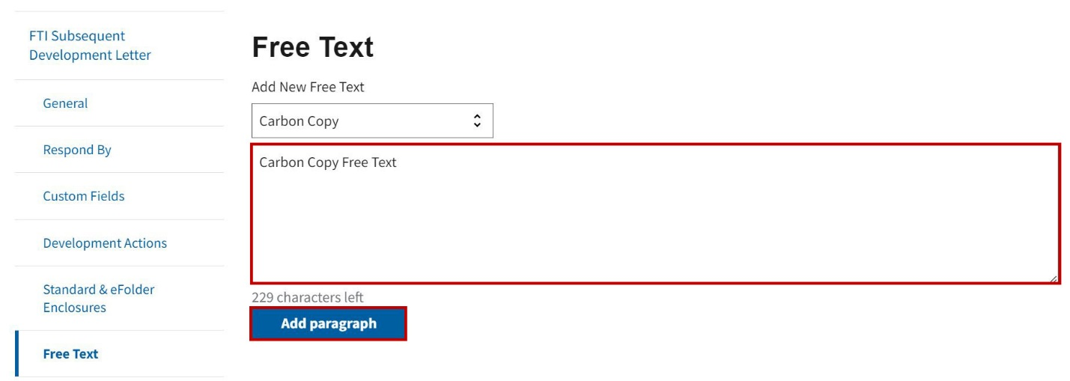

**Note:** Each category can only be used once by users, and the Free Text can only be added by selecting the Add Paragraph button upon completion.

### Previewing or Deleting the Letter

Select the **Preview** or **Delete** button to preview or delete the letter. Refer to Figure 28.

Figure : Preview and Delete Buttons

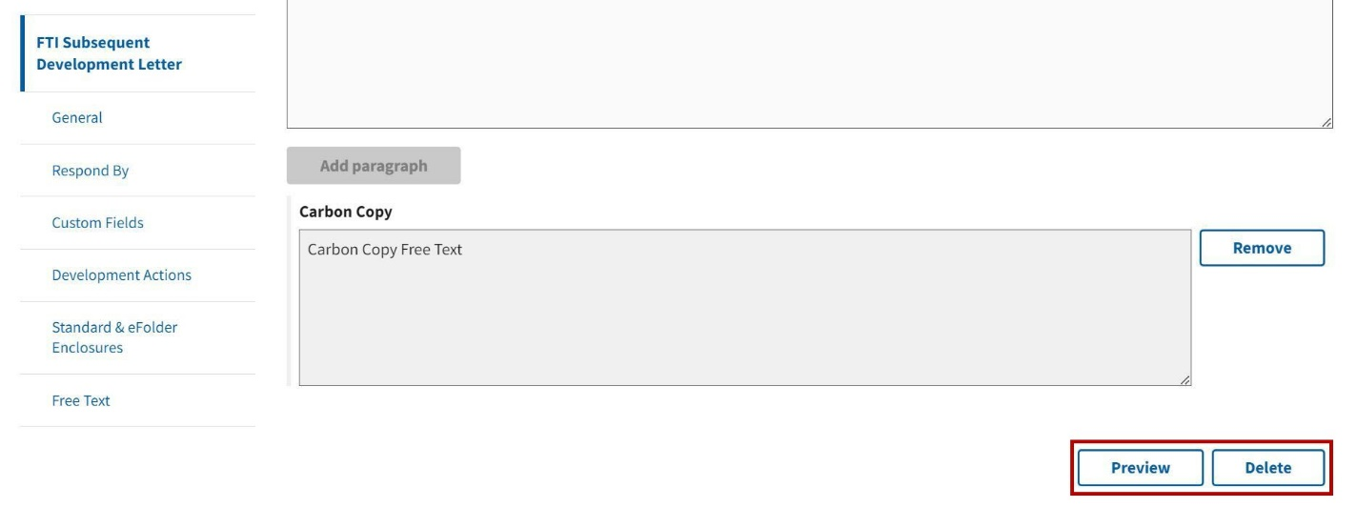

**Note:** If **Preview** is selected, a new tab will open in the browser displaying the completed letter in PDF format. If **Delete** is selected, the user will receive a prompt to confirm they want to delete the letter. Once the user confirms they would like to delete the letter, the letter will be deleted, and the user will be returned to the Letters List page.

### Saving the Letter

Select the **Save and Continue** button once all of the required fields are complete. Refer to Figure 29.

Figure : Save and Continue Button

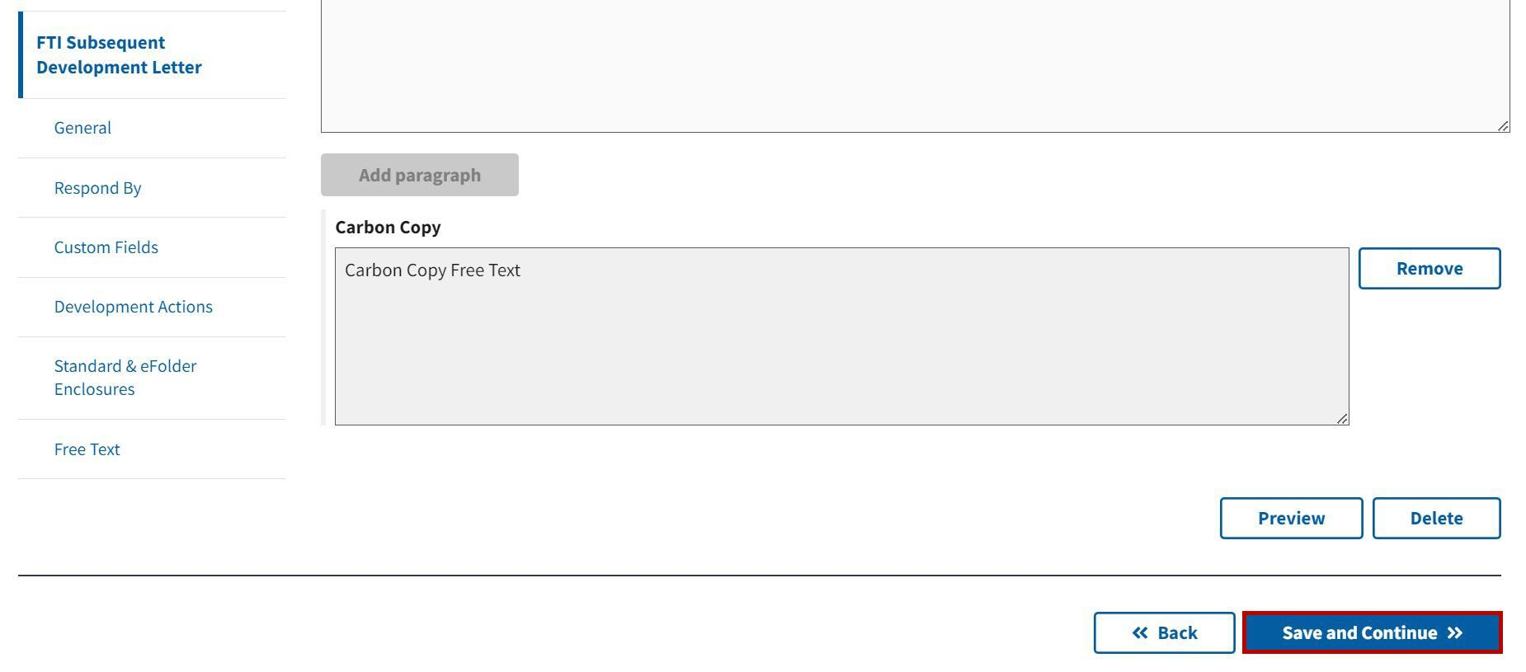

A success banner will appear on the Letters List page, notifying the user that the letter has successfully been saved. The FTI Subsequent Development Letter will appear in the letters list page to be finalized. Refer to Figure 30.

Figure : Success Banner

