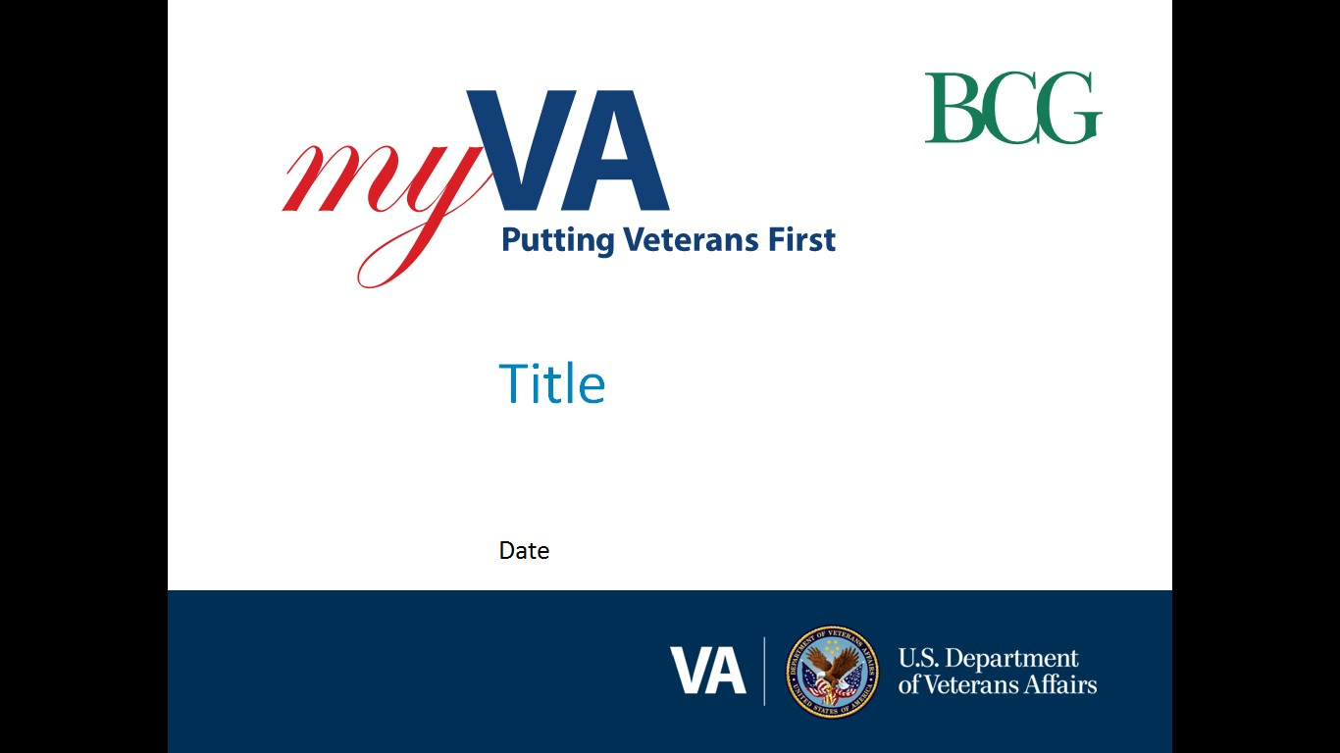

**Pension and Fiduciary Service (P&F)**

|  |  |
| --- | --- |
| Pension Quality Call | Date: September 24, 2024TMS: # VA 4665599 |

|  |  |
| --- | --- |
| AGENDA TOPICS ITEM 1: STAR ERROR TRENDS  ITEM 2: PACT ACT UPDATES  ITEM 3: ACCRUED NOTIFICATION REMINDERS  ITEM 4: ACCRUED BENEFITS – POLICY AND PROCEDURES  ITEM 5: QUALITY CALL Q&A  CLOSING, QUESTIONS, NEXT QUALITY CALL |  |

# AGENDA ITEMS

|  |  |  |  |
| --- | --- | --- | --- |
| Agenda item: | STAR Error Trends |  | **Presenter**: Jennifer Kunkel, Analyst |

#### Target Audience: Quality Review Team (QRT) and Management

#### Discussion:

A trend analysis was conducted of the errors cited on National STAR Pension Quality Reviews completed between the months of **July 2024 and August 2024** (transactions completed between June 1, 2024, through July 31, 2024). STAR reviews are performed the month after a claim is completed.

|  |  |  |  |  |  |  |  |
| --- | --- | --- | --- | --- | --- | --- | --- |
| **Review Month** | **Review Category** | **Total Reviewed** | **Total # of Errors** | **# Claims in Error** | **BE Errors** | **Recons Submitted** | **BE Accuracy %** |
| Jul | Authorization | 25 | 8 | 3 | 3 | 0 | 92% |
| Rating | 22 | 5 | 4 | 1 | 2 | 95.45% |
| Total | **47** | **13** | **7** | **4** | **2** |  |
| Aug | Authorization | 25 | 3 | 3 | 0 | 1 | 100% |
| Rating | 22 | 11 | 8 | 2 | 0 | 90.91% |
| Total | **47** | **14** | **11** | **2** | **1** |  |

Out of a total of **94** claims reviewed for quality, **18** claims had a total of **27** errors cited; **6** of those claims had BE errors.

**3** reconsiderations (recons) were submitted. One non-BE recon was upheld, two are still pending.

The **27** cited errors were within the following categories:

|  |  |  |  |
| --- | --- | --- | --- |
| **Jul Reviews** | | **Aug Reviews** | |
| BE | Non-BE | BE | Non-BE |
| |  | | --- | | 1 Burial | | 2 Income | | 1 MOD | |  | | |  | | --- | | 1 Accrued | | 2 Income | | 1 Net Worth | | 5 Notification | | |  | | --- | | 1 Income | |  | |  | | |  | | --- | | 2 Accrued | | 1 Income | | 3 Notification | | 5 Procedural | | 1 Basic Eligibility | |  | |

The *Error Drill Down* graph below shows a breakdown of the error categories:

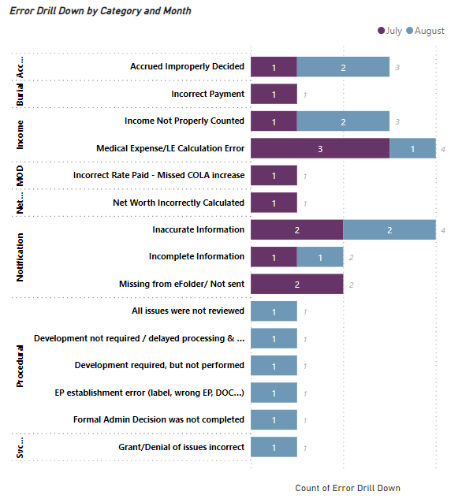

Notification errors were the highest cited category in July. However, procedural errors were the highest cited category in August.

Inaccurate notification letters continue to be the highest area of notification errors. Please be sure to include all appropriate attachments and proofread your letter for accuracy before releasing. Additionally, there has been a rise in errors for failing to address substitution when there was a claim pending at the time of death; please be sure accrued and substitution is properly addressed in notification letters.

Procedural and income counting/medical expense errors are the next highest categories of cited errors. The majority (67%) of the BE errors cited during this time were associated with the inaccurate counting of income or medical expenses. Procedural issues included: clearing incorrect EPs, development on a claim when the most recent SSA inquiry shows the Veteran had passed away and failing to upload the SSA match memo and calculator to the eFolder.

Please remind VSRs to review claims for ALL issues, perform complete development actions simultaneously to avoid avoidable claim delays, check that the claim is being processed under the correct EP(s) and that all evidence used to determine the claim (including administrative decisions, signature pages and calculations) are of record when needed.

It is important to communicate to claims processors they are reviewing their claims for issues that would cause BE errors, such as basic eligibility issues, income and medical calculations, income counting rules, effective dates, service eligibility and all claimed issues (like reviewing for A&A and incompetency). BE errors are rising, particularly on rating EPs, and increased BE errors in following months will cause accuracy to fall below national goals.

| References/Contacts |  |  |  |
| --- | --- | --- | --- |
| * STAR Reports |  | <https://vbaw.vba.va.gov/bl/21/star/reports/star_rptscurrent.htm> |  |
| * Pension STAR Dashboard |  | [Pension STAR Dashboard | Salesforce](https://va.lightning.force.com/lightning/r/Dashboard/01Z3d0000006l98EAA/view) |  |

|  |  |  |  |  |  |
| --- | --- | --- | --- | --- | --- |
| Agenda item: | PACT Act Updates |  | **Presenter**: Jennifer Kunkel, Analyst |  |  |

#### Discussion:

***Recent Key-Releases and Events:***

* July 15, 2024 – DOD released new features in ILER:
  + New Data: 50 million new Navy deployment records from Defense Manpower Data Center (DMDC) were added.
  + Consolidated Deployment Reporting
  + Deployments for PACT Act covered countries or operations are now displayed in purple text to easily identify deployments which qualify for presumptive coverage.
  + Improved Location Searching
  + Easier Account Management: HIPPA/Cyber training course numbers have been added to the My Profile and Account Request pages. The requirement for annual training certificate dates has been removed, and there will be no more emails or account locks due to expired training.
* July 17, 2024 – Updates to the ***ILER Guidance*** (v4) document. Available on the [CS PACT Act Intranet Page](https://vbaw.vba.va.gov/bl/21/pact.htm).
  + Changes and additions to the *ILER Guidance* are highlighted within the document.
* July 17, 2024 – SOP v5. (*Reminder*) This is the most current version.
* July 17, 2024 – ***TERA Exception Job Aid*** (v4)
  + Changes and additions to the *TERA Exception Job Aid* are highlighted within the document.
* July 19, 2024 – **Comp. Service’s** ***FAQ*** document updated.
  + Removed the Survivor Claims category within their FAQ in lieu of P&F’s updated FAQ document on the [P&F PACT Intranet page](https://vbaw.vba.va.gov/pensionandfiduciary/pact-act.asp).
  + Guidance related to TERA/MOS and TERA/noise exposure are currently under policy review. Questions in the FAQ related to TERA/MOS and TERA/noise exposure have been temporarily removed from the PACT Act FAQs and will be re-added once policy can be further clarified.
* July 24, 2024 -- Comp. Service updated the ***TERA Memorandum*** (v2).
  + Newest version is available on the [CS PACT intranet page](https://vbaw.vba.va.gov/bl/21/pact.htm) and attached with this bulletin. Please be sure claim processors are using the most updated version of the memo.

***M21-1 Updates Related to PACT***

* [VIII.i.1.B.1.i. Conditions Determined to Have No Positive Association With Herbicide Exposure](https://vaww.vrm.km.va.gov/system/templates/selfservice/va_kanew/help/agent/locale/en-US/portal/554400000001034/content/554400000177423/M21-1-Part-VIII-Subpart-i-Chapter-1-Section-B-Ratings-for-Disabilities-Associated-with-Herbicide-Exposure)

* [XI.ii.1.1 Referring Claims Involving Death After Service](https://vaww.vrm.km.va.gov/system/templates/selfservice/va_kanew/help/agent/locale/en-US/portal/554400000001034/content/554400000174189/M21-1-Part-XI-Subpart-ii-Chapter-1-Referral-for-Consideration-of-Survivors-Benefits)
  + Updated for implicit reviews of SC death:
    - XI.ii.1.1.c. Award of Survivors Pension Prior to Rating Decision Regarding SC Death
    - XI.ii.1.1.d. Specific Situations in Which Survivors Benefits Claims Must Be Referred to the Rating Activity
  + New sections added for implicit reviews of SC death:
    - XI.ii.1.1.e. Determining When a Review for Implicit SC for the Cause of Death Is Needed and Referring the Claim to the Rating Activity
    - XI.ii.1.1.f. Rating Activity’s Responsibilities Upon Review of an Implicit Claim for SC Death

* [XI.iii.1.B.3.c](https://vaww.vrm.km.va.gov/system/templates/selfservice/va_kanew/help/agent/locale/en-US/portal/554400000001034/content/554400000174201/M21-1-Part-XI-Subpart-iii-Chapter-1-Section-B-Burial-Benefits)[.  Referring a Claim for NSC Burial Allowance to the Rating Activity](https://vaww.vrm.km.va.gov/system/templates/selfservice/va_kanew/help/agent/locale/en-US/portal/554400000001034/content/554400000174201/M21-1-Part-XI-Subpart-iii-Chapter-1-Section-B-Burial-Benefits)

Please direct all PACT related questions to the FIT tool and select the PACT category.

| References/Contacts |  |  |  |
| --- | --- | --- | --- |
| * PMC Intranet Site |  | [PACT Act - Pension and Fiduciary Service (va.gov)](https://vbaw.vba.va.gov/pensionandfiduciary/pact-act.asp) |  |
| * CS Intranet Site |  | [PACT Act Information Page (va.gov)](https://vbaw.vba.va.gov/bl/21/pact.htm) |  |
| * Questions |  | [Field Inquiry Tool](https://gcc02.safelinks.protection.outlook.com/?url=https%3A%2F%2Fapps.gov.powerapps.us%2Fplay%2Fe%2Fdefault-e95f1b23-abaf-45ee-821d-b7ab251ab3bf%2Fa%2F0a333bae-1e5d-446f-b2d1-c25be963c99d%3FtenantId%3De95f1b23-abaf-45ee-821d-b7ab251ab3bf%26source%3Dportal&data=05%7C01%7C%7C4001aa0a69394c00f80908db518a1cd8%7Ce95f1b23abaf45ee821db7ab251ab3bf%7C0%7C0%7C638193425846402036%7CUnknown%7CTWFpbGZsb3d8eyJWIjoiMC4wLjAwMDAiLCJQIjoiV2luMzIiLCJBTiI6Ik1haWwiLCJXVCI6Mn0%3D%7C3000%7C%7C%7C&sdata=FkFpCbtdbRGl4EvZsKlCdLCum41gTxJ8pl8PJACuWJ4%3D&reserved=0)(FIT). |  |



|  |  |  |  |
| --- | --- | --- | --- |
| Agenda item: | Accrued Notification Reminders |  | **Presenter:** Chelsey Carlin, Analyst |

#### Discussion:

As part of the trend analysis noted in the STAR errors, inaccurate notification letters continue to provide the highest error rate amongst the PMCs. Inaccurate or premature decisions regarding the issue of accrued benefits was one of the trends identified while conducting monthly STAR reviews on initial survivor claims. VA Form 21P-534EZ is considered a non-discretionary application, and VA is obligated to address the claimant’s entitlement to all benefits per [M21-1 II.iii.1.A.3.e](https://vaww.vrm.km.va.gov/system/templates/selfservice/va_kanew/help/agent/locale/en-US/portal/554400000001034/content/554400000174869/M21-1-Part-II-Subpart-iii-Chapter-1-Section-A-Applications-for-Benefits) and substitution per [38 CFR 3.1010(c)(2)](https://​/​www.ecfr.gov/​current/​title-38/​part-3/​subpart-A#p-3.1010(c)(2)). Recurring non-BE errors are being cited for incorrectly addressing accrued and substitution benefits when a claim was pending at the time of death.

[M21-1 XI.ii.3.A.2.a](https://vaww.vrm.km.va.gov/system/templates/selfservice/va_kanew/help/agent/locale/en-US/portal/554400000001034/content/554400000174192/M21-1-Part-XI-Subpart-ii-Chapter-3-Section-A-Entitlement-to-Accrued-Benefits-Under-38-USC-5121) (and [38 CFR 3.1000(d)(5)](https://www.ecfr.gov/current/title-38/part-3/section-3.1000#p-3.1000(d)(5))), defines a claim that had not been finally adjudicated on or before the date of death. This includes a deceased claimant’s:

1. Initial claim
2. Informal claim received prior to March 24, 2015
3. Supplemental claim
4. Request for an HLR
5. Claim to raise a clear and unmistakable error in a prior rating or decision
6. Claim in which funds were withheld pending appointment of a fiduciary, OR
7. Claim in which the period to file a review option has not yet expired.

In these instances, VA may not administratively deny accrued benefits. Instead, the notification letter must indicate that the deceased beneficiary’s claim or appeal was not finalized at the time of passing while simultaneously deciding substitution using the language provided within [M21-1 XI.ii.3.C.5.d](https://vaww.vrm.km.va.gov/system/templates/selfservice/va_kanew/help/agent/locale/en-US/portal/554400000001034/content/554400000174206/M21-1-Part-XI-Subpart-ii-Chapter-3-Section-C-Development-for-Accrued-and-Requests-for-Substitution), and when applicable, provide the appropriate timeline for a substitute claimant to take action following guidance provided under [M21-1 XI.ii.3.B.3.a](https://vaww.vrm.km.va.gov/system/templates/selfservice/va_kanew/help/agent/locale/en-US/portal/554400000001034/content/554400000174205/M21-1-Part-XI-Subpart-ii-Chapter-3-Section-B-Substitution-in-Case-of-Death-of-Claimant). In cases where VA cannot grant substitution, notification that the issue of accrued and substitution eligibility is being deferred for further review and that the claimant will receive separate notification must be included. See [M21-1 XI.ii.3.E.17.c](https://vaww.vrm.km.va.gov/system/templates/selfservice/va_kanew/help/agent/locale/en-US/portal/554400000001034/content/554400000174208/M21-1-Part-XI-Subpart-ii-Chapter-3-Section-E-Accrued-Authorization-and-Notification) for additional guidance on jurisdiction and EP control.

If the issue pending at the time of death was a compensation issue, substitution should still be decided with notification that the issue of accrued benefits is deferred.

It is important to remember that, by the definition above, and specifically in the situation noted in (g), a claim that had an EP closed and decided (with a letter) is considered **not yet** finally adjudicated **until** the expiration of the review period ([38 CFR 3.160(d)](https://www.ecfr.gov/current/title-38/part-3#p-3.160(d))); or, in other words, one year after the notification letter with review rights provided for that decision is issued ([38 CFR 3.2500(a)](https://www.ecfr.gov/current/title-38/part-3/section-3.2500#p-3.2500(a))). In these specific instances:

* It is acceptable for VA to administratively deny accrued,
* grant substitution (if the claimant is eligible) for the review period that was not completed prior to the deceased’s passing in the notification letter, and
* provide the remaining time limit the claimant has to file a review.

Additional guidance can be found in [M21-1 XI.ii.3.B.3.a](https://vaww.vrm.km.va.gov/system/templates/selfservice/va_kanew/help/agent/locale/en-US/portal/554400000001034/content/554400000174205/M21-1-Part-XI-Subpart-ii-Chapter-3-Section-B-Substitution-in-Case-of-Death-of-Claimant?query=undefined) and [M21-1 XI.ii.3.B.3.c](https://vaww.vrm.km.va.gov/system/templates/selfservice/va_kanew/help/agent/locale/en-US/portal/554400000001034/content/554400000174205/M21-1-Part-XI-Subpart-ii-Chapter-3-Section-B-Substitution-in-Case-of-Death-of-Claimant?query=undefined).

|  |  |  |  |
| --- | --- | --- | --- |
| Agenda item: | Accrued Benefits – Policy and Procedures |  | **Presenter:** Robert Pomarico, Analyst |

#### Target Audience: QRT and Management

#### Discussion:

In August 2024, P&F updated several manual references regarding accrued benefits and substitution. Prior to the change, accrued/substitution claims based on reimbursement required verification of paid expenses, such as a receipt for funeral expenses, to be considered a complete claim. On August 12, that changed. We *do* still need verification of expenses to grant accrued benefits based on reimbursement, but we do not need the verification to consider the claim complete.

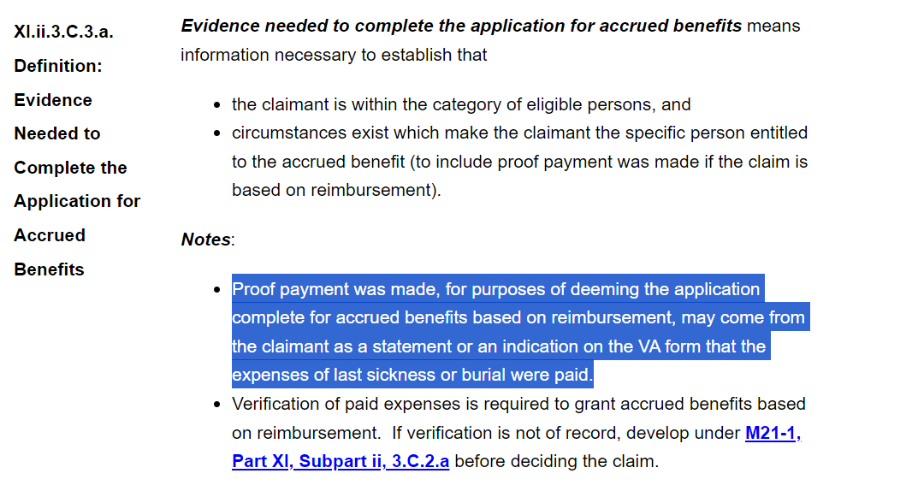

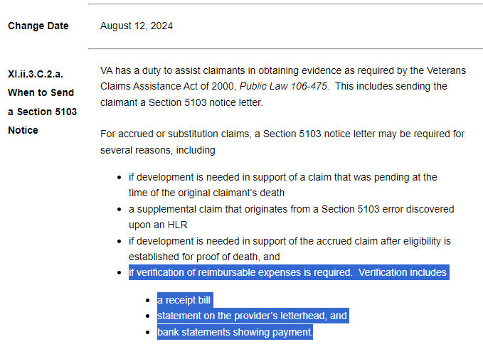

|  |  |  |  |
| --- | --- | --- | --- |
| Agenda item: | Quality Call Q&A |  |  |

#### Target Audience: QRT and Management

**Question 1:** If a claimant is in receipt of a compensation award and we receive a claim for pension and we recognize that compensation is the higher benefit, what are the proper procedures for the PMCs to follow?

* Does P&F agree with the following?:  If we can make a decision on pension, we should do so, even if we know compensation will be the greater benefit, because it then gives the claimant the option to elect between the two benefits ([M21-1 VI.ii.1.A.2.A](https://gcc02.safelinks.protection.outlook.com/?url=https%3A%2F%2Fvaww.vrm.km.va.gov%2Fsystem%2Ftemplates%2Fselfservice%2Fva_kanew%2Fhelp%2Fagent%2Flocale%2Fen-US%2Fportal%2F554400000001034%2Fcontent%2F554400000179475%2FM21-1-Part-VI-Subpart-ii-Chapter-1-Section-A-General-Information-on-Elections&data=05%7C02%7C%7C9be5cca6fc7f4068407308dccc18a364%7Ce95f1b23abaf45ee821db7ab251ab3bf%7C0%7C0%7C638609653395574290%7CUnknown%7CTWFpbGZsb3d8eyJWIjoiMC4wLjAwMDAiLCJQIjoiV2luMzIiLCJBTiI6Ik1haWwiLCJXVCI6Mn0%3D%7C0%7C%7C%7C&sdata=VOvCSeww9HLUsc0LFX8HnFs%2F4rI35KXOCEFRiaFI%2FGw%3D&reserved=0). Elections Between Compensation and Pension).  The thinking behind this is you can’t elect between the two benefits unless a formal decision is made and only providing a notice that “compensation is the higher rate” is not a formal decision on pension. We have come across situations where a formal decision on pension is not made where the claims processor simply states that compensation is the greater benefit without an evaluation of whether the claimant is entitled to pension.  The concern with that is it’s not a formal decision on pension and the claimant cannot elect between the two benefits. In situations like this where we receive a pension claim and compensation is the greater benefit, we believe that the proper way to address pension is to make a formal decision on pension based on the evidence of record.  Even if could grant pension based on the evidence of record, we would notify the claimant that we are continuing to pay compensation as the higher rate and to let us know if they would like to elect the lesser benefit.  Does P&F agree with this?
  + Furthermore, if development was needed to decide the pension claim, how should we be handling that? By developing in a case where we know compensation is the greater benefit, we would be delaying the claim for pension. Should we be developing the pension claim so we can make a formal decision? Is there a proper procedure to follow in this type of situation?

**P&F Response:** VA must address a claimant’s entitlement to each benefit that is applied for and/or named in the title of the application submitted by the claimant. This is a statutory requirement codified at [38 U.S.C. § 5101(b)(1)](https://www.govinfo.gov/content/pkg/USCODE-2022-title38/pdf/USCODE-2022-title38-partIV-chap51-subchapI-sec5101.pdf). If there is sufficient evidence on record to render a decision then one must be provided, even if it is known that entitlement to a greater benefit exists. At this time, there is no legal provision that would allow VA to not render a decision on a Veteran claiming pension when they are in receipt of compensation.

**Question 2:** When will the manual reference ([M21-1 X.ii.6.D.3.b.](https://gcc02.safelinks.protection.outlook.com/?url=https%3A%2F%2Fvaww.vrm.km.va.gov%2Fsystem%2Ftemplates%2Fselfservice%2Fva_kanew%2Fhelp%2Fagent%2Flocale%2Fen-US%2Fportal%2F554400000001034%2Fcontent%2F554400000177977%2FM21-1-Part-X-Subpart-ii-Chapter-6-Section-D-Processing-Awards-to-Incompetent-Beneficiaries&data=05%7C02%7C%7C9be5cca6fc7f4068407308dccc18a364%7Ce95f1b23abaf45ee821db7ab251ab3bf%7C0%7C0%7C638609653395588920%7CUnknown%7CTWFpbGZsb3d8eyJWIjoiMC4wLjAwMDAiLCJQIjoiV2luMzIiLCJBTiI6Ik1haWwiLCJXVCI6Mn0%3D%7C0%7C%7C%7C&sdata=dFKq5EXHMhV9oH1MAdCPLj%2FVabjGX7wPXjfyWYivibQ%3D&reserved=0)Text to Include in a Notice of a Proposed Rating of Incompetency) be updated to reflect the language included in the proposal of incompetency template letter that was sent to the field from OFO in the email dated 7/9/24 **(Subject:** Updated Incompetency Letters)?

**P&F Response:** Please, see Response 1. If there is not sufficient evidence on record to provide a decision on pension benefits, then development is likely required. In the process of development, the claimant may be notified that they are applying for a lesser benefit and that VA will “assume election of the greater benefit, unless the claimant provides information to the contrary” and to “routinely award the greater benefit at any time *without* requiring a formal election or reelection” Per [M21-1 VI.ii.1.A.2.A.](https://www.knowva.ebenefits.va.gov/system/templates/selfservice/va_ssnew/help/customer/locale/en-US/portal/554400000001018/content/554400000179475/M21-1-Part-VI-Subpart-ii-Chapter-1-Section-A-General-Information-on-Elections) If the claimant indicates that they would like to continue pursuing the claim either by the provision of additional documentation, or through written and/or verbal confirmation that a decision must be rendered. Again, claims processors must assume election of the greater benefit unless there is clear evidence indicating the claimant is electing the lesser benefit. An election for the lesser benefit will not be inferred.

**Question 3:** When will the manual reference ([M21-1 X.ii.6.D.3.b.](https://gcc02.safelinks.protection.outlook.com/?url=https%3A%2F%2Fvaww.vrm.km.va.gov%2Fsystem%2Ftemplates%2Fselfservice%2Fva_kanew%2Fhelp%2Fagent%2Flocale%2Fen-US%2Fportal%2F554400000001034%2Fcontent%2F554400000177977%2FM21-1-Part-X-Subpart-ii-Chapter-6-Section-D-Processing-Awards-to-Incompetent-Beneficiaries&data=05%7C02%7C%7C9be5cca6fc7f4068407308dccc18a364%7Ce95f1b23abaf45ee821db7ab251ab3bf%7C0%7C0%7C638609653395588920%7CUnknown%7CTWFpbGZsb3d8eyJWIjoiMC4wLjAwMDAiLCJQIjoiV2luMzIiLCJBTiI6Ik1haWwiLCJXVCI6Mn0%3D%7C0%7C%7C%7C&sdata=dFKq5EXHMhV9oH1MAdCPLj%2FVabjGX7wPXjfyWYivibQ%3D&reserved=0)Text to Include in a Notice of a Proposed Rating of Incompetency) be updated to reflect the language included in the proposal of incompetency template letter that was sent to the field from OFO in the email dated 7/9/24 **(Subject:** Updated Incompetency Letters)?

**P&F Response:** P&F identifies that the field must follow the guidance provided on July 9, 2024, by the Office of Field Operations regarding utilization of letters provided. Additionally, P&F is reviewing [M21-1 X.ii.6.D.3.b](https://gcc02.safelinks.protection.outlook.com/?url=https%3A%2F%2Fvaww.vrm.km.va.gov%2Fsystem%2Ftemplates%2Fselfservice%2Fva_kanew%2Fhelp%2Fagent%2Flocale%2Fen-US%2Fportal%2F554400000001034%2Fcontent%2F554400000177977%2FM21-1-Part-X-Subpart-ii-Chapter-6-Section-D-Processing-Awards-to-Incompetent-Beneficiaries&data=05%7C02%7C%7C9be5cca6fc7f4068407308dccc18a364%7Ce95f1b23abaf45ee821db7ab251ab3bf%7C0%7C0%7C638609653395588920%7CUnknown%7CTWFpbGZsb3d8eyJWIjoiMC4wLjAwMDAiLCJQIjoiV2luMzIiLCJBTiI6Ik1haWwiLCJXVCI6Mn0%3D%7C0%7C%7C%7C&sdata=dFKq5EXHMhV9oH1MAdCPLj%2FVabjGX7wPXjfyWYivibQ%3D&reserved=0).

***Note****:* If a manual change is implemented, you will be notified via the Compensation Service Calendar email blast. To subscribe to this email blast, visit the [Calendar Subscriptions](http://vbacoweb03.dva.va.gov/bl/21/Calendar/cal_Subscribe.asp) website.

**Field Question During Quality Call:** We will make a decision on a request for substitution (no standard form required per XI.ii.3.C.1.b.) when we receive a complete VAF 21-534EZ from a surviving spouse within a year of the Veteran's death, and the Veteran had claims where the review period had not yet expired. However, what is the lawful basis for not making a decision on a claim for accrued benefits when the required AMA review form has not been submitted per XI.ii.3.E.17.k. ?

I.e. why are we deferring a formal decision on accrued benefits when a proper AMA review form has not been submitted in these cases ? We are correctly addressing substitution as aforementioned and notifying the surviving spouse of the remaining time-limit for them to submit an AMA decision review form, which when received, then we can address a formal claim for accrued benefits. But without the required form, we have no basis for deferring a formal decision, and accordingly, would be incorrect to do so as I understand from reading the relevant references aforementioned. Therefore, shouldn't we grant substitution but deny accrued benefits in the interim until the required AMA review form is submitted as the correct procedure per the manual (XI.ii.3.B.3.c.)?

**P&F Response:** In cases where a Veteran’s claim was decided within one year of the Veteran’s death, and the survivor submitted only a complete 534EZ, the survivor has the right to request a decision review of the deceased Veteran’s claim or appeal that is not yet final (see [M21-1 XI.ii.3.A.2.a](https://vaww.vrm.km.va.gov/system/templates/selfservice/va_kanew/help/agent/locale/en-US/portal/554400000001034/content/554400000174192/M21-1-Part-XI-Subpart-ii-Chapter-3-Section-A-Entitlement-to-Accrued-Benefits-Under-38-USC-5121) and [38 CFR 3.1000 (d)(5)).](https://www.ecfr.gov/current/title-38/part-3#p-3.1000(d)(5)) However, the review request must be filed on the appropriate AMA form. In this scenario, VA should deny the accrued claim and decide substitution eligibility. Follow the guidance in [M21-1 XI.ii.3.B.3.c](https://vaww.vrm.km.va.gov/system/templates/selfservice/va_kanew/help/agent/locale/en-US/portal/554400000001034/content/554400000174205/M21-1-Part-XI-Subpart-ii-Chapter-3-Section-B-Substitution-in-Case-of-Death-of-Claimant?query=undefined).

Below is an example.

* **Example**: The Veteran submitted VA Form 21-526 on 04/15/24 requesting an increase in the PTSD rating currently at 30%. VA established an EP 020, and provided a decision with notification on 05/28/24, denying the request for increased rating. VA received notice that the Veteran passed away on 07/13/24, after the decision notice was issued.

VA received a 534EZ from the Veteran’s surviving spouse on 08/15/24, requesting survivors pension and accrued benefits. Review of the claim determined the surviving spouse was eligible for survivors pension benefits. Therefore, VA’s notification must include the following:

* + the award of survivors pension benefits,
  + administrative denial of DIC,
  + ***administrative denial of accrued benefits***
  + ***grant of substitution eligibility*** using the guidance in [M21-1 XI.ii.3.B.3.c](https://vaww.vrm.km.va.gov/system/templates/selfservice/va_kanew/help/agent/locale/en-US/portal/554400000001034/content/554400000174205/M21-1-Part-XI-Subpart-ii-Chapter-3-Section-B-Substitution-in-Case-of-Death-of-Claimant?query=undefined), and
  + ***provide the surviving spouse with the timeline*** to submit AMA review forms using the guidance in [M21-1 XI.ii.3.B.3.a](https://vaww.vrm.km.va.gov/system/templates/selfservice/va_kanew/help/agent/locale/en-US/portal/554400000001034/content/554400000174205/M21-1-Part-XI-Subpart-ii-Chapter-3-Section-B-Substitution-in-Case-of-Death-of-Claimant?query=undefined).

In this specific situation, VA must deny accrued benefits because the Veteran’s claim was decided prior to the Veteran’s passing and the applicable review rights were provided in the notification of that decision. Since VA has determined the claimant is the eligible surviving spouse, VA must grant substitution eligibility as a qualified claimant under [38 CFR 3.1000(a)(1)(i).](https://www.ecfr.gov/current/title-38/part-3#p-3.1000(a)(1)(i)) The surviving spouse is then required to submit a request for one of the review lanes that were communicated to the Veteran in the decision dated 05/28/24. The remaining timeline to submit such request must be included with the grant of substitution eligibility.

# Closing Comments

#### P&F Quality Call Topics:

#### We will solicit for agenda topic(s) for each future Quality Call. If you have a specific topic suggestion, please feel free to email it to the P&F Quality and Oversight mailbox at [PFTNGQUALOVRST.VBACO@va.gov](mailto:PFTNGQUALOVRST.VBACO@va.gov). For specific policy and procedures related topics, please send inquiries through the [Pension and Fiduciary - Field Inquiry Tracker (FIT) - Power Apps](https://apps.gov.powerapps.us/play/e/default-e95f1b23-abaf-45ee-821d-b7ab251ab3bf/a/020fd6a3-0920-4fdd-aa7f-b2738264218e?tenantId=e95f1b23-abaf-45ee-821d-b7ab251ab3bf&hint=3033d727-bd9a-4996-ad9e-1dbd7ed2be3c&sourcetime=1727662207701&source=portal).

#### Quality Call Bulletins

Quality Call Bulletins can be found within TMS along with call recordings. Once the monthly bulletin is finalized, information will be sent to the PMCs which will include the TMS #.

The next Quality Call is tentatively scheduled for November 2024.