

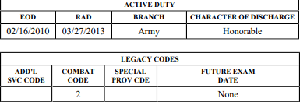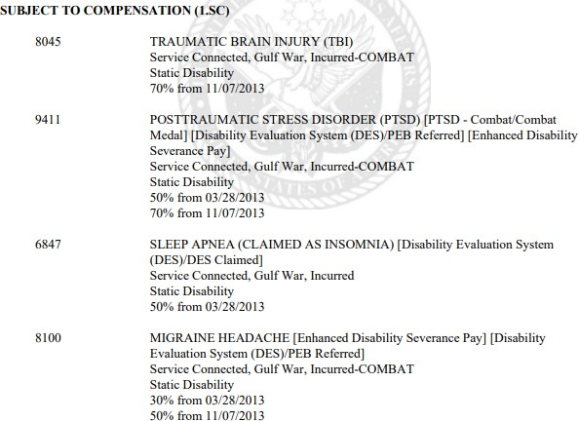

**38 USC 1318 SCENARIOS**

**38 USC 1318 Yes or No practice exercise. Please decide whether a grant of**

**beneﬁts under 38 USC 1318 is warranted.**

1. Veteran died February 27, 2023, death certiﬁcate list primary cause of death as acute hypoxic respiratory failure and Covid, there are no contributory causes of death listed on death certiﬁcate. The last Rating Decision prior to death details the following information:

**Is 38 USC 1318 warranted, Yes or No?**

**ANSWER: Yes.** Though on the surface the Veteran is not eligible for 1318

under the 10 year rule. they are about 1 month short, we must look into all facets of 1318 entitlement. They have entitlement to 1318 under the 5-year total evaluation following release from active-duty rule.

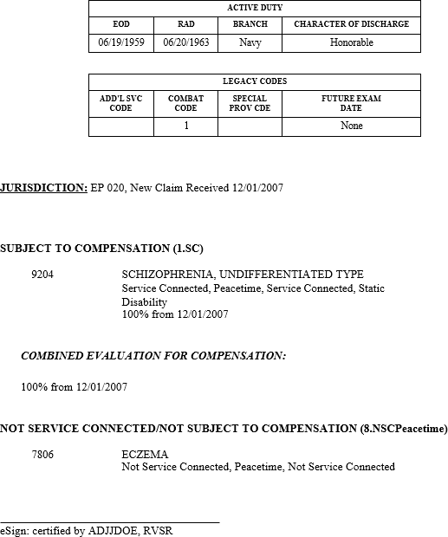

2. Veteran died March 27, 2023, death certificate list primary cause of

death as self-inﬂicted gunshot wound, there are no contributory causes of death listed on death certificate. The last Rating Decision prior to death details the following information:

**Is 38 USC 1318 warranted, Yes or No?**

**ANSWER: Yes.** The Veteran had a total evaluation of over 10 years to have claimants qualify for 38 USC 1318 DIC.

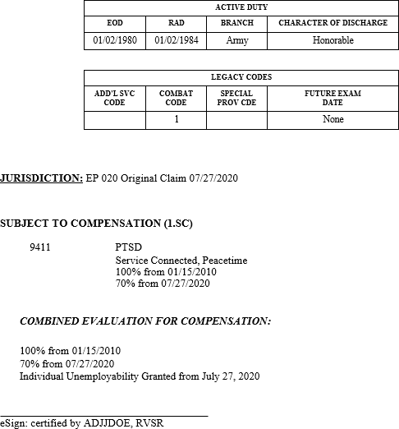

3. Veteran died July 27, 2023, death certificate list primary cause of death

as cardiopulmonary failure, there are no contributory causes of death listed on death certificate. The last Rating Decision prior to death details the following information:

**Is 38 USC 1318 warranted, Yes or No?**

**ANSWER: Yes.** The Veteran had a total evaluation of over 10 years to have claimants qualify for 38 USC 1318 DIC. Don’t be confused with the combined 100% dropping to 70% on July 27, 2020. The Veteran had a continuous total evaluation starting January 15, 2010. The term total evaluation encompasses both a 100% and a grant of IU.

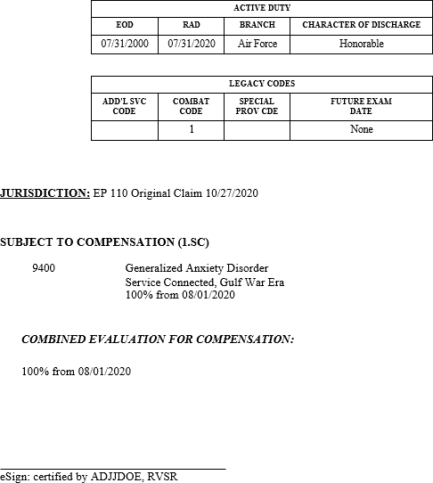

4. Veteran died June 21, 2024, death certificate list primary cause of death

as bacterial pneumonia, there are no contributory causes of death listed on death certificate. The Veteran only has no presumptive locations noted and the TERA Memo is negative. The last Rating Decision prior to death details the following information:

**Is 38 USC 1318 warranted, Yes or No?**

**ANSWER: No.** The Veteran had a total evaluation, but it was short of 10

years. The Veteran also had a total evaluation following separation from service, however this was short of 5 years.