Slide 1 - Minor Beneficiary Awards
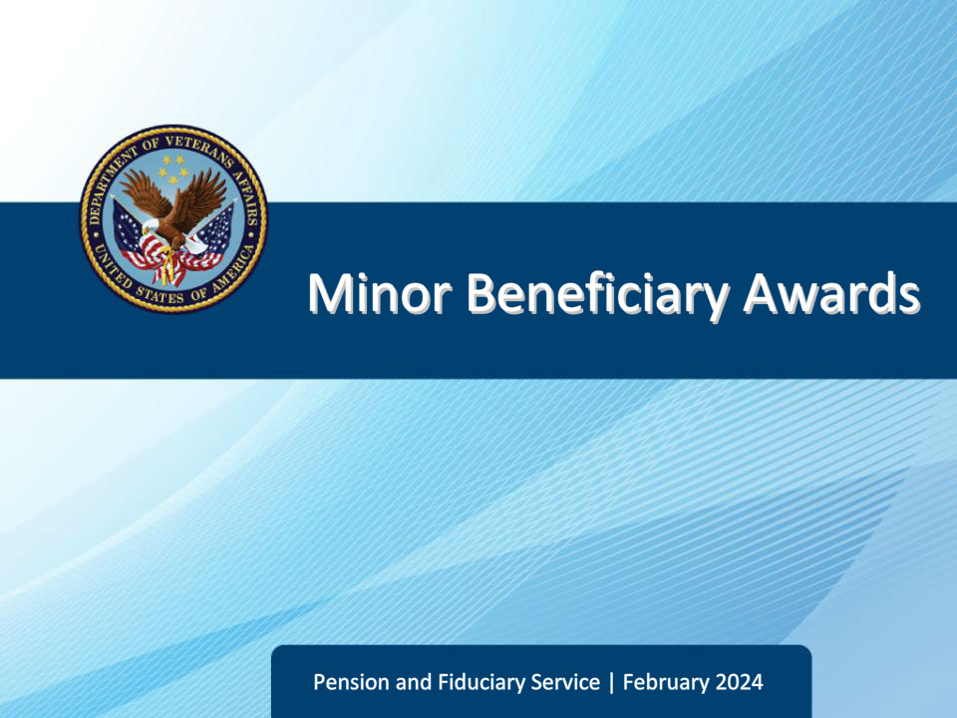
Slide notes

Instructor Notes:

Welcome to our training on ‘Minor Beneficiary Awards.’ Our objectives focus on understanding key regulations, comprehending fiduciary processes, and identifying specific procedures for minors’ awards.

Slide 2 - Navigation
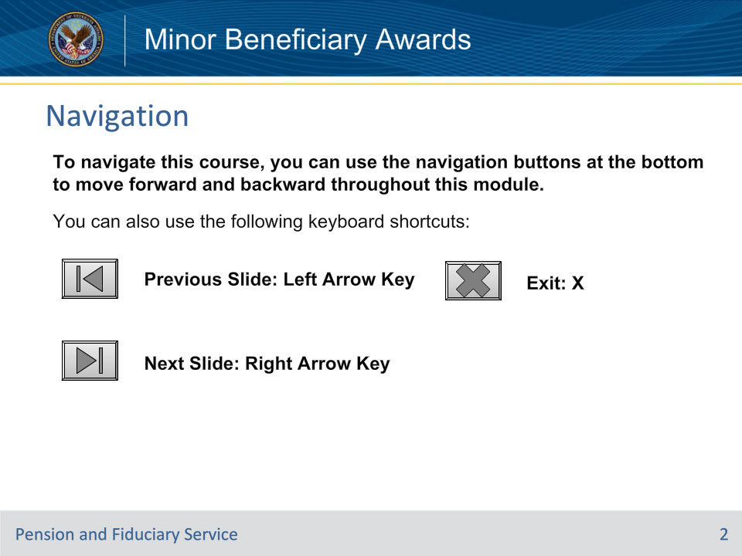
Slide notes

To navigate this course, you can use the navigation buttons at the bottom to move forward and backward throughout this module.

You can also use the following keyboard shortcuts:

• Previous Slide: Left Arrow Key

• Next Slide: Right Arrow Key

• Exit: X

• Comments: T

Slide 3 - Objectives
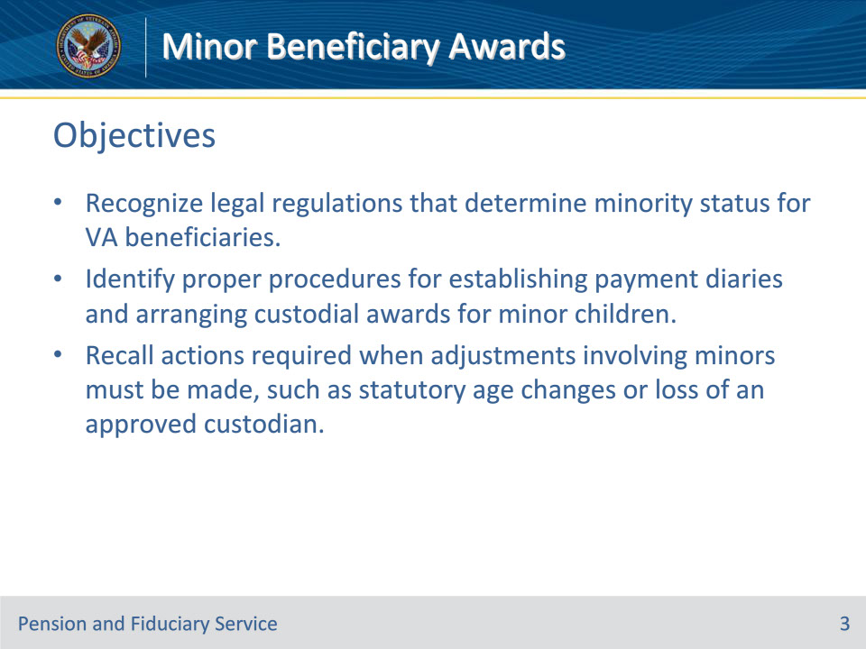
Slide notes

Instructor Notes:

By the end of this lesson, given the instruction and knowledge checks, the student will be able to do the following:

• Recognize legal regulations that determine minority status for VA beneficiaries.

• Identify proper procedures for establishing payment diaries and arranging custodial awards for minor children.

• Recall actions required when adjustments involving minors must be made, such as statutory age changes or loss of an approved custodian.

Slide 4 - References
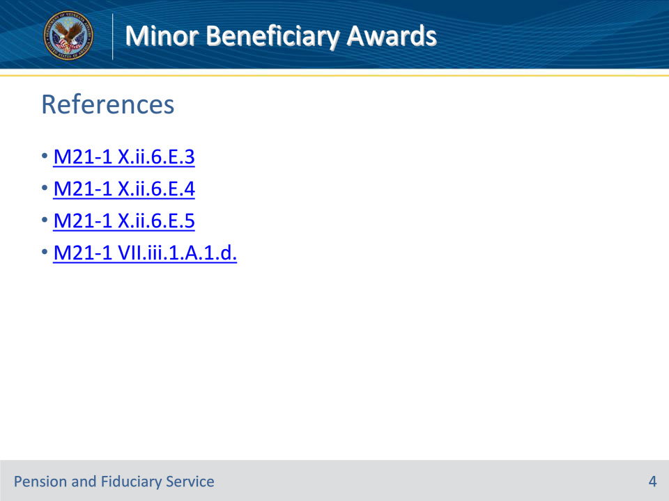
Slide notes

Instructor Notes:

These are the relevant references of this training:

M21-1 X.ii.6.E.3 Controlling Awards for Children

M21-1 X.ii.6.E.4 Authorizing Awards Involving a Custodian Under 38 U.S.C. 5502

M21-1 X.ii.6.E.5 Authorizing Awards Involving a Native American Minor or Incompetent Adult Under 38 CFR 13.100

M21-1 VII.iii.1.A.1.d. Regulations Under Which VA May Apportion Benefits

Slide 5 - Authority for Determining Minority Status
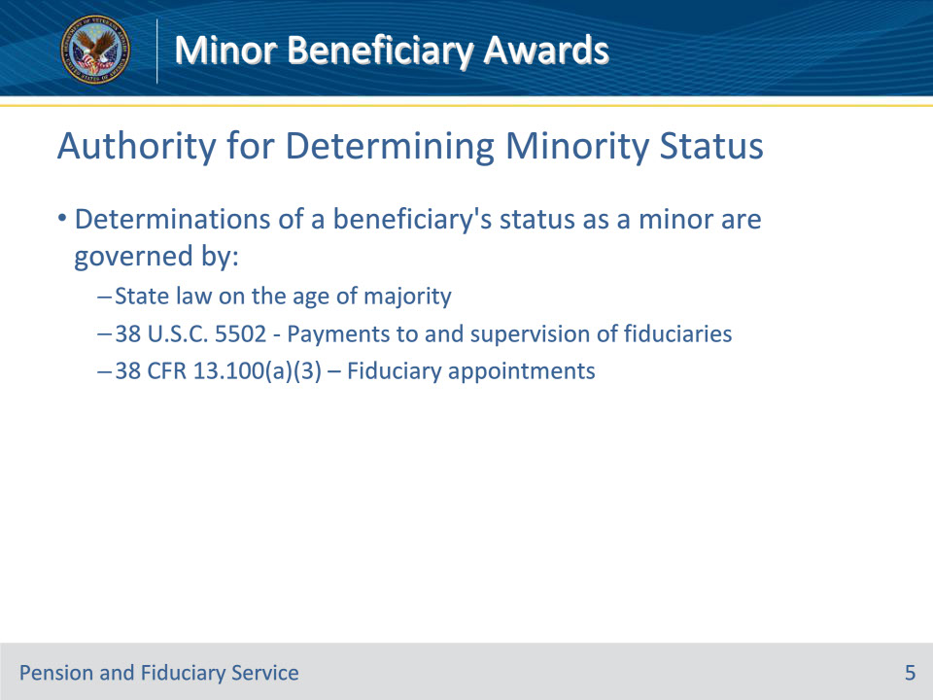
Slide notes

Instructor Notes:

M21-1 X.ii.6.E.3.a. Authority for Determining Minority Status and the Propriety of Making Direct Payments to Children

Determinations as to a beneficiary’s status as a minor and the propriety of making direct payments to children are governed by

• State law as to the age of attainment of majority

• 38 U.S.C. 5502 which covers Payments to and supervision of fiduciaries, and

• 38 CFR 13.100(a)(3) which covers Fiduciary appointments.

Slide 6 - Establishing Diaries for Awards to Minors
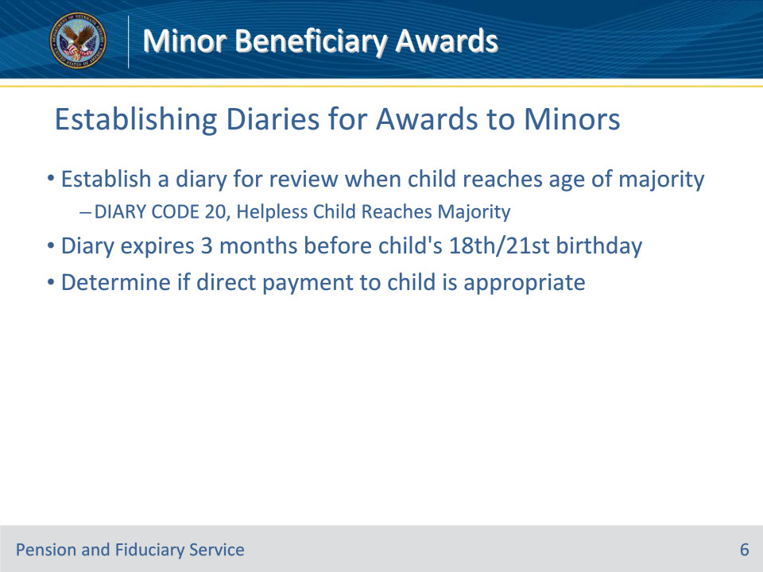
Slide notes

Instructor Notes:

M21-1 X.ii.6.E.3.b. Establishing a Diary When Awarding Benefits to a Fiduciary for a Minor

When an award is made to a fiduciary solely because the beneficiary is a minor, (including a fiduciary recognized under 38 U.S.C. 5502), establish a diary under DIARY CODE 20, Helpless Child Reaches Majority, that will expire three months before the date the child reaches the age of majority, so as to allow sufficient time to determine the propriety of making direct payments to the child.

Slide 7 - Diary Expiration for Awards to Minors
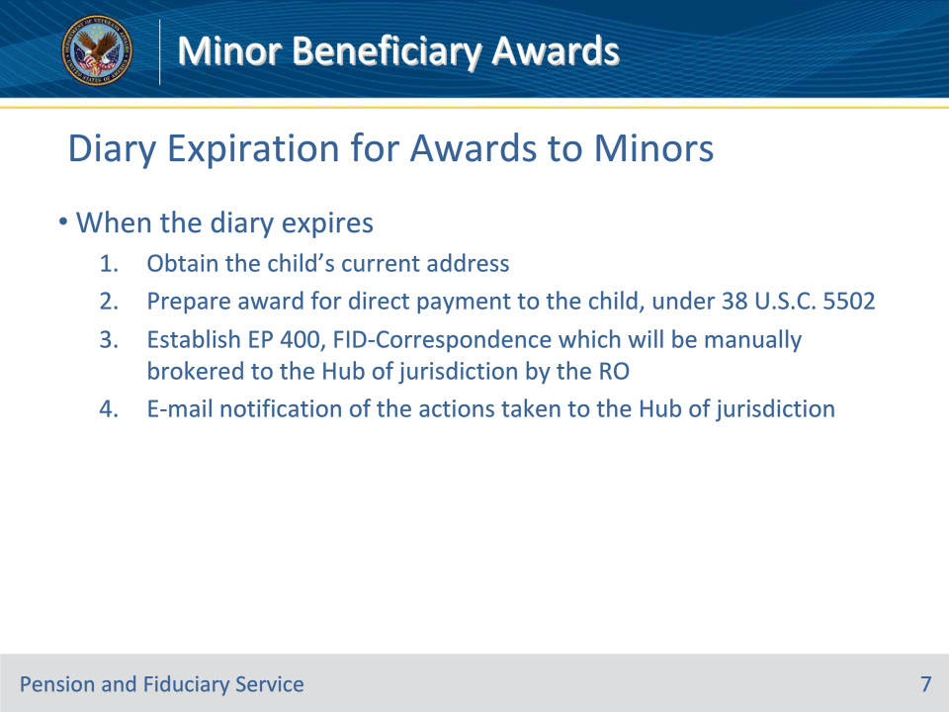
Slide notes

Instructor Notes:

M21-1 X.ii.6.E.3.b. Establishing a Diary When Awarding Benefits to a Fiduciary for a Minor

When the diary expires,

• obtain the child’s current address

• prepare an award providing direct payment to the child, under 38 U.S.C. 5502

• establish an EP 400, FID-Correspondence which will be manually brokered to the hub of jurisdiction by the RO, and

• e-mail notification of the actions taken to the Fiduciary Hub of jurisdiction.

Note: The establishment of an EP 400, FID-Correspondence is required at the time the diary expires regardless of payment status.

Slide 8 - Age of Majority by State
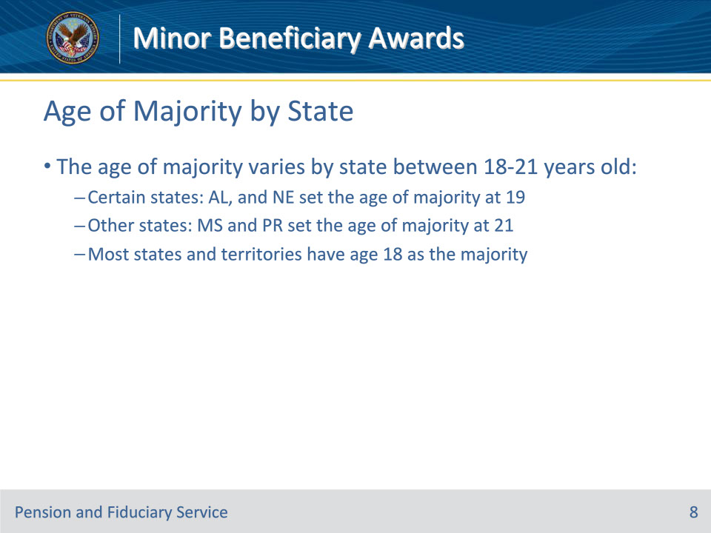
Slide notes

Instructor Notes:

M21-1 X.ii.6.E.3.c. Age of Majority by State/Territory

The age of majority varies by state between 18-21 years old. Certain states: for example, Alabama, and Nebraska set the age of majority at 19. Mississippi and Puerto Rico set the age of majority at 21. However, most states and territories have age 18 as the majority

Slide 9 - Additional Diary Rules
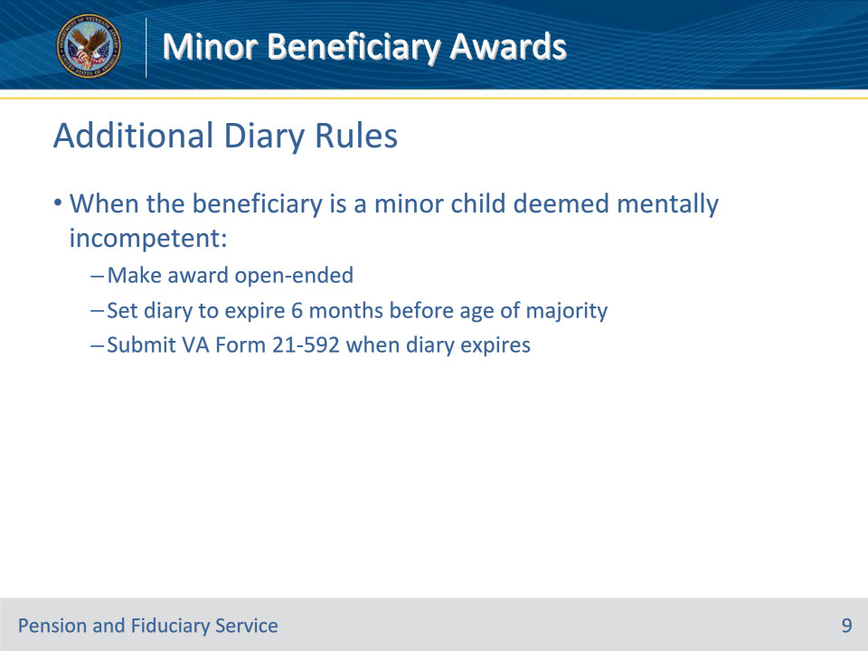
Slide notes

Instructor Notes:

M21-1 X.ii.6.E.3.d. Establishing a Diary When Awarding Benefits to a Fiduciary for a Minor Who Is Mentally Incompetent

For minors deemed mentally incompetent, awards should be ongoing with no defined end date. The diary should expire earlier - 6 months instead of 3 months before the age of majority. Note that form 21-592 is required to the hub when the diary expires.

Slide 10 - Preparing VA Form 21-592 - Incompetent Minors
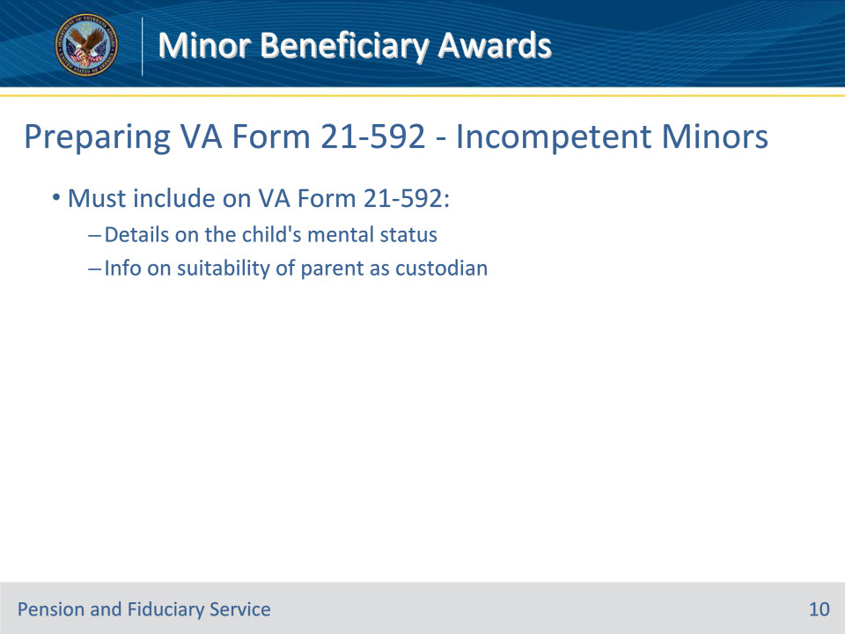
Slide notes

Instructor Notes:

M21-1 X.ii.6.E.3.d. Establishing a Diary When Awarding Benefits to a Fiduciary for a Minor Who Is Mentally Incompetent

When awarding benefits to a fiduciary for a minor whom the rating activity has determined is incapable of self-support due to mental incompetency, VA Form 21-592 should note detailed information regarding the child’s mental status and include any information regarding the suitability of a parent to act as the child’s custodian.

Slide 11 - Diary Rules for Student Minors
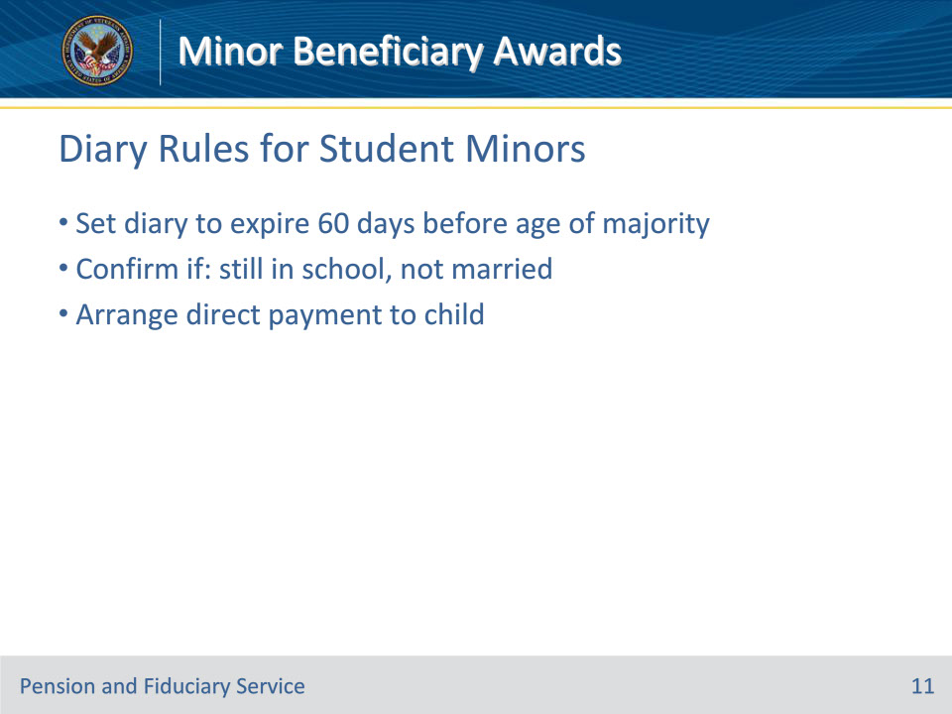
Slide notes

Instructor Notes:

M21-1 X.ii.6.E.3.e. Establishing a Diary When Awarding Benefits to a Fiduciary for a Minor Who Is Attending School

When awarding benefits for a child to a fiduciary or a parental custodian (only because the child is a minor), take the following actions if the child is over age 18 and attending school:

• establish a diary that will expire 60 days before the date the child reaches the age of majority, and

• when the diary expires,

• confirm the child has not married and is still attending school

• take action to provide direct payment to the child, and

• e-mail notification of the actions taken to the hub of jurisdiction.

Slide 12 - Diary Rules for Student Minors (Cont.)
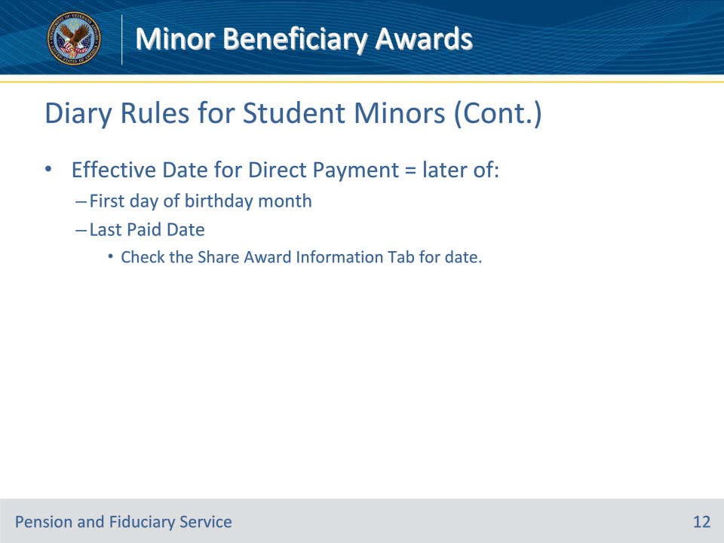
Slide notes

Instructor Notes:

M21-1 X.ii.6.E.3.e. Establishing a Diary When Awarding Benefits to a Fiduciary for a Minor Who Is Attending School

The proper effective date for direct payment is the later of the following dates:

• the first day of the month during which the child reaches the age of majority, or

• the date in the LAST PAID DATE field on the AWARD INFORMATION tab in Share.

Slide 13 - Statutory Changes to Age of Majority
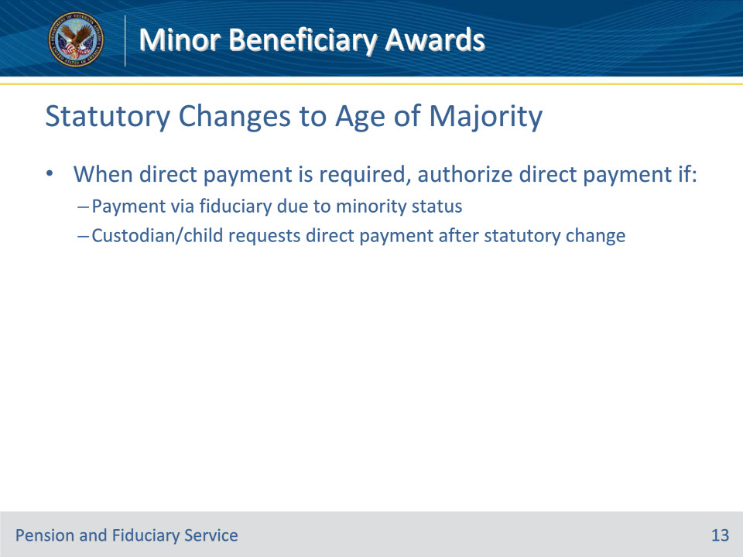
Slide notes

Instructor Notes:

M21-1 X.ii.6.E.3.f. Statutory Change in the Age of Majority

Statutory changes in the age of majority make it necessary to authorize direct payment when

• payments are being made through a fiduciary only because of the minority status of a child or children, and

• the custodian or child(ren) requests direct payment according to the statutory change.

Note: Hubs routinely identify beneficiaries under their jurisdiction that are affected by the enactment of a law that lowers the age of majority.

Slide 14 - Authorizing Direct Payment for Age Change
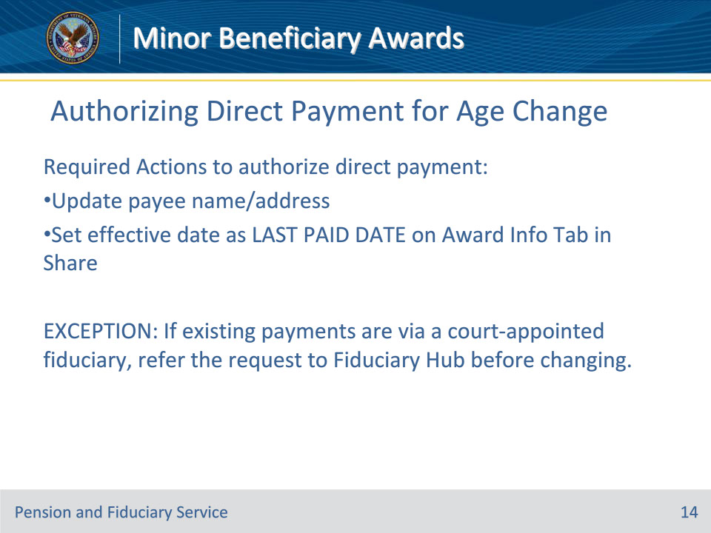
Slide notes

Instructor Notes:

M21-1 X.ii.6.E.3.g. Authorizing Direct Payment Due to a Statutory Change in the Age of Majority

To authorize a direct payment because of a statutory change in the age of majority,

• change the name and address of the payee, and

• make the change to direct payment effective the date in the LAST PAID DATE field on the AWARD INFORMATION tab in Share.

Exception: If payments are being made through a court-appointed fiduciary, refer the request for direct payment to the hub before making any change.

Slide 15 - Retroactive Awards After Age of Majority
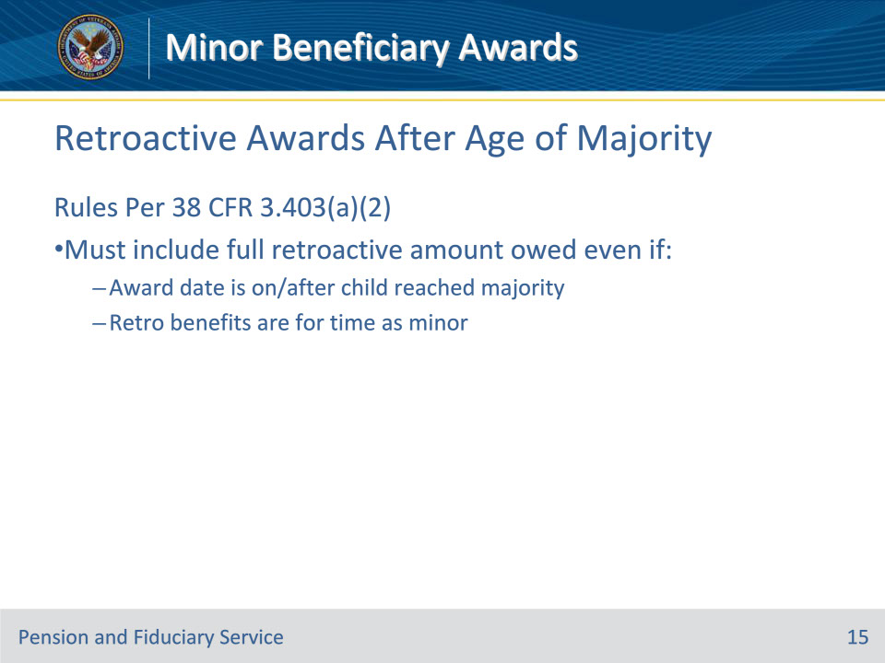
Slide notes

Instructor Notes:

M21-1 X.ii.6.E.3.h. Retroactive Benefits in an Award to a Child Who Has Reached the Age of Majority

Per 38 CFR 3.403(a)(2), when awarding benefits to a child on or after the date they reach the age of majority, include in the award any retroactive benefits owed to the child, even if the benefits are for a period of time during which the child was a minor.

Slide 16 - Knowledge Check 1
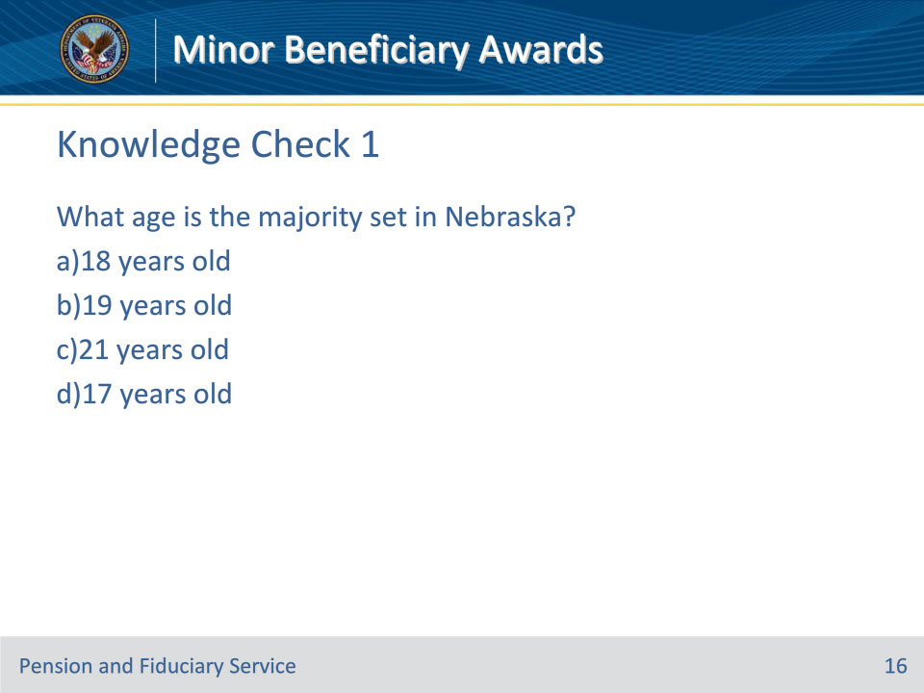
Slide notes

Instructor Notes:

Here is our first knowledge check of 6 that we have during this training.

What age is the majority set in Nebraska?

- 18 years old

- 19 years old

- 21 years old

- 17 years old

Slide 17 - Knowledge Check 1 - Answer
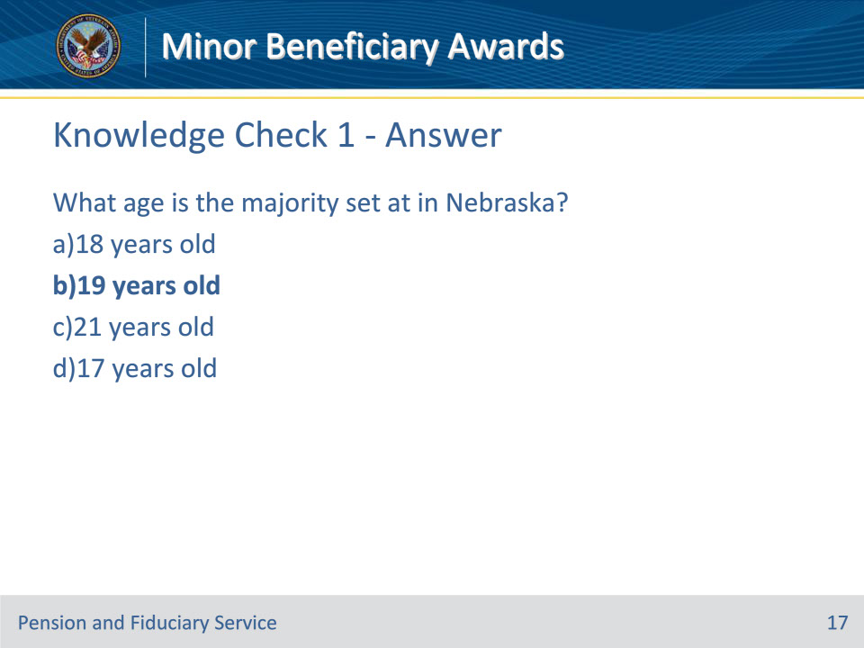
Slide notes

Instructor Notes:

The correct answer is b 19 years old. M21-1 X.ii.6.E.3.c. Age of Majority by State/Territory

Slide 18 - Knowledge Check 2
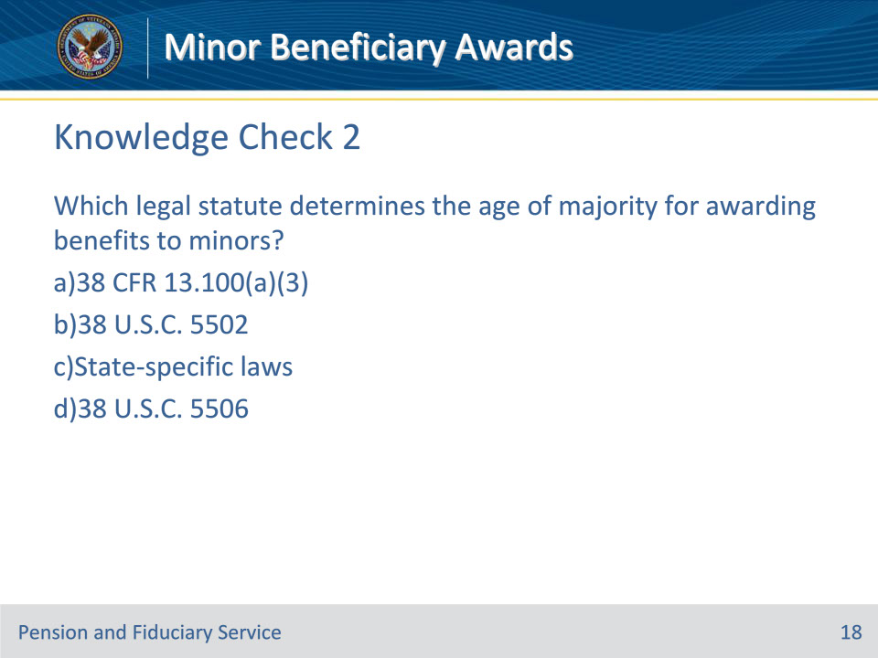
Slide notes

Instructor Notes:

Which legal statute determines the age of majority for awarding benefits to minors?

1. 38 CFR 13.100(a)(3)

2. 38 U.S.C. 5502

3. State-specific laws

4. 38 U.S.C. 5506

Slide 19 - Knowledge Check 2 - Answer
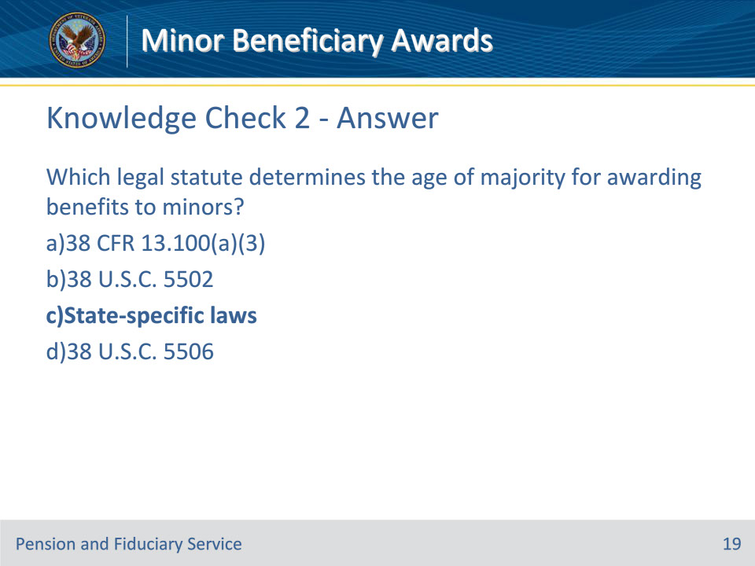
Slide notes

Instructor Notes:

The correct answer is C, State-specific laws. While federal regulations provide a framework, it’s the state laws that determine the age of majority for awarding benefits to minors.

M21-1 X.ii.6.E.3.a. Authority for Determining Minority Status and the Propriety of Making Direct Payments to Children

Slide 20 - Authorizing Custodial Awards Under 38 U.S.C. 5502
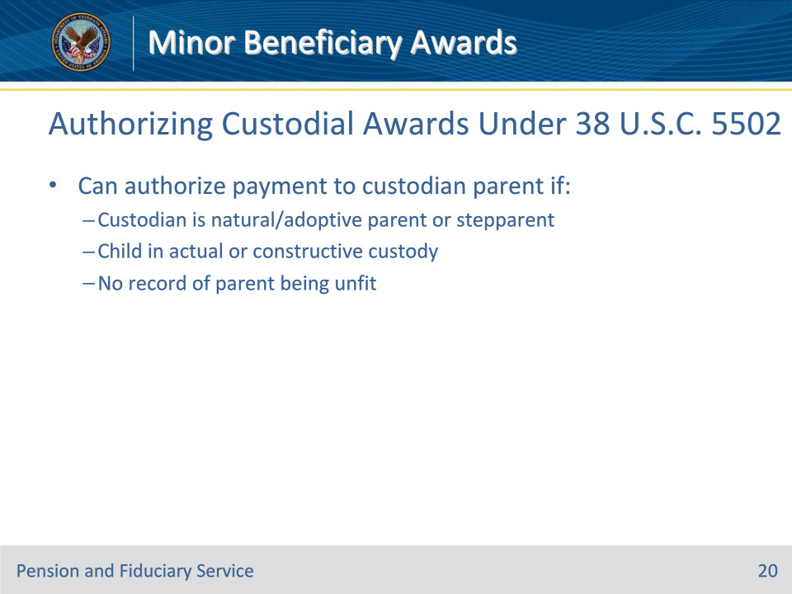
Slide notes

Instructor Notes:

M21-1 X.ii.6.E.4.a. When to Authorize an Award Releasing Payment of Funds Under 38 U.S.C. 5502

• Per 38 U.S.C. 5502, make payments to a custodian on behalf of a minor child according to the instructions in M21-1, Part X, Subpart ii, 6.E.4.c when the following conditions exist:

• the custodian to be recognized is the natural or adoptive parent or stepparent of the child

• the child is in the actual or constructive custody of the parent, and

• there is no information of record that indicates the parent is unfit.

Slide 21 - Restrictions on Custodial Payments
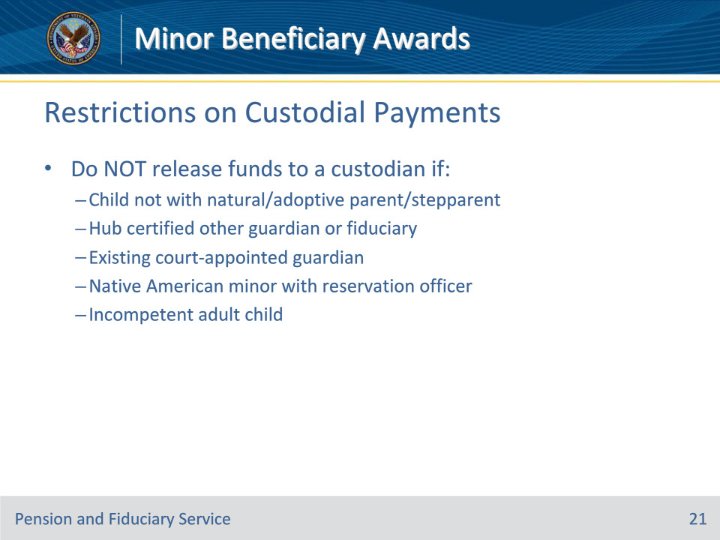
Slide notes

Instructor Notes:

M21- 1 X.ii.6.E.4.b. When Not to Release Payment of Funds Under 38 U.S.C. 5502

Do not release payment of funds under 38 U.S.C 5502 when any of the following situations exist:

• the beneficiary is a child that is not in the custody of their natural or adoptive parent or stepparent

• a hub has certified a legal custodian or fiduciary

• a court-appointed guardian and/or fiduciary is either in place or an appointment is pending

• the beneficiary is a Native American minor in the custody of a bonded officer of a Native American reservation, or

• a Veteran’s adult child is incapable of self-support because of incompetency under 38 U.S.C. 5502.

Follow the steps in the table below if an award of benefits is in order, but one of the situations described in the previous block exists.

Slide 22 - Required Actions if Custodial Payment Restricted
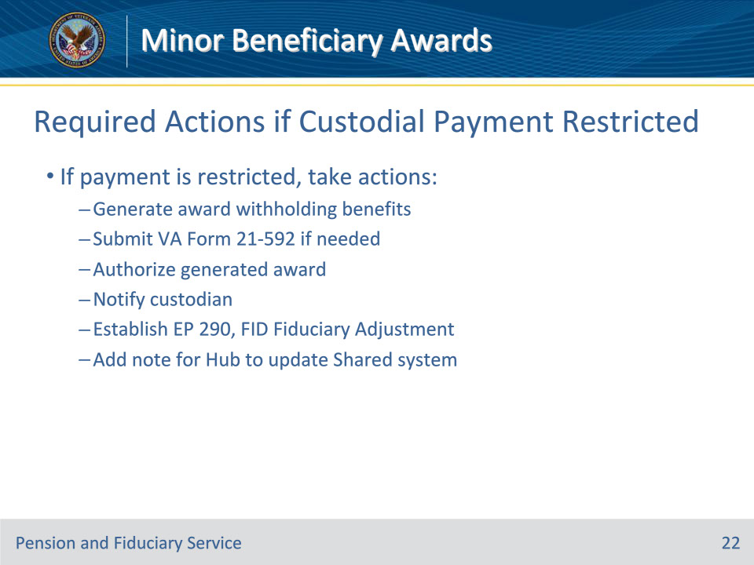
Slide notes

Instructor Notes:

M21-1 X.ii.6.E.4.b. When Not to Release Payment of Funds Under 38 U.S.C. 5502.

Here are the steps to follow if an award of benefits is in order, but one of the situations described in the previous slide exists. For additional information review the steps as detailed in the table listed in M21-1 X.ii.6.E.4.b.

1

Generate an award that withholds all retroactive and future funds VA owes the beneficiary.

2

Was a VA Form 21-592 completed and submitted to a hub?

If yes, proceed to the next step.

If no,

complete VA Form 21-592

upload a copy of the form into the corresponding eFolder, and

go to the next step.

3

Authorize the award.

4

Issue a decision notice to the custodian that filed the claim on behalf of the child.

5

Establish an EP 290, FID-Fiduciary Adjustment.

6

Associate a permanent note in VBMS that indicates the hub must update the CHANGE OF FIDUCIARY screen in Share before releasing funds to the beneficiary via award action.

Notes:

• The hub is responsible for appointing a fiduciary and authorizing the award for EP 290, FID-Fiduciary Adjustment.

• Use of the FID-Fiduciary Adjustment claim label allows NWQ to route the EP 290 to the hub of jurisdiction.

Slide 23 - Authorizing Awards to Custodians
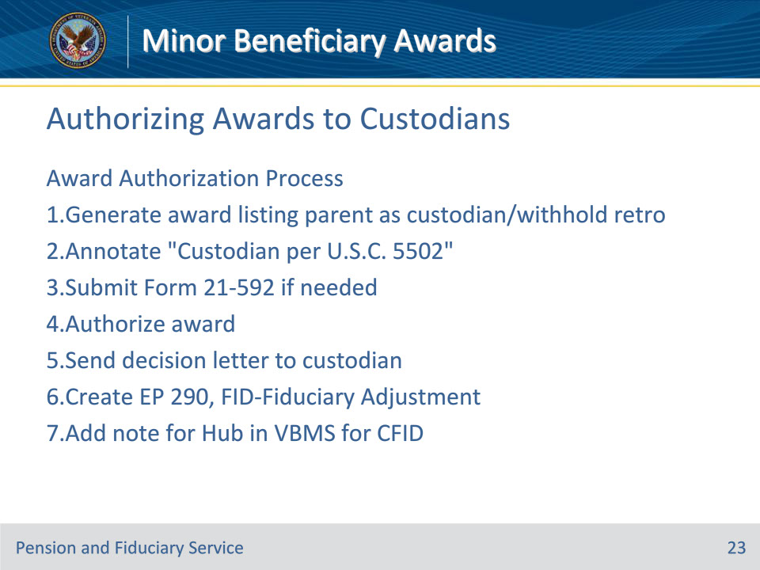
Slide notes

Instructor Notes:

M21-1 X.ii.6.E.4.c. Authorizing an Award Under 38 U.S.C. 5502

Follow these steps to authorize an award under 38 U.S.C. 5502 and notify the custodian.

1

Generate an award showing the name of the parent as the custodian.

Withhold all retroactive benefits payable to the custodian on behalf of the child.

2

Annotate Custodian recognized under 38 U.S.C. 5502 in the OTHER PRINT REMARKS field on the PRINT REMARKS screen in VBMS.

3

Was a VA Form 21-592 completed and submitted to a hub?

If yes,

prepare a memorandum or letter that alerts the hub of the award action, and

upload a copy of the document into the corresponding eFolder.

If no,

complete a VA Form 21-592, and

upload a copy of the form into the corresponding eFolder.

4

Authorize the award.

5

Send the decision notice to the custodian.

6

Establish an EP 290, FID-Fiduciary Adjustment.

Important: Claims processors may not cancel or change the EP 290 or change the EP’s claim label. If a claims processor establishes the EP in error, ask the hub of jurisdiction (by e-mail) to cancel it.

7

Associate a permanent note in VBMS that indicates the hub must update the CHANGE OF FIDUCIARY screen in Share before releasing retroactive funds to the beneficiary via award action.

Notes:

The hub is responsible for

appointing a fiduciary

authorizing the award for EP 290, FID-Fiduciary Adjustment, and

releasing all withheld retroactive benefits.

Use of the FID-Fiduciary Adjustment claim label allows NWQ to route the EP 290 to the hub of jurisdiction.

Reference: For more information on hub jurisdiction, see M21-1, Part X, Subpart ii, 6.C.1.d.

Slide 24 - Authorizing Awards to Custodians (Cont.)
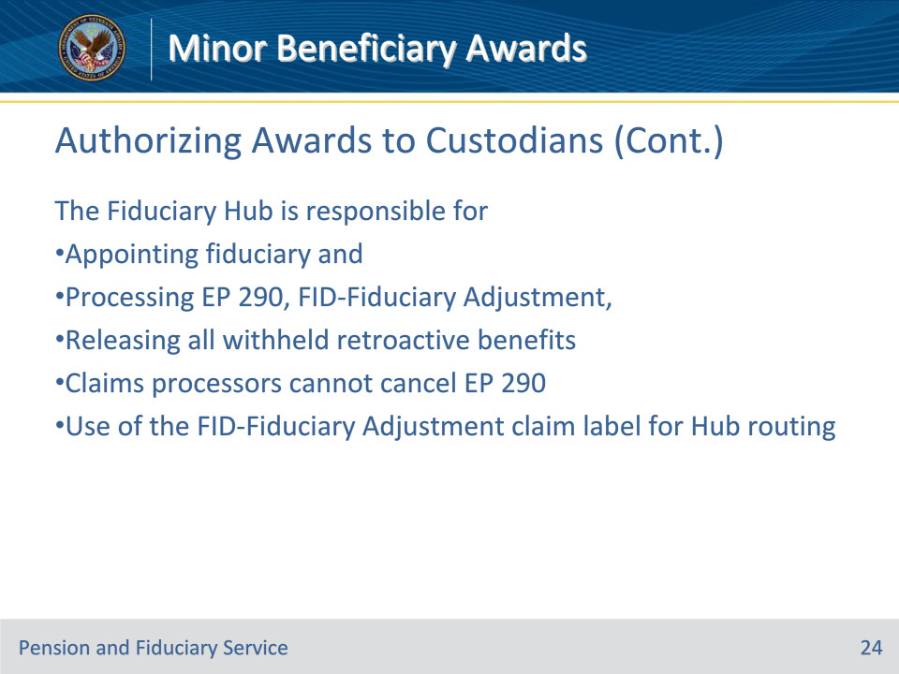
Slide notes

Instructor Notes:

M21-1 X.ii.6.E.4.c. Authorizing an Award Under 38 U.S.C. 5502

Notes: The hub is responsible for

• appointing a fiduciary

• authorizing the award for EP 290, FID-Fiduciary Adjustment, and

• releasing all withheld retroactive benefits.

Use of the FID-Fiduciary Adjustment claim label allows NWQ to route the EP 290 to the hub of jurisdiction.

Reference: For more information on hub jurisdiction, see M21-1, Part X, Subpart ii, 6.C.1.d.

Slide 25 - Handling Custodian Unsuitability
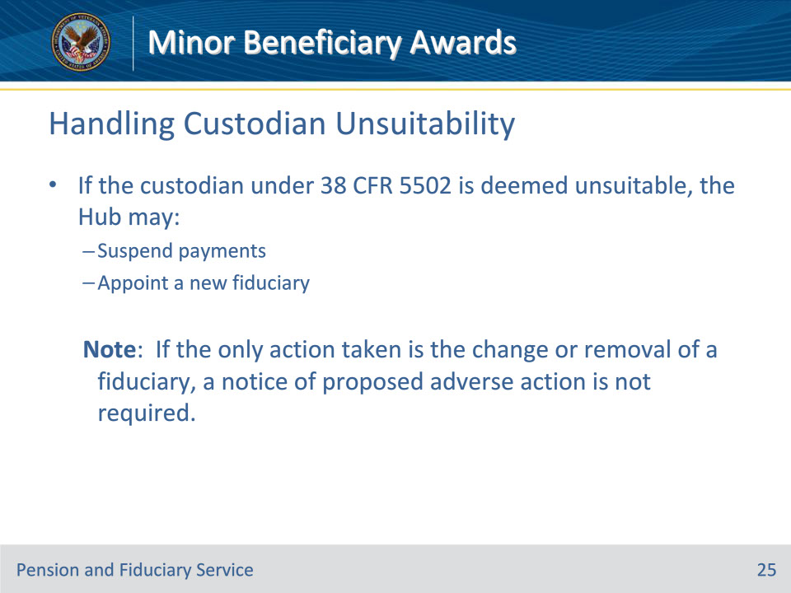
Slide notes

Instructor Notes:

M21-1 X.ii.6.E.4.d. Handling the Certification of a Fiduciary After Authorizing an Award Under 38 U.S.C 5502

In some cases, the custodian recognized by the authorization activity is found unsuitable to act in a fiduciary capacity. When this occurs, the hub may

• recommend a suspension of payments to conserve the beneficiary’s funds, and

• proceed with the appointment of an acceptable fiduciary.

When an award to a custodian has been authorized under 38 U.S.C 5502, and the hub subsequently certifies the same or a different person as fiduciary, make payments to the person certified by the hub.

Note: If the only action taken is the change or removal of a fiduciary, a notice of proposed adverse action is not required.

Slide 26 - When Custodian Loses Custody of Child
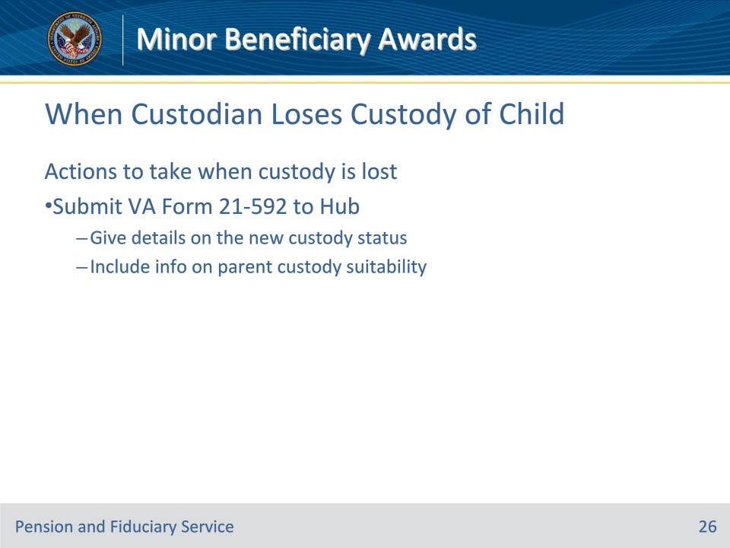
Slide notes

Instructor Notes:

M21-1 X.ii.6.E.4.e. Actions to Take When a Custodian Ceases to Have Custody of a Child Beneficiary

If the authorization activity learns that a custodian recognized under 38 U.S.C. 5502 ceases to have custody of a child beneficiary, submit VA Form 21-592 to the hub of jurisdiction.

When preparing the form,

• furnish detailed information as to the status of the child’s custody, and

• include any information on the suitability of a parent to act as the child’s custodian.

Slide 27 - Payments to Native American Reservation
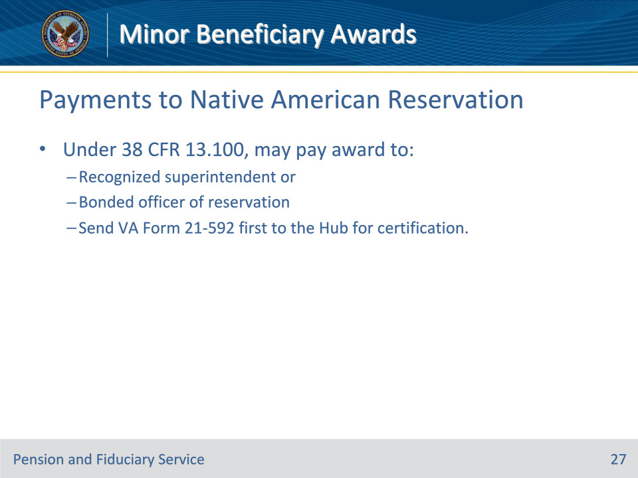
Slide notes

Instructor Notes:

M21-1 X.ii.6.E.5.a. Awards Under 38 CFR 13.100 to a Bonded Officer of the Native American Reservation

Under 38 CFR 13.100, an award for the use of a Native American beneficiary may be paid to the recognized superintendent or bonded officer of the Native American Reservation. Send a VA Form 21-592 to the hub for certification of the payee before processing the award.

Slide 28 - Payee Name for 38 CFR 13.100 Awards
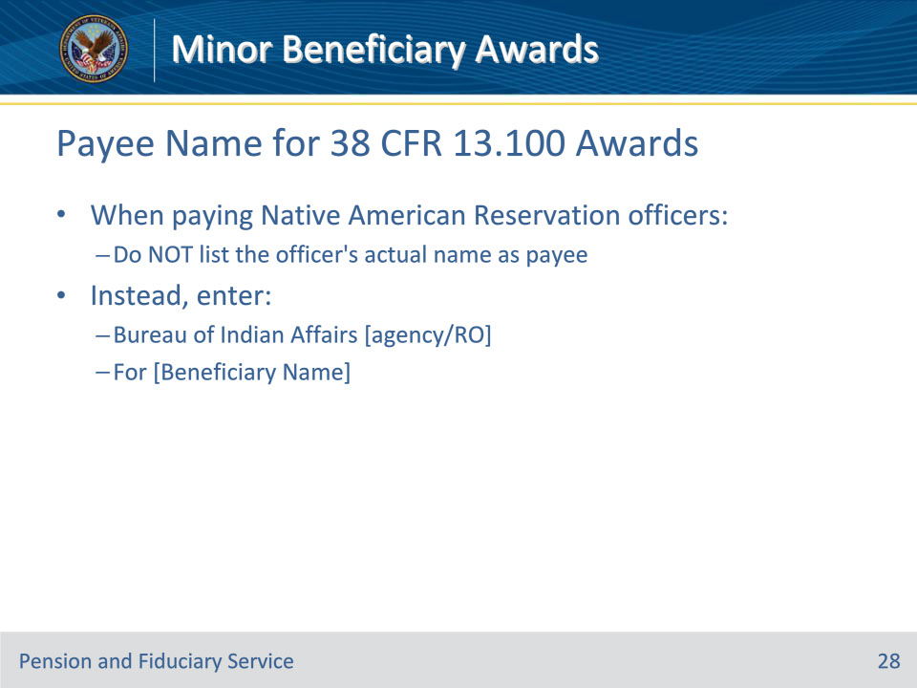
Slide notes

Instructor Notes:

M21-1 X.ii.6.E.5.b. Payee for Awards Authorized Under 38 CFR 13.100

Do not enter the name of the superintendent or bonded officer of the Native American Reservation as the payee when authorizing an award under 38 CFR 13.100. Enter the following instead: Bureau of Indian Affairs [name of agency or RO], for [name of Native American beneficiary].

Slide 29 - Appointing Fiduciary for Beneficiary's Child
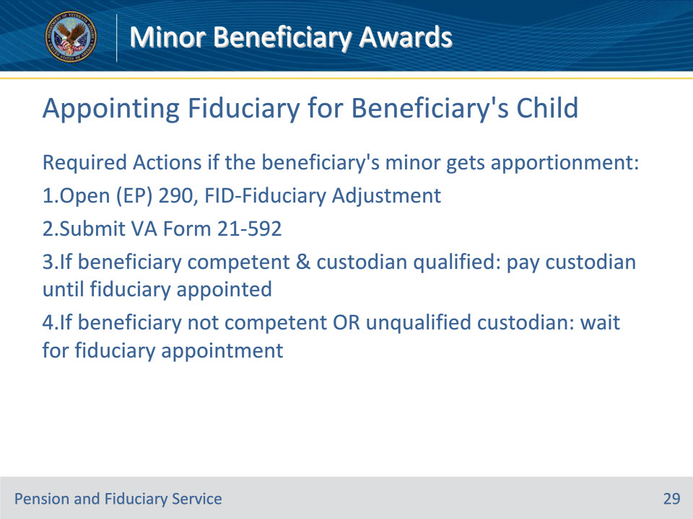
Slide notes

Instructor Notes:

M21-1 VII.iii.1.A.1.d. Regulations Under Which VA May Apportion Benefits

If a beneficiary’s minor child(ren) is entitled to an apportionment of the beneficiary’s benefits, request the appointment of a fiduciary for the minor child(ren) by

• establishing an end product (EP) 290, FID-Fiduciary Adjustment for automatic routing of the EP to the fiduciary hub of jurisdiction, and

• completing and uploading a VA Form 21-592, Request for Appointment of a Fiduciary, Custodian or Guardian, to the claims folder.

When the apportionment is for a minor child and the beneficiary is

• competent, make payments to a custodian on behalf of the minor child until a fiduciary is appointed if the situation meets the conditions for releasing funds to a custodian as outlined in M21-1, Part X, Subpart ii, 6.E.4.a and b, or

• incompetent, or the situation does not meet the conditions for releasing funds to a custodian as outlined in M21-1, Part X, Subpart ii, 6.E.4.a and b, do not pay the apportionment until a fiduciary is appointed.
Slide 30 - Knowledge Check 3
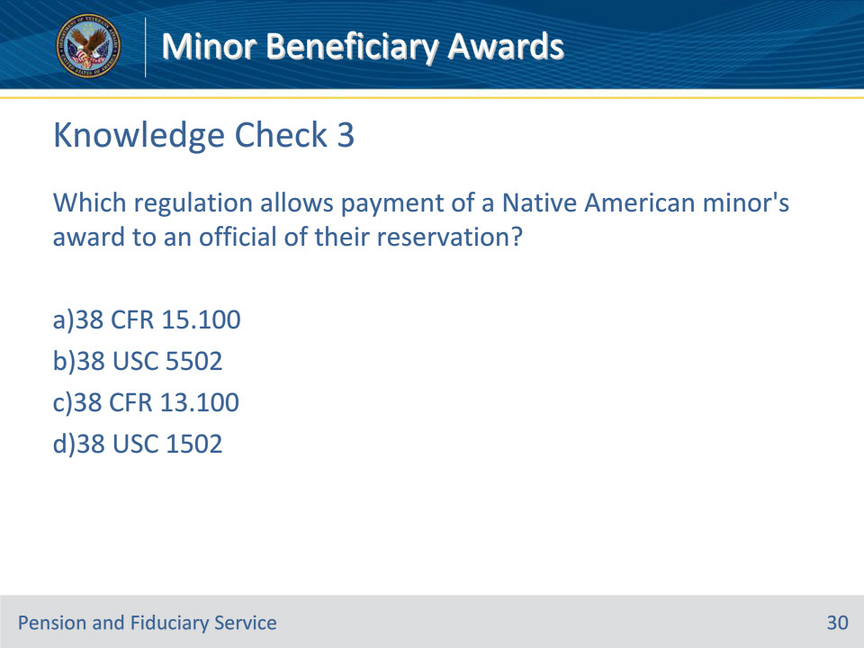
Slide notes

Instructor Notes:

Time for another series of Knowledge Checks

Which regulation allows payment of a Native American minor’s award to an official of their reservation?

1. 38 CFR 15.100

2. 38 USC 5502

3. 38 CFR 13.100

4. 38 USC 1502

Slide 31 - Knowledge Check 3 - Answer
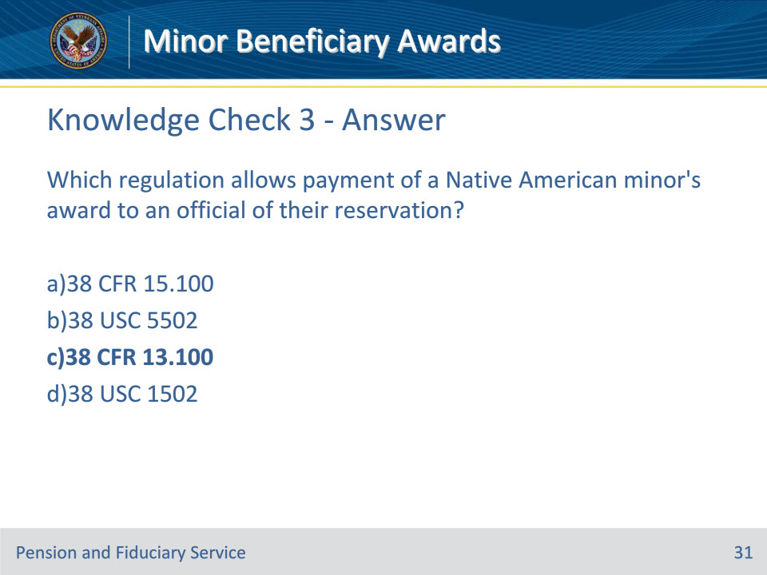
Slide notes

Instructor Notes:

The correct response is c) 38 CFR 13.100. Note that this regulation specifically allows payment to superintendents or bonded officers of the reservation for Native American minors.

M21-1 X.ii.6.E.5.a. Awards Under 38 CFR 13.100 to a Bonded Officer of the Native American Reservation

Slide 32 - Knowledge Check 4
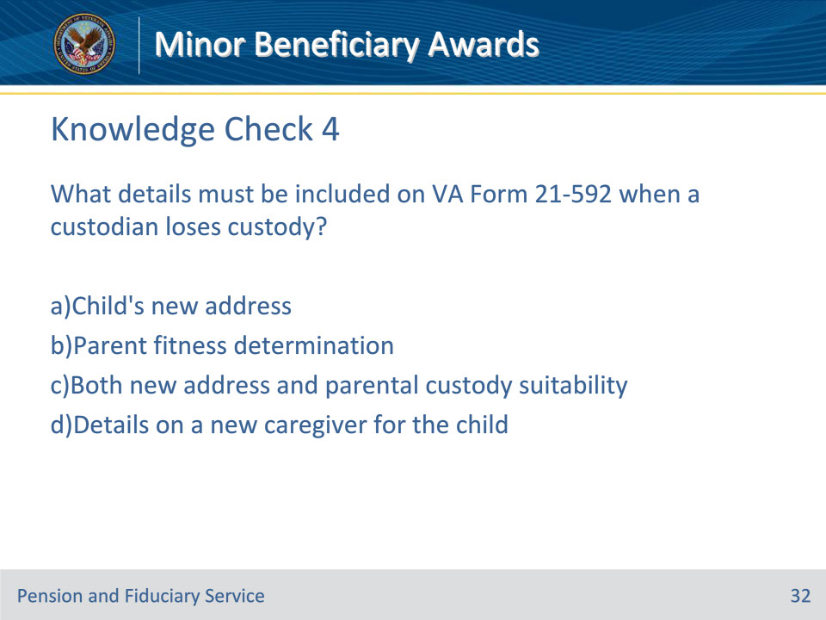
Slide notes

Instructor Notes:

What details must be included on VA Form 21-592 when a custodian loses custody?

1. Child’s new address

2. Parent fitness determination

3. Both new address and parental custody suitability

4. Details on a new caregiver for the child

Slide 33 - Knowledge Check 4 - Answer
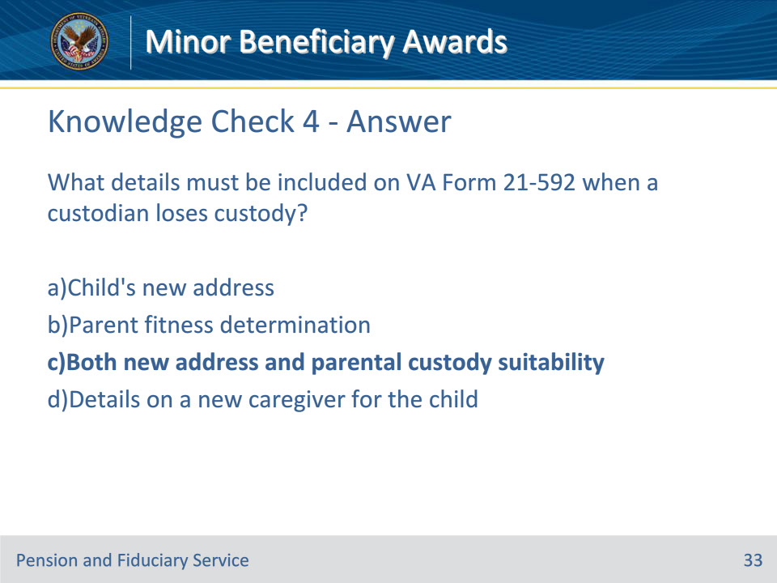
Slide notes

Instructor Notes:

C, is the correct answer- both the child’s new contact information and an evaluation of the parent’s fitness for custody should be provided when custody is lost.

M21-1 X.ii.6.E.4.e. Actions to Take When a Custodian Ceases to Have Custody of a Child Beneficiary

Slide 34 - Knowledge Check 5
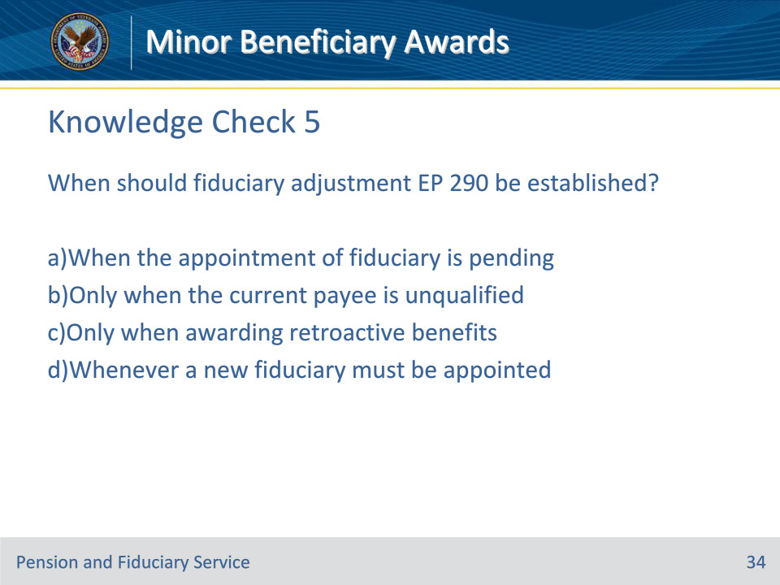
Slide notes

Instructor Notes:

When should fiduciary adjustment EP 290 be established?

1. When the appointment of fiduciary is pending

2. Only when the current payee is unqualified

3. Only when awarding retroactive benefits

4. Whenever a new fiduciary must be appointed

Slide 35 - Knowledge Check 5 - Answer
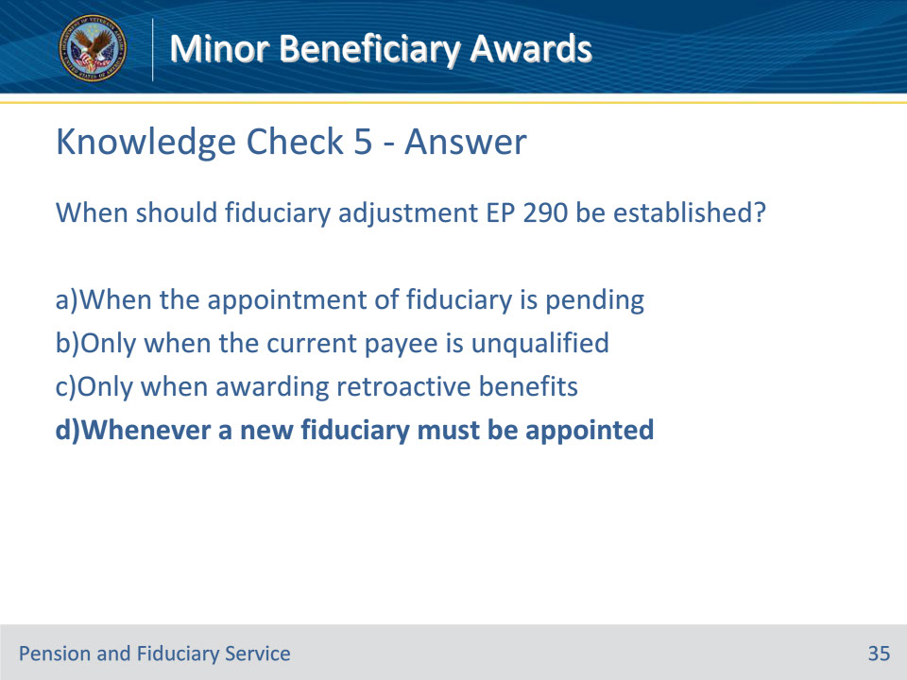
Slide notes

Instructor Notes:

Note that d is correct - EP 290 should be opened any time a new fiduciary appointment is required to allow for review and adjustment.

M21-1, Part X, Subpart ii, Chapter 6, Section E - Authorizing Awards for Fiduciary Cases

Slide 36 - Knowledge Check 6
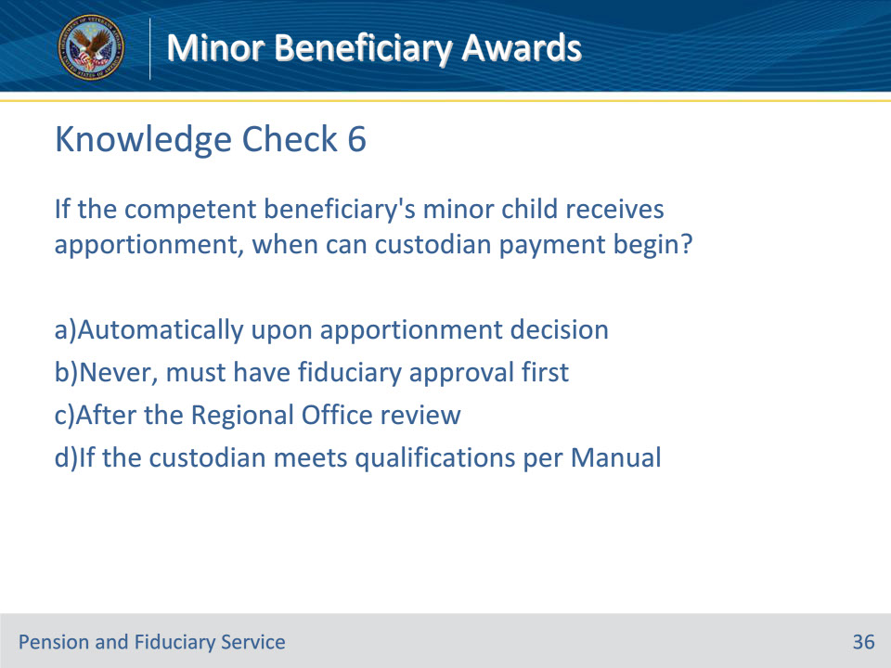
Slide notes

Instructor Notes:

If the competent beneficiary’s minor child receives apportionment, when can custodian payment begin?

1. Automatically upon apportionment decision

2. Never, must have fiduciary approval first

3. After the Regional Office review

4. If the custodian meets qualifications per Manual

Slide 37 - Knowledge Check 6
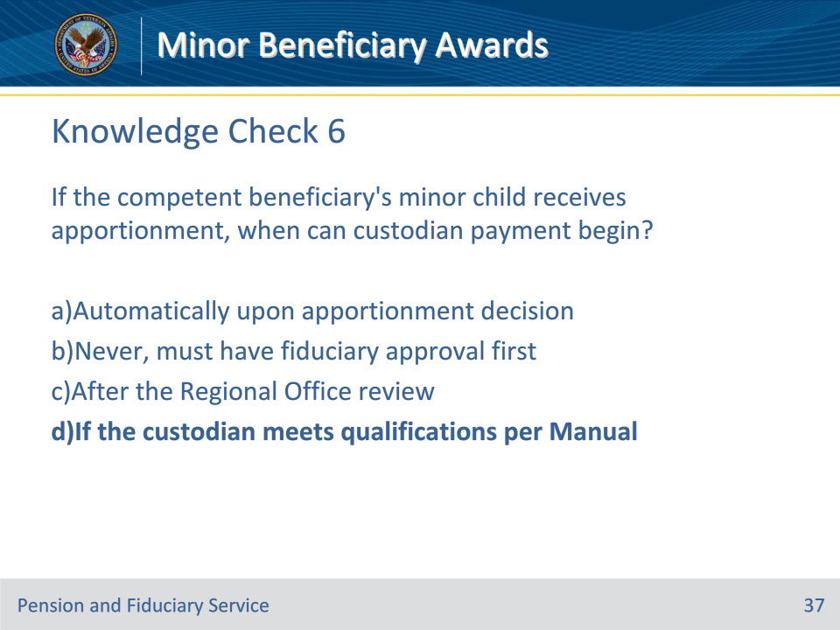
Slide notes

Instructor Notes:

Option d is correct - payment to qualified custodian may start pending full fiduciary appointment if conditions in Manual are met.

M21-1 VII.iii.1.A.1.d. Regulations Under Which VA May Apportion Benefits

M21-1 X.ii.6.E.4.a. When to Authorize an Award Releasing Payment of Funds Under 38 U.S.C. 5502

Slide 38 - Summary
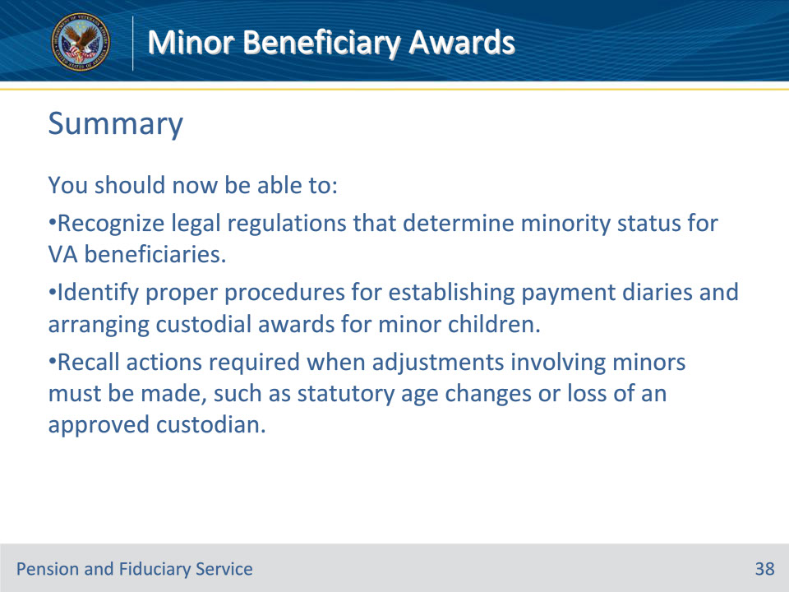
Slide notes

Instructor Notes:

These are our learning objectives as stated from the beginning of the training. You should now be able to:

• Recognize legal regulations that determine minority status for VA beneficiaries.

• Identify proper procedures for establishing payment diaries and arranging custodial awards for minor children.

• Recall actions required when adjustments involving minors must be made, such as statutory age changes or loss of an approved custodian.

Slide 39 - Questions?
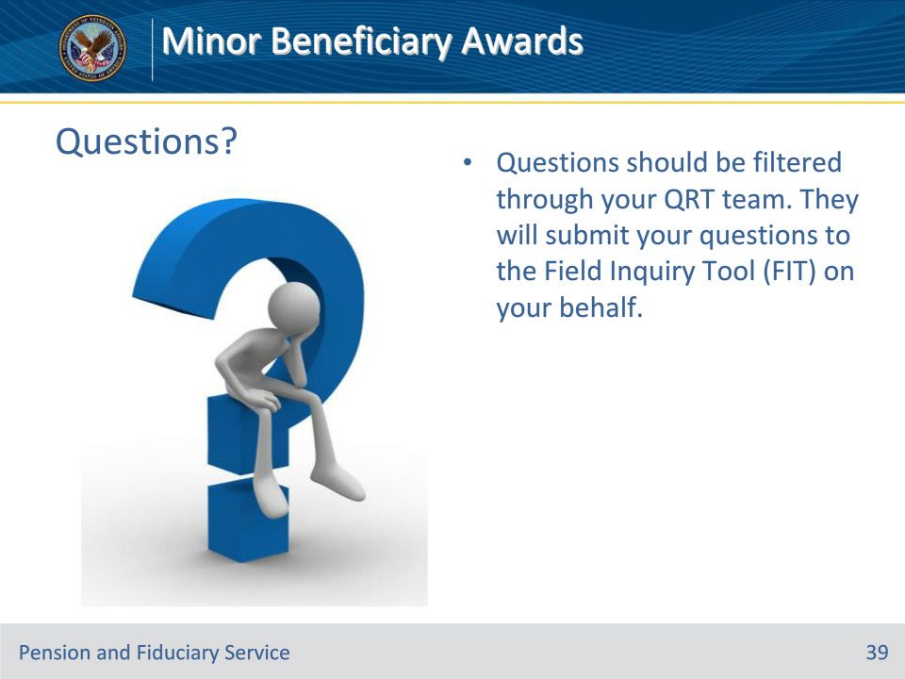
Slide notes

Instructor Notes:

Questions should be filtered through your QRT team. They will submit your questions to the Field Inquiry Tool (FIT) on your behalf.

Slide 40 - TMS Survey
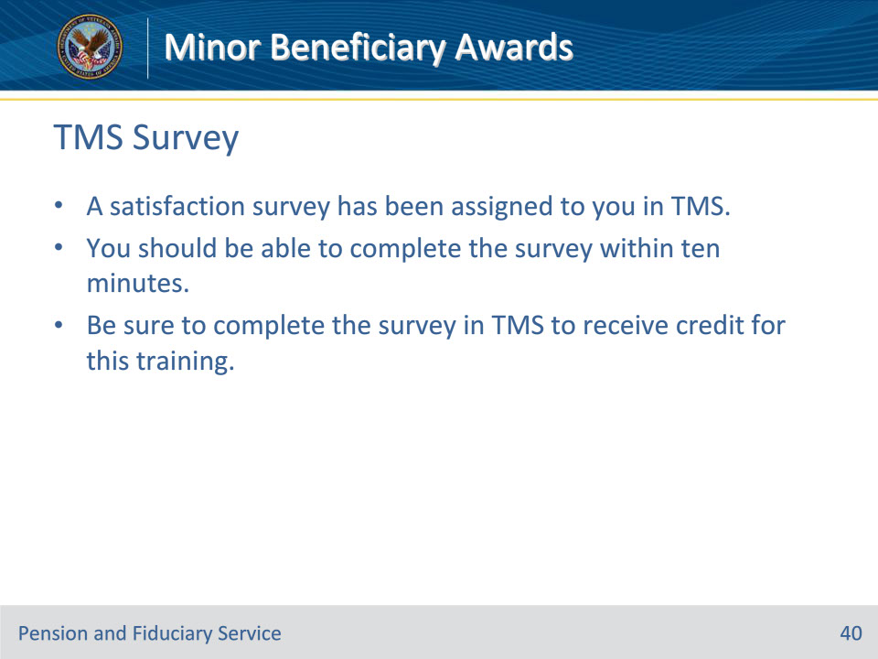
Slide notes

Instructor Notes:

A satisfaction survey has been assigned to you in TMS. You should be able to complete the survey within ten minutes. Completing the survey will allow you to receive credit for this training.

