Slide 1 - Effective Dates for DIC
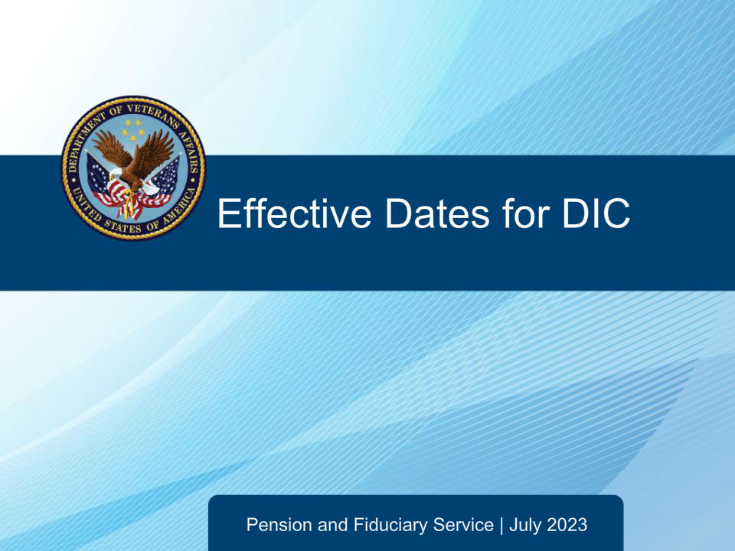
Slide notes
This course teaches learners about effective dates for Dependency and Indemnity Compensation claims.

Slide 2 - Navigation
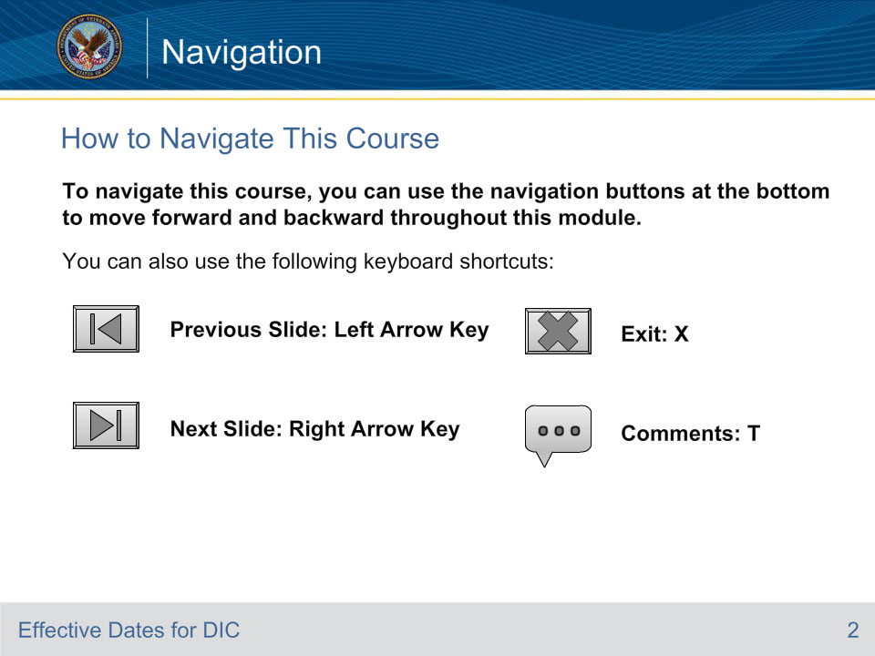
Slide notes

To navigate this course, you can use the navigation buttons at the bottom to move forward and backward throughout this module.

You can also use the following keyboard shortcuts:

• Previous Slide: Left Arrow Key

• Next Slide: Right Arrow Key

• Exit: X

• Comments: T

Slide 3 - References
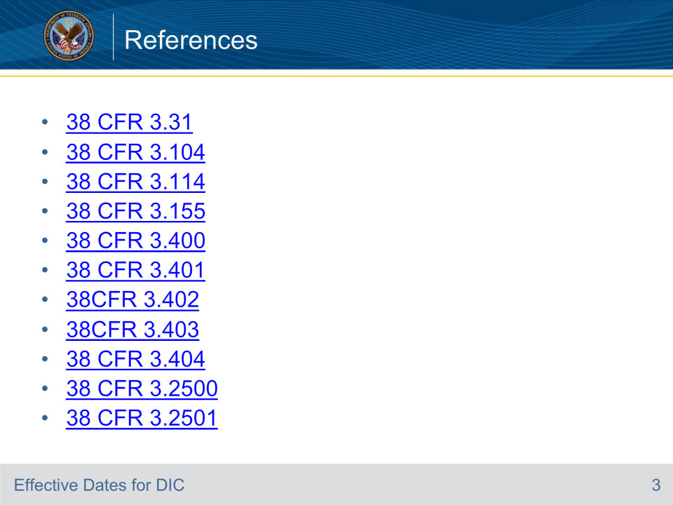
Slide notes

These are references for the training. Please take time to review them.

Slide 4 - References
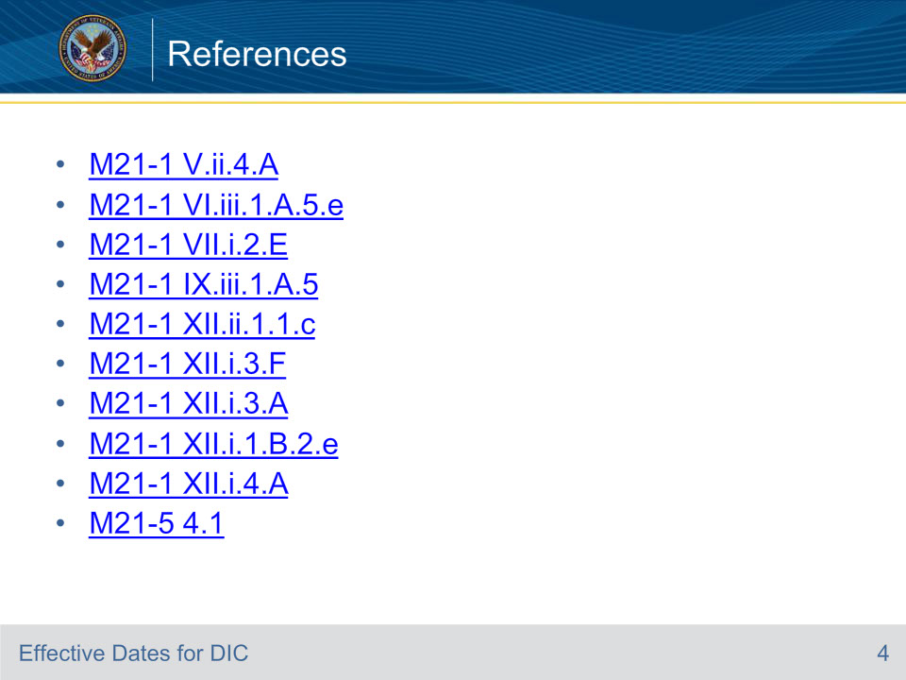
Slide notes

These are references for the training. Please take time to review them.

Slide 5 - Objectives
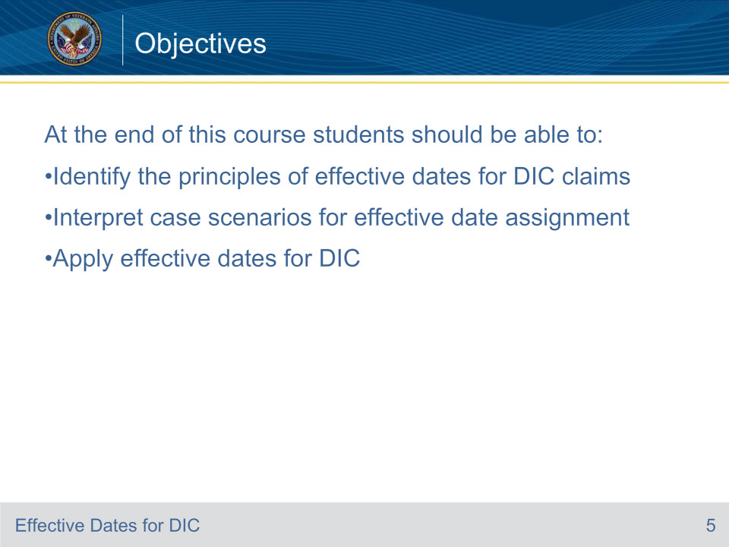
Slide notes

Expectations: By the end of this training, given the training and supporting resources you will be able to Identify the principles of effective dates for DIC claims, Interpret case scenarios for effective date assignment and Apply effective dates for DIC.

Slide 6 - Introduction
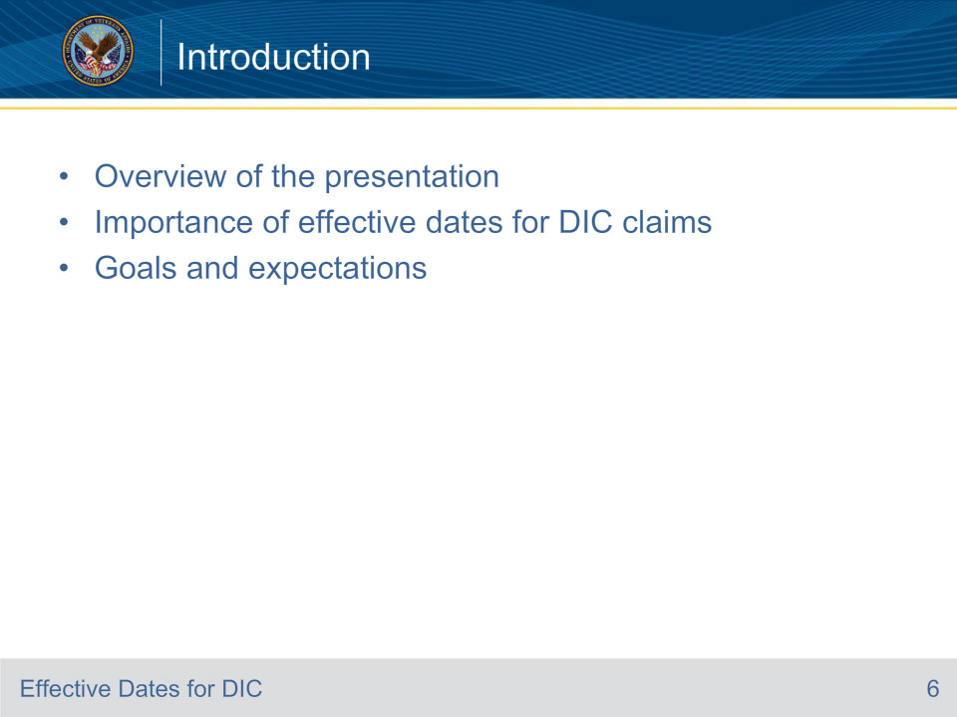
Slide notes

Overview: Today, we will delve into the crucial topic of understanding effective dates for Dependency and Indemnity Compensation (DIC) claims. This training module is designed to equip you with the knowledge and skills necessary to accurately determine effective dates for DIC claims, a fundamental aspect of adjudicating these claims.

Importance: The assignment of effective dates is not just a procedural step in the claims process. It determines when benefits begin, directly impacting the claimant’s compensation. A correct effective date ensures that survivors receive the benefits they are entitled to from the appropriate point in time.

Goals: Our goal is to enhance your comprehension of the principles and regulations that guide the assignment of effective dates. We will interpret various case scenarios to understand the factors influencing these dates. Finally, we will apply this knowledge to assign appropriate effective dates in different scenarios.

Slide 7 - DIC Quick Review (1 of 2)
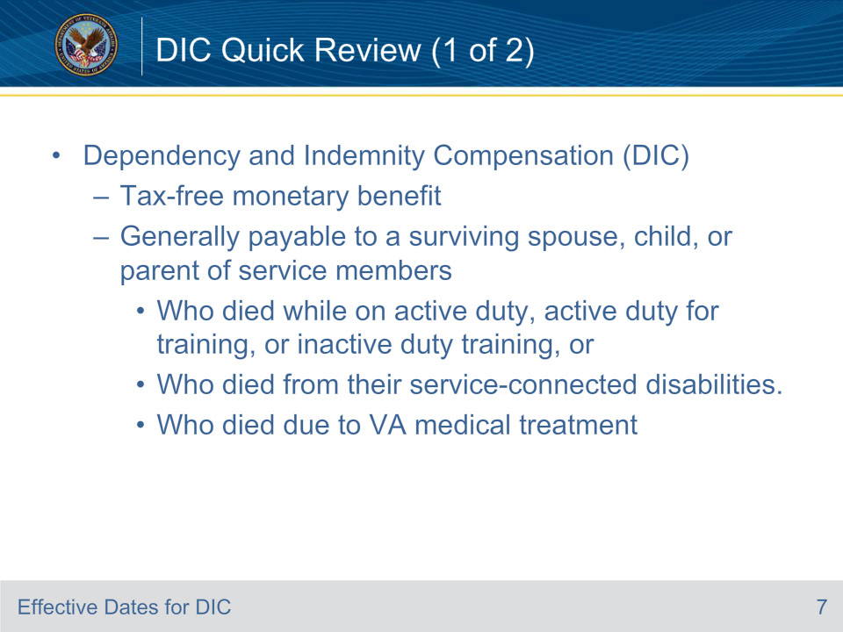
Slide notes

Dependency and Indemnity Compensation (DIC) is a tax-free monetary benefit generally payable to a surviving spouse, child, or parent of service members who died while on active duty, active duty for training, or inactive duty training, or to survivors of Veterans who died from their service-connected disabilities or Veterans who died due to VA medical treatment.

Slide 8 - DIC Quick Review (2 of 2)
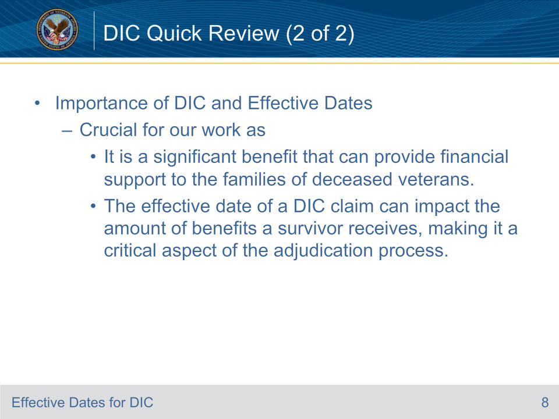
Slide notes

Understanding DIC is crucial for our work as it is a significant benefit that can provide financial support to the families of deceased veterans. The effective date of a DIC claim can impact the amount of benefits a survivor receives, making it a critical aspect of the adjudication process.

Slide 9 - Effective Dates Review
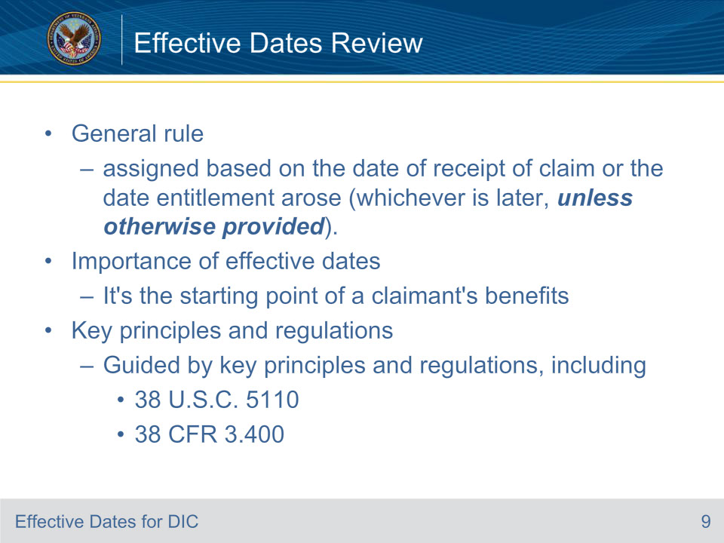
Slide notes

Objective 1 Understanding Effective Dates

Policy Reference: V.ii.4.A.1.b. General Effective Date Rule

The general rule is that the effective date is assigned based on the date of receipt of claim or the date entitlement arose, whichever is later. Before applying the general rule, however, all information gathered during evidence review must be considered to determine whether a more specific effective date rule applies.

Note: Date of claim and effective date are not synonymous. Although the effective date is often the date of receipt of the claim, the effective date is determined by a variety of factors and is frequently not the same date as the date on which the claim is received.

Importance of Effective Dates: The effective date is not merely a date on a document. It’s the starting point of a claimant’s benefits. An accurately assigned effective date ensures that claimants receive the benefits they are entitled to from the appropriate time.

Key Principles and Regulations: The assignment of effective dates is guided by key principles and regulations, including 38 U.S.C. 5110 and 38 CFR 3.400. These regulations provide the framework for assigning effective dates and are crucial to understand for accurate adjudication.

By understanding these principles, we can ensure that we are assigning effective dates correctly and in accordance with the law, thereby ensuring that claimants receive the benefits they are entitled to from the correct date.

Slide 10 - Effective Dates Determination
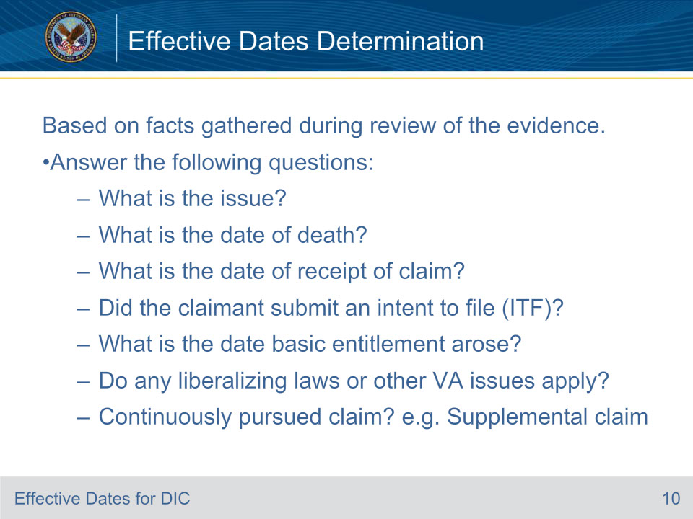
Slide notes

Policy Reference: V.ii.4.A.1.a. Gathering Evidence for Effective Date Determinations

Effective date determinations are made based on facts gathered during review of the evidence. Particularly, answers to the questions below drive the effective date determination.

What is the issue? Some examples of types of issues include but are not limited to claim for

• service connection (SC)

• pension entitlement, or

• increased evaluation, or

a request

• to review a prior claim

• to add a dependent, or

• for burial benefits.

What is the date of receipt of claim?

Did the claimant submit an intent to file (ITF)?

What is the date basic entitlement arose?

Do any liberalizing laws or other Department of Veterans Affairs (VA) issues apply?

Is this a continuously pursued claim or issue under 38 CFR 3.2500? For example, Supplemental claims.

Slide 11 - DIC Effective Dates
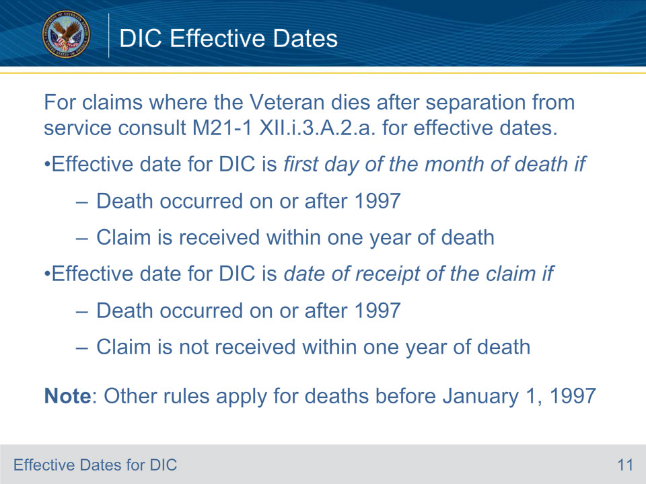
Slide notes

Policy Reference: M21-1 XII.i.3.A.2.a. Determining the Effective Date for DIC When Veteran Dies After Separation From Service

M21-1 XII.i.3.A.2.a. (Determining the Effective Date for DIC When Veteran Dies After Separation From Service) should be consulted to determine the effective date of DIC awards. There are different rules for date of deaths that occur before January 1, 1997.

Slide 12 - AMA and Effective Dates (1 of 2)
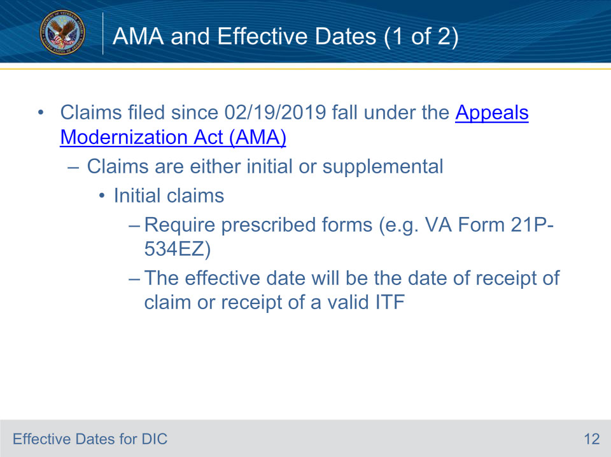
Slide notes

Policy Reference: M21-5 Appeals and Reviews

Claims filed since 02/19/2019 fall under the Appeals Modernization Act (AMA). Visit the link on this slide for additional information on the Appeals Modernization Act (AMA).

Slide 13 - AMA and Effective Dates (2 of 2)
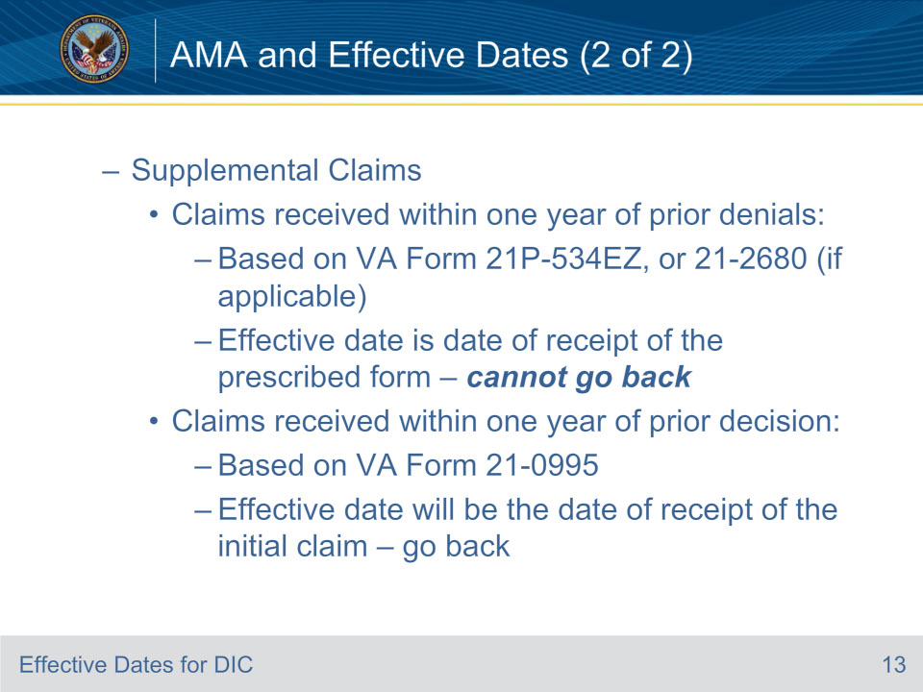
Slide notes

Policy Reference: M21-5 Appeals and Reviews

Slide 14 - AMA and Effective Dates (3 of 3)
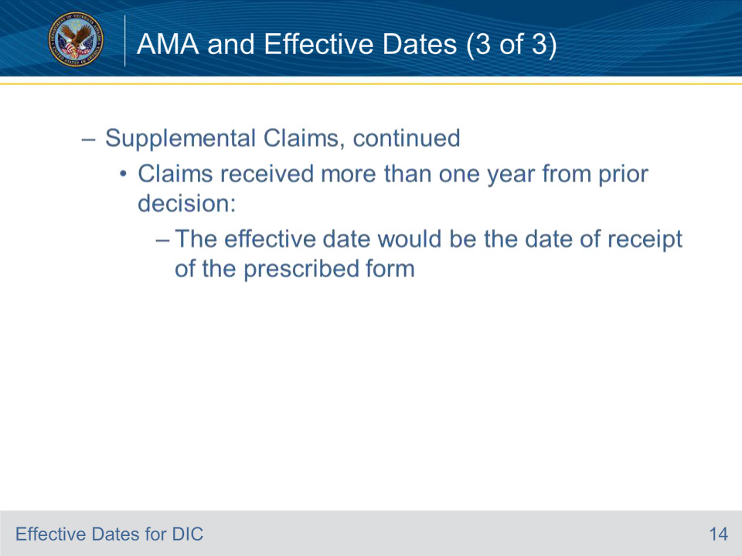
Slide notes

Policy Reference: M21-5 Appeals and Reviews

Slide 15 - Effective Date Scenario
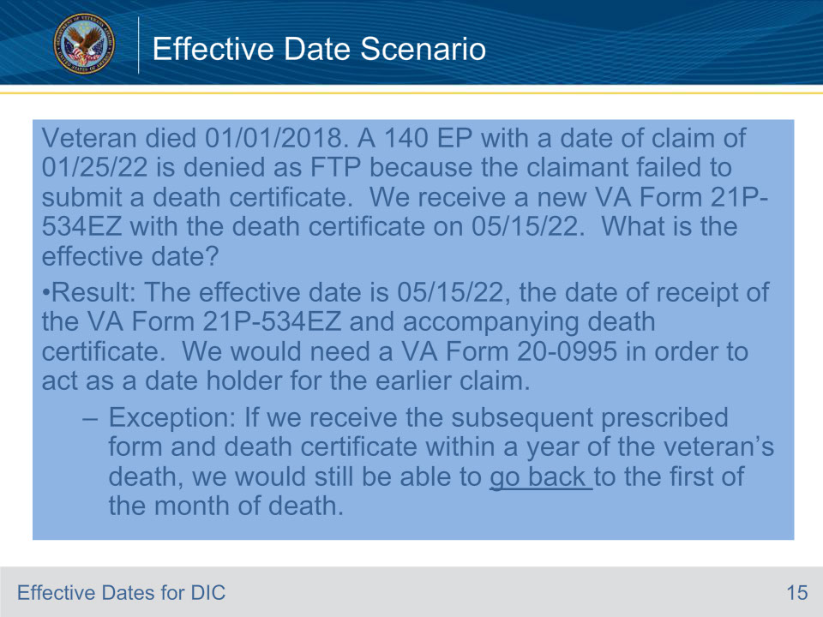
Slide notes

Scenario: Veteran died 01/01/2018. A 140 EP with a date of claim of 01/25/22 is denied as FTP because the claimant failed to submit a death certificate. We receive a new VA Form 21P-534EZ with the death certificate on 05/15/22. What is the effective date?

Result: The effective date is 05/15/22, the date of receipt of the VA Form 21P-534EZ and accompanying death certificate. We would need a VA Form 20-0995 in order to act as a date holder for the earlier claim.

Exception: If we receive the subsequent prescribed form and death certificate within a year of the veteran’s death, we would still be able to go back to the first of the month of death.

Slide 16 - Justification of Effective Date
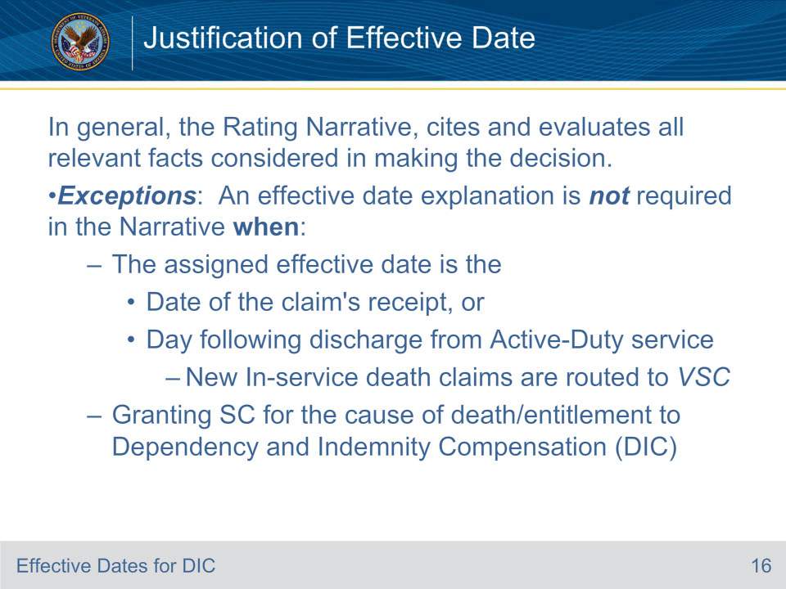
Slide notes

Policy Reference: M21-1 V.iv.1.A.5.a. Purpose of the Reasons for Decision

Generally, the Reasons for Decision section of the Rating Narrative, concisely cites and evaluate all relevant facts considered in making the decision on a claim, to include the effective date of an award.

However, when the assigned effective date for an award is the date of the claim’s receipt or the day following discharge from active-duty, it is the authorization’s activity responsibility to record the proper effective date. In the same manner, an effective date explanation is not required in the Rating Narrative when granting SC for the cause of death/entitlement to Dependency and Indemnity Compensation (DIC).

Again, an effective date explanation is not required in the Narrative when:

1- The assigned effective date is the Date of the claim’s receipt, or Day following discharge from Active-Duty service (typically seen when Veteran “Died in the Line of Duty” this is processed by Compensation ONLY) If you receive a claim where the Veteran Died recently in the Line of Duty inform your supervisor immediately, so it maybe routed to Compensation.

2- Granting SC for the cause of death/entitlement to Dependency and Indemnity Compensation (DIC)

Note: Always check to see if the rater lists the date of entitlement on the rating. If not, it is your responsibility to determine the correct entitlement date based on the evidence of record and applicable guidelines.

Slide 17 - Effective Dates and Liberalizing Legislation
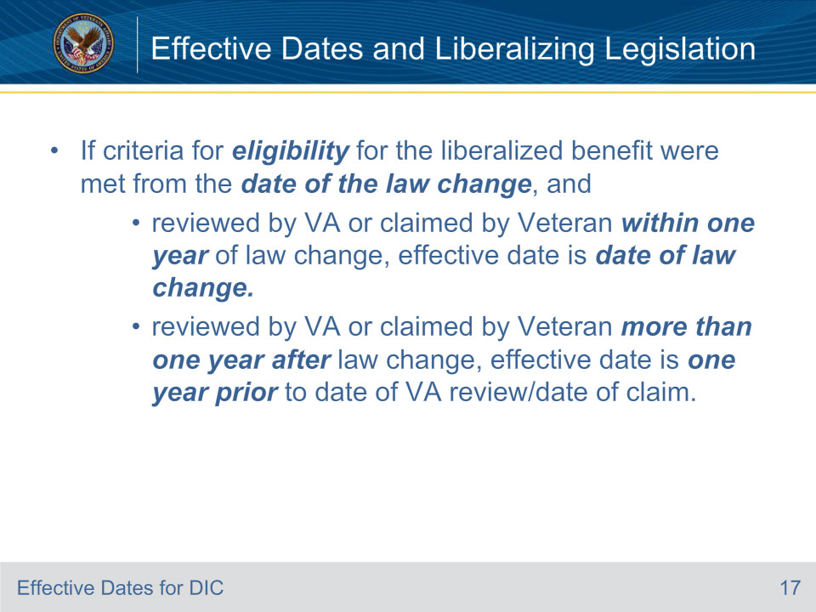
Slide notes

Policy Reference: M21-1 V.ii.4.A.6. Effective Dates Based on a Change of Law or Regulation and

NOTE: M21-1 XII.i.3.A.2.b. Application of 38 CFR 3.114 to DIC Claims

38 CFR 3.114 provides that an award of DIC associated with a liberalizing change of law cannot be earlier than the date a liberalizing law or administrative issue adding a new presumptive condition became effective. Thus, when service connection (SC) for cause of death is granted under a presumptive basis and no other service-related issues are linked to the Veteran’s death, the entitlement date for DIC cannot be earlier than the effective date of the change of law when granted under 38 CFR 3.114.

Notes: When SC for cause of death may be established on both a direct and a presumptive basis, the direct basis may result in a more favorable effective date since it is not limited by 38 CFR 3.114.

Pension should be considered and/or granted from the earliest qualifying date when the effective date for DIC under a presumptive basis is limited by 38 CFR 3.114 and entitlement to both benefits exists.

Slide 18 - Scenario Liberalizing Legislation
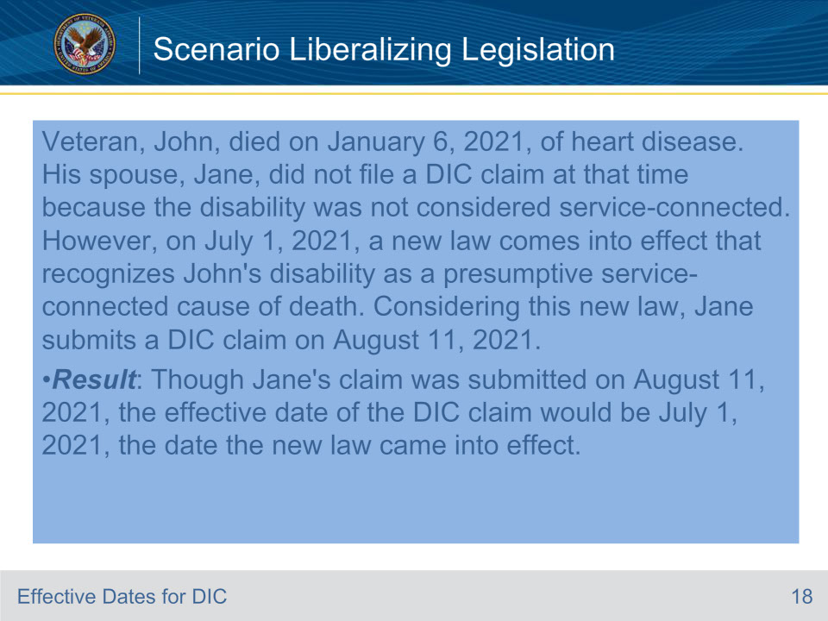
Slide notes

• Scenario 1 - Let’s consider a hypothetical situation where Veteran, John, died on January 6, 2021, of heart disease. His spouse, Jane, did not file a DIC claim at that time because the disability was not considered service-connected. However, on July 1, 2021, a new law comes into effect that recognizes John’s disability as a presumptive service-connected cause of death. Considering this new law, Jane submits a DIC claim on August 11, 2021.

• Result: Though Jane’s claim was submitted on August 11, 2021, the effective date of the DIC claim would be July 1, 2021, the date the new law came into effect. This is an exception to DIC effective date rules. The change in law allows for an earlier effective date. However, DIC benefits cannot be awarded back to the Veteran’s month of death. If applicable, Pension benefits could be awarded from January 1, 2021.

• Discussion: This scenario highlights the importance of staying up-to-date with changes in laws and regulations. It shows that such changes can potentially affect the assignment of effective dates.

Slide 19 - SSA Joint Applications and Effective Dates
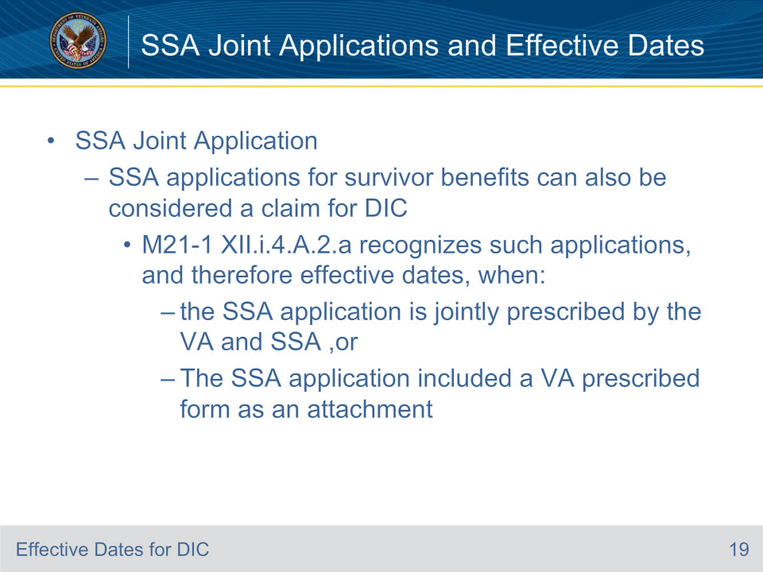
Slide notes

Policy Reference: M21-1 XII.i.4.A.2 Determining the Effective Date Based on Claims Filed With SSA

Under 38 U.S.C 5105, consider an application for survivors’ benefits filed as a result of the death of a Veteran with SSA on or after January 1, 1957, as a claim for Dependency and Indemnity Compensation (DIC), even if VA Form 21-4182, Application for Dependency and Indemnity Compensation or Death Pension (Including Accrued Benefits and Death Compensation Where Applicable) From the Department of Veterans Affairs, is not received by VA. The effective date of DIC will be the date survivors’ benefits were filed with SSA.

Slide 20 - Example on Claims Filed With SSA
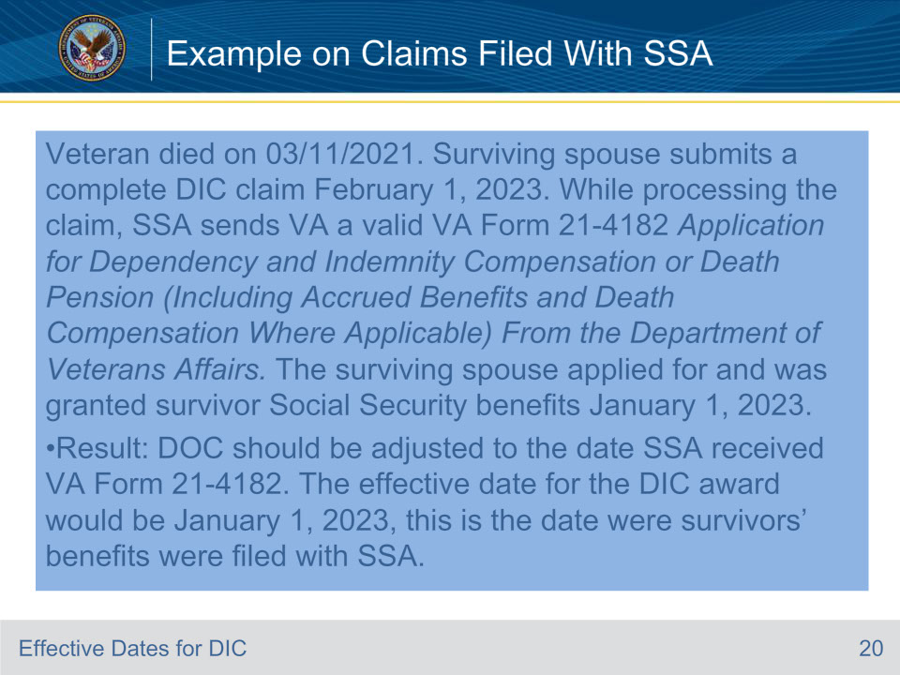
Slide notes

Policy reference: M21-1 XII.i.4.A.2.a. Recognition of Applications to SSA as an Application for DIC.

Let’s look at a scenario where the Veteran’s DOD is 03/11/2021. The Surviving spouse submits a complete DIC claim February 1, 2023. While processing the claim VA receives a valid VA Form 21-4182 Application for Dependency and Indemnity Compensation or Death Pension (Including Accrued Benefits and Death Compensation Where Applicable) From the Department of Veterans Affairs. The surviving spouse applied for and was granted survivor Social Security benefits January 1, 2023.

Result: The effective date for the DIC award would be January 1, 2023, this is the date were survivors’ benefits were filed with SSA. If the claim is pending the DOC should be adjusted accordingly.

Slide 21 - Effective Dates Granting SC for COVID-19
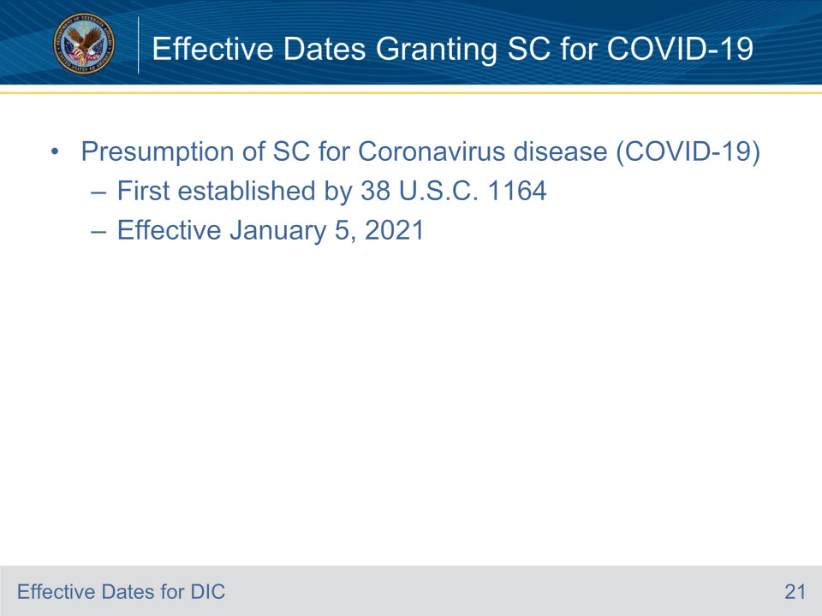
Slide notes

Policy Reference: M21-1 XII.i.3.A.2.c. Effective Dates When Granting SC for COVID-19

Presumption of SC for Coronavirus disease (COVID-19) was First established by 38 U.S.C. 1164. The effective date for presumption for COVID-19 is January 5, 2021.

Slide 22 - Scenario Effective Dates for SC COVID-19
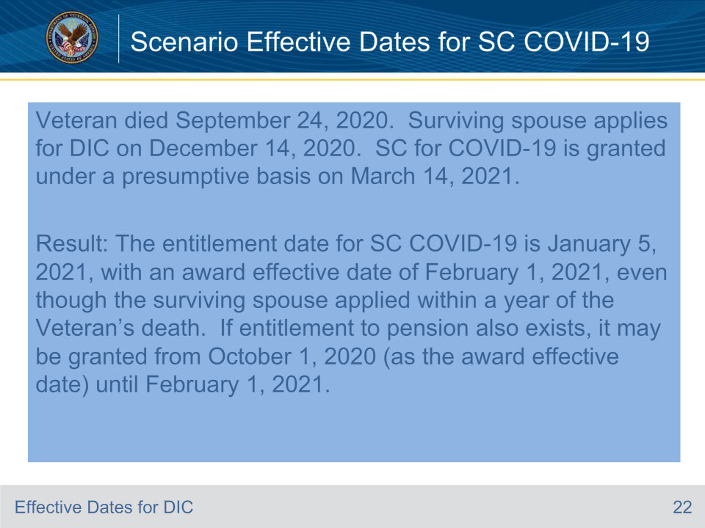
Slide notes

Policy Reference: M21-1 XII.i.3.A.2.c. Effective Dates When Granting SC for COVID-19

Let’s imagine that a Veteran died September 24, 2020. The Surviving spouse applies for DIC on December 14, 2020. SC for COVID-19 is granted under a presumptive basis on March 2021.

Result: The entitlement date for DIC is January 5, 2021, with an award effective date of February 1, 2021, even though the surviving spouse applied within a year of the Veteran’s death. If entitlement to pension also exists, it may be granted from October 1, 2020 (as the award effective date) until February 1, 2021.

Slide 23 - Role of an Intent To File (ITF)
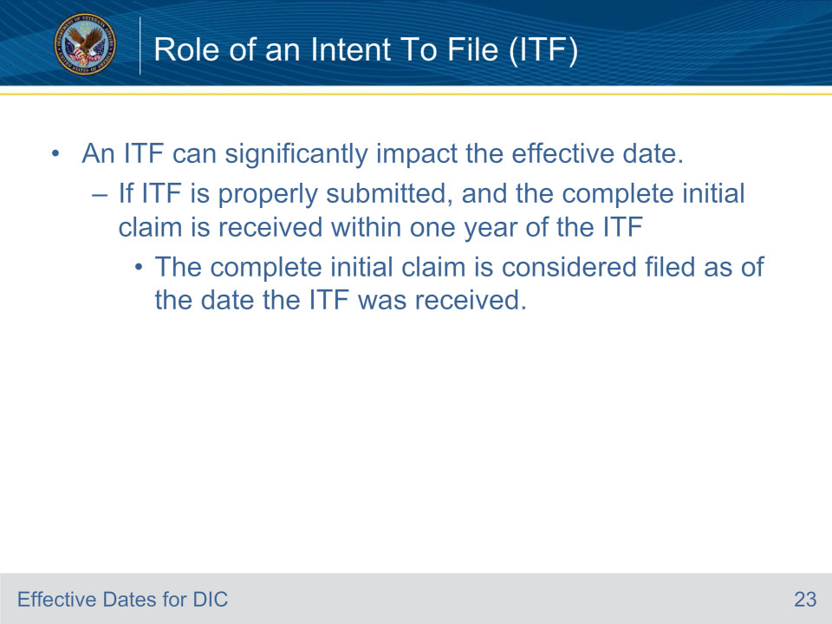
Slide notes

Policy Reference: V.ii.4.A.2.a. Applicability of ITF on Effective Date Assignment

Role of Intent to File (ITF): An ITF can significantly impact the effective date. If an ITF is properly submitted, and a complete initial claim is received within one year of the ITF, the complete initial claim is considered filed as of the date the ITF was received.

Slide 24 - Interpreting Case Scenarios
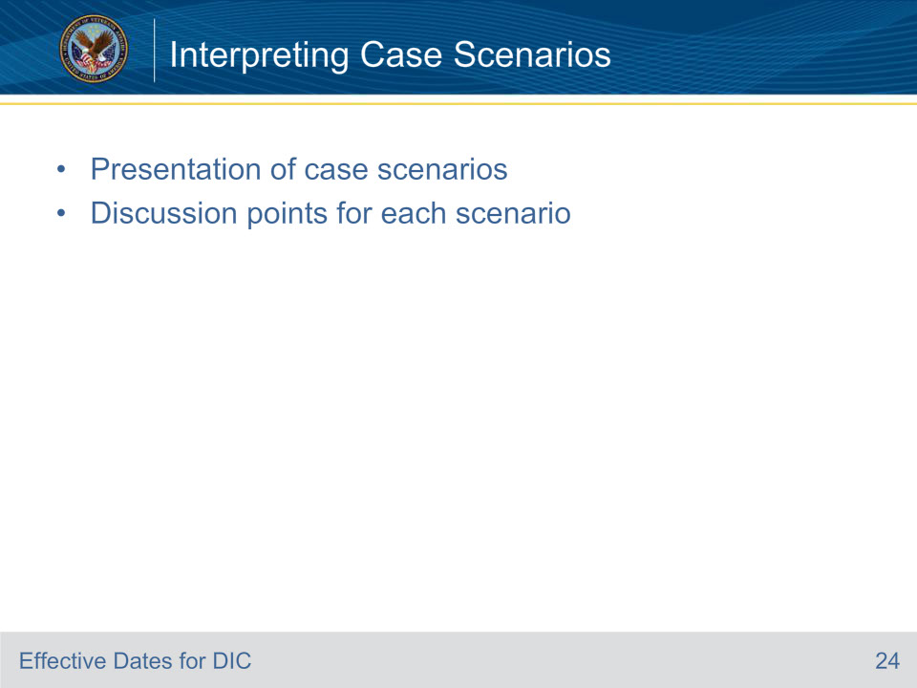
Slide notes

Objective 2 Interpreting Case Scenarios

The following slides cover the:

• Presentation of case scenarios

• Discussion points for each scenario

Slide 25 - Case Scenario 1
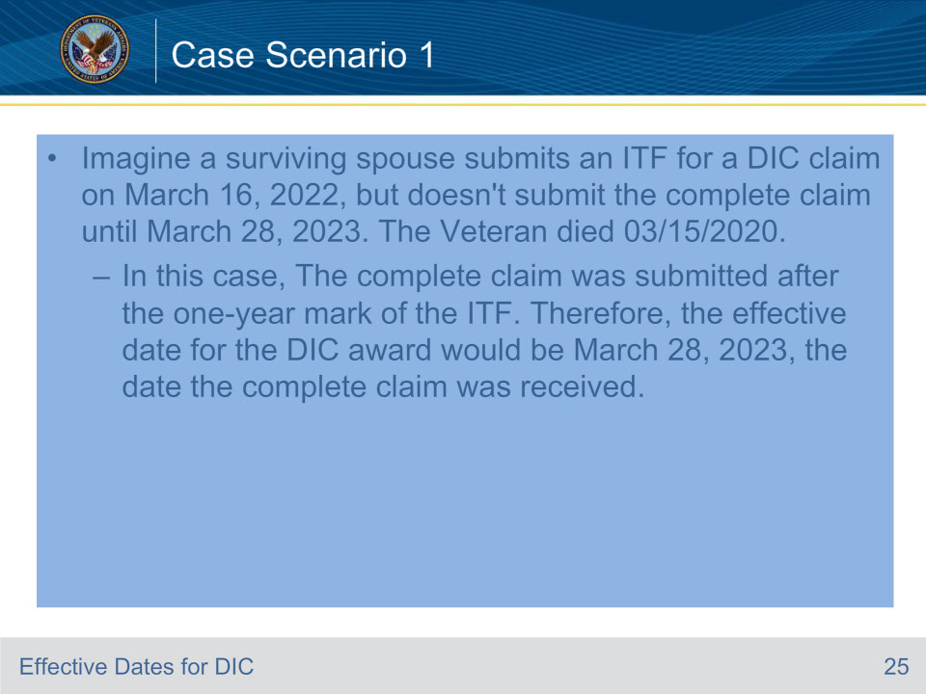
Slide notes

• Case Scenario 1: Imagine a surviving spouse submits an ITF for a DIC claim on March 16, 2022, but doesn’t submit the complete claim until March 18, 2023. The Veteran’s DOD is 03/15/2020.

• Result: In this case, The complete claim was not submitted within one year of the ITF. Therefore, the effective date for the DIC claim would be March 28, 2023, the date the complete claim was received.

Discussion: This scenario highlights the importance of the one-year timeframe for submitting a complete claim after an ITF. Remember that even if an ITF is submitted, the effective date can be later if the complete claim is not submitted within one year.

Slide 26 - Case Scenario 2
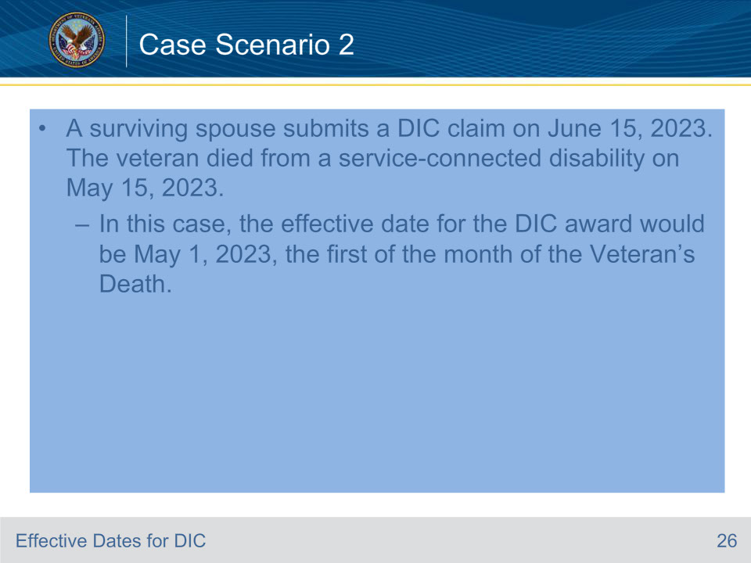
Slide notes

Case Scenario 2: A surviving spouse submits a DIC claim on June 15, 2023. The veteran died from a service-connected disability on May 15, 2023.

In this case, the effective date for the DIC claim would be May 1, 2023, the first of the month of the Veteran’s Death.

- Discussion: This scenario demonstrates that the date of receipt of the claim does not necessarily needs to be the effective date of entitlement if the entitlement arose from a prior date and within one year of the Veteran’s death.

Slide 27 - Special Circumstances
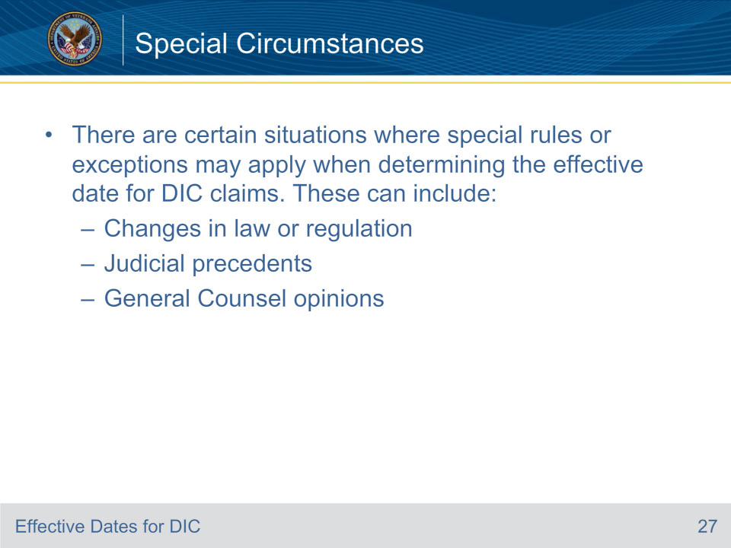
Slide notes

Policy Reference: M21-1 V.ii.4.A.6. Effective Dates Based on a Change of Law or Regulation and M21-1 V.ii.4.A.7. Effective Dates Based on Judicial Precedents or General Counsel Opinions

Special Rules or Exceptions: There are certain situations where special rules or exceptions may apply when determining the effective date for DIC claims. These can include changes in law or regulation, judicial precedents, or General Counsel opinions. Let’s quickly look at PACT Act effective dates in the next few slides.

Slide 28 - PACT Act Effective Dates (1 of 2)
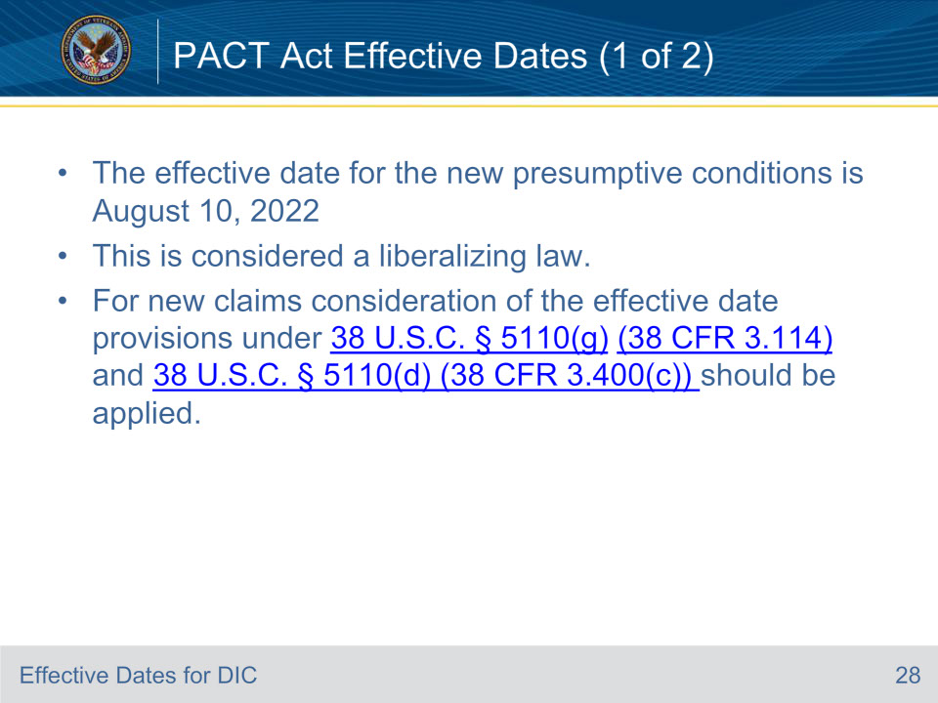
Slide notes

Policy Reference: VBA Letter 20-22-10.

The effective date for the new presumptive conditions under the PACT Act is August 10, 2022, the same day that the law went into effect. This is considered a liberalizing law.

Therefore, for new claims where the claimant did not elect VA reevaluate the previously denied claim, consideration of the effective date provisions under 38 U.S.C. § 5110(g) (38 CFR 3.114) and 38 U.S.C. § 5110(d) (38 CFR 3.400(c)) should be applied, allowing for consideration, in some cases, for an effective date earlier than the date of claim.

Remember: Claims regarding service-connected death benefits may have an effective date earlier than August 10, 2022.

Slide 29 - PACT Act Effective Dates (2 of 2)
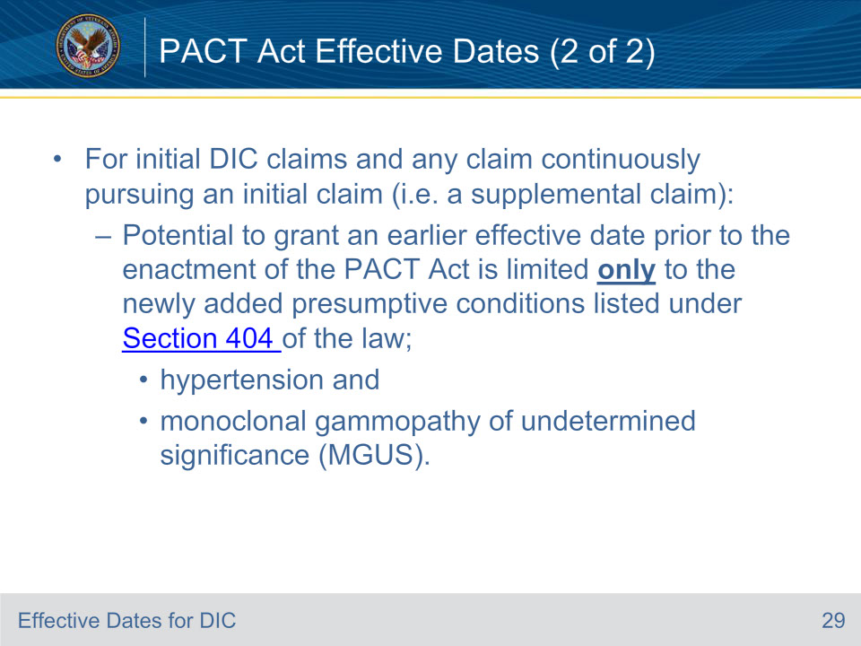
Slide notes

Policy Reference: VBA Letter 20-22-10.

For initial DIC claims and any claim that continuously pursues an initial claim (for example a supplemental claim filed on VA Form 0995), the potential to grant an earlier effective date prior to the enactment of the PACT Act is limited only to the newly added presumptive conditions listed under Section 404 of the law; hypertension and monoclonal gammopathy of undetermined significance (MGUS). This is the only section which authorizes VA to pay “retroactive” benefits to the extent authorized by 38 U.S.C. 5110(a) and 38 U.S.C 5110(d) without regard to the liberalizing law limitation in section 5110(g).

Slide 30 - Scenario 1 Change in Law
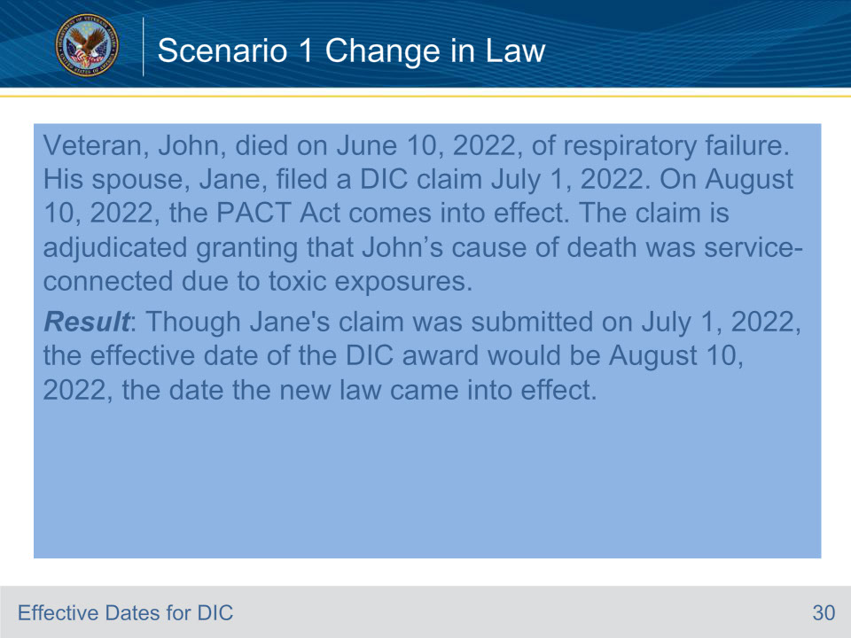
Slide notes

• Scenario 1 - Change in Law: Let’s consider a hypothetical situation where Veteran, John, died on June 10, 2022, of respiratory failure. His spouse, Jane, filed a DIC claim July 1, 2022. On August 10, 2022, the PACT Act comes into effect, and the claim is adjudicated granting that John’s cause of death was service-connected due to toxic exposures.

• Result: Though Jane’s claim was submitted on July 1, 2022, the effective date of the DIC award would be August 10, 2022, the date the new law came into effect.

Discussion: This scenario highlights the importance of staying up-to-date with changes in laws and regulations. It shows that such changes can potentially affect the assignment of effective dates.

Remember: If the surviving spouse meets eligibility for NSC Pension from the date of the Veteran’s death this may be granted until DIC is effective.

Slide 31 - Assigning Effective Dates
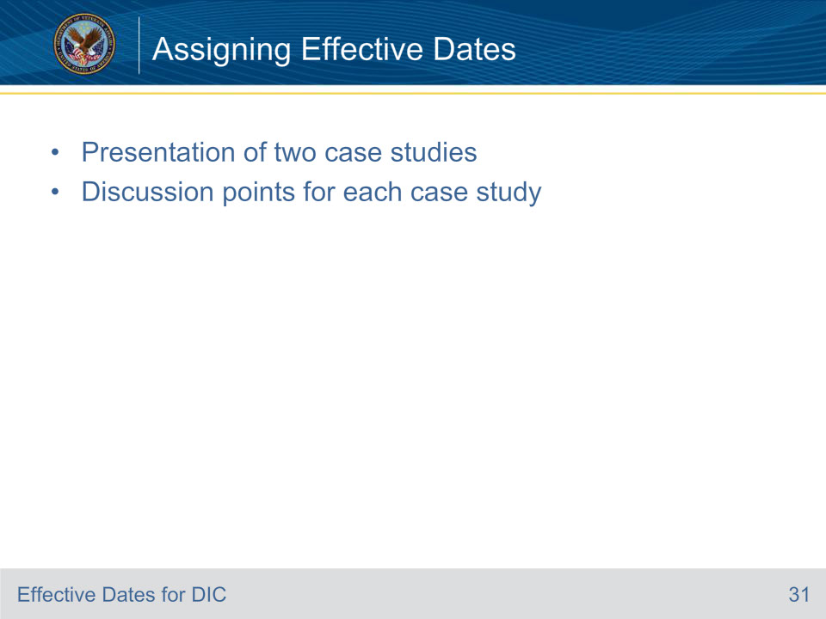
Slide notes

Objective 3 Applying Knowledge to Assign Effective Dates

Review the following two case studies and the discussion points for each one.

Slide 32 - Case Study 1
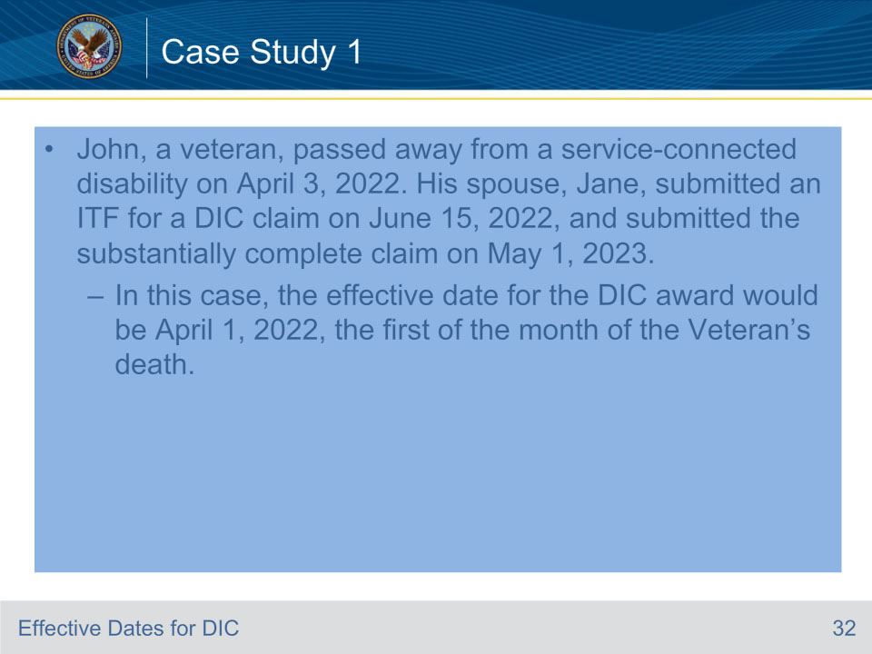
Slide notes

• Case Study 1 – ITF : John, a veteran, passed away from a service-connected disability on April 3, 2022. His spouse, Jane, submitted an ITF for a DIC claim on June 15, 2022, and submitted the substantially complete claim on May 1, 2023.

• Result: In this case, the effective date for the DIC award would be April 1, 2022, the first of the month of the Veteran’s death.

• Discussion: This case study demonstrates the importance of submitting an ITF as soon as possible after the event that caused the entitlement. It shows that an ITF can secure an earlier effective date than the date the complete claim is received.

Slide 33 - Case Study 2
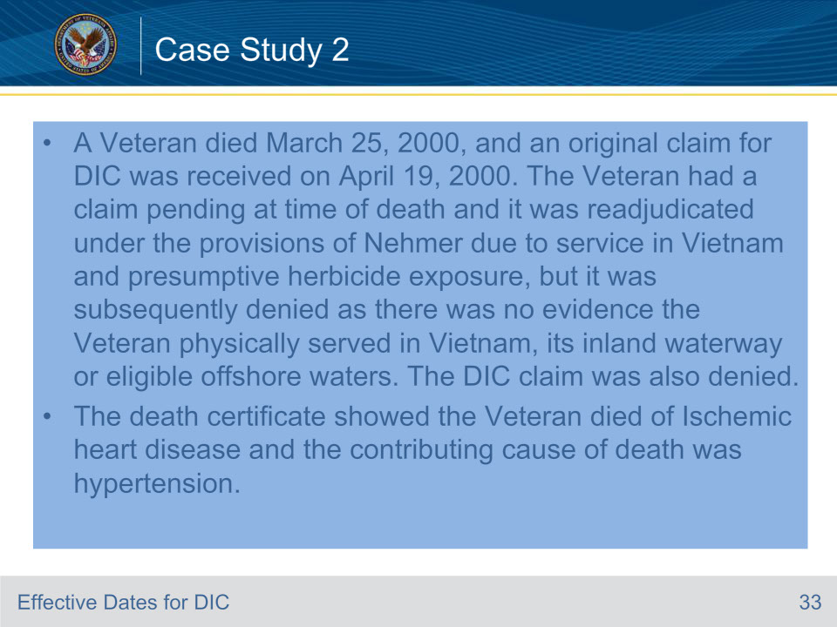
Slide notes

• Case Study 2 –A Veteran died March 25, 2000, and an original claim for DIC was received on April 19, 2000. The Veteran had a claim pending at time of death and it was readjudicated under the provisions of Nehmer due to service in Vietnam and presumptive herbicide exposure, but it was subsequently denied as there was no evidence the Veteran physically served in Vietnam, its inland waterway or eligible offshore waters.

• The DIC claim was also denied

• The death certificate showed the Veteran died of Ischemic heart disease and the contributing cause of death was hypertension.

Slide 34 - Case Study 2 (Cont.)
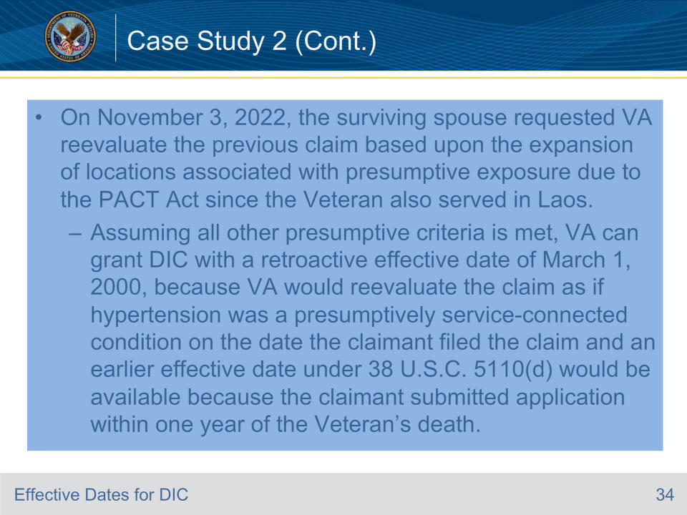
Slide notes

• Case Study 2 –A Veteran died March 25, 2000, and an original claim for DIC was received on April 19, 2000. The Veteran had a claim pending at time of death and it was readjudicated under the provisions of Nehmer due to service in Vietnam and presumptive herbicide exposure, but it was subsequently denied as there was no evidence the Veteran physically served in Vietnam, its inland waterway or eligible offshore waters.

• The DIC claim was also denied.

• The death certificate showed the Veteran died of Ischemic heart disease and the contributing cause of death was hypertension

• On November 3, 2022, the surviving spouse requested VA reevaluate the previous claim based upon the expansion of locations associated with presumptive exposure due to the PACT Act since the Veteran also served in Laos.

• Result: Assuming all other presumptive criteria is met, VA can grant DIC with a retroactive effective date of March 1, 2000, because VA would reevaluate the claim as if hypertension was a presumptively service-connected condition on the date the claimant filed the claim and an earlier effective date under 38 U.S.C. 5110(d) would be available because the claimant submitted application within one year of the Veteran’s death.

• Discussion: There is no time limit to elect reevaluation. However, the Nehmer accrued cannot be reevaluated. VA has determined that the provisions of the 1991 Nehmer v. United States Veterans Administration stipulation, per 38 CFR 3.816, does not apply to the new presumptive

• These case studies provide practical examples of how the principles and regulations we’ve discussed are applied in real-world scenarios. By studying these cases, we can better understand how to accurately assign effective dates for DIC claims.
Slide 35 - How to Avoid Common Mistakes
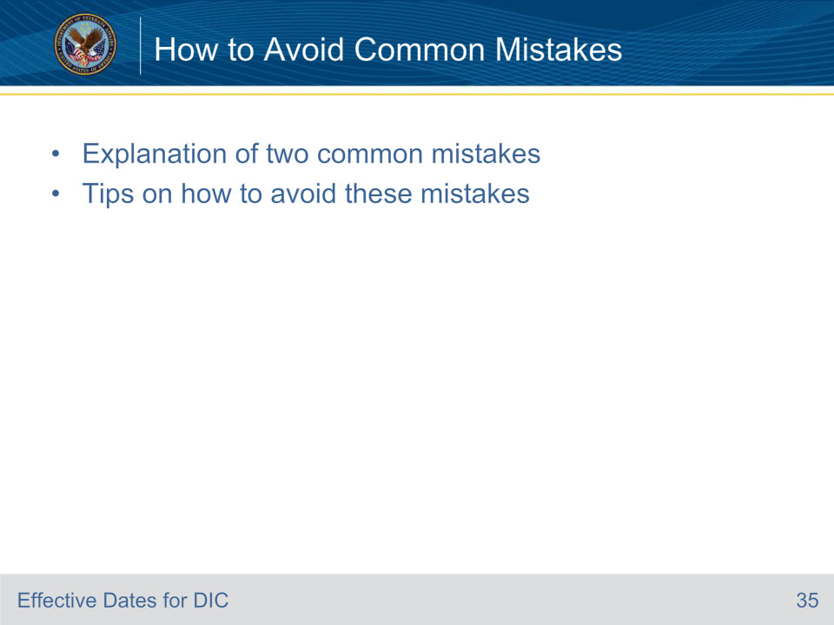
Slide notes

In the following slides we review and discuss common mistakes to avoid.

Slide 36 - Common Mistake 1
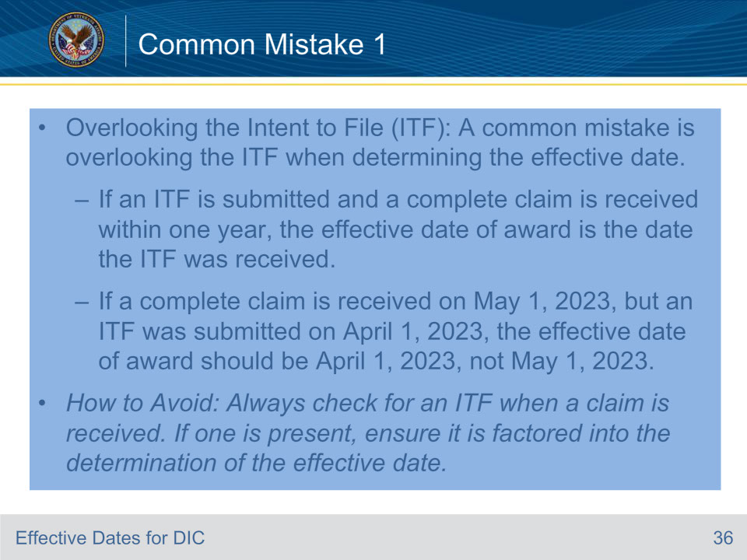
Slide notes

• Mistake 1 - Overlooking the Intent to File (ITF): A common mistake is overlooking the ITF when determining the effective date. If an ITF is submitted and a complete claim is received within one year, the effective date of the award is the date the ITF was received.

• Example: If a complete claim is received on May 1, 2023, but an ITF was submitted on April 1, 2023, the effective date of award should be April 1, 2023, not May 1, 2023.

- How to Avoid: Always check for an ITF when a claim is received. If one is present, ensure it is factored into the determination of the effective date.

Slide 37 - Common Mistake 2
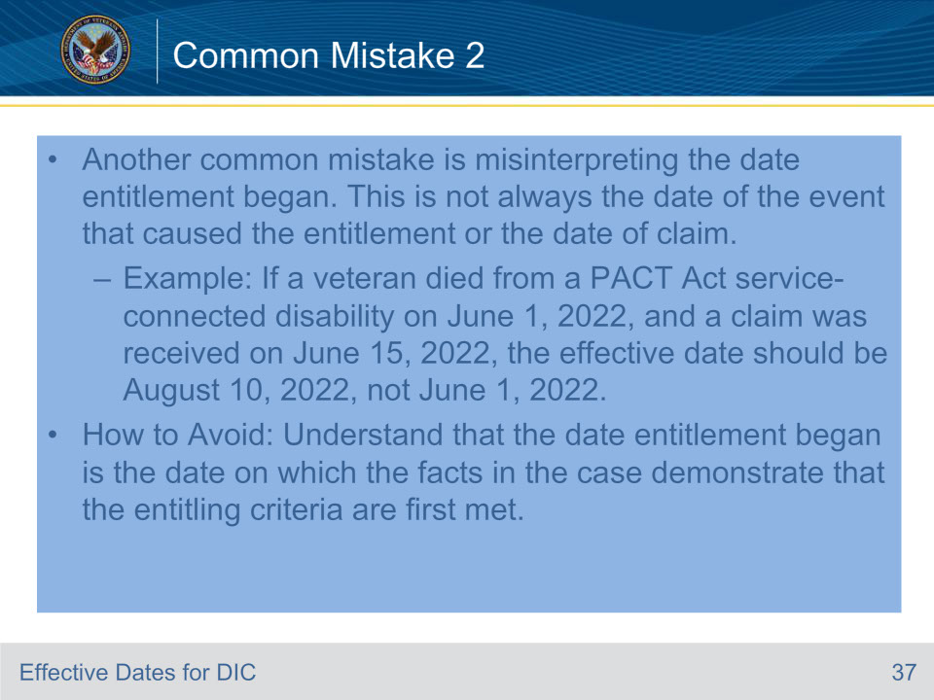
Slide notes

• Mistake 2 - Misinterpreting the Date Entitlement Arose- Another common mistake is misinterpreting the date entitlement arose. This is not always the date of the event that caused the entitlement or the date of claim.

• Example: If a veteran died from a PACT Act service-connected disability on June 1, 2022, and a claim was received on June 15, 2022, the effective date should be August 10, 2022, not June 1, 2022.

• How to Avoid: Understand that the date entitlement arose is the date on which the facts in the case demonstrate that the entitling criteria are first met. This may not always be the first of the month of the Veteran’s death.

• By being aware of these common mistakes and understanding how to avoid them, we can ensure that we are assigning the most accurate effective dates possible.

Slide 38 - Review
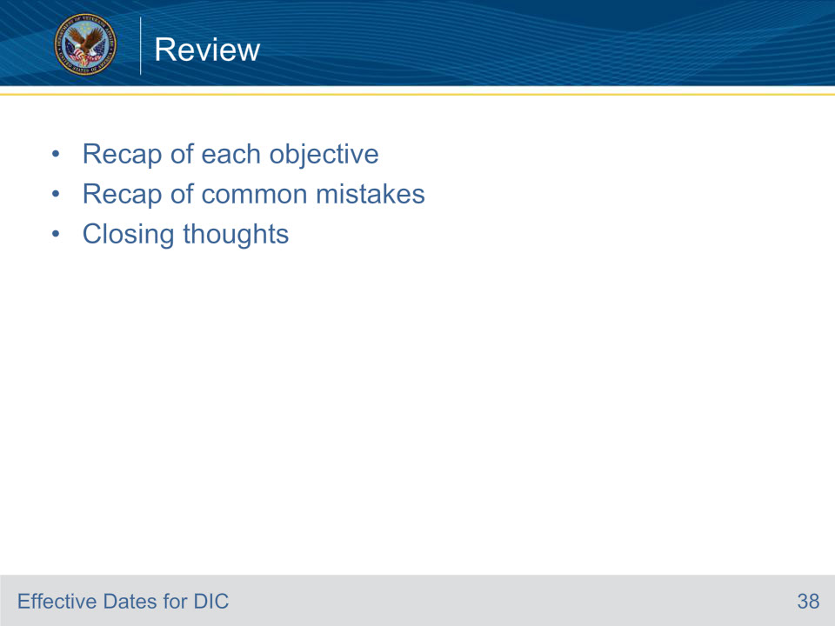
Slide notes

- Objective 1 Recap: We have learned the principles and regulations that guide the assignment of effective dates for DIC claims, including the role of Intent to File (ITF) and the general rule for assigning effective dates.

- Objective 2 Recap: We have interpreted various case scenarios and identified the key factors that influence the assignment of effective dates for DIC claims. This includes understanding the difference between the date of claim and the date entitlement arose, as well as the impact of submitting both an ITF and an incomplete claim.

- Objective 3 Recap: We have applied our understanding of the principles and regulations to assign appropriate effective dates for DIC claims in various scenarios. We have practiced this skill through case studies, demonstrating our ability to navigate the complexities of the process and make accurate decisions based on the facts of each case.

- Common Mistakes Recap: We have also discussed common mistakes made when determining effective dates and provided tips on how to avoid them. This includes overlooking the ITF and misinterpreting the date entitlement arose.

- Closing Thoughts: Remember, the assignment of an accurate effective date is not just a procedural step in the claims process. It directly impacts the claimant’s compensation and ensures that veterans or their dependents receive the benefits they are entitled to from the appropriate point in time.

Slide 39 - Questions
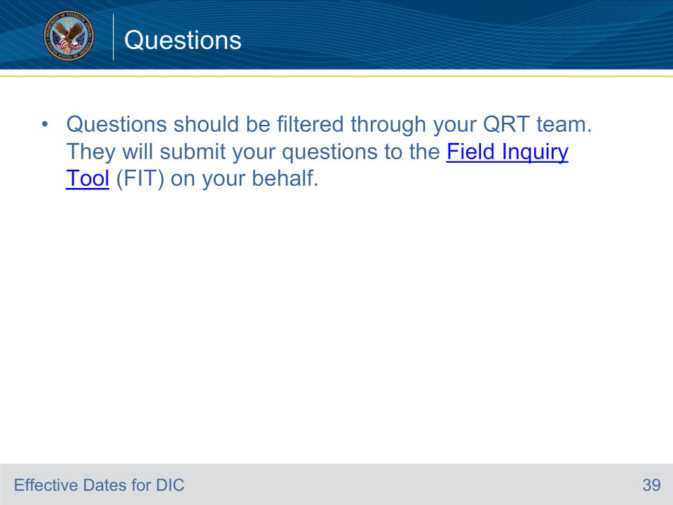
Slide notes

Please submit any questions through your QRT team. They will submit your questions to the Field Inquiry Tool (FIT) on your behalf.

Resources:

• M21-1 Manual: The M21-1 Adjudication Procedures Manual provides detailed guidance on all aspects of DIC claims.

- 38 U.S.C. 5110 and 38 CFR 3.400: These are the statutory and regulatory provisions that govern the assignment of effective dates for DIC claims. They provide the legal framework for our work and are essential reading for anyone involved in the adjudication of DIC claims.

- Peer Support and Supervisors: Don’t forget that your colleagues and supervisors are also valuable resources. They can provide practical advice, share their experiences, and offer guidance based on their expertise.
Slide 40 - TMS Survey
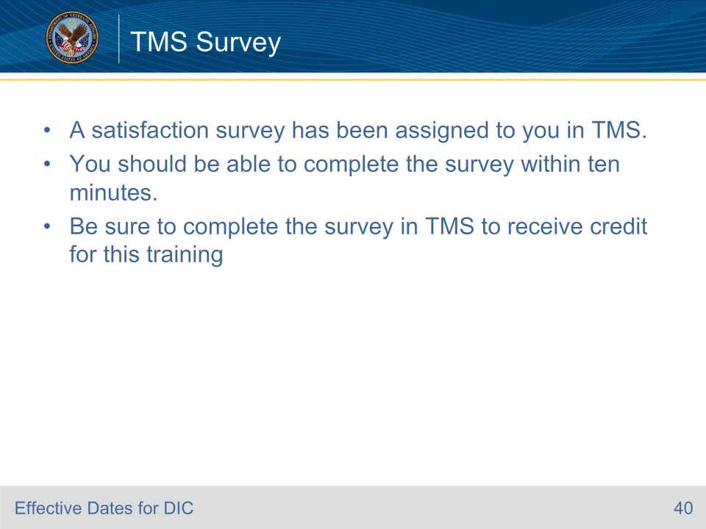
Slide notes

A satisfaction survey has been assigned to you in TMS. You should be able to complete the survey within ten minutes. Be sure to complete the survey in TMS to receive credit for this training.

