Slide 1 - PMC PACT Act Effective Dates

Slide notes

This lesson covers the PACT Act effective date requirements and how they relate to Pension benefits claims.

Slide 2 - Slide 2
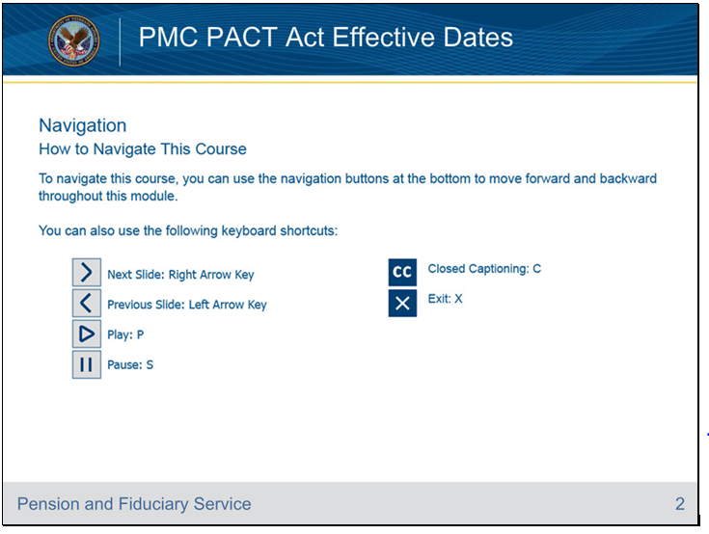
Slide notes

To navigate this course, you can use the navigation buttons at the bottom to move forward and backward throughout this module.

You can also use the following keyboard shortcuts listed on the screen.

Links will open in a new browser tab and pause the current slide and its audio.

You will need to select the play button again to resume.

Slide 3 - Objectives
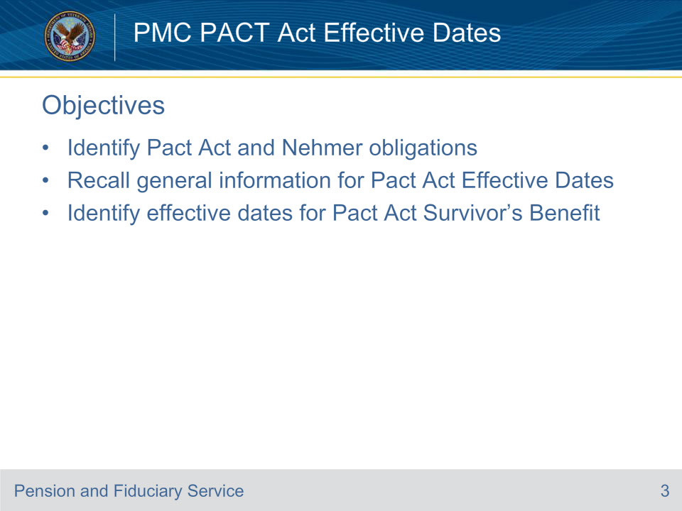
Slide notes

By the end of this lesson, given the training and references, the learner will be able to do the following:

Identify Pact Act and Nehmer obligations

Recall general information for Pact Act Effective Dates

Identify effective dates for Pact Act Survivor’s Benefit

Slide 4 - References
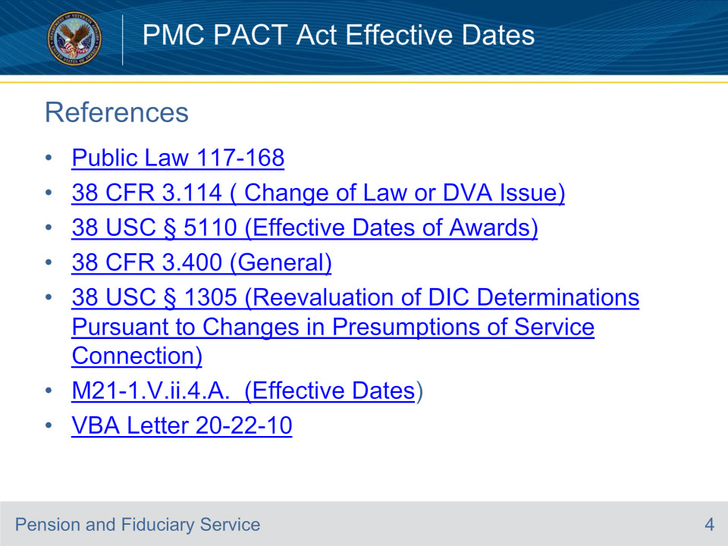
Slide notes

The following are relevant references for this training:

Public Law 117-168

38 CFR 3.114 (Change of Law or DVA Issue)

38 USC § 5110 (Effective Dates of Awards)

38 CFR 3.400 (General)

38 USC § 1305 (Reevaluation of DIC Determinations Pursuant

to Changes in Presumptions of Service Connection)

M21-1, Part V, Subpart ii, Chapter 4, Section A (Effective Dates)

VBA Letter 20-22-10

Slide 5 - A Note on Nehmer
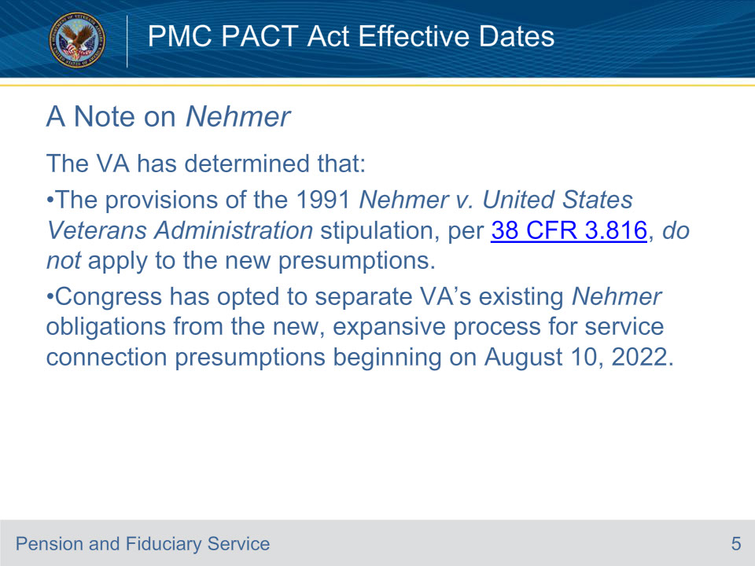
Slide notes

Policy Reference: VBA Letter 20-22-10.

On October 21, 2022 the Secretary of VA signed an executive decision memorandum,

Guidance for Processing Claims and Appeals for Disability Compensation and [DIC] Involving Presumptive Conditions Following the Enactment of the [PACT Act].

The memorandum addresses VA’s obligations under the Nehmer v. United States Department of Veterans Affairs, consent decree as they relate to the PACT Act.

In the PACT Act, Congress struck the presumptive processes established under Public Law 102-4,

Agent Orange Act of 1991 and codified in 38 U.S.C. § 1116(b), and created separate and distinct processes for newly created toxic exposure presumptions.

Note: Nehmer consent decree does not apply to presumptions of service connection created on or after August 10, 2022, the date the PACT Act was enacted.

This includes live compensation claims and claims based on service-connected death.

In other words, under Nehmer, VA benefits could be granted retroactively to when the condition/benefit was first filed.

However, under PACT, we cannot grant compensation or accrued benefits prior to the law change,

and cannot grant DIC benefits prior to the law change without a valid request for reconsideration.

The major take away from this training is that under 38 U.S.C. § 1305, at the election of the claimant,

VA would be required to reevaluate previously denied DIC claims for when presumptions of service connections are established or modified.

If VA grants any such claim, section 1305 provides for the award of effective dates

“as if the establishment or modification of the presumption of service connection had been in effect on the date of the submission of the original claim”

without regard to 38 U.S.C. § 5110.

Slide 6 - Effective Date Considerations
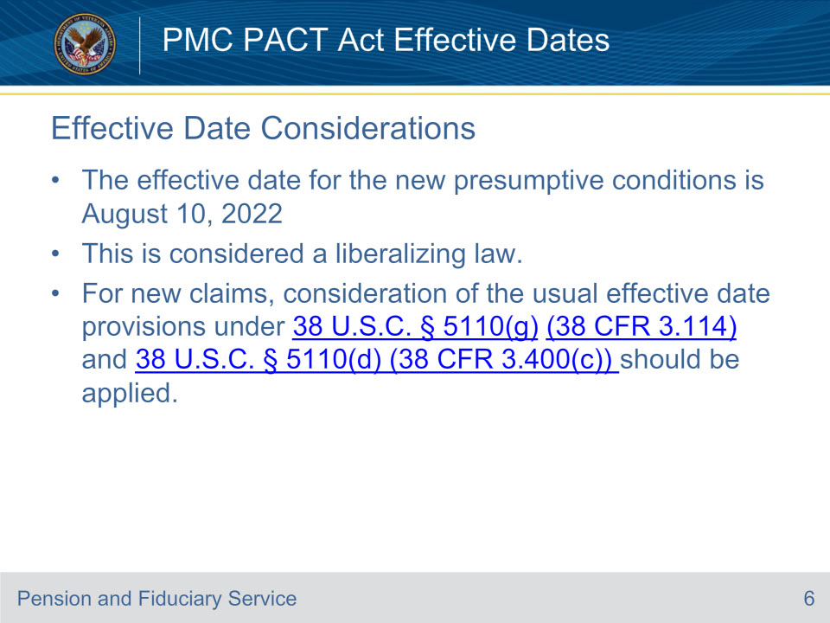
Slide notes

Policy Reference: VBA Letter 20-22-10.

The effective date for the new presumptive conditions is August 10, 2022, the same day that the law went into effect.

This is considered a liberalizing law. Therefore, for new claims (claimant did not elect VA reevaluate the previously denied claim), consideration of the usual effective date provisions

under 38 U.S.C. § 5110(g) (38 CFR 3.114) and 38 U.S.C. § 5110(d) (38 CFR 3.400(c))

should be applied, allowing for consideration, in some cases, for an effective date earlier than the date of claim.

For Compensation benefits all the presumptions in the PACT Act will be effective on the date of enactment, August 10, 2022. There are no tiered enactment or effective dates

Note: Claims regarding service-connected death benefits may have an effective date earlier than August 10, 2022.

Slide 7 - Effective Date for Initial DIC Claims
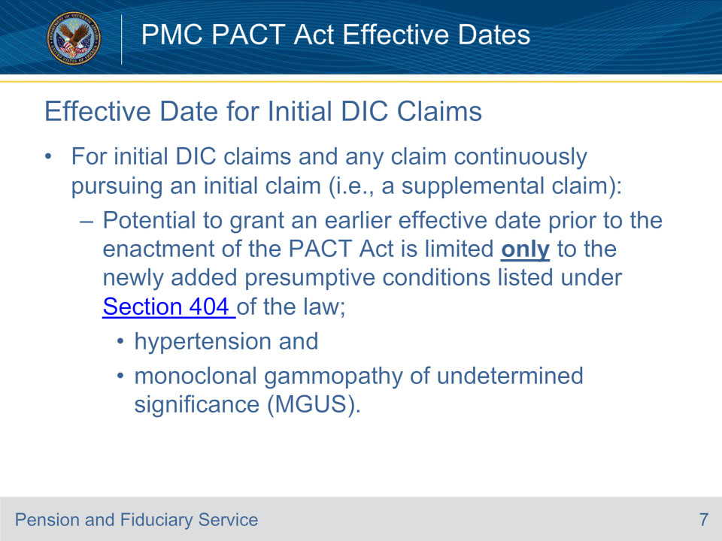
Slide notes

Policy Reference: VBA Letter 20-22-10.

For initial DIC claims and any claim that continuously pursues an initial claim (for example a supplemental claim filed on VA Form 0995),

the potential to grant an earlier effective date prior to the enactment of the PACT Act is limited only

to the newly added presumptive conditions listed under Section 404 of the law; hypertension and monoclonal gammopathy of undetermined significance (MGUS).

This is the only section which authorizes VA to pay “retroactive” benefits

to the extent authorized by 38 U.S.C. 5110(a) and 38 U.S.C 5110(d) without regard to the liberalizing law limitation in section 5110(g).

Slide 8 - Effective Dates Initial DIC Claim - Example
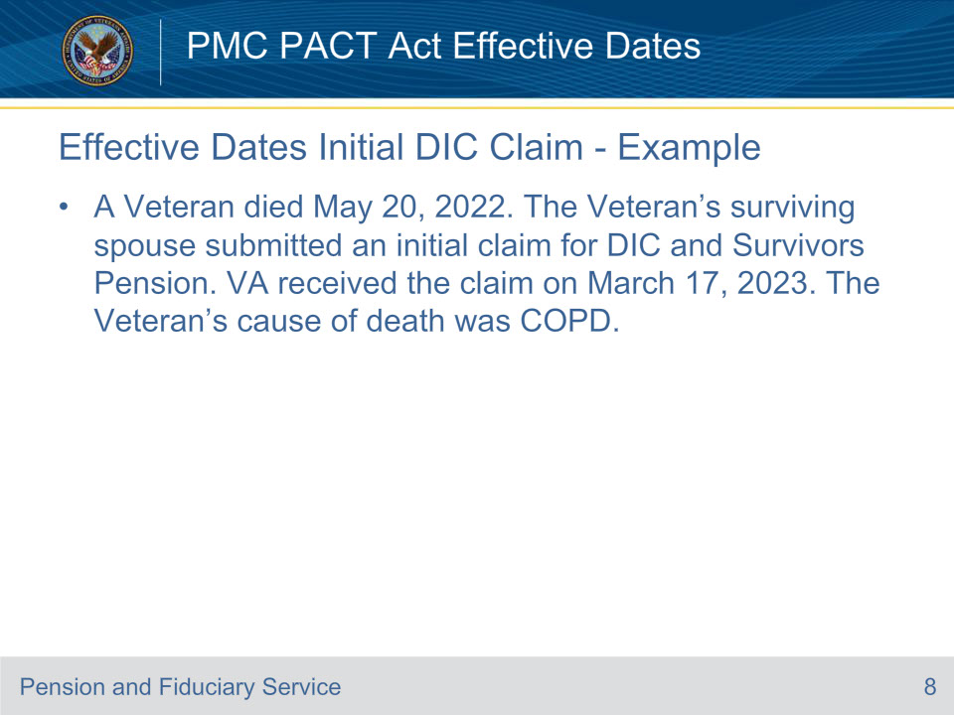
Slide notes

Effective Dates Initial DIC Claim - Example

A Veteran died May 20, 2022. The Veteran’s surviving spouse submitted

an initial claim for DIC and Survivors Pension. VA received the

claim on March 17, 2023. The Veteran’s cause of death was COPD.

Slide 9 - Effective Dates Initial DIC Claim - Response
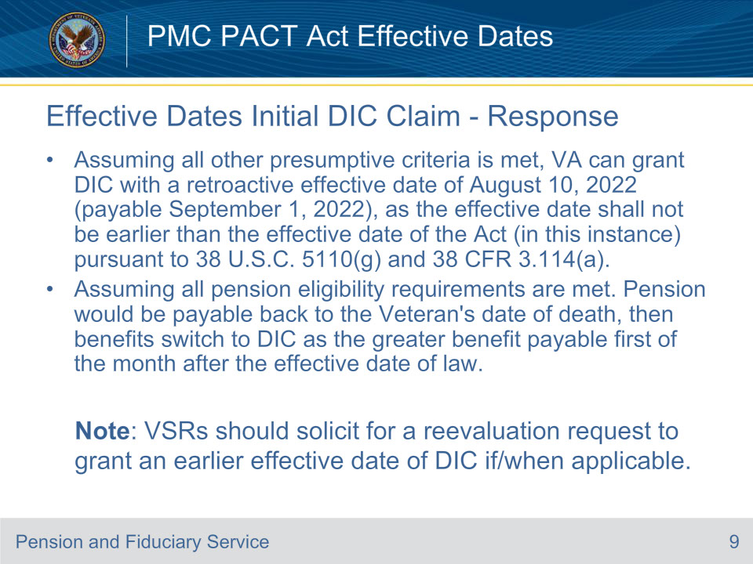
Slide notes

Effective Dates Initial DIC Claim - Response

Assuming all other presumptive criteria is met, VA can grant DIC with a retroactive effective date of

August 10, 2022 (payable September 1, 2022), as the effective date shall not

be earlier than the effective date of the Act (in this instance) pursuant to 38 U.S.C. 5110(g) and 38 CFR 3.114(a).

Assuming all pension eligibility requirements are met. Pension would be payable back to the Veteran’s

date of death, then benefits switch to DIC as the greater benefit

payable first of the month after the effective date of law.

Note that although not applicable in this example, VSRs should solicit for a reevaluation request to grant an earlier effective date of DIC if applicable to the claim being adjudicated.

Slide 10 - Effective Date for DIC Reevaluations 1 of 2
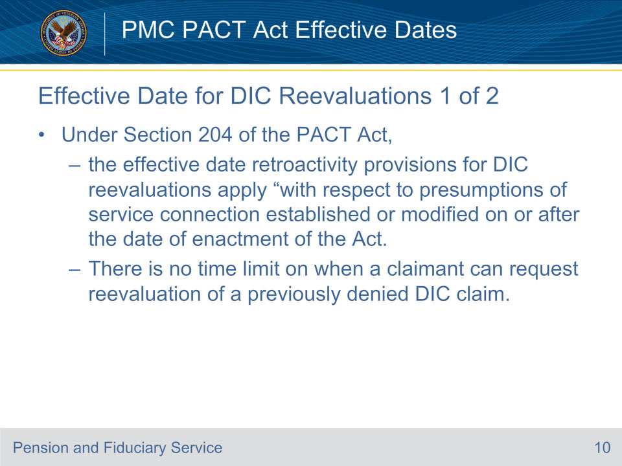
Slide notes

Policy Reference: VBA Letter 20-22-10.

Under section 204 of the PACT Act, the effective date retroactivity provisions for DIC reevaluations apply “with respect to presumptions

of service connection established or modified on or after the date of enactment of the Act,

including pursuant to amendments made by this Act.” This would include, for example, new presumptions created in sections 401, 402, 403, 404 and 406.

Slide 11 - Effective Date for DIC Reevaluations 2 of 2
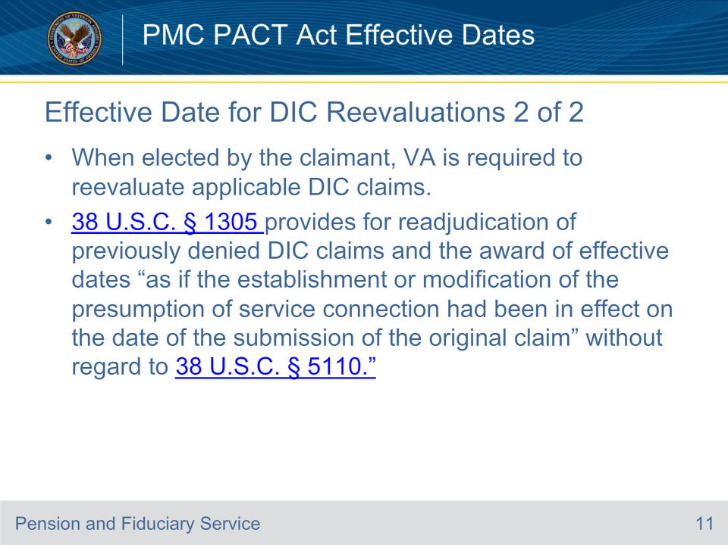
Slide notes

Policy Reference: VBA Letter 20-22-10. U.S.C. § 1305

When elected by the claimant, VA is required to reevaluate DIC claims. Section 1305 provides for reevaluation of previously denied DIC claims

and the award of effective dates “as if the establishment or modification of the presumption

of service connection had been in effect on the date of the submission of the original claim” without regard to 38 U.S.C. § 5110.

In other words, when a valid request to reevaluate a previously denied claim is received and retroactive benefits are warranted,

VA must assign an effective date as if the newly established or modified presumption was in effect at the time of the original DIC claim.

Slide 12 - Effective Dates DIC Reevaluation - Example
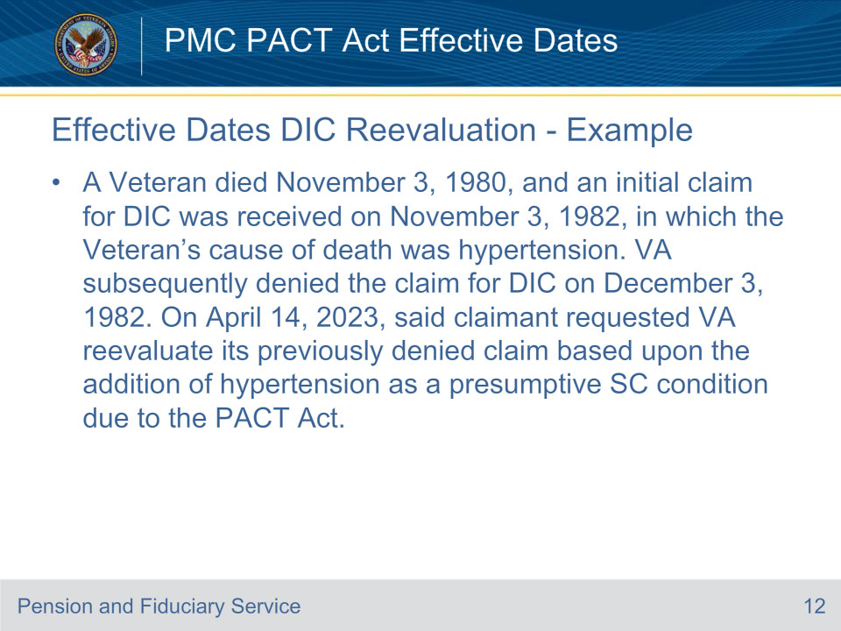
Slide notes

Effective Dates DIC Reevaluation - Example

A Veteran died November 3, 1980, and an initial claim for DIC was received on November 3, 1982,

in which the Veteran’s cause of death was hypertension.

VA subsequently denied the claim for DIC on December 3, 1982.

On April 14, 2023, said claimant requested VA reevaluate its previously denied

claim based upon the addition of hypertension as a presumptive SC condition due to the PACT Act.

Slide 13 - Effective Dates DIC Reevaluation - Response
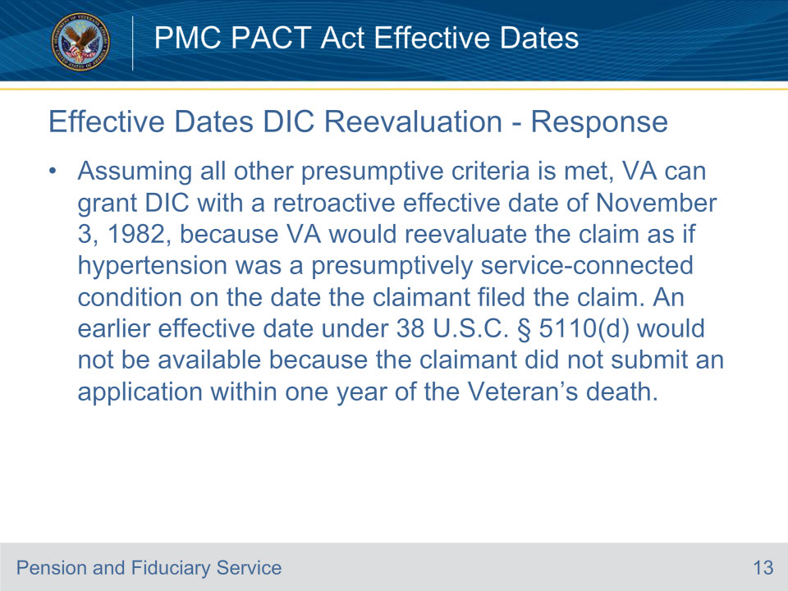
Slide notes

Effective Dates DIC Reevaluation - Response

Assuming all other presumptive criteria is met, VA can grant DIC with a retroactive effective date of November 3, 1982,

because VA would reevaluate the claim as if hypertension was a presumptively service-connected condition

on the date the claimant filed the claim. An earlier effective date under 38 U.S.C. § 5110(d)

would not be available because the claimant did not submit an application within one year of the Veteran’s death.

Slide 14 - Effective Dates DIC Reevaluation – Example 2
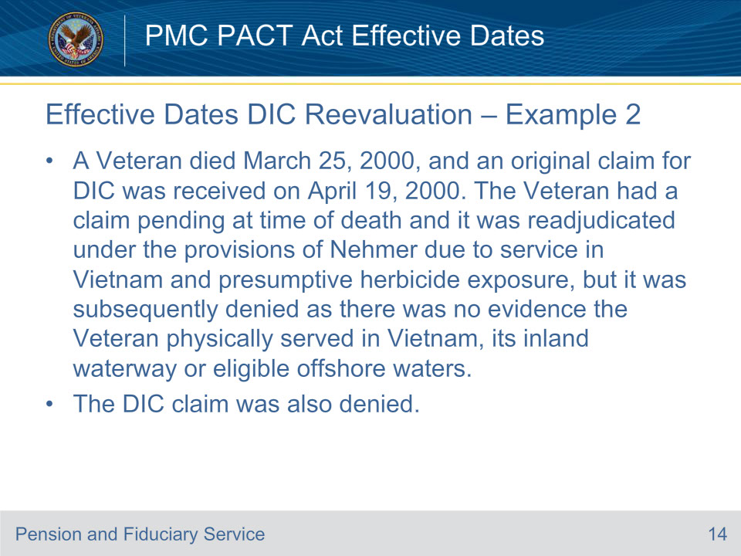
Slide notes

Effective Dates DIC Reevaluation Example 2

A Veteran died March 25, 2000, and an original claim for DIC was received on April 19, 2000.

The Veteran had a claim pending at time of death and it was readjudicated

under the provisions of Nehmer due to service in Vietnam and

presumptive herbicide exposure, but it was subsequently denied as there was no evidence the

Veteran physically served in Vietnam, its inland waterway or eligible offshore waters.

Slide 15 - Effective Dates DIC Reevaluation – Example 2 Cont.
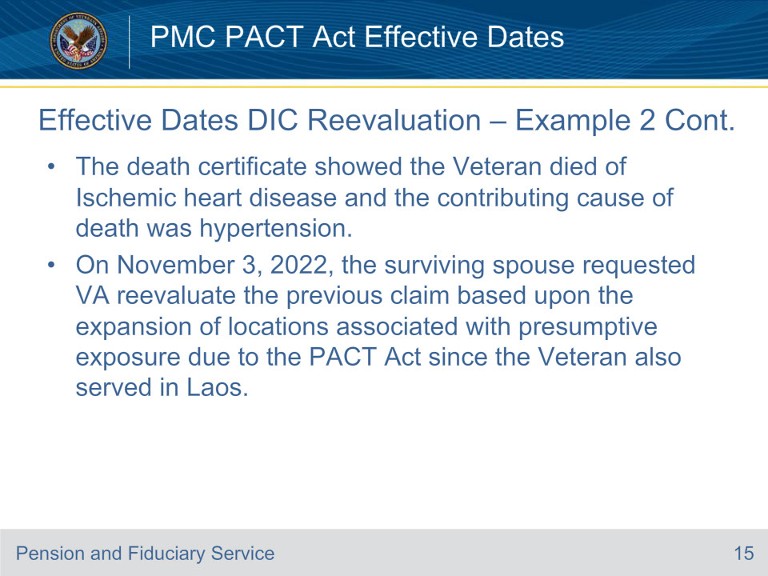
Slide notes

Effective Dates DIC Reevaluation Example 2 Continued

The death certificate showed the Veteran died of Ischemic heart disease and

the contributing cause of death was hypertension.

On November 3, 2022, the surviving spouse requested VA reevaluate the previous claim based

upon the expansion of locations associated with

presumptive exposure due to the PACT Act since the Veteran also served in Laos.

Slide 16 - Effective Dates DIC Reevaluation – Response 2
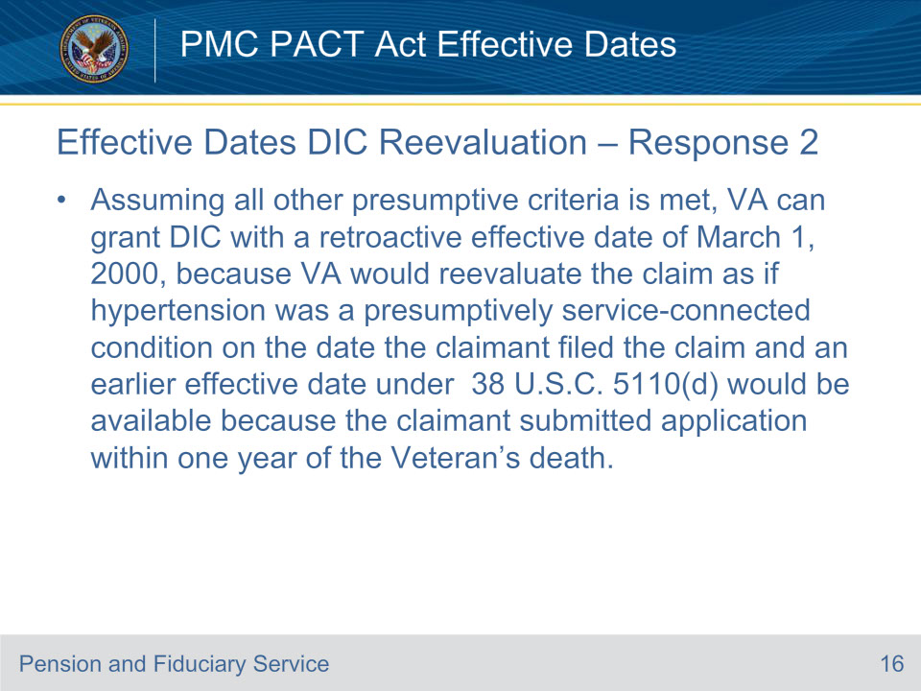
Slide notes

Effective Dates DIC Reevaluation Response 2

Assuming all other presumptive criteria is met, VA can grant DIC with a retroactive effective date of March 1, 2000,

because VA would reevaluate the claim as if hypertension was a presumptively service-connected

condition on the date the claimant filed the claim and an earlier effective date

under 38 U.S.C. 5110(d) would be available because the claimant submitted

application within one year of the Veteran’s death.

Slide 17 - Effective Dates DIC Reevaluation – Response 2 Cont.
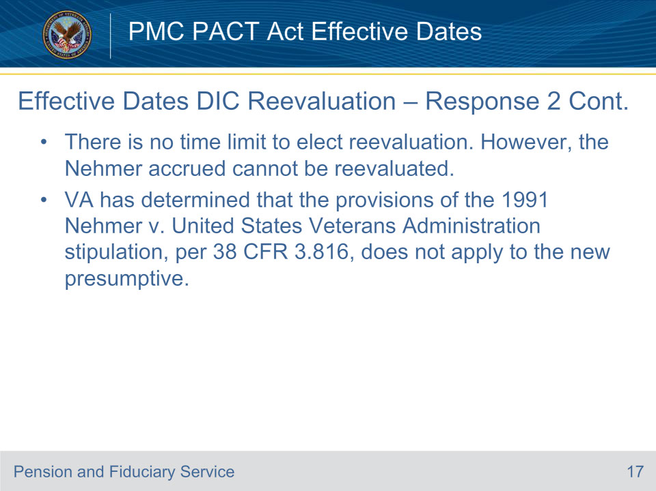
Slide notes

Effective Dates DIC Reevaluation Response 2 Continued

There is no time limit to elect reevaluation.

However, the Nehmer accrued cannot be reevaluated.

VA has determined that the provisions of the 1991 Nehmer v. United States Veterans Administration stipulation,

per 38 CFR 3.816, does not apply to the new presumptive.

Slide 18 - Effective Dates For Accrued/Substitution 1 of 3
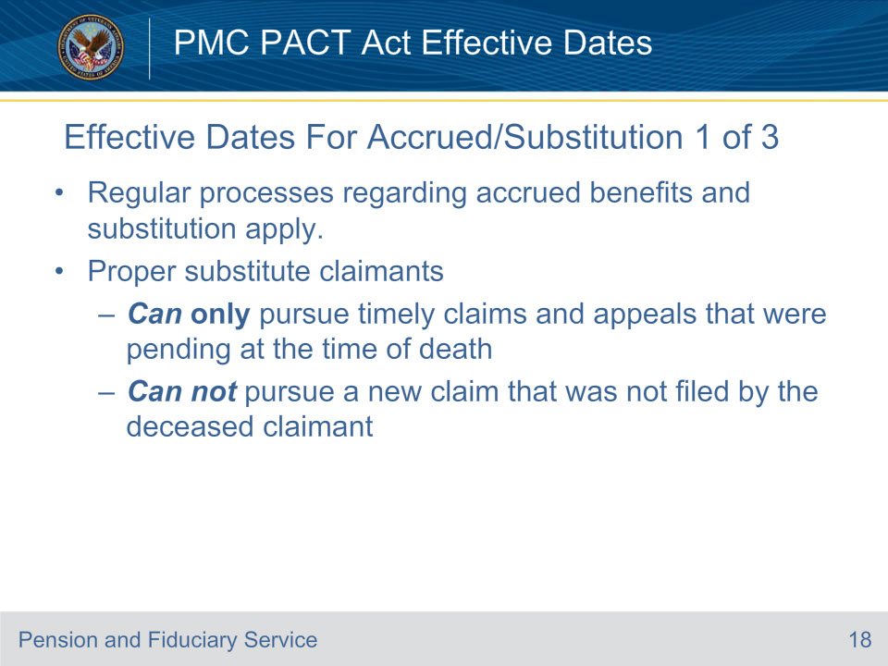
Slide notes

Policy Reference: 38 U.S.C. 5121, 38 U.S.C. 5121A

The regular processes regarding accrued benefits and substitution, contained in 38 U.S.C. 5121 and 38 U.S.C. 5121A, apply. Nothing has displaced 38 CFR 3.1000 or 38 CFR 3.1010(g),

so a proper substitute claimant can only pursue claims and appeals that were pending at the time of death, in a timely manner, and such an individual could not pursue a new claim that was not filed by the deceased claimant.

Important: Remember that PACT Act limits reevaluation to DIC and therefore, a surviving claimants cannot request reconsideration of the Veteran’s service connected conditions for accrued purposes as part of the PACT Act.

If the Veteran died before August 10, 2022, any issues pending at death would not be able to be granted based on PACT Act.

Slide 19 - Effective Dates For Accrued/Substitution 2 of 3
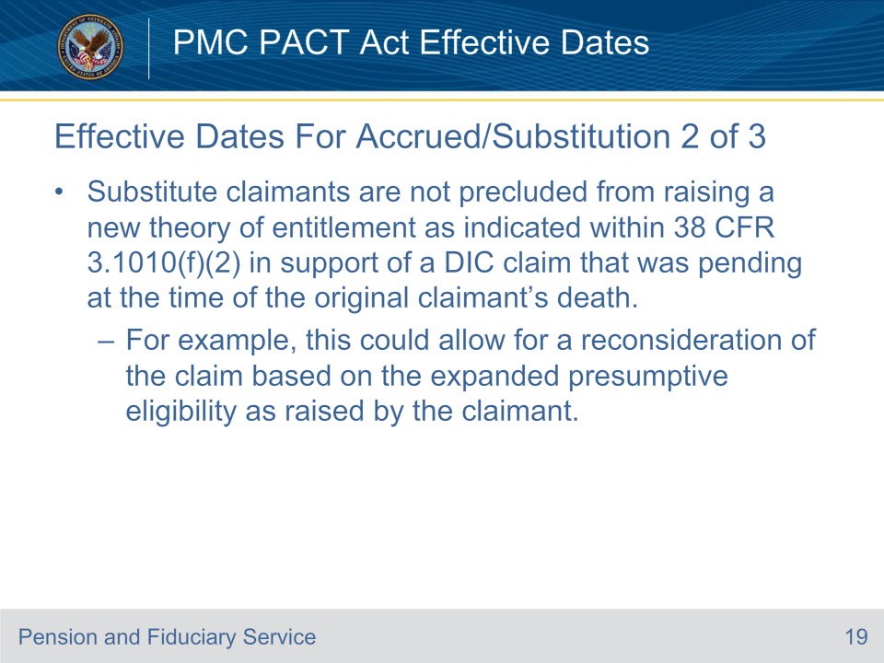
Slide notes

Further, a substitute claimant would not be precluded from raising a new theory of entitlement as indicated within 38 CFR 3.1010(f)(2)

in support of a DIC claim that was pending at the time of the original claimant’s death.

For example, this could allow for a reconsideration of the claim based on the expanded presumptive eligibility as raised by the claimant.

Notice that a DIC Claim must have been pending at the time of the original claimant’s death.

Slide 20 - Effective Dates For Accrued/Substitution 3 of 3
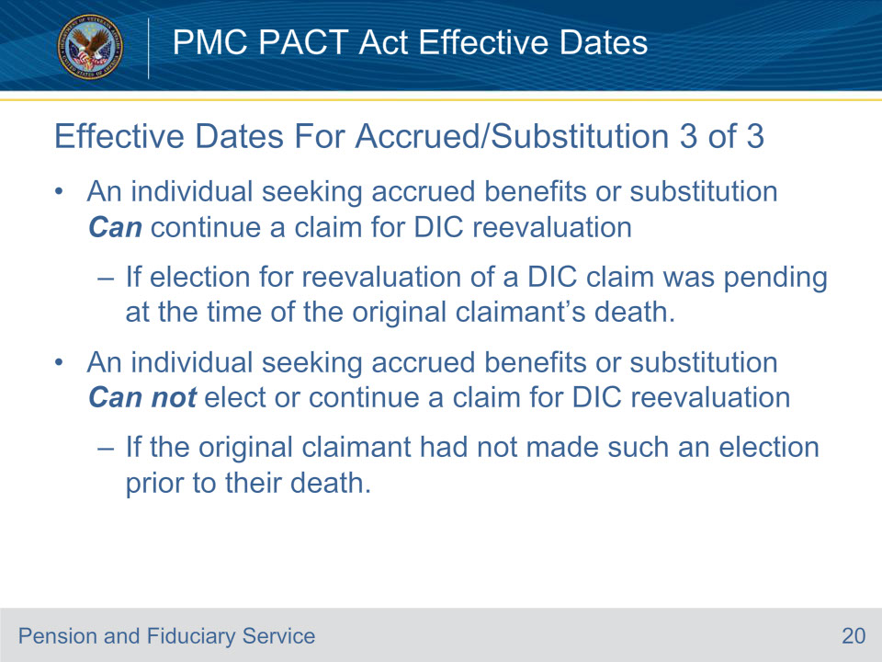
Slide notes

An individual seeking accrued benefits or substitution could

continue a claim for DIC reevaluation as long as an election for reevaluation

of a previously denied DIC claim was pending at the time of the original claimant’s death.

However, a potential substitute cannot elect a reevaluation under the PACT Act of a previously

denied DIC claim if the original claimant had not made such an election prior to their death.

Again, the key here is that a DIC reevaluation claim must have been pending

at the time of the original claimant’s death if an individual is seeking substitution/accrued benefits.

Slide 21 - Effective Dates Accrued/Substitution - Example
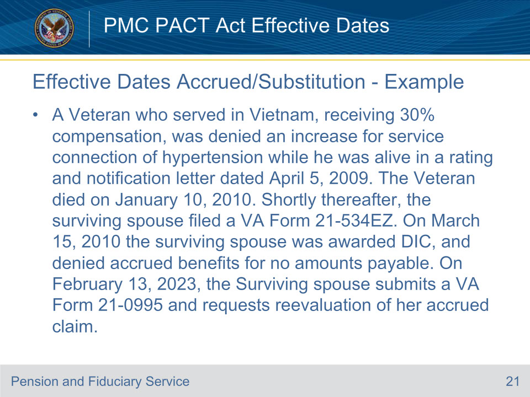
Slide notes

Effective Dates Accrued/Substitution - Example

A Veteran who served in Vietnam, receiving 30% compensation,

was denied an increase for service connection of hypertension

while he was alive in a rating and notification letter dated April 5, 2009.

The Veteran died on January 10, 2010.

Shortly thereafter, the surviving spouse filed a VA Form 21-534EZ.

On March 15, 2010 the surviving spouse was awarded DIC,

and denied accrued benefits for no amounts payable.

On February 13, 2023, the Surviving spouse submits a

VA Form 21-0995 and requests reevaluation of her accrued claim.

Slide 22 - Effective Dates Accrued/Substitution - Response
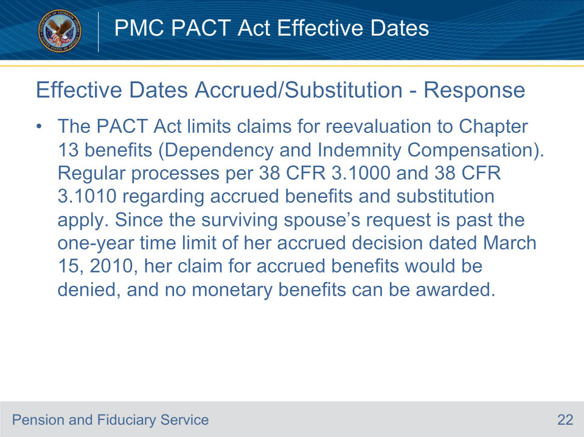
Slide notes

Effective Dates Accrued/Substitution - Response

The PACT Act limits claims for reevaluation to Chapter 13 benefits (Dependency and Indemnity Compensation).

Regular processes per 38 CFR 3.1000 and 38 CFR 3.1010 regarding accrued benefits and substitution apply.

Since the surviving spouse’s request is past the one-year time limit of her accrued decision

dated March 15, 2010, her claim for accrued benefits would be

denied, and no monetary benefits can be awarded.

Slide 23 - Effective Dates For Burial Claims - Example
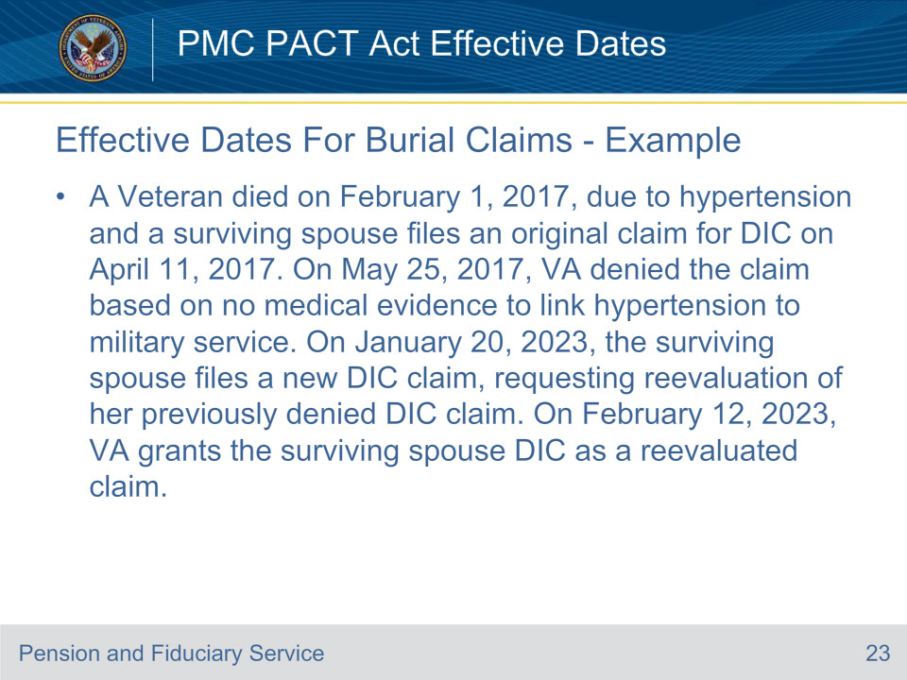
Slide notes

Effective Dates For Burial Claims - Example

A Veteran died on February 1, 2017, due to hypertension and a surviving spouse files an original claim for DIC on April 11, 2017.

On May 25, 2017, VA denied the claim based on no medical evidence to link hypertension to military service.

On January 20, 2023, the surviving spouse files a new DIC claim, requesting reevaluation of her previously denied DIC claim.

On February 12, 2023, VA grants the surviving spouse DIC as a reevaluated claim.

Slide 24 - Effective Dates For Burial Claims - Response
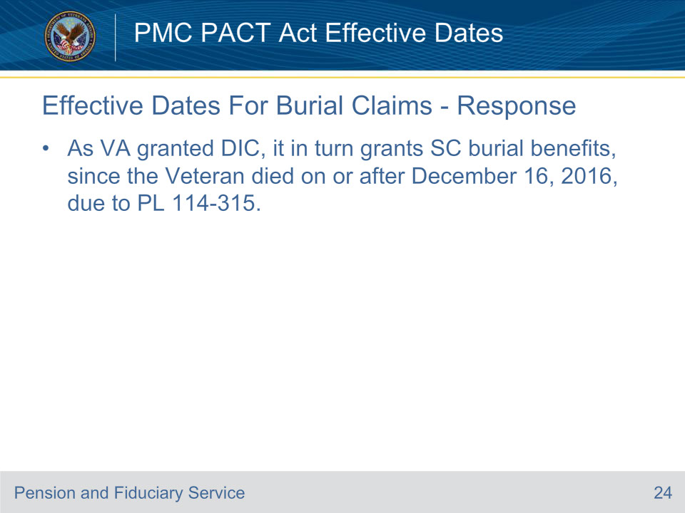
Slide notes

Effective Dates For Burial Claims - Response

As VA granted DIC, it in turn grants service connected burial benefits, since the Veteran died on or after December 16, 2016, due to policy letter 114-315.

Slide 25 - Summary
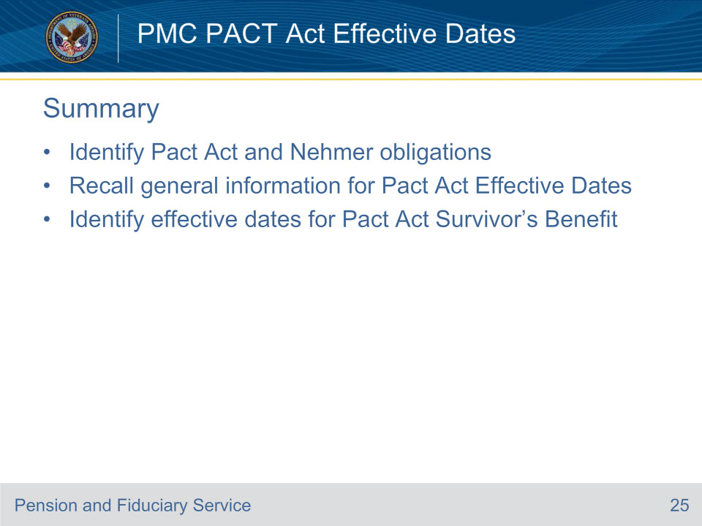
Slide notes

These are our learning objectives as stated from the beginning of the training. You should now be able to:

Identify Pact Act and Nehmer obligations

Recall general information for Pact Act Effective Dates

Identify effective dates for Pact Act Survivor’s Benefit

We discussed each of these learning objectives through the topics on each of the slides.

Slide 26 - Questions
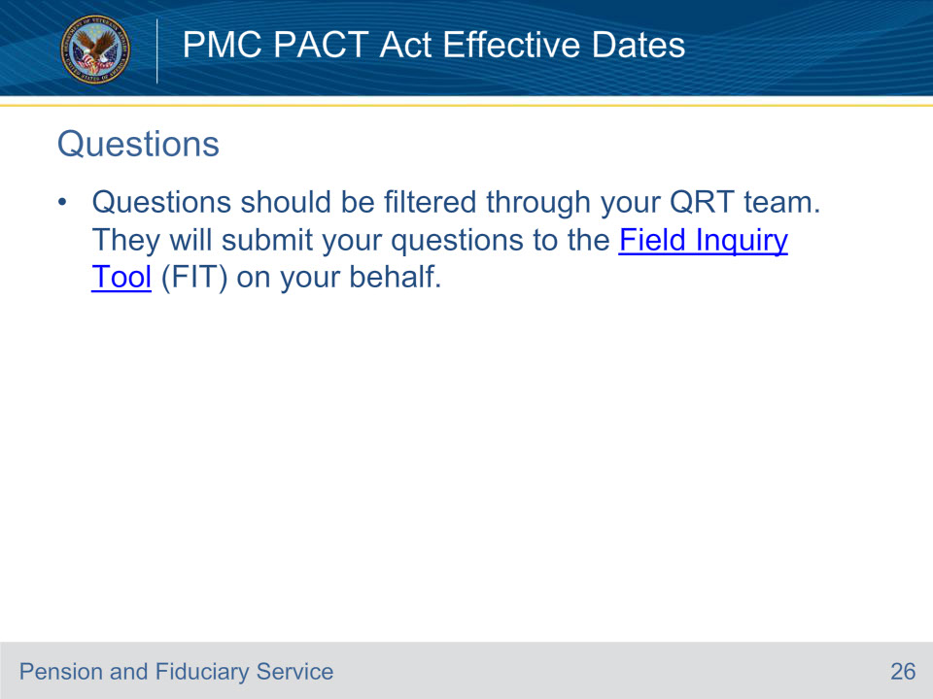
Slide notes

Questions should be filtered through your QRT team. They will submit your questions to the Field Inquiry Tool (FIT) on your behalf.

Slide 27 - TMS Survey and Assessment
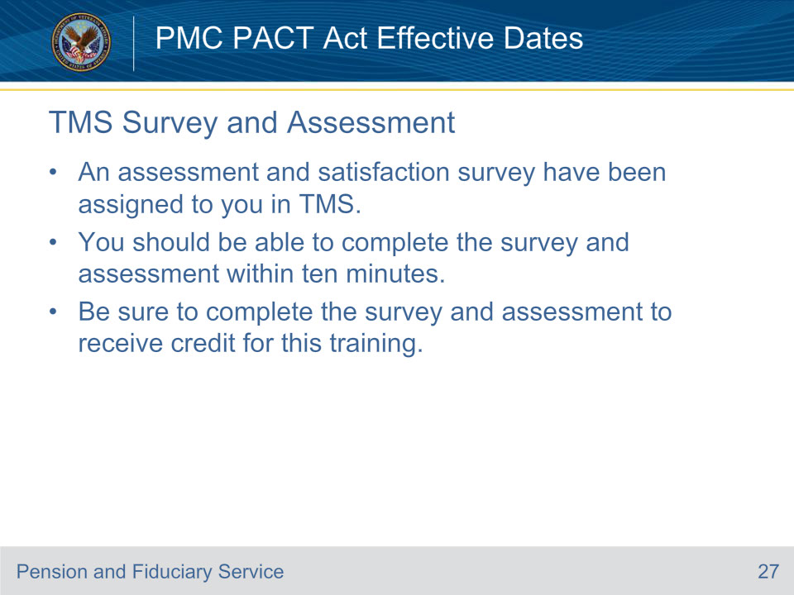
Slide notes

A satisfaction survey has been assigned to you in TMS.

You should be able to complete the survey within ten minutes.

Completing the survey will allow you to receive credit for this training.

