**Slide 1 - Special Monthly Benefits Overview**

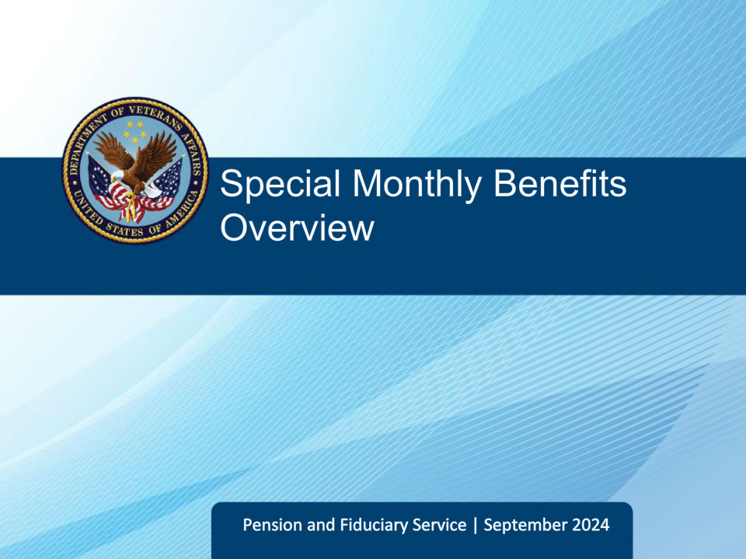

**Slide notes**

Welcome to the Overview of Special Monthly Benefits (SMP) course. This course provides an overview of the available SMP benefits.

**Slide 2 - Navigation**

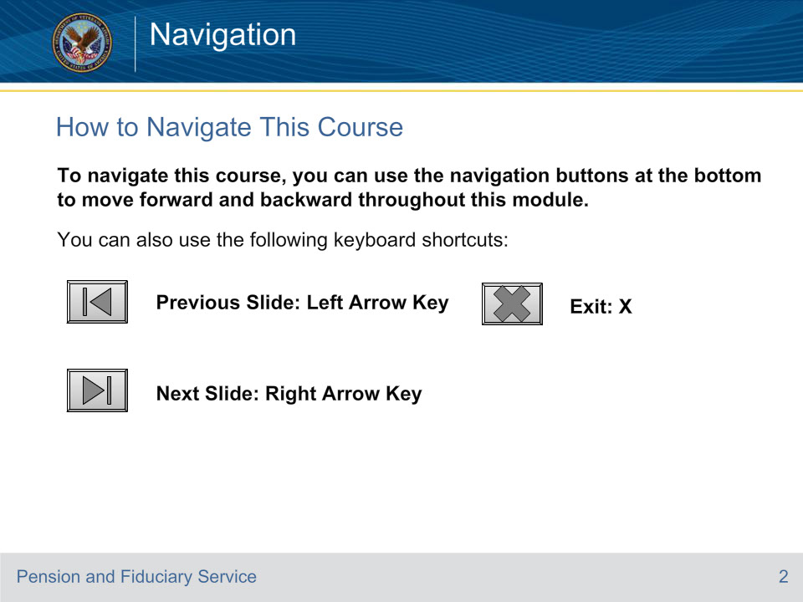

**Slide notes**

**Slide 3 - Objectives**

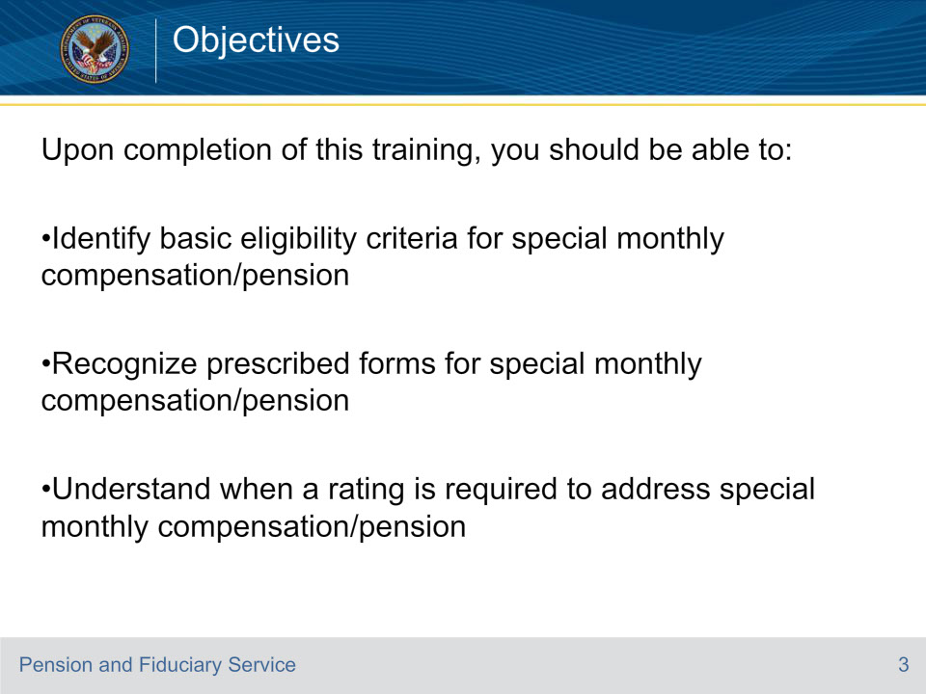

**Slide notes**

Present objectives.

**Slide 4 - References**

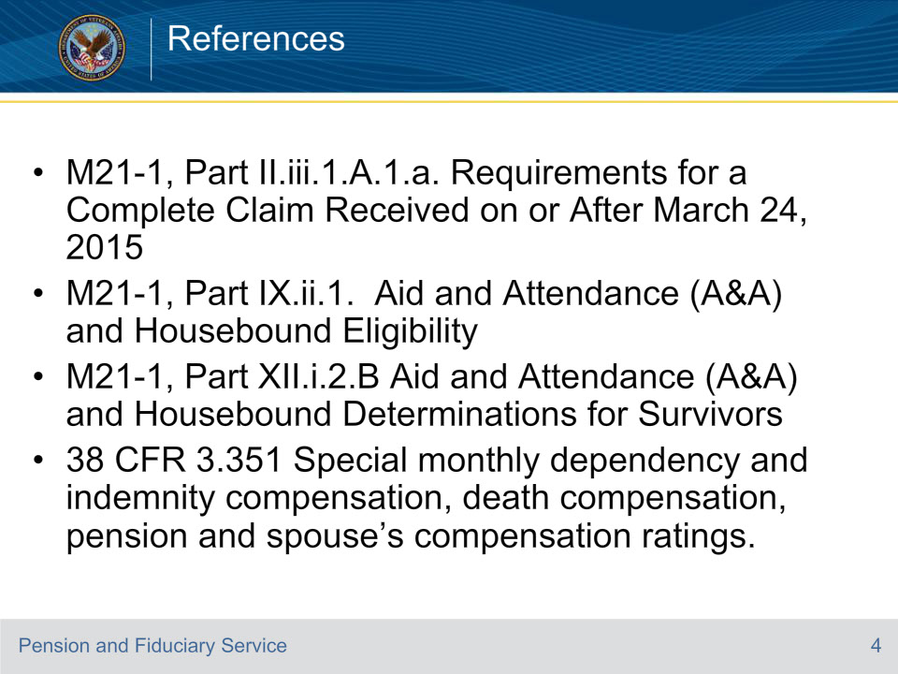

**Slide notes**

These are the references for today’s training topic. I encourage you to take the time to locate and review them after the conclusion of the training.

**Slide 5 - Special Monthly Benefits**

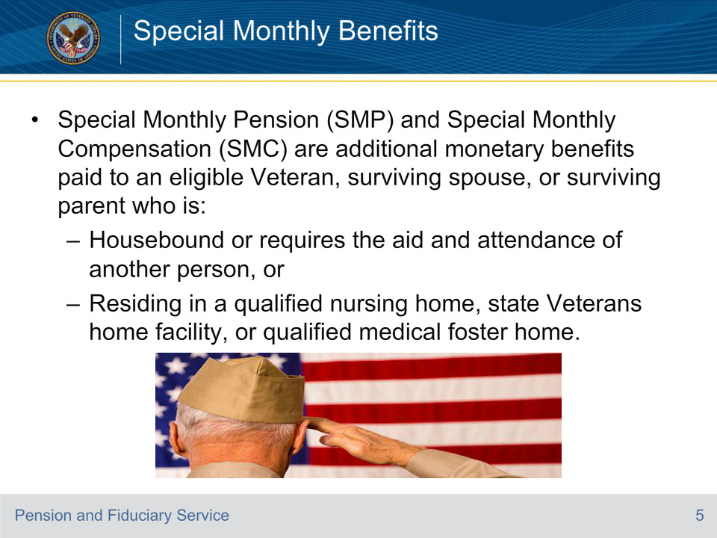

**Slide notes**

Special Monthly Pension and Special Monthly Compensation is an additional monetary benefit that can be paid to claimants once benefits for basic Veterans Pension, Survivors Pension or DIC have been awarded.

**Slide 6 - Who is Eligible for SMP/SMC?**

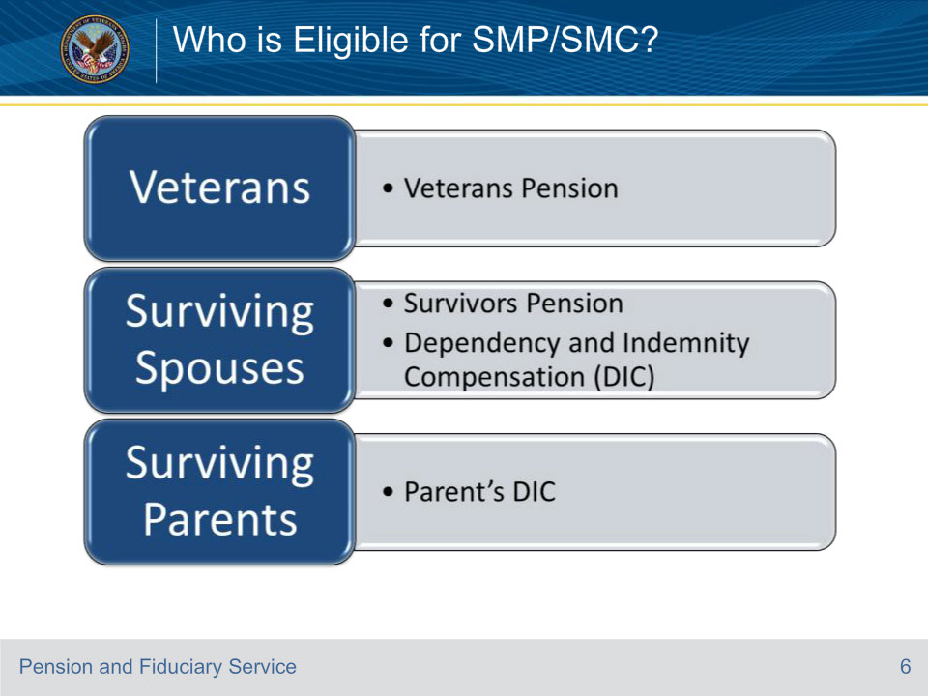

**Slide notes**

The term Special Monthly Pension applies to claimants in receipt of Veterans and Survivors Pension. The term Special Monthly Compensation applies to claimants in receipt of Compensation, DIC, or Parents DIC.

**Slide 7 - Definitions**

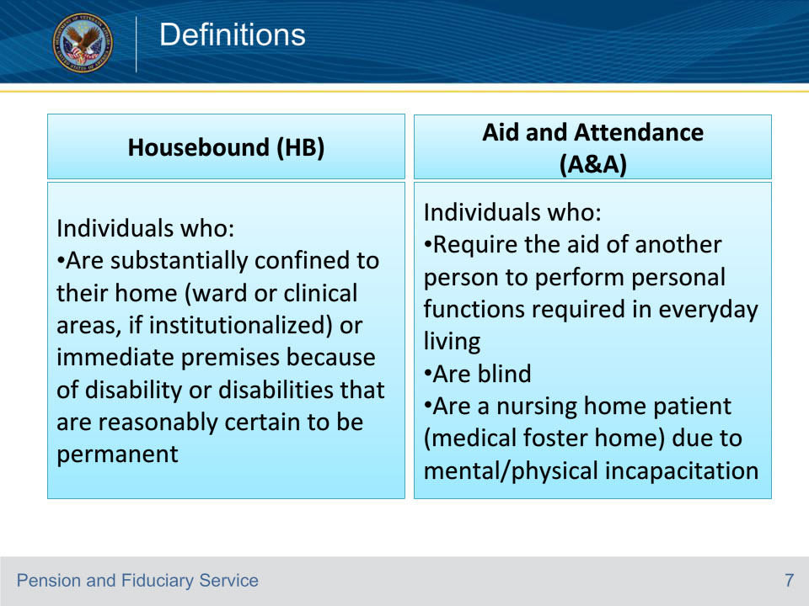

**Slide notes**

Special Monthly Pension and Special Monthly Compensation can be awarded at either the Housebound or Aid and Attendance Rate, each having their own set of criteria. This slide outlines the definitions of each.

It is important to understand that the grant of either status is “Not Permanent” as a claimant’s condition can change at anytime. Refer the claim to rating activity if VA receives medical evidence that a claimant’s status has changed.

**Slide 8 - Definitions (continued)**

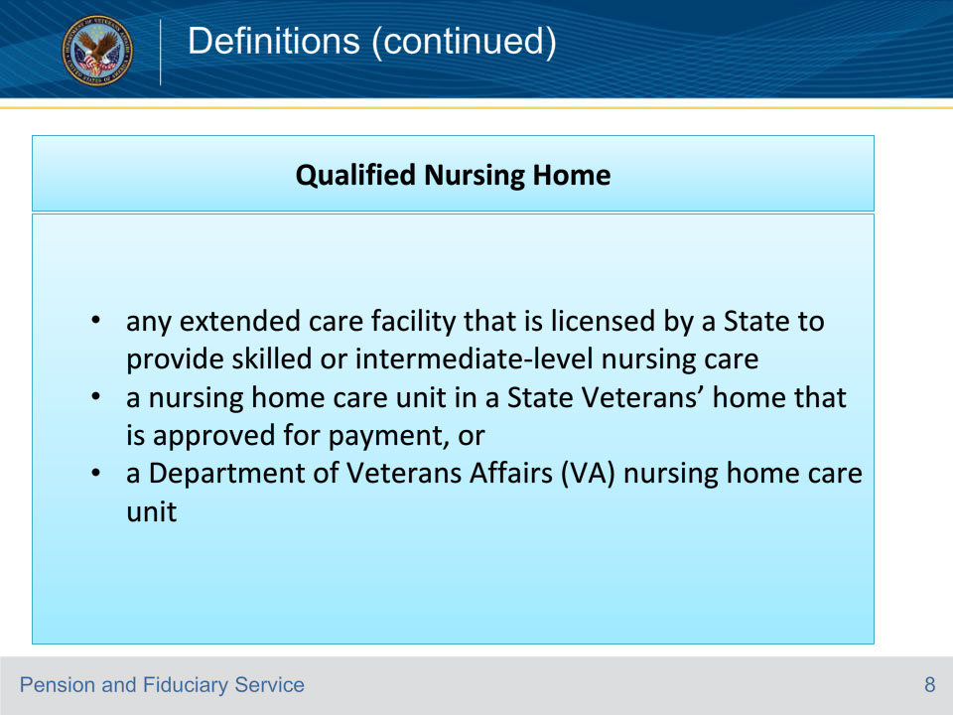

**Slide notes**

Veterans and survivors meet the Aid and Attendance criteria if they are a patient in a facility that meets the definition of a nursing home.

**Slide 9 - Nursing Home Requirements**

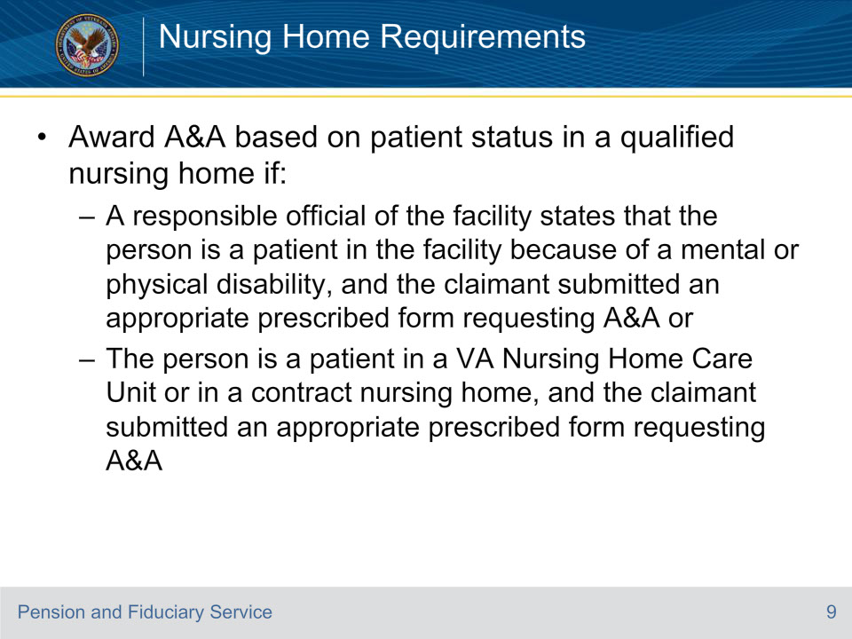

**Slide notes**

This slide states the criteria for awarding Aid and Attendance based on qualified nursing home status.

The term contract nursing home refers to a non-VA nursing home under contract with VA to provide nursing home care at VA expense for a specified period of time.

Reports of hospitalization received without a prescribed form will be treated as a request for application.

**Slide 10 - Rating SMP/SMC**

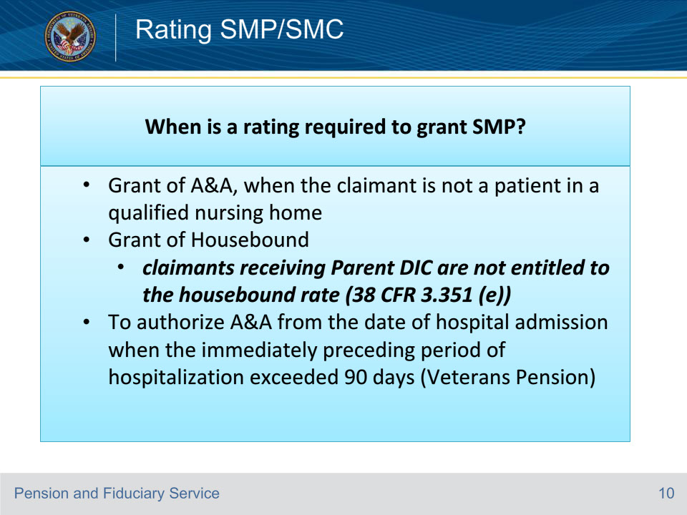

**Slide notes**

It is important to know the basis on which a claimant has been awarded Special Monthly Pension or Special Monthly Compensation. Unlike Aid & Attendance, Housebound can only be awarded by rating and does not apply to claimants in receipt of Parents DIC.

**Slide 11 - Monetary Benefits**

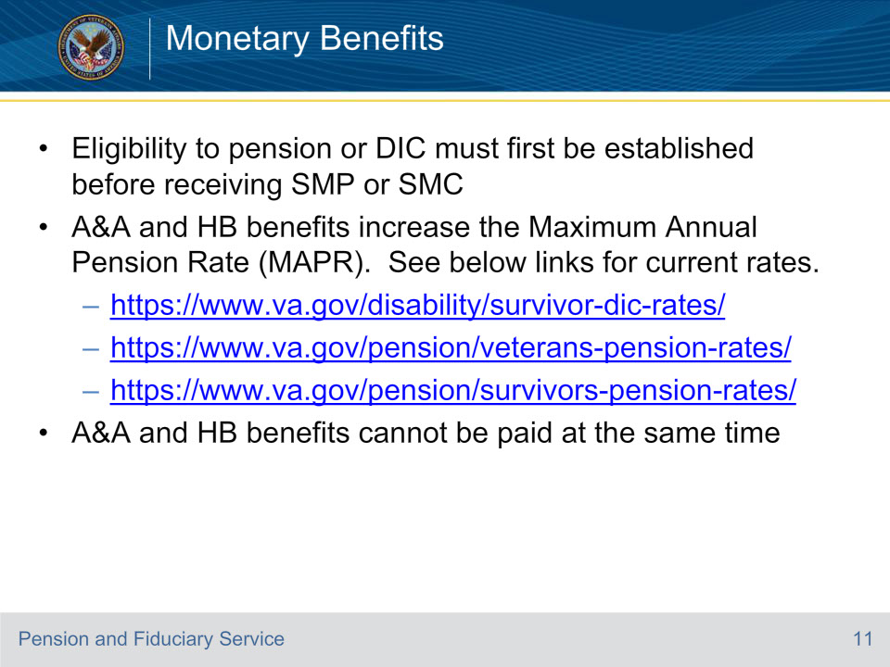

**Slide notes**

Qualifying for Aid and Attendance or Housebound increases a claimant's Maximum Annual Pension Rate (MAPR), providing additional monetary benefits. It is important to note that Aid & Attendance pays a higher monetary benefit than Housebound. Please visit the links provided for the most current rates.

**Slide 12 - Medical Expenses**

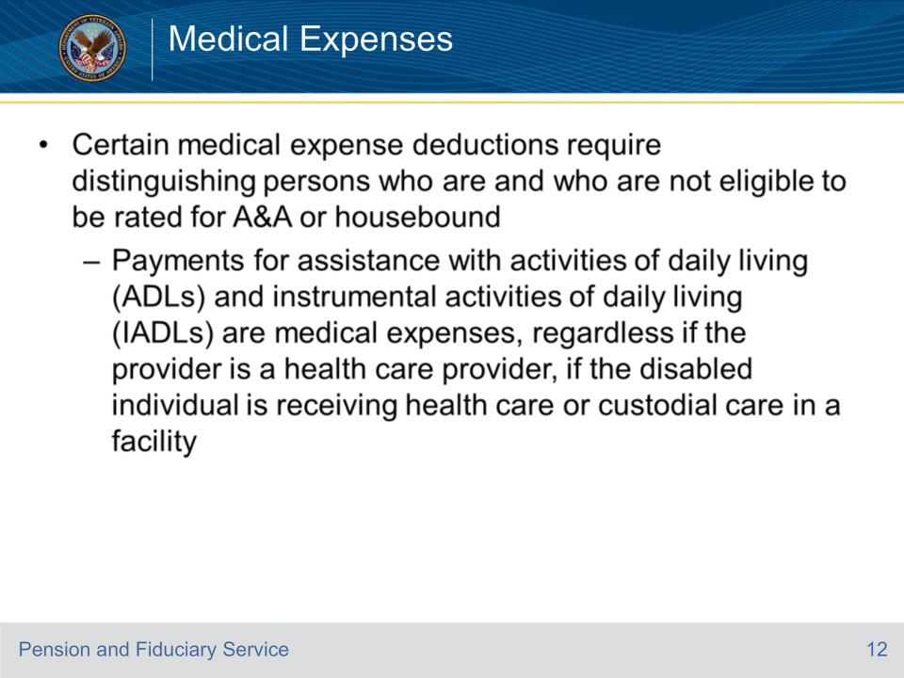

**Slide notes**

If the claimant has not been rated in need of Aid and Attendance or Housebound, certain medical expenses will require additional documentation when claimed.

**Slide 13 - Medical Expenses (continued)**

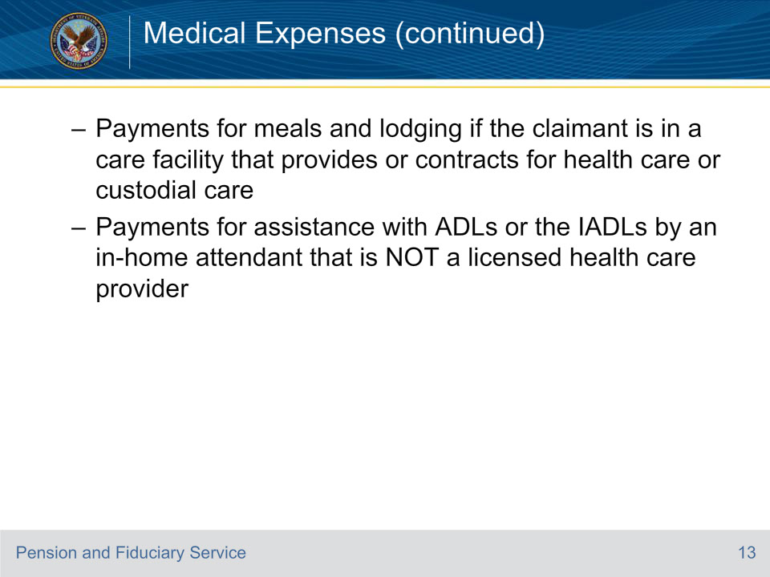

**Slide notes**

An example of this can be:

When a claimant is not receiving benefits at the Aid and Attendance or Housebound rate and claims fees for ADL or IADL’s, VA will require additional information. The claimant will need to submit a statement from a physician, physician assistant, certified nurse practitioner, or clinical nurse specialist stating that, due to a physical, mental, developmental, or cognitive disorder, the individual needs to be in a protected environment.

**Slide 14 - How to Apply**

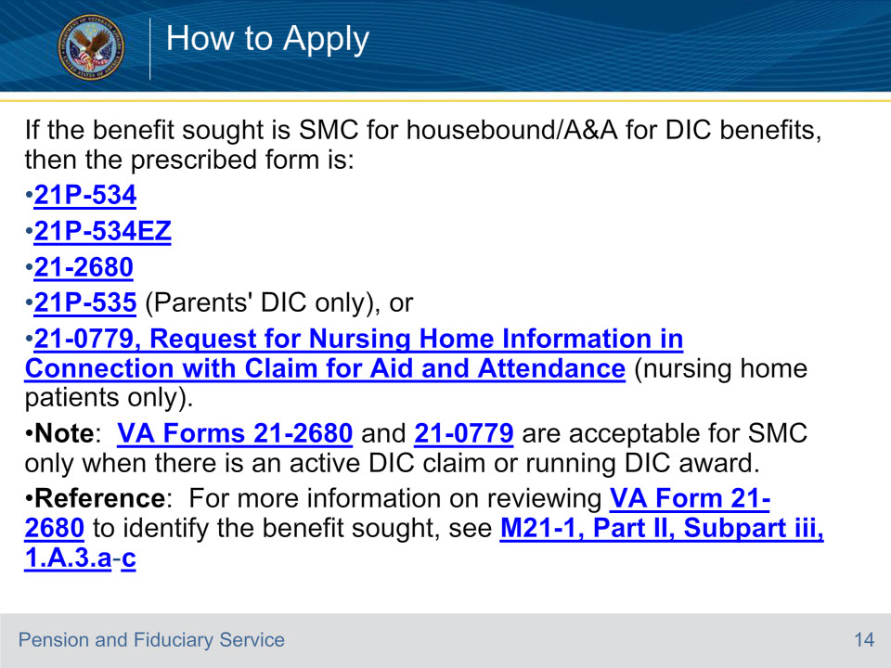

**Slide notes**

Present slide.

**Slide 15 - How to Apply (continued)**

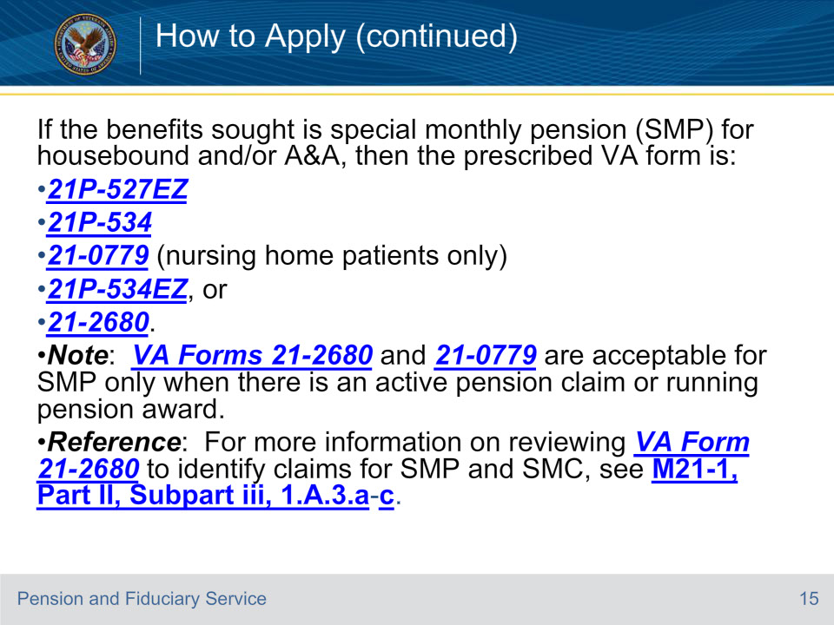

**Slide notes**

Present slide.

**Slide 16 - Questions**

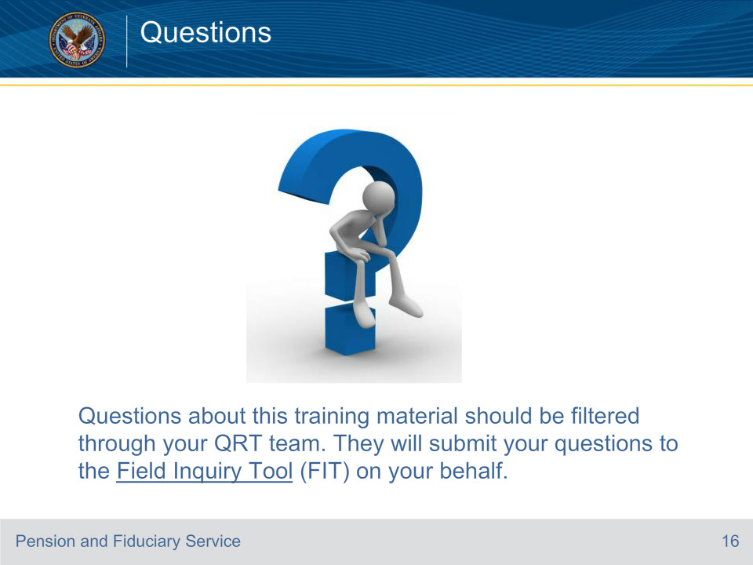

**Slide notes**

**Slide 17 - TMS Survey and Assessment**

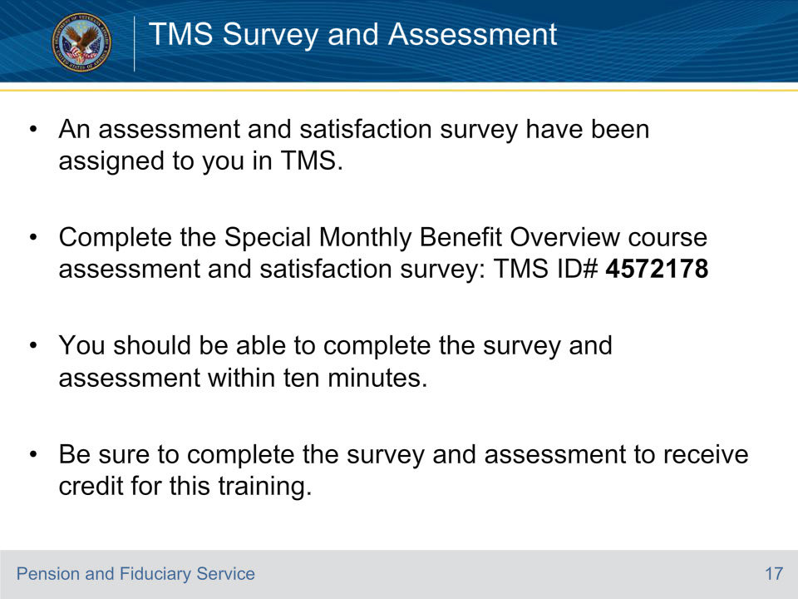

**Slide notes**

An assessment and satisfaction survey have been assigned to you in TMS. You should be able to complete the assessment and survey within ten minutes. Completing the assessment and survey will allow you to receive credit for this training.