

**Pension & Fiduciary Service**

**Inquiry Response Highlights**

**May 2020**

# Table of Contents

Table of Contents 1

**Pension Management Center Related Inquiries** 1

Compensation Claim Concurrently Pending 1

SC Death Grant - Mental Health 2

Burial Decision Elements/Favorable Findings in VBMS-A 3

**Fiduciary HUB Related Inquiries** 6

Stimulus Funds Issued Under the CARES Act 6

Bond Requirement For State Agency 6

**P&F Service Information** 8

P&F Service Contact Information 8

Disclaimer 8

# **Pension Management Center Related Inquiries**

# Compensation Claim Concurrently Pending

**Target Audience**: PMC Claims Processors

**Question**:The PMC is requesting clarification on how claims should be processed when pension and compensation or when non-appeal and appeal claims become intertwined to include proper jurisdiction. A review of the NWQ playbook (page 16 and 17) only addresses situations where there is a non-rating issue at one office along with a rating issue at another office but it does not address compensation vs pension or non-appeal issue vs appeal issue. The PMCs are unable to take action on the pension issue when there is a compensation rating but the claim has not been promulgated. In these instances, VBMS forces the compensation rates into the pension award.

**Response**: P&F Service is collaborating with the Office of Field Operations and Compensation Service to provide broader guidance on these types of scenarios. Veterans Benefits Management System (VBMS) does not allow users to simultaneously process separate rating or award decisions on concurrent EPs because there can only be one proposed rating or award at a time. If the concurrent EPs can be worked together by a single RO, then the impacted stations should coordinate to consolidate jurisdiction. If not, the stations must coordinate with each other to process the concurrent EPs separately. This means one station will have to process their claim first and maintain communication with the other station regarding the status. Determination as to which station completes the claim first must be coordinated on a case-by-case basis depending on the unique circumstances of the pending claims. In general, the involved stations should determine the processing order considering the greater benefit for the claimant. Also, if one claim can be granted administratively (without a rating action) at the time of the claims being intertwined, then that claim would likely be processed first as it can be more promptly decided. For the station that cannot take immediate action on a concurrent EP, a note should be added in VBMS that specifies why the claim could not be processed without action from the other station. The involved stations must coordinate so that the waiting station can take action as soon as possible after processing of the other EP.

**Result:** Clarification provided.

# SC Death Grant - Mental Health

**Target Audience**: PMC Claims Processors

**Question:** Can SC death be granted without a medical opinion for a Veteran who died by suicide and was service connected for mental health issues not listed on the death certificate?

The act of suicide or a bona fide attempt is evidence of mental unsoundness resulting from an increase in severity of the Veteran’s service-connected mental health condition per:

* III.iv.4.O.1.e. Considering SC for Mental Unsoundness in Suicide,
* 38 CFR 3.302 Service connection for mental unsoundness in suicide, and
* Elkins v. Brown, 8 Vet.App. 391 (1995).

In all instances, any reasonable doubt should be resolved favorably to support a finding of SC, preempting the need for a medical opinion to determine a nexus between the diagnosed condition and cause of death.

**Response**: No, VA may not eliminate the need for a medical opinion without careful review of specific circumstances of the case. In this situation, the medical opinion is part of the checks and balance system to ensure benefits are being properly granted. On the attached guidance sent on April 23, 2020, field stations were reminded of some situations where a reasonable probability of service-connected death should be inferred. In such cases, if service connection for the cause of the Veteran’s death cannot be granted by the rating activity based on the evidence of record, a medical opinion would normally be required to resolve the claim.

P&F Service concedes that reasonable doubt may be applied more than average in mental health and suicide claims; however, VA cannot automatically make an assumed connection in all claims simply based on the fact that a Veteran had a service connected medical diagnoses of a mental health issue (at any percentage) and suicide as cause of death. A review of the evidence must be conducted on each claim.

**Result:** Clarification provided.



# Burial Decision Elements/Favorable Findings in VBMS-A

**Target Audience**: PMC Claims Processors

**Question 1:**  Free text issue when denying SC burial by rating.  We have included the eligibility decision along with the suggested decision element free text.

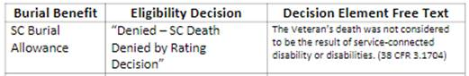

**Response 1:**  P&F will not be adding this element to the Burial Decision Elements Job Aide.  VBMS-A already populates language in the body of the letter, which is sufficient for notification requirements.  Do not add free text when SC Burial is denied by rating.

**Question 2:**  The PMC handles State Plot or interment allowance (per [M21-1 VII.1.B.5.g.](https://vaww.vrm.km.va.gov/system/templates/selfservice/va_kanew/help/agent/locale/en-US/portal/554400000001034/content/554400000014974/M21-1-Part-VII-Chapter-1-Section-B-Burial-Benefits?query=state%20plot#5g)), could P&F review the below suggested decision elements and possibly incorporate them into the AMA Burial Decision Elements document?  Below, we have included a text only version and a screen shot from a locally created document we use to outline the State Plot decision elements.

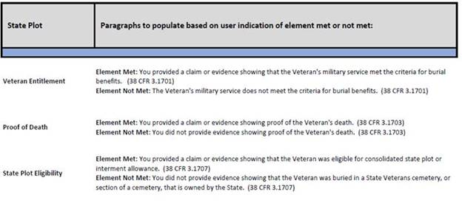

**Response 2:**  P&F Service agrees with your recommendations and has added the above State Plot elements to the attached job aide.

**Question 3:**  Since our previous email below (dated February 11th) was sent, it has been pointed out by an AQRS on our team who serves on VBMS details involving this topic, that the following decision element language (***Plot Allowance, C&P Eligibility***) has been updated in VBMS-A and therefore, N/A should not be used.  The text that now populates is:  “***You did not provide evidence showing that the Veteran was eligible to receive, or was retroactively found to have been eligible to receive, disability compensation or VA pension. (38 CFR 3.1707)***.”

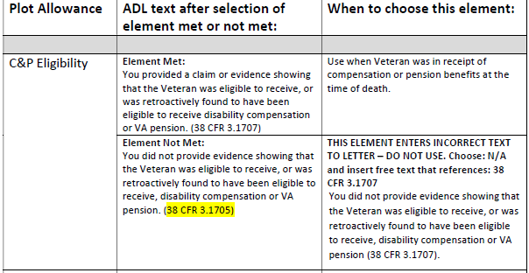

**Response 3:**  The attached job aide was updated to reflect the existing VBMS-A text and the correct CFR reference.

**Question 4:**  Lastly, we are wondering if the ***Transportation Allowance/C&P Eligibility*** decision element should remain as N/A, as indicated on the “AMA Burial Decision Elements Language Blocks” job aid, or if Free Text using the ADL text provided on the job aid could be used, but with a possibly corrected CFR reference (either 38 CFR 3.1709 or 38 CFR 3.1709), so that the Met or Not Met ADL text would be consistent with one another.

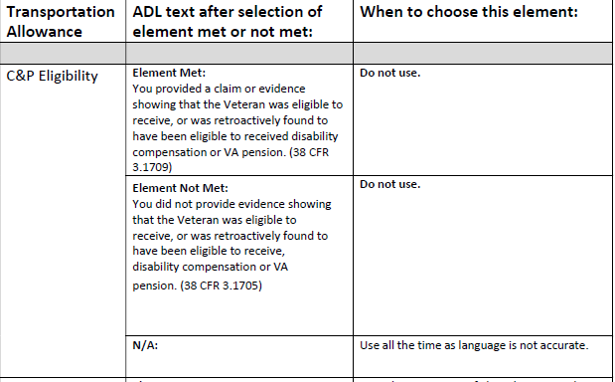

**Response 4:**  This element was created specifically to address burial transportation claims that are denied for no C&P.  All other burial claims should select N/A for this element.  The job aide was updated to reflect this guidance.

**Result:** Clarification provided. The Burial Decision Element Job Aid updated on June 8, 2020, is attached.



# **Fiduciary HUB Related Inquiries**

# Stimulus Funds Issued Under the CARES Act

**Target Audience**: Field Examiners and Legal Instrument Examiners

**Question:** How are the Fiduciary Hubs to treat stimulus funds issued under the CARES act? Are these stimulus funds to be managed by the fiduciary since they are not VA funds?  Is a commissioned fiduciary (authorized up to a 4% fee) permitted to take a fee from these funds?

**Response:** You are correct that the IRS Economic Payments from the CARES Act are not considered a VA benefit.  As such, a fiduciary fee is not applicable for this payment.

For the aspect of managing the payment within the custodial account, this payment would be treated the same way as a normal Federal tax refund.  The amount deposited must be annotated on any required accountings within the AMOUNT RECEIVED FROM OTHER SOURCES section.  [FPM 3.D.3.d](https://vaww.vrm.km.va.gov/system/templates/selfservice/va_kanew/help/agent/locale/en-US/portal/554400000001030/content/554400000052140/FPM-3D3-Verifying-Income-and-Expenses#3d) and [i](https://vaww.vrm.km.va.gov/system/templates/selfservice/va_kanew/help/agent/locale/en-US/portal/554400000001030/content/554400000052140/FPM-3D3-Verifying-Income-and-Expenses#3i) instruct the Legal Instruments Examiner to review these funds from other sources and implement misuse procedures if there is an indication of misuse.  No additional oversight of the stimulus payment is required.  The fiduciary does not need to manage the stimulus payment but must account for its deposit and must not misuse those funds.

*References:*

[FPM 3.D.4.a](https://vaww.vrm.km.va.gov/system/templates/selfservice/va_kanew/help/agent/locale/en-US/portal/554400000001030/content/554400000052142/FPM-3D4-Examining-VA-Appointed-Fiduciary-Fees#4a)

[FPM 3.D.3.d](https://vaww.vrm.km.va.gov/system/templates/selfservice/va_kanew/help/agent/locale/en-US/portal/554400000001030/content/554400000052140/FPM-3D3-Verifying-Income-and-Expenses#3d) and [i](https://vaww.vrm.km.va.gov/system/templates/selfservice/va_kanew/help/agent/locale/en-US/portal/554400000001030/content/554400000052140/FPM-3D3-Verifying-Income-and-Expenses#3i)

**Result:** Clarification provided.

# Bond Requirement For State Agency

**Target Audience**: Field Examiners and Legal Instrument Examiners

**Question**: Some time ago, we received clarification regarding bond requirements for state agencies. The clarification allowed for State agencies to serve without bond payable to VA. This is no longer the case and the clarification is outdated because the references have obviously been updated.

However, the problem regarding bond requirements for State agencies still exists. Most states have one or more State Veterans Homes that serve as fiduciary. And depending on the state laws, an accumulation of VA benefit might occur, triggering a bond requirement. Replacement of all of these fiduciaries, and cost to our beneficiaries is burdensome.

Does P&F anticipate relief for state agencies from the requirement when insured or bonded by the state? It would be helpful to update 4.G.1.e. to include an exception for governmental agencies. In the alternative, may the fiduciary hub accept bond payable to the states much like we now do with bonds payable to the courts per 4.G.1.k.?

|  |  |  |  |  |  |
| --- | --- | --- | --- | --- | --- |
| 4**.G.1.e****.** Corporate Surety Bond Exceptions | |  | | The following are exempted from obtaining a surety bond:   * a fiduciary that is a trust company or a bank with trust powers organized under the laws of the U.S. or a State * a fiduciary who is the beneficiary's spouse, or * a fiduciary in the Commonwealth of Puerto Rico, Guam, or another territory of the U.S., or in the Republic of the Philippines, who has entered into a restricted withdrawal agreement in lieu of a surety bond.   **Reference**:  For information on withdrawal agreements, see [FPM 4.G.3.a-d](https://vaww.vrm.km.va.gov/system/templates/selfservice/va_kanew/help/agent/locale/en-US/portal/554400000001030/content/554400000052158/FPM-4.G.3.--Withdrawal-Agreements). |  |
| **4.G.1.k****.  Bonds Payable to Courts** |  | | In some instances, the court of jurisdiction requires a VA-appointed fiduciary also serving as court-appointed fiduciary to obtain a surety bond with the court as the obligee.  When VA is considering the appointment of this court-appointed fiduciary also as the VA-appointed fiduciary, the Field Examiner or LIE must ensure the existing surety bond covers the amount of the FUM.  If the amount of the existing surety bond is high enough to fully cover FUM, accept the surety bond for VA purposes and upload the documentation to the beneficiary’s eFolder.  If the existing surety bond does not adequately cover the amount of FUM, follow the procedures listed in [FPM 4.G.1.i](https://vaww.vrm.km.va.gov/system/templates/selfservice/va_kanew/help/agent/locale/en-US/portal/554400000001030/content/554400000052151/FPM-4G1-General-Information-on-Corporate-Surety-Bonds#1i) to have the bond amended.  Once VA receives documentation of an updated surety bond which covers the FUM, notify the court of jurisdiction of the new amount.  Surety bond expenses related to the amendment of an existing, court-ordered surety bond meet the criteria listed in [38 CFR 13.230(g)](https://www.ecfr.gov/cgi-bin/text-idx?SID=ad6edd1d144aee61249d4fd49bc34251&mc=true&node=se38.1.13_1230&rgn=div8) and may be deducted from the beneficiary’s account.  If the fiduciary refuses or cannot obtain a bond that complies with the minimum criteria outlined in this section, the hub must appoint a successor fiduciary.  ***References***:  For more information on   * previously accepted restricted or blocked accounts or withdrawal agreements, see [FPM 4.G.3.d](https://vaww.vrm.km.va.gov/system/templates/selfservice/va_kanew/help/agent/locale/en-US/portal/554400000001030/content/554400000052158/FPM-4.G.3.--Withdrawal-Agreements), and * calculating the value of a beneficiary's VA benefit FUM, see [*FPG, Funds Under Management*](https://vaww.vrm.km.va.gov/system/templates/selfservice/va_kanew/help/agent/locale/en-US/portal/554400000001030/content/554400000054808/Funds-Under-Management). | | |

**Response**: Pension and Fiduciary Service has conducted research and consulted with the Office of General Counsel regarding whether a blanket insurance policy managed by a State for a State agency is acceptable in lieu of a corporate surety bond, when the amount of the policy far exceeds the amount of the required surety bond.

In response to your inquiry, yes, VA may accept liability insurance, or a State blanket bond in lieu of a corporate surety bond from State agencies that are serving as a VA fiduciary.

It is important to be aware that there may be instances in the future where State laws are misaligned to Federal policies. When this occurs, the Federal regulations supersede those of States. However, P&F Service will always work as best we can to ensure that we are supporting your needs while ensuring the protection of our beneficiaries.

**Result:** Clarification provided.

# **P&F Service Information**

# P&F Service Contact Information

Policy and Procedure questions from the PMCs or Fiduciary Hubs should be submitted to P&F Service at [VAVBAWAS/CO/P&F POL & PROC](mailto:PFPOLPROC.VBACO@va.gov) by the Quality Review coach or PMC/Fiduciary Hub Division Management.

P&F Service would like to remind you that all inquiries sent to the Policy and Procedures Mailbox must include the references previously researched, key words or phrases used to search in CPKM. P&F Service is available to assist when there is confusion about a certain policy or procedure, however, PMCs and Fiduciary Hubs are required to research and attempt to resolve the issue before sending the question to the P&F Service Policy and Procedures Mailbox. Additionally, including all words used to search topics in CPKM will allow P&F Service to add those search words into CPKM if they were not already in the metadata for a certain manual reference.

Training and Quality questions can be directed to: [VAVBAWAS/CO/P&F TNG QUAL OVRST](mailto:PFTNGQUALOVRST.VBACO@va.gov).

Systems-related questions can be directed to: [VAVBAWAS/CO/P&F BUS MGMT](mailto:PFBUSMGMT.VBAVACO@va.gov).

# Disclaimer

Please note that all responses provided are for informational purposes only. If changes to the M21-1 Adjudication Procedures Manual or Fiduciary Program Manual (FPM) are needed, they are made in conjunction with the response. The M21-1 and FPM supersede any inquiry response.