# MDE Vendor Clarification Request (CR) Job Aid

## Topic 1: Identifying Clarification Request (CR)

When an MDE vendor requires additional information or has questions regarding any aspect of the Exam Scheduling Request (ESR) submission, the MDE Vendor will submit a clarification request.

The following depicts a clarification that has been requested from the MDE vendor:

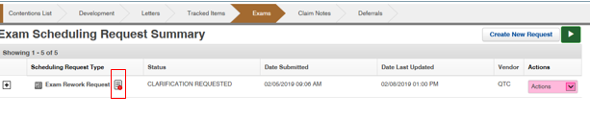

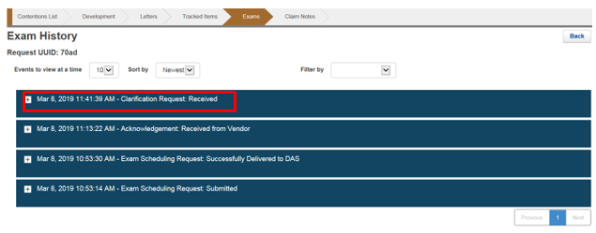

**Step 1:** By clicking the red explanation mark above the EMS request for clarification will populate with the details being requested. The user can respond from this screen.

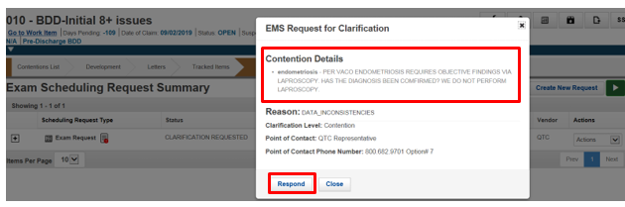

**Step 2:** Users can also utilize the “*View Details*” from the “*actions*” drop-down to review and respond to the pending CR. The user will choose the “*Edit Clarification*” function.

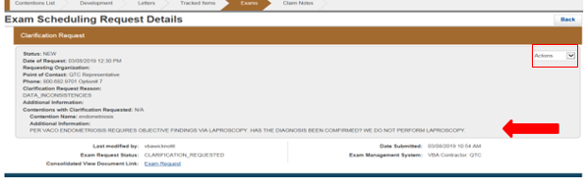

## Topic 2: Responding to the Clarification Request (CR)

**Step 1**: Once “*Respond*” is clicked, the user will ensure that the “*Full Edit*” option is highlighted.

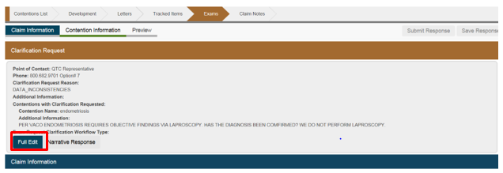

**Step 2**: User will respond to the MDE Vendor with the response actions being taken using the “*Clarification Request Response*” Field. User will then ensure that VBA Contractor is selected and the corresponding MDE Vendor is being displayed.

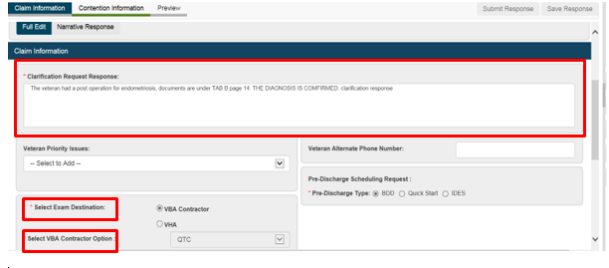

**Step 3:** User will verify that the information for the mailing address is the same as the original request.

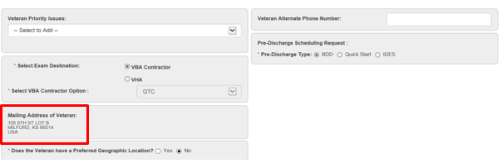

**Step 4**: The user will then click on contention information.

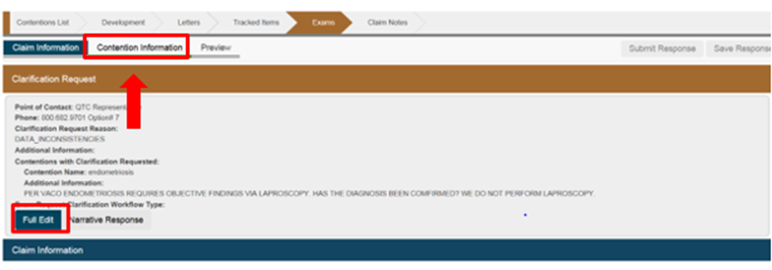

**Step 5**: If necessary, the user will make any changes to the DBQ(s) in the original ESR. The user should only make changes based on the questions (if necessary) from the clarification request. Only the question that is asked by the inquiry should be answered.

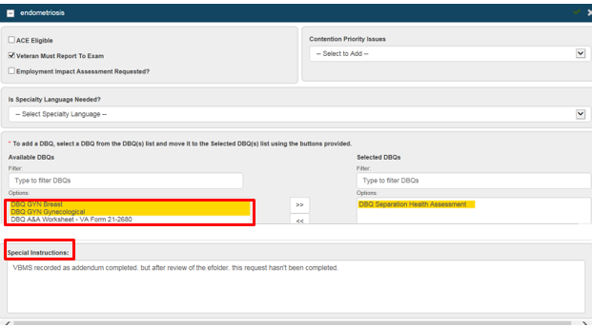

**Step 6:** User will then click preview and then submit the response.

**Note:** User should review preview to ensure accuracy.

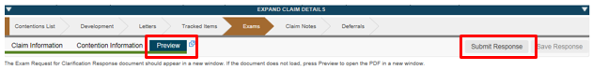

**Step 7**: After submission of the CR the MDE vendor will review the CR response and will continue the scheduling process.