**ESR Copy Functionality**

ESR “Copy” functionality allows users to recreate, with minimal input, a new ESR which had been previously cancelled or completed. The function is to be mainly utilized for previously cancelled ESR(s).

**Rework:**

When a previously completed ESR does not have the “Rework” function available, the user is required to submit a new request using specified special instructions to the MDE Vendor. The copy functionality would then be used from a previously completed ESR.

1. From ESR summary the user will select “Copy” from the actions drop down for the ESR being requested.

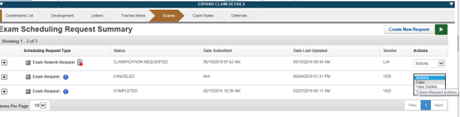

1. Under “Select Contentions” tab the user will select all contentions or individual contentions to be copied.

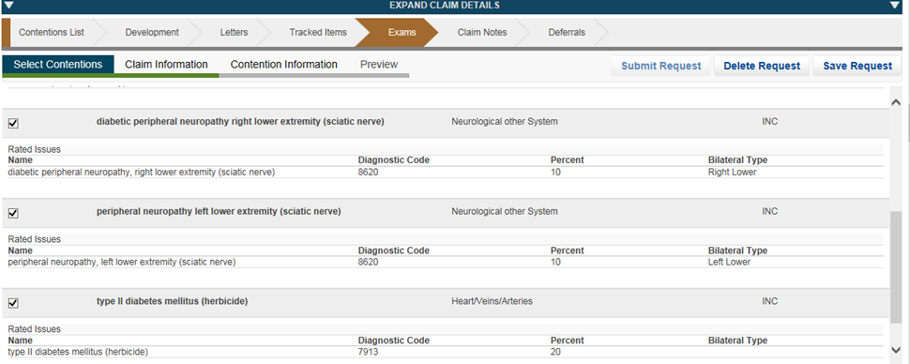

1. The user will verify address and POA/VSO type for the claimant.

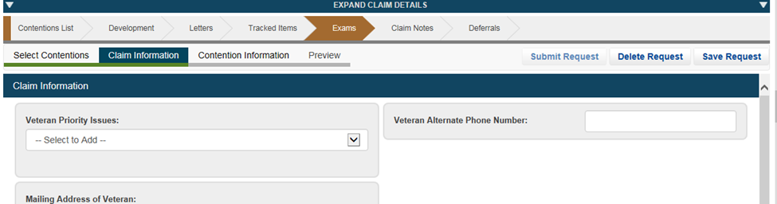

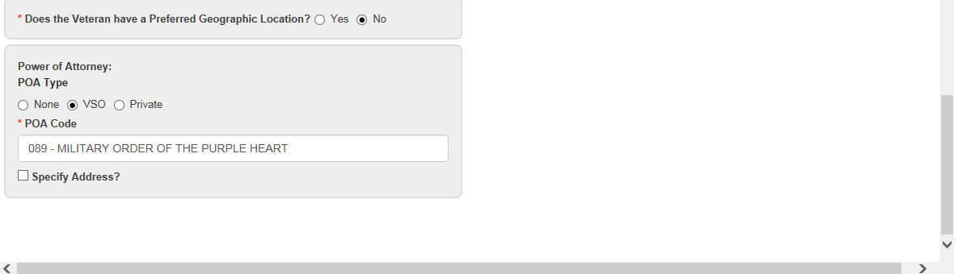

1. The user will select the “Contention Information” tab and verify all DBQ(s) and specialty language, if applicable.

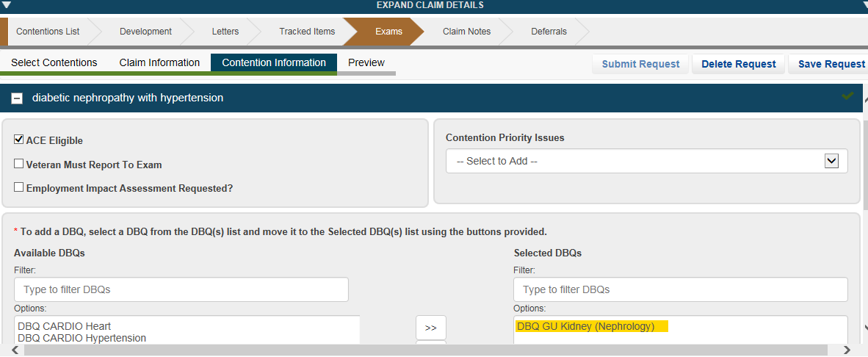

1. The user will then select “Preview” and ensure the ESR is accurate prior to clicking submit.