**Contract Exam Scheduling Request (ESR) Process**

**The names and file numbers on the screen shots do not originate from real claimants**

Prior to ordering an EMS exam, the user must ensure that a contention is correctly identified in the contention development tab. It is essential that the user has the correct options identified in the drop downs as this directly affects the ability to order exam.

**Note:** Any section marked with a red asterisk is a required field and must be filled out to move on.

**A: Adding Contentions**

1. Click Add Contentions Button

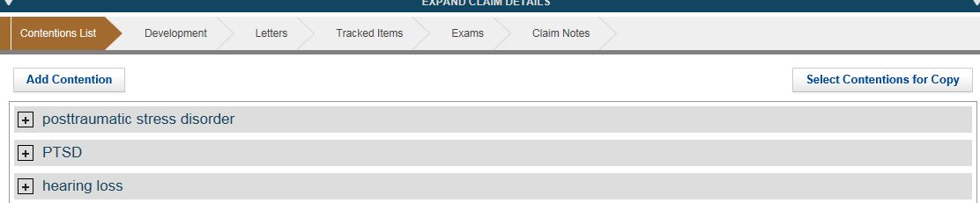

2. Add contention and select corresponding classification

3. Verify Date of Contention

4: Verify the correct Type of contention from dropdown (New, Increase, Reopen, RFE)

**Note:** It is required to select the correct classification, from the dropdown menu, as identified in the DBQ search index for EMS to suggest to the appropriate DBQ examination

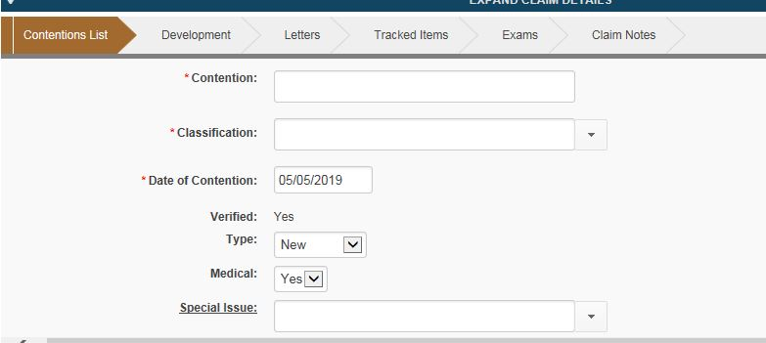

**B: Creating Exam Scheduling Request (ESR)**

1. Click the exam chevron. Click Create New Request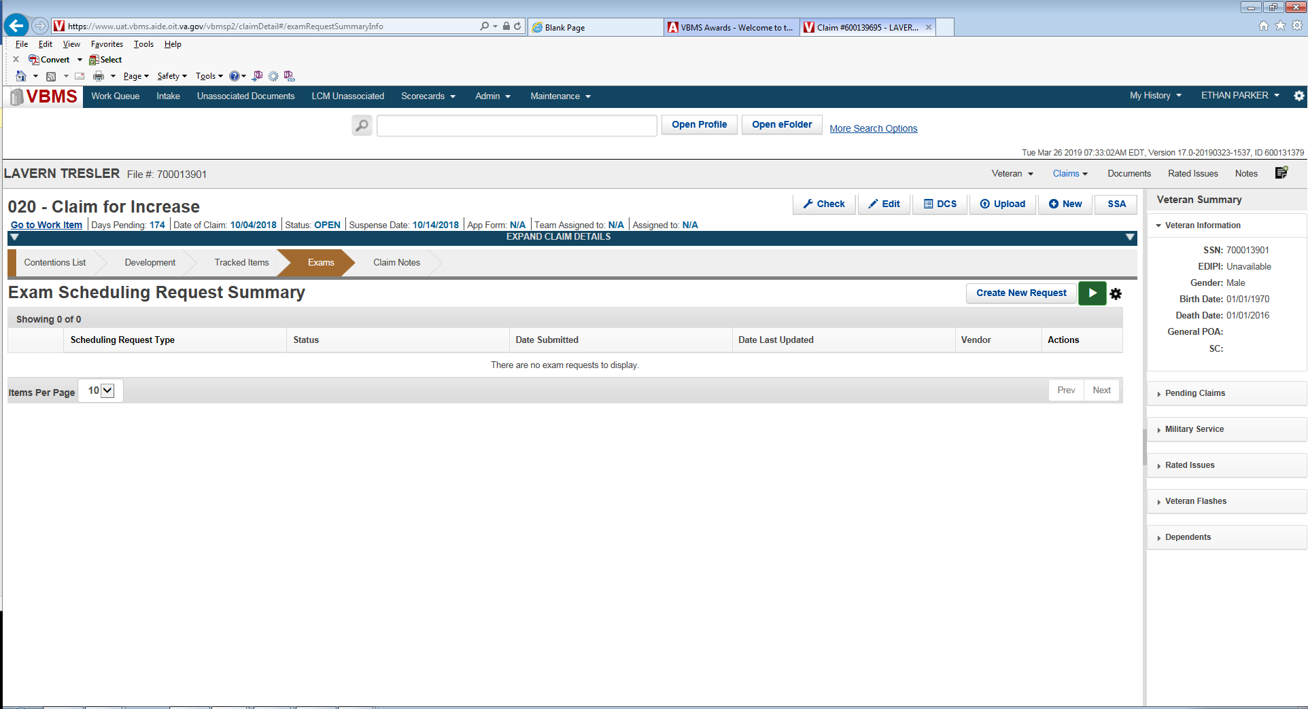

2. Select box for the appropriate contention(s). The Claim Information button will turn green and you may click it to proceed. If the system does not allow you to select a contention, this means that there is an error in the way the data or attributes in the contention tab was entered:

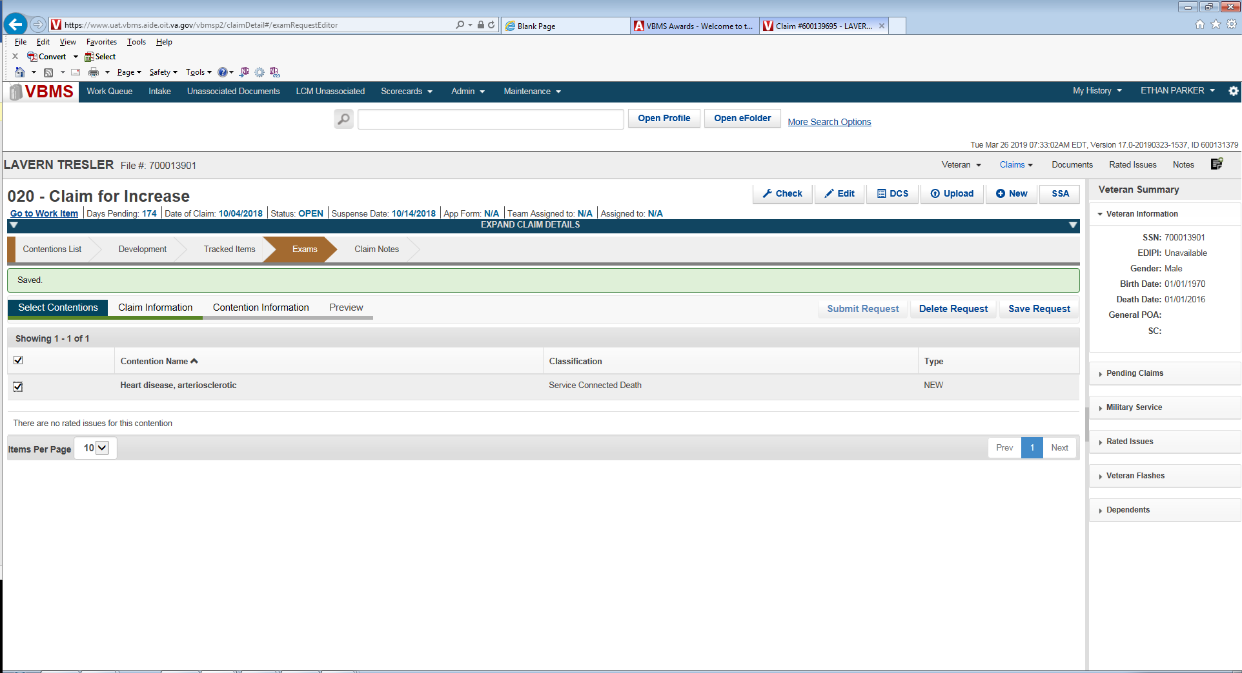

3. Identify, if applicable, any Veteran priority issues.

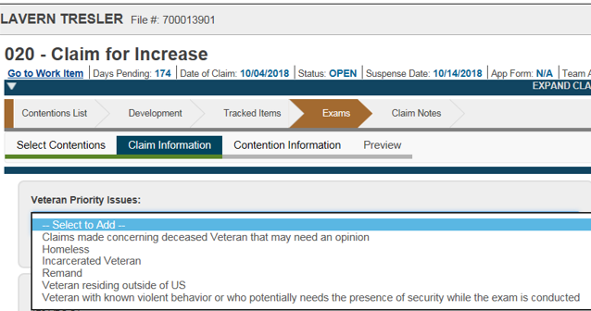

4. For Veteran’s pension, verify Veteran’s address. If alternate address is needed or the Veteran is temporarily relocated, use the temporary Geographic Location, to enter the temporary address.

VBMS does not yet automatically populate the claimant address, and so you must enter the claimant address by selecting ‘Yes’ to the question *‘Does the Veteran have a Preferred Geographic Location.’* You can then input the claimant address here. Note, that if there was no mailing address for the Veteran previously entered, no address will display in the ‘Mailing Address of Veteran’. After all necessary details have been added, click ‘Contention Information.’:

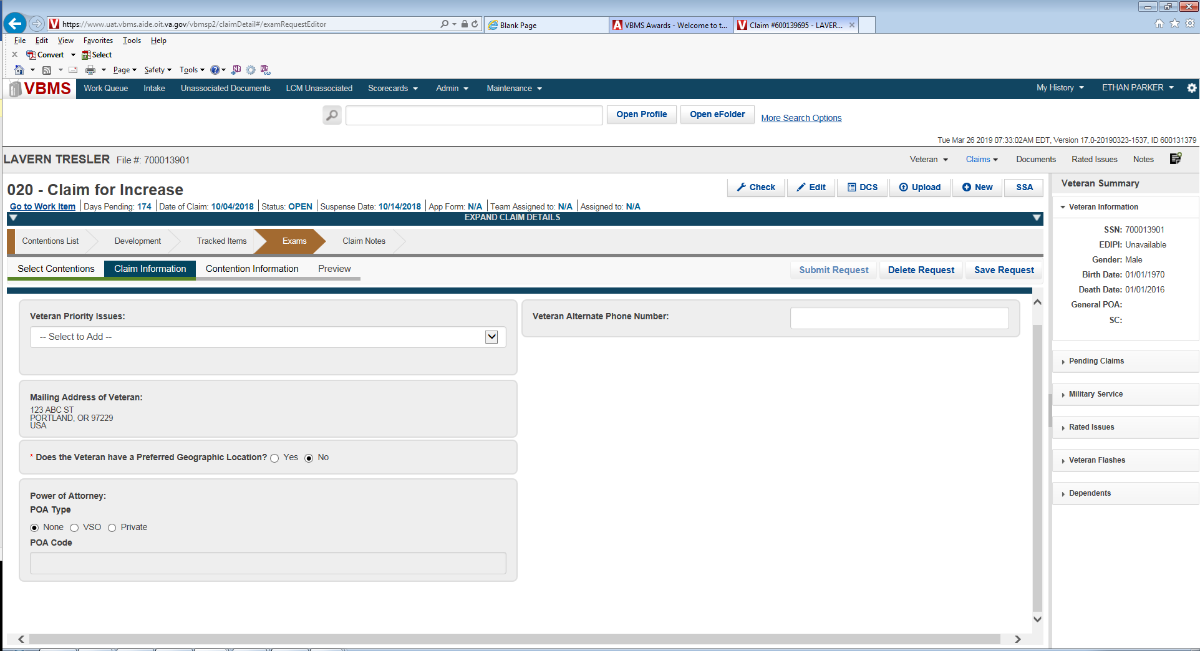

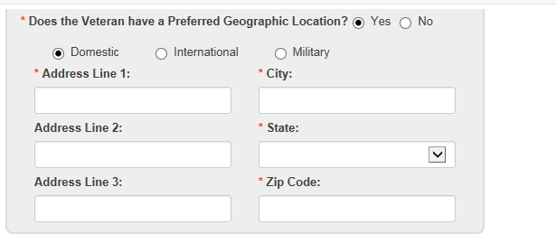

5. User has option to select whether the claim is ACE eligible, Veteran must report to exam or Employment Impact Assessment is requested.

6. User must select an appropriate opinion or examination verbiage. Under the ‘Specialty Language Needed’, you will always select ‘Other’, so that you can subsequently enter the required tabbed documentation and opinion request language. If a specialist is needed, note this in the ‘Supporting Specialty Language Information’. Also, ensure that every document that requires the examiner’s review for the opinion is thoroughly referenced. There will be an option for selecting predefine ‘Additional Special Language’ as applicable. Since no specific specialty language exists for service-connected death Medical Opinion, this is where you will input the ERB language.

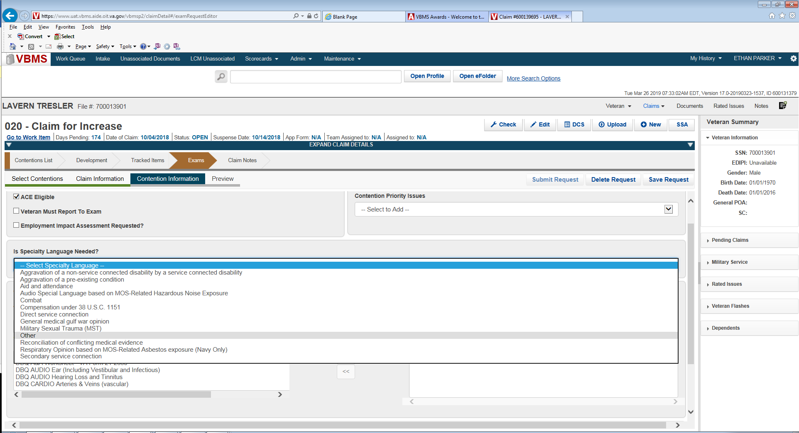

**Note**: The 17.1 VBMS Release will update to include SC Death Medical Opinion language here. 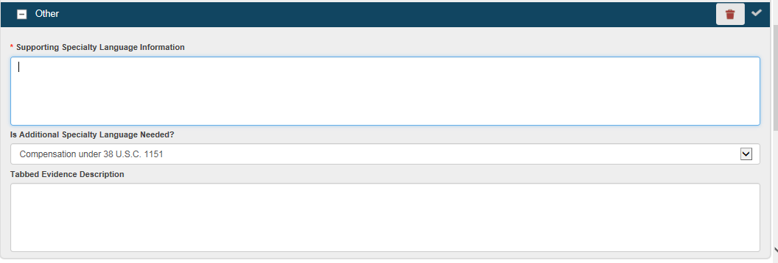

7. Next, the VSR will select a corresponding DBQ based on the contentions. You can select from the full list below, or type in a keyword search based on the DBQ needed. EMS will highlight the recommended DBQ based on the classification chosen for the contention. After selecting the DBQ in the ‘Available DBQs’ section, you slide it over into the ‘Selected DBQs’ section:

**Note:** If a medical opinion is required and the DBQ does not have the opinion language embedded you must always select ‘DBQ Medical Opinion (Examiner’s Version)’ **in addition** to the DBQ selected for the contention.

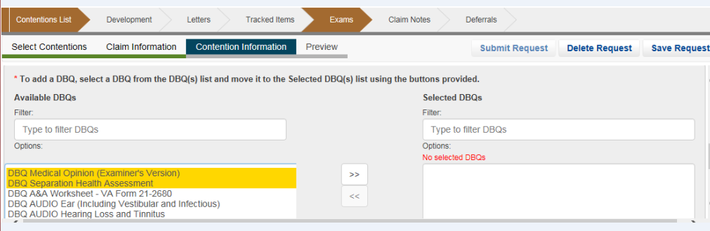

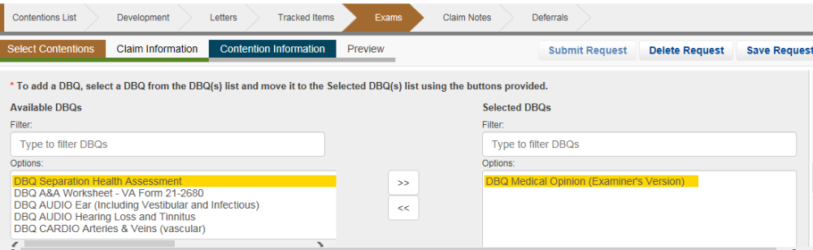

8. Next click ‘Preview’ from the Exam subcategories list. This will generate a PDF Exam Scheduling Request (ESR) which will contain the information provided to the examiner. Review the PDF and validate that all necessary information is included, then can close out the PDF. If any information needs to be amended, you can go back and update as necessary. You can now click ‘Submit Request’:

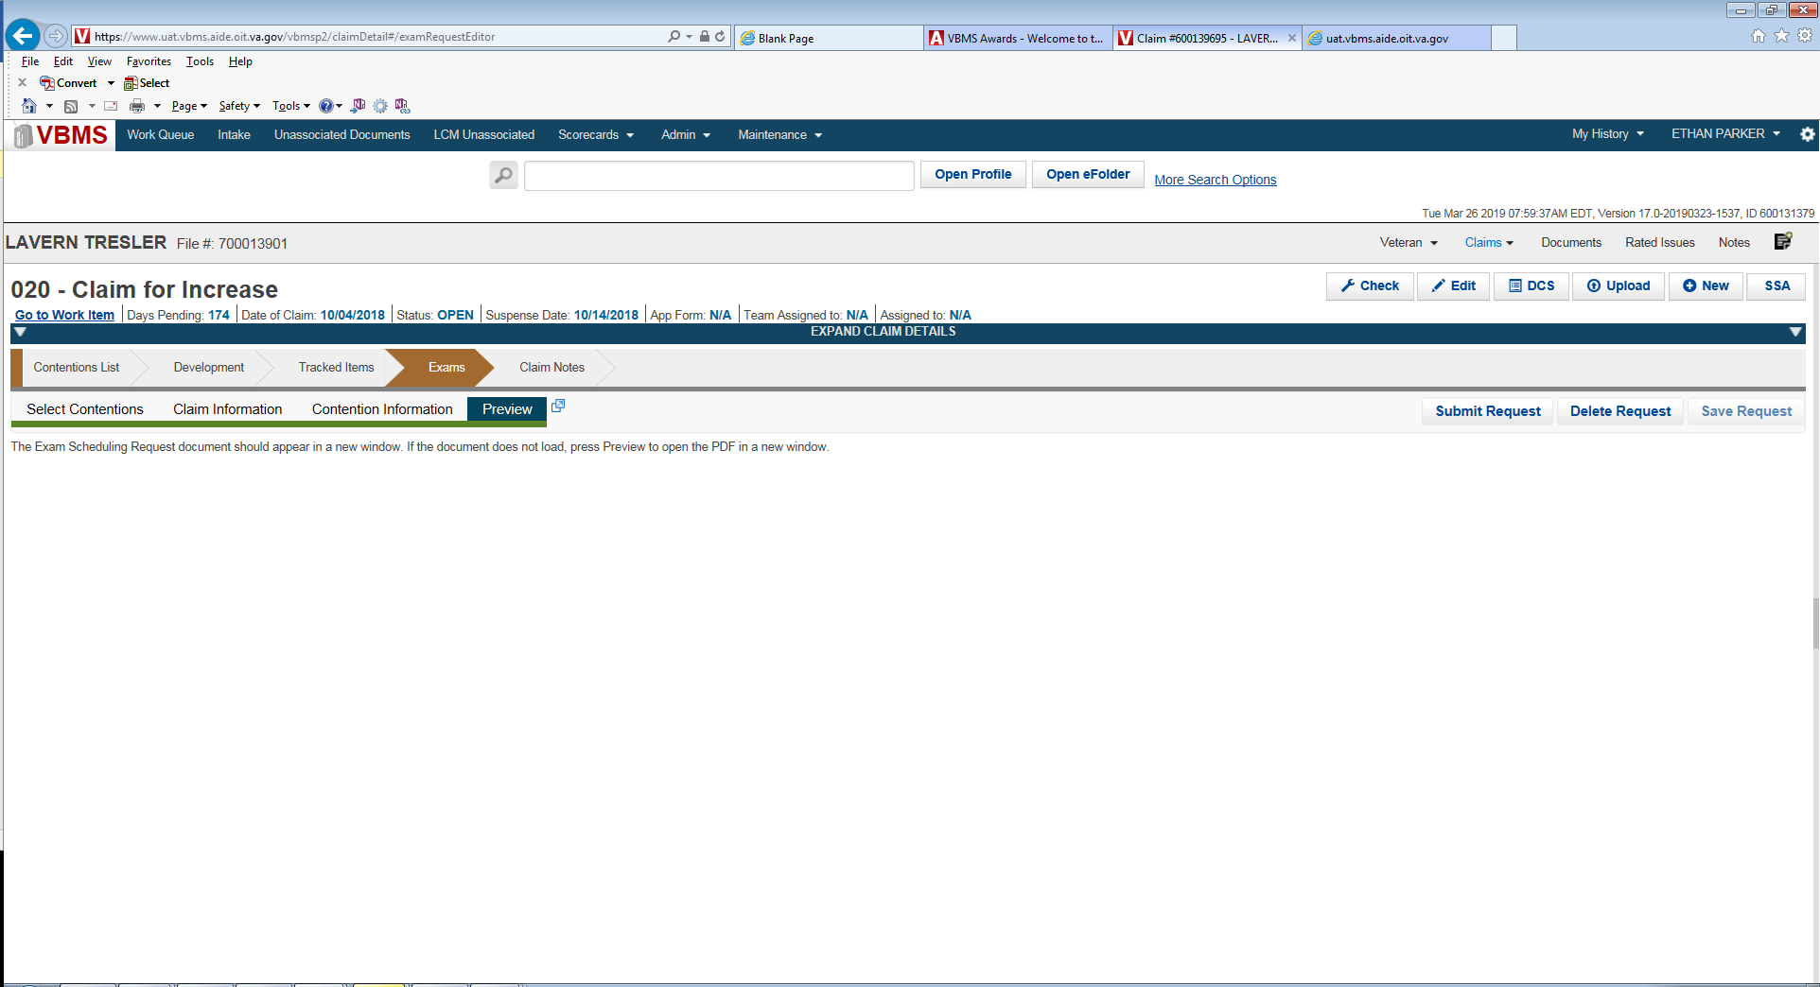

9. The VSR will select the recommended MDE Vendor destination. If an alternate MDE Vendor must be chosen, the user must use the “View Alternate Vendor Destinations”.

Note: Use of Alternate MDE Vendor destination will require a justification.

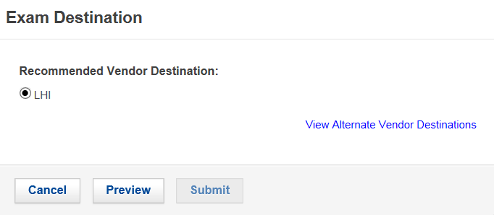

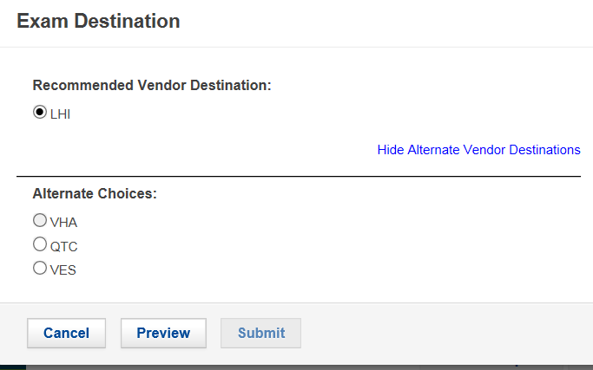

10. After clicking ‘Preview’ and again reviewing the ESR, you can now click ‘Submit’. Once you submit from this point, you cannot make changes to the ESR. You can only modify the ESR once the submission is in “triage” or “open” status.

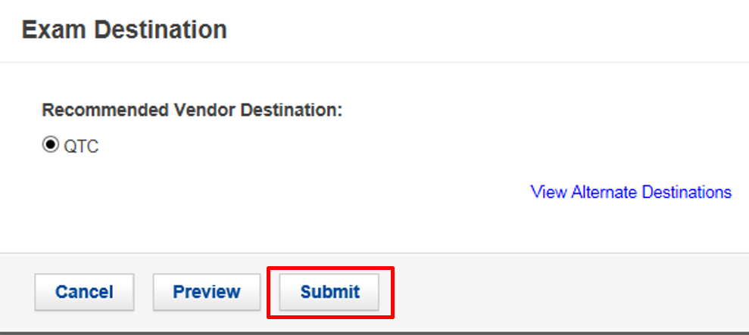

11. Prior to ordering the exam, if at any point you must close out before submitting the request, you can return to the Exam chevron and if you had saved your work, you will be able to edit your draft request.

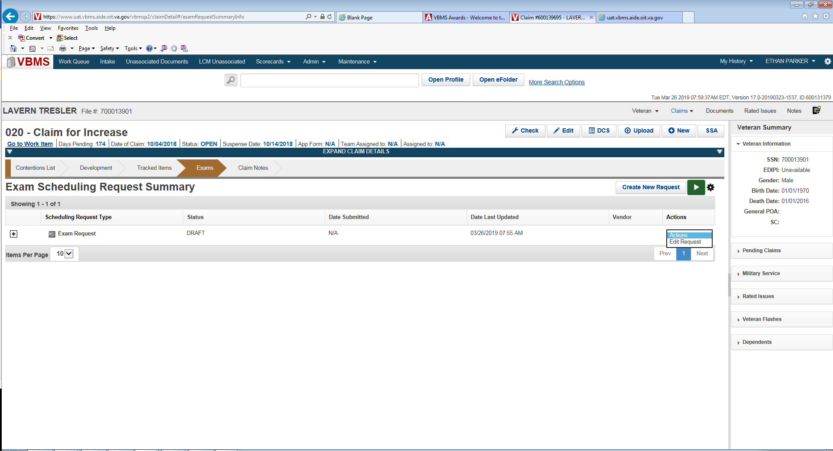

12. Upon submitting the ESR, you should verify that the correct ‘Tracked Items’ were created and that the claim suspense updated appropriately:

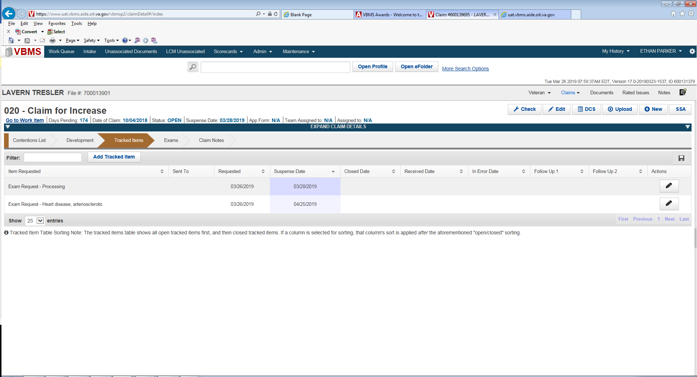

13. After the ESR has been submitted, you can review the ESR metadata by clicking the Newspaper icon from the Exams Chevron: The status will indicate “Processing” until the ESR has been accepted by the MDE Vendor. Once the MDE Vendor has accepted the ESR, the status will show “Triage” or “Open”.

