Slide 1 - Decision Notices and System Enhancements for PMCs
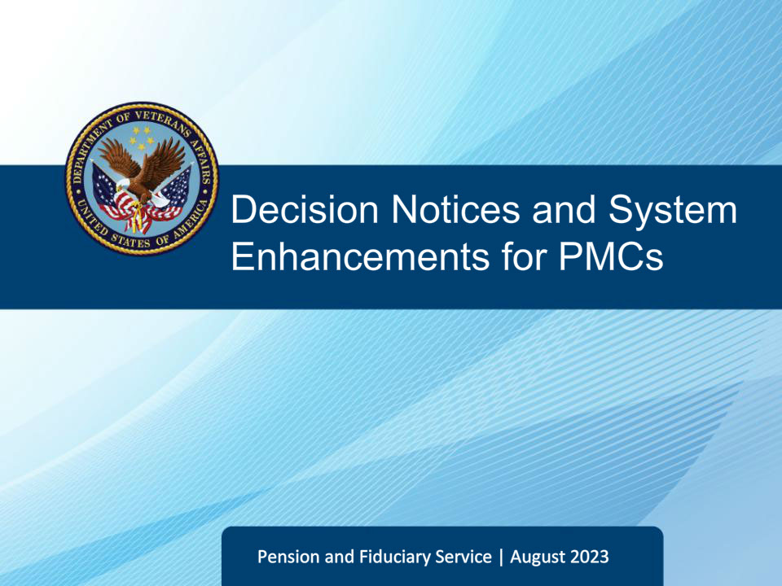
Slide notes

Slide 2 - References
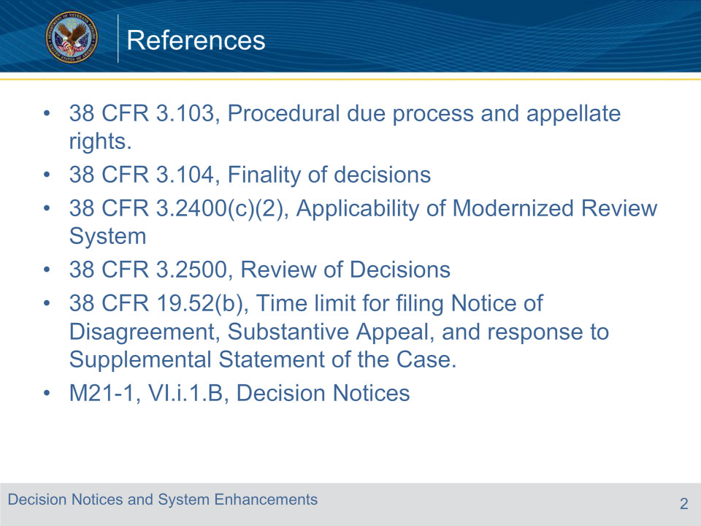
Slide notes

Slide 3 - Objectives
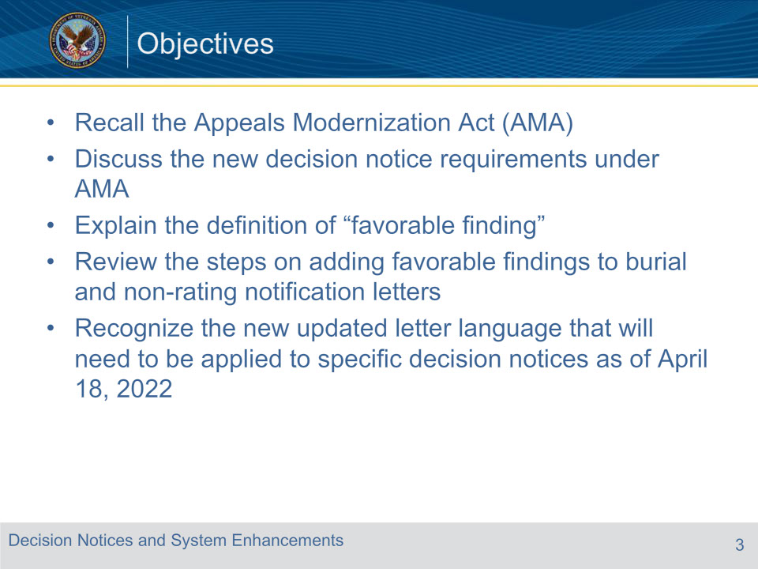
Slide notes

Slide 4 - Appeals Modernization Act (AMA)
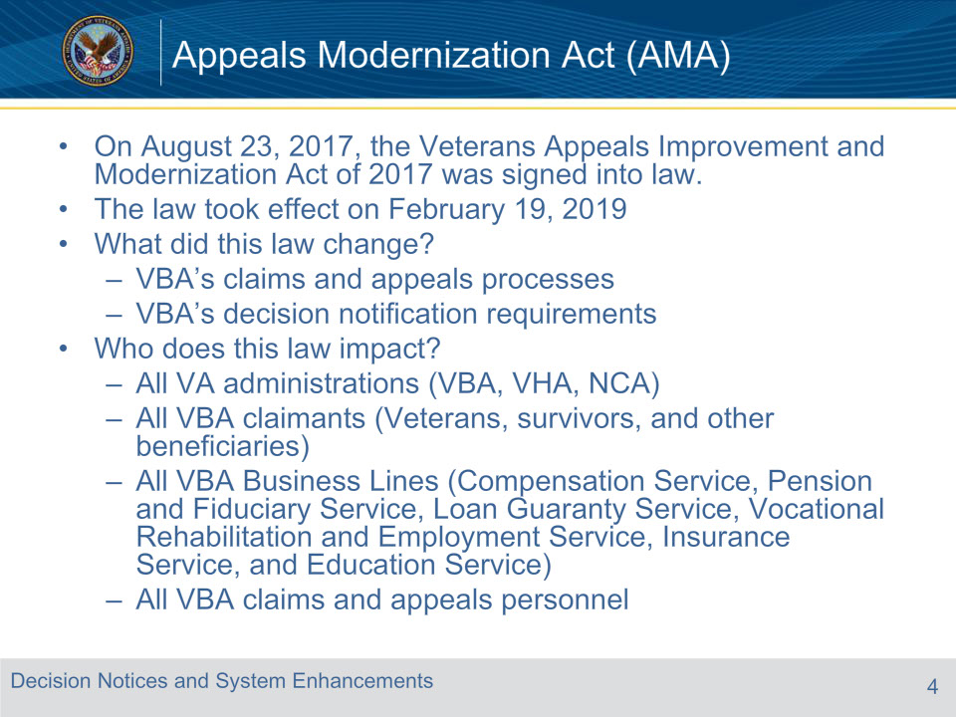
Slide notes

AMA features a three option framework for claimants to choose from when dissatisfied with VA’s decision on their claim: Supplemental Claim, Higher-Level Review, and Board Appeal.

•Additional changes found in the new law include:

Improved notification of all VA decisions (8-point requirement)

Effective date protections for continuously pursued claims

Findings favorable to a claimant are binding on VA and Board adjudicators

Elimination of the split jurisdiction between VBA and the Board for appeals processing (no certification process). The only lanes that VBA will be in control of are Supplemental Claims and HLRs

Slide 5 - Improved Decision Notice Requirements
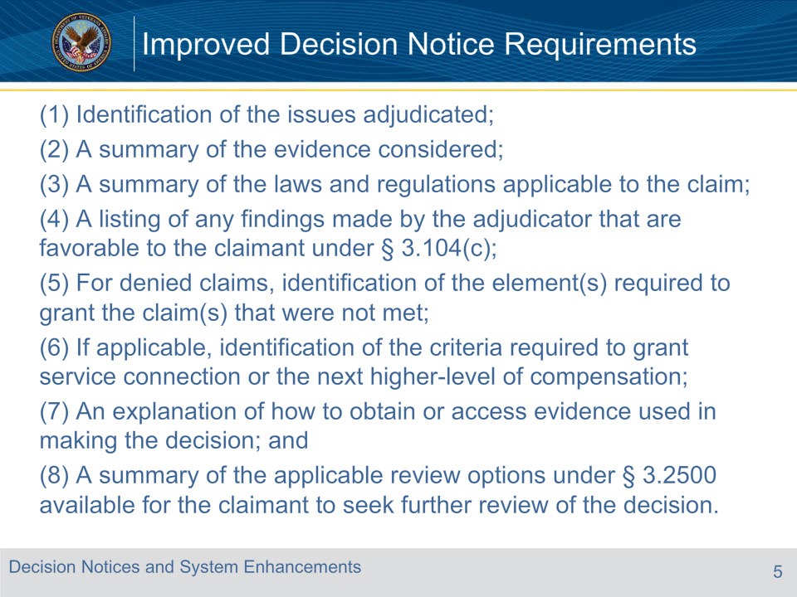
Slide notes

• Pub. L. 115-55 revised 38 U.S.C. 5104(b) to specify that each notice provided under section 5104(a) must include all of the following:

• We already list requirements 1 and 2 in our letters.

• Requirement 3 will be added to the letters as an attachment

• Requirements 4 and 5 – we will provide the PMCs with language to add to the letters for applicable cases

• Requirement 6 refers to compensation

• Requirements 7 and 8 are covered in the new appeals paragraphs that we will discuss later

Slide 6 - Favorable Findings
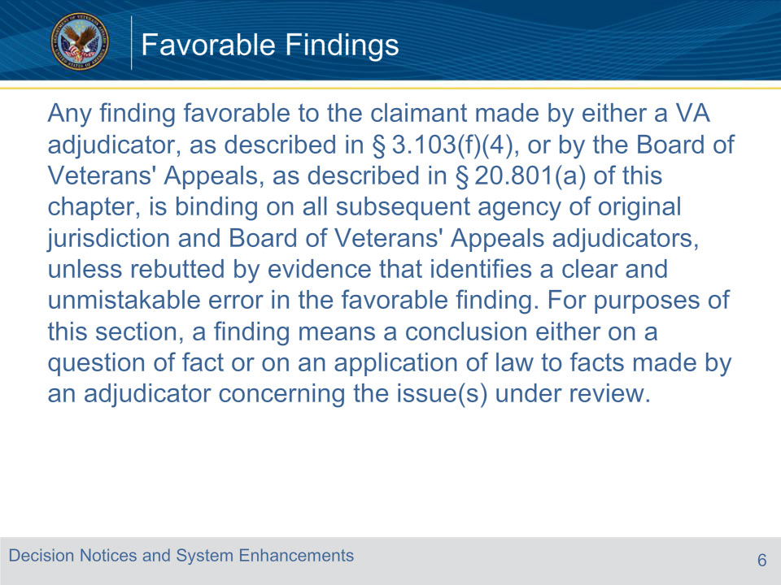
Slide notes

A favorable finding is a determination of fact, based on applicable laws and regulations, made by the adjudicator on an issue under review.

The finding is based on evidence supported by the record.

38 CFR 3.04( c) defines favorable findings as:

• Favorable findings are binding and require VA to have clear and unmistakable evidence to change any findings favorable to a claimant in a previous VA decision.

• Not binding in contested claims

• The favorable finding rule is impossible to apply in the context of contested claims, because a particular factual finding might be favorable to one appellant but unfavorable to another.

Slide 7 - Legacy Claims
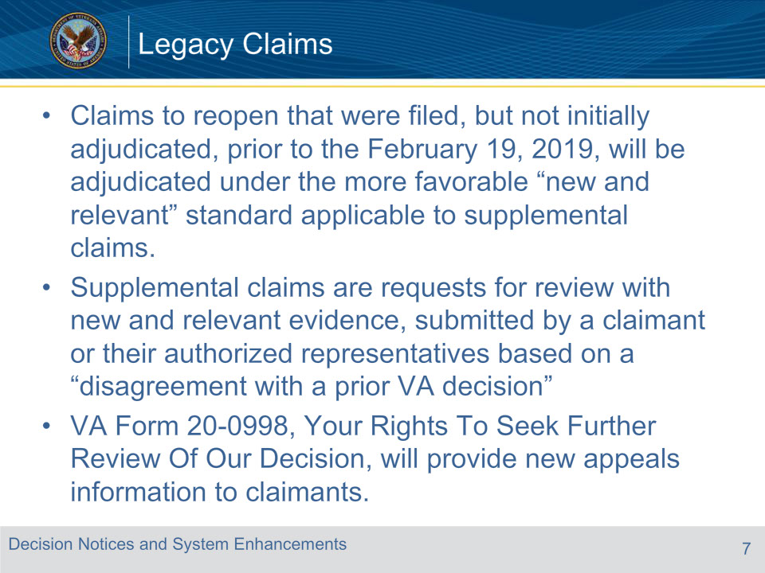
Slide notes

Effective date of February 19, 2019

Reopened claims referring to DIC.

In addition, a supplemental claim subject to the more favorable standard may be filed after the effective date of the modernized review system, even with respect to legacy claims finally adjudicated prior to the effective date of the new system.

Reminder: supplemental claims are requests for review with new and relevant evidence, submitted by a claimant or their authorized representatives based on a “disagreement with a prior VA decision” (see 38 CFR §§ 3.1(p) and 3.2501).

Slide 8 - Slide 8
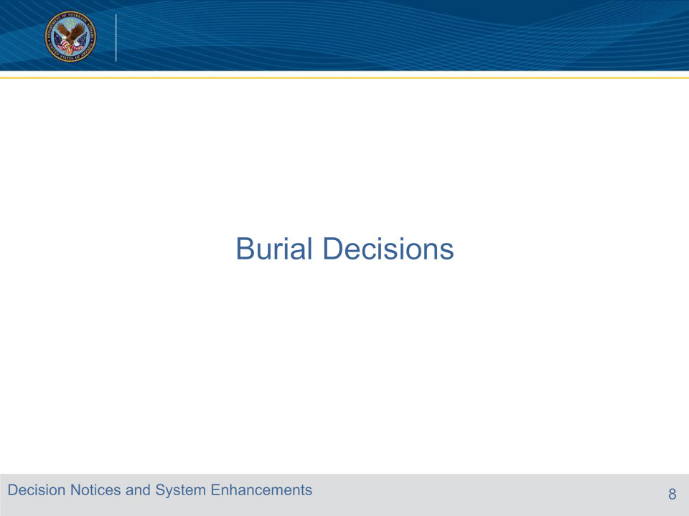
Slide notes

Burial favorable findings and decision notices will differ from non-rating Pension claims. You will need to enter them through VBMS-A and they will auto-populate into the letter.

Slide 9 - Decision Elements for Burial
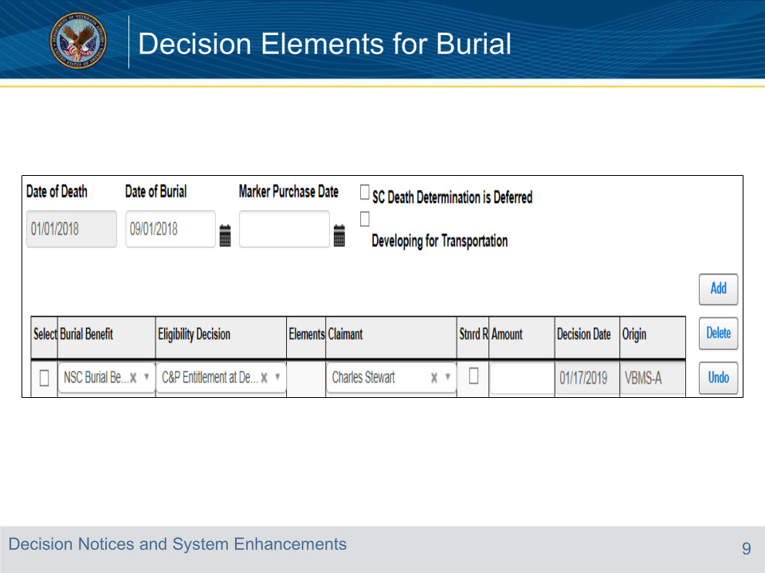
Slide notes

Changes to Burial screen within VBMS-A and the Burial ADL to comply with Improved Decision Notice Requirements under Veterans Appeals Improvement and Modernization Act:

In the Burial screen, a new column will appear, entitled ‘Elements.’ When the ‘Eligibility Decision’ entered for a Burial Benefit is a grant, the Elements box will be disabled:

Slide 10 - Decision Elements for Burial
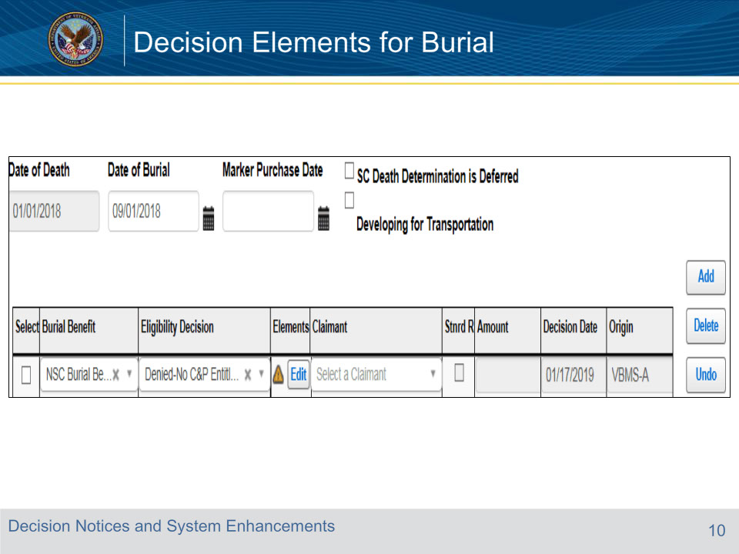
Slide notes

When the ‘Eligibility Decision’ entered for a Burial Benefit is a denial, an ‘Edit’ button will appear within the Elements box for that issue:

Slide 11 - Decision Elements for Burial
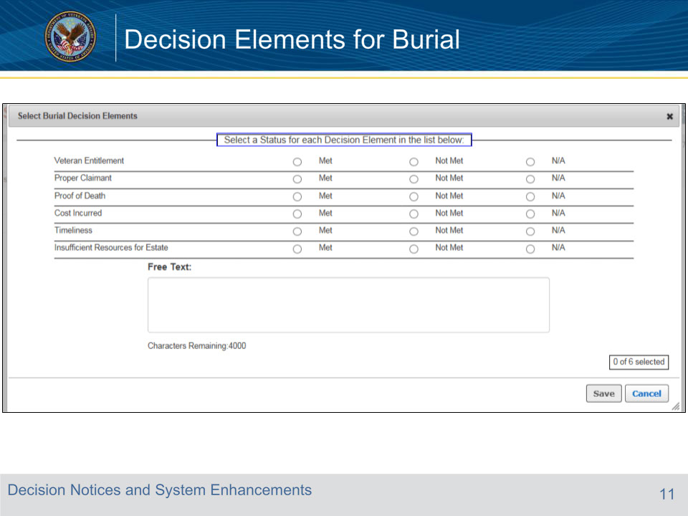
Slide notes

Upon selecting the ‘Edit’ button, the following Burial Decision Elements pop-up screen will appear:

Slide 12 - Decision Elements for Burial
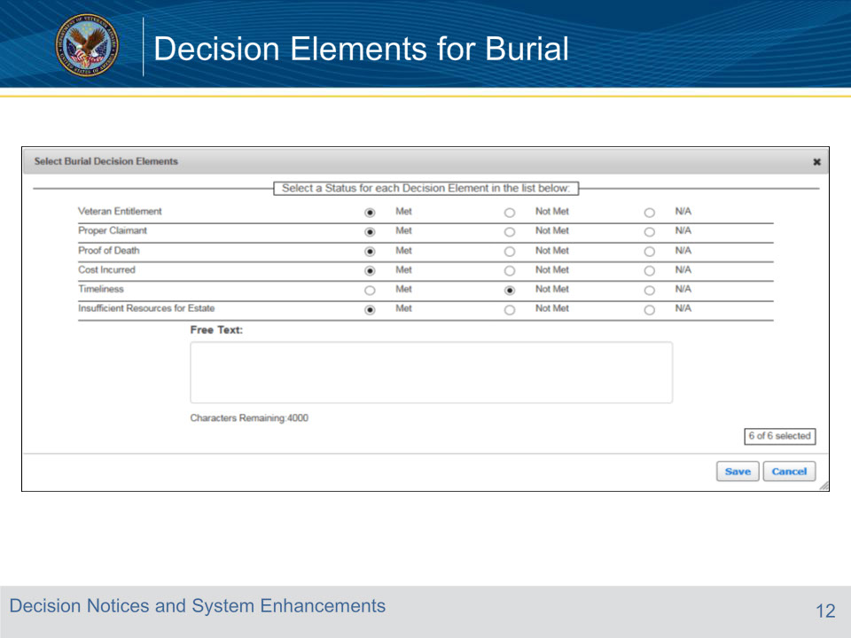
Slide notes

You must enter a selection for each element before being able to proceed:

Slide 13 - Decision Elements for Burial
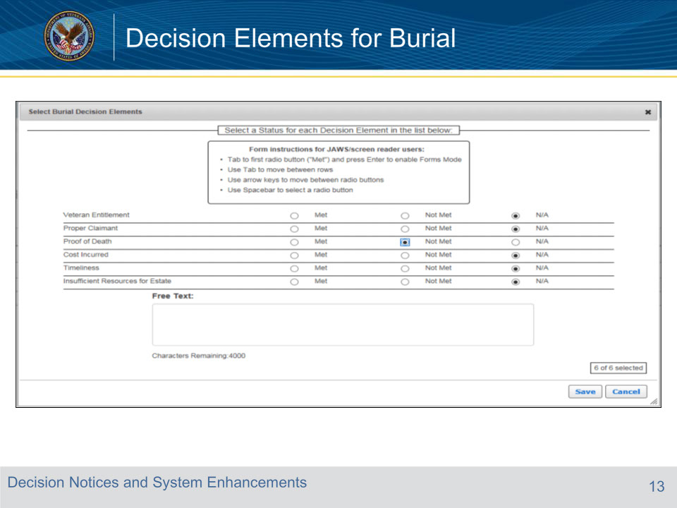
Slide notes

The Free Text field is available for providing any ‘Met’ or ‘Not Met’ Decision Element language not shown in the list that automatically displays in VBMS-A. The known gaps are listed in a separate training document entitled “Burial Decision Element requiring Free Text or N/A”

Slide 14 - Decision Elements for Burial
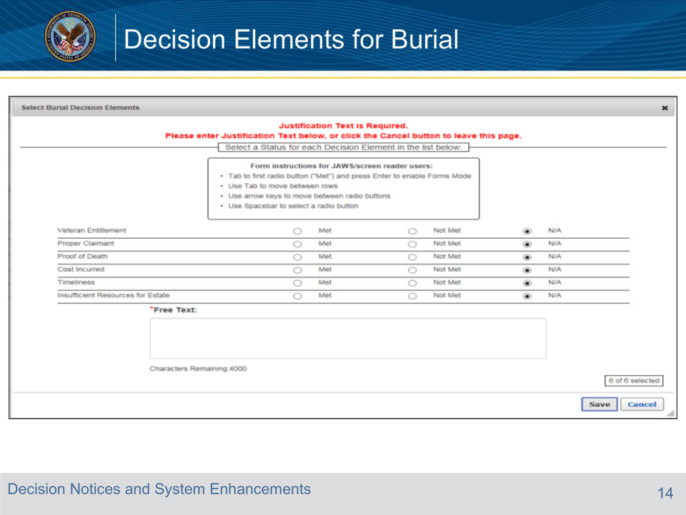
Slide notes

VBMS-A does not require data entry into the Free Text field unless all Decision Elements are selected as N/A. In that case, you will be required to enter free text before you can proceed.

Slide 15 - Decision Elements for Burial
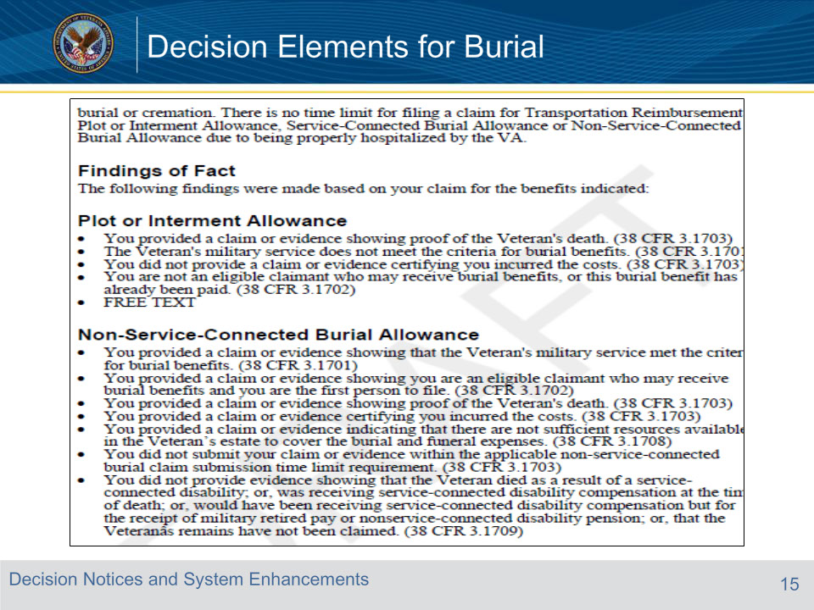
Slide notes

After award generation, new language will populate within the Burial Letter under the ‘Findings of Fact’ header based on the Decision Element selections that were entered in the ‘Burial’ screen.

Slide 16 - Decision Elements for Burial
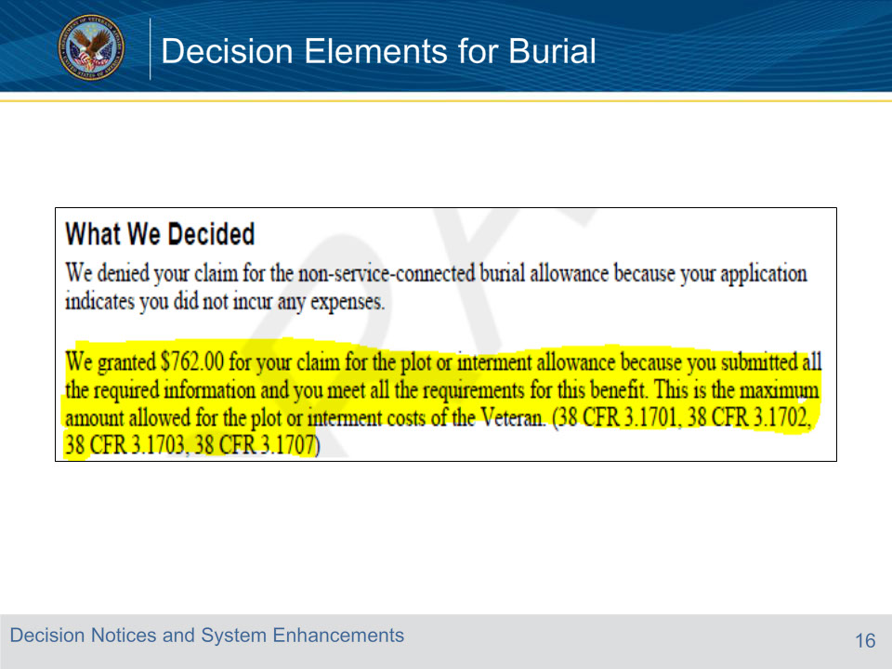
Slide notes

For grant decisions, expanded regulatory language relevant to the burial benefit type will appear within the letter under the ‘What We Decided’ section:

Slide 17 - Decision Notices for Burial
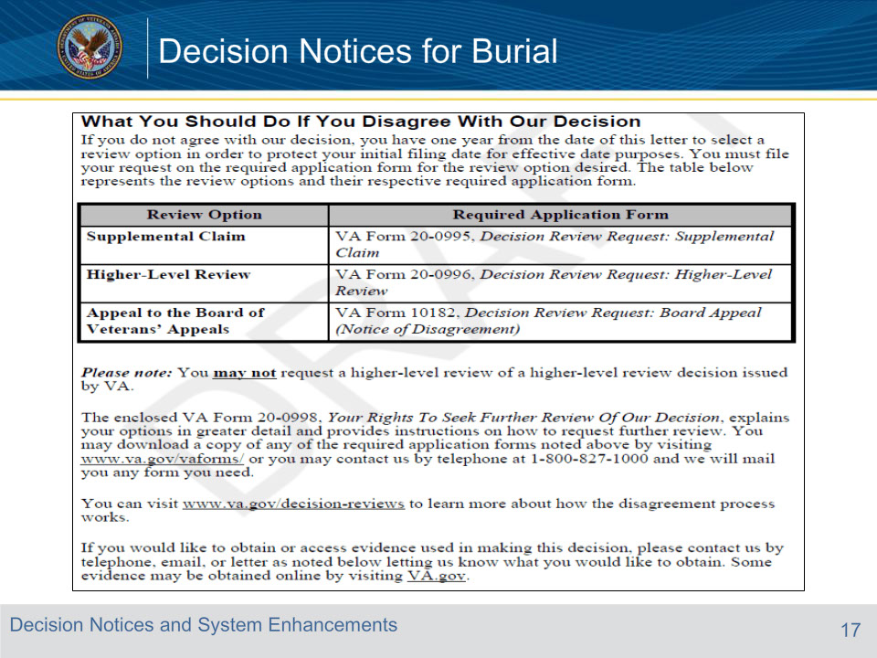
Slide notes

The language populating below ‘What You Should Do If You Disagree With Our Decision’ is updated to discuss the new review options available to claimants

VA Form 4107 will no longer automatically attach to the Burial Letter. Following VBMS Release 16.1, the letter will automatically attach VA Form 20-0998, Your Rights to Seek Further Review of Our Decision.

Slide 18 - Slide 18
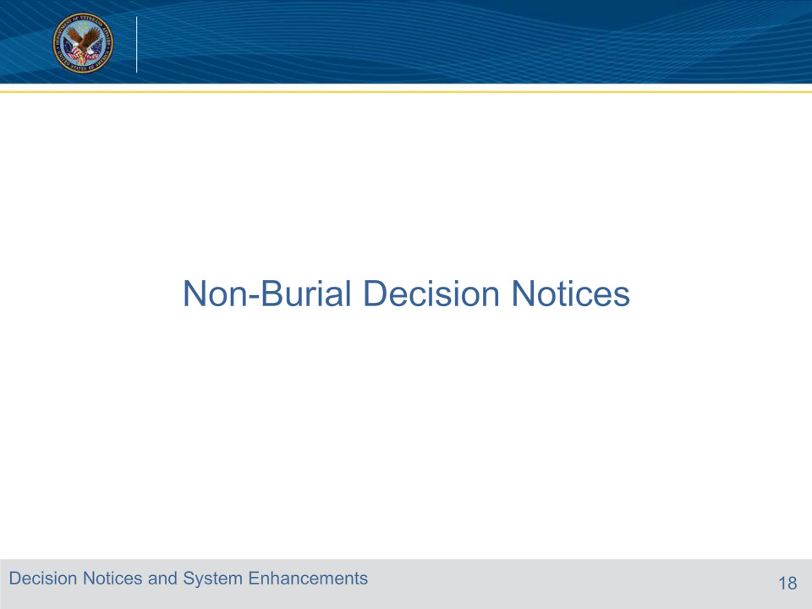
Slide notes

While the PMCs will not be adding favorable findings to ratings, you will need to copy and paste applicable favorable findings for non-rating decisions into a PCGL letter.

Slide 19 - Examples of Favorable Findings
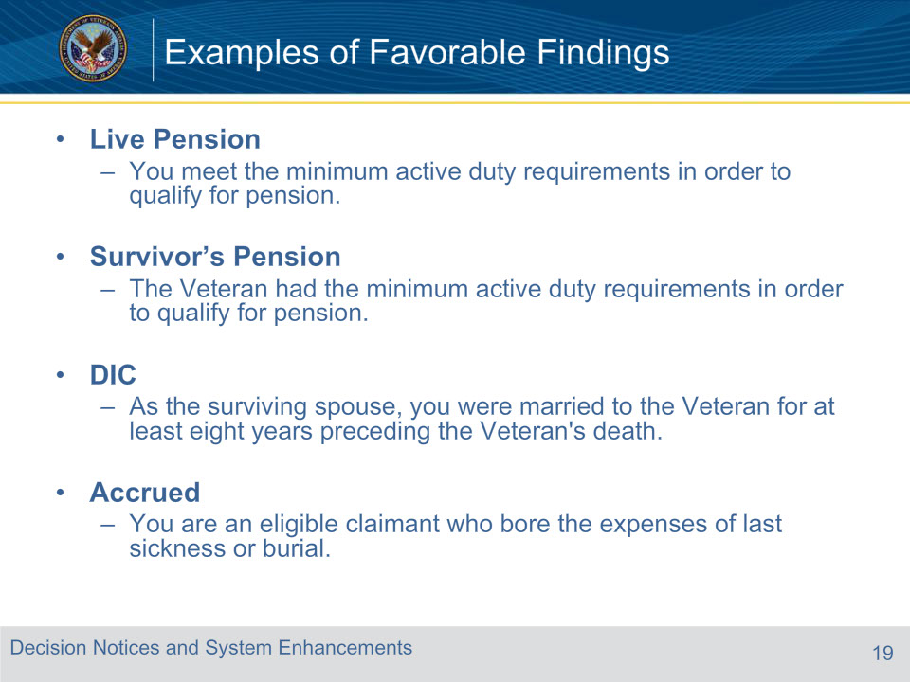
Slide notes

Favorable findings will only go into letters for originals, and claims after period of non-entitlement.

You will need to copy and paste applicable favorable findings into a PCGL letter.

All favorable findings for Non-Rating decisions are listed in the handout. This slide shows some examples.

Slide 20 - Decision Notices
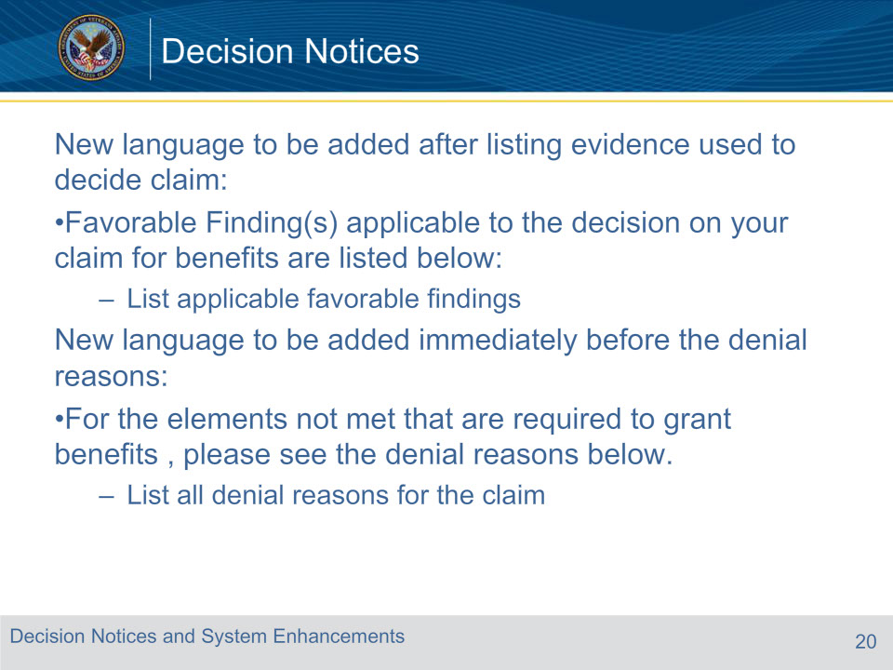
Slide notes

You will need to copy and paste applicable favorable findings into a PCGL letter.

Slide 21 - Dependency Work-around
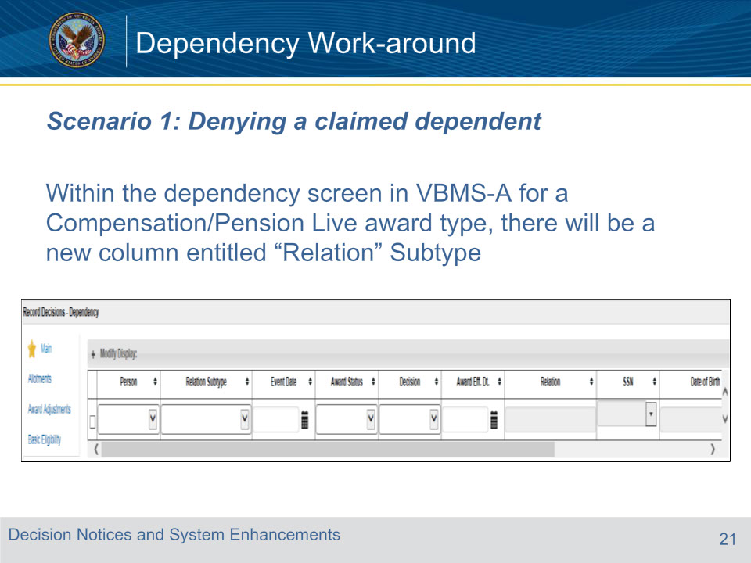
Slide notes

There were updates to the Dependency screen under the AMA with the VBMS-A 16.1 Release. For pension, we use an alternative workflow to bypass unnecessary steps required for the Compensation ADL.

Within the dependency screen in VBMS-A there is a column entitled “Relation” Subtype

Slide 22 - Dependency Work-around
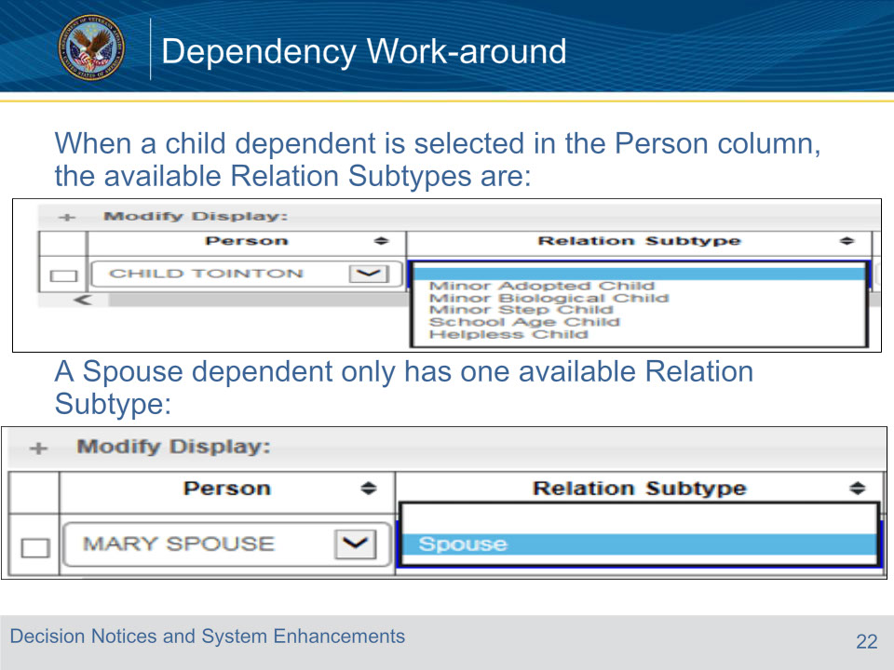
Slide notes

Slide 23 - Dependency Work-around
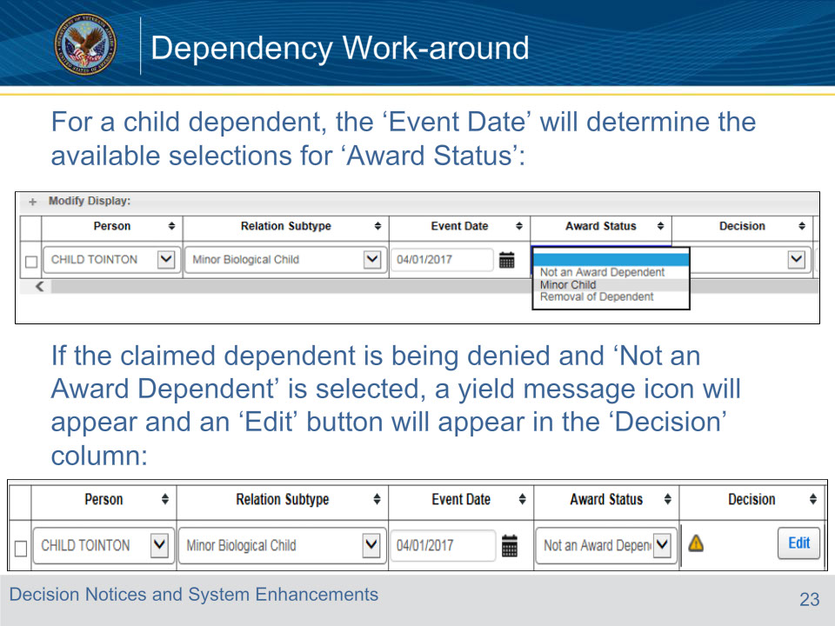
Slide notes

Slide 24 - Dependency Work-around
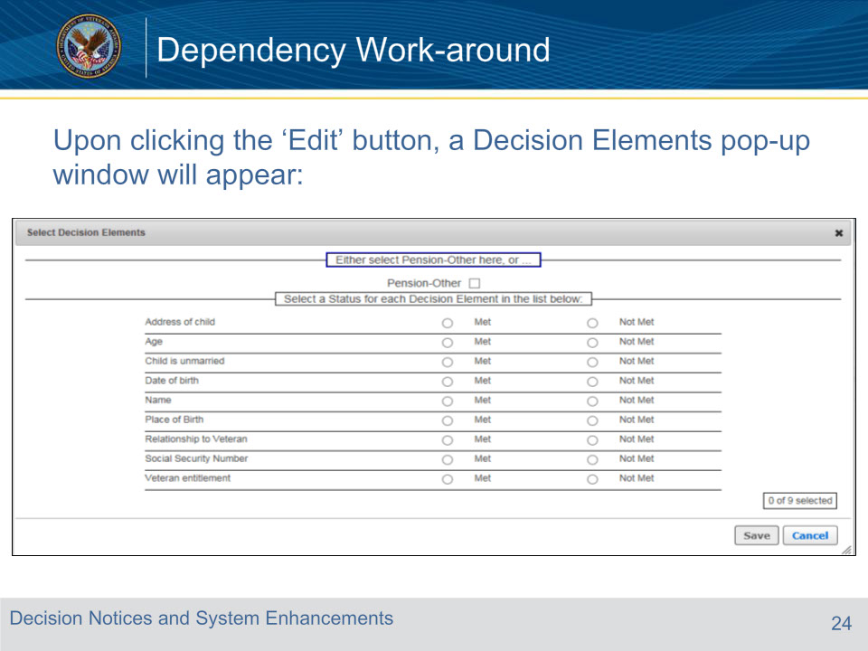
Slide notes

Slide 25 - Dependency Work-around
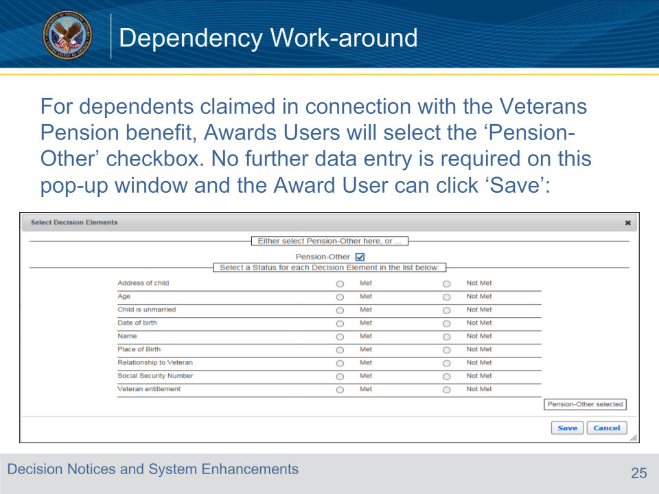
Slide notes

Slide 26 - Dependency Work-around
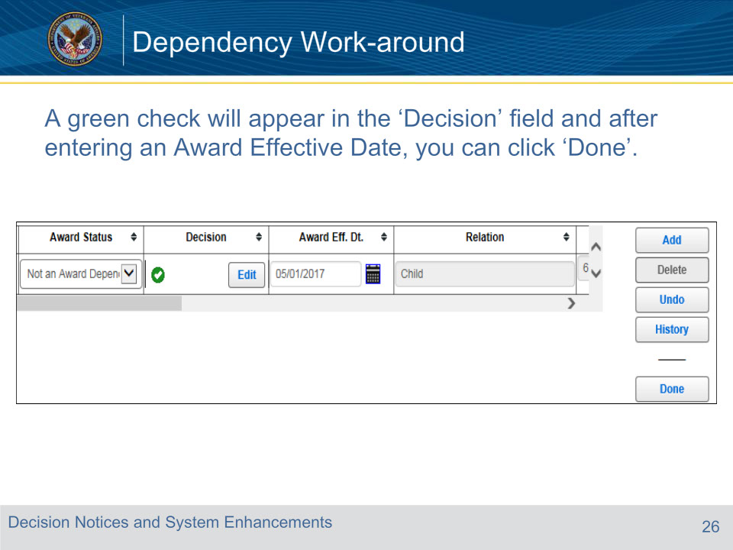
Slide notes

Slide 27 - Dependency Work-around
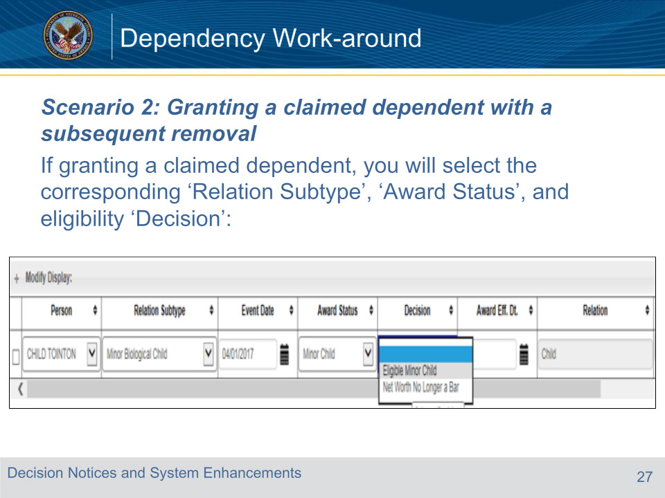
Slide notes

Slide 28 - Dependency Work-around
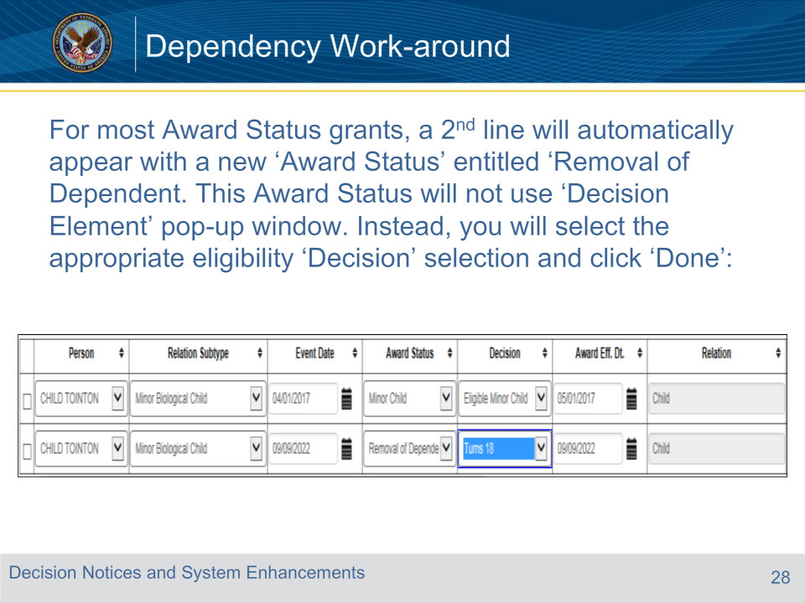
Slide notes

Slide 29 - Dependency Work-around
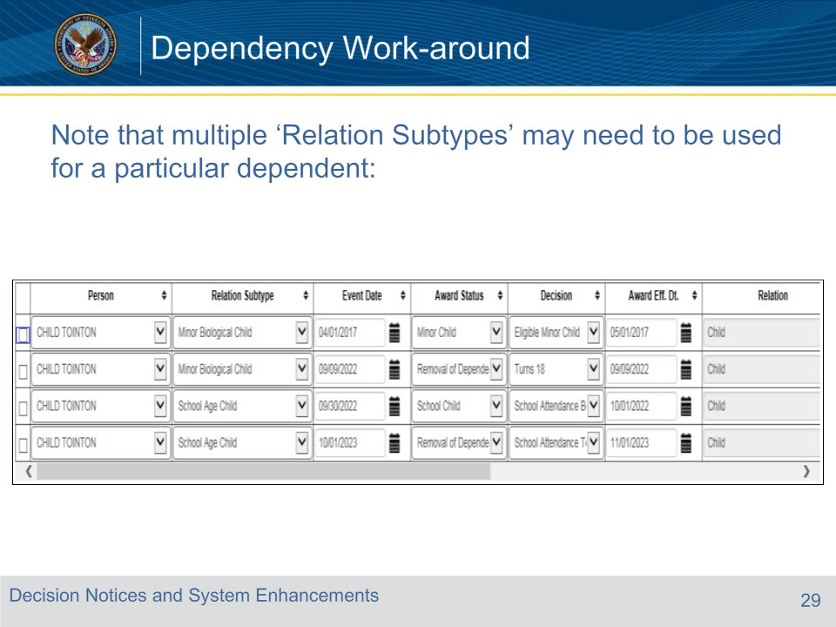
Slide notes

Slide 30 - Slide 30
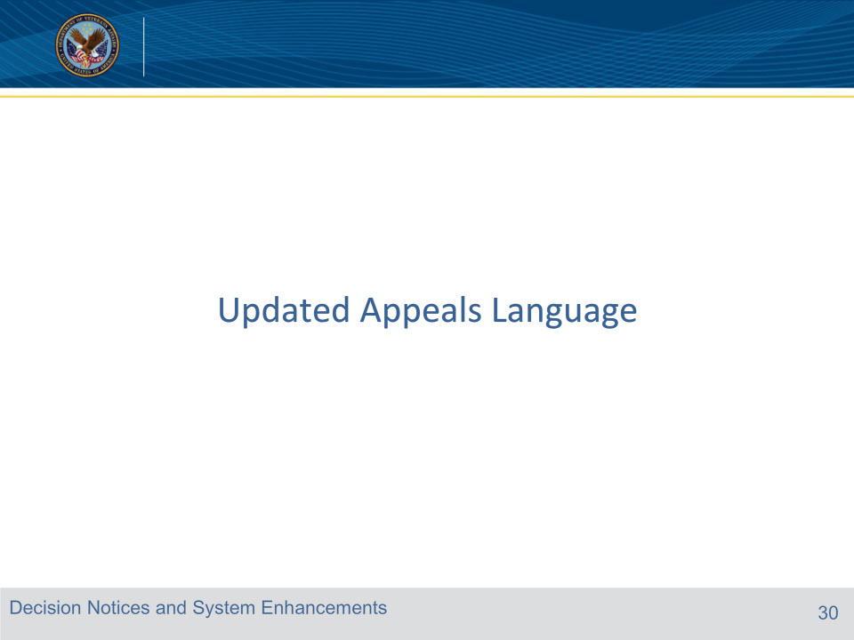
Slide notes

The next few slides we will discuss the new appeals paragraphs for non-contested and contested claims, as well as an update to an existing paragraph for due process letters concerning representation.

Slide 31 - New Appeals Paragraph for Non-contested Claims
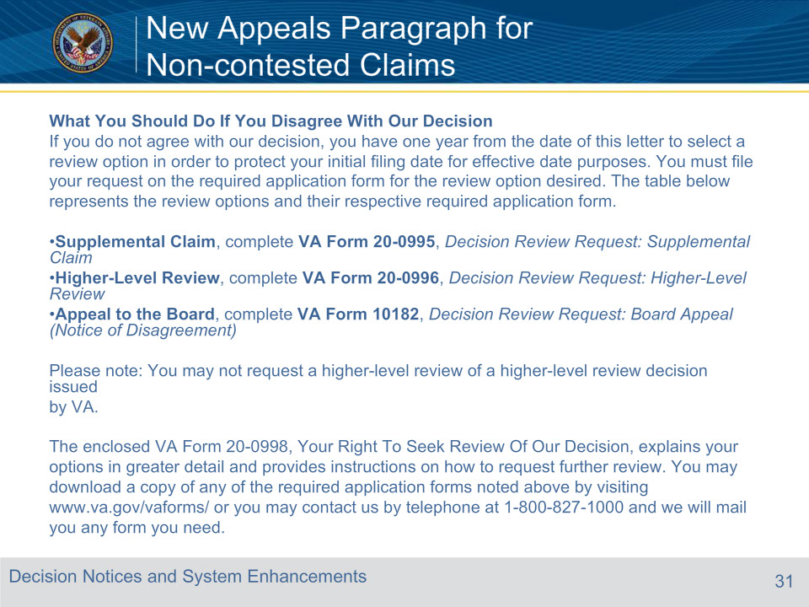
Slide notes

The only form to enclose will be the 20-0998, Your Rights to Seek Further Review of Our Decision. The other forms are available via the website and do not need to be attached.

Slide 32 - New Appeals Paragraph for Contested Claims
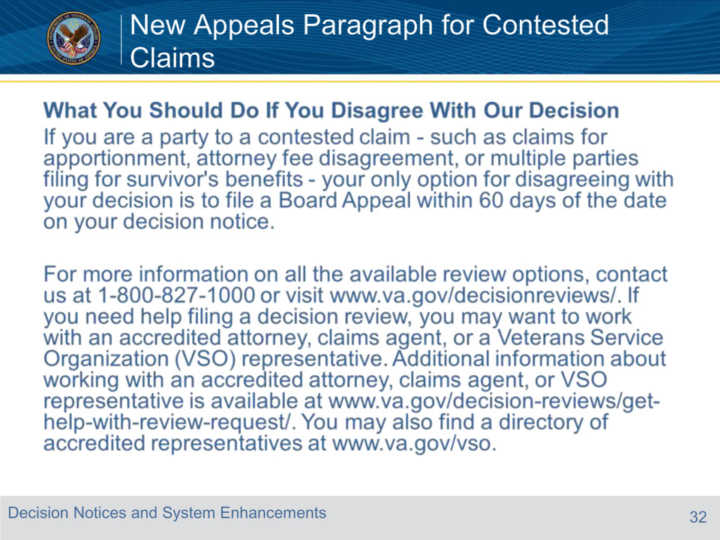
Slide notes

For contested claims, they will have 60 days from the date of the letter.

Slide 33 - Additional Attachments on Decision Letters
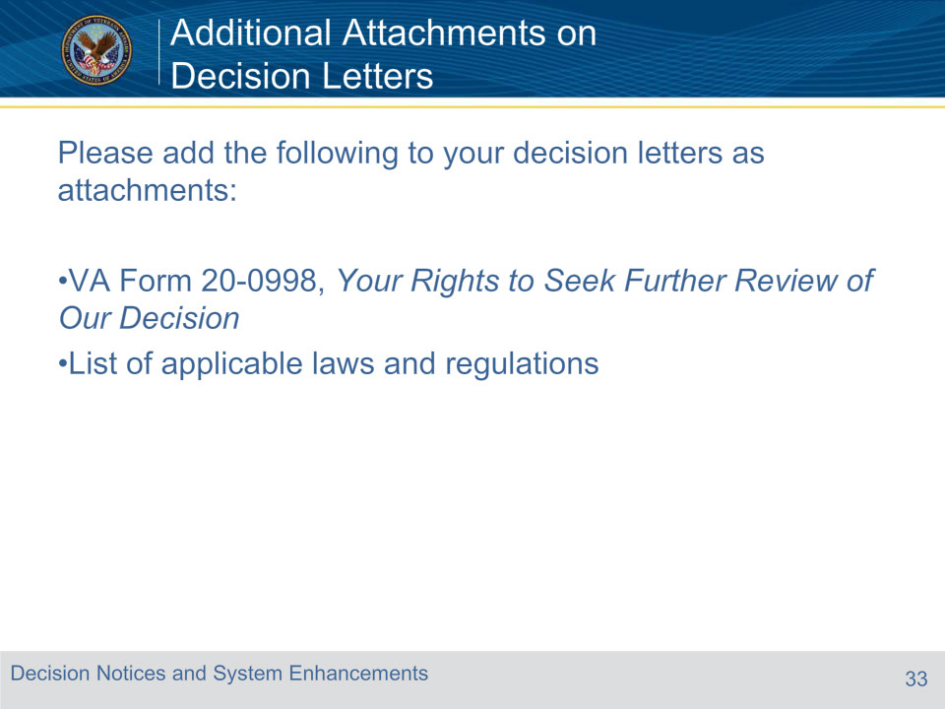
Slide notes

Slide 34 - New Representation Paragraph for Due Process Letters
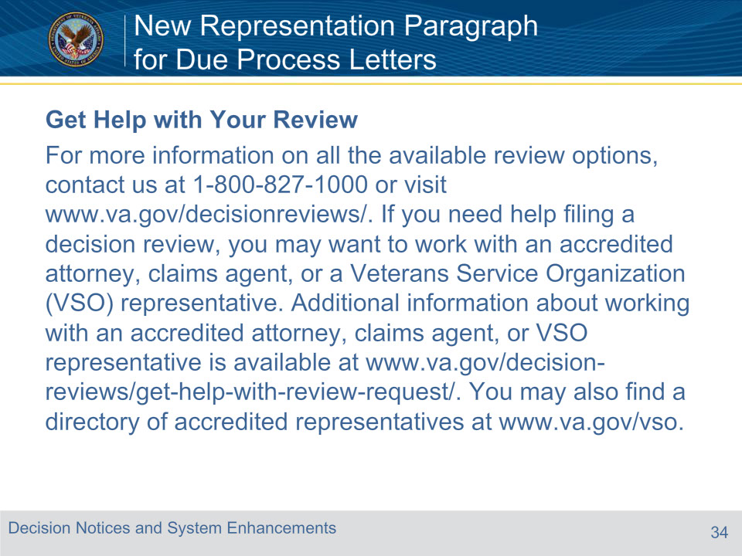
Slide notes

CHANGE:

Attorney fees can be charged, even for supplemental claims, therefore language was updated.

Slide 35 - Questions?
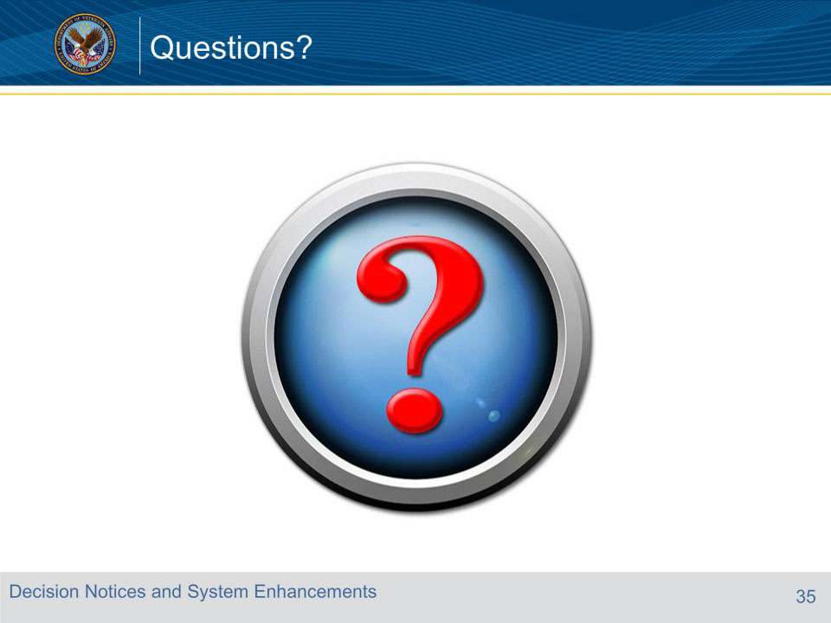
Slide notes

*After questions, pull up the forms (0995, 0996, 0998) for review. *

Slide 36 - Next Steps
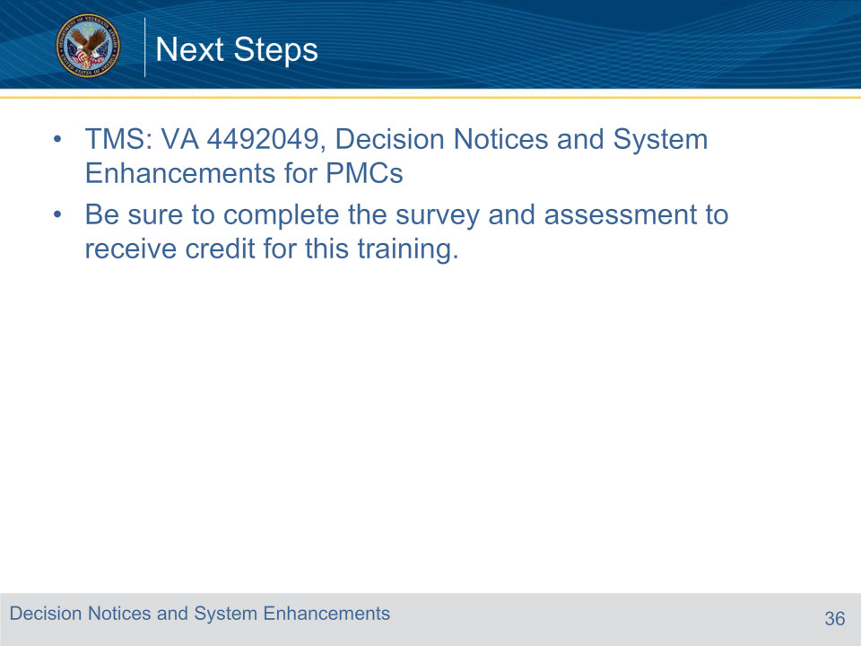
Slide notes

An assessment and satisfaction survey have been assigned to you in TMS. You should be able to complete both within ten minutes.

Completing both will allow you to receive credit for this training.

.

For this training, the intended audience is PMC VSRs, SrVSRs, RVSRs, DROs, AQRSs, RQRSs.

