

PMC VSR Core Course Phase 5: Stages of Claim

Part 4: Prepare Decision Notice

Lesson 1: Prepare Personal Computer Generated Letter (PCGL)

Knowledge Check Appendix A: Catherine Abel Claim

(TRA-57-6817)

May 2022

## For Training Purposes Only

*THIS IS AN IMPORTANT RECORD SAFEGUARD IT*

|  |  |  |  |  |  |  |  |  |  |  |  |  |  |  |  |  |  |  |  |  |  |  |  |  |
| --- | --- | --- | --- | --- | --- | --- | --- | --- | --- | --- | --- | --- | --- | --- | --- | --- | --- | --- | --- | --- | --- | --- | --- | --- |
| 1. LAST NAME - FIRST NAME -MIDDLE NAME  Abel, Catherine R. | | | | | | | | | | | | 2. SEX  F | | 3. SOCIAL SECURITY NUMBER | | | | | | 4.  DATE OF BIRTH | YEAR  49 | | MONTH  04 | DAY  19 |
| TRA | 57 | | 6817 | | |
| 5. DEPARTMENT, COMPONENT AND BRANCH OR CLASS  Marine Corps | | | | | | | | | | | | 6a. GRADE, RATE OR RANK  Captain | | | | | 6b. PAY  GRADE  O-3 | | | 7.  DATE OF RANK | YEAR  78 | | MONTH  07 | DAY  17 |
| 8a. SELECTIVE SERVICE NUMBER | | | | | | | b. SELECTIVE SERVICE LOCAL BOARD NUMBER, CITY, STATE AND ZIP CODE | | | | | | | | | c. HOME OF RECORD AT TIME OF ENTRY INTO ACTIVE SERVICE  *(Street, RFD, City, State and Zip Code)*  57251 Serene Blvd, Van Nuys, CA 91411  (US) | | | | | | | | |
|  |  | |  | |  | |
| 9a. TYPE OF SEPERATION | | | | |  | Discharge | | |  | | |  | b. STATION OR INSTALLATION AT WHICH EFFECTED  Camp Pendleton California | | | | | | | | | | | |
| c. AUTHORITY AND REASON | | | | | | | | | | | | | | | | | | | d.  EFFECTIVE DATE | | YEAR  78 | | MONTH  08 | DAY  31 |
| e. CHARACTER OF SERVICE | | | | | |  |  | Honorable | |  |  | |  |  | f. TYPE OF CERTIFICATE ISSUES | | | | | | 10. REENLISTMENT CODE | | | |
| 11. LAST DUTY ASSIGNMENT AND MAJOR COMMAND  Camp Pendleton | | | | | | | | | | | | | 12. COMMAND TO WHICH TRANSFERRED | | | | | | | | | | | |
| 13. TERMINAL DATE OF RESERVE/  MSS OBLIGATION | | | | | | | 14. PLACE OF ENTRY INTO CURRENT ACTIVE SERVICE *(City, State and ZIP Code)*  Van Nuys, CA | | | | | | | | | | | | | | 15. DATE ENTERED ACTIVE DUTY THIS PERIOD | | | |
| YEAR | | MONTH | | DAY | | | YEAR  72 | | MONTH  08 | DAY  31 |
| 16a. PRIMARY SPECIALTY NUMBER | | | | | | | | b. RELATED CIVILIAN OCCUPATION AND | | | | | 18. | | | | | | | |  | |  |  |
| AND TITLE  0802 - Field Artillery Officer | | | | | | | | D.O.T. NUMBER  Logistics | | | | | RECORD OF SERVICE | | | | | | | | YEARS | | MONTHS | DAYS |
| (5 years) | | | | | | | |  | | | | | (a) NET ACTIVE SERVICE THIS PERIOD | | | | | | | | 06 | | 01 | 01 |
|  | | | | | | | |  | | | | | (b) PRIOR ACTIVE SERVICE | | | | | | | | 00 | | 00 | 00 |
| 17a. SECONDARY SPECIALTY NUMBER AND TITLE | | | | | | | | b. RELATED CIVILIAN OCCUPATION AND  D.O.T. NUMBER | | | | | (c) TOTAL ACTIVE SERVICE (a & b) | | | | | | | | 06 | | 01 | 01 |
| (d) PRIOR INACTIVE SERVICE | | | | | | | | 00 | | 00 | 00 |
| (e) TOTAL SERVICE FOR PAY (c & d) | | | | | | | | 06 | | 01 | 01 |
| (f) FOREIGH AND/OR SEA SERVICE THIS PERIOD | | | | | | | | 00 | | 00 | 00 |
| 19. INDOCHINA OR KOREA SERVICE SINCE AUGUST 5, 1964 | | | | | | | | | | | | | 20. highest education level successfullt completed *(In Years)*  SECONDARY/HIGH SCHOOL YRS (1-12 grades) | | | | | | | | | COLLEGE YRS | | |
| 21. TIME LOST *(Preceeding Two Yrs)* | | | | | | 22. DAYS ACCRUED LEAVE PAID | | | 23. SERVICEMEN'S GROUP LIFE INSURANCE COVERAGE | | | | 24. DISIBILITY SEVERANCE PAY | | | | | 25. PERSONNEL SECURITY INVESTIGATION | | | | | | |
| a. TYPE | | | | b. DATE COMPLETED | | |
|  | | | | | |  | | |  | $15,000 | $5,000 | |  | NO |  | YES | |  | | | |  | | |
|  | | | | | |  | | |  | $10,000 | NONE | | AMOUNT | | | | |  | | | |  | | |
| 26. DECORATIONS, MEDALS, BADGES, COMMENDATIONS, CITATIONS AND CAMPAIGN RIBBINS AWARDED OR AUTHORIZED  Joint Service Commendation Medal 03/31/1973  Marine Corps Achievement Medal with 1 Oak Leaf Cluster 09/03/1972 Marine Corps Commendation Medal with 1 Gold Star 06/01/1974 Marine Corps Good Conduct Medal with 1 Bronze Star 10/05/1975 | | | | | | | | | | | | | | | | | | | | | | | | |
| 27. REMARKS | | | | | | | | | | | | | | | | | | | | | | | | |
| 28. MAILING ADDRESS AFTER SEPERATION *(Street, RFD, City, County, State, ZIP)*  57251 Serene Blvd  Van Nuys, CA 91411 (US) | | | | | | | | | | | | | 29. SIGNATURE OF PERSON BEING SEPARATED  *Catherine R. Abel* | | | | | | | | | | | |
| 30. TYPED NAME, GRADE AND TITLE OF AUTHORIZING OFFICER  SAMUEL D. HAWKINS, CAPT. ADMIN OFFICER | | | | | | | | | | | | | 31. SIGNATURE OF OFFICER AUTHORIZED TO SIGN  Samuel D. Hawkins | | | | | | | | | | | |

**FORM 1 NOV 72**

**DD**

**214**

**PREVIOUS EDITIONS OF THIS FORM ARE OBSOLETE.**

*THIS IS AN IMPORTANT RECORD SAFEGUARD IT.*

**REPORT OF SEPARATION FROM ACTIVE DUTY**

## For Training Purposes Only

OMB Control No. 2900-0002 Respondent Burden: 25 minutes Expiration Date: 4/30/2019

|  |  |  |  |  |  |  |  |  |  |  |  |  |  |  |  |  |  |  |  |  |
| --- | --- | --- | --- | --- | --- | --- | --- | --- | --- | --- | --- | --- | --- | --- | --- | --- | --- | --- | --- | --- |
| VA Logo **Department of Veterans Affairs** | | | | | | | | | | | | | | | | **VA DATE STAMP**  **(DO NOT WRITE IN THIS SPACE)**    VARO 328 03/05/2017 8:00AM | | | | |
| **APPLICATION FOR PENSION** | | | | | | | | | | | | | | | |
| IMPORTANT: Please read the Privacy Act and Respondent Burden on page 8 before completing the form. | | | | | | | | | | | | | | | |
| **SECTION I: VETERAN'S PERSONAL INFORMATION *(MUST COMPLETE)*** | | | | | | | | | | | | | | | | | | | | |
| 1. VETERAN'S NAME (Last, first, middle)  Abel, Catherine R. | | | | | 2. SOCIAL SECURITY NUMBER  TRA-57-6817 | | | | | | | | | | | 3. DATE OF BIRTH (MM,DD,YYYY)  04/19/1949 | | | | |
| 4. SEX  MALE FEMALE | | 5. HAVE YOU EVER FILED A CLAIM WITH VA?  YES NO (If "Yes," provide your file number in Item 6) | | | | | | | | | | | | | | 6. VA FILE NUMBER  TRA-57-6817 | | | | |
| 7A. MAILING ADDRESS | | |  | | |  | | | | 7B. TELEPHONE NUMBERS (Include Area Code) | | | | | | | | | | |
| 57251 Serene Blvd  Street address, rural route, or P.O. Box | | |  | | | Apt. number | | | | DAYTIME | | | | | ( 747 | |  | ) | 555-0171 | |
|  | | |  | | |  | | | | EVENING | | | | | | | | | | |
| Van Nuys, CA 91411 (US) | US |  |  | | |  | | | | ( ) | | | | | | | | | | |
| City | State |  | ZIP Code | | | Country | | | | CELL PHONE  ( ) | | | | | | | | | | |
| 8A. PREFERRED E-MAIL ADDRESS (If applicable)  [catherine0@my-case.com](mailto:catherine0@my-case.com) | | | | | | | 8B. ALTERNATE E-MAIL ADDRESS (If applicable) | | | | | | | | | | | | | |
| 9. WHAT DISABILITY(IES) PREVENTS YOU FROM WORKING? | | | | | | | | | | | | | | | | | | | | |
| A. DISABILITY(IES) | | | | | | | B. DATE DISABILITY(IES) BEGAN | | | | | | | | | | | | | |
|  | | | | | | |  | | | | | | | | | | | | | |
|  | | | | | | |  | | | | | | | | | | | | | |
| 10. LIST ANY VA MEDICAL CENTERS WHERE YOU RECEIVED TREATMENT FOR YOUR CLAIMED DISABILITY(IES) AND PROVIDE TREATMENT DATES | | | | | | | | | | | | | | | | | | | | |
| A. NAME AND LOCATION OF VA MEDICAL CENTER | | | | | | | | | B. DATE(S) OF TREATMENT | | | | | | | | | | | |
|  | | | | | | | | |  | | | | | | | | | | | |
|  | | | | | | | | |  | | | | | | | | | | | |
| **SECTION II: VETERAN'S SERVICE INFORMATION (*MUST COMPLETE*)** | | | | | | | | | | | | | | | | | | | | |
| 11A. DID YOU SERVE UNDER ANOTHER NAME?  YES (If "Yes," complete Item 11B) NO (If "No," skip to Item 12A) | | | | | | 11B. PLEASE LIST THE OTHER NAME(S) YOU SERVED UNDER | | | | | | | | | | | | | | |
| 12A. I ENTERED ACTIVE SERVICE ON (MM,DD,YYYY)  08/31/1972 | | | | 12B. BRANCH OF SERVICE  Marine Corps | | | | | | | | | | 12C. RELEASE DATE OR ANTICIPATED DATE OF RELEASE FROM ACTIVE SERVICE  08/31/1978 | | | | | | |
| 12D. DID YOU SERVE IN A COMBAT ZONE SINCE 9-11-2001?  YES NO | | | | | | | | | 12E. PLACE OF LAST OR ANTICIPATED SEPARATION  California | | | | | | | | | | | |
| 13A. ARE YOU CURRENTLY ACTIVATED TO FEDERAL ACTIVE DUTY UNDER THE AUTHORITY OF TITLE 10, U.S.C. (National Guard)?  YES NO (If "Yes," provide date of activation in Item 13B) | | | | | | | | | | | | | 13B. DATE OF ACTIVATION (MM,DD,YYYY) | | | | | | | |
| 14A. WHAT IS THE NAME AND ADDRESS OF YOUR RESERVE/NATIONAL GUARD UNIT? | | | | | | | | | | | | | | | | 14B. WHAT IS THE TELEPHONE NUMBER OF  YOUR CURRENT UNIT? (Include Area Code)  ( ) | | | | |
| 15A. HAVE YOU EVER BEEN A PRISONER OF WAR?  YES NO (If "Yes," complete Item 15B) (If "No," skip to Item 16A) | | | | | | | | 15B. DATES OF CONFINEMENT ON (MM,DD,YYYY)  From: To: | | | | | | | | | | | | |
| 16A. DID YOU RECEIVE ANY TYPE OF SEPARATION/SEVERANCE RETIRED PAY?  YES NO (If "Yes," complete Items 16B and 16C) | | | | | | | | 16B. LIST AMOUNT (If  $ | | | | known) | | |  | |  | 16C. LIST TYPE (If known) | | |
| **SECTION III: VETERAN'S WORK HISTORY *(MUST COMPLETE)*** | | | | | | | | | | | | | | | | | | | | |
| ***NOTE****: In the table below, tell us about all of your employment, including self-employment, for* ***one*** *year before you became disabled to the present.* | | | | | | | | | | | | | | | | | | | | |
| 17A. WHAT WAS THE NAME AND ADDRESS OF YOUR EMPLOYER? | | | 17B. WHAT WAS YOUR JOB TITLE? | | | | | 17C. WHEN DID YOUR JOB BEGIN? | | | 17D. WHEN DID YOUR JOB END? | | | | | | 17E. HOW MANY DAYS WERE LOST DUE TO DISABILITY? | | | 17F. WHAT WERE YOUR TOTAL ANNUAL EARNINGS? |
|  | | |  | | | | |  | | |  | | | | | |  | | | $ |
|  | | |  | | | | |  | | |  | | | | | |  | | | $ |

**VA** FORM **21P-527EZ**

APR 2016

SUPERSEDES VA FORM 21-527EZ, JUN 2014, WHICH WILL NOT BE USED.

## For Training Purposes Only

Page 5

|  |  |  |  |  |  |  |  |  |  |  |  |  |  |  |  |  |  |  |  |  |  |  |  |  |  |  |  |  |  |
| --- | --- | --- | --- | --- | --- | --- | --- | --- | --- | --- | --- | --- | --- | --- | --- | --- | --- | --- | --- | --- | --- | --- | --- | --- | --- | --- | --- | --- | --- |
| **SECTION IV: MARITAL STATUS *(MUST COMPLETE)*** | | | | | | | | | | | | | | | | | | | | | | | | | | | | | |
| 18A. | WHAT IS YOUR MARRIED | MARITAL STATUS?  DIVORCED | | *(Check* | | | *one)* | WIDOWED | |  | NEVER | MARRIED | | | (Skip | | to | Section | | VI | if | never | married) | | | | | | |
| **TELL US ABOUT YOUR MARRIAGE/PREVIOUS MARRIAGES** | | | | | | | | | | | | | | | | | | | | | | | | | | | | | |
| 18B. HOW MANY TIMES HAVE YOU BEEN MARRIED (including current marriage)?  1 | | | | | | | | | | | | | | | | | | | | | | | | | | | | | |
| 19A. DATE (month, day, year) AND PLACE OF MARRIAGE (city/state or country) | | | | | 19B. TO WHOM MARRIED  (first, middle, last name) | | | | | 19C. TYPE OF MARRIAGE  (ceremonial, common-law, proxy, tribal, or other) | | | | | | | | | 19D. HOW MARRIAGE TERMINATED  (death, divorce, marriage has not been terminated) | | | | | | | | 19E. DATE (month, day, year) AND PLACE MARRIAGE TERMINATED  (city/state or country) | | |
| 05/20/1965  Memphis, TN | | | | | Pat Abel | | | | | ceremonial | | | | | | | | | N/A | | | | | | | | N/A | | |
|  | | | | |  | | | | |  | | | | | | | | |  | | | | | | | |  | | |
| 19F. IF YOU INDICATED "OTHER" AS TYPE OF MARRIAGE IN ITEM 19C, PLEASE EXPLAIN: | | | | | | | | | | | | | | | | | | | | | | | | | | | | | |
| **SECTION V: CURRENT MARITAL INFORMATION (*COMPLETE ONLY IF YOU ARE CURRENTLY MARRIED)*** | | | | | | | | | | | | | | | | | | | | | | | | | | | | | |
| **Note** - Skip to Section VI if not currently married. | | | | | | | | | | | | | | | | | | | | | | | | | | | | | |
| **TELL US ABOUT YOUR SPOUSE'S MARRIAGE/PREVIOUS MARRIAGES** | | | | | | | | | | | | | | | | | | | | | | | | | | | | | |
| 20. HOW MANY TIMES HAS YOUR SPOUSE BEEN MARRIED (including current marriage)?  1 | | | | | | | | | | | | | | | | | | | | | | | | | | | | | |
| 21A. DATE (month, day, year) AND PLACE OF MARRIAGE (city/state or country) | | | | | 21B. TO WHOM MARRIED  (first, middle, last name) | | | | | 21C. TYPE OF MARRIAGE  (ceremonial, common-law, proxy, tribal, or other) | | | | | | | | | 21D. HOW MARRIAGE TERMINATED  (death, divorce, marriage has not been terminated) | | | | | | | | 21E. DATE (month, day, year) AND PLACE MARRIAGE TERMINATED  (city/state or country) | | |
| 05/20/1965  Memphis, TN | | | | | Abel, Catherine R. | | | | | ceremonial | | | | | | | | | N/A | | | | | | | | N/A | | |
|  | | | | |  | | | | |  | | | | | | | | |  | | | | | | | |  | | |
| 21F. IF YOU INDICATED "OTHER" AS TYPE OF MARRIAGE IN ITEM 21C, PLEASE EXPLAIN: | | | | | | | | | | | | | | | | | | | | | | | | | | | | | |
| 22A. WHAT IS YOUR SPOUSE'S DATE OF  BIRTH? (month, day, year)  05/04/1944 | | | | | | | 22B. WHAT IS YOUR SPOUSE'S SOCIAL SECURITY NUMBER?  TRA-20-5835 | | | | | | | | | 22C. IS YOUR SPOUSE ALSO A VETERAN?  YES NO | | | | | | | | 22D. WHAT IS YOUR SPOUSE'S VA FILE NUMBER (if any)? | | | | | |
| 22E. DO YOU LIVE WITH YOUR SPOUSE?  (If "Yes," skip to Section VI)  YES NO (If "No," complete Items 22F - 22H) | | | | | | | | | | | 22F. WHAT IS YOUR SPOUSE'S ADDRESS? (Number and street or rural route, city or P.O., State, ZIP Code and country) | | | | | | | | | | | | | | | | | | |
| 22G. TELL US THE REASON WHY YOU ARE NOT LIVING WITH YOUR SPOUSE  (i.e.; illness, work, etc.) | | | | | | | | | | | | | | 22H. HOW MUCH DO YOU CONTRIBUTE MONTHLY TO YOUR SPOUSE'S SUPPORT?  $ | | | | | | | | | | | | | | | |
| **SECTION VI: DEPENDENT CHILDREN *(COMPLETE IF YOU HAVE DEPENDENT CHILDREN)*** | | | | | | | | | | | | | | | | | | | | | | | | | | | | | |
| **Note** - Skip to Section VII if you have no dependent children. | | | | | | | | | | | | | | | | | | | | | | | | | | | | | |
| 23A. NAME OF DEPENDENT CHILD  (First, middle initial, last) | | | 23B. DATE AND PLACE OF BIRTH  (city, state or country) | | | | | | 23C. SOCIAL SECURITY NUMBER | *(Check all that apply)* | | | | | | | | | | | | | | | | | | | |
| 23D. BIOLOGICAL | | | 23E. ADOPTED | | | 23F. STEPCHILD | | | | 23G.  18-23 YEARS  OLD (in school) | | | | | 23H. SERIOUSLY DISABLED | | | 23I. CHILD MARRIED | 23J. CHILD PREVIOUSLY MARRIED |
| Sunil Abel | | | 01/04/1967  Houston, TX | | | | | | TRA-01-1776 |  | | |  | | |  | | | |  | | | | |  | | |  |  |
|  | | |  | | | | | |  |  | | |  | | |  | | | |  | | | | |  | | |  |  |
|  | | |  | | | | | |  |  | | |  | | |  | | | |  | | | | |  | | |  |  |
| **Note** - In Items 24A through 24D, tell us about the children listed in Item 23A who ***do not*** live with you. | | | | | | | | | | | | | | | | | | | | | | | | | | | | | |
| 24A. NAME OF DEPENDENT CHILD  (First, middle initial, last) | | | | | | 24B. CHILD'S COMPLETE ADDRESS  (Number and street or rural route, city or P.O., city, State, ZIP Code and country) | | | | | | | | | 24C. NAME OF PERSON THE CHILD  LIVES WITH (If applicable) | | | | | | | | | | | 24D. MONTHLY AMOUNT YOU CONTRIBUTE TO THE CHILD'S SUPPORT | | | |
|  | | | | | |  | | | | | | | | |  | | | | | | | | | | | $ | | | |
|  | | | | | |  | | | | | | | | |  | | | | | | | | | | | $ | | | |
|  | | | | | |  | | | | | | | | |  | | | | | | | | | | | $ | | | |

**VA** FORM 21P-527EZ, APR 2016 Page 6

## For Training Purposes Only

|  |  |  |  |  |  |  |  |  |
| --- | --- | --- | --- | --- | --- | --- | --- | --- |
| **SECTION VII: INCOME VERIFICATION - NET WORTH *(MUST COMPLETE)*** | | | | | | | | |
| 25. **NET WORTH** (DO NOT LEAVE ANY ITEMS BLANK. If your household has no net worth in a particular source, write "0" or "none") | | | | | | | | |
| Report total net worth for your household. You must report your net worth and the net worth of your dependents (spouse, child, etc.), if any. Identify the  ***specific*** owner for each net worth source, yourself or another person in your household, as applicable. | | | | | | | | |
| SOURCE | AMOUNT | | OWNER | SOURCE | AMOUNT | | | OWNER |
| CASH/NON-INTEREST BEARING BANK ACCOUNTS | $ 100 | | Veteran/Spouse | REAL PROPERTY  *(Not your home, vehicle, furniture, or clothing)* | $ 0 | | |  |
| INTEREST-BEARING BANK ACCOUNTS | $ 0 | |  | ALL OTHER PROPERTY  *(Please write source)* | $ 0 | | |  |
| IRA'S, KEOGH PLANS, ETC. | $ 0 | |  | ALL OTHER PROPERTY  *(Please write source)* | $ 0 | | |  |
| STOCKS, BONDS, MUTUAL FUNDS, ETC. | $ 0 | |  | OTHER *(Provide source)* | $ 0 | | |  |
| **SECTION VIII: INCOME VERIFICATION - MONTHLY INCOME *(MUST COMPLETE )*** | | | | | | | | |
| 26. **GROSS MONTHLY INCOME** (DO NOT LEAVE ANY ITEMS BLANK. If no income was received from a particular source, write "0" or "none") | | | | | | | | |
| Report total monthly income for your household. You must report your income and the income of your dependents (spouse, child, etc.), if any. Identify the ***specific*** income recipient for each income source, yourself or another person in your household, as applicable. | | | | | | | | |
| SOURCE | AMOUNT | RECIPIENT | | SOURCE | | AMOUNT | RECIPIENT | |
| SOCIAL SECURITY | $ 755.00 | Veteran | | SERVICE RETIREMENT | | $ 0 |  | |
| SOCIAL SECURITY | $ 540.00 | Spouse | | SUPPLEMENTAL SECURITY INCOME (SSI)/PUBLIC ASSISTANCE | | $ 0 |  | |
| U.S. CIVIL SERVICE | $ 0 |  | | OTHER *(Provide source)*  State Retirement | | $ 93.50 | Veteran | |
| U.S. RAILROAD RETIREMENT | $ 0 |  | | OTHER *(Provide source)* | | $ 0 |  | |
| BLACK LUNG BENEFITS | $ 0 |  | | OTHER *(Provide source)* | | $ 0 |  | |
| **SECTION IX: EXPECTED INCOME *(MUST COMPLETE)*** | | | | | | | | |
| 27. **EXPECTED INCOME - NEXT 12 MONTHS** (DO NOT LEAVE ANY ITEMS BLANK. If no income was received from a particular source, write "0" or "none") | | | | | | | | |
| Report expected total household income for the next 12 months. You must report your expected income and the expected income of your dependents (spouse, child, etc.), if any. Identify the ***specific*** income recipient for each income source, yourself or another person in your household, as applicable. | | | | | | | | |
| SOURCE | AMOUNT | RECIPIENT | | SOURCE | | AMOUNT | RECIPIENT | |
| GROSS WAGES AND SALARY | $ 0 |  | | OTHER INCOME  EXPECTED *(Provide source)* | | $ 0 |  | |
| GROSS WAGES AND SALARY | $ 0 |  | | OTHER INCOME  EXPECTED *(Provide source)* | | $ 0 |  | |
| TOTAL DIVIDENDS AND INTEREST | $ 0 |  | | OTHER INCOME  EXPECTED *(Provide source)* | | $ 0 |  | |
| **SECTION X: MEDICAL, LEGAL, OR OTHER UNREIMBURSED EXPENSES *(MUST COMPLETE)*** | | | | | | | | |
| 28. MEDICAL, LEGAL, OR OTHER UNREIMBURSED EXPENSES (IF NONE WRITE "0" OR "NONE") | | | | | | | | |
| Report your family medical expenses and certain other expenses actually paid by you that may be deductible from your income. Show  the amount of unreimbursed medical expenses, including the Medicare deduction you paid for yourself or relatives who are members of your household. Also, show unreimbursed last illness and burial expenses and educational or vocational rehabilitation expenses you paid. Last illness and burial expenses are unreimbursed amounts paid by you for the last illness and burial of a spouse or child at any time prior to the end of the year following the year of death. Educational or vocational rehabilitation expenses are amounts paid for courses of education, including tuition, fees, and materials. Show medical, legal or other expenses you paid because of a disability for which civilian disability benefits have been awarded. When determining your income, we may be able to deduct them from the disability benefits for the year in which the expenses are paid. ***Do not include any expenses for which you were reimbursed.*** | | | | | | | | |
| AMOUNT PAID BY YOU | DATE PAID  (mm/dd/yy) | | PURPOSE  (Doctor's fees, hospital charges, attorney fees, tuition, education materials, etc.) | | PAID TO (Name of doctor, hospital, pharmacy, etc.) | | | RELATIONSHIP OF PERSON FOR WHOM EXPENSES PAID  (Spouse, child, etc.) |
| $ 106.00 | monthly | | Medicare Part B Premium | | Social Security | | | Veteran |
| $ 106.00 | monthly | | Medicare Part B Premium | | Social Security | | | Spouse |
| $ 485.00 | monthly | | Private Medical Insurance Premium | | AETNA | | | Veteran/Spouse |
| $ |  | |  | |  | | |  |

**VA** FORM 21P-527EZ, APR 2016 Page 7

## For Training Purposes Only

|  |  |  |
| --- | --- | --- |
| **SECTION XI: DIRECT DEPOSIT INFORMATION *(MUST COMPLETE)*** | | |
| The Department of Treasury requires all Federal benefit payments be made by electronic funds transfer (EFT), also called direct deposit. Please attach a voided personal check or deposit slip or provide the information requested below in Items 29, 30, and 31 to enroll in direct deposit. If you ***do not*** have a bank account, you must receive your payment through Direct Express Debit MasterCard. To request a Direct Express Debit MasterCard you must apply at [www.usdirectexpress.com](http://www.usdirectexpress.com/) or by telephone at 1-800-333-1795. If you elect not to enroll, you must contact representatives handling waiver requests for the Department of Treasury at 1-888-224-2950. They will encourage your participation in EFT and address any questions or concerns you may have. | | |
| 29. ACCOUNT NUMBER (Check the appropriate box and provide the account number, or simply write "Established" if you have a direct deposit with VA.)  CHECKING SAVINGS I CERTIFY THAT I DO NOT HAVE AN ACCOUNT WITH A FINANCIAL INSTITUTION OR CERTIFIED PAYMENT AGENT  Account No.: Account No.: | | |
| 30. NAME OF FINANCIAL INSTITUTION (Please provide the name of the bank where you want your direct deposit) | 31. ROUTING OR TRANSIT NUMBER (The first nine numbers located at the bottom left of your check) | |
| **SECTION XII: CLAIM CERTIFICATION AND SIGNATURE *(MUST COMPLETE)*** | | |
| I certify and authorize the release of information. I certify that the statements in this document are true and complete to the best of my knowledge. I authorize any person or entity, including but not limited to any organization, service provider, employer, or government agency, to give the Department of Veterans Affairs any information about me and I waive any privilege which makes the information confidential.  I certify I have received the notice attached to this application titled *Notice to Veteran of Evidence Necessary to Substantiate a Claim for Veterans Non-Service Connected Pension Benefits.*  I certify I have enclosed all the information or evidence that will support my claim, to include an identification of relevant records available at a Federal facility, such as a VA medical center; **OR,** I have no information or evidence to give VA to support my claim; **OR**, I have checked the box in Item 32, indicating that I do not want my claim considered for rapid processing in the Fully Developed Claim (FDC) Program because I plan to submit further evidence in support of my claim. | | |
| 32. The FDC Program is designed to rapidly process compensation or pension claims received with the evidence necessary to decide the claim. VA will *automatically* consider a claim submitted on this form for rapid processing under the FDC Program. Check the below box **ONLY if you DO NOT want your claim considered for rapid processing** under the FDC Program because you plan to submit further evidence in support of your claim.  **I DO NOT want my claim considered for rapid processing** under the FDC Program because I plan to submit further evidence in support of my claim. | | |
| 33A. VETERAN'S SIGNATURE (**REQUIRED**)  *Catherine R. Abel* | | 33B. DATE SIGNED  03/03/2017 |
| **SECTION XIII: WITNESSES TO SIGNATURE *(MUST COMPLETE ONLY IF VETERAN SIGNED ITEM 33A WITH AN "X")*** | | |
| 34A. SIGNATURE OF WITNESS (If veteran signed above using an "X") | 34B. PRINTED NAME AND ADDRESS OF WITNESS | |
| 35A. SIGNATURE OF WITNESS (If veteran signed above using an "X") | 35B. PRINTED NAME AND ADDRESS OF WITNESS | |
| **PRIVACY ACT NOTICE**: The form will be used to determine allowance to pension benefits (38 U.S.C. 5101). The responses you submit are considered confidential (38 U.S.C. 5701). VA may disclose the information that you provide, including Social Security numbers, outside VA if the disclosure is authorized under the Privacy Act, including the routine uses identified in the VA system of records, 58VA21/22/28, Compensation, Pension, Education, and Vocational Rehabilitation and Employment Records - VA, published in the Federal Register. The requested information is considered relevant and necessary to determine maximum benefits under the law. Information submitted is subject to verification through computer matching programs with other agencies. VA may make a "routine use" disclosure for: civil or criminal law enforcement, congressional communications, epidemiological or research studies, the collection of money owed to the United States, litigation in which the United States is a party or has an interest, the administration of VA programs and delivery of VA benefits, verification of identity and status, and personnel administration. Your obligation to respond is required in order to obtain or retain benefits. Information that you furnish may be utilized in computer matching programs with other Federal or State agencies for the purpose of determining your eligibility to receive VA benefits, as well as to collect any amount owed to the United States by virtue of your participation in any benefit program administered by the Department of Veterans Affairs. Social Security information: You are required to provide the Social Security number requested under 38 U.S.C. 5101(c)(1). VA may disclose Social Security numbers as authorized under the Privacy Act, and, specifically may disclose them for purposes stated above.  **RESPONDENT BURDEN**: We need this information to determine your eligibility for pension. Title 38, United States Code, allows us to ask for this information. We estimate that you will need an average of 25 minutes to review the instructions, find the information, and complete this form. VA cannot conduct or sponsor a collection of information unless a valid OMB control number is displayed. You are not required to respond to a collection of information if this number is not displayed. Valid OMB control numbers can be located on the OMB Internet Page at [www.reginfo.gov/public/do/](http://www.reginfo.gov/public/do/) PRAMain. If desired, you can call 1-800-827-1000 to get information on where to send comments or suggestions about this form. | | |

**VA** FORM 21P-527EZ, APR 2016 Page 8

## For Training Purposes Only

**310 Philadelphia**

## For Training Purposes Only

File Number Message

|  |  |  |  |  |  |
| --- | --- | --- | --- | --- | --- |
|  | TRA-57-6817 | Payee | 00 | Name | Catherine R. Abel |
|  | | | | | |

File Number Name

Catherine R. Abel

TRA-57-6817

SSN - Verified 1

TRA-57-6817

Insurance File No.

Claim Folder Location Date Of Death

Cause Of Death

Insurance Policy No. Date Of Birth

F

04/19/1949

Sex

Service Data

SERVICE NUMBER EOD

RAD BRANCH CHAR SVR SEP REASON PAY GRADE

O-3

NON PAY DAYS

Death In SVC 0

Positive Indication 0

# Power of Attorney

Search

/ /

|  |  |
| --- | --- |
| TRA-4485460 | |
|  | |
| 08/31/1972 | |
|  | |
| 08/31/1978 | |
|  | |
| MARINE CO |  |
|  |
| HON |
|  |
| SAT |

|  |
| --- |
|  |
|  |
| / / |

/ /

Drop down window button



GW In-Theater Start

|  |
| --- |
|  |
|  |
| / / |

End Days

/ /

/ /

Contested Data 0



VADS

VERIFIED

Y

**7:32 AM**

***For Training Purposes Only***

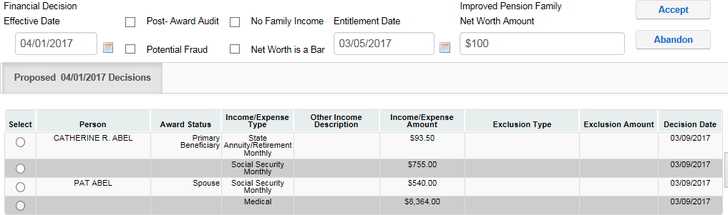

# Financial Data

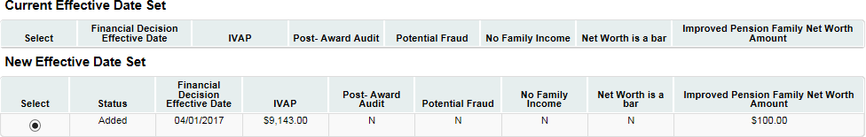

Current/ Proposed Award

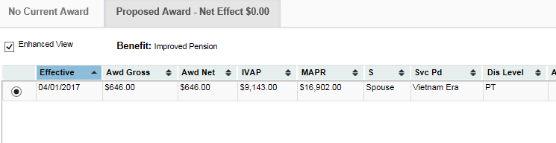

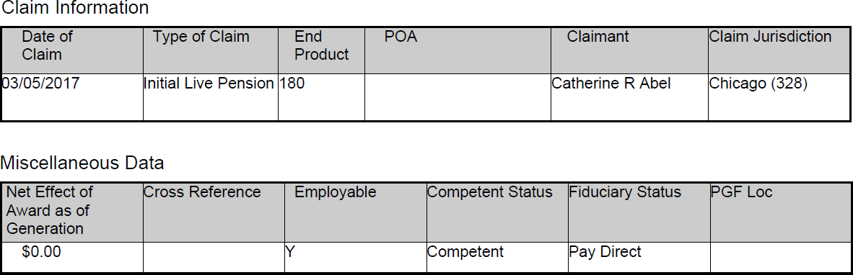

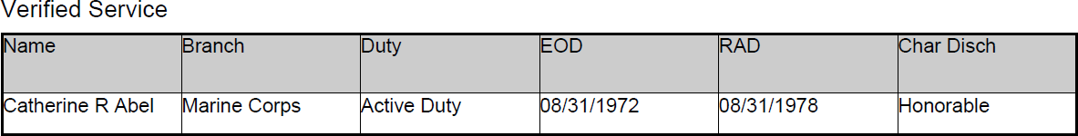

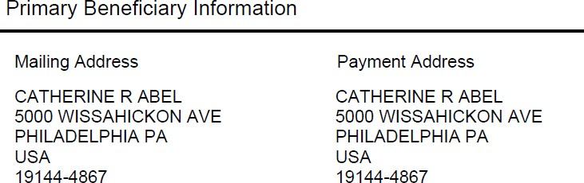

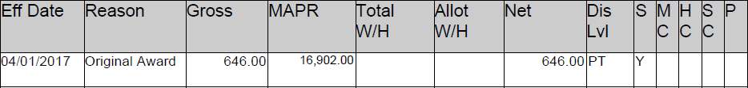

Dependents

|  |  |
| --- | --- |
| \Jame | DOB |
| Pat Abel | 01/01/1948 |