Appendix B

June 2024



PMC VSR Intermediate Core Course

P

hase 5: Proficiency Development

Part

5

:

Award Adjustments

**Determine**

**Qualifying**

**Expense Adjustments**

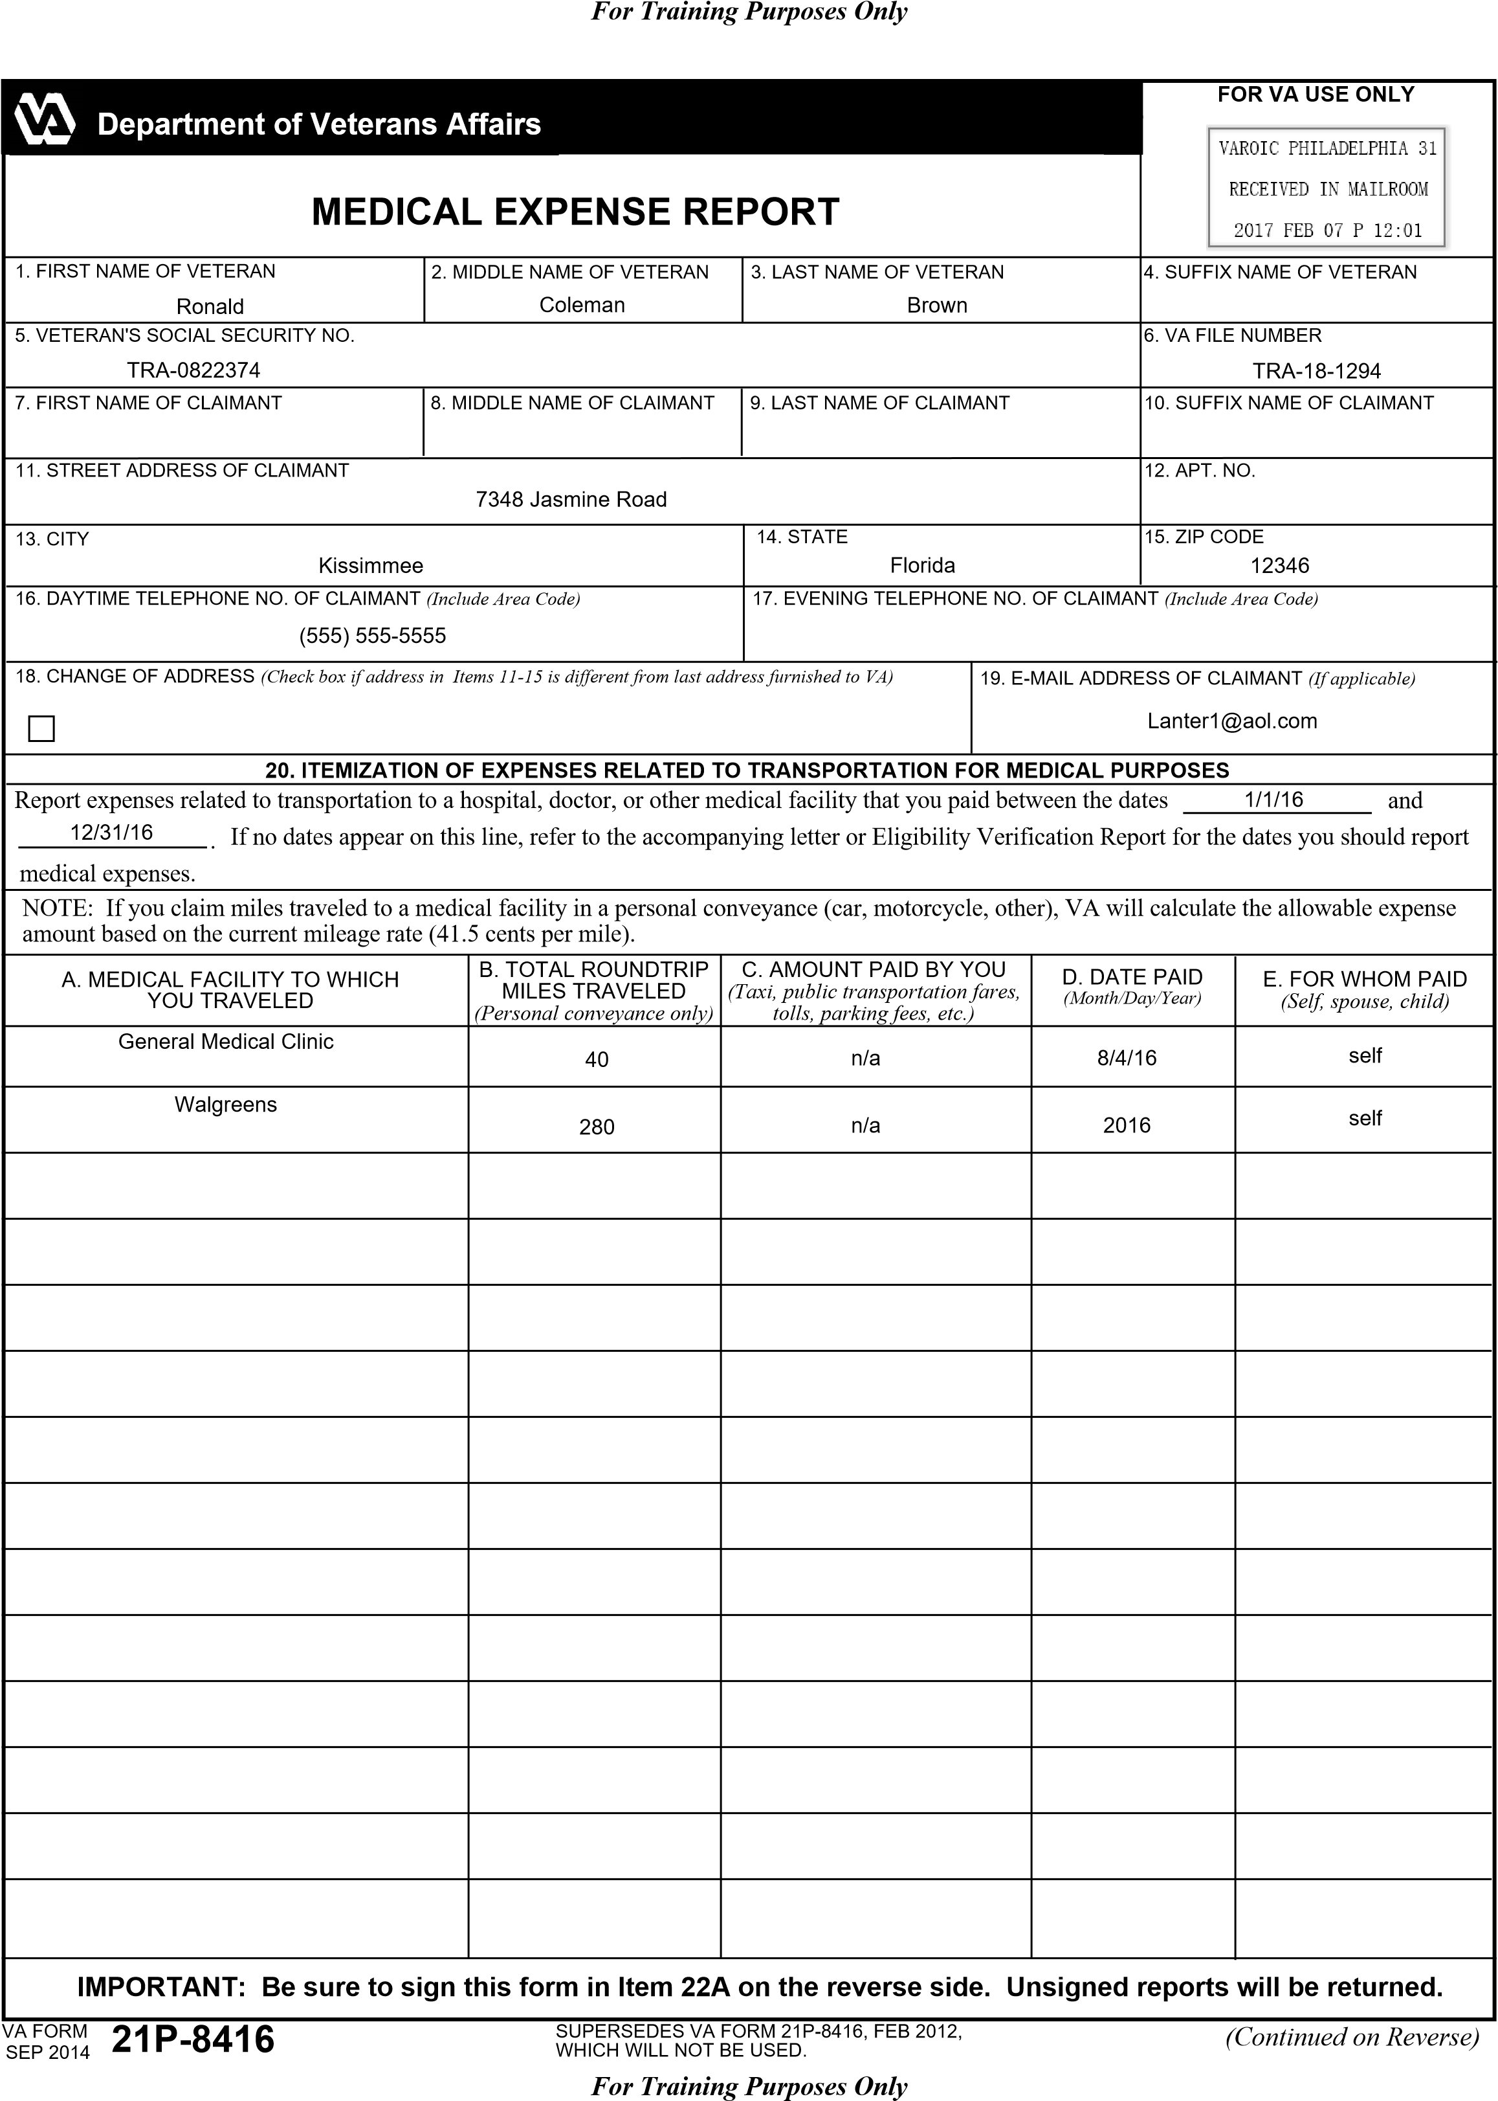

***For Training Purposes Only***

***For Training Purposes Only***

**21**

**.ITEMIZATION OF MEDICAL EXPENSES**

Report medical expenses that you paid between the dates

and

.

If no dates appear on this line, refer to

the accompanying letter or Eligibility Verification Report for the dates you should report medical expenses.

A.MEDICAL EXPENSE

*(*

*Physician or*

*Hospital Charges, Eyeglasses, Oxygen*

*Rental, Medical Insurance, etc.)*

B.AMOUNT PAID

BY YOU

C.DATE PAID

*)*

*(*

*Month/Day/Year*

D.NAME OF PROVIDER

*Name of doctor, dentist,*

*(*

*hospital, lab, etc.)*

E.FOR WHOM PAID

*)*

*Self, spouse, child*

*(*

MEDICARE (PART B)

MEDICARE (PART D)

PRIVATE MEDICAL INSURANCE

CERTIFICATION: I have not and will not receive reimbursement for these expenses. I certify that the above information is true.

22A. SIGNATURE OF CLAIMANT

*Do NOT print*

*(*

*)*

22B. DATE

PENALTY: The law provides severe penalties which include fine or imprisonment, or both, for the willful submission of any statement or evidence

of a material fact, knowing it is false, or fraudulent acceptance of any payment to which you are not entitled.

VA FORM 21P-8416, SEP 2014

1

16

/1/

16

12

/31/

104.90

monthly

Social Security

self

22.50

monthly

Social Security

self

234.00

monthly

Constitution Life

self

D

octor visit

30.00

8

/4/

16

General Medical Clinic

self

P

rescriptions

750.00

2016

Walgreens

self

V

itamins

1600.00

2016

Walgreens

self

*Ronald Coleman Brown*

0

2

/

01

/201

7