**Overview of Post Award Audit (PAA) Match**

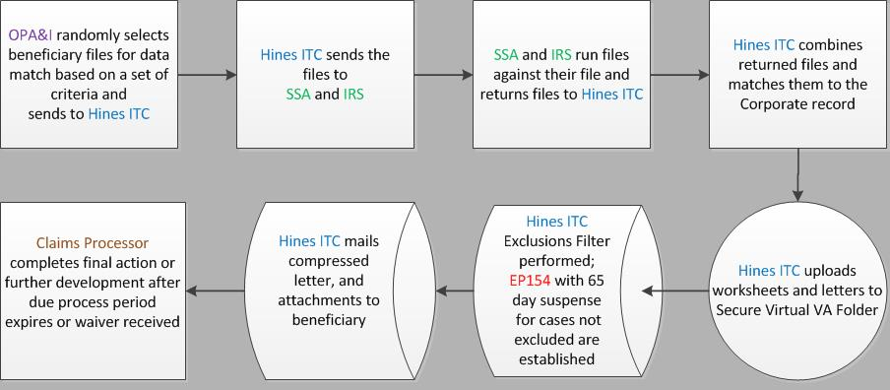

**OPA&I Automatic Exclusions**

OPA&I selects eligible beneficiary records to send to Hines ITC.  Prior to selecting records, OPA&I will automatically exclude records in which the beneficiary

* has a pending Federal tax information (FTI) eligible EP during the PAA match
* has had an FTI eligible EP claim established within two years from the date OPA&I selects records for a PAA match
* is receiving a payment of $90 due to Medicaid status as of the date of the PAA selection
* is greater than 90 years old as of the date of selection
* has a missing cost of living adjustment (COLA) line for the tax year of the requested match, or
* is deceased.

***Note***:  The first two bullets apply to EP series 180s and 190s only.

**Hines ITC Automatic Exclusions**

Prior to releasing PAAs to the PMCs, Hines ITC will exclude the matches in which

* the beneficiary is deceased
* the medical expenses of record exceed the higher of either the
  + total income of record in Corporate, or
  + total countable FTI
* the benefit was discontinued for the full calendar year matched
* the total income of record for the year matched in Corporate is greater than the total countable FTI
* the total income in Corporate for the matched year is $0 and the total countable FTI is $0
* the total countable FTI exceeds the income in Corporate, for the same year, by $100 or less, or
* the following three statements are true
  + value listed in the NET WORTH field in Corporate is $0
  + the total income reported on *1099-INT, Statement for Recipients of Interest Income,* is less than or equal to $100.00, and
  + the medical expenses of record exceed the greater of income in Corporate or total countable FTI.

***Exception***: Hines ITC will not exclude those cases identified for a substantial net worth discrepancy in which medical expenses exceed the greater income.

Reference: [M21-1, Part X, Chapter 9, Section E, Federal Tax Information (FTI) Match: Post Award Audit (PAA) for Pension and Parent’s Dependency and Indemnity Compensation (DIC) Beneficiaries.](https://vaww.compensation.pension.km.va.gov/system/templates/selfservice/va_ka/portal.html?encodedHash=%23!agent%2Fportal%2F554400000001034%2Farticle%2F554400000048702%2FM21-1-Part-X-Chapter-09-Section-E)

**Notification and Verification Requests**

Hines will produce and release the following letter types to the recipients:

* **Compressed Beneficiary Letter** 
  + The letter sent to the beneficiary is a compressed letter that combines the independent verification of the identified income and due process
  + Letter is released after an EP 154 is autocested
* **Attachment(s)**
  + For Pension and Parents’ DIC claims, when a letter is created and income is identified as having a source of net worth, attachments generate automatically with the letter
  + The list of attachments are located in the [Live Manual](https://vaww.compensation.pension.km.va.gov/system/templates/selfservice/va_ka/portal.html?encodedHash=%23agent%2Fportal%2F554400000001034%2Farticle%2F554400000048702%2FM21-1-Part-X-Chapter-09-Section-E)

**Note:** Claims processors must review the PAA worksheet and analyze the table in the [Live Manual](https://vaww.compensation.pension.km.va.gov/system/templates/selfservice/va_ka/portal.html?encodedHash=%23agent%2Fportal%2F554400000001034%2Farticle%2F554400000048702%2FM21-1-Part-X-Chapter-09-Section-E) to determine how long the income should be counted.In addition, spousal income should not be included on the beneficiary’s letter as this is prohibited by the IRS.

Hines ITC will generate a worksheet for all cases. The worksheet is uploaded to secure IRS/SSA folder in Virtual VA.


Letter example of the PAA Compressed Beneficiary Letter released by HINES ITC

Example of PAA Compressed Beneficiary Letter

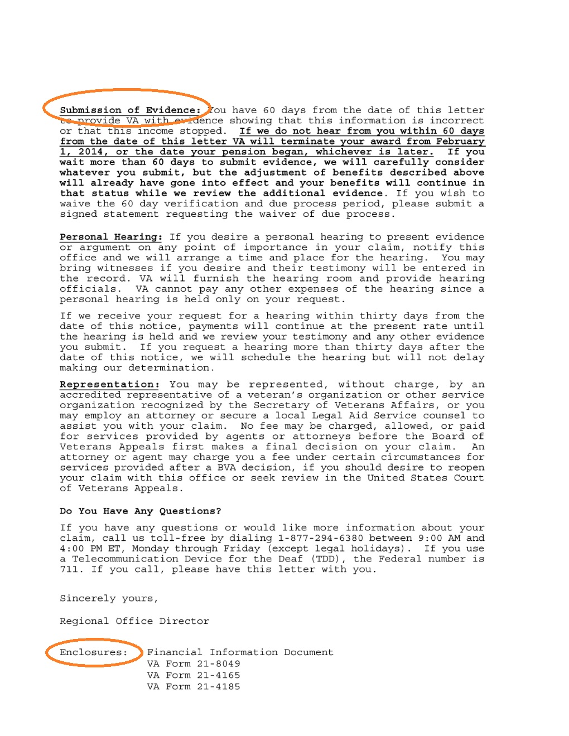Financial Information Page. 
Text reads that document contains Federal Tax Information.

Example of PAA Compressed Beneficiary Letter Cont’d

Example of PAA Compressed Beneficiary Letter Cont’d