Pension and fiduciary

PMC VSR Advanced Core Course   
Phase 5: Stages of a Claim   
Part 1: Determine Eligibility

VA Representation and Third Party Authorization

Appendix A

April 2020

VA Representation and Third Party Authorization

M21-1 Exercise

Answer the following questions.

1. What is the POA code for the Disabled American Veterans?

Manual Reference_______________________

1. True or False: a VSO can sign an original claim for VA benefits?

Manual Reference_______________________

1. A claimant can appoint a Veteran Service Organization (VSO) as their representative using what form?

Manual Reference_______________________

1. What form is used for VA to release information to an authorized third party?

Manual Reference_______________________

Practical Exercise

Review the following VA Forms and answer the questions for each form.

* + - 1. Is the VAF 21-22 or VAF 21-22a complete?
      2. Is the VSO authorized to review the claims folder?
      3. Is the VSO authorized to change the claimant’s address?

**VA Form 21-22 Example #1**

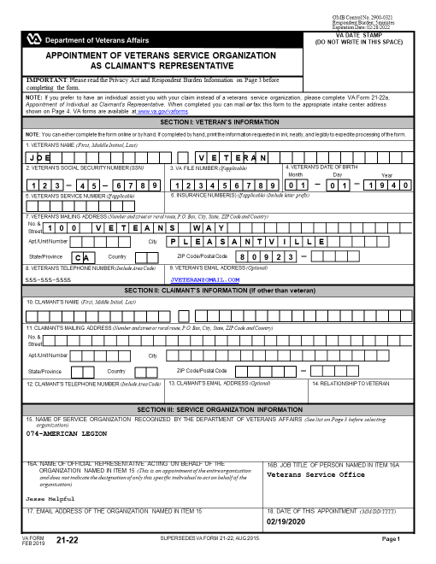

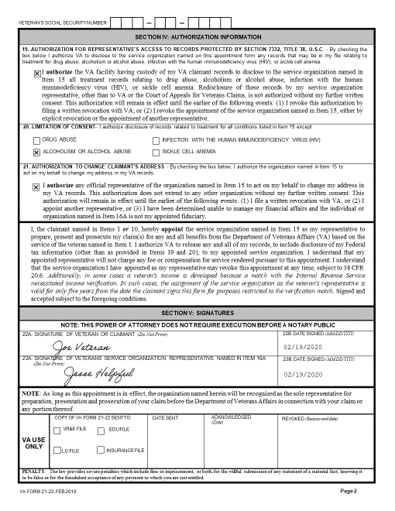

**VA Form 21-22 Example #2**



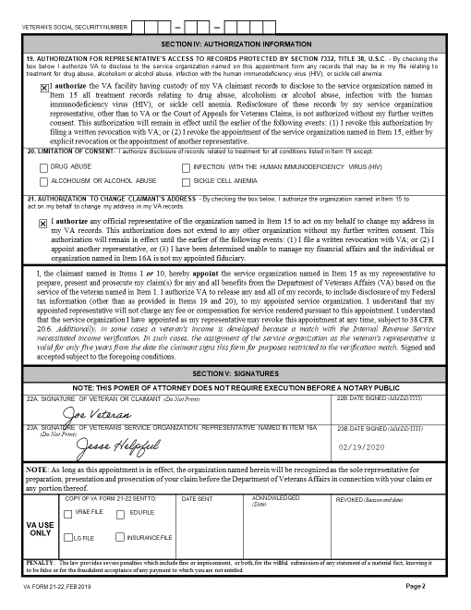

**VA Form 21-22 Example #3**



