Contents (jump to a subject by clicking below)

Objectives 2

What is SharePoint 2

Site Architecture 3

Team and Communication Pages 3

Anatomy of a Site 5

Modify the Home Page 6

Change Site Permissions 8

Explore the Site Settings 9

Create a Cusom List 10

Quantifying your Employee List Within SharePoint 13

Importing a Spreadsheet to Create a List 14

Collaborating in SharePoint 14

Additional Resources 15

## **Objectives**

After this course, you will be able to:

* Understand permissions
* Modify the homepage
* Create a custom list
* Collaborate in SharePoint
* Understand SharePoint integration with Teams

## **What is SharePoint**

SharePoint's primary reason for being is to serve as a place where things can be shared – and you can share all different kinds of files and information for several purposes. Here are some examples:

* **Pages** – Primarily contain text but you can embed images, links, and lists within. Pages can be used to share news or other stories with site members.
* **Document Libraries** – Allows you to upload and share documents. Document libraries support assigned permission levels and they allow you to check documents in and out for editing that includes version management.
* **SharePoint Lists** – Contains data organized like what you see in a table. Lists come in a variety of types, calendars, tasks, and surveys are all examples of different SharePoint lists.
* **Other libraries** – Example: an image library that may store your site assets for reference from pages you’ve created.
* **Websites** – May be nested within other sites. A group of sites is called a Site Collection.

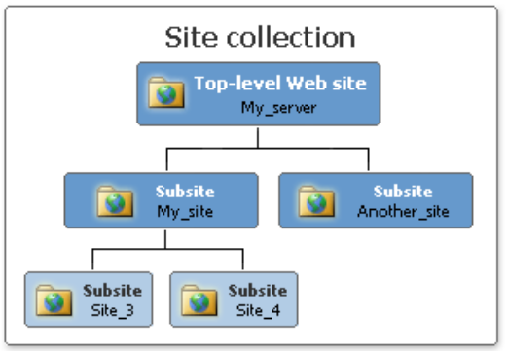

## **Site Architecture**

If a site is not well organized and simple - people will be confused and less likely to adopt the site as a resource. This makes site architecture very important.

* If an area has too many links or feels too busy, then continue to simplify
* Assess who your end user is and how they are likely to interact with the site
* Maintain a consistent aesthetic throughout the site
* Ensure that it’s easy for the user to navigate through the site and return to important pages quickly (i.e. both the quick launch pane and top link bar are very useful for this purpose)

## **Team and Communication Pages**

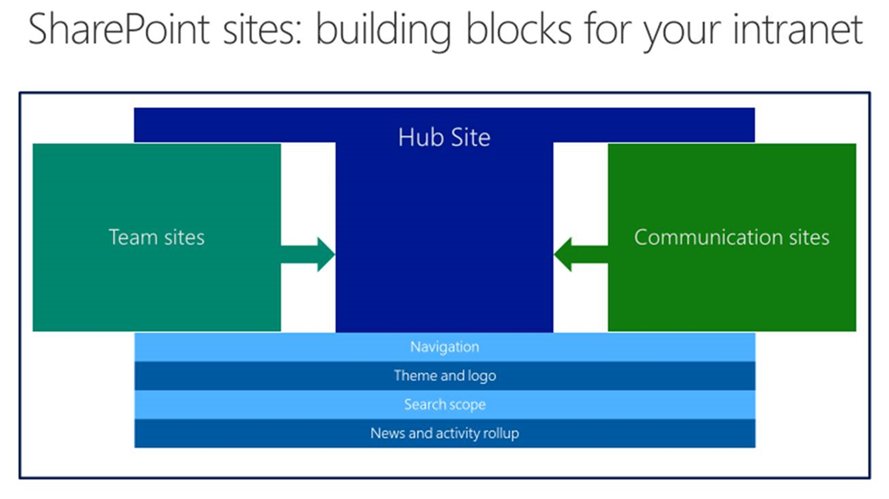

SharePoint hub sites can be associated with many different sites, not just subsites. SharePoint now lets you link to other pages as well. This helps you to manage growth over time, giving you flexibility to expand when you need to. Hub sites give you:

* **Shared navigation and brand** – so things look consistent wherever you are
* **Roll-up of content and search** – allowing you to search within the site first, and expand if needed
* **A home destination for the hub** – giving you a centralized point to work from and share information

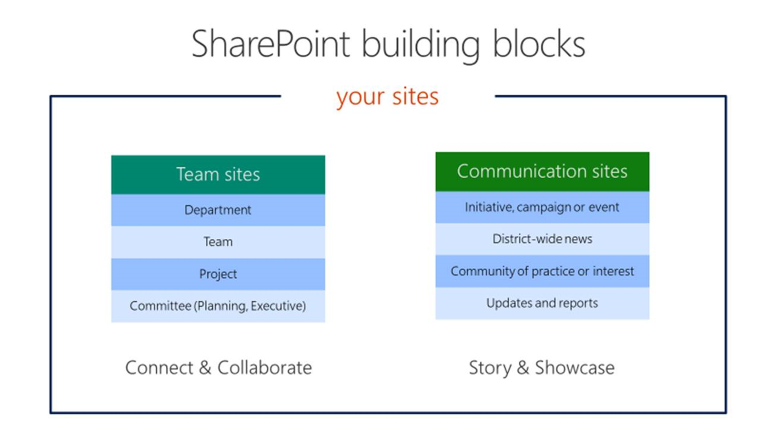

Team sites and communication sites are the building blocks of your site in the modern experience. A Team site is associated with a Group. Team sites are used for two-way communication. If you are collaborating on a project, working on live documents, or any project that is still in process, you’ll want a Team site.

Communication sites are for one-way communication. These are for finalized projects, static documents like finalized SOPs, any document where collaboration is no longer needed.

Team sites and communication sites are similar in appearance and functionality. Meaning for the most part, you will use the same steps to update one as you would use in the other. The primary difference is a team site is connected to a group, and a communication site is not. Therefore, permissions for the sites are handled differently.

## **Anatomy of a Site**

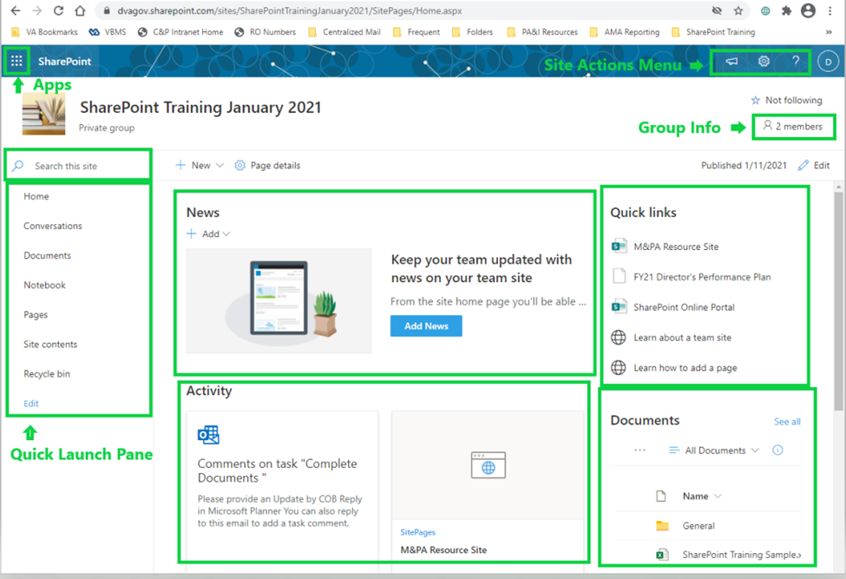

From the default format of the Quick Launch Pane (also called Site Navigation) you can access:

* **Home** page, shown above.
* **Conversations** will launch Outlook Online.
* **Documents**, a library of documents for Group use.
* **Pages** will show links for any pages within the SharePoint site.
* **Site contents** will show all folders including ones not listed on the Pages site
* **Recycle bin** temporarily hold any pages or documents after being deleted. This will automatically empty after a few days, so it should only be used for short term retrieval.

The center panel defaults will display the following panes:

* **News**: A central point to include recent information relevant to the Group.
* **Activity**: Shows recent actions on the site such as additions to the page.
* **Documents**: Shows another view of items on the documents tab we saw in Site Navigation.
* **Quick Links**: A place to centralize frequently used links, including links from unassociated sites. This is the section that allows a Home Page to be used like a Hub site.

Central panels can be added, removed, or customized as needed.

## **Modify the Home Page**

Communication sites (SharePoint sites separate from a Team) may be established by submitting a [Web Request](https://vaww.va.gov/webrequest). However, creating a Team in Teams will also create a modern experience SharePoint Team site. To open a site created in Teams, select **File > Open in SharePoint**.

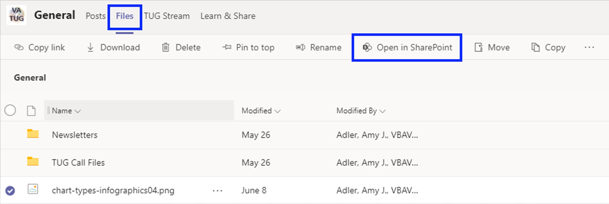

Opening the site from Teams will land on the Documents Library, from there you can navigate to the Home page using the Quick Launch Pane.

1. To edit the panes displayed in the central panel on the Home page, select the pencil icon on the right-hand side of the screen. This will open the editor.

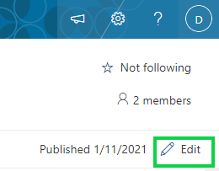

1. In the editor, toolbars are visible for the full panel section (highlighted on the left), and individual panes (highlighted on the right). The “**+**” icon is used to add additional sections to the panel.

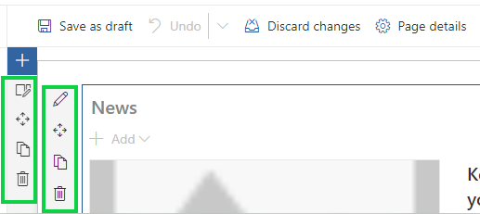

1. Section layouts can be changed using the panel icon, and panel contents can be edited using the pencil icon.
2. The main panel and smaller panes can be moved using the arrow icon, copied or deleted.

You can change the site header and color scheme of the SharePoint site by selecting the gear icon at the top right and selecting **Change the look***.*  From here, you can select color schemes in the **Theme** menu and the site logo can be updated using the **Header** menu

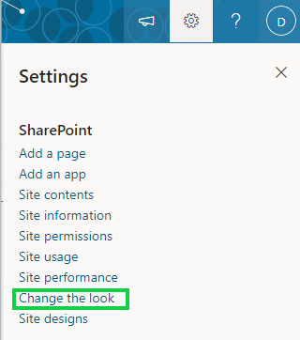

Additional formatting options are available within **Site Settings**.

## **Change Site Permissions**

To add users to the Microsoft 365 Group, which includes access in Teams, Outlook and OneNote, select the **members** icon and then select **Add members.**

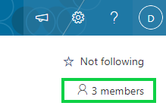

To update or add a user to the SharePoint site *only*, for example when updating permissions for a Communication page, use the gear icon to open **Settings**, and then select **Site Permissions.**

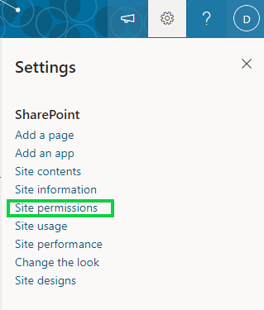

Selecting the **Invite Button** will allow users to add individuals to that permission level.

Below this section, you’ll find the **Advanced Permissions and Sharing** link. This menu allows site owners to update the Permission Levels associated with each group type, or update permissions for individual users if needed. Establishing and editing individual user permissions is not recommended. To save time establishing set permission levels on a group, and then adding users to that group is considered a best practice.

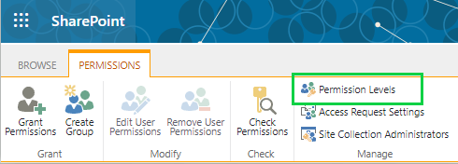

## **Explore the Site Settings**

**Site Settings** is the primary control center for a site and includes many tools for updating and monitoring the health of your site. Some of the highlights include:

1. **Look and Feel**
   1. Select **Quick launch** to add, remove or change the order of options displayed in the Quick Launch Pane
   2. Select **Change the look** to modify the colors for your site.
2. **Site Actions**
   1. **Manage site features** allows you to add or remove apps from the site

The following menu is located at **Site Contents > Site Settings:**

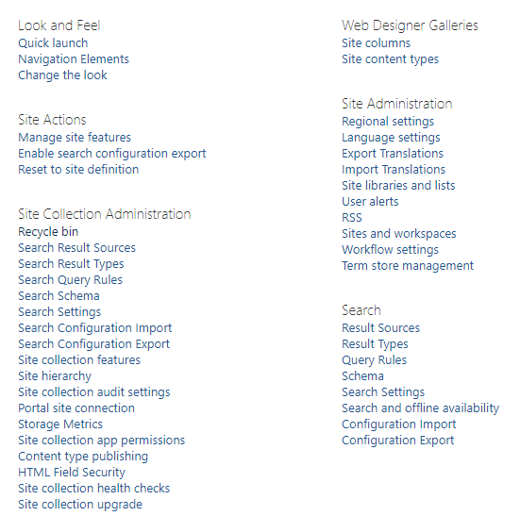

## **Create a Cusom List**

To create a custom list, use the following steps.

1. From your **New** menu, select **List**

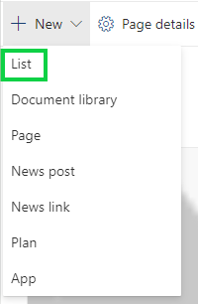

1. Select **Blank List**

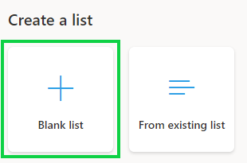

1. Enter the name *Employee Contact List* and click **Create**.
2. SharePoint will default to one column. To change the column name from Title to something more descriptive, rename the default column, by selecting the dropdown by **Title** and select **Column Settings** > **Rename** then change the name to *Employee Short Name*
3. Select **+ Add Column** and select **Person**

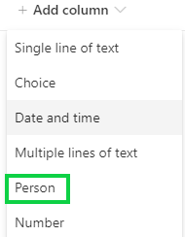

1. In the **Name** field, type *Employee Name* and select the **Person or Group** from the **Type** dropdown. Select **More options** and **Enforce unique values**, this prevents duplicative information. You can choose from an existing SharePoint group by selecting **Allow selection of Groups**.

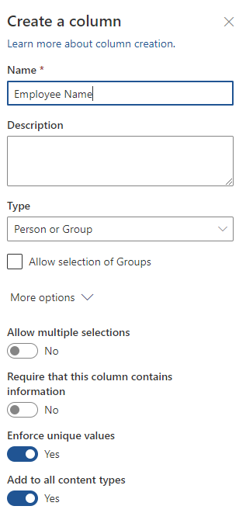

1. Select **+ Add Column** and select **More…** This will open a menu with additional options.

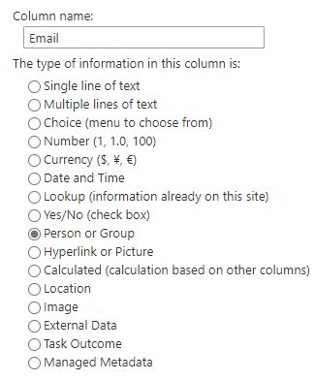 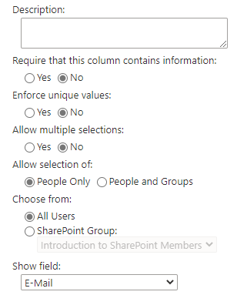

1. Name the column *Email* and then select **Person or Group** and then select *Work email* from the **Show field** dropdown.

*This automatically populates the phone number from in the GAL.*

1. The last column for this list will indicate where the person sits in the building. To keep the results consistent, limit the options users are allowed enter.
2. Create column named *Location* and select the Choice type. Make it a required column and type the following choices, each on a separate line:

Team 1

Team 2

Team 3

Telework-No Desk

1. Delete the **Default value** from the text box at the bottom so it is blank (It is automatically set to the first value).

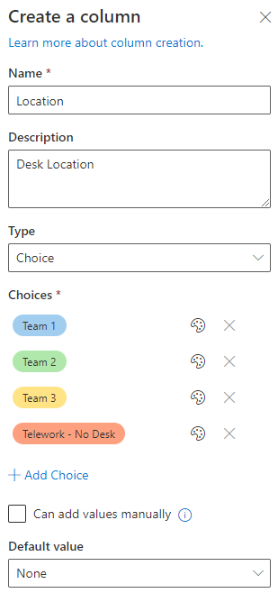

You can add a default value; however, then you can’t determine if the user changed the column or not. Remember that you’re requiring the field and if it’s pre-populated, that rule will be satisfied regardless of what the user does.

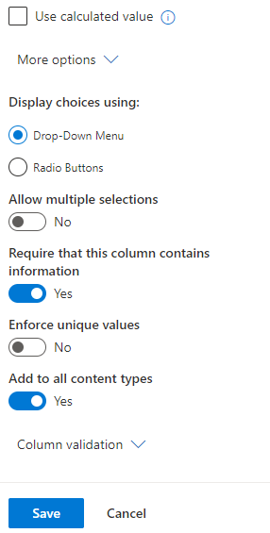

1. You can re-order the columns by selecting the column header, and dragging it to the new location.

Adding items:

1. Select **New** and let’s fill in the fields.
2. Add yourself to test the fields (for phone number and email, enter your name again and click save)
3. Notice at the bottom of the panel you can attach a file as well.
4. Click Save.
5. If you go next to **New** and click on **Edit in grid view**, this makes it very easy to edit multiple records in one view. This is also called a datasheet view.

## **Quantifying your Employee List Within SharePoint**

1. You can use the dropdowns to create groups within the category by selecting **Group by (column name)**. From there, you can select **Totals,** andSharePoint will display totals for each category.
2. If this is information you will need regularly, you can save the view by going to the **All Items** on the right-hand side of the screen, and select **Save view as.**

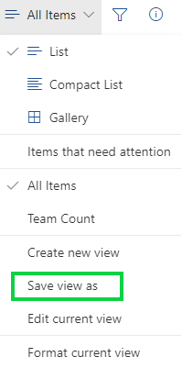

1. To share your view via email in a user-friendly link, select **Share** from the list ribbon, then add the email address of the users the email should go to**.**
2. To create an alert so you are notified of any changes to the list, select **Alert Me**.

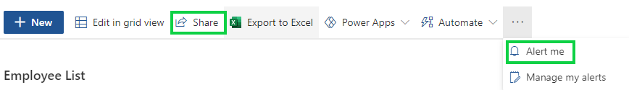

## **Importing a Spreadsheet to Create a List**

If you would like to import data from an Excel file, you may do so by first formatting the Excel data into a table. Information on creating and tables is available on the [Microsoft Support](https://support.microsoft.com/en-us/office/create-and-format-tables-e81aa349-b006-4f8a-9806-5af9df0ac664) page.

1. Select **Settings** using the gear icon and select **Add an app**.
2. Use the search function to locate the **Import Spreadsheet** app.

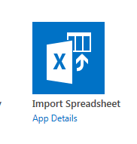

1. Name your list and Browse to select the spreadsheet you would like to import.

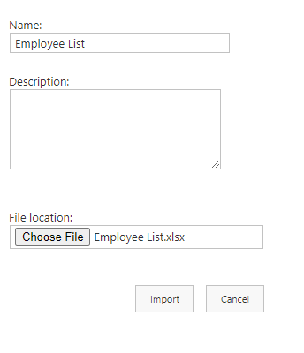

1. Your Excel list will now be imported into SharePoint.

## **Collaborating in SharePoint**

SharePoint now allows multiple users with editing permissions to update a single document at the same time. This prevents the creation of multiple versions of the same document.

Co-authoring is only supported on modern file formats including: .docx (Word), .pptx (PowerPoint), and .xlsx (Excel).

SharePoint retains version history, so users can see who made changes and when.

## **Additional Resources**

Training Courses for SharePoint provided by Microsoft

<https://support.microsoft.com/en-us/office/sharepoint-video-training-cb8ef501-84db-4427-ac77-ec2009fb8e23>

<https://docs.microsoft.com/en-us/sharepoint/introduction>

SharePoint Community of Practice & SharePoint Online Portal

[https://teams.microsoft.com/l/channel](https://teams.microsoft.com/l/channel%20)

<https://dvagov.sharepoint.com/sites/spo/SitePages/Home.>[aspx](https://dvagov.sharepoint.com/sites/spo/SitePages/Home.aspx)

To request a new site or link an existing site to a Group

<https://vaww.va.gov/webrequest>

Information about VA SharePoint Online Governance:

<https://dvagov.sharepoint.com/sites/spo/Governance/Forms/AllItems.aspx>

Provided by the Office of Performance Analysis & Integrity (PA&I)

If you find corrections are needed, [please email us](mailto:PACATSTEAM.VBAVACO@va.gov).

Last updated: 6/15/2021