**Procedure for using Single Sign-On in Adobe Captivate Prime**

Adobe Captivate Prime has moved to **Single Sign-On (SSO)**. There are two ways to access Prime, by using your PIV Card for most users or if you are an external user, your directions will be provided in separate correspondence. The following steps will guide you through the Single Sign-On process for Adobe Captivate Prime.

1. Click <https://captivateprime.adobe.com/USDepartmentofVeteransAffairs4> (Production site). It is recommended to use Chrome as your browser.
2. Click **Sign In with VA PIV Card**.

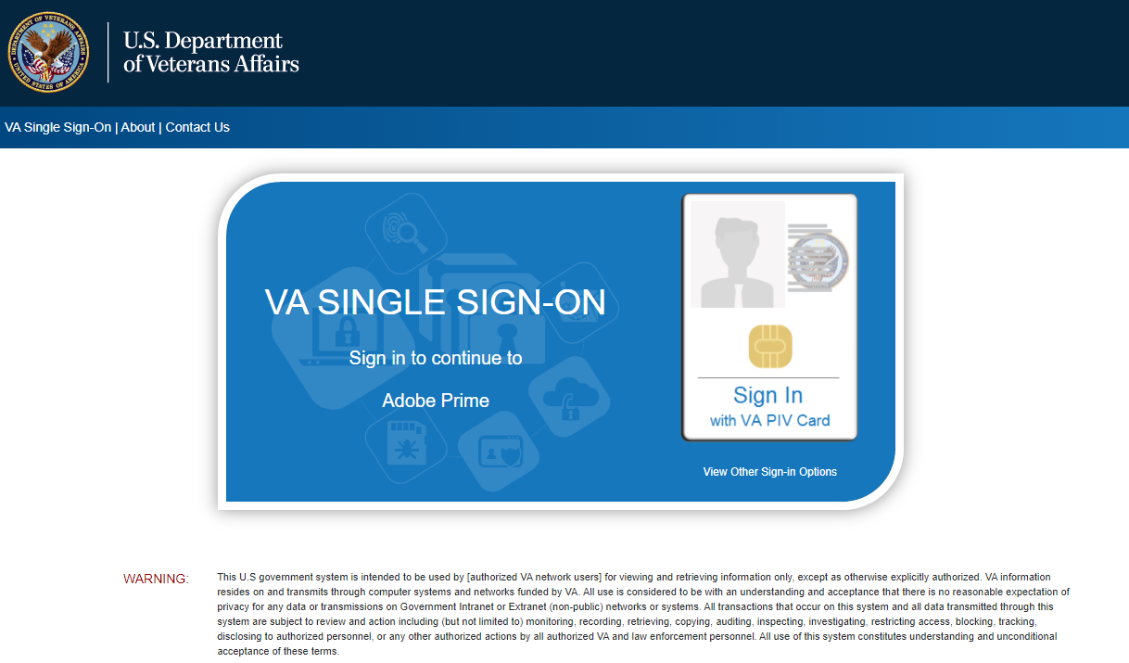

1. Click the appropriate certificate.

**Note**: this screen might not display to all users. If not, skip to step 5.

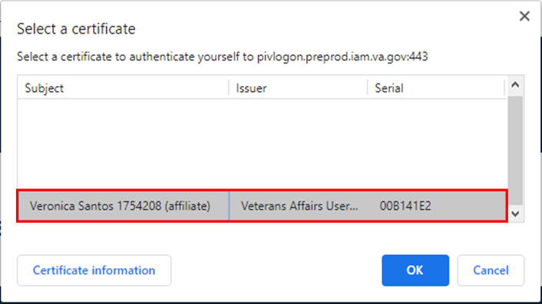

1. Click **Ok**.
2. The **ActivClient** Login page displays.

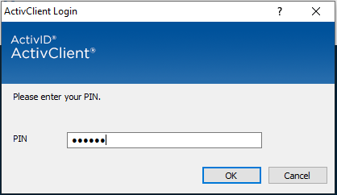

1. Enter your PIV Card **PIN.**
2. Click **OK.**

The **Adobe Captivate Prime Learner’s** page displays.

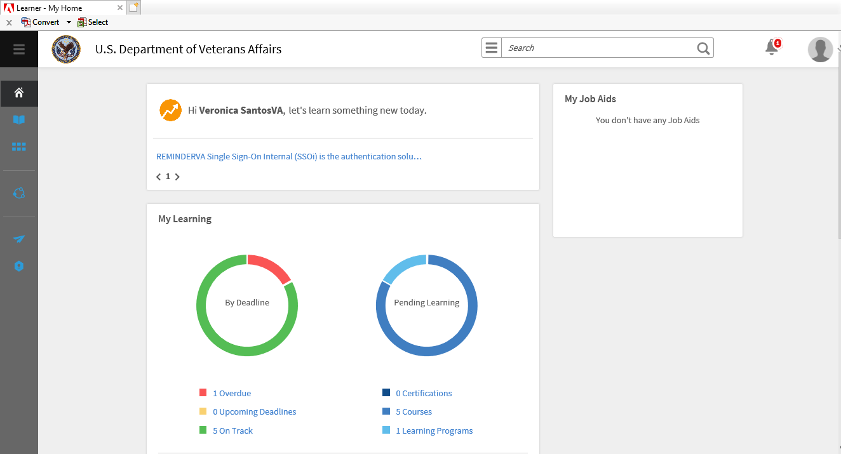

*If you require any additional assistance, please contact:* [VBAADOBEHELP.VBACO@va.gov](mailto:VBAADOBEHELP.VBACO@va.gov)