FMS Reports

RSD
FMS
CAATS

Rogers Software Development Instructions

Tutorial on Rogers Software Development System
Online. Mirco Focus version, and CAATS

Online Version:

- Click on this link: https://aacmf.aac.va.gov/eos/cgi-bin/logeoshome.cgi

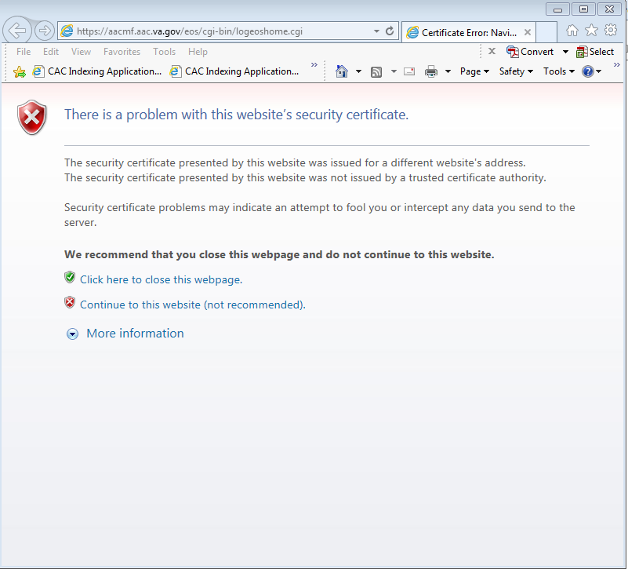

- Next, log on using the FMS username and password

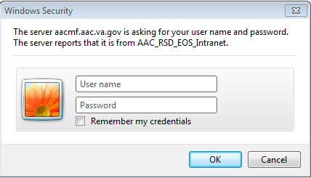

- Select E3 – FINANCIAL & DOORS REPORTS – PAID and click “Logon to EOS”

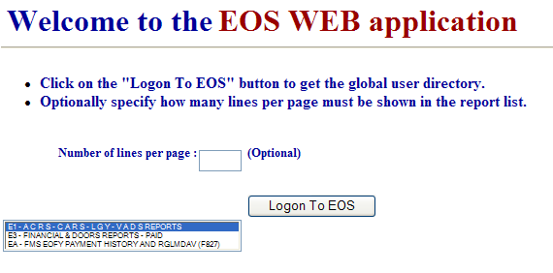

- Select the folder with the reports with F then the station number (ex. F3XX), the other folders have reports for use by other divisions

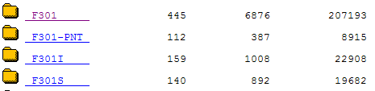

- The reports are listed in date order, some reports are available longer than others, but most of the he daily and monthly reports are kept for 30 to 45 days. To view a report click on the blue hyperlink under “Report Name”. The Categories are:
  - Form S – Form Number
  - Report Description – Title of report
  - Pg – Number of Pages in report
  - Date – Date and time of report

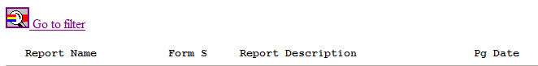

- To view a particular report, select “Go to Filter” and enter the Form Name and submit. Note: Form Name must be in capital letters, example F20D

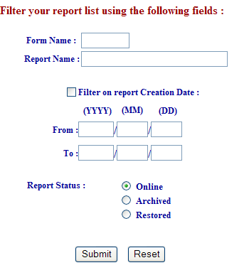

- To view reports properly:
  - Select Text size as Smallest
  - For Number of pages, enter the number of pages of the report selected and click submit

- To print the report:
  - Open Page Setup and select Landscape
  - Under Select Printer, choose printer that will be used
  - At Page Range
    - Select All to print entire report
    - Select Selection to print highlighted portion
  - Click Print

MICRO FOCUS Version:

- Click on Start, Communications and locate the MICRO FOCUS version (same as FMS)

- Enter RSD in the SELECTION section and enter the same FMS login in the USERID and PASSWORD section
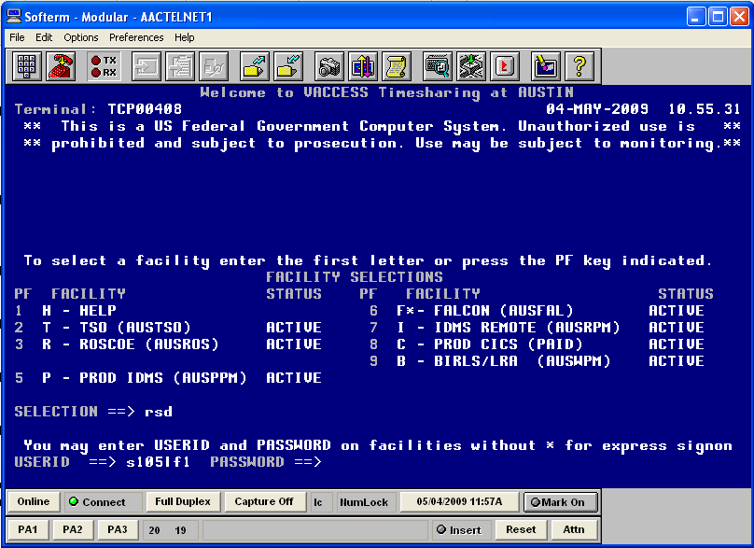

- Select E3 for FINANCIAL & DOORS REPORTS – PAID
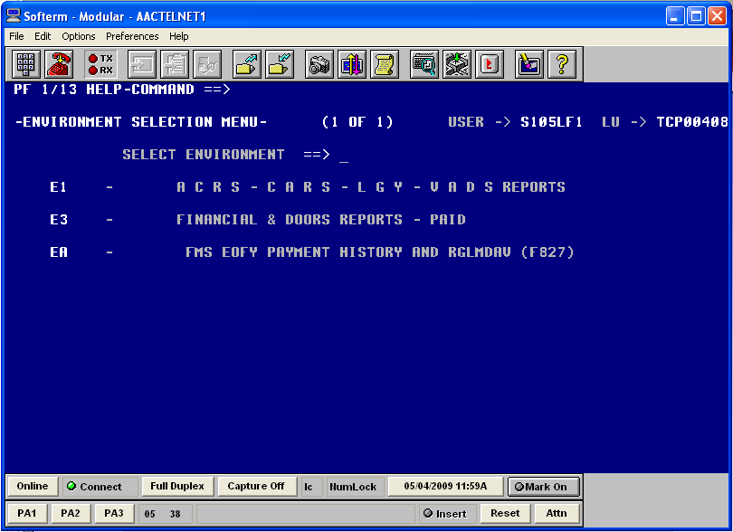

- To move throughout the system, select F7 to move up, F8 to move down, and F3 to go to the previous screen
- Under USERNAME locate the station with F3XX

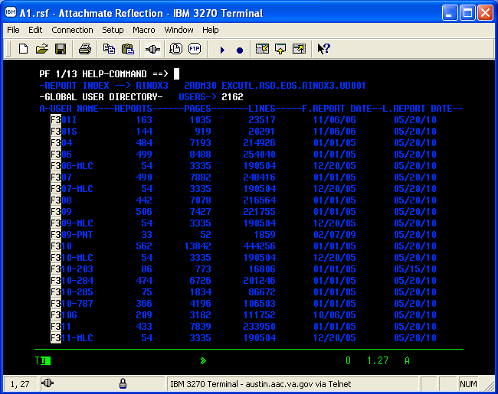

- Under the A, enter B for batch. This will show the list of reports
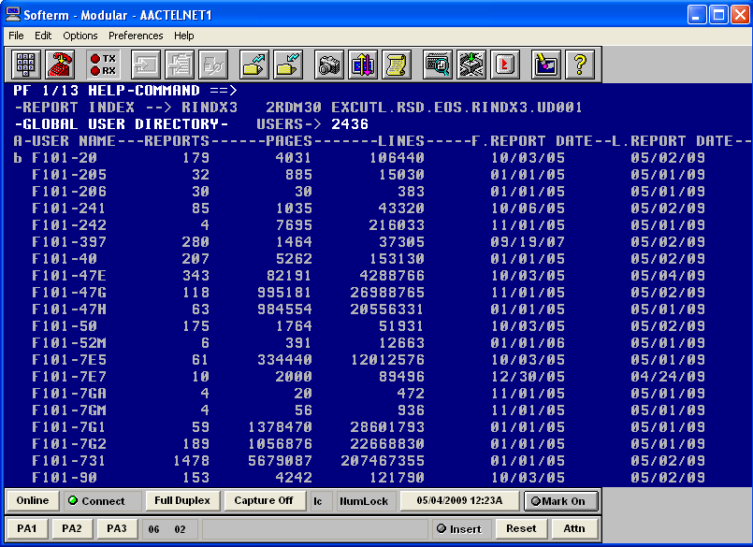

- To look at an RSD report, tab down to the report and enter S to scan the report
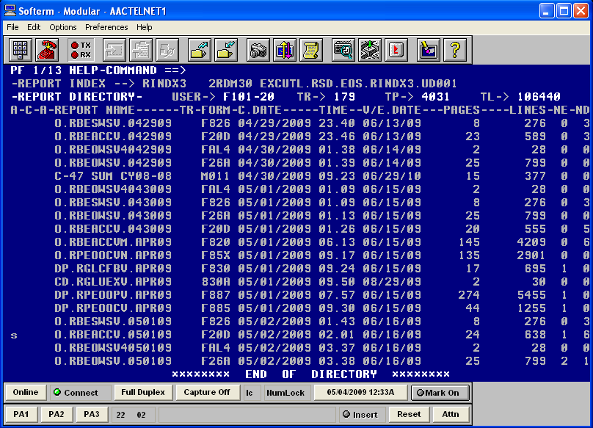

- Report in RSD
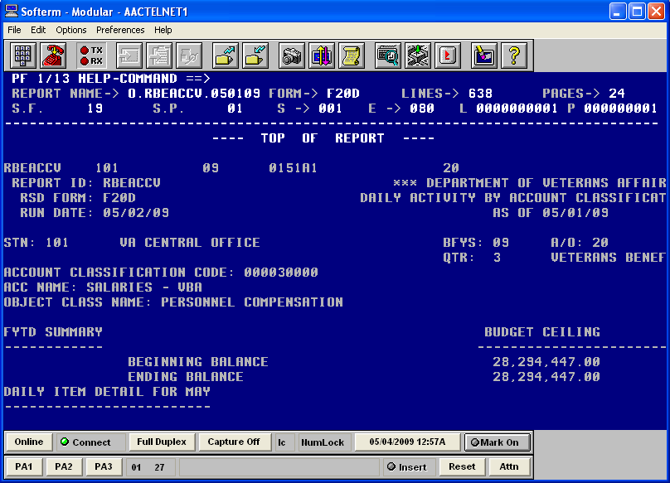

- To print the report, enter E under the first A to extract the report (similar to the S to scan)

- Next change the P to L to select a local printer
- Enter the printer name in the “Local Printer ID” section, this is the printer the report will be sent
- In the “From/To Lines” enter P and page number for the first page, tab to the next line and enter P and page number for the last page to be printed
  - Note: To be sure the correct page(s) is (are) printed, select a page before and after. Example; to print page 5, select P4 and P6
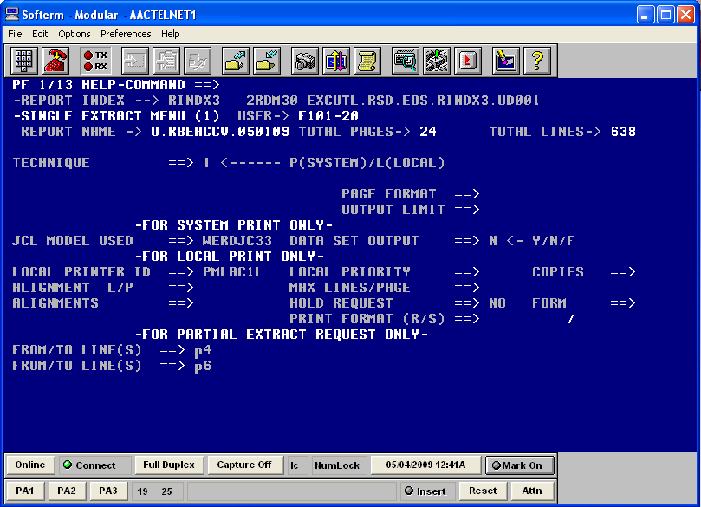

- Enter Y for Yes and confirm printing
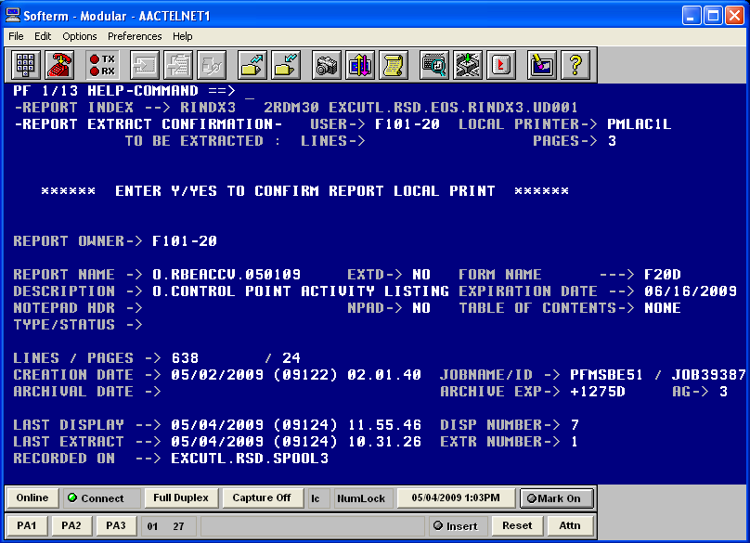

- Document has been printed, hit enter and return to the report listing
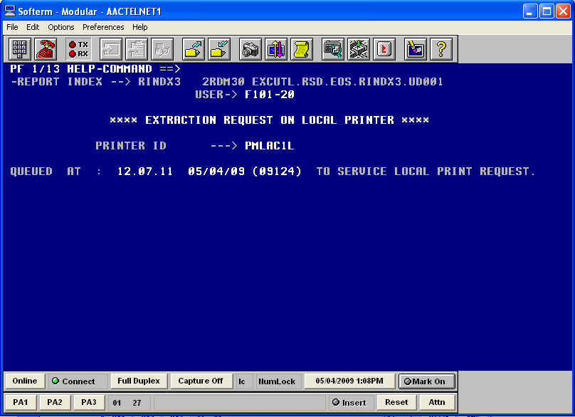

CAATS Reports

The Reports module has two different types of reports (1) FMS Reports and (2) Internal Reports. There are currently a total of 24 reports.

FMS Reports

There are 13 FMS reports. These reports are received daily from an extract file from FMS. The reports are for the previous day activity and can be printed.

Report Name | Report Number in RSD | Report ID in RSD | Frequency | Comments
Advances (Federal & Non-Federal) | F 855 | RAPVGLVM | Daily
Unapplied Deposits | F 856 | RGSUDVV | Daily
Obligations | F 850 | RPEDUO2M | Daily
Payables | F 851 | RPEVGLVM | Daily
Receivables | F 853 | RARVGLVM | Daily
Allowances | F 826 | RBESWSV | Daily
Object Class by Allowances | F 26A | RBEOWSV | Daily
Daily Activity | F 20D | RBEACCV | Daily | Link only to Web RSD
Accepted Documents | F 829 | RGSADLV | Daily
Rejected Documents | F 97D | RGSGDPV2 | Daily
Fixed Assets | F852 | RFAVGLV | Daily
Travel Advance | F854 | RTAVGLV | Daily
Budget Object Report | F885
Open Balance | 889B | RGSAPTVB | Daily

Once the user selects the report the sub-module of the report will open. The following screen will be displayed.
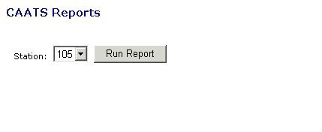

If you have access to multiple stations, select the station and the select the RUN REPORT button

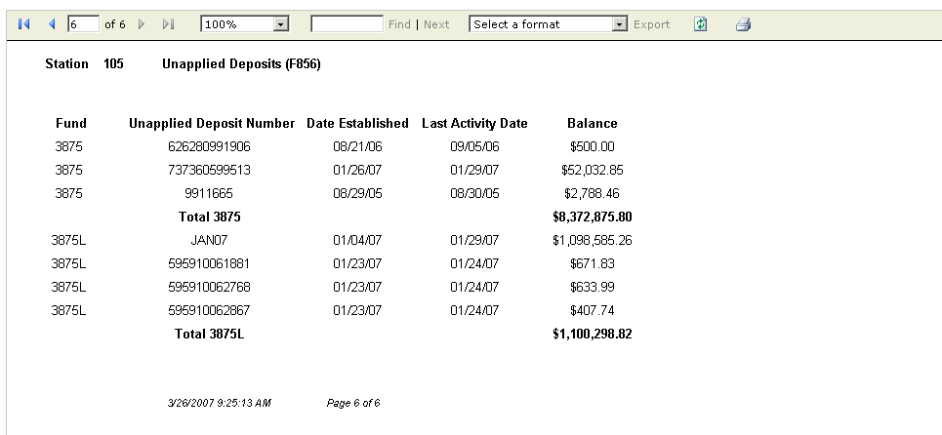

Not all reports were available for this version. The F26A and the F20D when selected will take you to the following screen. This will allow you to log into Web RSD to see those reports. The User Name and Password are the same as those you would use in FMS/RSD

