VBA Agent Cashier

Virtual Instructor-Led Training

Participant Guide

 

This page intentionally left blank.

VBA Agent Cashier

VALU VILT Participant Guide

Table of Contents

1.0 About This Training 1

1.1 Training Purpose 1

1.2 Learning Environment 1

2.0 How to Use this Participant Guide 1

2.1 Icon Legend 1

3.0 Course Overview 2

3.1 Course Description 2

3.2 Target Audience 2

3.3 Learning Objectives 2

3.3.1 Web-Based training 2

3.3.2 Instructor-Led Training 3

4.0 Course Schedule 4

4.1 Web-Based Training 4

4.2 Virtual Instructor-Led Training 4

5.0 Course Preparation 5

5.1 Technology Requirements 5

5.1.1 General Equipment/Software Specifications 5

5.2 Participant Preparation 5

5.2.1 Day of the Session 5

6.0 Course Content 6

6.1 Session 1 6

Slide 1 6

Slide 2 7

Slide 3 7

Slide 4 8

Slide 5 9

Slide 6 10

Slide 7 11

Slide 8 12

Slide 9 13

Slide 10 14

Slide 11 15

Slide 12 16

Slide 13 17

Slide 14 18

Slide 15 19

Slide 16 20

Slide 17 21

Slide 18 22

Slide 19 23

Slide 20 24

Slide 21 24

6.2 Session 2 25

Slide 22 25

Slide 23 25

Slide 24 26

Slide 25 27

Slide 26 28

Slide 27 29

Slide 28 30

Slide 29 31

Slide 30 32

Slide 31 33

Slide 32 34

Slide 33 35

Slide 34 36

Slide 35 37

Slide 36 38

Slide 37 39

Slide 38 40

Slide 39 41

Slide 40 42

Slide 41 43

Slide 42 44

Slide 43 44

6.3 Session 3 45

Slide 44 45

Slide 45 45

Slide 46 46

Slide 47 47

Slide 48 48

Slide 49 49

Slide 50 50

Slide 51 51

Slide 52 52

Slide 53 53

Slide 54 54

Slide 55 55

Slide 56 56

Slide 57 57

Slide 58 58

Slide 59 59

Slide 60 60

Slide 61 61

Slide 62 62

Slide 63 63

Slide 64 64

Slide 65 65

Slide 66 66

Slide 67 67

Slide 68 68

Slide 69 69

Slide 70 70

Slide 71 71

Slide 72 72

Slide 73 73

Slide 74 74

Slide 75 74

List of Tables

Table 1: Acronyms vi

Table 2: Icon Legend 1

**Acronyms**

Table : Acronyms

| **Term** | **Defined** |
| --- | --- |
| **AC** | Agent Cashier |
| **ACA** | Agent Cashier Accountability |
| **ALC** | Agency Location Code |
| **BDN** | Benefits Delivery Network |
| **CAATS** | Centralized Administrative Accounting Transaction System |
| **CAROLS** | Centralized Account Receivable On-Line System |
| **C&P** | Compensation and Pension |
| **DMC** | Debt Management Center |
| **FAS** | Finance and Accounting System |
| **FOIA** | Freedom of Information Act |
| **FSR** | Field Service Receipts |
| **MQAS** | Management Quality Assurance Services |
| **OMB** | Office of Management and Budget |
| **ORM** | Office of Resource Management |
| **OTCnet** | Over-the-Counter Channel Application |
| **RO** | Regional Office |
| **VA** | Department of Veterans Affairs |
| **VBA** | Veterans Benefits Administration |
| **VR&E** | Vocational Rehabilitation & Education |

# About This Training

## Training Purpose

The purpose of this VBA Agent Cashier course is to provide participants with the opportunities, tools, resources, and assistance necessary to succeed in the role of Agent Cashier.

The participants in the course will be Agent Cashiers who have been working for two or more years in this field. With this training, participants will be able to gain knowledge and critical thinking skills for assessing real-life scenarios and situations.

## Learning Environment

This course will be presented online via a virtual classroom environment. The course is facilitated by an instructor and a producer. The instructor serves as the host and the producer assists and facilitates the online sessions. The producer also provides technical assistance to participants, as needed. Instructors and producers work together to deliver the course.

You will need a computer with speakers, a microphone, and an internet connection to participate in the training.

# How to Use this Participant Guide

This Participant Guide contains all key content presented in this training, including PowerPoint® slides, activities, and demonstrations. Space is provided for taking notes.

It is highly recommended that you print a hardcopy of this Participant Guide for use during the training. It will be difficult to follow this guide online during the class sessions, especially if you have only one computer monitor.

Icons are displayed on slides as visual cues or indicators of an associated activity. Table 2 presents the icons used in this course.

## Icon Legend

Table : Icon Legend

| **Icon** | **The participants will:** |
| --- | --- |
| Icon of gears on a monitor screen | View a demonstration conducted by the instructor. |
| Icon of a maze with the correct path highlighted | Complete an activity. |
| Icon of the silhouettes of people | Engage in a group discussion. |
| Icon of a hammer hitting ice | Engage in an icebreaker activity. |
| Icon of a movie frame with a play button | Watch a video. |
| Icon of a checkbox with a checkmark in it | Answer progression checks or polling questions. |
| Icon of a silhouette of a speaker standing behind a podium | Listen to/view a guest speaker. |
| Icon of the silhouette of a head with a question mark inside | Ask the instructor questions, if applicable. |
| Icon of an hour glass | Take a break. |

# Course Overview

The following information presents an overview of the course structure of the VBA Agent Cashier course.

## Course Description

The course content educates VBA employees (Agent Cashiers) about the various types of programs used by Agent Cashiers, as well as real-life scenarios and situations that may occur on the job.

## Target Audience

The VBA Agent Cashier course targets VBA employees who have two to three years of experience as Agent Cashiers.

## Learning Objectives

### Web-Based training

After successful completion of the VBA Agent Cashier course, the participants will be able to:

**Identify the computer systems and programs that are used for VBA agent cashier**

* Explain the purpose and functions of Share
* Explain the purpose and functions of BDN
* Explain the purpose and functions of FAS
* Explain the purpose and functions of CAROLS
* Explain the purpose of OTCnet

**Identify the policies and procedures that agent cashiers must follow**

* List the policies and procedures that apply to agent cashiers
* Identify the major business processes for agent cashier activity
* Identify the guiding policies and principles for transfer of accountability
* Identify the guiding policies and principles for Separation of Duty

**Identify the transaction process followed by an agent cashier**

* Identify different types of incoming checks
* Identify how to deposit other forms of payment

### Instructor-Led Training

After successful completion of the VBA Agent Cashier course, the participants will be able to:

**Identify the computer systems and programs that are used by VBA Agent Cashiers.**

* Demonstrate Agent Cashier job responsibilities for SHARE, given case-based scenarios
* Demonstrate Agent Cashier job responsibilities for BDN, given case-based scenarios
* Demonstrate Agent Cashier job responsibilities for FAS, given case-based scenarios
* Demonstrate Agent Cashier job responsibilities for CAROLS, given case-based scenarios
* Demonstrate Agent Cashier job responsibilities for OTCnet, given case-based scenarios

**Identify the proper protocol and security procedures.**

* Apply the proper procedures to complete FMS form 2958 correctly, given case-based scenarios
* Analyze the purpose and common errors of form VAF-0901, given case-based scenarios
* Analyze the purpose of internal audits, given case-based scenarios
* Analyze the purpose of Agent Cashier internal controls and security, given case-based scenarios

**Identify the transaction process followed by Agent Cashiers.**

* Identify how to deposit various types of checks, given case-based scenarios
* List the steps to issue convenience checks, given case-based scenarios

# Course Schedule

The total estimated course time is 240 minutes, or 4 hours. It is recommended that the course be taught in sessions with breaks in between. Each session should cover one lesson. A 10-minute break should be taken after each lesson.

## Web-Based Training

**Lesson 1: Computer Systems and Programs used by VBA Agent Cashiers**

* Share
* BDN
* FAS
* CAROLS
* OTCnet

**Lesson 2: Agent Cashier Protocol and Security**

* Policies and Procedures
* Agent Cashier Business Processes
* Transfer of Accountability
* Separation of Duty

**Lesson 3: Transaction Process**

* Processing Incoming Checks
* Other Forms of Payments Deposit Process

## Virtual Instructor-Led Training

**Lesson 1: Computer Systems and Programs used by VBA Agent Cashiers**

* Share
* Benefits Delivery Network (BDN)
* Finance and Accounting System (FAS)
* Centralized Account Receivable On-Line System (CAROLS)

**Lesson 2: Agent Cashier Protocol and Security**

* FMS 2958, Delegation of Authority
* VAF-0901, Request for Change or Establishment of Imprest Fund
* Internal controls and security
* Internal audits

**Lesson 3: Transaction Process**

* Check Deposit Process
* Convenience Checks

# Course Preparation

## Technology Requirements

### General Equipment/Software Specifications

You will need a computer with microphone/speakers/earphones/headset and an internet connection to access and participate in this training. The course is accessed using a communication platform, similar to Adobe® Connect™ or Blackboard®. The technical requirements necessary to use the communication platform of choice vary; therefore, to prepare for the course, it is recommended to research the technical requirements in advance in order to acquire the appropriate information needed for the platform being used.

## Participant Preparation

Participants must complete the following prior to this training:

* + Register for training through the VA TMS.
  + Print a hardcopy of this Participant Guide for use during training. It will be difficult to follow this guide electronically during training.
  + Complete any pre-requisite assignments.

### Day of the Session

* Log into the communication platform and dial into the conference line 5 – 10 minutes before scheduled start time for session(s).
  + Mute your phone line for the duration of the training session, unless otherwise instructed.

**NOTE:** The Chat feature will be used for any questions during the session. The facilitator or producer may be able to answer your question(s) immediately. Questions may also be answered at the close of the training session. You are also encouraged to email any questions you have to the facilitator, once the training session is complete

# Course Content

## Session 1

Slide 1

VBA Agent Cashier

Slide image displays the I CARE logo, VA logo, and the VALU logo across the top banner 

**Key Points:**

This will be the introduction and housekeeping items (to be discussed).

**Notes:**

Slide 2

In this course, you will learn about: 
Computer Systems and Programs Used by VBA Agent Cashiers
Agent Cashier Protocol and Security
Transaction Process

Slide includes the I CARE logo in the top left corner of the banner 

**Notes:**

Slide 3

Computer Systems and Programs Used by VBA Agent Cashiers
In this lesson, we will briefly go over the agent cashier systems and scenarios related to:
Share
Benefits Delivery Network (BDN) (on a limited basis)
Finance and Accounting System (FAS)
Centralized Account Receivable On-Line System (CAROLS)
Over-the-Counter Channel Application (OTCnet)

**Notes:**

Slide 4

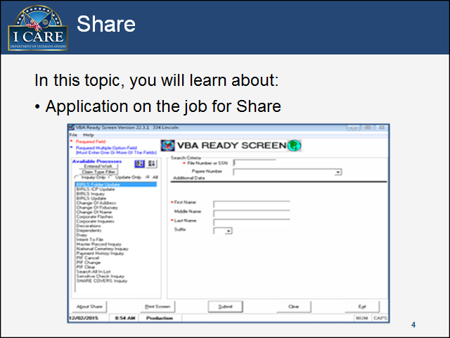

**Key Points:**

In this topic, we are going to briefly discuss what SHARE is and go over a case-based scenario together.

**Notes:**

Slide 5

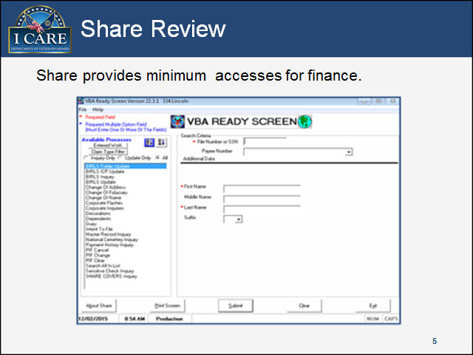

**Key Points:**

SHARE provides minimum accesses for finance needs, such as review military information. As an agent cashier you will use SHARE to assist in determining how a check should be disbursed (e.g. checking the Veteran’s corporate award for any existing debts/overpayments, etc.).

**Notes:**

Slide 6

Discussion Scenario 1-1

Slide includes an icon image of characters standing next to each other as a group.

**Key Points:**

Manuel has received a check from a Veteran and is trying to determine how to proceed. Process payment or send to appropriate parties? What program will allow Manuel to get this information?

**Notes:**

Slide 7

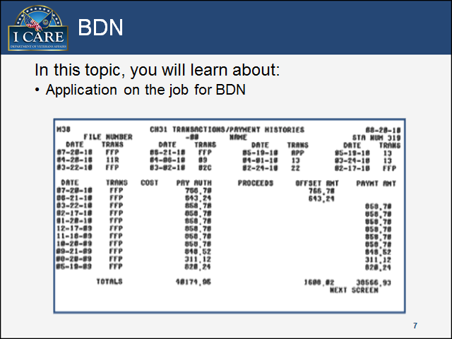

**Notes:**

Slide 8

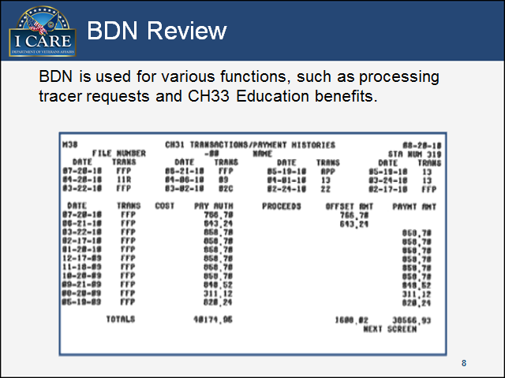

**Key Points:**

BDN is used for various functions, such as processing tracer requests and CH33 Education benefits. An agent cashier will use BDN to assist in determining how an education check (e.g. returned school payment, etc.) should be disbursed.

**Notes:**

Slide 9

Discussion Scenario 1-2

Slide includes an icon image of characters standing next to each other as a group.

**Key Points:**

Amanda, an Agent Cashier, is sorting incoming mail. After she has separated the mail into the appropriate categories, she finds a check with an education debt. What steps should Amanda follow in order to determine that this check is in fact an existing education debt?

**Notes:**

Slide 10

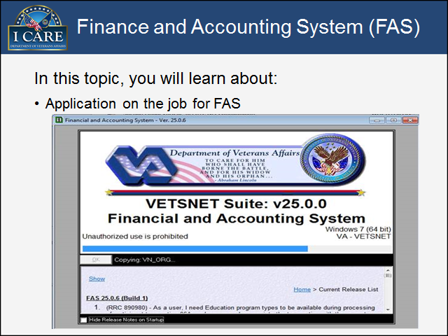

**Notes:**

Slide 11

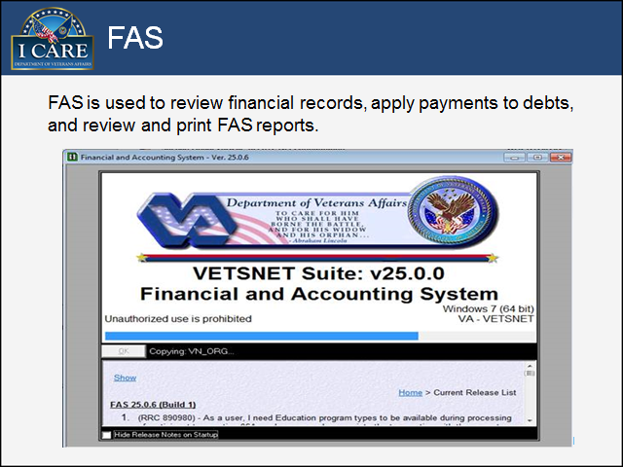

**Key Points:**

FAS is used to review financial records, apply payments to debts, and review and print FAS reports. An agent cashier will use FAS to assist in determining the status of the award for a returned benefit check and how the check should be disbursed (i.e. FAS shows multiple benefit payments have returned with a reason code of 21 (Incorrect Address)).

**Notes:**

Slide 12

Discussion Scenario 1-3

Slide includes an icon image of characters standing next to each other as a group.

**Key Points:**

Ebony receives a check in the mail from a Veteran. The “For” section of the check reads “VA Debt.” Ebony needs to determine what type of debt the Veteran is attempting to pay off. Which VBA system should she look into for this information?

**Notes:**

Slide 13

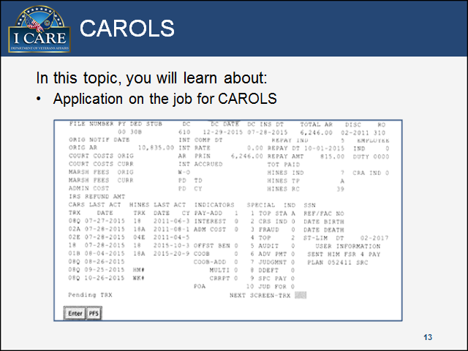

**Notes:**

Slide 14

Purpose of CAROLS

Slide image displays a screenshot from CAROLS.

**Key Points:**

CAROLS provides information on existing debts with the Debt Management Center (DMC). An agent cashier will use CAROLS to assist in determining if a check is being submitted for an overpayment that is currently being collected upon by the Debt Management Center; if so, the check will be disbursed accordingly (e.g. completing VA Form 4-5216, etc.).

**Notes:**

Slide 15

Discussion Scenario 1-4

Slide includes an icon image of characters standing next to each other as a group.

**Key Points:**

Dennis accepts remittances received at regional offices for receivables, maintained by the Debt Management Center (DMC) and related to compensation, pension, and education debts. Which system should he look the Veteran’s file up to determine if the DMC is collecting any debts before preparing the original and three copies of VA Form 24-5216?

**Notes:**

Slide 16

OTCnet

Slide includes the a screenshot of the main page of OTCnet. 

**Notes:**

Slide 17

Functions of OTCnet

Slide also includes a screenshot of the main page of OTCnet. 

**Key Points:**

OTCnet:

* Offers VA the capability to handle cash and check deposits using a single web-based application.
* Automates and improves the collection, reconciliation, research and reporting processes associated with Federal agency over-the-counter check collections.
* Converts paper checks into electronic debits to facilitate the process of depositing checks in a timely manner.

**Notes:**

Slide 18

Functions of OTCnet Cont.

Silde includes an image of a blurry background with the word "SECURITY" in the center

**Key Points:**

On OTCnet, agency users report receipts through a secure web-based application rather than by using paper-based credit vouchers. It is used to create the SF-215 deposit report and allows the agency to scan check image into the system as a “check capture” which is then securely stored online.

**Notes:**

Slide 19

Discussion Scenario 1-5

Slide includes an icon image of characters standing next to each other as a group.

**Key Points:**

Kristin has received a completed and signed Vocational Rehabilitation & Education (VR&E) school refund check in the mail. What system and functionality will Kristin use to process this check?

**Notes:**

Slide 20

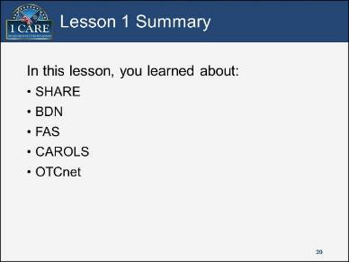

**Notes:**

Slide 21

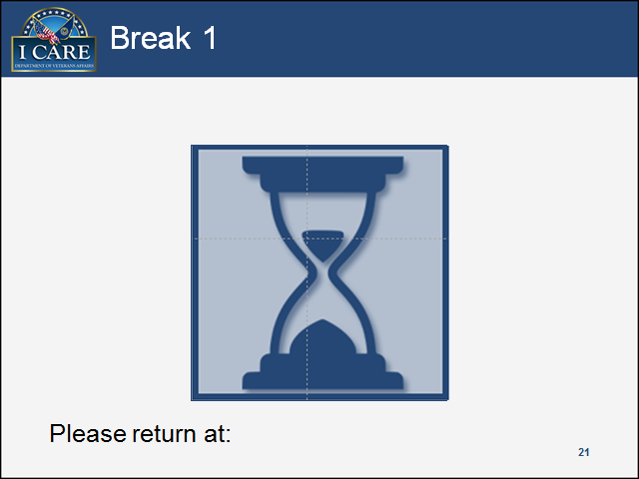

**Notes:**

## Session 2

Slide 22

In this lesson, you will learn about:
FMS 2958, Delegation of Authority
VAF-0901, Request for Change or Establishment of Imprest Fund
Internal controls and security
Internal audits

**Notes:**

Slide 23

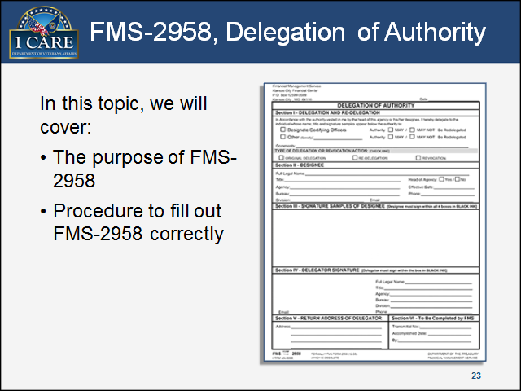

**Notes:**

Slide 24

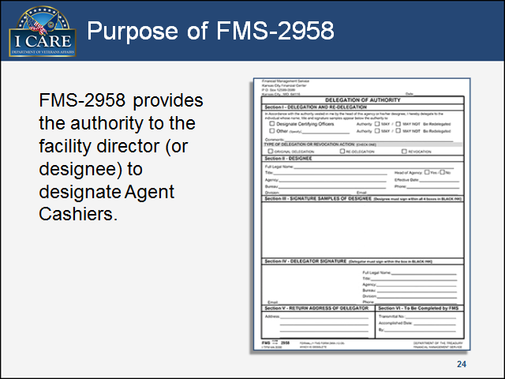

**Key Points:**

FMS-2958 provides the authority to the facility director (or designee) to designate Agent Cashiers. Treasury/FMS reviews delegations periodically and reserves the right to revoke this authority if it is deemed there is any misuse or abuse by Federal agency approving officials.

**Notes:**

Slide 25

Completing Form FMS-2958


**Key Points:**

To complete form FMS-2958, you will use the following procedures:

* Station completes the form (including the current Director’s signature) and forwards it to the Office of Resource Management (ORM).
* ORM then forwards the form to the Department of Treasury, where it is verified and stamped before being sent back to ORM.
* ORM now sends one completed copy to Agent Cashier Accountability (ACA), and a second copy to the Station.

FMS-2958 is valid for two years from the date the delegation is accepted/stamped by Treasury.

Please note that the amount of time it takes Treasury to return the 2958 to ORM can vary. Average turn-around is currently 30 days; therefore, Stations should plan accordingly as the expiration date on the 2958 approaches. Best practice would be to initiate this process 6 to 8 weeks before the current 2958 expires.”

**Notes:**

Slide 26

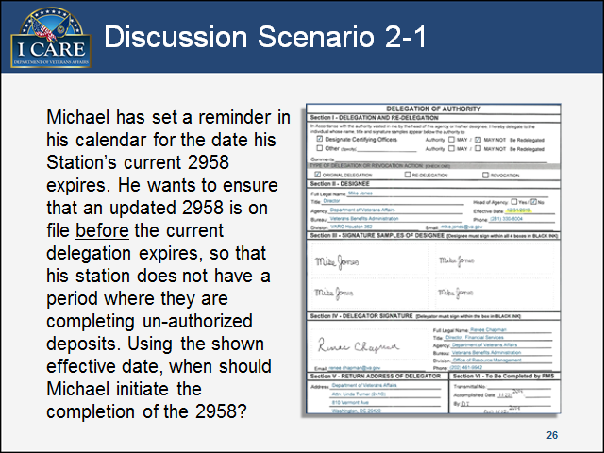

**Key Points:**

Michael has set a reminder in his calendar for the date his Station’s current 2958 expires. He wants to ensure that an updated 2958 is on file before the current delegation expires, so that his Station does not have a period where they are completing un-authorized deposits. Using the shown effective date, when should Michael initiate the completion of the 2958?

**Notes:**

Slide 27

In this topic, you will learn about:
Purpose of form VAF-0901
Different scenarios to fill out form VAF-0901

Slide includes a binder that is open to show a page that reads "VAF-091, Request for Change or Establishment of Imprest Funds"

**Notes:**

Slide 28

Purpose of VAF-0901

Slide includes an image of form VAF-0901, Request for Change or Establishment of Imprest Fund.

**Key Points:**

VAF-0901 is used to designate or revoke primary and alternate Agent Cashier (AC) responsibilities for current VBA employees. VAF-0901 also specifies the type of payment each cashier (primary or alternate) is authorized to distribute. Unlike FMS 2958, VAF-0901 does **not** have an expiration date. Therefore, there is no requirement to be updated every two years. VAF 0901 remains valid until a revocation is submitted for processing. Form FMS-2958 **must be current** and on file before the Director can sign VAF-0901. This is one of the main reasons submitted VAF-0901 are rejected or returned.

**Notes:**

Slide 29

VAF-0901 Common Errors


**Key Points:**

Some of the common errors that result in VAF-0901 being rejected are as follows:

* Failing to log the Control Number in Section I.
* Failing to make a selection in Section II - Action Requested (i.e. Change to Principal, Revocation, etc.)
* Having an individual other than the Head of Agency or Designee sign the form as the authorizing official.

**No one** can sign for, or in place of, the Designee (whom Treasury has verified to have that level of authority), or the Head of Agency.

**Notes:**

Slide 30

Discussion Scenario 2-2

Slide includes an icon image of characters standing next to each other as a group.

**Key Points:**

Lani is designating a new primary agent cashier for her facility. Under Section I, of VAF-0901, she lists the address of her RO under the heading title (Name and Address of Agency). However, she does not know what to list under the heading title of Name and Location of Dispersing Officer, so she leaves that section blank. VAF-0901 is returned to her for correction. What did Lani do incorrectly?

**Notes:**

Slide 31

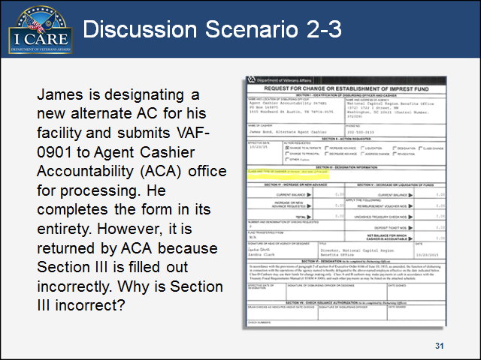

**Key Points:**

James is designating a new alternate AC for his facility and submits VAF-0901 to ACA for processing. He completes the form in its entirety. However, it is returned by ACA because Section III is filled out incorrectly. Why is Section III incorrect?

**Notes:**

Slide 32

In this topic, you will learn about:
Purpose of internal controls and security
Agent Cashier security

Slide includes an image of a blurry background woth the word Security in the center.

**Notes:**

Slide 33

Purpose of Internal Controls and Security

Slide includes an image of the top portion of a social security card; focused on the word Security

**Key Points:**

As an Agent Cashier, one important aspect of your job is proper safeguarding of negotiable instruments. The term “Negotiable Instruments” refers to items such as a safe/vault or locking file cabinet. Internal controls and security measures are in place to aid you in securing the imprest fund.

**Notes:**

Slide 34

Agent Cashier Security

Slide includes an image of a file folder with a lock and key.


**Key Points:**

Within their area, an Agent Cashier must have a safe/vault or locking file cabinet with the following items locked inside:

* All checks
* All unused/undesignated Field Service Receipts (FSR)
* Any other Agent Cashier-related items that need to be secured, such as logs
* Lockboxes/locked bags

**Notes:**

Slide 35

Agent Cashier Security Cont.

Slide includes an image of two locks, one locked and the other unlocked.

**Key Points:**

Safe combination, safe keys, and/or lockbox keys should be changed:

* Upon the departure of Agent Cashier, or
* At least once a year, or
* After the safe/lockbox is opened in an emergency

**Notes:**

Slide 36

Items Stored in the Director's Office

Slide includes an image of three keys with different dates on each; 2010, 2011, and 2012.


**Key Points:**

Items that should be stored in the Director’s secure office area include:

* Original Agent Cashier safe combination, or
* Duplicate safe keys and/or lockbox keys, or
* Duplicate keys to the Agent Cashier’s office/workspace

All of these must be in a seal envelope, and it must be signed and dated by the Primary AC, and the Finance Officer prior to being placed in the Director’s office. And, if for any reason, the seal on the envelope is broken- the locks or safe combination need to be changed.

**Notes:**

Slide 37

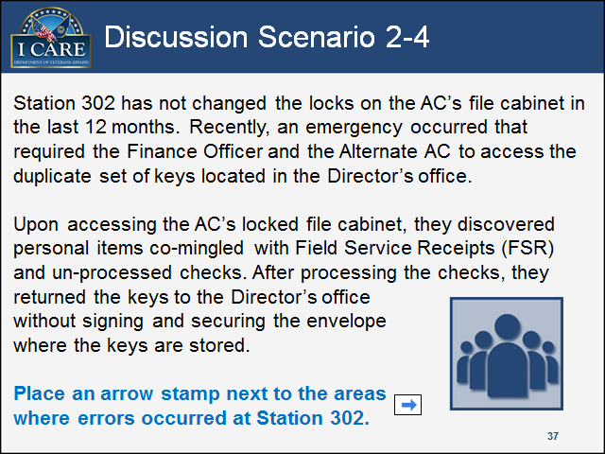

**Key Points:**

Station 302 has not changed the locks on the AC’s file cabinet in the last 12 months. Recently, an emergency occurred that required the Finance Officer and the Alternate AC to access the duplicate set of keys located in the Director’s office. Upon accessing the AC’s locked file cabinet, they discovered personal items co-mingled with Field Service Receipts (FSR) and un-processed checks. After processing the checks, they returned the keys to the Director’s office without signing and securing the envelope where the keys are stored. Place an arrow stamp next to the areas where errors occurred.

**Notes:**

Slide 38

In this topic, you will learn about:
Purpose of audits
Unannounced Agent Cashier internal audits

Slide includes an image of a calendar (barely visible) with the words "Unannounced Audits?" on the center.

**Notes:**

Slide 39

Purpose of Audits

Slide includes an image of the word "Performance" highlighted.

**Key Points:**

Audits are used to verify the integrity of the Agent Cashier’s disbursing funds as well as to improve Agent Cashier operations.

* Findings are reported to the Director, who should then implement corrective action measures based upon any irregularities discovered during the audit.
* The Chief of Finance is responsible for ensuring that the corrective action is implemented.”

**Notes:**

Slide 40

Unnannounced Agent Cashier Audits

Slide includes an image of a calendar (barely visible) with the word "Bi-Annual" on the center.

**Key Points:**

Unannounced Audits:

* Must be done at least twice a year (Bi-Annual basis)
* Must be done on a random basis
* Findings are reported to the Director

Bi-annual audits are the bare minimum. Additional audits may be prescribed as necessary. Also, audits should not exceed a period of one week. ALL Agent Cashier functions must be suspended during the audit.

Care should be exercised to vary the scheduled date and time of unannounced audits in order to prevent the establishment of a pattern of regularity, which would nullify the element of surprise.

Lastly, audits should be completed by two Station employees (if possible, one of the auditors should be outside of Support Services/Finance). The unannounced audits must be carried out by the Support Services Division (SSD).

**Notes:**

Slide 41

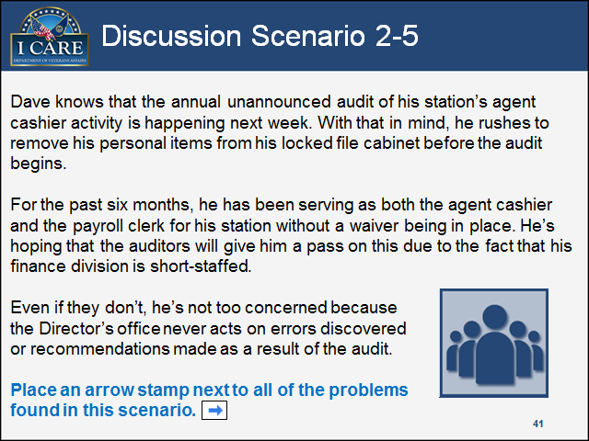

**Key Points:**

Dave knows that the annual unannounced audit of his Station’s Agent Cashier activity is happening next week. With that in mind, he rushes to remove his personal items from his locked file cabinet before the audit begins. For the past six months, he has been serving as both the Agent Cashier and the payroll clerk for his Station without a waiver being in place. He’s hoping that the auditors will give him a pass on this due to the fact that his finance division is short-staffed. Even if they don’t, he’s not too concerned because the Director’s office never acts on errors discovered or recommendations made as a result of the audit. Place an arrow stamp next to all problems found in this scenario.

**Notes:**

Slide 42

Lesson 2 Summary

In this lesson, you learned about:
FMS 2958, Delegation of Authority
VAF-0901, Request for Change or Establishment of Imprest Fund
Internal Controls and Security
Internal Audits

**Notes:**

Slide 43

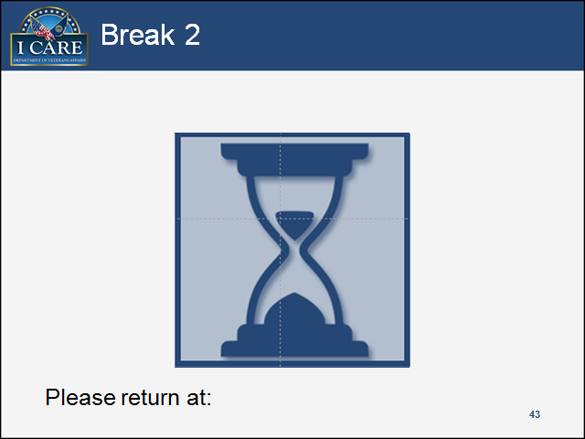

**Notes:**

## Session 3

Slide 44

In this lesson, you will learn about:
Check Deposit Process
Convenience Checks 


**Notes:**

Slide 45

Check Deposit Process

In this topic, you will learn about:
Depositing Treasury checks
Depositing all other checks
Check deposit process
OTCnet check deposit process

Slide includes an image of two checks: U.S. Treasury Check, and a regular check with the words "All Other Checks" above it. 


**Notes:**

Slide 46

Depositing Treasury Checks

Slide includes an image of a U.S. Treasury Check.

**Key Points:**

You will deposit Treasury checks if they are received:

* As a reimbursement to the Agent Cashier, such as reimbursement for convenience check
* For payment towards a Veteran’s attorney fees

Most Treasury checks will be voided and returned to the department of Treasury/Financial Management Service. You can return Treasury checks for VA benefit payments to the following address:

Dept. of the Treasury

Financial Management Service

P.O. Box 51320

Philadelphia, PA 19115-6316

You can return all other VA payments to the following address:

Dept. of the Treasury

Financial Management Service

P.O. Box 51316

Philadelphia, PA 19115-6316

**Notes:**

Slide 47

Depositing All Other Checks

Slide includes an image of a blank regular check.

**Key Points:**

You will deposit all other checks if they are:

* Personal checks for employee debts or jury duty fees
* Vendor checks
* Personal checks from Veterans
  + For Freedom of Information Act request (FOIA)
  + For debts if the record is not in CAROLS

**Notes:**

Slide 48

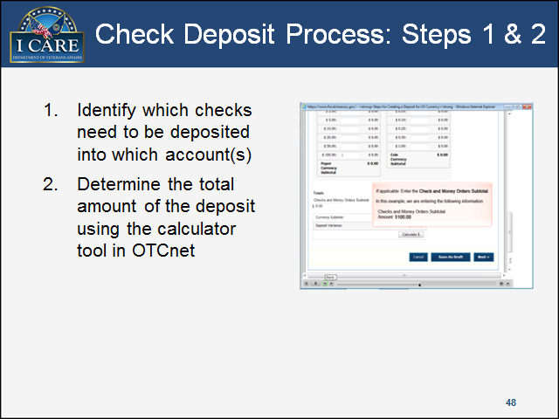

**Key Points:**

To deposit checks, you must follow the following steps:

1. Identify which checks need to be deposited into which account(s) by researching the available systems (SHARE, BDN, FAS, CAROLS, etc.).
2. Determine the total amount of the deposit using the calculator tool in OTCnet.

**Notes:**

Slide 49

Check Deposit Process: Step 3

Slide includes an image of a blank check

**Key Points:**

The following step involves the following:

1. Stamp/frank checks for deposit to the appropriate Agency Location Code (ALC).
   * 1200: FMS Account that is used for everything else, including suspense

To prevent out-of-balances access to ALC, 0201 has been revoked and will only be granted on an as-needed basis. 0201 is a Compensation and Pension (C&P) Account that is used for all C&P collections that get applied to current debts.

**Notes:**

Slide 50

Check Deposit Process: Step 4

Slide includes an image of a blank Field Service Receipt with a check below. The check is blurry and has illegible text. Below the check is another FSR that is filled out but illegible as well. 


**Key Points:**

This next step goes over:

1. Complete Field Service Receipts (FSR)
   * Must date FSR with the date the check is received
   * Must utilize FSRs in the proper sequence
   * Must ensure FSRs are stored in a secured location

Field Service Receipts can be completed electronically via Microsoft Excel/Microsoft Access templates. However, a copy of the on-hand FSR must be attached to the electronic copy and the document control numbers on both the physical and electronic copies must match.

**Notes:**

Slide 51

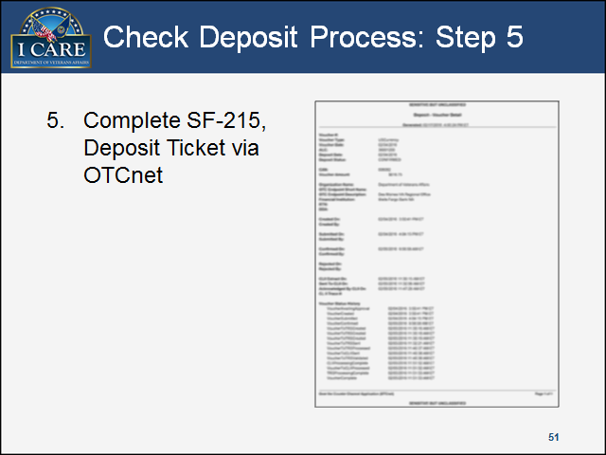

**Key Points:**

For the next step:

1. You must complete SF-215, and Deposit Ticket via OTCnet. Banks and financial institutions will not accept deposits without a SF-215 created electronically through either OTCnet Deposit Processing or Check Capture Processing.

**Notes:**

Slide 52

Check Deposit Process: Steps 6 & 7

Slide includes an image of a blank regular check.  

**Key Points:**

In these next steps:

1. You want to make sure that you copy supporting documentation and send it to accounting.
2. Then you make a deposit. This deposit must be made via the Check Capture Processing module within OTCnet (with limited exceptions), and/or on a daily basis as checks are received.

Please keep in mind that Check Capture Processing has eliminated the need for VAF-1011, Record of Shipment of Valuables. When you are shipping a copy of the electronic 215 and check to your bank, the VAF-1011 form will need to be filled out. Whether you are mailing it or physically delivering it to the bank, you will be required to fill out VAF-1011 because you need to account for the check. It is important to always keep a record of transactions. In order to complete VAF-1011, Record of Shipment of Valuables you:

* Must include the signature of at least one witness
* Must assign a sequential log number to each VAF-1011
* If these forms are mailed, must have a certified mail control number for tracking purposes

**Notes:**

Slide 53

OTCnet Check Capture Process: Step 1

Slide includes a screenshot of the top portion of the OTCnet page. There are four main tabs: 1. Deposit Processing, 2. Check processing, 3. Administration, and 4. Reports. The Administration is selected; under Administration there are three sub-tabs: 1. Manage Check Processing, 2. Terminal Configuration, and 3. Manage Centralized Deployment. Termina Configuration is selected and the Modify option is higlighted. 

**Key Points:**

Step 1. The first step in the check capture process is to make sure that the necessary firmware and root certificates are installed onto the AC’s computer by an information technology (IT) specialist.

**Please note**: If you are dealing with Foreign Money, you must select the Deposit Processing tab on OTCnet. After this, you can then select Create Deposit. This will provide two options: Foreign Currency Cash, and Foreign Check Items. You can choose whichever option is necessary. This process must be done specifically for foreign money because you cannot process foreign items drawn from non-U.S. financial institutions via the check capture process.

**Notes:**

Slide 54

OTCnet Check Capture Process: Step 2

Slide includes  a screenshot of step 2 from the check capture process. Information such as Processing, CashFlow, Batch Control, Devices Configuration, Keypad enabled, and other options are provided for manual configuration. 

**Key Points:**

Step 2. Once the firmware and root certificates are installed, the Check Capture terminal will have to be configured at that particular work Station by the Check Capture Administrator/AC.

**Notes:**

Slide 55

OTCnet Check Capture Process: Step 3

Slide includes a screenshot of OTCnet Administration page, step 3. 

**Key Points:**

Step 3. The Check Capture lead operator, who should be the registered Agent Cashier for your Station, prepares and submits a Check Capture batch (which includes an electronic deposit ticket) for approval using the RDM EC-7000i or Panini X Vision series check scanner(s) via OTCnet.

**Notes:**

Slide 56

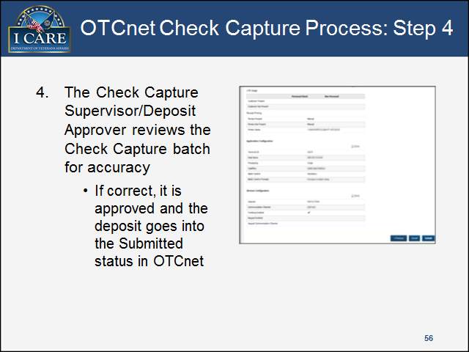

**Key Points:**

Step 4. The Check Capture Supervisor/Deposit Approver reviews the Check Capture batch for accuracy. If correct, it is approved and the deposit goes into the Submitted status in OTCnet.

**Notes:**

Slide 57

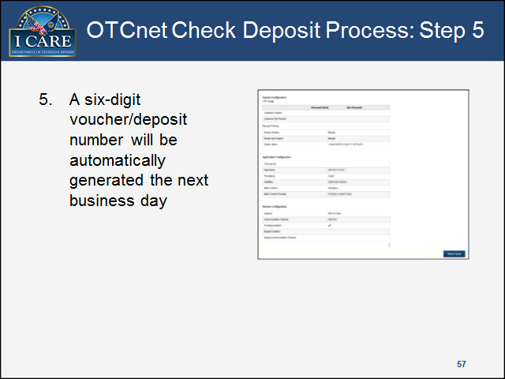

**Key Points:**

Step 5. Once the Check Capture batch is confirmed by the bank, a six-digit voucher/deposit number will be automatically generated the next business day. This voucher/deposit number is available via the SF-215 deposit ticket report in OTCnet and should be reported to your Station’s accounting section so that the transaction can be recorded in the Centralized Administrative Accounting Transaction System (CAATS).

**Notes:**

Slide 58

OTCnet Check Deposit Process: Step 6

Slide includes an image of a blank regular check 

**Key Points:**

Step 6. Physical copies of the check(s) should be retained for five business days to ensure that there are no problems with the file transmission, image quality, and processing of the checks. After five business days, the checks can be shredded. Once a batch is confirmed, the check image is stored online via OTCnet for seven years.

**Notes:**

Slide 59

Discussion Scenario 3-1

Slide includes an icon image of characters standing next to each other as a group.

**Key Points:**

Tracie receives a foreign money order for processing that is not payable in U.S. currency. What steps would Tracie follow to deposit the foreign money order using OTCnet?

**Notes:**

Slide 60

Discussion Scenario 3-2

Slide includes an icon image of characters standing next to each other as a group.

**Key Points:**

Desiree receives error message stating (This request requires terminal to be configured.) in OTCnet. What procedures would Desiree follow to get past this technical issue?

**Notes:**

Slide 61

Discussion Scenario 3-3

Slide includes an icon image of characters standing next to each other as a group.

**Key Points:**

Brandy receives a CH. 31 school refund check in the amount of $10,000. She attempts to access the Check Capture Processing module in OTCnet to submit this check to the bank. However, upon accessing OTCnet, she receives an error message stating that the Java version installed on her computer is not compliant with OTCnet system configuration. How should Brandy proceed?

Option 1: Hold the check until her information technology specialist can come look/work on her computer.

Option 2: Complete the deposit the “old-fashioned” way using a paper SF-215 (deposit ticket).

Option 3: Access the deposit processing module in OTCnet using one of her colleague's computer/work Station.

**Notes:**

Slide 62

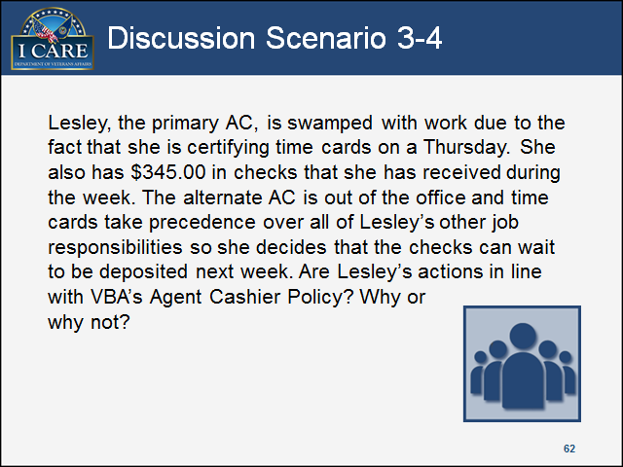

**Key Points:**

Lesley, the primary AC, is swamped with work due to the fact that he is certifying time cards on a Thursday. He also has $345.00 in checks that he has received during the week. The alternate AC is out of the office and time cards take precedence over all of Tony’s other job responsibilities so he decides that the checks can wait to be deposited next week. Are Lesley’s actions in line with VBA’s Agent Cashier Policy? Why or why not?

**Notes:**

Slide 63

Convenience Checks

In this topic, you will learn about:
Purpose of convenience checks
Authorized Uses
Restrictions
Required documentation
Issuance of convenience checks

Slide includes an image of two checks: U.S. Treasury Check, and a regular check with the words "All Other Checks" above it. 

**Notes:**

Slide 64

Purpose of Convenience Checks

Slide includes an image of a filled out convenience check. The information on the check has been blurred out for the protection of PII.

**Key Points:**

The purpose of convenience checks includes:

* Payment of procurement tool that is only used for:
  + Merchants that do not accept purchase cards; and
  + Other authorized purposes where charge cards are not accepted

**Notes:**

Slide 65

Requirement of Convenience Checks

Slide includes an image of a filled out convenience check. The information on the check has been blurred out for the protection of PII.

**Key Points:**

The requirement of convenience checks:

* Must be a purchase card holder, or have received purchase card training and a Delegation of Authority, to issue convenience checks.

Convenience checks should only be used as a last resort, such as when no reasonable alternative merchant is available who accepts the purchase card.

An individual does not have to be designated as an AC to issue convenience checks. Completed purchase card training and Delegation of Authority authorizes the individual to issue convenience checks.

**Notes:**

Slide 66

Authorized Uses

Slide includes an image of a stack of money with the words "Budget Control" over it. 


**Key Points:**

Authorized uses include:

* Vendors who do not accept the purchase card
* Emergency incident response
  + An example of an emergency incident response would be Hurricane Katrina. In the aftermath of the hurricane, an emergency was declared and a waiver was granted which allowed VBA to issue benefit payments via convenience checks.
* Other agency-approved purposes that comply with P.L. 104-134, *The Debt Collection Improvement Act of 1996.*

**Notes:**

Slide 67

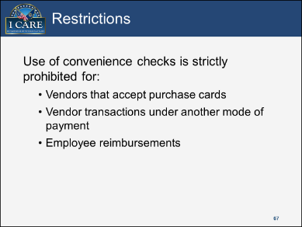

**Key Points:**

The use of convenience checks is strictly prohibited for vendors that accept purchase cards, vendor transactions under another mode of payment (such as contract or Purchase Order), and employee reimbursements.

**Notes:**

Slide 68

Restrictions Cont.


**Key Points:**

Continuing from the previous slide, here are other restrictions:

* Cash advances
* Salary payment/cash awards
* Travel-related transportation tickets
* Other restrictions as determined by agency policy

**Notes:**

Slide 69

Discussion Scenario 3-5

Slide includes an icon image of characters standing next to each other as a group.

**Key Points:**

Angelo must make a purchase for the Station. However, the first merchant he went to does not accept the purchase card. Is it okay for Angelo to use a convenience check for payment?

**Notes:**

Slide 70

Required Documentation

Slide includes an image of a blank regular check 

**Key Points:**

Required documentation for convenience checks include:

* Convenience check memo
* Supported paperwork with required signatures

This would include invoice(s) from the vendor or an emergency declaration

**Notes:**

Slide 71

Issuance of Convenience Checks

Slide includes an image of a blank regular check 

**Key Points:**

The minimum requirements of a properly written check include:

* The Date
  + Enter issue date
  + Spell out date, such as April 15, 2015
* Payee
  + Individual’s name
  + Obligation
* Amount
  + In numbers and words (e.g. *Three hundred forty five and 00/100 dollars*)
* Original Signature

These are the minimum requirements per the Office of Management and Budget (OMB) for each convenience check.

**Notes:**

Slide 72

Issuance of Convenience Checks Cont.

Slide includes an image of a blank regular check 

**Key Points:**

Here are some key points to note on Issuance of Convenience checks:

* Issue in sequential order
* Enter into a check register/log
* Write only for the exact amount of purchase
* Deduct the check fee in the register/log

**Notes:**

Slide 73

**Discussion Scenario 3-6

Slide includes an icon image of characters standing next to each other as a group.**

**Key Points:**

A homeless Veteran arrives at Gabrielle’s Station and is claiming non-receipt of his pension benefit payment. After reviewing the Veteran’s record in SHARE, Gabrielle determines that the Veteran’s direct deposit information was fraudulently changed. The Veteran states that he does not have any money and begs Gabrielle to issue him a payment immediately. Gabrielle has initiated suspected fraud procedures for the missing payment. However, she is sympathetic to this Veteran and is considering writing him a convenience check in the amount of his missing benefit payment. Additionally, there is no Delegation of Authority on file for Gabrielle. Should she proceed in writing the convenience check? Why or why not?

**Notes:**

Slide 74

In this course, we covered information about:
Computer Systems and Programs Used by VBA Agent Cashiers
Agent Cashier Protocol and Security
Transaction Process

Slide includes an image of an envelope with the word "Completed" stamped on it. 

**Notes:**

Slide 75

Questions or Comments?

Slide includes an image of a chalkboard with question marks and a hand erasing the question marks


**Notes:**