MRRC RORC Quality Newsletter

Volume 1, Issue 10 January 2025

|  |  |
| --- | --- |
| RORC IPR Data-December 2024 | Total |
| Total # of RORC IPRs - December 2024 | 499 |
| Total # of RORC IPR Errors-December 2024 | 118 |
| Percent Error Rate | 24% |



ERROR BREAKDOWN

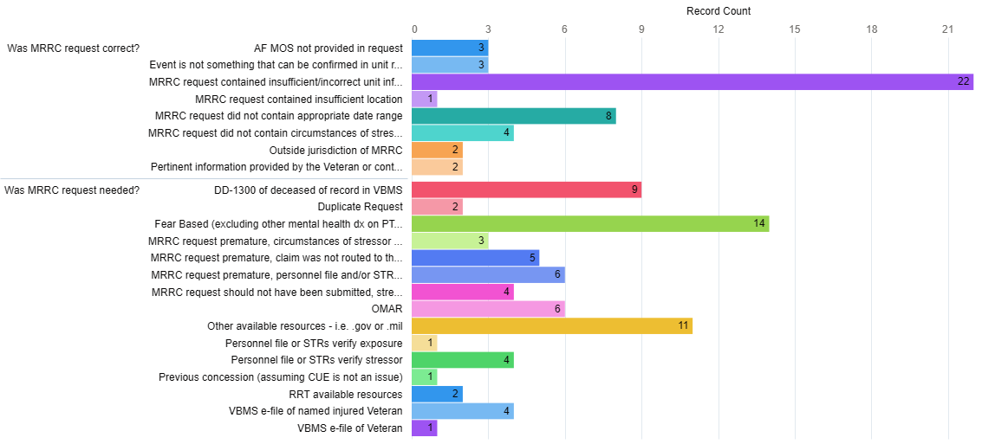

**Error Trends**

**Unit information**

Incorrect unit info continues to be our most cited errors. Please be sure to review the personnel records to locate the correct unit assignment and timeframe. Do not default to the unit listed on the 0781! Don’t forget to utilize the Unit of Assignment Job Aid for assistance in identifying the correct unit and time frame.

[RORC Community of Practice - Unit of Assignment Job Aid 1.1.pdf - All Documents](https://dvagov.sharepoint.com/sites/RecordsResearchRequestSupport/Shared%20Documents/Forms/AllItems.aspx?id=%2Fsites%2FRecordsResearchRequestSupport%2FShared%20Documents%2FGeneral%2FUnit%20of%20Assignment%20Job%20Aid%201%2E1%2Epdf&viewid=ff5d8033%2Db8b8%2D406c%2D80a5%2D8f99a5226b29&parent=%2Fsites%2FRecordsResearchRequestSupport%2FShared%20Documents%2FGeneral)

**Fear Based Exams**

Remember, if the Veteran has confirmed service in an area of hostile military or terrorist activity, they are entitled to an initial PTSD exam.

### ***VIII.iv.1.A.3.i.  Examples of Service in Areas of Hostile Military or Terrorist Activity***

### ***VIII.iv.1.A.3.k.  Establishing a Stressor Related to Fear of Hostile Military or Terrorist Activity***

### ***VIII.iv.1.C.1.a.  When to Proceed with an Examination in a PTSD Claim***

### ***VIII.iv.1.A.3.b.  When a Veteran’s Lay Testimony Alone May Establish an In-Service Stressor***

### ***VIII.iv.1.A.3.d.  Stressor Verification Review Procedure step 2***

**A FEW REMINDERS**

If the Veteran claims multiple stressor events and you can confirm one, there is no need to conduct further research.

### **VIII.iv.1.A.4.c.  Procedures for Conducting RO Research Coordinator Review step 1 & step 5**.

If an exam has been completed and the stressor(s) (associated to the diagnosis) are different from what was listed on the 0781, the stressor(s) on the exam need to be verified.

**NOTE:**

RAR verifies stressors and events. However, it will not typically verify what the role of the Veteran was during the stressor. Placing the Veteran, or Unit at the stressor/event becomes the responsibility of the RO. Occasionally, a Veteran’s name will incidentally be found in the records during research, but that is not their primary focus. The RO must then correlate the evidence to establish the Veteran's involvement in the verified stressor.

The *Records Research Task Tracked Item* is auto generated when a research request is submitted. This tracked item is used to monitor the number of pending records research requests. Manually inputting this tracked item can skew the data to indicate an inflated number of pending records research requests.

**Tour of Duty Dates**

When submitting a research request, do not use the Veteran’s service dates for the tour of duty date fields. This timeframe is related to the unit of assignment when the incident occurred. See MRRC Field Playbook page 12-13 Stressors & page 13-14 Exposures.

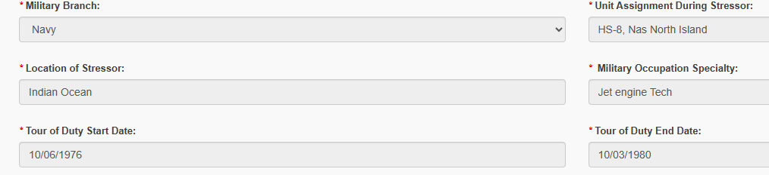

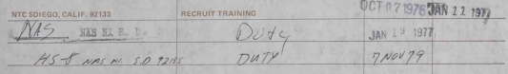 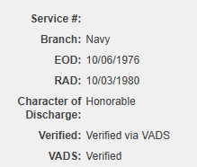

This is incorrect. The tour of duty start date should be 11/7/79. Please utlilize the Unit of Assignment job aid and MRRC Field Playbook page 14-16 & 47-54 for help with identifying the correct unit and timeframe.

**Below is a correct example:**

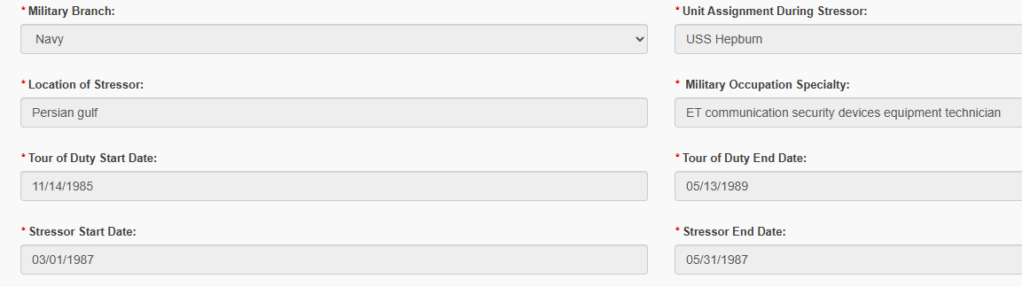

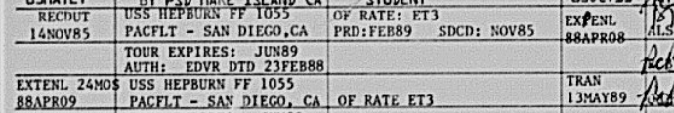

**RORC Help Desk**

The purpose of the RORC Help Desk is to provide assistance related to stressor and exposure research. Questions will be answered by RAR staff. The help desk will be utilized to build a database of searchable questions and answers for use as a quick reference.

Access to the help desk can be located on the RORC SharePoint or via the following link: [RORC Community of Practice - RORC Help Desk](https://dvagov.sharepoint.com/sites/RecordsResearchRequestSupport/Lists/RORC%20Help%20Desk/AllItems.aspx?viewid=9a402039%2D938d%2D4340%2D9ecb%2D240b3e47419f)



Suggestions

Have information you would like to see included in our monthly newsletter? Please send suggestions to:

[VAVBAWAS/CO/OFO/RAR/MRRC](mailto:%20VAVBAWAS/CO/OFO/RAR/MRRC)



The *Secondary Action Required* tracked item has been discontinued. When you need to route a claim to the RRT for further nautical herbicide exposure research, please use the Stage 2 Development tracked item.

[Nautical Herbicide Exposure Centralized Processing SOP v.17 (12.04.2024).pdf](https://dvagov.sharepoint.com/sites/VBA21CBWN/INQ/Shared%20Documents/SOPs/Nautical%20Herbicide%20Exposure%20Centralized%20Processing%20SOP%20v.17%20(12.04.2024).pdf)

