**Question**   
M21-1, Part VIII, Subpart iv, Chapter 1, Section E - Evidence Evaluation and Decisions for Posttraumatic Stress Disorder (PTSD) Claims Based on Personal Trauma

How to develop for personal trauma that deal with environment i.e. harassment, discrimination as oppose to an event, and why you do not make a RRR.

**Answer**   
Per MRRC Field Playbook V3.0; page 30

**MST and most personal trauma**

Follow the procedures in M21-1 VIII.iv.1.B.1 *General Development for PTSD Claims Related to Personal Trauma*.

MRRC does not routinely research MST and most personal trauma stressors. Per M21-1 VIII.iv.1.B.2.g, these types of incidents should only be referred to an RORC when the claimed events are of a nature that would otherwise warrant MRRC research.

**Question**You might want to discuss the initial PTSD DBQ.  Why do rater’s deferrer it i.e. DX not PTSD or it is a non-fear based stressor and which stressors you need to verify (not the ones on the 0781 but the ones on the DBQ)

**Answer**[**38 CFR 3.304(f)(3)**](https://www.ecfr.gov/cgi-bin/text-idx?SID=fa147f1fcb9203350440f9242f1b8e27&node=se38.1.3_1304&rgn=div8)

(3) If a stressor claimed by a veteran is related to the veteran's fear of hostile military or terrorist activity and a VA psychiatrist or psychologist, or a psychiatrist or psychologist with whom VA has contracted, confirms that the claimed stressor is adequate to support **a diagnosis of posttraumatic stress disorder** and that the veteran's symptoms are related to the claimed stressor, in the absence of clear and convincing evidence to the contrary, and provided the claimed stressor is consistent with the places, types, and circumstances of the veteran's service, the veteran's lay testimony alone may establish the occurrence of the claimed in-service stressor. For purposes of this paragraph, “fear of hostile military or terrorist activity” means that a veteran experienced, witnessed, or was confronted with an event or circumstance that involved actual or threatened death or serious injury, or a threat to the physical integrity of the veteran or others, such as from an actual or potential improvised explosive device; vehicle-imbedded explosive device; incoming artillery, rocket, or mortar fire; grenade; small arms fire, including suspected sniper fire; or attack upon friendly military aircraft, and the veteran's response to the event or circumstance involved a psychological or psycho-physiological state of fear, helplessness, or horror.

**VIII.iv.1.A.3.f****.  Definition:  Fear of Hostile Military or Terrorist Activity**

### VII VIII.iv.1.A.3.k.  Establishing a Stressor Related to Fear of Hostile Military or Terrorist Activity

**I.iv.1.A.3.i****.  Examples of Service in Areas of Hostile Military or Terrorist Activity**The rater will defer claims when the exam results show that a diagnosis of other mental disorder and not PTSD. “Fear” can only be used for the diagnosis of PTSD

When this occurs the VSR will need to verify the claimed stressor the vet stated at their exam, not the stressor listed on the 0781. The stressor stated at the exam is the one the examiner associated to the mental disorder.

**Question**I would like to request to see more in-depth info when the slide is presented for the Error Trends – proper submission of MRRC requests:

Trends with RO’s, Trends with New RORC’s, Trends with Those not attending the RORC COP calls/recordings

**Answer**There have been a total of 35 RORC IPR errors cited. Please see the below breakdown of the types and number of errors. There were 18 MRRC requests that were incorrect. Insufficient and/or incorrect unit information and premature MRRC requests were the top 2 error types is this category. There were 17 MRRC requests that were not needed. These 17 requests could have been verified by using VBMS and VBA approved resources (MRRC Field Playbook pages 19-24).

QMS resource

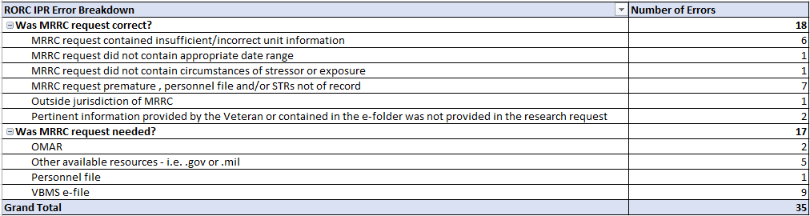

**Question**

For MST – while no one should be submitting that since MRRC does not do MST – MST Cases are only worked by the MST-OC and 8 MST Help Sites currently.  Having a blanket reminder that MST cases should not be being worked by all stations may also help decrease this error trend as well.

**Answer**All claims for MST should be routed to the Military Sexual Trauma Operations Center (MST-OC) and no MRRC Request should be submitted.   
  
Personal trauma for the purpose of Department of Veterans Affairs (VA) disability compensation claims based on posttraumatic stress disorder (PTSD) refers broadly to stressor events involving harm perpetrated by a person who is not considered part of an enemy force. The MSTOC specifically works a subset of personal trauma, military sexual trauma (MST). MST is defined as sexual harassment, sexual assault, or rape that occurs in a military setting. If the claim is for any condition, mental or physical (including PTSD), resulting from MST the special issue indicator of military sexual trauma is added to the contention on the claim. This special issue indicator identifies the claim for routing to one of the MST consolidated sites. Currently, there are nine (9) sites that have special teams set up to focus on this inventory. Eventually, the MST-OC will be the sole processing cite. The site works all the contentions on the disability claim to include but not limited the claim for PTSD due to MST. Incidents of personal trauma are not often officially reported, and the victims of this type of in-service trauma may find it difficult to produce evidence to support the occurrence of the stressor. The MST-OC is ensuring that we take care of these Veterans.

**Question**Non-PACT-applicable Thailand Research (pre-PACT ACT effective dates) I have seen an uptick in requests for RRC research of vet Thailand SVC where PACT can’t automatically concede because the claim predates PACT legislation and may affect effective dates. I have seen MRRC kick back these requests with a blanket response like: “PACT conceded Thailand, no research done” For some claims, research *IS still needed for effective date purposes. Can we have more guidance and information about how PACT has affected Thailand research requests including effective dates?

**Answer**Under the PACT Act there is a presumption of herbicide exposure for Veterans who served in Thailand at any United States or Royal Thai base on or between January 9, 1962, to June 30, 1976.

Evidence of a specific military occupational specialty (MOS) or duties on the perimeter of the base is no longer required as of the effective date of the PACT ACT, August 10, 2022. However, if the DOC is prior to 8/10/22 then the old procedures still apply. This includes completing formal findings.  PACT Act FAQs V4 p14 question 3, VIII.i.1.A.7.a

*If you receive a response on a pre-PACT act Thailand claim and no research is done, please email the MRRC mailbox for a review of the synopsis at VAVBAWAS/CO/OFO/RAR/MRRC