**Introduction to Workload Management and Why It Matters**

**Training Aid**

Practical Exercise 1 (Slide 11) -- Answer the questions below about your current team.

1. What team am I supervising? ________________________________________
2. What do we produce? _____________________________________________
3. What are our goals and our priorities? __________________________________

________________________________________________________________

1. Who are my team members? ________________________________________

________________________________________________________________

1. What is their availability? ____________________________________________

________________________________________________________________

1. What are their levels of experience? ___________________________________

________________________________________________________________

1. What are their training or other needs? _________________________________

________________________________________________________________

1. What specialized capacity (if any) does my team have? ____________________

________________________________________________________________

1. What are my expectations for my team? ________________________________________________________________________________________________________________________________
2. What does my management team expect of me? ________________________________________________________________________________________________________________________________

Practical Exercise 2 (Slide 17)

Review your notes about your team and your expectations.

Review your station’s workload management plan and VA’s defined priorities.

Consider and discuss with a partner:

What are the differences between my expectations and the expectations of our workload management plan/priorities? ________________________________

_______________________________________________________________

_______________________________________________________________

How can I adjust my expectations of my team to meet our goals? ___________

_______________________________________________________________

_______________________________________________________________

Practical Exercise 3 (Slide 39) -- Review the workload report for a rating team shown below.

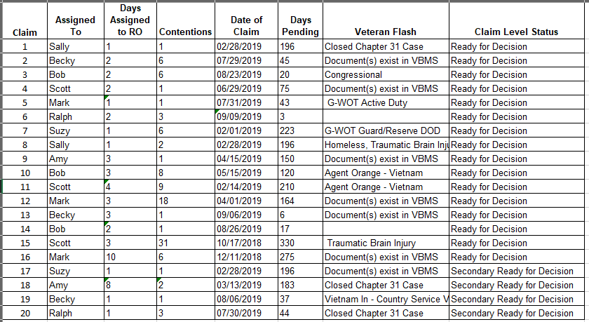

What “outliers” did you identify from your review? What claims should be worked first?

__________________________________________________________________________________________________________________________________________________________________________________________________________________

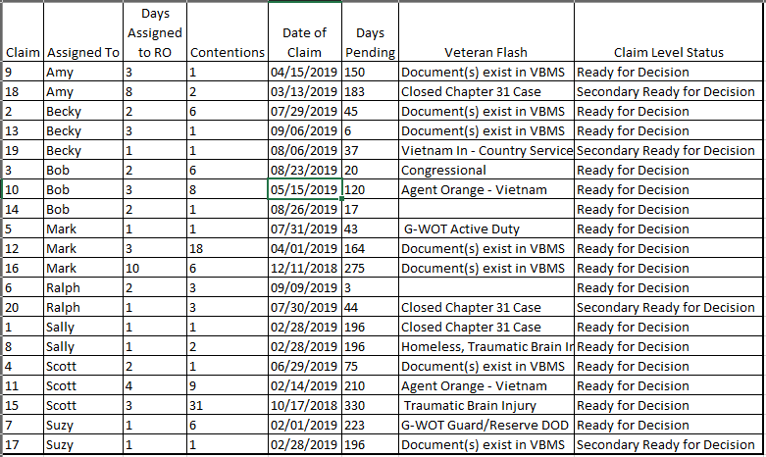

Scenario: You are supervising a rating team with the eight members shown above. Your employee, Scott, just called you to say he will be out due to illness for at least three days. Your AVSCM stopped you in the hall this morning to say Amy will be working on a special project the remainder of the week. It’s Tuesday. Using the sorted report above, what claims do you need to reassign? To whom could you reassign them? Why?

__________________________________________________________________________________________________________________________________________________________________________________________________________________