**Government Travel Steps**

1. **Submit a VA Form 10091, “Employee Vendor File Request”**
2. Sign on to the [FSC Customer Self Service Portal](https://vaww.cpm.fsc.va.gov/prweb/webagent/app/default/DrBbxuwfn6I9W0w5VcIP-PdAMUN-Xn9rb_V0RFD3y3o*/!STANDARD)
3. Click “Form” and “Employee Form” under the Vendor File Forms section to access the “Employee Vendor File Webform.”

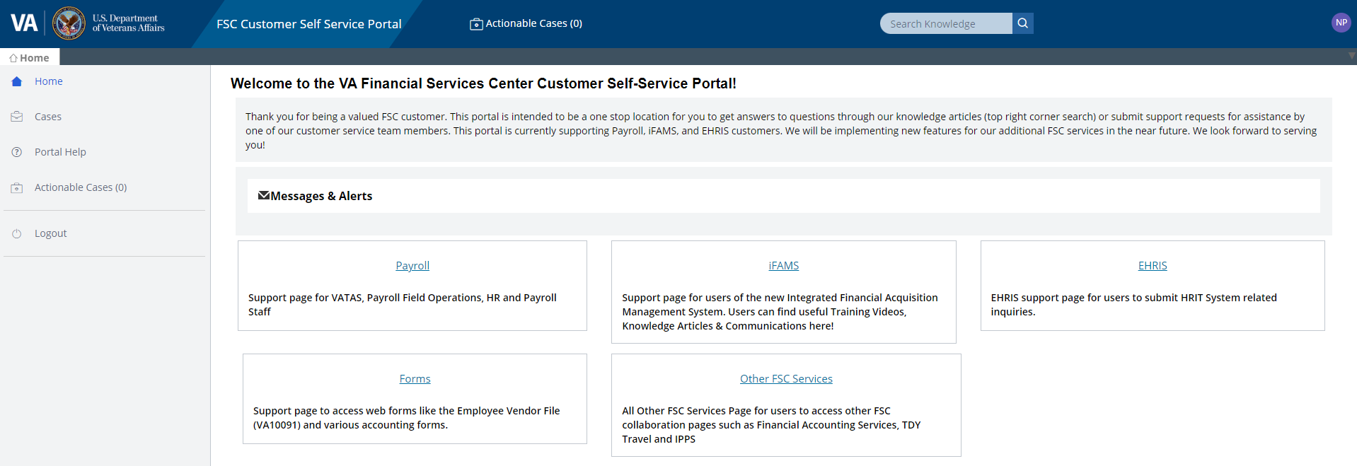

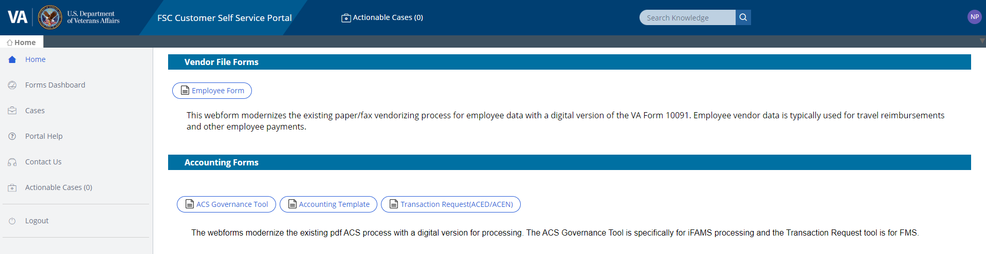

1. Fill out the required information:
2. Under “Request Type”, select New or Update
3. Select “Submitting for Self”
4. Select “Yes” or “No” for the question “Are you living outside the USA?”
5. Enter your social security number and confirm the number again
6. Complete the employee information
7. Complete the bank information
8. Verify the information is “CORRECT”
9. Click “Finish” to submit the form.
10. Log back in the FSC Customer Self Service Portal after two working days to retrieve your employee vendor code.
11. **Travel Charge Card Training**
12. Click on the link [Talent Management System](https://hcm03.ns2cloud.com/sf/start?_s.crb=E5TqEKRvG0uI%252f8D6Jh5xOI8zpzWVO39FpIZfyJtgbO4%253d#Shell-home)
13. Click on Learning Module under “My Info”

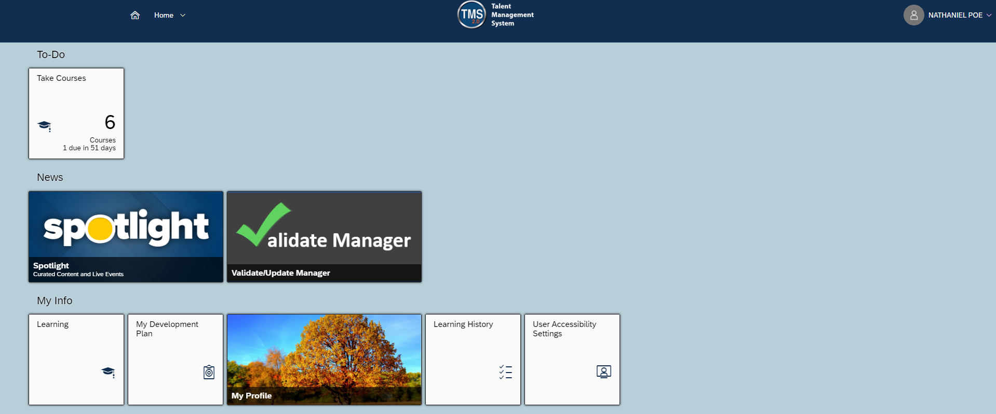

1. Type in “VA 5508” in search field under “Find Learning”

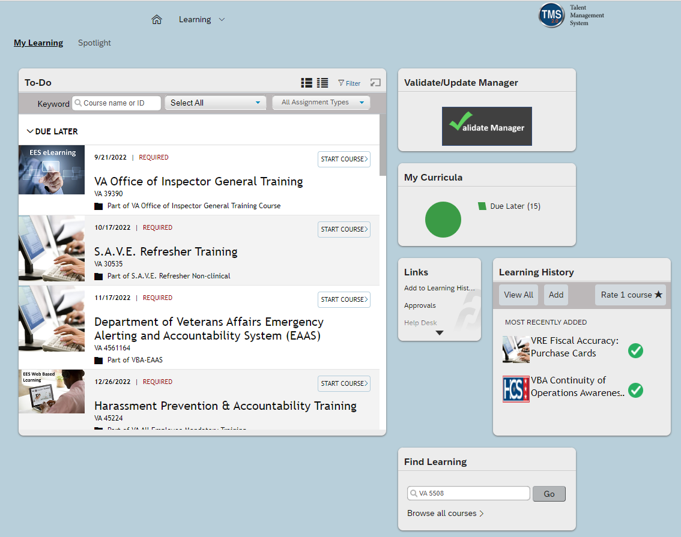

1. Find “VA Online Travel Card Training” course then click “Start Course”

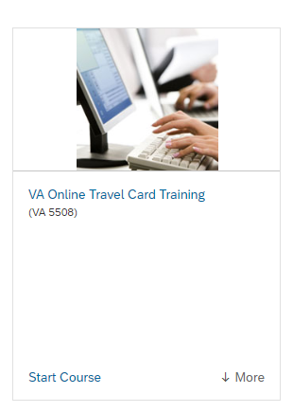

1. **Individual Travel Charge Card Application**
2. To apply for a travel charge card, an employee is required to complete and submit the following documents:
3. **Certificate of completion on the TMS training course VA 5508, “VA Online Travel Card Training,” which must be completed within 3 years.**
4. **US Bank Travel** [**Cardholder Setup Form**](https://www.usbank.com/dam/documents/pdf/commercial-banking/government-forms/CPS-GSA-Ci-Travel-Cardholder-Setup-Form.pdf)
5. Select “8201 (Visa)”
6. Issue Plastic “Yes”
7. Card Setup (Select “Expedite” if you have to travel within 10 days)
8. Ship to
9. Card delivery (Select “Overnight” if you have to travel within 10 days)
10. Required Cardholder Information Section
11. Required Cardholder Legal Information Section
12. Enter an alternate delivery address only if you want the card delivered to an address other than your residency
13. Cardholder/Applicant Understanding/Signature Section
14. [**VA Form 0933**](https://vaww.va.gov/vaforms/va/pdf/VA0933.pdf) **– Statement of Understanding For The Government Travel Charge Card Program**
15. Complete the following:
16. Initial all the provisions
17. Applicant’s Signature
18. Applicant’s Printed Name
19. Date
20. Applicant’s Title
21. Forward the VA Form 0933 to your supervisor for the following:
22. Supervisor’s Signature
23. Supervisor’s Printed Name
24. Date
25. Supervisor’s Title
26. [**VA Form 0868**](https://vaww.va.gov/vaforms/va/pdf/VA0868.pdf) **– Credit Worthiness Evaluation**
27. Section I
28. Blocks 1-4
29. Block 5, if applicable
30. Blocks 6-10
31. Section II only if you selected “Denied” in Section I block 1
32. For Station 101 employees, submit the documents to the Office of Financial Management, Travel Mailbox: [VAVBAWAS/CO/241C/TRAVEL](mailto:VAVBAWAS/CO/241C/TRAVEL)
33. For Regional Office employees, submit the documents to your local Travel A/OPC.