**VA Travel Checklist**

**OFM Improper Payments and Internal Controls (IPIC) Team**

All VBA personnel (regardless of pay grade, title, position, who you know, and how it was done before) are responsible for following all VA travel policy and Federal Travel Regulations for official travel.

**Talent Management System (TMS) Training**

* For travelers: complete a one-time Basic Travel Authorization and Travel Claim (VA 2052511) in TMS.
* For CONCUR travel certifiers, reviewers, and approvers: complete Travel Policy Services: Accountable Officials (VA 3867465) in TMS every two years.
* Agency/Organization Program Coordinators (A/OPCs): complete the GSA SmartPay A/OPC training every two years. Note: You take the training in GSA SmartPay, and self-certify in TMS (TMS course ID: GSA SmartPay Travel Card Training for A/OPC, OFED 3946996).
* For travel cardholders: complete VA Online Travel Card Training (VA 5508) in TMS every three years.

**Travel Authorization**

* Obtain permission to travel in advance of submitting a travel authorization.
  + Example: Email or travel letter from supervisor, leadership program manager, or other leader giving you permission to travel.
* Upload evidence of approval to travel in VA’s travel system, CONCUR, when creating the travel authorization.

**VA Travel Charge Card**

* All VA employees must apply for, receive, and activate the USBank government issued travel charge card, known as an Individually Billed Account (IBA), within 60 days of receipt.
* Notify the A/OPC once the card is activated so the A/OPC can complete items on their end.
* Any employee who has an IBA must use it to pay for all official travel expenses.
* Only appropriate uses of the IBA will be acceptable while on official travel.

**Submission of Expenses**

* Itemized receipts are required for a meal when the total cost, including tax and tip, is greater than $75.
* The IBA travel card cannot be used to purchase alcoholic beverages.
* Cardholders must ensure the total outstanding authorized reimbursable charges made to the IBA travel card are designated for split disbursement on the travel vouchers. Here are 3 Pro Tips for split disbursement on travel vouchers as well as an example.

Pro Tip #1: Check Your USBank Statement. Add up all your IBA expenses.

Note: My last travel was a few months ago, so I had to take a photo of the statement to show the balance.

However, at the time of your travel, you’ll be able to see the itemized charges in USBank.

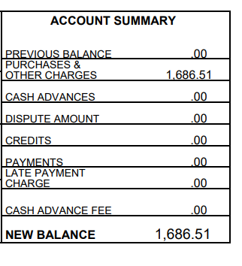

Pro Tip #2: In CONCUR under the Expenses & Receipts tab, make sure your IBA expenses have the IBA Payment Method.

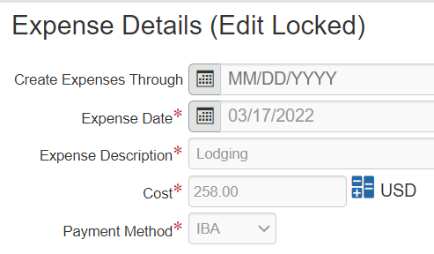

Pro Tip #3: In Concur, perform split disbursement under the Totals tab, Charge Card Reconciliation section.

My total USBank expenses was $1,686.51 (see Pro Tip #1). The first row represents the total amount marked as IBA Payment Method on the CONCUR travel voucher (see Pro Tip #2). I need to type 402.78 (because $1,686.51 - $1,283.73 = $402.78) into the second row so that the third row reflects my total USBank expenses. In summary, Row 1 + Row 2 must equal your total USBank expenses on Row 3.

1,283.73 + 402.78 = 1,686.51

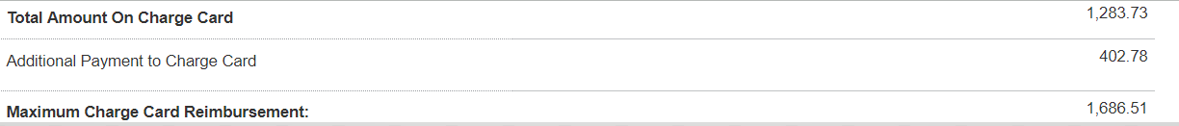

* Upon completion of authorized travel, travelers must submit a travel voucher in CONCUR within 5 workdays after completion of a trip.
* Employees on extended travel must submit a travel voucher in CONCUR every 30 days. If the traveler doesn’t comply, the single purchase limit will be reduced to $1 until the traveler submits a voucher in CONCUR.
* Approving officials will have 3 business days to review the travel voucher and make a decision (approve or return the voucher to the traveler for correction).
* VA will reimburse authorized travel expenses no later than 21 days after submission of a travel voucher.

**If you have any further questions, contact the FORD Travel Team for travel questions, including Permanent Change of Station (PCS), TDY Travel, and Travel Cards:**

VAVBAWAS/CO/241C/TRAVEL

**Additional Resources and Links:**

[Improper Payments & Internal Controls (IPIC)](https://dvagov.sharepoint.com/sites/vbaofmhub/SitePages/Internal-Control-&-Improper-Payments.aspx)

[VA Financial Policy – Travel](https://www.va.gov/finance/policy/pubs/volumeXIV.asp)

[Knowledge Management Portal, M24-4 Chapter 02, Travel](https://vaww.vrm.km.va.gov/system/templates/selfservice/va_kanew/help/customer/locale/en-US/portal/554400000001057/content/554400000198077/M24-4-Chapter-02-Travel)

[Federal Travel Regulation](https://www.ecfr.gov/current/title-41/subtitle-F)

**Acronyms:**

A/OPC Agency/Organization Program Coordinators

GSA General Services Administration

IBA Individually Billed Account

IPIC Improper Payments and Internal Controls

OFM Office of Financial Management

TMS Talent Management System

VA Veterans Affairs

VBA Veterans Benefits Administration