**FAS BENEFICIARY TRAVEL PAYMENT GUIDE**

**PURPOSE:** The purpose of this guide is to provide the process for Beneficiary Travel Payments in Support Services Division Finance*.* When a Veteran meets the conditions for the various situations explained on the reference manual, VA may authorize the Beneficiary Travel. The Veteran will be asked if he/she wishes to claim travel for the appointment or evaluations and must file the claim within 30 days after the completion of travel. Reimbursement will be for the mileage driven in a private vehicle at a rate prescribed in the manual.

**REFERENCES:**

* M28R, Part V, Section B, Chapter 6

**FINANCE PROCEDURES:**

1. Open FAS - 
2. Ensure “Adobe PDF” is selected as your default printer.
3. Type in Veteran’s File Number and click “Search”.

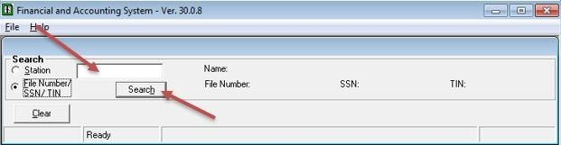

1. Click on the “View Transaction History” button.

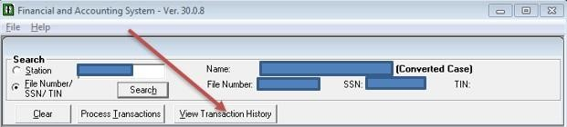

1. Click on the “All Transactions” tab and verify there are no previous 06A payments in the “List All Transactions” field.

* 1. If an 06A payment is equal to the pending amount, verify it is not a duplicate payment by viewing “Transaction Notes”.
  2. If it is a duplicate 06A payment, return the BT to VR&E. If this is not a duplicate 06A payment, proceed to the next step.

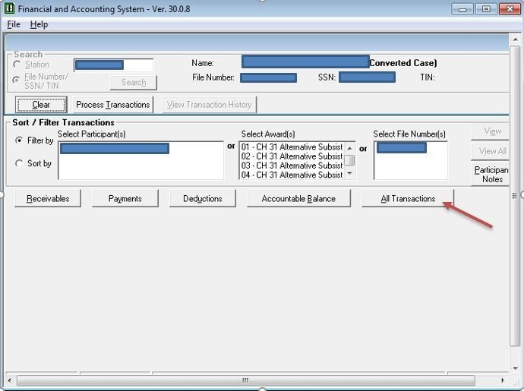

1. Click on the “Process Transactions” tab.

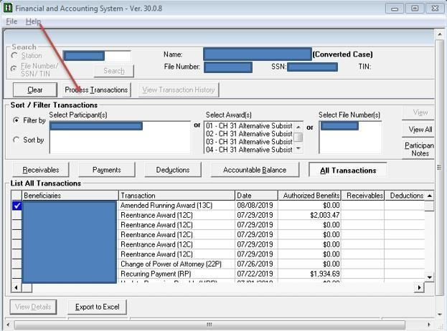

1. Choose the “CH31 Award” (if available, otherwise select Compensation/Pension) and click on the “Process Participant Transaction” tab.

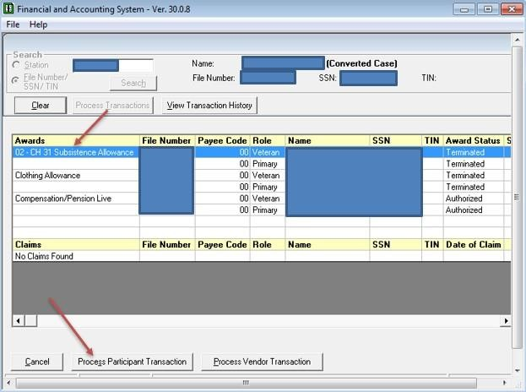

1. Under “Payments” choose “One Time Payments (06A)” and click next.

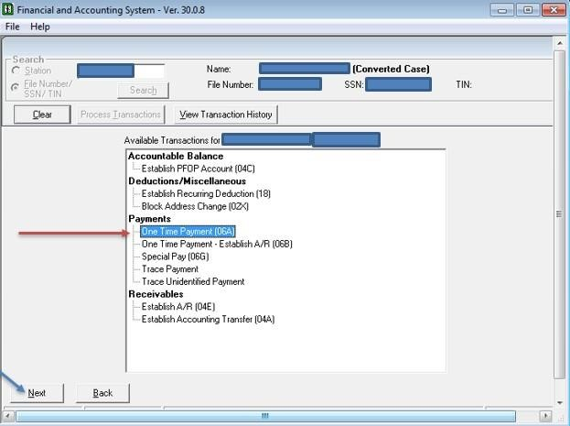

1. In “Program Type” choose “Chapter 31” in the dropdown box.

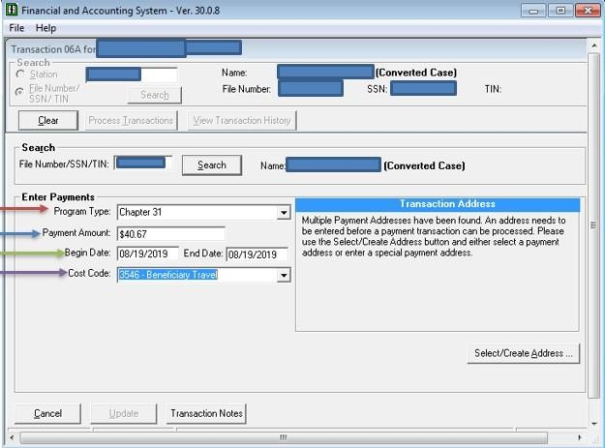

1. In the “Payment Amount” field, enter the total amount to be paid.

1. In the “Begin Date” field, use the date listed on the 20-0968 Beneficiary Travel form.

1. In the “End Date” field, use the date listed on the 20-0968 Beneficiary Travel form.
2. In the “Cost Code” dropdown box, choose the cost code “3546 – Beneficiary Travel”.
3. Click on the “Transaction Notes” button.

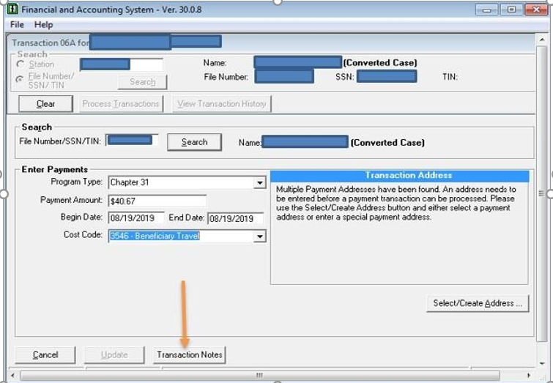

1. Type in a description of the payment and click the “OK” button.

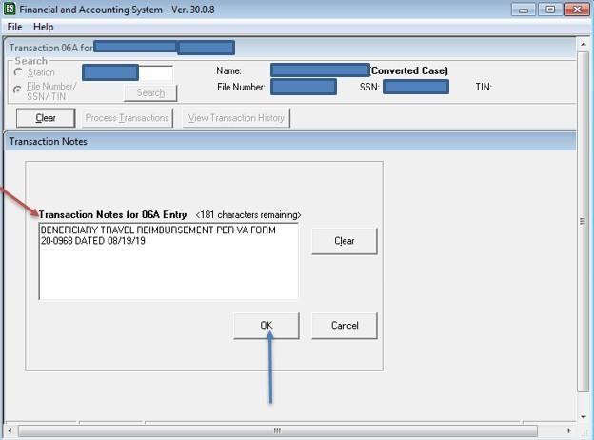

1. Click on the “Select/Create Address” tab.

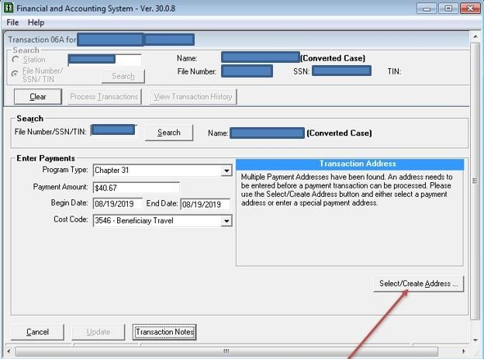

1. Select EFT Payment Address – If more than one option is available for “CH31 Alternative Substance Allowance”, choose the latest option as shown in the screenshot below and click “OK”.

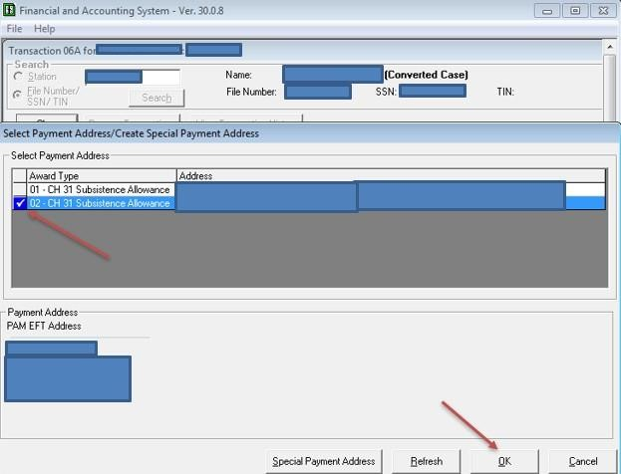

1. Verify all entered data is correct.

1. Click the “Update” button.

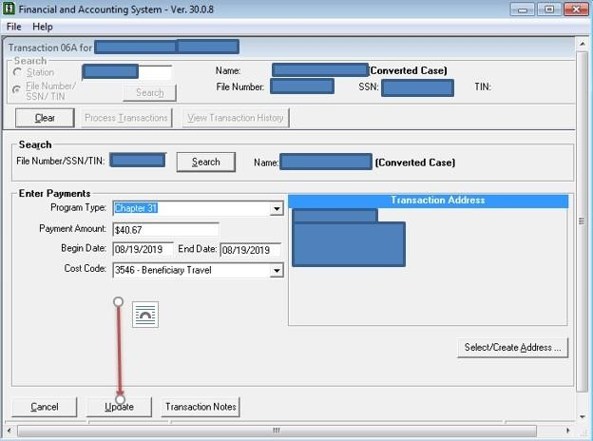

1. Electronically sign the automated FAS print copy.

1. Send to be approved.
2. Once approved, upload all documents into VBMS.