**Rapid Improvement Event (RIE) – SOP Development**

**Process: Beneficiary Travel**

**PURPOSE:** The purpose of this Standard Operating Procedure (SOP) is to outline the procedures for processing a claimant’s request for reimbursement of beneficiary travel (BT) expenses to and from the Vocational Rehabilitation & Employment (VR&E) office or other place in connection with vocational rehabilitation. Reimbursement for BT may be authorized at government expense within the limits specified by law in accordance with Title 38 United States Code (38 U.S.C) 111 in the following situations: Initial evaluation, reevaluation and counseling appointments, intraregional travel, interregional travel and attendant travel.

1. **SCOPE**: When a claimant meets the conditions for the various situations explained in the reference manual (M28R), VA staff may authorize the BT. The claimant will be asked if he/she wishes to claim travel for the appointment or evaluations and must file the claim within 30 days after the completion of travel. Reimbursement will be for the mileage driven in a private vehicle at a rate prescribed in 38 U.S.C 111 – Payments or Allowances for Beneficiary Travel.

This SOP applies to all VR&E personnel processing beneficiary travel within the Regional Office (RO), as well as the Finance Administration personnel in Finance, receiving and processing the requests. Each employee is individually responsible for the proper execution of the guidance provided in this document.

Effective with the pilot start date, CWNRS will only be used to generate VAF-0968, and to document required actions, described in the procedures below. Financial and Accounting System (FAS) is the primary application to process and approve voucher

1. **REFERENCES:** 
   1. M28R.V.B.6

**Standard Operating Procedure**

**VR&E PROCEDURES:**

* + 1. Generate electronic copy of driving directions from any reputable application (e.g., MapQuest or Google) that shows the travel origin, destination, and total mileage.
    2. Generate VAF 20-0968, Claim for Reimbursement of Travel Expenses, in CWINRS Financial tab. Select *Beneficiary Travel*, click *Add Beneficiary Travel* transaction, and click *Travel Voucher*.
    3. Ensure that the claimed dates of travel, mileage, and amounts are correct.
    4. Complete the applicable items #1 through #29 on VAF 20-0968.
    5. Ensure claimant signs and dates VAF 20-0968 on items #25 and #26 to certify the travel cost.
    6. Review VAF 20-0968 and certify the payment by completing items #15, #28 and #29.

**Note**: Digital signatures and/or signatures using e-signature pads on forms are preferred, however, wet signatures are acceptable.  This is applicable to VRC and claimant signatures.

* + 1. Create a package for each claimant in a .pdf format, and name the file using your station’s naming convention (e.g., last name, first name, date of form or invoice number - $total). that includes all supporting documentation.  The package must include the following:

1. Completed VAF 20-0968
2. Copy of information from Mapquest or other reputable site verifying mileage.
3. If applicable, receipts for parking, tolls, etc.
4. Any other necessary supporting documentation to justify the reimbursement.
5. VR-64, Ch31 Positive Decision Letter.
   * 1. Send the .pdf file to SSD electronically. The local SSD will instruct VR&E staff the method for electronic transmittal, e.g. email, SharePoint, shared drives. VRC is not required to maintain copies of documentation. SSD staff will upload documentation to VBMS after payment is processed
     2. Send VR-64, Ch31 Positive Decision Letter, to claimant.

**FINANCE PROCEDURES**:

* + 1. SSD electronically receives VAF 20-0968 and all applicable documents to perform audit and validation.
    2. SSD employee reviews for accuracy and completeness on the following:

Block 1: Date issued

Blocks 2-3: Name and address of Claimant/SSN

Block 6: Self populates (When to report)

Block 8: Authorization for travel at government expense

Block 10: Rate of Mileage (verify correct rate)

Block 15: Signature of Authorizing Official

Block 17: Location from/to, total miles, amount claimed, Total mileage allowance

Block 18: Other expenses (if Yes, verify item 19 / if No, skip to 20)

Block 20: Total amount claimed

Block 21: Name of Claimant

Block 22: Claimant SSN

Block 25-26: Signature and date of Claimant

Block 28-29: Date and Signature of VRC

Block 30-32: Completed by SSD in the audit process

If error found, return to VR&E. If audit clears, generate 06A payment in FAS. (Note: All screenshots below contain fictitious test data. No PII is included.)

* + - 1. Reset printer default to Adobe.
      2. Input file number and search
      3. Select Process Transaction button
      4. Highlight correct participant and award (Ch. 31 if available, otherwise select Compensation/Pension Live)
      5. Select Process Participant Transaction button

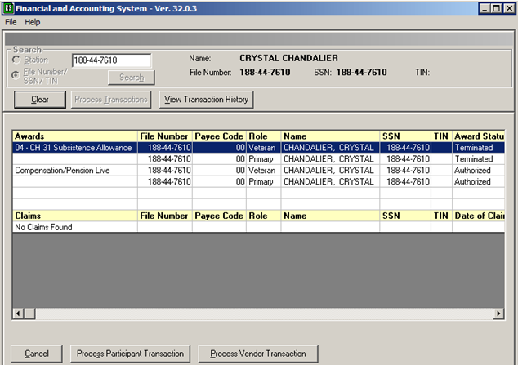

* + - 1. Under Payments, select one-time payment 06A
      2. Press Next

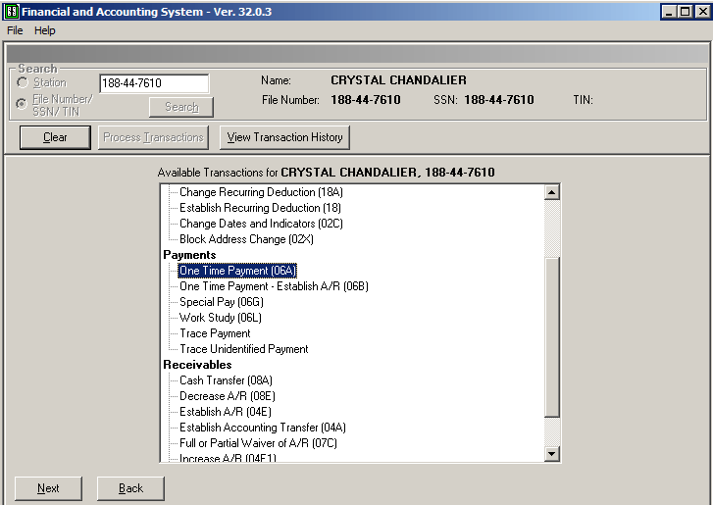

* + - 1. Under Enter Payments, Program Type (dropdown), select Ch. 31
      2. For Payment Amount, use amount in Block 30 of VAF 20-0968
      3. Input Begin Date and End Date
      4. Select cost code from dropdown (3546-Beneficiary Travel)
      5. Go to Transaction Notes – insert report date, mileage (if applicable) and other details as needed.
      6. Press OK.

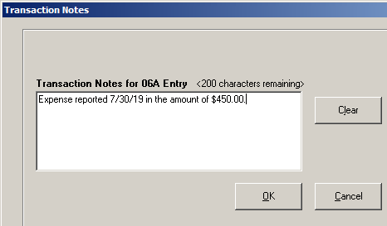

* + - 1. Verify transaction address. Alternate address can be entered.
      2. Select Update and notify authorizing official.

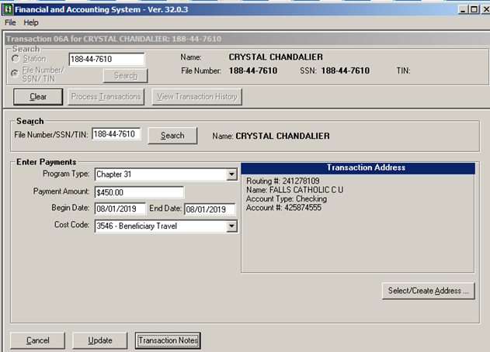

Authorize 06A payment in FAS. (Note: All screenshots below contain fictitious test data. No PII is included.)

* + - 1. Reset printer default to Adobe.
      2. Review all electronic documents
      3. Click Station from dropdown.
      4. Search

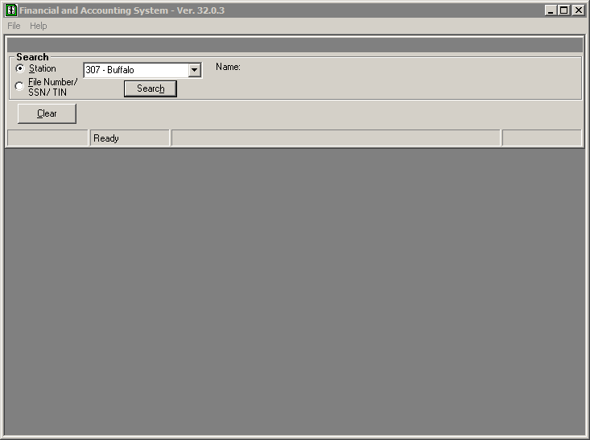

* + - 1. Select Authorization button
      2. Select the line to be authorized
      3. Click Next

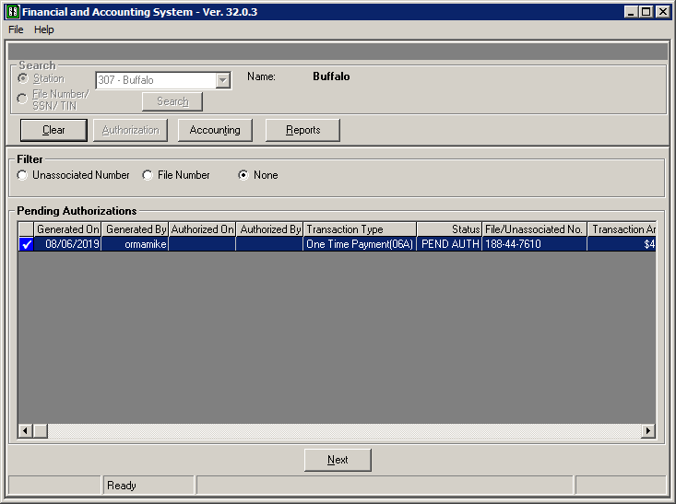

* + - 1. If payment OK, authorize transaction, if not, disapprove

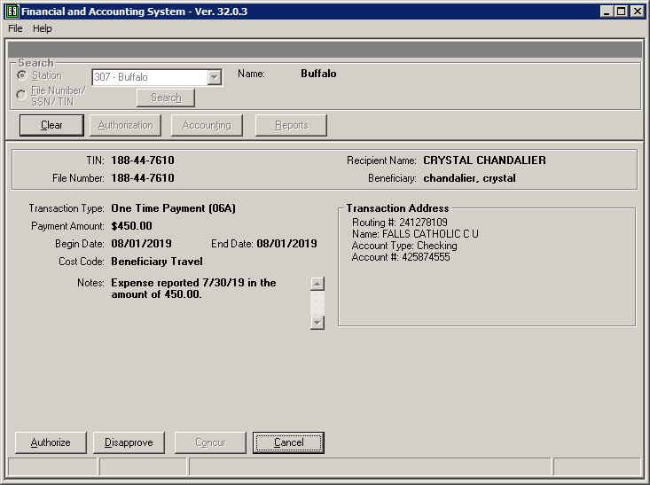

* + - 1. FAS will automatically generate the fiscal print in electronic format.
    1. SSD uploads authorized fiscal documents, VAF 20-0968, and supporting documents into VBMS folder.
       1. Log into VBMS
       2. Select Search tab
       3. Insert File Number
       4. Open eFolder
       5. Select Upload Documents from Actions dropdown options
       6. Select Browse to select appropriate file
       7. Complete Subject Line: Beneficiary Travel [Report Date (mm/dd/yyyy]
       8. Category Type: Select Financial Actions: FAS All Transactions
       9. Content Source: Select VRE
       10. Enter date of receipt from VRE
       11. Select Upload