**FAS PAYMENT INQUIRY GUIDE**

**PURPOSE:** The purpose of this guide is to provide the local process for researching payment inquiries in the Financial and Accounting System (FAS) for VR&E*.*

**VR&E PROCEDURES:**

1. Open FAS - 
2. Type in Veteran’s File Number and click the “Search” button.

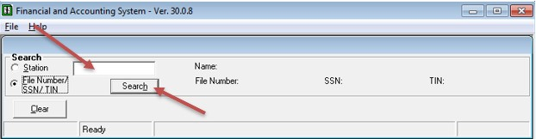

1. Click on the “View Transaction History” button.

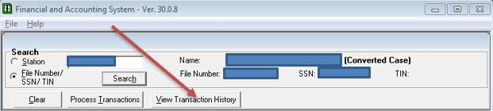

1. Click on the “All Transactions” button.

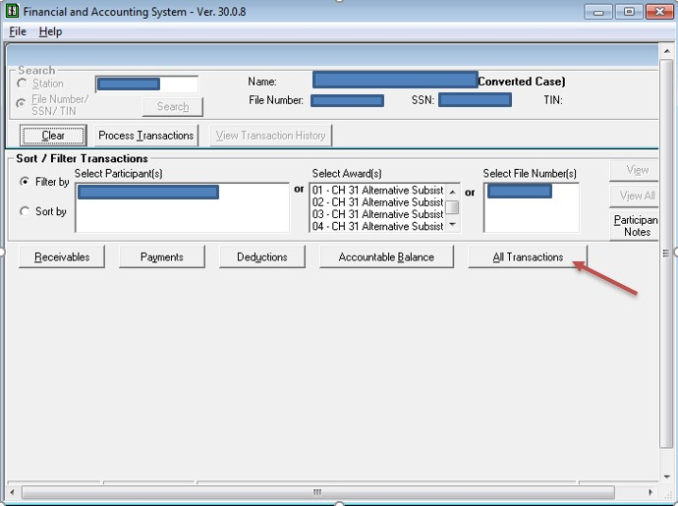

1. Search for payments in the “Authorized Benefits” column and look for “One Time Payments (06A)” in the transaction column.

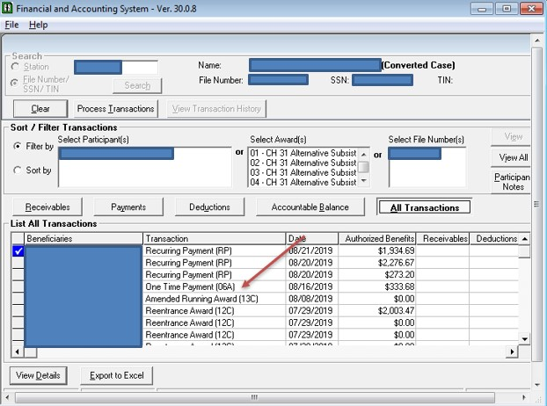

1. When you find the total in the “Authorized Benefits” column, click on the “View Details” to find out additional information regarding the payment.

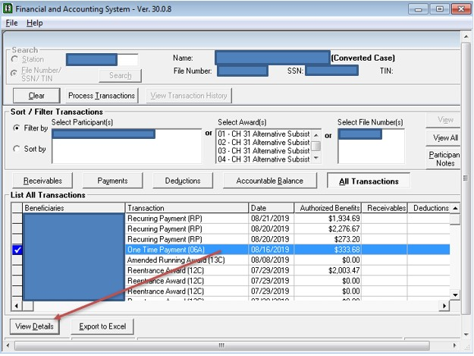

1. Schedule Date – The date the payment was made. Payment Date – The date the Veteran received the funds in direct deposit. Click on the “View Details” to find out additional information regarding the payment.

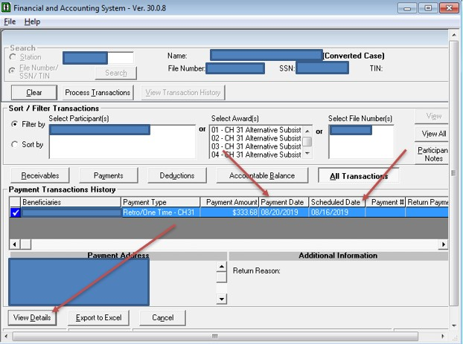

1. For a detailed description of the payment, click on “Transaction Notes” button.

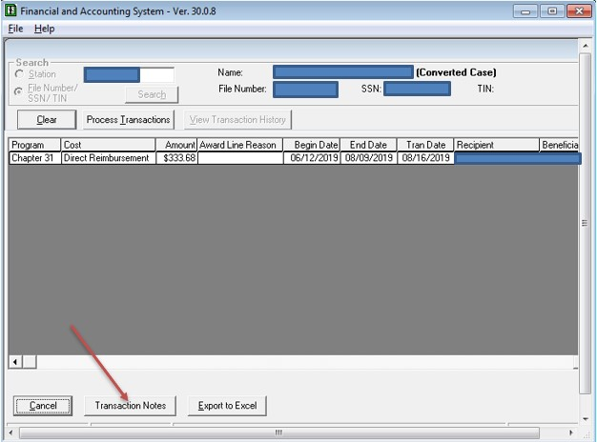

1. The detailed description for the payment is located in the “Transaction Notes for O6A” field.

