**FAS DIRECT REIMBURSEMENT PAYMENT GUIDE**

**PURPOSE:** The purpose of this guide is to provide the process for Direct Reimbursement Payment in Support Services Division Finance*.* Direct reimbursement is appropriate when a facility bookstore does not carry required supplies, or a vendor does not accept the government purchase card. Reimbursement to a Veteran for the purchase of supplies or services should be the last available option and should not be utilized unless there is no other way to obtain the supplies in a timely manner. A Veteran who is attending a facility that does not have a bookstore on campus or who is participating in an online training program should be given VAF 28-1905 to authorize payment for books and supplies at a local facility bookstore that has been approved and has a valid facility code before considering direct reimbursement.

**REFERENCES**:

* M28-1, Part III, Chapter 6, Supplies
* M28R, Part V, Section A, Chapter 3 & 4

**FINANCE PROCEDURES**:

1. Open FAS - 
2. Ensure “Adobe PDF” is selected as your default printer.
3. Type in Veteran’s File Number and click “Search”.

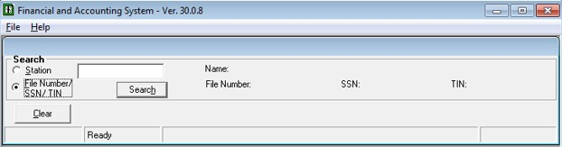

1. Click on the “View Transaction History” button.

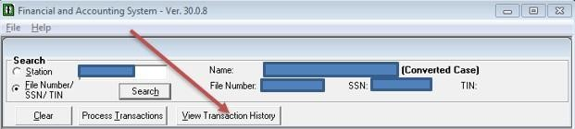

1. Click on the “All Transactions” tab and verify there are no previous 06A payments equal to the pending amount.

1. If an equal 06A payment has been previously processed return the Direct Reimbursement to VR&E.
2. If there are no previous 06A payments equal to the pending amount, proceed to the next step.

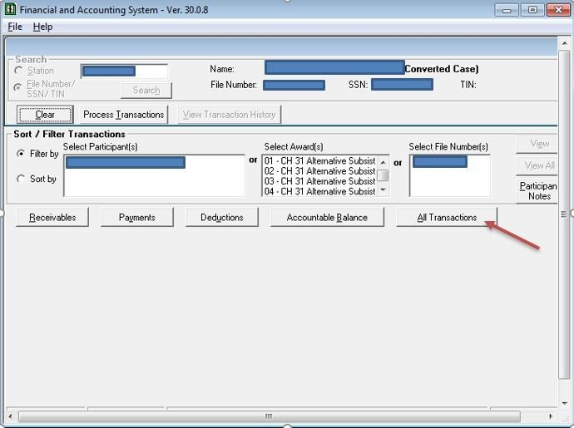

1. Click on the “Process Transactions” tab.

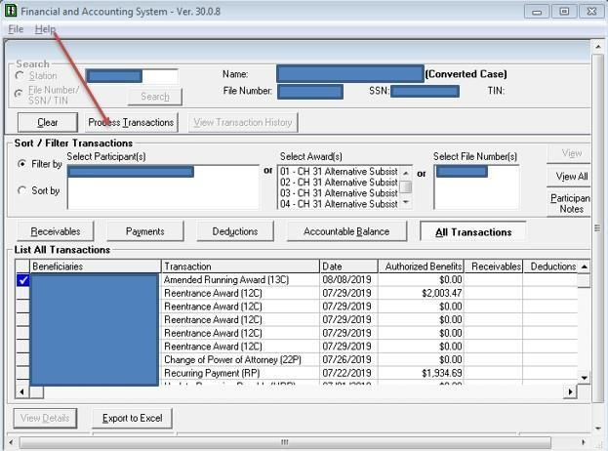

1. Click on the "CH31" award (If available, otherwise select Compensation/Pension Live), and then “Process Participant Transaction” tab.

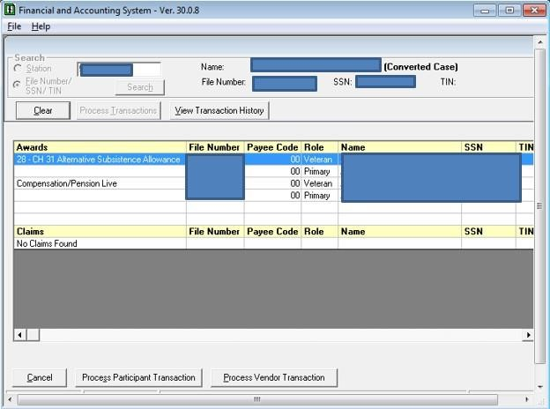

1. Under “Payments” choose “One Time Payments (06A)” and click “Next”.

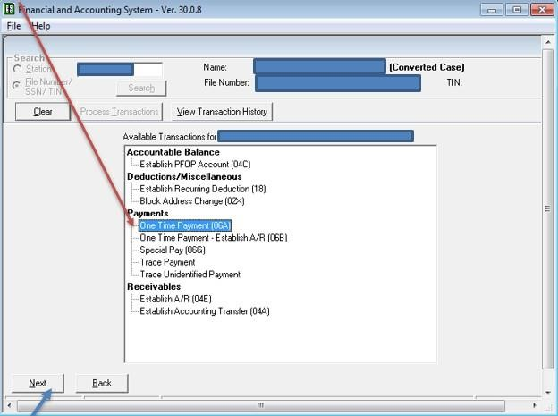

1. In “Program Type” choose “Chapter 31” in the dropdown box.

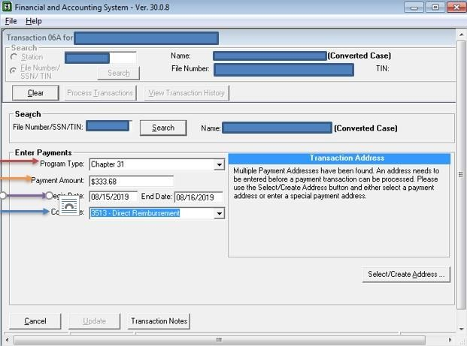

1. In the “Payment Amount” field enter the total amount to be paid shown in the “Total” field on the SF1034.

1. In the “Begin Date” field add yesterday’s date.

1. In the “End Date” field add today’s date.

1. In the “Cost Code” dropdown box, choose the cost code “3513 – Direct Reimbursement”.
2. Click on the “Transaction Notes” button.

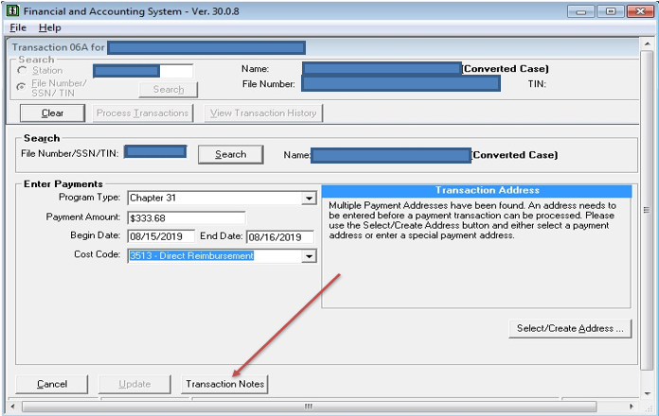

1. Type in a description of the payment and click the “OK” button.

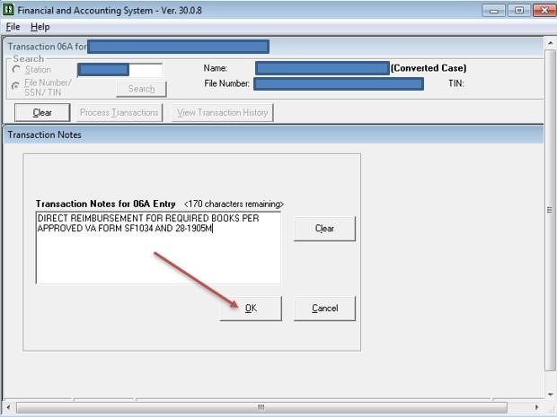

1. Click on the “Select/Create Address” tab

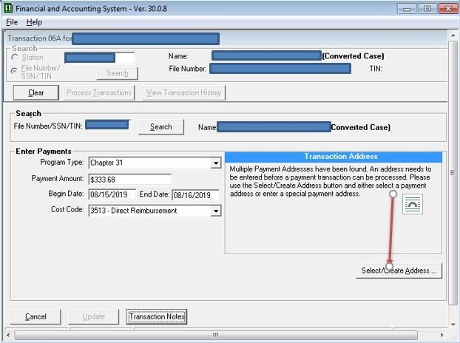

1. Select EFT Payment Address – If more than one option is available for “CH31 Alternative Substance Allowance”, choose the latest option as shown in the screenshot below and click “OK”.

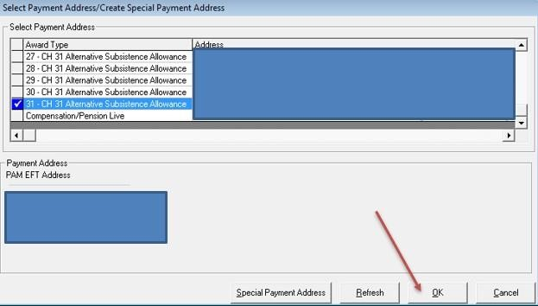

1. Verify all entered data is correct.

1. Click the “Update” button.

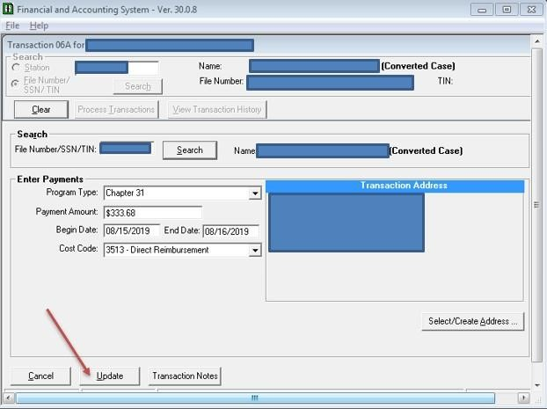

1. Electronically sign the automated FAS print copy.

1. Send to be approved.

1. Once approved, upload all documents into VBMS.