**Rapid Improvement Event (RIE) – SOP Development**

**Process: Direct Reimbursement**

**PURPOSE:** The purpose of this Standard Operating Procedure (SOP) is to outline the procedures for processing a Claimant’s request for reimbursement for Chapter 31 services and supplies needed to participate in the Vocational Rehabilitation and Employment (VR&E) program when the facility bookstore does not carry required supplies or does not accept the government purchase card.

1. **SCOPE**: Direct reimbursement is appropriate when a facility bookstore does not carry required supplies, or a vendor does not accept the government purchase card. Reimbursement to a claimant for the purchase of supplies or services should be the last available option and should not be utilized unless there is no other way to obtain the supplies in a timely manner. A claimant who is attending a facility that does not have a bookstore on campus or who is participating in an online training program should be given VAF 28-1905 to authorize payment for books and supplies at a local facility bookstore that has been approved and has a valid facility code before considering direct reimbursement. Note: For terms beginning on or after January 1, 2020, and for claimants currently enrolled at University of California-San Diego or Strayer University, VAF-1905 will no longer be used to authorize supplies. Authorizations will be sent electronically through Invoice Payment Processing System (IPPS) to those vendors with a valid facility code.

This SOP applies to all VR&E personnel processing direct reimbursement requests within the Regional Office (RO), as well as the Finance Administration personnel in Finance, receiving and processing the requests. Each employee is individually responsible for the proper execution of the guidance provided in this document.

Effective with the pilot start date, CWNRS will only be used to generate VAF-1905ms, SF-1034s, and to document required actions, described in the procedures below. Financial and Accounting System (FAS) is the primary application to process and approve voucher payments.

1. **REFERENCES:**

M28R.V.A.3.05.a, M28R,V.A.4.05.c.







**Standard Operating Procedure**

**VR&E PROCEDURES:**

* + 1. Obtain written request for supply from the claimant (an email satisfies this requirement).
    2. Enter justification for the direct reimbursement in CWINRS Notes.  The documentation must explain the reason for using direct reimbursement in lieu of direct purchase from the school or bookstore or use of government purchase card.  Additionally, justify purchases of items not listed in the rehabilitation plan.  Justify purchase of incidental goods or supplies - items that are not required but needed by the claimant to complete his or her rehabilitation program.
    3. Authorize the request using VAF-1905m.  Claimant’s signature must also be included on this form.
    4. Generate SF 1034 in CWINRS after items are received with proof of receipt.
    5. Complete SF 1034 using information from purchase documentation.

Ensure that all required information below is completed on the SF 1034:

* Station number
* Name, Address, and Claim Number (use full claim number)
* Date Invoice Received (by VR&E)
* Number and Date of Order
* Date of Delivery of Services
* Articles or Services
* Quantity
* Cost and Per (description of unit, ex, pack, hour, etc.)
* Total (amount)
* By (Signature of the VRC approving the purchase)
* Title
* Authorizing Certifying Officer (VREO’s concurrence and signature required for incidental goods/services exceeding $1,250 in a 12-month period. VRC is responsible for keeping track of the goods/services total. If the total is less than or equal to $1,250, VRC’s signature is required on this block.)
* Date
* Title

**Note: Digital signatures and/or signatures using e-signature pads on forms are preferred; however, wet signatures are acceptable**.

* + 1. Create a package for each claimant in a .pdf format, and name the file using your station’s naming convention (e.g., last name, first name, date of form or invoice number - $total). that includes all supporting documentation.  The package must include the following:

1. Completed SF 1034
2. The written request from the claimant
3. Completed VAF 28-1905m
4. Receipts and/or invoices
5. Documented proof of receipts of purchased goods or services from claimant
6. Any other necessary supporting documentation to justify the purchase
7. Copy of completed VR-64, Chapter 31 Positive Decision Letter (not required if VR-67 previously issued)
   * 1. Send the .pdf file to SSD electronically. The local SSD will instruct VR&E staff the method for electronic transmittal, e.g. email, SharePoint, shared drives. VRC is not required to maintain copies of documentation. SSD staff will upload documentation to VBMS after payment is processed.
     2. Send VR-64, Chapter 31 Positive Decision Letter to claimant.

**FINANCE (SSD) PROCEDURES**:

* + 1. SSD electronically receives SF 1034 and all applicable documents to perform audit and validation.
    2. SSD employee reviews for accuracy and completeness on the following:
* Station number
* Name, address, and full claim number
* Date invoice received (report date)
* Validating
  + Number and date of order
  + Date of delivery of services
  + Articles or services
  + Quantity
  + Cost each
  + Total cost
  + Email address on file (when requested via email)
* By equals VRC
  + Signature
  + Title
* Authorizing certifying officer (VRC or VREO depends on the total of the incidental goods/services. See VR&E Procedures v. above)
  + Date
  + Signature
  + Title
* SSD auditor verifies correct amount for payment
  + 1. If error found, return to VR&E. If audit clears, generate 06A payment in FAS.

(Note: All screenshots below contain fictitious test data. No PII is included.)

* + - 1. Reset printer default to Adobe.
      2. Input file number and search
      3. Select Process Transaction button
      4. Highlight correct participant and award (Ch. 31 if available, otherwise select Compensation/Pension Live)
      5. Select Process Participant Transaction button

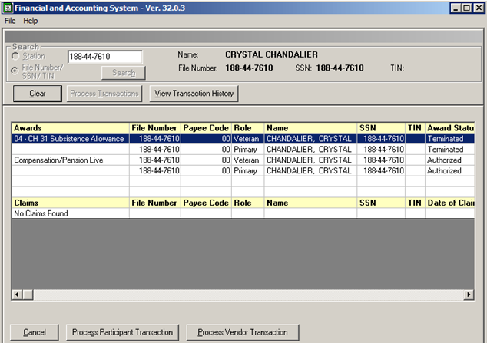

* + - 1. Under Payments, select one-time payment 06A
      2. Press Next

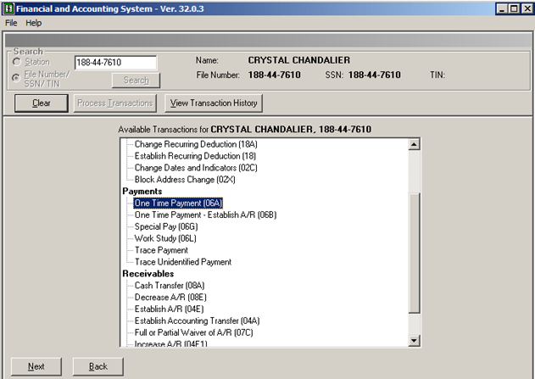

* + - 1. Under Enter Payments, Program Type (dropdown), select Ch. 31
  + For Payment Amount, use amount in “Total cost” of SF 1034
    - 1. Input Begin Date and End Date
      2. Select cost code from dropdown (3513-Direct Reimbursement)
  + For Retroactive Inductions (cases where we are paying the difference between Chapter 33 and Chapter 31 tuition) select cost code 3507 – Tuition and Fees.
    - 1. Go to Transaction Notes – enter “Direct Reimbursement”, date invoice received by VR&E (refer to SF 1034 field), Mileage (if applicable) and other details as needed.
      2. Press OK.

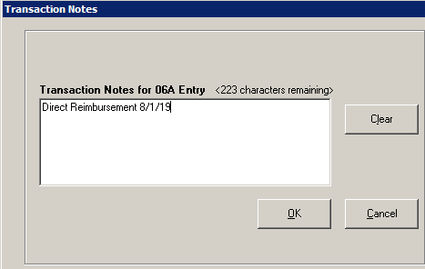

* + - 1. Verify transaction address. Alternate address can be entered.
      2. Select Update and notify authorizing official.

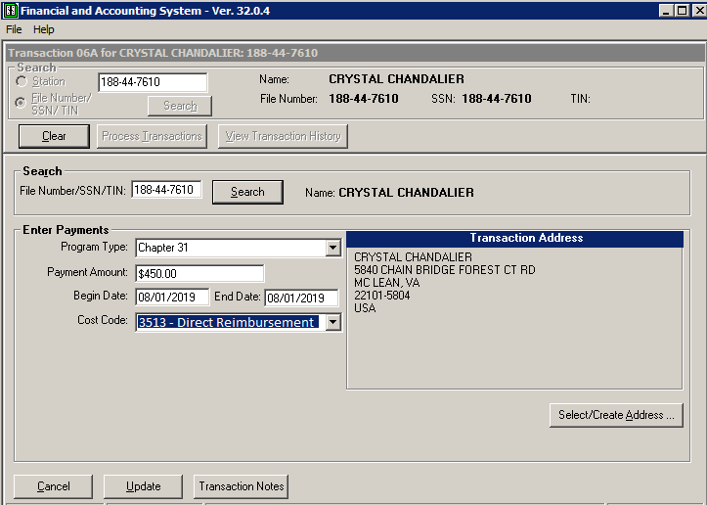

Authorize 06A payment in FAS. (Note: All screenshots below contain fictitious test data. No PII is included.)

* + - 1. Reset printer default to Adobe.
      2. Review all electronic documents
      3. Click Station from dropdown.
      4. Search

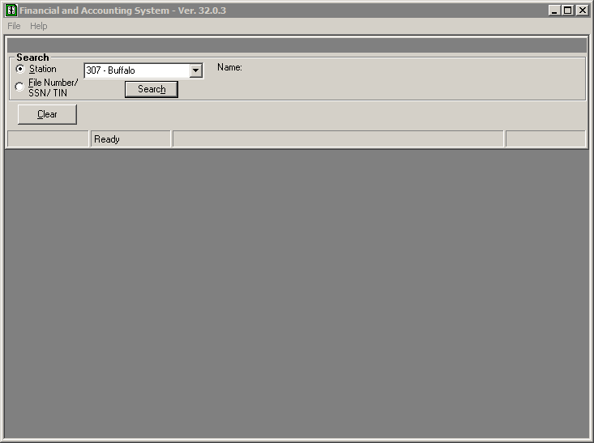

* + - 1. Select Authorization button
      2. Select the line to be approved
      3. Click Next

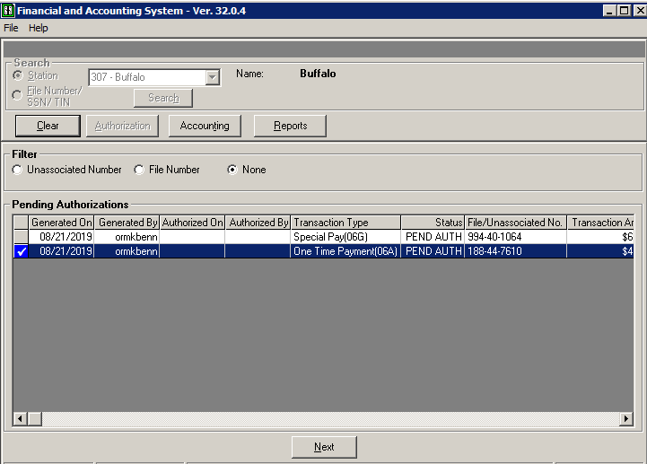

* + - 1. If payment OK, approve transaction, if not, disapprove

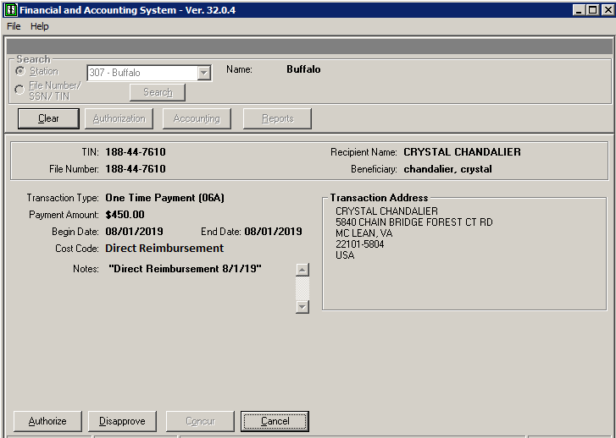

* + - 1. FAS will automatically generate the fiscal print in electronic format.
    1. SSD uploads authorized fiscal documents, SF 1034, and supporting documents into VBMS folder.
       1. Log into VBMS
       2. Select Search tab
       3. Insert File Number
       4. Open eFolder
       5. Select Upload Documents from Actions dropdown options
       6. Select Browse to select appropriate file
       7. Complete Subject Line: Direct Reimbursement and [Date Invoice Received (mm/dd/yyyy)]
       8. Category Type: Select Financial Actions: FAS All Transactions
       9. Content Source: Select VRE
       10. Enter date of receipt from VRE
       11. Select Upload