VBA Budget Formulation and Execution

May 30-31, 2018

Instructor-Led Training

Participant Guide

 

VBA Budget Formulation and Execution

ILT Participant Guide

This page intentionally left blank.

Table of Contents

1.0 About This Training 1

1.1 Training Purposes 1

1.2 Learning Environment 1

2.0 How to Use this Participant Guide 1

2.1 Participant Materials 1

2.2 Icons 2

3.0 Course Overview 2

3.1 Course Description 2

3.2 Target Audience 2

3.3 Learning Objectives 3

3.3.1 Web-Based Training 3

3.3.2 Instructor-Led Training 4

4.0 Course Schedule 5

4.1 Web-Based Training 5

4.2 Instructor-Led Training 6

5.0 Course Preparation 7

6.0 Course Content 9

6.1 Introduction 9

6.1.1 Introduction to VBA Budget Formulation and Execution 9

Slide 1 9

Slide 2 9

6.2 Lesson 1: Budgets Recap 10

6.2.1 Introduction 10

Slide 3 10

6.2.2 General Five Step Budget Process 10

Slide 4 10

Slide 5 11

Slide 6 12

Slide 7 13

Slide 8 14

Slide 9 15

6.2.3 Continuing Resolution 16

Slide 10 16

Slide 11 16

Slide 12 18

Slide 13 21

6.2.4 Common Financial Reports and Systems 22

Slide 14 22

Slide 15 23

Slide 16 25

Slide 17 27

Slide 18 29

Slide 19 31

Slide 20 32

Slide 21 33

Slide 22 34

Slide 23 36

Slide 24 38

Slide 25 39

Slide 26 40

Slide 27 41

Slide 28 42

Slide 29 43

Slide 30 45

Slide 31 47

Slide 32 48

Slide 33 49

Slide 34 50

Slide 35 51

Slide 36 52

Slide 37 53

Slide 38 54

Slide 39 55

Slide 40 56

Slide 41 57

Slide 42 57

6.3 Lesson 2: Budget Call 59

6.3.1 Introduction 59

Slide 43 59

6.3.2 General Operating Expense Budget Call 59

Slide 44 59

Slide 45 60

Slide 46 62

Slide 47 63

6.3.3 Minor Construction Budget Call 64

Slide 48 64

Slide 49 65

Slide 50 66

Slide 51 67

Slide 52 68

Slide 53 69

Slide 54 69

Slide 55 70

6.4 Lesson 3: Operating Plan 71

6.4.1 Introduction 71

Slide 56 71

6.4.2 Budget Formulation 72

Slide 57 72

Slide 58 73

Slide 59 75

Slide 60 77

Slide 61 78

Slide 62 80

Slide 63 82

Slide 64 84

6.4.3 Impact Statement 86

Slide 65 86

Slide 66 87

Slide 67 88

Slide 68 89

Slide 69 91

Slide 70 93

Slide 71 93

6.5 Lesson 4: Execute and Accrue 95

6.5.1 Introduction 95

Slide 72 95

6.5.2 Budget Formulation 95

Slide 73 95

Slide 74 96

Slide 75 98

6.5.3 Accruals 99

Slide 76 99

Slide 77 100

Slide 78 100

Slide 79 101

Slide 80 101

Slide 81 103

Slide 82 104

Slide 83 104

Slide 84 105

Slide 85 105

Slide 86 106

Slide 87 106

Slide 88 107

Slide 89 107

6.5.4 Fiscal Year Close 108

Slide 90 108

Slide 91 109

Slide 92 110

Slide 93 111

Slide 94 112

Slide 95 113

Slide 96 114

Slide 97 116

Slide 98 118

Slide 99 119

Slide 10 119

Slide 101 120

Slide 102 120

7.0 Appendix: Performance Support Tools 121

7.1 Transaction Codes 121

7.2 Budget Call Letter 122

7.3 Budget Call Sample Spreadsheet 118

7.4 Minor Construction SCIP FYXX Call Letter Justification 119

7.5 Attachment B Minor Construction Project Proposal FYXX Any Town VR&E Out-based Office 120

7.6 Minor Construction Action Plan Call Memo FY17 121

7.7 Station Budget Operating Plan: Work Areas – Definitions 122

7.8 2015 Paid Calendar 123

7.9 Hourly Salary Table 124

7.10 Purchase Card Accrual Form 125

7.11 Populated Purchase Card Accrual Form 126

List of Figures

Figure 1: Continuing Resolution Letter 17

Figure 2: Extension Letter 18

Figure 3: F826 - Status of Allowance 25

Figure 4: F26A - Object Class by Allowance – Example of Being Under a CR 28

Figure 5: F26A - Object Class by Allowance - Example of Balances After Receiving Budget Allowance 29

Figure 6: F829 - Accepted Document Listing by Station 31

Figure 7: F850 - Verification of General Ledger Balances – Undelivered 33

Figure 8: F851 - Verification of General Ledger Balances - Payables Federal/Non-Federal 35

Figure 9: F852 - General Ledger Reconciliation of FMS and Fixed Asset Subsystem 37

Figure 10: F853 - Verification of General Ledger Balances - Accounts Receivables Federal/Non-Federal 38

Figure 11: F854 - Travel Advances 39

Figure 12: F855 - Verification of General Ledger Balances - Advances Federal/Non-Federal 41

Figure 13: F856 - Unapplied Deposits Verification Report 42

Figure 14: F20D - Daily Activity by Accounts Classification Code 44

Figure 15: F885 - Obligations by Budget Object Code Report 46

Figure 16: Trend Analysis with Actual Figures 47

Figure 17: Trend Analysis with Actual Figures, cont. 48

Figure 18: CAATS Reports 53

Figure 19: CAATS Main Menu 54

Figure 20: Example of an Allowance Letter 74

Figure 21: Example of an Attachment A 76

Figure 22: Finished Sheet (Funding Tab) 84

Figure 23: Example of an Impact Statement 90

Figure 24: VBA District Locations 91

Figure 25: Budget Execution Timeline 97

Figure 26: Example of Payroll Analysis 115

Figure 27: Example of Non-Payroll Analysis 117

Figure 28: Budget Call Sample Spreadsheet 118

Figure 29: Minor Construction Action Plan Memo 121

Figure 30: Paid Calendar 2015 123

Figure 31: Hourly Salary Table 124

Figure 32: Blank Purchase Card Accrual Form 125

Figure 33: Example of Populated Purchase Card Accrual Form 126

List of Tables

Table 1: Acronyms viii

Table 2: Icon Legend 2

Table 3: Fiscal Year 2016 VBA Minor Construction Project Proposal 120

Acronyms

Table : Acronyms

| **Acronym** | **Definition** |
| --- | --- |
| AAC | Austin Automation Center |
| AL | Allowance Letter |
| ALAC | Administrative Loan and Accounting Center |
| BOC | Budget Object Code |
| CAATS | Centralized Administrative Accounting Transaction System |
| CO | Central Office |
| CR | Continuing Resolution |
| EOFY | End of Fiscal Year |
| EOM | End of Month |
| FA | Fixed Asset |
| FMS | Financial Management System |
| FY | Fiscal Year |
| GL | General Ledger |
| GOE | General Operating Expense |
| GS | General Service |
| GSA | General Service Administration |
| ILT | Instructor-led Training |
| IT | Informational Technology |
| OFO | Office of Field Operations |
| ORM | Office of Resource Management |
| PP | Pay Period |
| RO | Regional Office |
| RSD | Rogers Software Development |
| SA | Suballowance |
| ST | Suballowance Transfer |
| SV | Standard Voucher |
| VACO | Veterans Administration Central Office |
| VBA | Veterans Benefits Administration |
| VR&E | Vocational Rehabilitation and Employment |
| WIP | Work in Progress |

# About This Training

## Training Purposes

The purpose of this course, VBA Budget Formulation and Execution, is to teach with application and practice the VBA-specific budgeting formulation and execution processes and procedures.

## Learning Environment

This course will be presented by an instructor in a traditional classroom environment.

During this training, you will complete practice activities. The purpose of these activities is to allow you to study and apply what you have learned during this course. The steps for each practice activity have been provided in this guide so that you may follow along. These steps may also be referenced after you have completed your training.

# How to Use this Participant Guide

This Participant Guide contains all key content presented in this training, including PowerPoint slides, activities, and demonstrations. Space is provided for taking notes.

## Participant Materials

The following presentations are available as downloads from the [Administrative and Loan Accounting Center’s SharePoint site](https://vaww.vashare.vba.va.gov/sites/VBAOfficeOfResourceManagement/ALAC/NFTS/Web%20Based%20Training%20Material%20Budget%20Agent%20Cashier%20a/Forms/AllItems.aspx?RootFolder=%2Fsites%2FVBAOfficeOfResourceManagement%2FALAC%2FNFTS%2FWeb%20Based%20Training%20Material%20Budget%20Agent%20Cashier%20a%2FBudget%20Formulation%20and%20Execution%2FJob%20Aids&FolderCTID=0x0120008661AC9ADA05FC4AAEDB26774936B4B1&View=%7B2CE9900D%2DC381%2D4AC8%2DAEF3%2D806CADF8AAA8%7D). It is at the Facilitator’s discretion whether to review these files in the VILT session. Ensure you have access to:

* + Final Reports 101 Presentation
  + RSD Viewing and Extracting Reports
  + Financial Management System Access

The Austin Automation Center Performance Support Tool/Job Aid is available as a download in the Web-Based Training (WBT) prerequisite accessed through the Talent Management System (TMS).

## Icons

Icons may be displayed on slides, as visual cues or indicators of an associated activity. Table 2 defines the icons used in this course.

Table : Icon Legend

| **Icon** | **The participants will:** |
| --- | --- |
| Icon depicts the correct path going through a maze | Complete an activity. |
| Icon depicts the silohuette of a group of people | Engage in a group discussion. |
| Icon depicts a checked box | Answer progression checks or polling questions. |
| Icon depicts the silohuette of a head with a question mark inside | Ask the instructor questions, if applicable. |
| Icon depicts the silohuette of an hour glass | Take a break. |

# Course Overview

## Course Description

The VBA Budget Formulation and Execution course is a blended learning solution offered as Web-Based and Instructor-Led training. The Web-Based Training (WBT) is comprised of ten lessons that focus on the presentation of facts, and the ILT includes four lessons that build upon those facts, bringing real-life practical applications and examples to the instruction. Course participants must complete the WBT component on their own, prior to attending the ILT ensuring essential knowledge is learned before proceeding to the advanced VBA Budget Formulation and Execution content. Both delivery methods, when combined, provide participants with the necessary training for performing VBA-specific budgetary tasks.

## Target Audience

The VBA Budget Formulation and Execution serves as training for new VBA employees as well as refresher training for Support Services Chiefs.

## Learning Objectives

### Web-Based Training

After successful completion of the WBT VBA Budget Formulation and Execution course, the participants will be able to:

Describe the legal authority that guides VBA’s five-step budget process

* Identify the three key prohibitions where funds are concerned.
* Describe the five components in the stations’ overarching budget process.

Explain a Continuing Resolution

* Identify the purpose of a Continuing Resolution.
* List the features and impacts of a Continuing Resolution.

Explain Budget Formulation

* Identify the association between the Allowance Letter and the Operating Plan.
* Identify the Operating Plan’s primary categories and forecasting tools.

Explain an Impact Statement

* Identify the importance of an Impact Statement.
* Identify the steps and strategies to complete an Impact Statement.

Explain Budget Execution

* List the items included on the Funds Distribution spreadsheet.
* List the Budget Execution Steps.
* List the Automatic Funds Distribution process.

Explain Accruals

* Identify the purpose and frequency of accruals.
* Identify the types of accruals and their subcomponents.

Explain Fiscal Year Close

* Identify the importance of monthly reconciliations.
* List steps to review obligations in July.
* List steps to review obligations in September.

Explain General Operating Expense (GOE) Budget Call

* Describe the elements included in the GOE Budget Call.
* Identify the steps in the process for completing a GOE Budget Call.

Explain Minor Construction Budget Call

* Identify the purpose and scope of a Minor Construction request.
* List actions to take when a Minor Construction request is pending or approved.

Review Financial Reports and Systems

* Identify the purpose of the most frequently used FMS reports.
* Identify accounting systems.

### Instructor-Led Training

After successful completion of the ILT VBA Budget Formulation and Execution course, the participants will be able to:

Explain the budget process.

* Review previous learning.
* Examine a Continuing Resolution letter.
* Analyze the most frequently used FMS reports using accounting software systems.

Develop the budget call.

* Prepare a General Operating Expense (GOE) Budget Call.
* Examine Minor Construction Budget Call sample justification letters and proposals.

Develop an Operating Plan.

* Prepare a Budget Formulation Operating Plan.
* Prepare an Impact Statement.

Calculate stations’ accruals.

* Explain the budget execution steps and Automatic Funds Distribution process.
* Prepare an Accrual Calculation.
* Explain obligations and reconciliations for fiscal year end close out process.

# Course Schedule

The entire blended VBA Budget Formulation and Execution training course is an estimated six (6) hours. The WBT *VBA Budget Formulation and Execution*, a two-hour course, is an introduction to the VBA budget process and must be taken prior to participating in the ILT session. The ILT session is estimated at four (4) hours.

## Web-Based Training

The lessons and associated topics included in the WBT are as follows:

Lesson 1: Overview

* Federal Appropriations Law
* Components of the Budget Process

Lesson 2: Continuing Resolution

* Purpose of a Continuing Resolution
* Continuing Resolution Considerations

Lesson 3: Budget Formulation

* Allowance Letter and Operating Plan
* Primary Categories of the Operating Plan

Lesson 4: Impact Statement

* Importance of the Impact Statement
* Process Steps

Lesson 5: Budget Execution

* Funds Distribution Spreadsheet
* Execution Steps
* Automatic Fund Distribution

Lesson 6: Accruals

* Purpose and Frequency of Accruals
* Types

Lesson 7: Fiscal Close Year

* Importance of Monthly Reconciliations
* Reviewing Obligations in July
* Reviewing Obligations in September

Lesson 8: General Operating Expense Budget Call

* Elements
* Process

Lesson 9: Minor Construction Budget Call

* Purpose and Scope of a Minor Construction Project
* States of Fund Requests

Lesson 10: Financial Reports and systems

* Common Reports
* Accounting Software Systems

## Instructor-Led Training

The lessons and associated topics included in the ILT are as follows:

Welcome and Introductions

Lesson 1: Budgets Recap

* General Five Step Budget process
* Continuing Resolution
* Common Financial Reports and Systems

Lesson 2: Budget Call

* General Operating Expense Budget Call
* Minor Construction Budget Call

Lesson 3: Operating Plan

* Budget Formulation
* Impact Statement

Lesson 4: Execute and Accrue

* Budget Execution
* Accruals
* Fiscal Year Close

Appendix: Performance Support Tools

* Transaction Codes
* Minor Construction SCIP FYXX Call Letter Justification
* Attachment B Minor Construction Project Proposal FYXX Any Town VR&E Out-based Office
* Minor Construction Action Plan Call Memo FY17
* Station Budget Operating Plan: Work Areas – Definitions
* 2015 Paid Calendar
* Hourly Salary Table
* Purchase Card Accrual Form
* Purchase Card Accrual Scenario 4 Form

# Course Preparation

You must complete the following prior to this training:

* + Register for training through the VA TMS.
  + Take the WBT course titled *VBA Budget Formulation and Execution*.
  + Take the associated pretest.
  + Print a hardcopy of this Participant Guide for use during training. It will be difficult to take notes and follow this guide electronically during training.
  + Bring a calculator. If you do not have one, your computer may come with a calculator. Go to All Programs 🡪 Accessories 🡪 Calculator.

This page intentionally left blank.

# Course Content

## Introduction

### Introduction to VBA Budget Formulation and Execution

#### Slide 1



Notes:

#### Slide 2

Course Introduction:
Beware of the little expenses. A small leak will sink a great ship.
– Ben Franklin

This course continues the VBA Budget Formulation and Execution training with application and practice of the VBA-specific approach to the process of forming and executing station’s budgets.
Lesson 1: Budgets Recap
Lesson 2: Budget Call
Lesson 3:  Operating Plan
Lesson 4:  Execute and Accrue

A magnifying glass reading "VBA Budgets"

Notes:

## Lesson 1: Budgets Recap

### Introduction

#### Slide 3

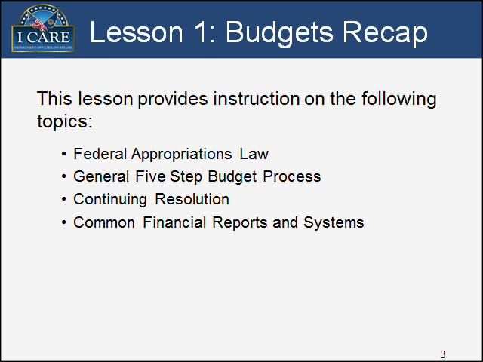

Notes:

### General Five Step Budget Process

#### Slide 4

General Five Step Budget Process:
This topic provides instruction about the five components of the VBA budget process and the Federal Appropriations Law that guides and limits the obligations and expenditures.

Image is a computer screen with the words Topic Introduction

Notes:

#### Slide 5

Federal Appropriations Law

Image is of a gavel beside a plaque with the word "Law" on it.

Key Points:

The U.S. Constitution gives Congress the authority to raise revenue, borrow funds, and appropriate the proceeds for federal agencies. In implementing these express constitutional powers, Congress strictly limits the obligation and expenditure of public funds by the Executive Branch. Congress regulates virtually all Executive Branch programs and activities through the appropriations process.

What are the main financial limitations of the Federal Appropriations Law?

* + An agency may obligate and expend appropriations only for a bonafide need of the Federal Government;
  + An agency may obligate only within the time limits applicable to the appropriation; and
  + If activities do not obligate the funds during the period of availability, the funds expire and are generally unavailable for obligation thereafter.
  + An agency may not obligate more than the amount appropriated by Congress.

Notes:

#### Slide 6

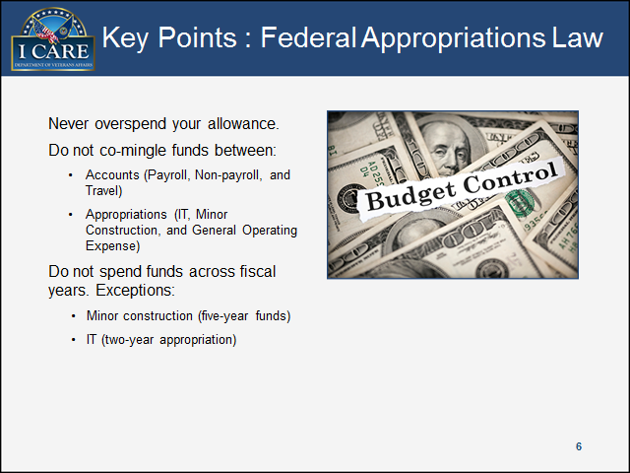

Notes:

#### Slide 7

Title: Five Budget Components: Description: Allocations given via a VBA-specific defined process that includes the following fundamental components:
Budget Call – request for funds; begins the process
Allowance Letter – essential communication outlining budget constraints
Operating Plan – critical forecasting and budgeting tool
Impact Statement – vehicle to request additional funds
Budget Execution – carries out budgetary decisions

image is a circle with 5 partitions - Budget Call, Allowance Letter, Operating Plan, Impact Statement, Budget Execution

Key Points:

**Budget Call -** The purpose of the budget call is to help Central Office (CO) predict or forecast VBA’s entire budget for 2 years. The budget call occurs each year in March or April.

**Allowance Letter** - Office of Field Operations (OFO) sends an Allowance Letter, a detailed letter outlining essential budget information.

* + A link to download your facility’s Operating Plan template.
  + An attached spreadsheet (Attachment A) with your facility’s allowance figures.
  + Instructions on how to complete Operating Plan.

**Operating Plan** - The Operating Plan is the forecasting tool for the Regional Office (RO) and outlines how the RO plans to spend the given money. The Operating Plan is a budgeting tool for CO and is completed by fund, by quarter, and by Budget Object Code (BOC). The total dollar amount on Operating Plan must balance with the funds approved on Allowance Letter.

**Impact Statement -** The Impact Statement is used to identify shortfalls and request additional non-payroll and travel funds. You are competing with other stations for additional funds; therefore, tailor and write your Impact Statement to justify the extra resources you are requesting.

**Budget Execution** - During budget execution, ORM distributes funds by quarter and posts the Distribution Spreadsheet (FYXXDIST.xls) to the ORM Budget server.

Notes:

#### Slide 8

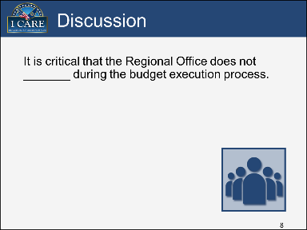

Notes:

#### Slide 9

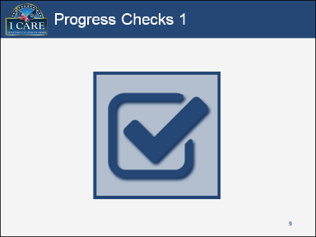

Progress Check 1:

1. How often does the Budget Call occur?
   1. Annually
   2. Biannually
   3. At the beginning of the fiscal year
   4. Every two years
2. Which is the correct purpose of the Impact Statement?
   1. Budgeting tool for the Regional Office.
   2. To identify shortfalls and request additional funding.
   3. Budgeting tool for Central Office.
   4. Help Central Office project VBA’s budget for two years.

Notes:

### Continuing Resolution

#### Slide 10

Continuing Resolution:
This topic provides instruction about the Continuing Resolution (CR) declaration that is passed by Congress to allow an agency to operate without an approved budget.

Image is a computer screen with the words Topic Introduction

Notes:

#### Slide 11

Initial Continuing Resolution Letter:
Outlines the effective dates, importing directives, and the obligation amount (shown as a percentage and varies between years) of the fiscal year's Annual Allowance for ongoing contracts.
Detailed description next page.



Key Points:

The Continuing Resolution letter outlines the effective dates, important directives/guidelines, and the obligation amount (shown as a percentage and varies between years) of the fiscal year’s Annual Allowance for ongoing contracts. During a Continuing Resolution, obligations - as stated in a letter from the OFO - are limited to a percentage of the prior year’s approved appropriation.

The Continuing Resolution is a percentage amount and varies from year to year. The outlined percentage represents the previous fiscal year’s base budget, not including special conditions. Until Congress approves the current fiscal year’s budget, your station’s budget is based on the percentage outlined in the Continuing Resolution letter.

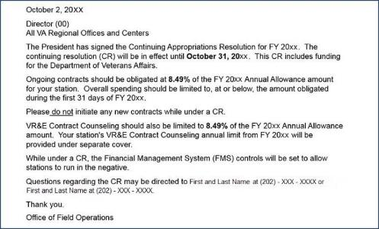

Figure : Continuing Resolution Letter

Example of an Initial Continuing Resolution letter that reads:

October 2, 20XX

Director (00)

All VA Regional Offices and Centers

The President has signed the Continuing Appropriations Resolution for FY 20XX. The continuing resolution (CR) will be in effect until October 31, 20XX. This CR includes funding for the Department of Veterans Affairs. Ongoing contracts should be obligated at 8.49% of the FY 20XX Annual Allowance amount for your station. Overall spending should be limited to, at or below, the amount obligated during the first 31 days of FY 20XX.

Please do not initiate any new contracts while under a CR.

VR&E Contract Counseling should also be limited to 8.49% of the FY 20XX Annual Allowance amount. Your station's VR&E Contract Counseling annual limit from FY 20XX will be provided under separate cover. While under a CR, the Financial Management System (FMS) controls will be set to allow stations to run in the negative. Questions regarding the CR may be directed to Andrea Epps Marryshow at 202-461-9351 or Randy Kauffman at 202-461-9942.

Thank you.

Office of Field Operations

Notes:

#### Slide 12

Extension Letter:
If an extension to the Continuing Resolution is given, a second letter is sent outlining updated information. Detail description next page.



Figure : Extension Letter

Graphic is an image of a sample extension letter that displays:

November 3, 20xx

All VA Regional Offices and Centers

Good Afternoon. A second FY 20xx Continuing Resolution (CR) was signed last week, which provides funding through December 18, 20xx. Ongoing contracts should be increased to 21.64% of the FY20xx annual amount for your station. Please do not initiate any new contracts while under a CR.  Attached is the guidance from ALAC with instruction on the appropriate obligating methodology.

While under a CR, the Financial Management System (FMS) controls will be set to allow stations to run in the negative.

Questions regarding the CR may be directed to OFO or ORM Budget Officer.

Thank you. Office of Field Operations

Notes: Graphic is an image of a sample extension letter that displays:

November 3, 20xx

All VA Regional Offices and Centers

Good Afternoon. A second FY 20xx Continuing Resolution (CR) was signed last week, which provides funding through December 18, 20xx. Ongoing contracts should be increased to 21.64% of the FY20xx annual amount for your station. Please do not initiate any new contracts while under a CR.  Attached is the guidance from ALAC with instruction on the appropriate obligating methodology.

While under a CR, the Financial Management System (FMS) controls will be set to allow stations to run in the negative.

Questions regarding the CR may be directed to OFO or ORM Budget Officer.

Thank you. Office of Field Operations

Notes:

#### Slide 13

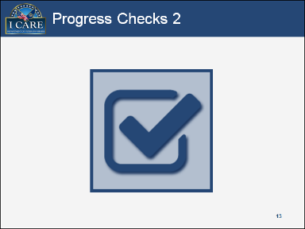

Progress Check 2:

1. What does the initial CR letter include?
2. Effective dates
3. Important directives/guidelines
4. Obligation amount (shown as a percentage)
5. All of the above
6. Until Congress ________ the current fiscal year’s budget, your station’s budget is based on the percentage outlined in the Continuing Resolution letter.
7. disapproves
8. extends
9. approves
10. rejects

Notes:

### Common Financial Reports and Systems

#### Slide 14

Common Financial Reports and Systems: This topic provides instruction about the common financial reports and accounting software systems.

Image is a computer screen with the words Topic Introduction

Notes:

#### Slide 15

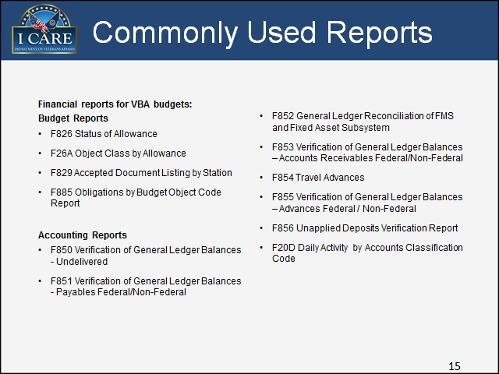

There are 2 major groups of financial reports for VBA budgets: Budget Reports and Accounting Reports.

Budget Reports

§ F826 Status of Allowance

§ F26A Object Class by Allowance

§ F829 Accepted Document Listing by Station

§ F885 Obligations by Budget Object Code Report

Accounting Reports

§ F850 Verification of General Ledger Balances - Undelivered

§ F851 Verification of General Ledger Balances - Payables Federal/Non-Federal

§ F852 General Ledger Reconciliation of FMS and Fixed Asset Subsystem

§ F853 Verification of General Ledger Balances – Accounts Receivables Federal/Non-Federal

§ F854 Travel Advances

§ F855 Verification of General Ledger Balances – Advances Federal / Non-Federal

§ F856 Unapplied Deposits Verification Report

§ F20D Daily Activity by Accounts Classification Code

Key Points:

Reports are an essential part of budget formulation and execution. After your station is allocated money, these reports help you to keep track of your available funds and your current expenses.

Refer to Section 7.1 of the Appendix for the *Transaction Codes* Job Aid, which is a list of the transaction codes and abbreviations that are used in the reports.

The Facilitator may decide to review the *Final* *Reports 101 Presentation* (Job Aids available on the [Administrative and Loan Accounting Center’s SharePoint site](https://vbaw.vba.va.gov/VBAORM/alac/training.asp)) at this point in the training.

Notes:

#### Slide 16

Title: F826
F826 Status of Allowance
The F826 is a key report as it represents your station's overall budget.
Includes image of sample F826.
Detailed description below.

Key Points:

Track budget data and analyze available balances on a daily basis by reviewing the funds that have been distributed to you. Daily, automatically generated printouts of this report are possible through ALAC in Austin.

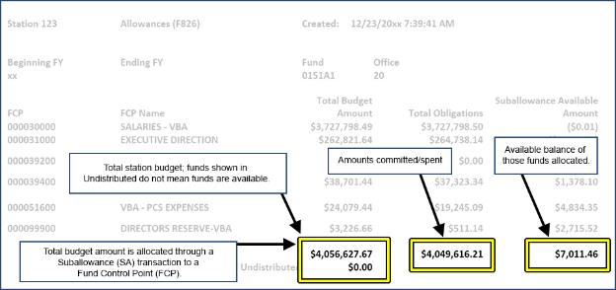

Figure : F826 - Status of Allowance

Example of a F826 Status of Allowance report with the information greyed out and three total amounts highlighted. Four text boxes appear. A text box points to the highlighted amount of $4,056,627.67 and $0.00. The text box displays, "Total budget amount is allocated through a Suballowance (SA) transaction to a Fund Control Point (FCP). A second text box points to the same highlighted amount and displays, "Total station budget funds shown in Undistributed do not mean funds are available." A third text box points to a highlighted amount of $4,049,616.21. The text displays "Amounts committed/spent". The fourth text box points to a highlighted amount of $7,011.46, and displays, "Available balance of those funds allocated."

Notes:

#### Slide 17

F26A
F26AObject Class by Allowance.
This is an example of not having money you are under a CR.

Includes image of sample F26A Next page has complete description.

Key Points:

Similar to the F826 report, but more detailed and comprehensive, the F26A report shows the fund distributions, obligated amounts, and available amounts on a daily basis. Use the F26A report for budgeting, reviewing status of funds, and planning and executing the year-end budget. Daily, automatically generated printouts of this report are possible through ALAC in Austin.

This graphic shows an example of not having money; you are under a CR.

TIP – Suballowance Amount (1st column) – Total Obligations (2nd column) = Available Amount (3rd column)

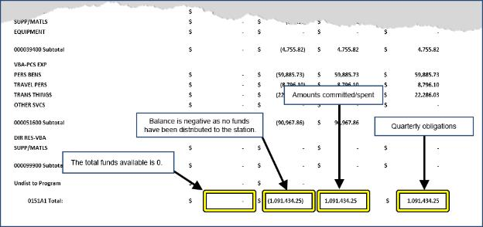

Figure 4: F26A - Object Class by Allowance – Example of Being Under a CR

Example of a F26A Object Class Allowance when your station does not have money and you are under a CR. The example shows the top part of the page torn off and four 0151A1 Totals highlighted. There are four text boxes. The first text box displays, "The total funds available is 0," and points to the first column that shows a blank 0151A1 highlighted Total. The second text displays, "Balance is negative as no funds have been distributed to the station," and points to the second column 0151A1 Total with the amount of $(1,091,434.25). The third text box displays, "Amounts committed/spent," and points to the third column 0151A1 Total with the amount of $1,091,434.25. The fourth text box displays, "Quarterly obligations," and points to the fourth and last column of 0151A1 Total with an amount of $1,091,434.25.

Notes:

#### Slide 18

F26A, Continued
F26A Object Class by Allowance-Example 2.

Example of a F26A when  allowance/money received. Next page has complete description.

Key Points:

This graphic shows an example of balances after receiving your budget allowance.

TIP – Suballowance Amount (1st column) – Total Obligations (2nd column) = Available Amount (3rd column) Example shows how report would look with FMS controls off.

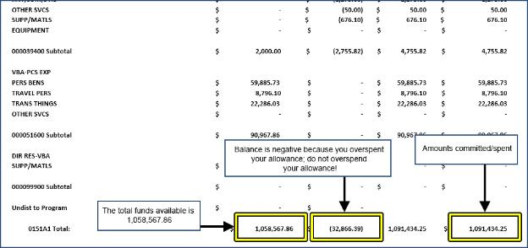

Figure : F26A - Object Class by Allowance - Example of Balances After Receiving Budget Allowance

This image is a second example of a partial F26A Object Class by Allowance. This example shows balances when your station received allowance/money and how it would look with FMS controls off. There are three text boxes. The first text box displays, "The total funds available is $1,058,567.86" and points to the first column of 0151A highlighted Total amount of $1,058,567.86. The second text box displays, "Balance is negative because you overspent your allowance; do not overspend your allow" and points to the second column of 0151A1 highlighted Total of $(32,866.39). The third text box displays, "Amounts committed/spent" and points to the fourth and last column highlight 0151A1 Total amount of $1,01,434.25.

Notes:

#### Slide 19

Title F829:
F829 Accepted Document Listing by Station
The 101 AL Transaction indicates Central Office provided that amount of money.
Includes image of sample F829

Key Points:

The F829 represents all transactions processed for your station for that day (i.e., allowances, obligations, payments, increases/decreases, expenditure transfers). Conduct daily verification with the F829 report. The F829 is an essential report for audit trails and validation purposes. Daily, automatically generated printouts of this report are possible through ALAC in Austin.

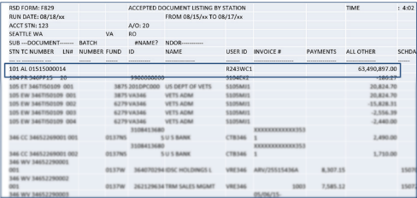

Figure : F829 - Accepted Document Listing by Station

Notes:

#### Slide 20

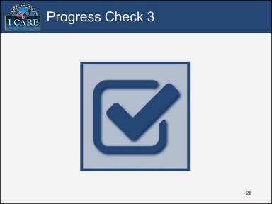

Progress Check 3:

1. Which report is an in-depth representation of a station’s overall budget?
2. F26A Object Class by Allowance
3. F829 Accepted Document Listing by Station
4. F826 Status of Allowance
5. F850 Verification of General Ledger Balances – Undelivered
6. When should verification of the F829 Accepted Document Listing by Station report be conducted to ensure all transactions processed appropriately?
7. Year end
8. Monthly
9. Weekly
10. Daily

Notes:

#### Slide 21

Title: F850
F850 Verification of General Ledger Balances – Undelivered
The F850 report lists all open obligations and statuses.
Includes image of example F850. Next page has complete description.

Key Points:

Most obligations are contained within one fiscal year, except Minor Construction. The F850 report is essential because it shows the balance of all open obligations. Review this report to determine potential increases/decreases needed to be performed.

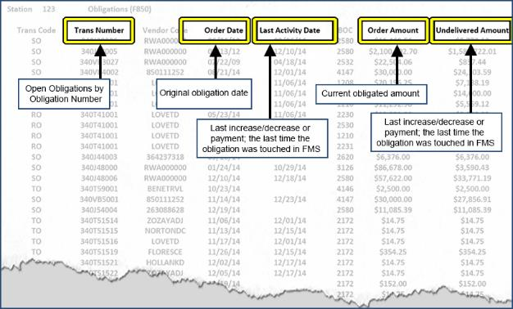

Figure : F850 - Verification of General Ledger Balances – Undelivered

Example of a partial F850 Verification of General Ledger Balances - Undelivered. The F850 report lists all open obligations and statuses. The F851 report shows status of open payables and identifies the ending date.

All page information is greyed out except for five column headers. There are five text boxes. Text box 1 displays "Open Obligations by Obligation Number" and points to the column header titled, "Trans Number". The second text box displays "Original obligation date" and points to the column header titled, "Order Date". The third text box displays "Last increase/decrease or payment, the last time the obligation was touched in FMS" and points to the column header titled, "Last Activity Date". The fourth text box displays "Current obligated amount" and points to the column header titled, "Order Amount". The fifth text box displays "Last increase/decrease or payment, the last time the obligation was touched in FMS" and points to the column header titled, "Undelivered Amount".

#### Slide 22

Title: F851.
F851 Verification of General Ledger Balances – Payables Federal/Non-Federal
The F851 report shows status of open payables and identifies the ending date.
Includes example of F85. Next page has complete description.

Key Points:

Use the F851 report to manage operations on a monthly basis. Tip - Ensure that payments reference AR12, if they exist, or the obligation will be increased when payments are made. Decreases must be made from AR12, if they exist, prior to decreasing SO.

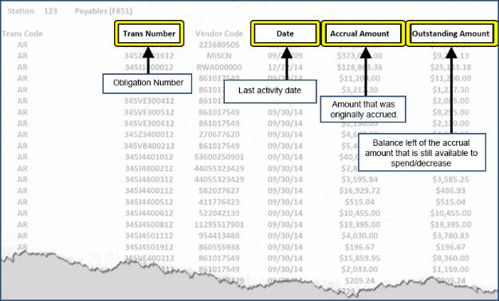

Figure : F851 - Verification of General Ledger Balances - Payables Federal/Non-Federal

Example of a partial F851, Verification of General Ledger Balances - Payables Federal/Non-Federal. The information is greyed out except for four column titles. There are four text boxes. The first text box displays "Obligation Number" and points to the highlighted second column title "Trans Number". The second text box displays "Last activity date" and points to the highlighted fourth column title "Date". The third text box displays "Amount that was originally accrued" and points to the highlighted column title "Accrual Amount." The fourth text box displays "Balance left of the accrual amount that is still available to spend/decrease" and points to the highlighted column title "Outstanding Amount."

#### Slide 23

Title: F852
Example of a F852 General Ledger Reconciliation of FMS and Fixed Asset Subsystem.
The monthly F852 report shows capitalized items and depreciations.
Includes example F852

Key Points:

Assets must be capitalized for the depreciation to be automatic. The F852 report is important because it validates and reconciles assets and depreciations across the FMS GL and FA Subsystem. Use the F852 report to ensure the FMS GL and FA Subsystem balance to zero and to determine depreciation amounts.

The Asset Account outlines the values of the FMS General Ledger (FMS GL) and the Fixed Asset Subsystem (FA Subsystem). The FMS GL system shows the purchased asset; the FA Subsystem is the depreciation of purchased asset.

Compare the two Asset Accounts (FMS GL and FA Subsystem) to ensure the difference is 0. Then compare the two Accumulated Depreciation Accounts (FMS GL and FA Subsystem) to ensure the difference is 0. Next, compare the total amount of the Asset Account to the total amount of the Accumulated Depreciation Account to determine the remaining balance to be depreciated. If Asset Accounts and Accumulated Depreciation Accounts are 0, then the balance is fully depreciated.

However, an asset that has not been fully depreciated will show that the Asset Account and Accumulated Depreciation Account does not equal the total cost.

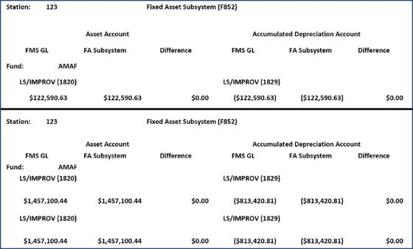

Figure : F852 - General Ledger Reconciliation of FMS and Fixed Asset Subsystem

Notes:

#### Slide 24

Title: 853:
F853 Verification of General Ledger Balances - Accounts Receivables Federal/Non-Federal
On a monthly basis, the F853 report shows the outstanding accounts receivables and lists the date the receivable was established as well as the date of the last activity.
Includes example of F853

Key Points:

The F853 report validates the accuracy of amounts due and identifies possible debt write-offs. Use the F853 to take required collection action(s).

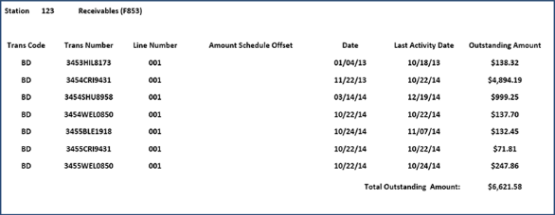

Figure : F853 - Verification of General Ledger Balances - Accounts Receivables Federal/Non-Federal

Notes:

#### Slide 25

Title: 854
F854 Travel Advances
The F854 report monitors travel activity.
Includes example F854

Key Points:

The F854 report shows monthly travel advances and advance statuses for Temporary Duty Travel/Permanent Change of Station (TDY/PCS) travel. The F854 monitors travel activity. Use the F854 to clear travel advances.

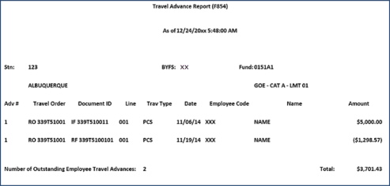

Figure : F854 - Travel Advances

Notes:

#### Slide 26

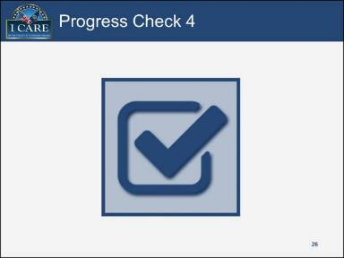

Progress Check 4:

1. What does the F850 Verification of General Ledger Balances – Undelivered report identify?
2. Aged documents and accrual status
3. Unpaid vouchers and travel advances
4. Open obligations and obligations’ status
5. Incomplete transactions and service orders
6. What report should you use to ensure the FMS GL and FA Subsystem balance to zero and to determine depreciation amounts?
7. F855 Verification of General Ledger Balances – Advances Federal / Non-Federal
8. F852 General Ledger Reconciliation of FMS and Fixed Asset Subsystem
9. F850 Verification of General Ledger Balances – Undelivered
10. F854 Travel Advances

Notes:

#### Slide 27

Title 855:
F855 Verification of General Ledger Balances – Advances Federal / Non-Federal 
On a monthly basis, the F855 report shows advances pending any offsets.
Includes example F855

Key Points:

Because timely processing of advances is required for accounting purposes, the F855 report is an important report when verifying accounts and balancing budgets. Use the F855 report to process transactions in Centralized Administrative Accounting Transaction System (CAATS).

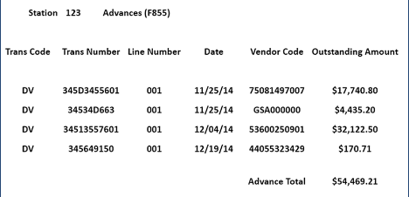

Figure : F855 - Verification of General Ledger Balances - Advances Federal/Non-Federal

#### Slide 28

Title F856:
F856 Unapplied Deposits Verification Report
Reviewed monthly, the F856 report shows unapplied (also referred to as suspense) accounts and balances.
Include example F856

Key Points:

The F856 holding account report identifies items pending a financial action. Use the F856 report to process items from suspense.

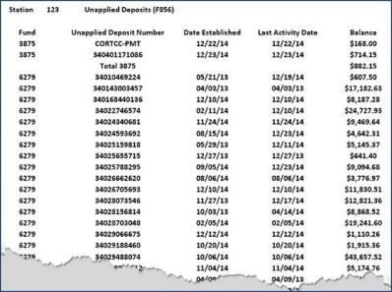

Figure : F856 - Unapplied Deposits Verification Report

#### Slide 29

Title: F20D
F20D Daily Activity by Accounts Classification Code
The F20D report shows a daily, detailed activity of balances on a per account basis, providing a regular audit trail.
Includes example F20D

Key Points:

Use the F20D report to conduct research of daily transactions and associated classification codes. Remember you control the budget ceiling; this amount can be increased and decreased as needed as long as funds are available.

TIP: Budget Ceiling – Obligations = Unobligated Balance

Obligations Beginning Balance is added to the Total Adjustment amount to equal the Obligations Ending Balance.

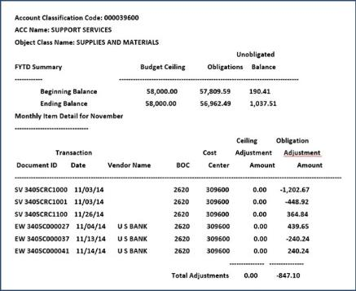

Figure : F20D - Daily Activity by Accounts Classification Code

Notes:

#### Slide 30

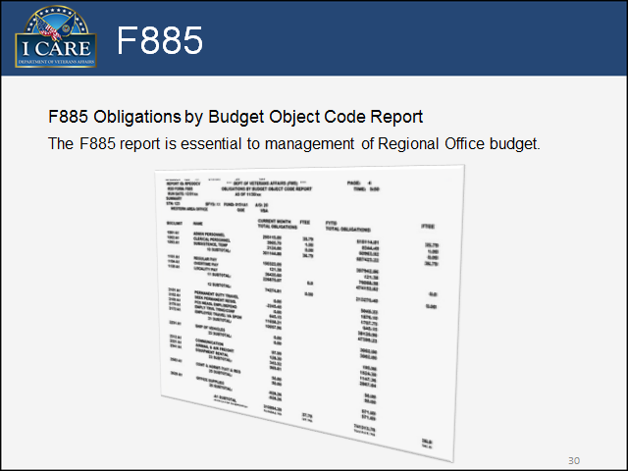

Key Points:

The F885 report shows monthly expenditures as well as year-to-date obligations. The F885 report is an essential budgeting and forecasting tool. Use the F885 report to analyze financial statuses and make budget decisions.

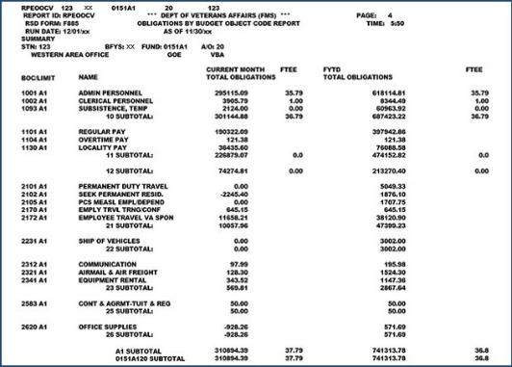

Figure : F885 - Obligations by Budget Object Code Report

#### Slide 31

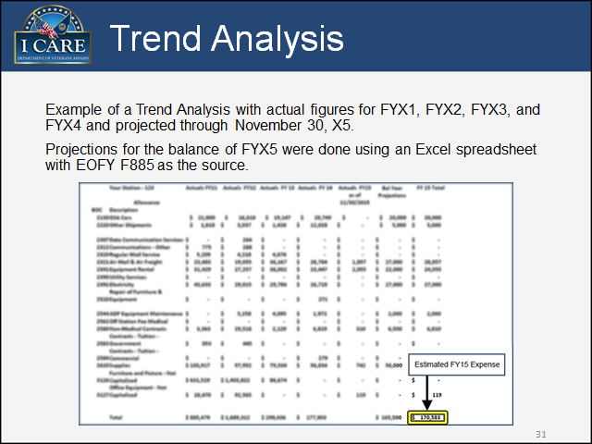

Key Points:

Analyze and review the individual reports on a daily or monthly basis for expenditure trends and inconsistencies to capture data to use when estimating current non-payroll budgets.

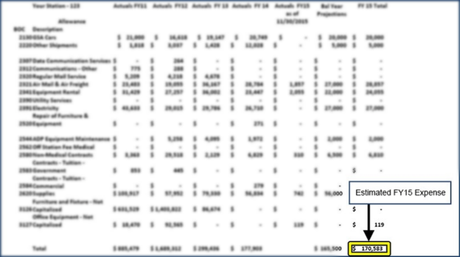

Figure : Trend Analysis with Actual Figures

Notes:

#### Slide 32

Trend Analysis Continued.
Projected FY15 expenses from previous Trend Analysis example reflects $170,583 in expenses.
Includes example trend analysis report

Example of projected expenses


Figure : Trend Analysis with Actual Figures, cont.

Notes:

#### Slide 33

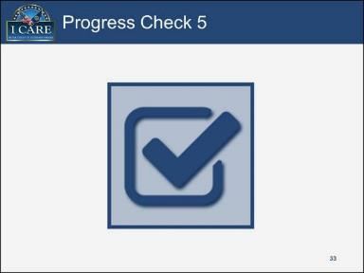

Progress Check 5:

1. What report identifies items pending a financial action?
2. F20D Daily Activity by Accounts Classification Code
3. F885 Obligations by Budget Object Code Report
4. F26A Object Class by Allowance
5. F856 Unapplied Deposits Verification Report
6. What report should you use to conduct research of daily transactions and associated classification codes?
7. F26A Object Class by Allowance
8. F20D Daily Activity by Accounts Classification Code
9. F856 Unapplied Deposits Verification Report
10. F885 Obligations by Budget Object Code Report

Notes:

#### Slide 34

There are a several accounting systems used to access and retrieve financial reports. 
Rogers Software Development (RSD)
Financial Management System (FMS)
Austin Automation Center (AAC)
Centralized Administrative Accounting Transaction System (CAATS)

image is a cartoonish computer screen

Notes:

#### Slide 35

RSD Viewing and Extracting Reports.
Rogers Software Development (RSD) system is the main system to view and extract reports.

Let’s review the Job Aid.

Key Points:

The Facilitator may decide to review the *RSD Viewing and Extracting Reports* (available on the [Administrative and Loan Accounting Center’s SharePoint site](https://vaww.vashare.vba.va.gov/sites/VBAOfficeOfResourceManagement/ALAC/NFTS/Web%20Based%20Training%20Material%20Budget%20Agent%20Cashier%20a/Forms/AllItems.aspx?RootFolder=%2Fsites%2FVBAOfficeOfResourceManagement%2FALAC%2FNFTS%2FWeb%20Based%20Training%20Material%20Budget%20Agent%20Cashier%20a%2FBudget%20Formulation%20and%20Execution%2FJob%20Aids&FolderCTID=0x0120008661AC9ADA05FC4AAEDB26774936B4B1&View=%7B2CE9900D%2DC381%2D4AC8%2DAEF3%2D806CADF8AAA8%7D)) at this point in the training.

Notes:

#### Slide 36

FMS Access:
The RSD pulls reports from the Financial Management System (FMS), which is the main accounting system of record.

Let’s review the Job Aid.


Key Points:

The Facilitator may decide to review the *Financial Management System Access* (available on the [Administrative and Loan Accounting Center’s SharePoint site](https://vaww.vashare.vba.va.gov/sites/VBAOfficeOfResourceManagement/ALAC/NFTS/Web%20Based%20Training%20Material%20Budget%20Agent%20Cashier%20a/Forms/AllItems.aspx?RootFolder=%2Fsites%2FVBAOfficeOfResourceManagement%2FALAC%2FNFTS%2FWeb%20Based%20Training%20Material%20Budget%20Agent%20Cashier%20a%2FBudget%20Formulation%20and%20Execution%2FJob%20Aids&FolderCTID=0x0120008661AC9ADA05FC4AAEDB26774936B4B1&View=%7B2CE9900D%2DC381%2D4AC8%2DAEF3%2D806CADF8AAA8%7D)) at this point in the training.

Notes:

#### Slide 37

Title: CAATS
Centralized Administrative Accounting Transaction System (CAATS) is the front end to the FMS.

includees image of the initial welcome CAATS screenshot

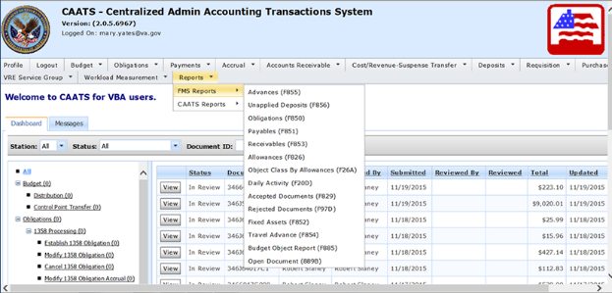

Figure : CAATS Reports

Notes:

#### Slide 38

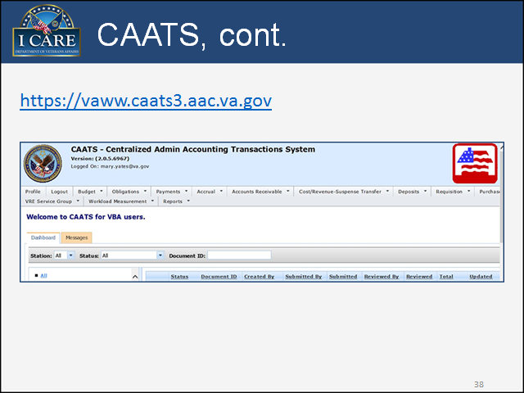

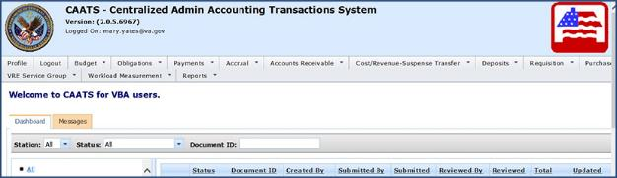

Figure : CAATS Main Menu

Notes:

#### Slide 39

Title: AAC.
The Austin Automation Center (AAC) is a server that houses the financial systems (FMS and RSD). 
Contains a user-friendly, windows-based, report-extraction system.

Let’s review the Job Aid.


Key Points:

The Instructor may decide to review the *Austin Automation Center* (previously available in the WBT prerequisite training as a download) at this point in the training.

Notes:

#### Slide 40

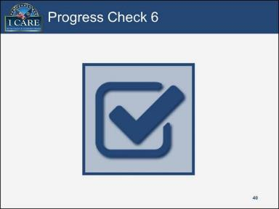

Progress Check 6:

1. The ______ is the key system used to extract and view reports.
2. Centralized Administrative Accounting Transaction System
3. Financial Management System
4. Austin Automation Center
5. Rogers Software Development
6. The _____ is the main accounting system of record.
7. Centralized Administrative Accounting Transaction System
8. Financial Management System
9. Austin Automation Center
10. Rogers Software Development

Notes:

#### Slide 41

In summary, Lesson 1 provided instruction about the:
Five step budget process:
Budget Call 
Allowance Letter 
Operating Plan 
Impact Statement 
Budget Execution
The Federal Appropriations Law and Continuing Resolutions
Common financial reports and the accounting systems where they reside

Image is a projector screen with the words Lesson Summary.

Notes:

#### Slide 42

Title: Questions?
Questions?
What’s next?
Budget Call


Notes:

This page intentionally left blank

## Lesson 2: Budget Call

### Introduction

#### Slide 43

Lesson 2: Budget Call:
This lesson provides instruction on the following topics:
General Operating Expense Budget Call 
Minor Construction Budget Call

Notes:

### General Operating Expense Budget Call

#### Slide 44

General Operating Expense Budget Call:
This topic provides a practical exercise about the General Operating Expense Budget Call.

Image is a computer screen with the words Topic Introduction

Notes:

#### Slide 45

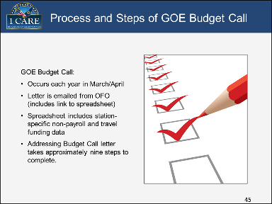

Key Points:

GOE Budget Call:

* Occurs each year in March or April.
* Letter e-mailed from OFO with attached link.
  + Download file/spreadsheet from FTP server.
* Spreadsheet Information.
  + GOE spreadsheet contains only non-payroll and travel funding data.
  + Spreadsheet is pre-populated by BOC w/station-specific current year allowance baseline information.
  + Also pre-populated with an inflationary index for 2 years out.
  + Allows for future (2 years out) requests for additional funding (if necessary).
  + Allows for reclassification of current year money in future years.
* Nine Process Steps.

1. Review baseline information to ensure accuracy.
   1. Check existing Allowance Letter to verify the current allowance is reflected on the budget call spreadsheet.
   2. Check current allowance figures and update amounts for any necessary reclassification.
2. Increase the current allowance figures by any approved and/or pending recurring impact statement requests
3. Ensure the associated inflationary factor is included in your impact statement figure(s).
4. Provide impact statement justification for changed projection figures.
5. Review expenditure trends in the 885 report for current and 2 prior year’s data.
   1. Is anything out of line?
   2. Are any budget variances recurring?
6. Consult with local Senior Management to identify projected new initiatives and/or unfunded needs.
7. Add updated figures and provide any necessary justification.
8. Brief Director and receive concurrence on ‘finalized’ spreadsheet.
9. Upload spreadsheet to ORM. (ftp://budget.vba.va.gov).

Notes:

#### Slide 46

Title: Purpose.
The GOE Budget Call Letter request fiscal year completions of non-payroll and travel budget by all Regional Offices, District Offices and HRCs, AMC, and RMC.

Completing the templates outlined in the letter will give OFO a more granular representation of true field needs and allow to better justify the overall funding request.

Image of a yellow note with a blue paperclip in the upper left corner and the word "PURPOSE" centered in all caps in red with two lines underneath the word.

Notes:

#### Slide 47

Title: GOE Budget Call Practical Exercise.
Refer to the sample GOE Budget Call Letter and the Spreadsheet.
Follow the instructions in the letter to complete the exercise

Key Points:

Refer to Appendix 7.2 for the Budget Call Exercise Letter and Appendix 7.3 for a sample graphic of the Budget Call Exercise spreadsheet.

**NOTE:** The actual Budget Call Exercise spreadsheet is not provided in Appendix 7.3, only a graphical depiction.

Notes:

### Minor Construction Budget Call

#### Slide 48

Title: Minor Construction Budget Call.
This topic provides instruction about requesting additional funds for minor facility/station construction.

Image is a computer screen with the words Topic Introduction

Notes:

#### Slide 49

Minor Construction Execution:

A man's right hand holding a pen and writing on a document under a heading titled "Received".

Key Points:

Minor Construction Execution Steps:

1. Minor construction funds are received from VACO Facilities.
2. Ensure estimates obtained prior to requesting minor construction funds for a project are up to date. If not, request new estimates from GSA/vendors. Request additional minor construction funds if required.
3. Obligate funds by contracting for work via Reimbursable Work Authorization (GSA), or via CAATS Purchase Requisition module (VA Contracting Officer) for vendors other than GSA.
4. Monitor minor construction funds (certify and pay bills). Watch for minor construction charges that show as expenses in your GOE accounting. These charges must be expenditure transferred to the minor construction obligation.

Notes:

#### Slide 50

At Conclusion of Project:

An interoffice envelope with the word "Completed" stamped on it

Key Points:

Determine whether project and associated work in process needs to be written off or capitalized:

* Minor construction projects under $100,000, prior to October 1, 2013 and under $1,000,000, on or after October 1, 2013 will be written off.
* Minor construction over these amounts will be capitalized and depreciated over the life of the asset.

All Minor construction expenses will flow into work in process (1820 account)

* Process write off transactions per above guidance
* Minor construction projects over the above guidance will capitalize the Work in Progress (WIP) and create an asset in the Fixed Asset Subsystem via your ALAC Accountant.

Notes:

#### Slide 51

Title: Practical Exercise
Let’s review:
An example of a minor construction request.
The formal process that puts the request in the required format.


Key Points:

Refer to the following Performance Support Tools/Job aids in the Appendix:

* Appendix 7.4 - Minor Construction SCIP FYXX Call Letter Justification – example of justification; “white paper”.
* Appendix 7.5 - Attachment B Minor Construction Project Proposal FYXX Any Town VR&E Out-based Office – Formal process that puts the white paper into the format required.

Notes:

#### Slide 52

Example of Detailed Request:
Let’s review the Job Aid.


Key Points:

Refer to Section 7.6 of the Appendix for the following Performance Support Tools/Job aid in the Appendix:

* + Minor Construction Action Plan Call Memo FY17

**NOTE**: The memo in Appendix 7.6 is incomplete and provides only the first page of a detailed minor construction request to show as a brief example. A complete detailed request is comprehensive and lengthy.

Notes:

#### Slide 53

Title: Budget Call:
In summary, Lesson 2 provided instruction about the General Operating Expense and Minor Construction budget calls.

Image is a projector screen with the words Lesson Summary.

Notes:

#### Slide 54

Title: Questions about Budget Call?
Questions?
What’s next?
Break
Operating Plan


Notes:

#### Slide 55

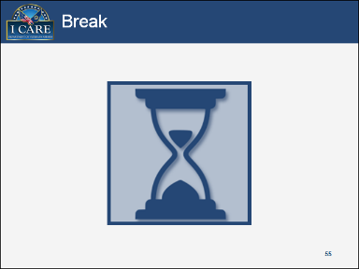

Notes:

## Lesson 3: Operating Plan

### Introduction

#### Slide 56

Title: Lesson 3: Operating Plan
This lesson provides instruction on the following topics:
Budget Formulation
Impact Statement

Notes:

### Budget Formulation

#### Slide 57

This topic provides instruction about the functions of the Allowance Letter and Operating Plan in budget formulation.

Image is a computer screen with the words Topic Introduction.

Notes:

#### Slide 58

Title: Allowance Letter:
Starts the budget formulation process
Essential, detailed letter outlining the funds you will receive.
Includes:
Attachement A - Itemizes per category the amount your station will receive to spend for the fiscal year
Instructions to complete the Operating Plan

Image is an example of an Allowance Letter

Key Points:

Budget Formulation begins with the Allowance Letter and the Operating Plan.

The Allowance Letter is an essential, detailed letter outlining what you will receive excluding some items.

The Allowance Letter includes instructions to complete the Operating Plan, a spreadsheet with your facility’s allowance figures, and the link to download the template. Once you receive the Allowance Letter, you may begin the budget formulation process. Use the link in the Allowance Letter to set up access to the Budget FTP site.

Notes:

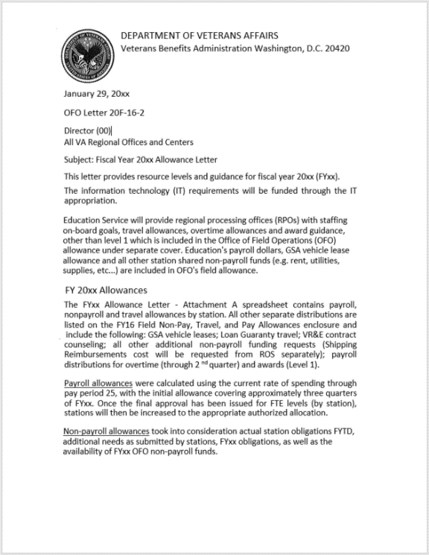

Figure : Example of an Allowance Letter

#### Slide 59

Attachment A:
Outlines fund distributions for every Regional office in the country 

Includes image of sample Attachment A

Key Points:

Listing every Regional Office in the country, Attachment A (enclosed with the Allowance Letter) itemizes per category the amount your station will receive to spend for the fiscal year.

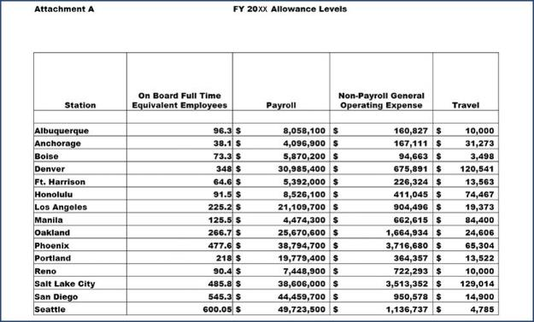

Figure : Example of an Attachment A

#### Slide 60

Title: Operating Plan
Objective of the Operating Plan is to balance it with your station’s Allowance Letter. 
Once balanced, the purpose of the Operating Plan tells Central Office when your station wants to receive the funds.

Image is a computer keyboard with the letter spelling Operating Plan Objective highlighted

Key Points:

Allocation of the money depends upon on how your station operates, so explicitly communicate to the CO when you need the money (quarterly).

Notes:

#### Slide 61

Title: Download the Template
The first step is to download the Operating Plan template from the FTP site.
Refer to the Participant Guide for step-by-step instructions.

Key Points:

To download the Operating Plan template, follow these steps:

1. In Excel, Select **Data**.
2. Click **From Web**.
3. In address window, type in ftp://10.220.1.16/
4. Select **Go**.
5. Double-Select **Download**.
6. Double- Select **GOE**.
7. Double-Select **Plans.**
8. Double-Select **FYXX Station Op Plans**.
9. Double-Select your station’s file.
10. Select “No” when the box comes up asking if you want to change the data.
11. Input your station number when the popup box displays.
12. Data will be downloaded to your “C” drive. If you want to save this data elsewhere on your PC, browse to the location. **NOTE: Steps 10 - 12 may not apply if Sharepoint is used instead of FTP.**

Note: In addition to the Allowance Letter providing instructions for completing the Operating Plan, the Help tab in the downloaded spreadsheet template also contains instructions, helpful hints, and tips.

Notes:

This page intentionally left blank.

#### Slide 62

Title: PayProj and NNProj Tabs
The Payroll (PayProj) and NonPayroll/Travel (NPProj) tabs contain specific funding allocations for your station.

Refer to the Participant Guide for complete instructions.

The Station Budget Operating Plan: Work Areas – Definition job aid defines terms and 
acronyms used in the Operating Plan template.

Key Points:

PayProj Tab (Payroll)

1. Read the Help tab.
2. Select the Funding tab. Ensure that Attachment A money matches Allowance money. Ultimate goal: difference = 0.
3. Select the **PayProj** tab. Column A is the Payroll Period (PP). Key: White cell = hire someone (only for that pay period); grey cell = 1x bonus (carries to all pay periods thereafter).
4. To access the drop-down menu, simultaneously press the Ctrl and M keys.
5. Go back to FTP and select GOE.
6. Above the Get Actual heading, select **Pay Period (PP)**.
7. Select **FY XX** folder for previous pay period data.
8. Select the pay period you want to update.
9. Select the .csv file.
   * The data downloads to the spreadsheet.
10. Return to the Funding tab and rectify any differences due to overspending.
11. Select the + (plus) sign to expand the data.
    * Consider all items that are going to impact payroll from this point forward.
    * Consult with HR and business lines for details on upcoming gains, losses, and/or increases in grade (varies by stations).
12. Go to affected pay period and make increase or decrease changes to:

* FTE
* Base Pay
* Fringe Benefits (such as Dental/Vision/Health Insurance, Social Security, Medicare)
* Within Grade Increases / Career Ladder Promotions

NPProj (Non-Payroll and Travel)

1. In the **NPProj** tab, in access the drop-down menu, simultaneously press the Ctrl and M keys.
2. Under “Get Actual” heading, select “Month”.
3. Select the month you want to update.
4. Press “OK”. Data downloads to spreadsheet.
5. Update the plan with all available actual data.

Referto Section 7.7 of the Appendix for the Performance Support Tool/Job Aid: Station Budget Operating Plan: Work Areas – Definitions.

Notes:

#### Slide 63

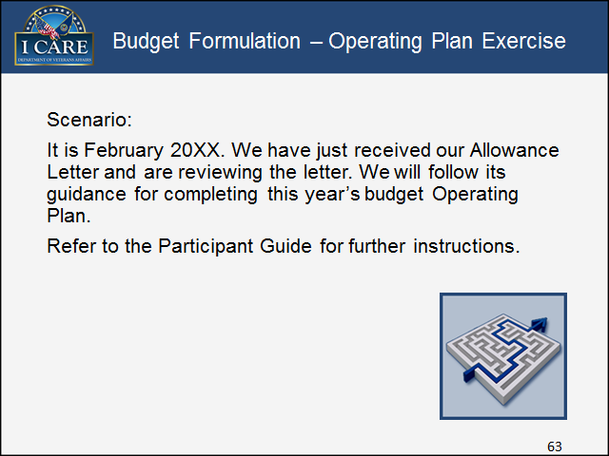

Key Points:

1. Download the PlangenMB Exercise with information populated through November 2008.
2. Note what is already in the Operating Plan (Oct – Nov).
3. Verify that Operating Plan figures on Funding tab are equal to the Allowance Letter.
4. Download the Dec and Jan information non-payroll and PPs 24-02.
5. Delete the reimbursable items from actual pay period information (OT, awards, terminal leave, etc.).
6. Go to the non-payroll tab and remove the contract counseling dollars (2504, 2505).
7. Review the Funding tab to determine surpluses and shortages.

* Travel: There is a $1,460 shortage.
  + Note the role of the Impact Statement.
  + Consult with Senior Management regarding needs and Division funding.
  + All travel funds are already obligated; students must decrease travel by the shortage. Decrease taken in March.
* Payroll: There is a surplus of $133,021.
  + Consult with Human Resources regarding personnel changes. We find out that we are hiring the following employees: (Note: assume 30% for Fringe Benefits.)
    - PP08 – VSR, GS 7/1
    - PP10 – Director, GS 15/1
    - PP14 – Assistant Support Services Chief, GS 12/1
    - PP03 – Adjustment of +$25,444 to base pay
* Non-Payroll: All major contracts have been obligated for the year.
  + Director wants $21,000 obligated for training (2584).
  + Chairs are breaking. We need 20 new chairs at $300 each ($6,000 BOC 3126).
  + Have a balance of $45,644 for supplies to be pro-rated through the end of the fiscal year ($75,839 in total, then Tools, Pro-rate).

1. Go to the Funding tab to verify that we have allocated all funds given.
2. Brief Director.
3. Upload to FTP Server.

Notes:

#### Slide 64

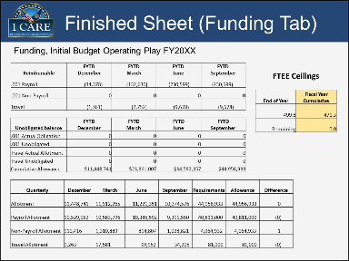

Figure : Finished Sheet (Funding Tab)

| Reimbursable | FYTD  December | FYTD  March | FYTD  June | FYTD  September |
| --- | --- | --- | --- | --- |
| .001 Payroll | (34,378) | (132,630) | (230,599) | (230,599) |
| .001 Non-Payroll | 0 | 0 | 0 | 0 |
| Travel | (1,761) | (2,752) | (9,678) | (9,678) |

| Unobligated balance | FYTD  December | FYTD  March | FYTD  June | FYTD  September |
| --- | --- | --- | --- | --- |
| .001 Actual Obligation | 0 | 0 | 0 | 0 |
| .001 Unobligated | 0 | 0 | 0 | 0 |
| Travel Actual Allotment | 0 | 0 | 0 | 0 |
| Travel Unobligated | 0 | 0 | 0 | 0 |
| Cumulative Allowance | $11,448,741 | $23,361,007 | $34,582,357 | $44,956,933 |

| Quarterly | December | March | June | September | Requirements | Allowance | Difference |
| --- | --- | --- | --- | --- | --- | --- | --- |
| Allotment | 11,448,741 | 11,912,265 | 11,221,351 | 10,374,576 | 44,956,933 | 44,956,933 | 0 |
| Payroll Allotment | 10,529,062 | 10,583,796 | 10,386,592 | 9,311,550 | 40,811,000 | 40,811,000 | (0) |
| Non-Payroll Allotment | 910,416 | 1,310,889 | 814,807 | 1,028,821 | 4,064,932 | 4,064,933 | 1 |
| Travel Allotment | 9,263 | 17,581 | 19,952 | 34,205 | 81,000 | 81,000 | (0) |

FTEE Ceilings

| End of Year | Fiscal Year Cumulative |
| --- | --- |
| 499.8 | 471.3 |
| Remaining | 0.0 |

Notes:

### Impact Statement

#### Slide 65

This topic provides instruction about the function of an Impact Statement.

Image is a computer screen with the words Topic Introduction

Notes:

#### Slide 66

Title: Need More Money?
Impact Statement is the opportunity to request additional funding for new initiatives or to cover deficits.
Impact Statements are not used to request additional funds for payroll or awards. 
Impact Statements are only used when requesting additional funds for non-payroll and travel. 

Image is a graphic of a yellow note with a cartoon image of a dollar sign in the center and surrounded by exclamation marks to show emphasis.

Key Points:

Remember that because you are competing for resources, your Impact Statement must be concise, well written, and succinctly explain the reasons you are requesting additional money.

If the station needs to request additional funding for office supplies or travel expenses, for example, then the Impact Statement is the opportunity to ask to fund new initiatives or cover deficits.

Notes:

#### Slide 67

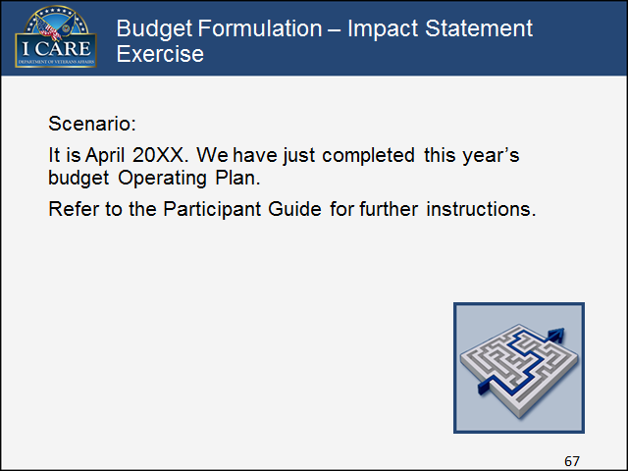

Key Points:

We have completed a review of the Operating Plan and found the following shortages:

* Travel: There is a $1,460 shortage.
* We have consulted with Senior Management regarding needs and Division funding. An additional $1,460 is needed to cover VR&E out-based supervisory visits.
* Service Center has hired a Military Services Coordinator who will be required to complete multiple trips estimated at a cost of $6,000.

Hints for writing a well-crafted Impact Statement:

* How is this going to positively/negatively affect Veterans of your state?
* How is this going to affect normal operations (quantify, if possible)?
* What will be accomplished/not accomplished?
* What is the benefit to the station/employees?
* What is the impact of receiving/not receiving the funds?

Notes:

#### Slide 68

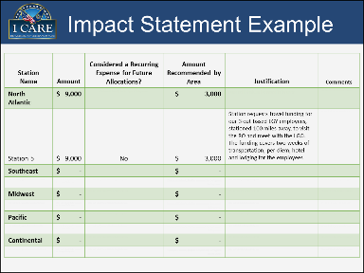

In this example, there are six columns titled: 1) Station Name, 2) Amount, 3) Considered a Recurring Expense for Future Allocations? 4) Amount Recommended by Area, 5) Justification, and 6) Comments. Station Name examples shown are: North Atlantic, Southeast, Midwest, Pacific, and Continental. Under the North Atlantic Station Name, Station 5 is listed with an amount of $9,000, an indicator "No" in the Considered a Recurring Expense for Future Allocations? Column, an amount of $3,000 in the Amount Recommended by Area column, and the following content in the Justification column: Station requests travel funding for our 3 outbased LGY employees, stationed 100 miles away, to visit the RO and meet with the LGO. The funding covers two weeks of transportation, per diem, hotel, and lodging for the employees.

| **Station Name** | **Amount** | **Considered a Recurring Expense for Future Allocations?** | **Amount Recommended**  **by Area** | **Justification** | **Comments** |
| --- | --- | --- | --- | --- | --- |
| **North Atlantic** | **$ 9,000** | **Data cell blank, to be typed in by user** | **$3,000** | **Data cell blank, to be typed in by user** | **Data cell blank, to be typed in by user** |
| Station 5 | $ 9,000 | No | $3,000 | Station requests travel funding for our 3 out based LGY employees, stationed 100 miles away, to visit the RO and meet with the LGO. The funding covers two weeks of transportation, per diem, hotel and lodging for the employees. | **Data cell blank, to be typed in by user** |
| **Southeast** | **$-** | **Data cell blank, Yes or NO to be typed in by user.** | **$ -** | **Data cell blank, to be typed in by user** | **Data cell blank, to be typed in by user** |
| Data cell blank, type station number southeast | **Data cell blank, Dollar amount to be typed in by user.** | **Data cell blank, Yes or NO to be typed in by user.** | **Data cell blank, Dollar amount to be typed in by user.** | **Data cell blank, to be typed in by user** | **Data cell blank, to be typed in by user** |
| **Midwest** | **$** | **Data cell blank, Yes or NO to be typed in by user.** | **$** | **Data cell blank, to be typed in by user** | **Data cell blank, to be typed in by user** |
| Data cell blank, type station number Midwest | **Data cell blank, Dollar amount to be typed in by user.** | **Data cell blank, Yes or NO to be typed in by user.** | **Data cell blank, Dollar amount to be typed in by user.** | **Data cell blank, to be typed in by user** | **Data cell blank, to be typed in by user** |
| **Pacific** | **$** | **Data cell blank, Yes or NO to be typed in by user.** | **$** | **Data cell blank, to be typed in by user** | **Data cell blank, to be typed in by user** |
| Data cell blank, type station number Pacific | **Data cell blank, Dollar amount to be typed in by user.** | **Data cell blank, Yes or NO to be typed in by user.** | **Data cell blank, Dollar amount to be typed in by user.** | **Data cell blank, to be typed in by user** | **Data cell blank, to be typed in by user** |
| **Continental** | **$** | **Data cell blank, Yes or NO to be typed in by user.** | **$** | **Data cell blank, to be typed in by user** | **Data cell blank, to be typed in by user** |
| Data cell blank, type station number Continental | **Data cell blank, Dollar amount to be typed in by user.** | **Data cell blank, Yes or NO to be typed in by user.** | **Data cell blank, Dollar amount to be typed in by user.** | **Data cell blank, to be typed in by user** | **Data cell blank, to be typed in by user** |

Figure : Example of an Impact Statement

Notes

#### Slide 69

VBA District Locations
The legend for the map of the United States coded by District:
North Atlantic District ;
Southeast District;
Midwest District ;
Continental District ;
Pacific District . Detailed description next page.

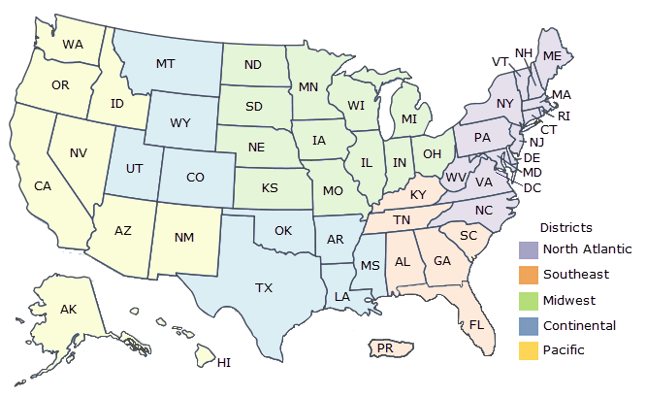

Figure : VBA District Locations

A map of the United States that is coded by District.

North Atlantic District:

Maine (ME), New Hampshire (NH), Vermont (VT), Massachusetts (MA), Rhode Island (RI)Connecticut (CT), New Jersey (NJ), Delaware (DE), Maryland (MD), Washington DC (DC), Pennsylvania (PA), New York (NY), West Virginia (WV), Virginia (VA), North Carolina (NC)

Southeast District:

Puerto Rico (PR), Florida (FL), Alabama (AL), Georgia (GA), South Carolina (SC), Tennessee, TN), Kentucky (KY)

Midwest District:

Ohio (OH), Indiana (IN), Illinois (IL), Missouri (MO), Kansas (KS), Nebraska (NE), Iowa (IA), Michigan (MI), Wisconsin (WI), Minnesota (MN), North Dakota (ND), South Dakota (SD)

Continental District:

Texas (TX), Louisiana (LA), Mississippi (MS), Arkansas (AR), Oklahoma (OK), Colorado (CO), Utah (UT), Wyoming (WY), Montana (MT)

Pacific District (Light Yellow):

New Mexico (NM), Arizona (AZ), California (CA), Nevada (NV), Oregon (OR), Washington (WA), Idaho (ID), Hawaii, (HI), Alaska (AK), Philippines (PH)

The legend for the map of the United States that is color-coded by District: North Atlantic District

Southeast District, Midwest District, Continental District, Pacific District

Notes:

#### Slide 70

In summary, Lesson 3 provided instruction about the mechanisms of the Operating Plan:
Initial Allowance Letter
Itemized funds in Attachment A
Operating Plan Template
Requesting additional funds via an Impact Statement

Notes:

#### Slide 71

Questions about the Operating Plan?
Questions?
What’s next?
Execute and Accrue


Notes:

This page intentionally left blank.

## Lesson 4: Execute and Accrue

### Introduction

#### Slide 72

Lesson 4: Execute and Accrue:
This lesson provides information on the following topics:
Budget Execution
Accruals
Fiscal Year Close

Notes:

### Budget Formulation

#### Slide 73

This topic provides instruction about executing the budget.

Image is a computer screen with the words Topic Introduction

Notes:

#### Slide 74

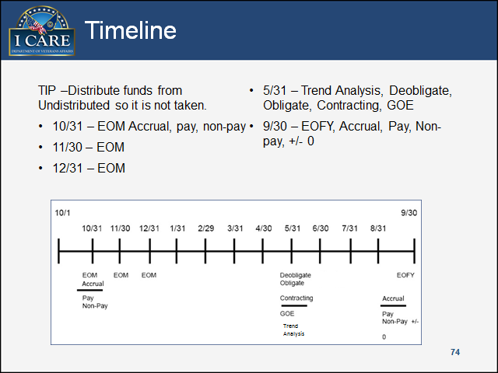

Key Points:

At the end of every month, accrue the unknown due to hiring, firing, awards, LWOP, etc. to bring payroll and non-payroll accounting systems to current. At the end of May – July, look at spending to adjust: deobligate – trend analysis, obligate, contracting, GOE etc.

As you get to the EOFY hopefully, on the GOE side, all these events have occurred. So either spend or return the money, but really scrutinize. Accruals come into play at the EOFY. The goal is to use allotted funds without overspending and return unneeded funds to VACO.

Notes:

Budget Execution Timeline. Below for complete description of Figure.


Trend Analysis

Figure : Budget Execution Timeline

Linear Timeline chart line. Starts on October 1 and ends September 30 with points at 10/31 EOM Accrual Pay and Non Pay.11/30 EOM (end of month); 12/31 EOM (end of month); 1/31; 2/29; 3/31; 4/30; 5/31 Deobligate and obligate, Contracting and GOE.6/30 End of June - Trend Analysis; 5/31; 8/31; and final 9/30 End of Sept - end of fiscal year, accrual, payroll, non-payroll plus or minus zero. End of Sept - end of fiscal year, accrual, payroll, non-payroll plus or minus

TIP – Remove money from Undistributed so it is not taken.

#### Slide 75

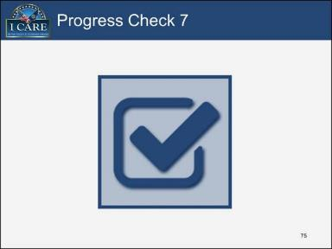

Progress Check 7:

1. According to the timeline, which months should you adjust obligations / deobligations, trend analysis, and GOE contracting?
2. September and October
3. May, June, July
4. October and November
5. December
6. Fill in the blank. Accruals are done monthly and at ______.
7. Midyear (May, June, July)
8. Beginning of the fiscal year (October)
9. End of the fiscal year (September)
10. End of the calendar year (December)

Notes:

### Accruals

#### Slide 76

This topic provides instruction about payroll and non-payroll accruals.

Image is a computer screen with the words Topic Introduction

Key Points:

Accruals are transactions that obligate / de-obligate funds to account for items that have not yet been processed in the accounting system. Manual accruals reflect the actual costs for a given period that have not been recorded.

Using a Standard Voucher (SV) accrual transaction, accruals should be done at the end of each month. However, end of fiscal year accruals are the most critical.

There are two types of accruals:

* Payroll
* Non-Payroll

Notes:

#### Slide 77

Title: Payroll Accruals:
Overtime
Awards
Accessions, Separations, Conversions (PT/FT), and/or Additional Hours Worked
Salary Dollars
Hours
Fringe Benefits
Within Grade/Career Ladder Promotions
Leave Without Pay (LWOP)
Terminal Leave (if applicable)

Image is a closeup of a corner of a pay stub

Notes:

#### Slide 78

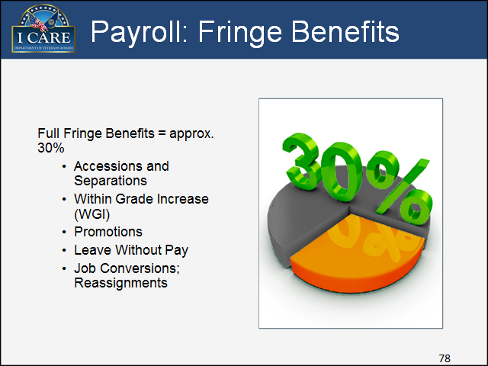

Notes:

#### Slide 79

Social Security (6.2%) and Medicare (1.45%) = 7.65%
Overtime
Awards
Within grade / promotions
Terminal leave

Image of the top right corner of two social security cards

Notes:

#### Slide 80

Credit Card
VR&E Contract Counseling (End of Fiscal Year only)

Graphic image of three hands exchanging currency in the form of cash, credit card, and check.

Key Points:

The following are examples of non-payroll accruals:

* Credit Card
  + Completed credit card orders that have not yet processed in the accounting system.
  + Manual accrual required for GOE purchases not included in the CAATS Purchase Card module and outstanding VR&E purchases.
* VR&E Contract Counseling (End of Fiscal Year only)
  + Accrue for contracting services where a Veteran has seen a counselor by September 30.
  + Information provided by VR&E Officer.

Notes:

#### Slide 81

It is the end of the fiscal year and time to complete EOFY accruals. 
Refer to the following Job aids as guidance when you work these four exercises:
2015 Paid Calendar
Hourly Salary Table

Key Points:

Refer to Sections 7.8 and 7.9 of the Appendix for the following Performance Support Tools/Job Aids:

* 2015 Paid Calendar
* Hourly Salary Table

Notes:

#### Slide 82

Scenario 1:
You have $3,000 worth of awards funds that have not yet been expended this fiscal year.  
Your Director wants to give a Special Contribution award to the Support Services Chief.  
Payroll will not run until end of given month.  
What do you do?


Notes:

#### Slide 83

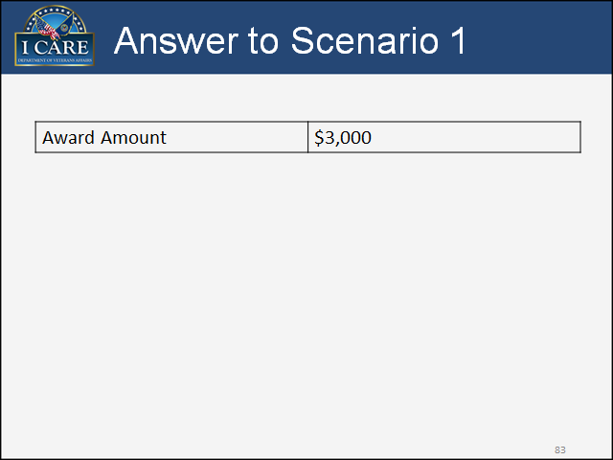

Notes:

#### Slide 84

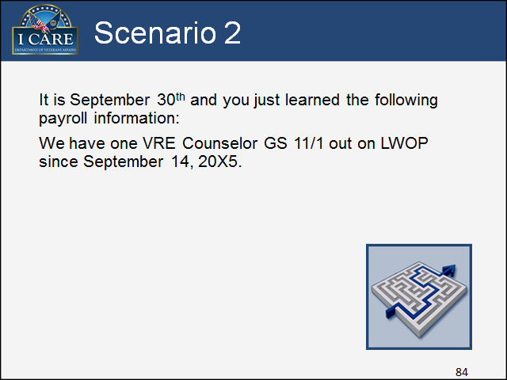

Notes:

#### Slide 85

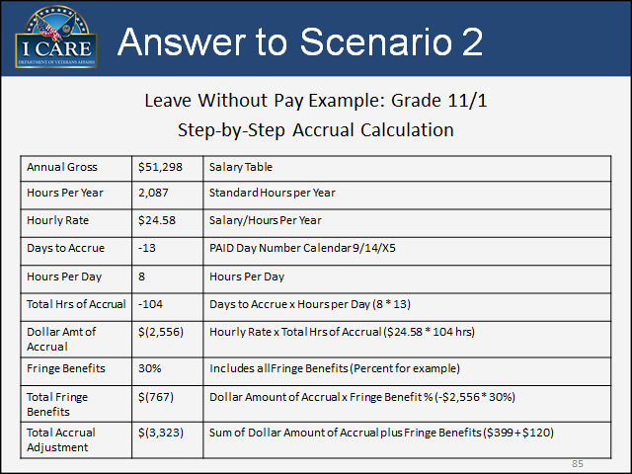

Notes:

#### Slide 86

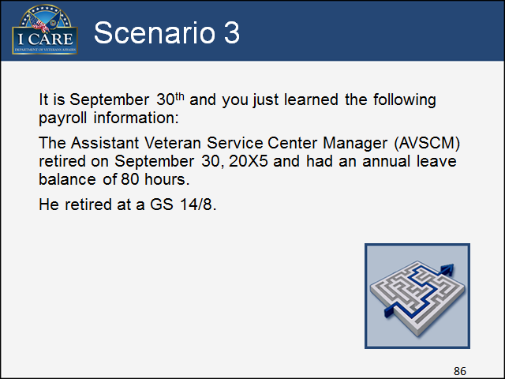

Notes:

#### Slide 87

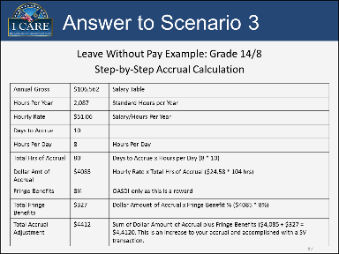

Notes:

#### Slide 88

Scenario 4:
We are going to purchase $2,000 worth of paper for the Regional Office. 
The CAATS purchase card module is disabled for the EOFY. 
What do you do?


Key Points:

Refer to Section 7.10 of the Appendix for the *Purchase Card Accrual Form* Performance Support Tool/Job Aid to use to work this scenario.

Notes:

#### Slide 89

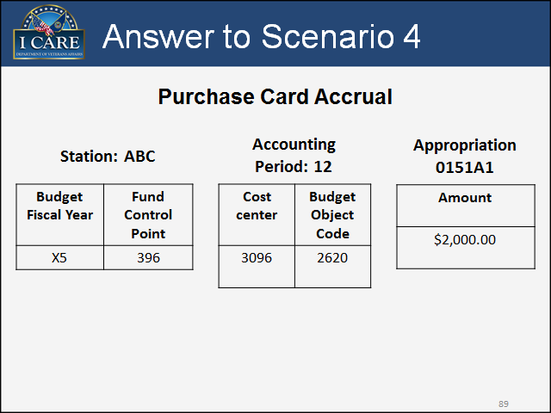

Key Points:

Refer to Section 7.11 of the Appendix for the *Populated Purchase Card Accrual Form* Performance Support Tool/Job Aid to use to work this scenario.

Notes:

### Fiscal Year Close

#### Slide 90

This topic provides instruction about closing the end of the fiscal year.

Image is a computer screen with the words Topic Introduction

Notes:

#### Slide 91

Begin working early (May/June) with your contracting specialist on procurements that need to move through contracting. 
Keeping up with monthly reconciliations will make the process much easier, more accurate and predictable, and less stressful.

Image of a calendar icon inside a circle with the label May/June centered above the circle.

Key Points:

Due to contracting timeframes, it is recommended to begin working early (May/June) with your contracting specialist on procurements that need to move through contracting. For new contractual requirements, you will need to create Statement(s) of Work, conduct market research, and prepare the procurement checklist. For routine purchase orders under $25,000, begin 15 days earlier. For purchase orders over $25,000, you will need 30 to 120 days complete the contracting process.

Notes:

#### Slide 92

Review the spending projections for upcoming three months (July, August, and September).
Are current obligations still needed?
Identify shortfalls or surpluses.
Meet with Senior Management to identify and prioritize needs and deficits.
Monitor the Field Distribution spreadsheet and Status of Allowance report.

Image is a July Calendar

Key Points:

Starting the tasks of a project early is best practice regardless of the type of project. The responsibilities that encompass fiscal year end closing are no different. Therefore, it is recommended to start in July thoroughly reviewing the spending projections for the upcoming next three months (July, August, and September).

Begin by determining whether the current obligations are still needed. Next, identify any shortfalls and surpluses. If there are surplus travel funds, identify the extras and either return or ask to convert.

Meet with Senior Management to identify and prioritize unfunded needs as well as address any unexpected deficits. If shortfalls are noted, you may need to remove some items or ask for additional funding.

Ensure you have received all approved funding (i.e., credit card rebates; VACO Reimbursables, such as, terminal leave, PCS travel; transfers to / from other stations).

Diligently monitor both the Field Distribution spreadsheet and Status of Allowance report.

Notes:

#### Slide 93

Early/Mid-September

Graphic image of a clipboard with a list of items checkmarked and a pen laying on top of the clipboard.

Key Points:

The following process outlines the tasks required during early to mid-September to close out the fiscal year.

* Continue thorough review of obligations.
* Affix certification stamp to obligations.
  + Typically an Accounting Section function.
  + Stamp indicates a valid obligation.
* Review payroll expenditures.
  + Notify ORM of any shortfalls or surpluses.
  + Request or return funds as needed.
* Continue monitoring allowance and expenditures.
* Closely control purchases for the remainder of the FY.
* Execute all GOE/payroll funds as appropriate and return unused funds to VACO. (Get what you need and return what you don’t.)

Note: If you need assistance, ORM provides year-end closing guidance.

Notes:

#### Slide 94

End of September

Image of a partical generic calendar month zoomed in at the end of the month

Key Points:

At the end September, ensure funding is adequate in all obligations.

* Brief Director on any surpluses or shortfalls.
* Payroll surplus? Return it.
* Travel surplus? Return it.
* Non-Payroll surplus?
  + Address Station unfunded needs / requirements.
  + Take appropriate action (i.e. return and / or spend funds).
* Procurements must be executed by close of business September 30 to be valid, current year expenditures.
* Process end of fiscal year (EOFY) accruals.
* Review Status of Allowance report to ensure funds are appropriately accounted.
* Complete final Suballowance Transfer (ST)/Suballowance (SA) transactions.

Notes:

#### Slide 95

EOFY Best Practices:
Consider Director’s reserve account.
Discontinue credit card use early.
Daily Suballowance Transfer transactions using F26A report.
EOFY purchases (early projections – early requests).
Finish early - September 28.

Image of the words "Helpful Tips" overlapped and positioned as a plus shape.  The word "Helpful" is written horizontally while the word "Tips" is written vertically.  The letter "P" is used as the central connecting point for both words.  A hand appears with a marker writing the last letter in the word "Helpful".

Key Points:

Finish Early!

Set aside September 29th and 30th for emergencies or for closing one or two transactions.

Notes:

#### Slide 96

Payroll Analysis Example

Image is example of payroll analysis

Example Payroll Analysis as of 8/14/15  
   
SASP 300/11  $ 3,000,000 
SASP 300/12  $ 1,000,000 
   
Total Available  $ 4,000,000 
   
Normal Payroll Pay Period #16  $ 1,000,000 
Normal Payroll Pay Period #17  $ 1,000,000 
Normal Payroll Pay Period #18  $ 1,000,000 
Accrual Pay Period #19 (8 days)  $ 800,000 
Awards Balance  $ 1,500 
Overtime Balance  $ 50,000 
Benefits Awards/OT (7.65%)  $ 3,940 
New Hires  $ 2,000 
Benefits New Hires (30%)  $ 600 
Within Grades  $ 500 
Benefits on Within Grades (7.65%)  $ 38 
 
Total Expenses  $ 3,858,578 
   
Balance  $                          141,422

Figure : Example of Payroll Analysis

Notes:

#### Slide 97

Non Payroll Analysis Example

Image is example of non-payroll analysis

Non Payroll Analysis as of 9/7/15  
   
310/26  $ 400 
340/22  $ 974 
340/25  $ 421 
350/26  $ 7,258 
394/25  $ 2,279 
396/23  $ 5,261 
   
Total Available  $ 16,593 
   
Obligations J599999  $ 800 
Credit Card Accruals  $ 1,942 
LGY Chairs  $ 1,800 
Toner Order Pending Contracting  $ 3,600 
   
Dependent on Funding Availability   
        New Area Office Desk   $1,742 
   
Total Expenditures  $ 9,884 
   
Balance  $ 6,709

Figure : Example of Non-Payroll Analysis

Notes:

#### Slide 98

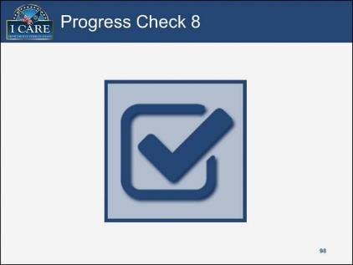

Progress Check 8:

1. In what month should you begin EOFY spending projection analysis?
2. July
3. August
4. September
5. October
6. Best practice is to finish EOFY on _______.
7. August 28
8. September 28
9. September 30
10. October 1

Notes:

#### Slide 99

Execute and Accrue:
In summary, Lesson 4 provided instruction about closing the end of the fiscal year.

Image is a projector screen with the words Lesson Summary.

Notes:

#### Slide 10

Questions about Execute and Accrue?
Questions?
Congratulations! You have completed the VBA Budget Formulation and Execution course.


Notes:

#### Slide 101

This course provided instruction about:
General Five Step Budget Process
Continuing Resolution
Common Financial Reports and Systems
General Operating Expense Budget Call 
Minor Construction Budget Call
Budget Formulation (Operating Plan, Allowance Letter, Attachment A)
Impact Statement
Budget Execution
Accruals
Fiscal Year Close

Image is a car racing Finish flag

Notes:

#### Slide 102

Remember:
Your opinion matters! Please complete the course evaluation.
If you have any additional questions, please contact your course instructor. Happy Budget Forming and Executing!

image is a small chalkboard with the words VBA Budget
1. Formulation
2. Execution
3. Start today; don't delay!

Notes:

# Appendix: Performance Support Tools

## Transaction Codes

Below are the defined transaction codes used in many reports:

* + AL – Allowance Posted
  + AR – Accrual
  + AR12 – Accrual on 12th Month
  + BD – Account Receivable
  + CC – Credit Card
  + CR – Cash Receipts
  + CT – Voucher Payment
  + DV – Advance Direct Disbursement Voucher
  + EB – Expenditure Transaction
  + EW – Expenditure Transaction
  + IF – Travel Advance
  + JV – Journal Voucher
  + MO – Miscellaneous Order
  + PCS – Permanent Change of Stations
  + PR – Payroll Accrual
  + PV – Payment Voucher
  + RO – Relocation Order
  + SO – Service Order
  + SV – Accrual
  + TO – Travel Order
  + TV – Travel Voucher
  + WR – Write Off
  + WV – WINRS Voucher

## Budget Call Letter

April 6, 20X2,

Director (00)

The Office of Field Operations is requesting the completion of FYX3 and FYX4 non-payroll budget requests by all Regional Offices, District Offices & HRCs, AMC, and RMC.

Completing these templates accurately will give OFO a more granular representation of true field needs, and allow us to better justify the overall funding request.  Please take time to make sure you are submitting the most accurate request possible. Be sure to include things like guard service, utilities, increased rent, shipping costs, and GSA car lease estimates.  Also account for all required program travel in your travel estimates/requests.

The budget request templates are located at: “ftp://budget.vba.va.gov/DOWNLOAD/OFO/20X4_Budget_####.xls” with #### being the first four letters of your station name. Once complete, operating plans should be uploaded to:“ftp://budget.vba.va.gov/UPLOAD/OFO/”

* Column 'C ' shows your actual FYX2 allocation.
* Column 'D' allows for changes that were made to your FYX2 allocation after the initial allowance letter was issued.
* Column 'E' shows your current FYX3 estimate based on the 1.3% inflation factor. (No input in this column is necessary)
* Column 'F' will be your FYX3 request.  Please use this column for your anticipated funding level of operational need for FYX3.
* Column 'G' will be your FYX4 estimate based on the 1.5% inflation factor.  (No input in this column is necessary)
* Column 'H' will be your FYX4 request based on your anticipated funding level of operational need for FYX4.

*Note that double-Selecting a blue background cell in columns D, F, or H will copy-in the "Current Estimate" amount.  If requests are made for funding in excess of the standard inflation levels for FYX3 or FYX4, please use column 'K' for comments.

*Rows/Columns should not be added or deleted.

In November 2011, the President issued Executive Order (EO) 13589 "Promoting Efficient Spending." The EO instructed all Departments and Agencies to reduce combined costs associated with travel and relocation, employee IT devices, printing, professional and technical services, supplies and materials, and promotional items.  VBA will continue to place emphasis on savings in these areas.  Please consider this when submitting your request.

Please submit your completed budget request to the ORM budget server by 12:00 EST on Monday, April 16, 20X2.

Questions can be directed to **xxx in the Office of Field Operations**.  Technical questions regarding the download/upload of the template can be directed to **xxxx** in the Office of Resource Management.

Thank you,

Office of Field Operations

## Budget Call Sample Spreadsheet

Note: This graphical depiction of the actual Budget Call spreadsheet is to be used for reference only. The full Budget Call Exercise Spreadsheet Orlando Excel file is available as a download in the Web-Based Training (WBT) prerequisite accessed through TMS.

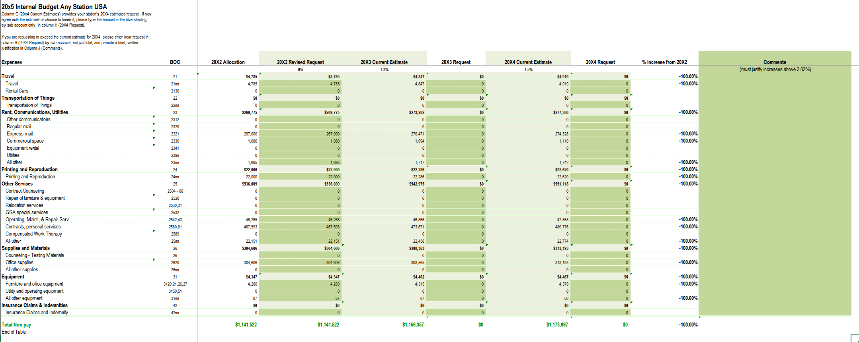

Figure : Budget Call Sample Spreadsheet

## Minor Construction SCIP FYXX Call Letter Justification

**Note:** The below scripted call letter is to be used for reference only. This letter is a reference and should be retyped replacing specific Station, code, Regional Office and Town between the left and right brackets. Minor Construction justification and totals will need to be retyped as per specific VR&E request.

**STRATEGIC CAPITAL INVESTMENT PLANNING (SCIP) FY16 CALL LETTER**

**[Type Your Regional Office and Station number replacing left to right brackets [Station 123]]**

The [123 Regional Office] requests minor construction funds totaling **$41,000.00** to address security concerns and facility maintenance issues at our [Any Town] out-based VR&E office. VBA originally opened this office in 2003. The office is staffed by three Vocational Rehabilitation Counselors.

We have received complaints from employees at this location regarding the ability for the public to come into the space and move freely in the office when the counselors are behind closed doors with clients. The original design for the office allowed for a small lobby area with a standing height counter that has a pass through door in it. Minor construction funds in the amount of **$16,000** are needed to remove the pass through door, extend the counter-height wall to the ceiling and install a small customer window.

Funds are also requested to paint and carpet the [Any Town VR&E site]. We have been in the space for 10 years and both our carpet and paint desperately need a refresh. VBA signed an occupancy agreement with GSA in August 2010 for another 10-year period. Estimated amount for paint and carpet is **$25,000**.

## Attachment B Minor Construction Project Proposal FYXX Any Town VR&E Out-based Office

**Instructions**: Complete the following VBA Minor Construction Project Proposal form by entering all relevant information related to the proposed minor construction.

Table : Fiscal Year 2016 VBA Minor Construction Project Proposal

| **Construction Project Information** | **Proposed Construction Project Details** |
| --- | --- |
| **Submitting Station & Station No.** | **[**Type **Submitting Station** and number replacing left and right bracket**]** |
| **Project Title** | **[**Type **Project Title** replacing left and right bracket and example in parentheses (Any Town VRE out based Office) **]** |
| **Proposed Start Date** | **[**Type **Proposed Start Date** replacing left and right bracket by month, month/day, day/year**]** |
| **VARO Project Contact & Phone No.** | **[**Type **Your Name and Phone Number** replacing left and right bracket**]** |
| **Station Priority** | **[**Type **Station Priority** replacing left and right bracket and example 1**]** |
| **District Priority** | **[**Type **District Priority** replacing left and right bracket**]** |
| **VACO Project Number Assignment** | **[**Type VACO Project Number Assignment replacing left and right bracket**]** |
| **PROJECT SCOPE & DESCRIPTION** (Describe project scope, what divisions are affected, domino moves, what the project will accomplish, etc.) | **[**Type **PROJECT SCOPE & DESCRIPTION** replacing left and right bracket and example in parentheses. **(**Install a security system of Any Town VRE out based Office. Any Town security system must be compatible with existing security system at 123 Regional Office. Requirements: Design and installation of Lenel security system, 3 HSPD card/pin readings, 7 motion sensors, 1 temperature/humidity gauges, 1 horn, 1 notification, 3 crash bars, and 1 AC backup. Refresh for paint and carpet are needed after expiration of our first 10-year lease. Total cost of project is $41,000.**)]** |
| **PROJECT JUSTIFICATION** (Describe how this project relates to an approved initiative, supports strategic goals, produces improvements, generates space reduction, corrects health and safety conditions, etc.) | **[**Type **PROJECT JUSTIFICATION** replacing left and right bracket and example in parentheses. **(**This project is a result of employee security concerns and ISO CRISP related IT security items. The CRISP items are outstanding POAMs that must be corrected ($16,000). Our Regional Office has also recently renewed lease after occupying our current space for 10 years. Paint and carpet refresh for this VRE out based office is desperately needed ($25,000).**)** **]** |
| **IT IMPACT**  (Does this project have an impact on IT systems? If yes, describe extent and need for voice/data, cable, closets, computer room, VACO/ITC/NSC technical assistance and support.) | **[**Type **IT IMPACT** replacing left and right bracket and example in parentheses. **(**Requires space for security panels, data line for connectivity to 123 Regional Office Level system. Low voltage cabling and electrical to be paid from GSA funding source.**)]** |
| **MINOR CONSTRUCTION COST** (Itemize costs, such as demolition, cable, construction, GSA fees, etc.) | **[**Type **MINOR CONSTRUCTION COST** replacing left and right bracket and example in parentheses. **(**$41,000**)]** |
| **GOE COST** (Show detail in Attachment C) | **[**Type **GOE COST** replacing left and right bracket and example in parentheses. **(**$0**)]** |

## Minor Construction Action Plan Call Memo FY17

Note: The below image is to be used for reference only. This memorandum is the first page of a detailed call request. Access the full PDF file from the VA intranet through this link: [Signed Memo with Attachments](https://vaww.portal.va.gov/sites/2017SCIP/Shared%20Documents/Action%20Plan%20Resource%20Documents/7546257%20-%20004%20Signed%20Memo%20w-attachments%2011-10-14.pdf).

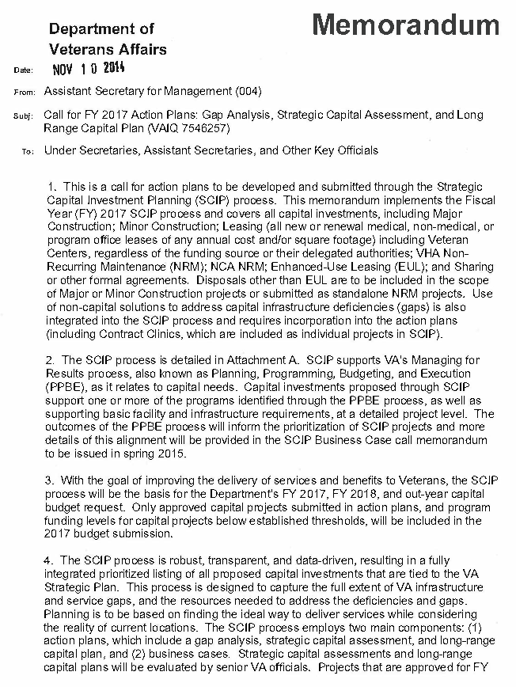

Figure : Minor Construction Action Plan Memo

## Station Budget Operating Plan: Work Areas – Definitions

* **PayProj** (Payroll model) – This sheet is used to update payroll projections.
* **NPProj** – Used to enter current non-payroll and travel projections. Amounts are rolled into the Proj sheet.
* **Proj** – Summary of projected payroll, non-payroll, and travel expenditures. It consists nearly entirely of formulas summarizing data from other sheets on the spreadsheet. Non-recurring payroll costs are manually entered (i.e., overtime, terminal leave and/or awards).
* **Plan** – Preserves the original plan submitted to VACO. It is created when the first plan is saved. No input necessary. The CompMo and CompFY sheets feed from this sheet to make the comparisons. Do not make any changes to this sheet.
* **PayPlan** – Preserves the original payroll plan submitted to VACO (by pay period). It is created when the first plan is saved. No input necessary. It is provided for information only. Do not make any changes to this sheet.
* **Changes** – Accommodates the need to modify the original plan (increases/decreases to the allowance). It provides an excellent tool to track increases/decreases to the original budget allowance as well as reimbursable items and carries those adjustments to the CompFY sheet to reflect the “Revised” Plan (original plan plus/minus adjustments – Column D). When comparing the “revised plan” vs. the actual projections, it will provide you with a current budget status. The file FY10DIST.xls (funds distribution worksheet) will assist you in entering the data on the Changes sheets as well as reconcile the balances with FMS.
* **CompMo** (Monthly Comparison) – Shows how current monthly obligations compare with the original plan (as amended). This sheet uses formulas to collect information from PayProj, NPProj, Changes, and Plan sheets. It is updated to include actual monthly data by the Get actual Month macro.
* **CompFY** (Fiscal Year Totals) – Comparison of current projection vs. Plan. Shows how current actual and projected fiscal year obligations compare to the original plan (as amended). This sheet uses formulas to collect information from PayProj, NPProj, Changes, and Plan sheets.
* **Help** – Station Budget Operating Plan user’s manual and technical description.
* **Funding** – The Funding sheet has two uses, depending whether the Plan is being prepared at the start of the fiscal year or after one or more quarters have already passed. At the start, only the Station Allowance need be entered (cell g14). If the station allowance or if the plan over or under obligates the allowance, cell F1 in the Proj sheet will show that fact. Do not override this feature!

## 2015 Paid Calendar

Note: This graphical depiction of the actual Paid Day Number Calendar is to be used for reference only. Access the full PDF file from the VA intranet: [2015 Paid Calendar](http://vaww.fscdirect.fsc.va.gov/docs/Payroll/PAID/Paid_Calendar_2015.pdf).

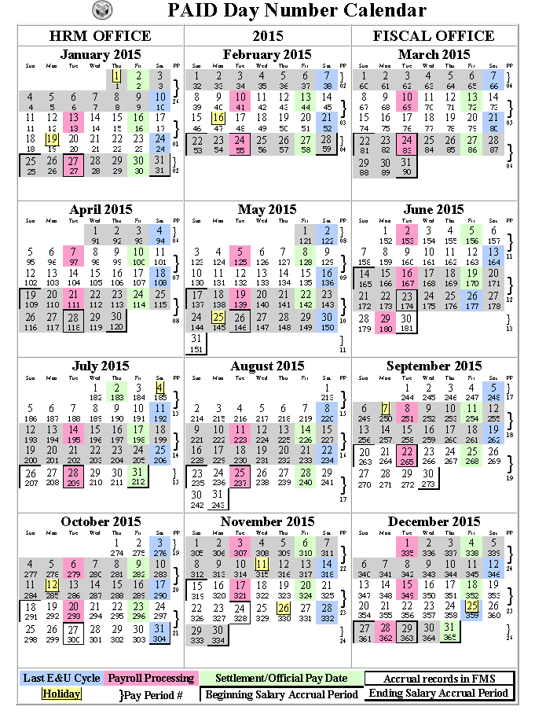

Figure : Paid Calendar 2015

## Hourly Salary Table

Note: This graphical depiction of the actual Hourly Salary Table is to be used for reference only. Access the full PDF file available on OPM’s website: [Salary Table 2015-GS](https://www.opm.gov/policy-data-oversight/pay-leave/salaries-wages/salary-tables/pdf/2015/GS_h.pdf).

SALARY TABLE 2015-GS

INCORPORATING THE 1% GENERAL SCHEDULE INCREASE

EFFECTIVE JANUARY 2015

*Hourly Basic (B) Rates by Grade and Step*

*Hourly Overtime (O) Rates by Grade and Step*

| Grade | B/O | Step 1 | Step 2 | Step 3 | Step 4 | Step 5 | Step 6 | Step 7 | Step 8 | Step 9 | Step 10 |
| --- | --- | --- | --- | --- | --- | --- | --- | --- | --- | --- | --- |
| 1 | B | $ 8.70 | $ 8.99 | $ 9.28 | $ 9.57 | $ 9.86 | $ 10.03 | $ 10.32 | $ 10.60 | $ 10.61 | $ 10.88 |
| *O* | *13.05* | *13.49* | *13.92* | *14.36* | *14.79* | *15.05* | *15.48* | *15.90* | *15.92* | *16.32* |
| 2 | B | 9.78 | 10.02 | 10.34 | 10.61 | 10.73 | 1 1.05 | 1 1.37 | 1 1.68 | 12.00 | 12.31 |
| *O* | *14.67* | *15.03* | *15.51* | *15.92* | *16.10* | *16.58* | *17.06* | *17.52* | *18.00* | *18.47* |
| 3 | B | 10.68 | 1 1.03 | 1 1.39 | 1 1.74 | 12.10 | 12.46 | 12.81 | 13.17 | 13.52 | 13.88 |
| *O* | *16.02* | *16.55* | *17.09* | *17.61* | *18.15* | *18.69* | *19.22* | *19.76* | *20.28* | *20.82* |
| 4 | B | 1 1.98 | 12.38 | 12.78 | 13.18 | 13.58 | 13.98 | 14.38 | 14.78 | 15.18 | 15.58 |
| *O* | *17.97* | *18.57* | *19.17* | *19.77* | *20.37* | *20.97* | *21.57* | *22.17* | *22.77* | *23.37* |
| 5 | B | 13.41 | 13.85 | 14.30 | 14.75 | 15.20 | 15.64 | 16.09 | 16.54 | 16.98 | 17.43 |
| *O* | *20.12* | *20.78* | *21.45* | *22.13* | *22.80* | *23.46* | *24.14* | *24.81* | *25.47* | *26.15* |
| 6 | B | 14.95 | 15.44 | 15.94 | 16.44 | 16.94 | 17.44 | 17.94 | 18.43 | 18.93 | 19.43 |
| *O* | *22.43* | *23.16* | *23.91* | *24.66* | *25.41* | *26.16* | *26.91* | *27.65* | *28.40* | *29.15* |
| 7 | B | 16.61 | 17.16 | 17.72 | 18.27 | 18.82 | 19.38 | 19.93 | 20.48 | 21.04 | 21.59 |
| *O* | *24.92* | *25.74* | *26.58* | *27.41* | *28.23* | *29.07* | *29.90* | *30.72* | *31.56* | *32.39* |
| 8 | B | 18.39 | 19.01 | 19.62 | 20.23 | 20.85 | 21.46 | 22.07 | 22.69 | 23.30 | 23.91 |
| *O* | *27.59* | *28.52* | *29.43* | *30.35* | *31.28* | *32.19* | *33.1 1* | *33.56* | *33.56* | *33.56* |
| 9 | B | 20.32 | 20.99 | 21.67 | 22.35 | 23.02 | 23.70 | 24.38 | 25.06 | 25.73 | 26.41 |
| *O* | *30.48* | *31.49* | *32.51* | *33.53* | *33.56* | *33.56* | *33.56* | *33.56* | *33.56* | *33.56* |
| 10 | B | 22.37 | 23.12 | 23.86 | 24.61 | 25.35 | 26.10 | 26.85 | 27.59 | 28.34 | 29.08 |
| *O* | *33.56* | *33.56* | *33.56* | *33.56* | *33.56* | *33.56* | *33.56* | *33.56* | *33.56* | *33.56* |
| 11 | B | 24.58 | 25.40 | 26.22 | 27.04 | 27.86 | 28.68 | 29.50 | 30.32 | 31.13 | 31.95 |
| *O* | *33.56* | *33.56* | *33.56* | *33.56* | *33.56* | *33.56* | *33.56* | *33.56* | *33.56* | *33.56* |
| 12 | B | 29.46 | 30.44 | 31.43 | 32.41 | 33.39 | 34.37 | 35.36 | 36.34 | 37.32 | 38.30 |
| *O* | *33.56* | *33.56* | *33.56* | *33.56* | *33.56* | *34.37* | *35.36* | *36.34* | *37.32* | *38.30* |
| 13 | B | 35.03 | 36.20 | 37.37 | 38.54 | 39.70 | 40.87 | 42.04 | 43.21 | 44.38 | 45.54 |
| *O* | *35.03* | *36.20* | *37.37* | *38.54* | *39.70* | *40.87* | *42.04* | *43.21* | *44.38* | *45.54* |
| 14 | B | 41.40 | 42.78 | 44.16 | 45.54 | 46.92 | 48.30 | 49.68 | 51.06 | 52.44 | 53.82 |
| *O* | *41.40* | *42.78* | *44.16* | *45.54* | *46.92* | *48.30* | *49.68* | *51.06* | *52.44* | *53.82* |
| 15 | B | 48.70 | 50.32 | 51.94 | 53.57 | 55.19 | 56.81 | 58.44 | 60.06 | 61.68 | 63.31 |
| *O* | *48.70* | *50.32* | *51.94* | *53.57* | *55.19* | *56.81* | *58.44* | *60.06* | *61.68* | *63.31* |

Figure : Hourly Salary Table

## Purchase Card Accrual Form

Note: This graphical depiction of the actual Purchase Card Accrual spreadsheet is to be used for reference only. The full Purchase Card Accrual Form Excel file is available as a download in the WBT prerequisite accessed through TMS.

Purchase Card Accrual

| **Station** | **Accounting Period** | **Appropriation** |
| --- | --- | --- |
| replace ABC with station | 12 replace 12 with correct accounting period | 0151A1 replace o121a1 with correct appropriation |

| **Budget Fiscal Year** | **Fund Control Point** | **Cost Center** | **Budget Object Code** | **Amount** |
| --- | --- | --- | --- | --- |
|  |  |  |  |  |
|  |  |  |  |  |
|  |  |  |  |  |
|  |  |  |  |  |
|  |  |  |  |  |
|  |  |  |  |  |
|  |  |  |  |  |
|  |  |  |  |  |
|  |  |  |  |  |
|  |  |  |  |  |
|  |  |  |  |  |
|  |  |  |  |  |
|  |  |  |  |  |
|  |  |  |  |  |
|  |  |  |  |  |
|  |  |  |  |  |
|  |  |  |  |  |
|  |  |  |  |  |
|  |  |  |  |  |
|  |  |  |  |  |
| End of table 2 after Total |  |  | Total | End of table 2 |

|  |  |
| --- | --- |
| **Reason:** | To record the accrued amount not expensed. If other reason, please specify. |

**Financial Liaison Signature** **Type Date**”

Figure : Blank Purchase Card Accrual Form

## Populated Purchase Card Accrual Form

Note: This graphical depiction of the actual Purchase Card Accrual spreadsheet is to be used for reference only. The full Purchase Card Accrual Scenario 4 Form Excel file is available as a download in the WBT prerequisite accessed through TMS.

Purchase Card Accrual

| **Station** | **Accounting Period** | **Appropriation** |
| --- | --- | --- |
| replace ABC with station | 12 replace 12 with correct accounting period | 0151A1 replace o121a1 with correct appropriation |

| **Budget Fiscal Year** | **Fund Control Point** | **Cost Center** | **Budget Object Code** | **Amount** |
| --- | --- | --- | --- | --- |
| 16 | 396 | 3096 | 2620 | 2,000.00 |
|  |  |  |  |  |
|  |  |  |  |  |
|  |  |  |  |  |
|  |  |  |  |  |
|  |  |  |  |  |
|  |  |  |  |  |
|  |  |  |  |  |
|  |  |  |  |  |
|  |  |  |  |  |
|  |  |  |  |  |
|  |  |  |  |  |
|  |  |  |  |  |
|  |  |  |  |  |
|  |  |  |  |  |
|  |  |  |  |  |
|  |  |  |  |  |
|  |  |  |  |  |
|  |  |  |  |  |
| End of table 2 after Total Amount |  |  | **Total** | **$2,000.00** |

|  |  |
| --- | --- |
| **Reason:** | To record the accrued amount not expensed. If other reason, please specify. |

**Financial Liaison Signature** **Type Date**”

Figure : Example of Populated Purchase Card Accrual Form

This page intentionally left blank.